KWAME NKRUMAH UNIVERSITY OF SCIENCE AND TECHNOLOGY

DEPARTMENT OF COMPUTER ENGINEERING
COE 472 – DIGITAL SIGNAL PROCESSING
Mini Project 3: Harmonic Signature Disaggregation for Load Monitoring on an Unstable Feeder
Group Project Report — Non-Intrusive Load Monitoring
Group: [GROUP NUMBER]
Date of Submission: 4 August 2026
Members: twelve members; individual contributions and signatures are listed in Section 8.

1. Problem Definition
Non-intrusive load monitoring works out which appliances are running from one measurement point, instead of fitting a meter to every socket. It is possible because appliances draw differently shaped currents: a heater draws an almost pure sine wave, while a motor or a charger distorts it in its own characteristic way. Each therefore leaves a recognisable fingerprint in the frequency domain.
Three things make this hard. The meter sees only the SUM of the appliance currents, which looks like none of them individually. On a weak feeder the supply is itself distorted: sags shrink every current at once, harmonics from other customers land on the frequencies our rectifier loads use, and short interruptions remove the signal completely. A low-cost meter also limits the sampling rate, and so the highest harmonic we can see. The task is to work backwards from a distorted, noisy spectrum to the few appliances that produced it.
2. Literature and Research Basis
[BENJAMIN AND KWAKU: two short paragraphs here summarising your sources, full list in Section 9. Required: two on NILM and harmonic signatures, one on power-quality disturbances. For each, say what we took from it — the rubric rewards interpretation, not just a citation.]
Two standards anchor Section 3. IEEE Std 1159 defines the depth and duration categories used for our sag and interruption; IEEE Std 519 sets the harmonic limits against which our background distortion is chosen.
3. Methodology and Design Justification
3.1 Appliance mix and sampling rate
Our group received no parameter sheet, so the appliance mix is itself a decision we must defend. We modelled four loads covering all three classes the brief names: an electric kettle (resistive, 6.0 A), a refrigerator compressor (motor, 2.0 A, lagging 35°), an LED lamp bank (rectifier, 0.7 A) and a laptop charger (switch-mode supply, 1.1 A). Two are rectifier loads, which is the harder case — they are the pair most easily confused. Their currents differ by almost ten times, so a quiet appliance must be found beneath a loud one, and their on/off times overlap in every combination.
The highest harmonic we model is the 15th, at 750 Hz, so Nyquist requires more than 1500 Hz. We sample at 4000 Hz — 5.3 times the highest frequency of interest and 2.7 times the Nyquist minimum. That headroom lets a realistic anti-aliasing filter roll off gradually between 750 Hz and 2000 Hz instead of needing an impossible brick wall, and 4 kHz remains within reach of a cheap metering ADC.
3.2 Supply disturbance model
Four disturbances are applied in the order they physically occur between feeder and meter. A sag drops the supply to 0.70 pu for 0.30 s; at 15 cycles IEEE Std 1159 calls this an instantaneous sag, the commonest kind on a distribution feeder. Background distortion is injected at the 5th, 7th and 11th harmonics totalling 8% THD — above the 5% IEEE Std 519 recommends, because an unstable feeder is precisely one where that limit is not met. A 0.10 s interruption with 50 ms recovery represents a recloser clearing a fault. Noise at 35 dB SNR is added last, as it comes from the meter, not the network.
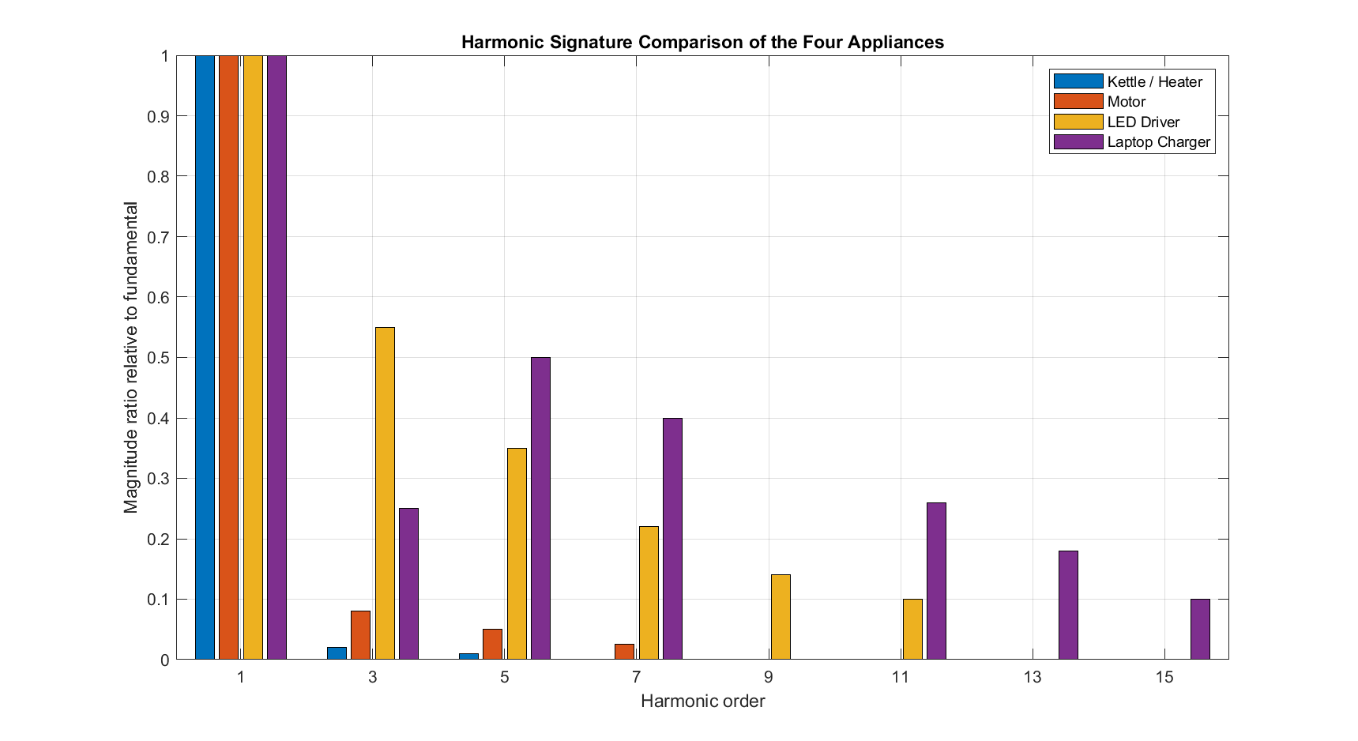  Figure 1: Harmonic content of each appliance relative to its own fundamental. The kettle is nearly a pure sine wave; the LED bank is dominated by its 3rd harmonic; the charger’s 5th and 7th exceed its 3rd. | 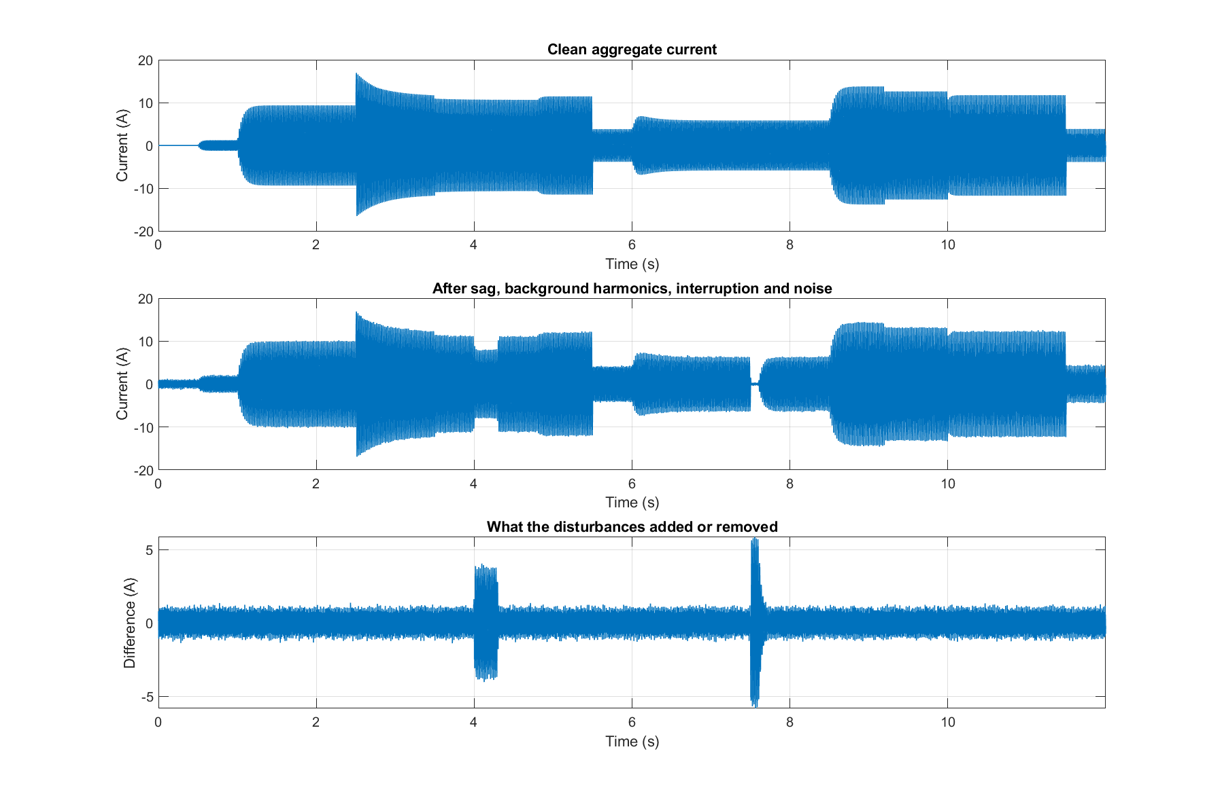  Figure 2: Clean aggregate current, the same signal after all four disturbances, and the difference. The sag at t = 4.0 s and the interruption at t = 7.5 s are visible.

3.3 FIR filtering
A linear-phase low-pass filter removes everything above the highest harmonic we use. The cutoff is 775 Hz — half a harmonic above 750 Hz — so the 15th sits inside the passband, not on the shoulder where it would be weakened. A Hamming window gives about 53 dB of stopband attenuation; Blackman’s 74 dB would need a far longer filter for little gain. The transition-width rule gives 528 taps. Linear phase matters because a filter delaying harmonics unequally would destroy the phase relationships the classifier needs. Out-of-band content is suppressed by 37.9 dB.
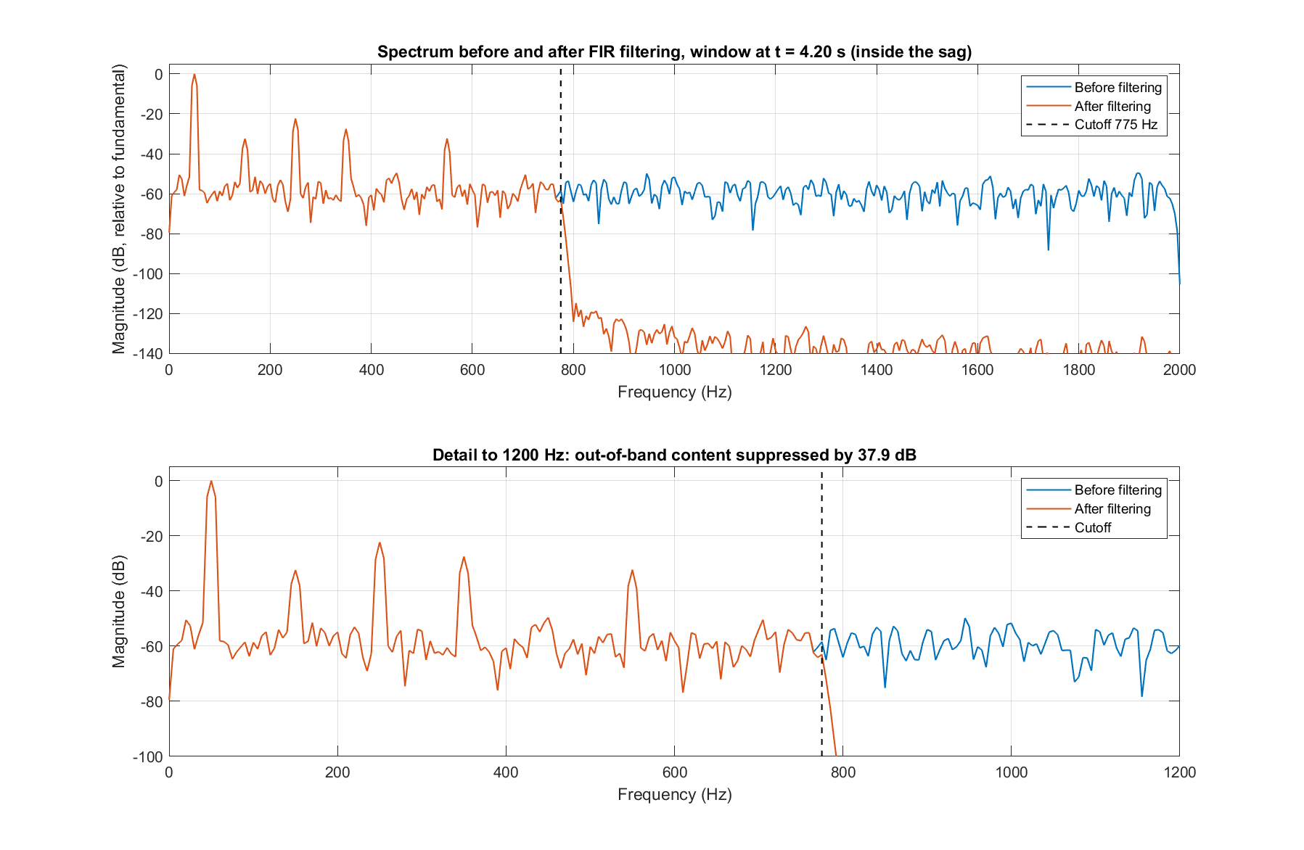
Figure 3: One window taken from inside the sag, before and after filtering, in decibels relative to the fundamental. Everything above 775 Hz is suppressed by 37.9 dB while every analysed harmonic passes untouched.
3.4 Windowing
The analysis window is 200 ms, exactly ten cycles at 50 Hz — the most important single choice in the pipeline. With a whole number of cycles every harmonic falls exactly on an FFT bin, so no energy leaks between harmonics and each amplitude is read straight from its bin. At 4 kHz that is 800 samples with 5 Hz spacing, so every harmonic of 50 Hz lands precisely on a bin. The 100 ms hop is five cycles, also whole, so phases stay comparable between windows, and the 50% overlap leaves no gap where a switching event could hide. Each frame uses a Hann window, whose sidelobes fall at 18 dB per octave against Hamming’s 6 dB — which matters when separating the 0.7 A LED bank from the 6 A kettle.
3.5 Feature extraction
From each window we take the size and phase angle of the odd harmonics 1 to 15, forming a complex phasor. Even harmonics are ignored because a symmetric load produces none. Phase angles are corrected for the window’s start time so every window shares one reference. Keeping phase matters: two appliances drawing the same harmonic at different angles partly cancel, and only a phasor can represent that.
3.6 Classification
Each appliance is described by a template — the phasor it contributes at each harmonic, calculated from its rated current, phase angle and harmonic ratios. For each window we find the non-negative amounts of each appliance that best reproduce the measurement:
minimise || y − Σ c_{i} T_{i} ||² subject to c_{i} ≥ 0
Here y is the measured phasor vector, T the templates and c the amounts. Each amount is that appliance’s current as a fraction of its rating: near 1 means running, near 0 means absent, and an appliance is declared ON at 0.55. No optimisation toolbox is needed — the answer must use one of 16 combinations, so we fit each by least squares, reject any needing a negative current, and keep the best fit. Fundamental and harmonics are weighted equally so the kettle cannot drown the harmonic detail that identifies the small loads.
3.7 Removing the feeder’s own distortion
Not all measured harmonics are ours. Background distortion belongs to the supply, so it appears in every window, while an appliance affects only the windows it runs in — and that difference separates them. The classifier runs twice: it classifies, takes the median of what it could not explain across all live windows as the background, subtracts it, and classifies again. The median resists distortion by a few badly fitted windows. The fundamental is never adjusted, since our appliances dominate it.
3.8 Handling interruptions
A window with no current has two possible causes needing opposite responses: the supply failed while appliances were still on, or nothing was running. Current alone cannot tell them apart, so we use duration. IEEE Std 1159 puts the instantaneous/momentary boundary at 30 cycles, or 0.6 s — six of our windows. Shorter silence is treated as an outage and the previous decision held; longer silence is reported as an idle installation.
4. Implementation
The system is written in MATLAB with no toolbox dependencies; every window, filter and transform is built from first principles, and running main.m regenerates every number and figure here. Everything after signal generation lives in one function, runPipeline.m, called by both the local run and the blind test, so an unseen recording passes through identical code. runBlindTest.m loads a waveform from .mat, .csv, .txt or .wav and adopts the sampling rate stated in the file.
5. Validation and Results
5.1 Our own recording
Twelve seconds gives 119 windows and 476 appliance decisions. Overall accuracy is 97.48%, macro-F1 0.9809, and 90.8% of windows have all four appliances correct at once.
Table 1: Per-appliance performance on our own recording (119 windows).
Appliance | TP | FP | FN | TN | Precision | Recall | F1
Kettle | 73 | 0 | 4 | 42 | 1.000 | 0.948 | 0.973
Refrigerator | 71 | 0 | 5 | 43 | 1.000 | 0.934 | 0.966
LED bank | 93 | 0 | 3 | 23 | 1.000 | 0.969 | 0.984
Laptop charger | 60 | 0 | 0 | 59 | 1.000 | 1.000 | 1.000
Precision is perfect for every appliance — the system never reports a load that is not there. Every error is a missed detection, and these occur almost entirely at switching boundaries, where a window genuinely contains both states, and at the two disturbances.
5.2 Comparison with other classifiers
Two alternatives were run on identical features: conventional per-appliance threshold rules on THD, RMS and phase — swept from ±25% to ±1000%, reporting the best any setting achieved — and a trivial classifier declaring every appliance permanently ON, the floor any real method must beat.
Table 2: Method comparison on our own recording.
Method | Accuracy | Macro-F1
Decomposition (adopted) | 97.48% | 0.9809
All-or-nothing combination search | 98.32% | 0.9853
Best-tuned threshold rules | 64.92% | 0.5840
Trivial "always ON" baseline | 64.92% | 0.7822
The threshold rules cannot be rescued by tuning: even at their best they score below the trivial baseline. The problem is the question, not the thresholds. Asking whether an aggregate window "looks like a kettle" makes no sense when three appliances run at once, because the combined measurement looks like none of them.
5.3 Testing on unseen recordings
Performance on the recording a system was designed around says little about unseen data, so we generated three held-out recordings and never tuned against them. Each differs in four ways: a different subset of appliances, random switching times, harsher disturbances (45% sag, 12% background THD, two interruptions, 25 dB SNR), and appliance values shifted by up to 15% in current, 20% in harmonic ratios and 10° in phase. Our library was not updated to match.
Table 3: Held-out recordings (149 windows each), compared with our own.
Recording | Appliances | Accuracy | Macro-F1
Held-out A | Four | 97.65% | 0.9804
Held-out B | Four | 97.82% | 0.9400
Held-out C | Three | 97.32% | 0.9761
Mean of held-out | — | 97.60% | 0.9655
Our own recording | Four | 97.48% | 0.9809
Accuracy on unseen recordings, 97.60% on average, matches that on the recording the system was built around, 97.48%. That the two agree is the strongest evidence that the method captures the underlying physics rather than one dataset. It is also how the classifier was chosen: under these conditions the all-or-nothing search, slightly better in Table 2, degrades noticeably, because one overall scaling cannot absorb differences between individual appliances. Two caveats, for honesty: held-out C contains no refrigerator, and a correctly-absent appliance scores as perfect under our convention, which lifts that row; held-out B’s lower macro-F1 comes from the charger being active in only 15 of 149 windows, where six false alarms weigh heavily though accuracy stayed at 97.8%.
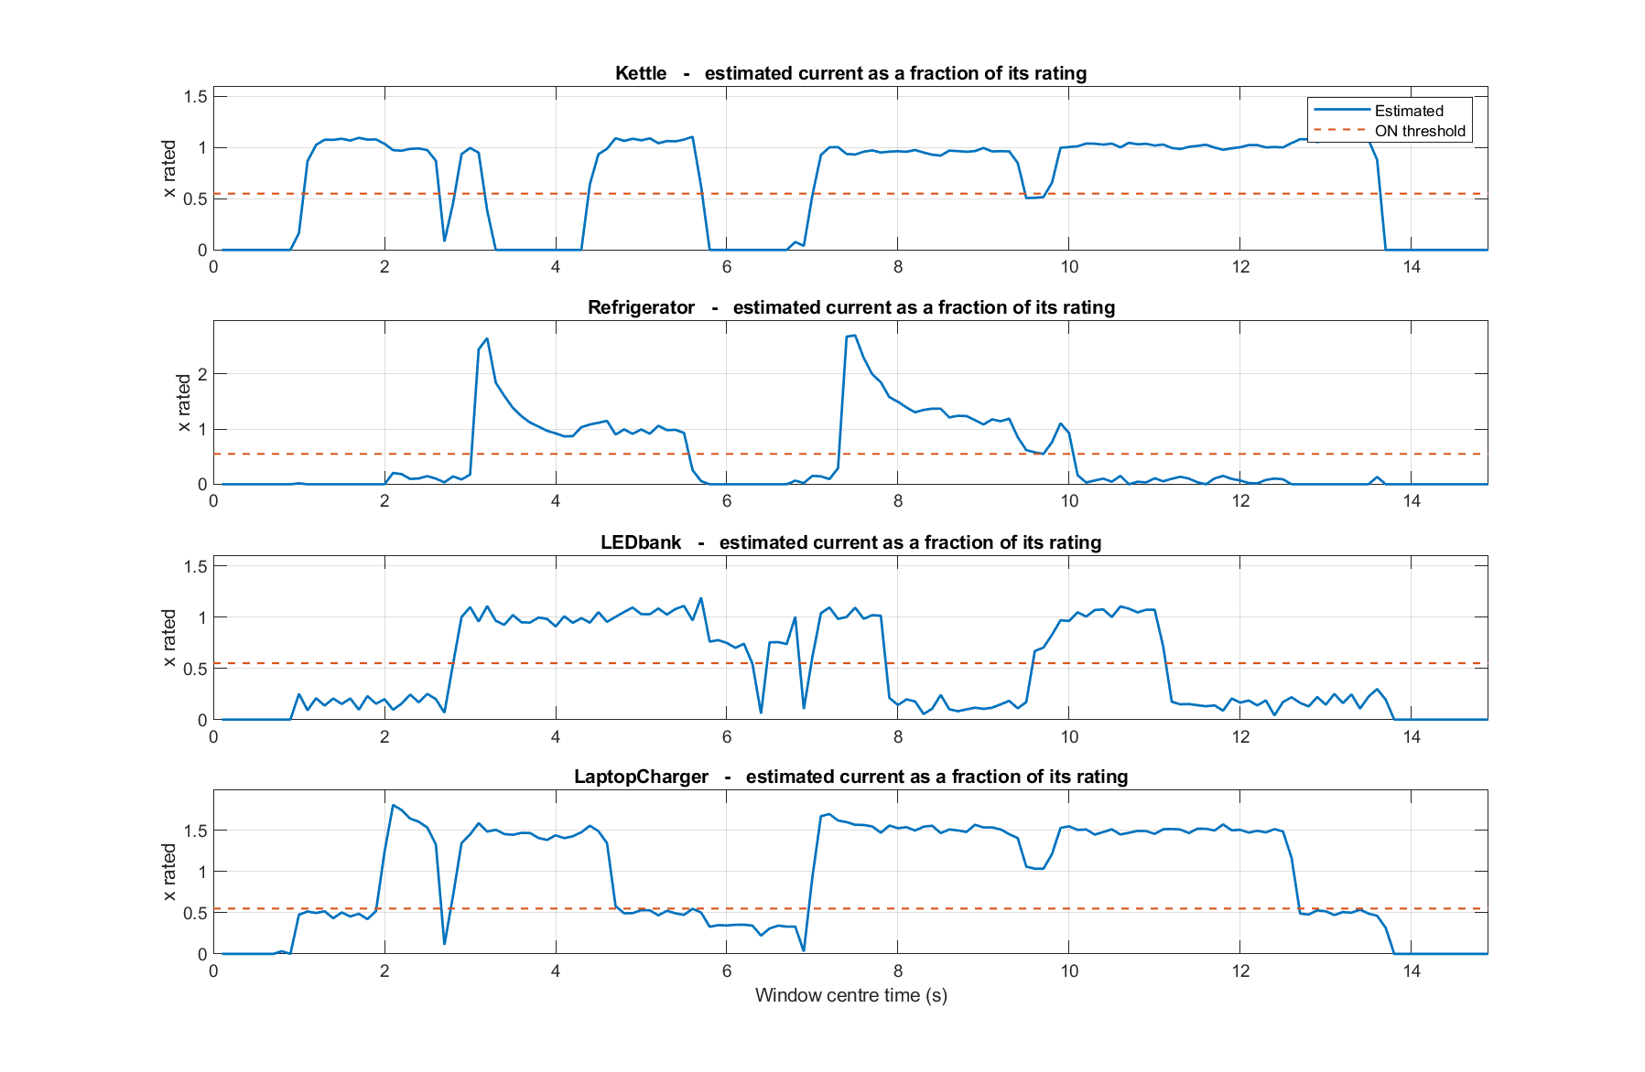
Figure 4: The decomposition working on an unseen recording — the estimated current of each appliance, as a fraction of its rating, before any on/off decision is taken. The dashed line is the 0.55 ON threshold. Three things are visible: the refrigerator’s start-up inrush reaching 2.6 times its rating and decaying, the kettle dipping onto the threshold at t = 9.6 s where the sag bites, and the charger settling near 1.5 rather than 1.0 because it still absorbs some distortion that is not its own.
6. Failure Modes and Limitations
Two failure modes were found by testing on unseen data; neither was visible on our own recording. The first was misreading supply distortion as an appliance. On a held-out recording where only the kettle ran, a window showed 11.9% THD with the 5th, 7th and 11th harmonics in the ratio 1 : 0.64 : 0.35 — almost exactly the injected background, where a kettle alone should show 2.2%. Those harmonics were credited to the laptop charger, whose signature has the same shape, and its precision fell to 0.730 with 31 false alarms. The background removal in Section 3.7 raised it to 0.988, and macro-F1 on that recording from 0.9488 to 0.9804.
The second remains. A large appliance drawing below its rated current can be missed: kettle recall across the three held-out recordings was 0.906, 0.933 and 0.864. When a deep sag reduces it further, its estimated amount falls below the 0.55 threshold. This is the price of the threshold that suppresses false alarms, and we judge the trade worthwhile — a meter that occasionally misses a load is more useful than one reporting loads that are not there.
A third limit is structural rather than a defect. Background distortion above roughly 15% THD cannot be separated from a genuine rectifier load, because at the measurement point the two become physically indistinguishable. Every harmonic-signature method shares this bound.
7. Suggestions for Future Improvement
- Measure voltage as well as current, so an interruption is recognised from the voltage collapse rather than inferred from the length of the silence, and a sag can be divided out directly.
- Let the templates adapt: an appliance consistently estimated at 1.14 of its rating means the template is wrong, and updating it would remove the missed detections in Section 6.
- Use the switch-on transients. The motor inrush reaches 3.2 times normal current and is modelled but unused; it would help exactly where most errors remain.
- Replace the exact search with a greedy solver, since testing every combination does not scale to many more appliances.

8. Member Contributions
[EVERY MEMBER: confirm your contribution wording, add your index number, and sign.]
Member | Index No. | Contribution | Signature
Bill Etornam Kwame Gbadago |  | Technical lead; repository, integration, end-to-end pipeline
Joseph Lebuni Daveson |  | Signal generation: appliance 1 and 2 current models
Edmund Kwame Denteh |  | Signal generation: appliance 3 and 4 models; aggregate signal
Tetteh Prince Djangmah |  | Disturbances: sag, harmonic distortion, interruption, noise
Joseph Maxwell Donkor |  | Preprocessing: FIR filter design and windowing
Jojo Selasie Amani Dogbo |  | FFT, spectrum analysis and harmonic extraction
Papa Kojo Afoa Eshun |  | Harmonic feature extraction
Owusu Kelvin Frimpong |  | Classification algorithm
Reginald Jojo Gwira |  | Evaluation metrics, confusion matrices, performance analysis
Benjamin Darko |  | Research: NILM and harmonic signature literature
Kwaku Agyemang Darko |  | Research: power quality; IEEE references
Gyamfi Felix Kwaku Mensah-Abrampah |  | Documentation: report, figures, presentation
We confirm that the contributions listed above are accurate.
9. References
[BENJAMIN AND KWAKU: full IEEE-format references here — minimum four.]
[1] …
[2] …
[3] IEEE Std 1159, IEEE Recommended Practice for Monitoring Electric Power Quality.
[4] IEEE Std 519, IEEE Recommended Practice and Requirements for Harmonic Control in Electric Power Systems.

