
Option C Task Report
COS30018 – Intelligent Systems
Lecturer: Dr. Nguyen Manh Toan
Group: 3.1 – OpenBuffet
Task name: C.4 – Machine Learning 1

In this week task – C4: Machine Learning 1, we’ve done our research on how to integrate different Deep Learning Networks (LSTM, GRU and RNN) using Keras’ Sequential Model.
We’ve also refactored our code to separate the concerns and make the code base maintainable.
Here are the detailed code descriptions of our works:
1. Task_4/model_builder.py/build_model()
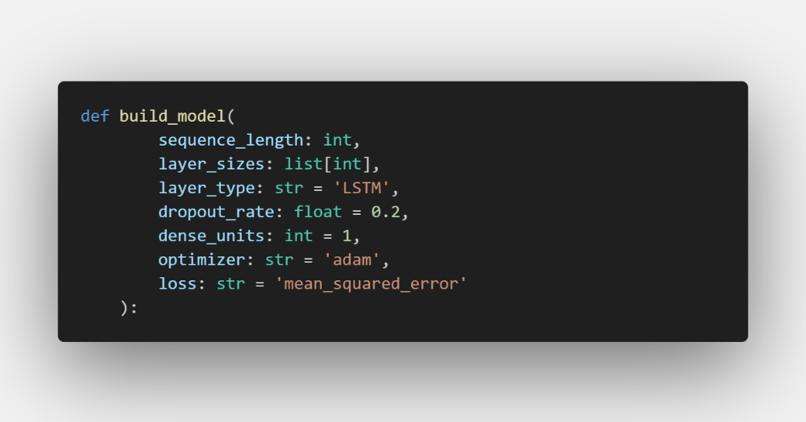
This is the required Task C.4 function. Instead of hardcoding layers manually, all architectural decisions are passed as parameters. layer_sizes serves double duty - its length determines the number of layers, and each value sets the units in that layer. This means changing from a 3-layer to a 1-layer network only requires changing the list, not rewriting model code.
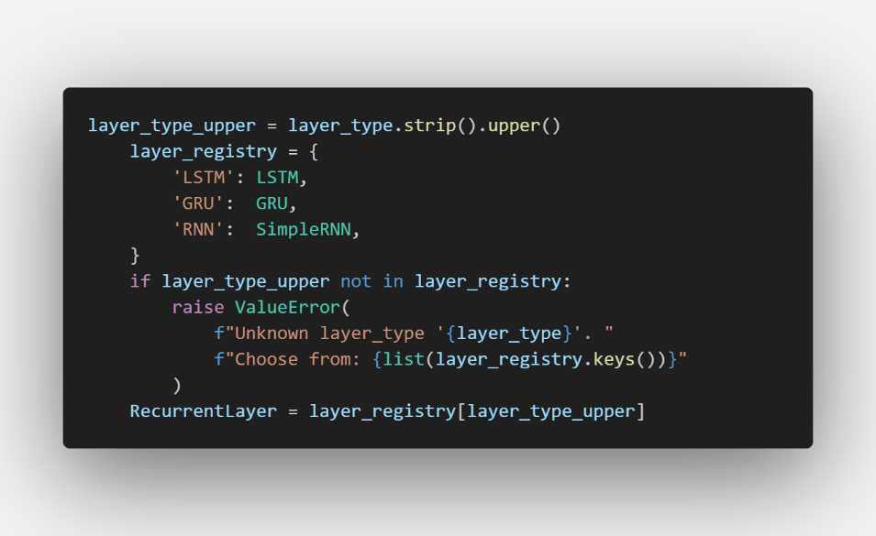
Rather than using if/elif chains to pick the layer class, a dictionary maps string names to Keras layer classes. RecurrentLayer then holds the actual class object (not an instance), so it can be called like RecurrentLayer(units=128) later in the loop. This is the Python pattern of treating functions/classes as first-class objects.
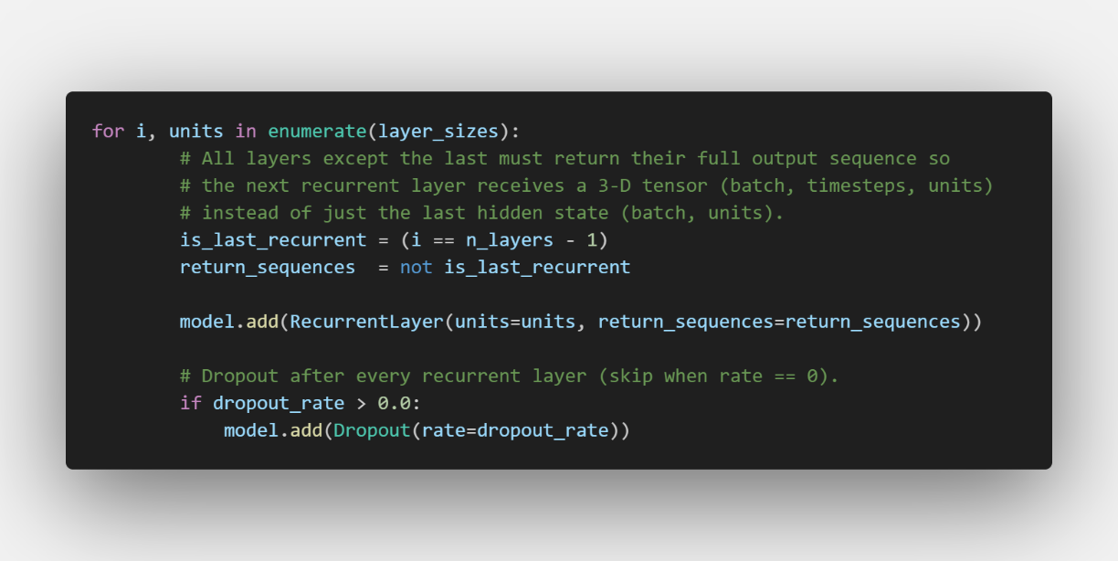
In this code, return_sequences=True tells a recurrent layer to output its hidden state at every timestep, producing a 3D tensor (batch, timesteps, units). return_sequences=False (the default) outputs only the final hidden state, collapsing to 2D (batch, units). Every layer except the last must use return_sequences=True and if you set it to False on an intermediate layer, the next recurrent layer receives a 2D tensor and crashes because it expects a sequence to iterate over [1].
Next is “Dropout”, it randomly sets a fraction (dropout_rate) of neuron outputs to zero during each training step. This prevents neurons from co-adapting - where one neuron compensates for the mistakes of another - forcing the network to learn more robust, distributed representations.
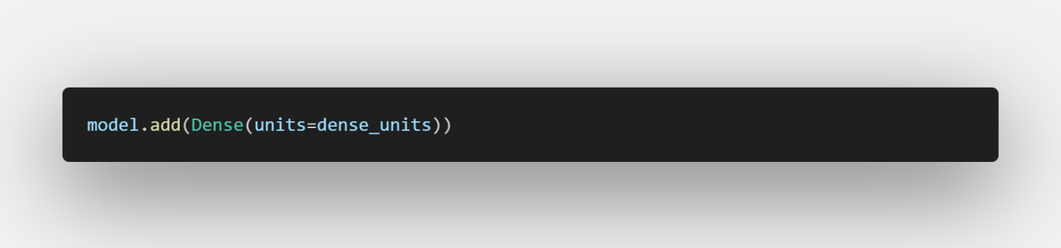
A Dense layer with no activation function (linear by default) maps the final hidden state to the predicted price. No activation is correct here because this is a regression task - we want an unbounded real number output, not a probability or a value squashed into [0, 1]. Using sigmoid or relu here would artificially constrain the prediction range.
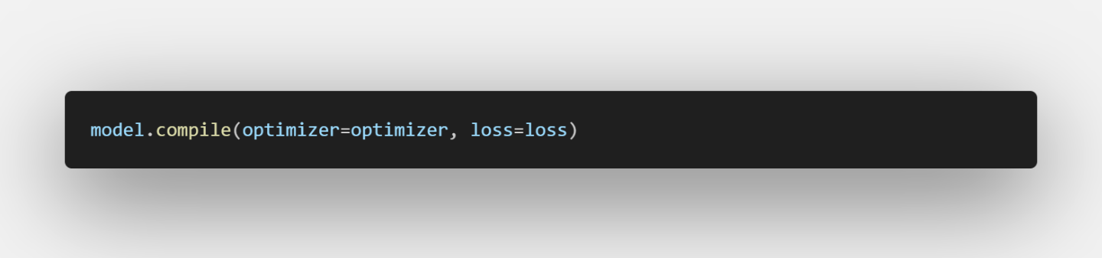
Finally is the compile(), adam (Adaptive Moment Estimation) is used as the optimiser. It combines momentum (using past gradients to smooth updates) and adaptive learning rates (scaling updates per parameter), making it converge reliably without manual learning rate tuning. mean_squared_error is the loss function standard for regression - it penalises large errors more heavily than small ones due to the squaring, which suits stock price prediction where large mispredictions are costly.
I ran a GRU network, the model then saved in models/
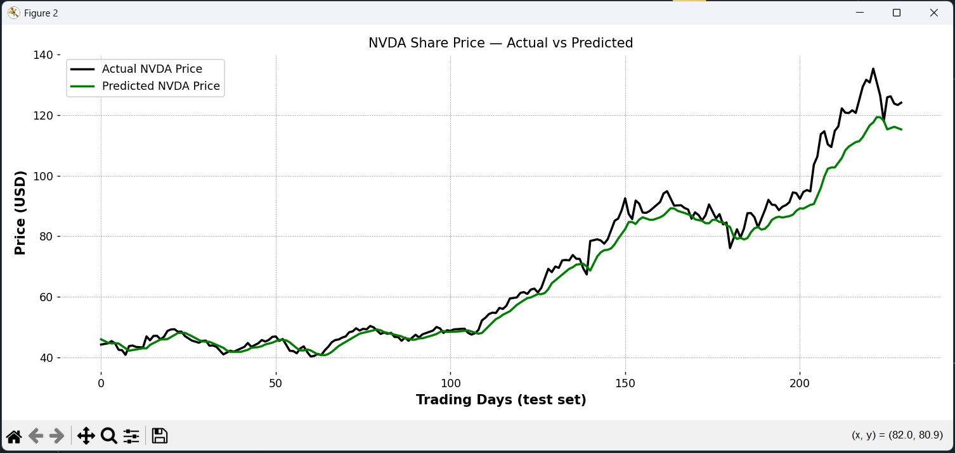
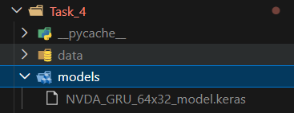
2. Code Base Refactoring
Our team has decided to moving from the original monolithic approach where everything being held in a same Python file to modularize weekly tasks.
data_loader.py ← Task C.2: download, NaN handling, split, scale
visualiser.py ← Task C.3: candlestick, boxplot, prediction plot, CLI helpers
model_builder.py ← Task C.4: build_model() + save/load helpers
predictor.py ← test-set windowing, inference, next-day forecast

