
Option C Task Report
COS30018 – Intelligent Systems
Lecturer: Dr. Nguyen Manh Toan
Group: 3.1 – OpenBuffet
Task name: C.5 – Machine Learning 2

When it comes to the machine learning section of this week's assignment, which is called C5: Machine Learning 2, then the LSTM/GRU/RNN algorithm that was created in the previous section (C.4) was expanded in order to forecast two more complicated tasks, such as multistep prediction (forecasting closing prices in k steps in the future instead of forecasting the next day's price) and multivariate prediction (using the following prices as an input: Open, High, Low, Close and Volume instead of only Close price). Consequently, multivariate multistep predictor has been developed. In all the cases above, the same generalised functions are applied, therefore the feature/k can be included/excluded arbitrarily.
Here are the detailed code descriptions of our work:
1. Task_5/data_loader.py / prepare_sequences()
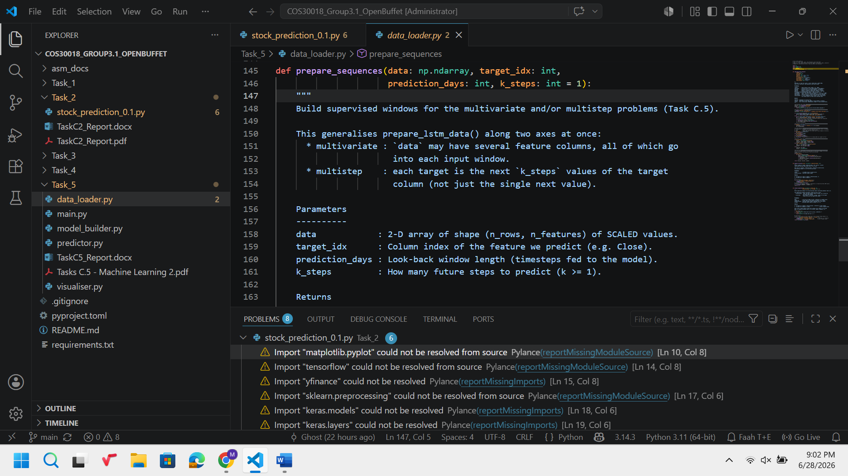

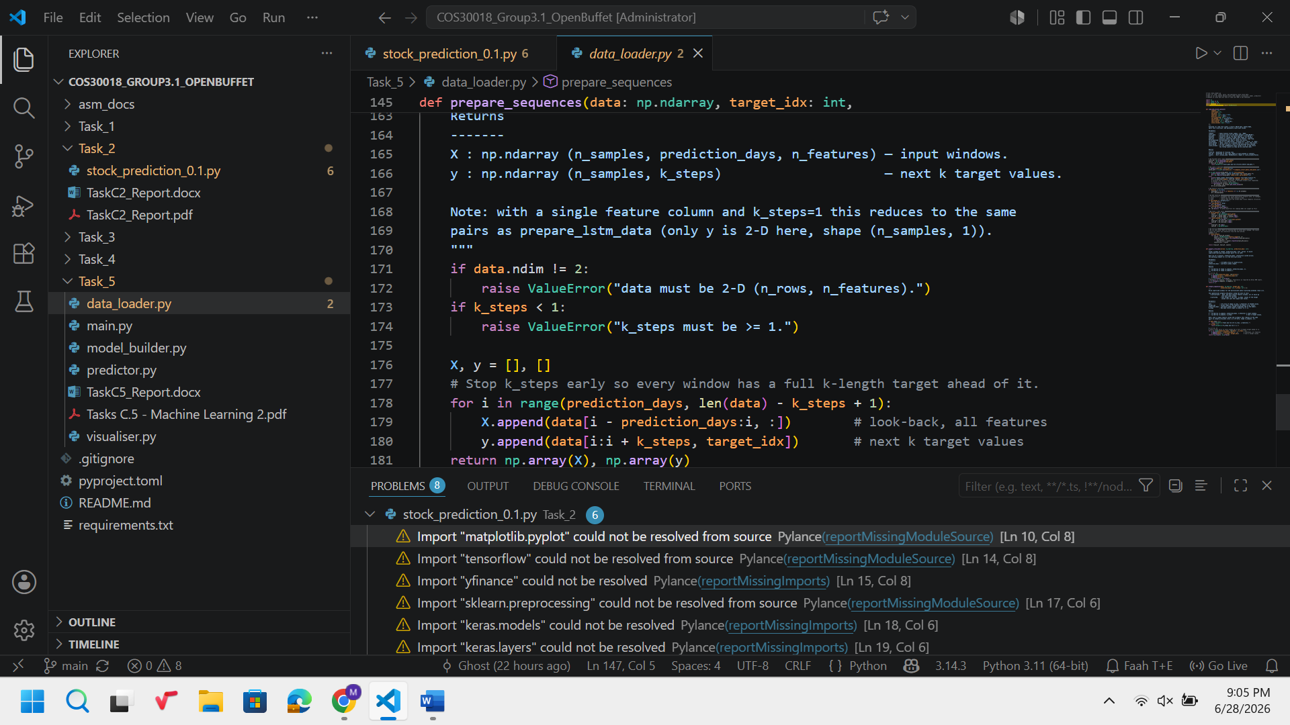
prepare_multivariate_multistep_lstm_data() is the main part of the processing in Task C.5. This function differs from the previous prepare_lstm_data() function in two ways: it can take more than one feature column in the input window (multivariate) and the target output of each window will be k-steps long.
As one can see, the end of the loop range is now len(data) - k_steps + 1 and not just len(data). If the change is not done, the last windows will go out of the range while trying to generate the target vector and thus, IndexError will be raised or the target vector may become partially filled. The +1 is used because of exclusive nature of Python slicing range, so the last window should be able to produce a target vector of length k.
In the loop, data[i - prediction_days : i, :] uses 2-D slicing of NumPy arrays and selects all columns (:) of the desired rows. In this way, the multivariate property of the function is ensured: using of the data array with 5 columns (Open, High, Low, Close, Volume) gives input windows of shape (prediction_days, 5) without any additional conditionals.
data[i : i + k_steps, target_idx] selects only the target column (for example, the third column for Close) of the next k rows. Selection of only the target column among other input columns guarantees that the model will know about all features, but predict only one of them — typical multivariate to univariate forecasting problem.
One can see that the shape of y is (n_samples, k_steps). When k_steps = 1, the y becomes a 2-D column vector, not 1-D, as returned by prepare_lstm_data(). The decision was made on purpose to ensure 2-D shape of the target. Such target shape is required for Keras Dense layer with dense_units = k_steps.

2. Task_5/model_builder.py / build_model() — n_features & dense_units
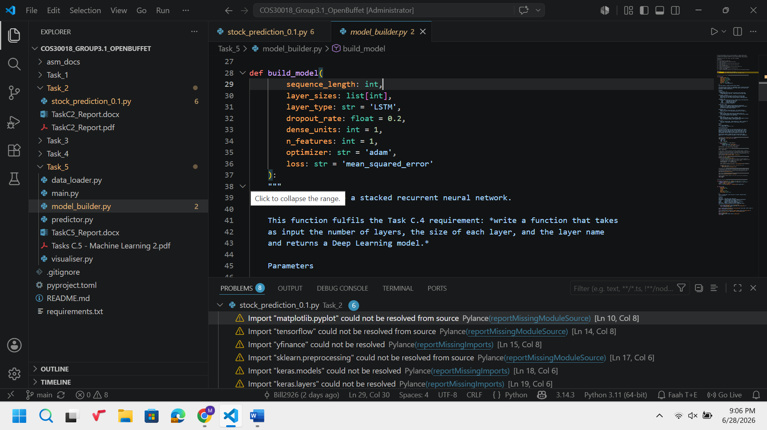
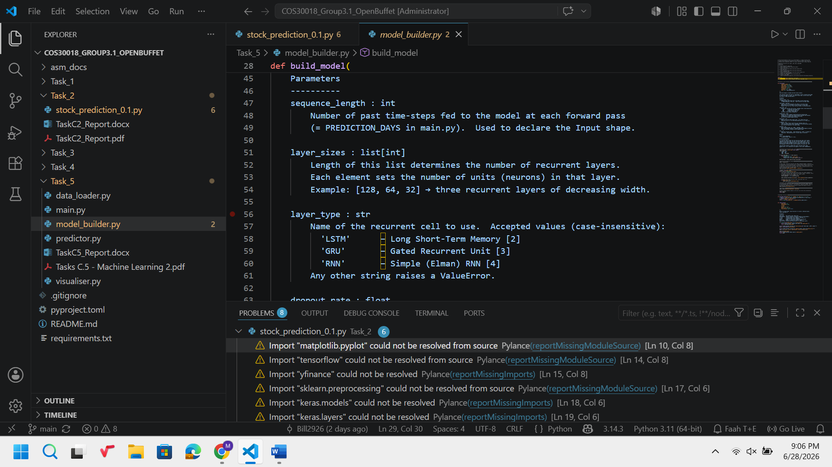
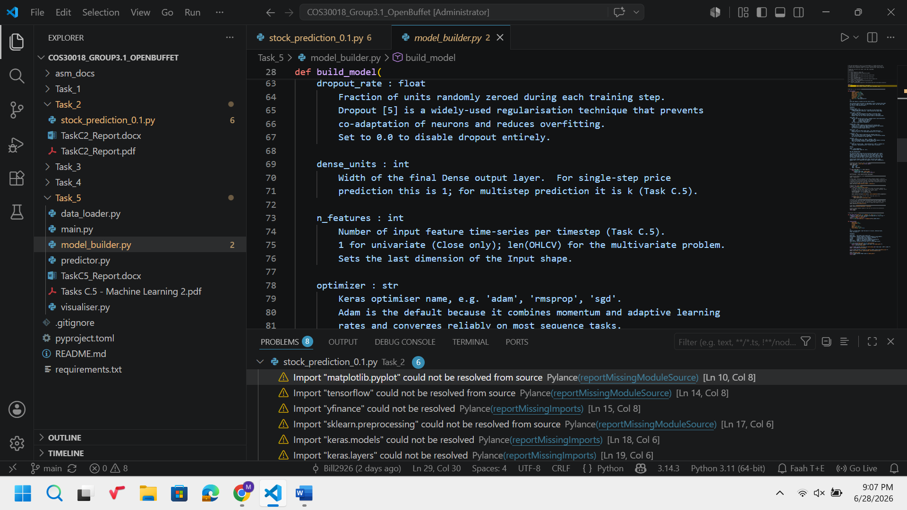
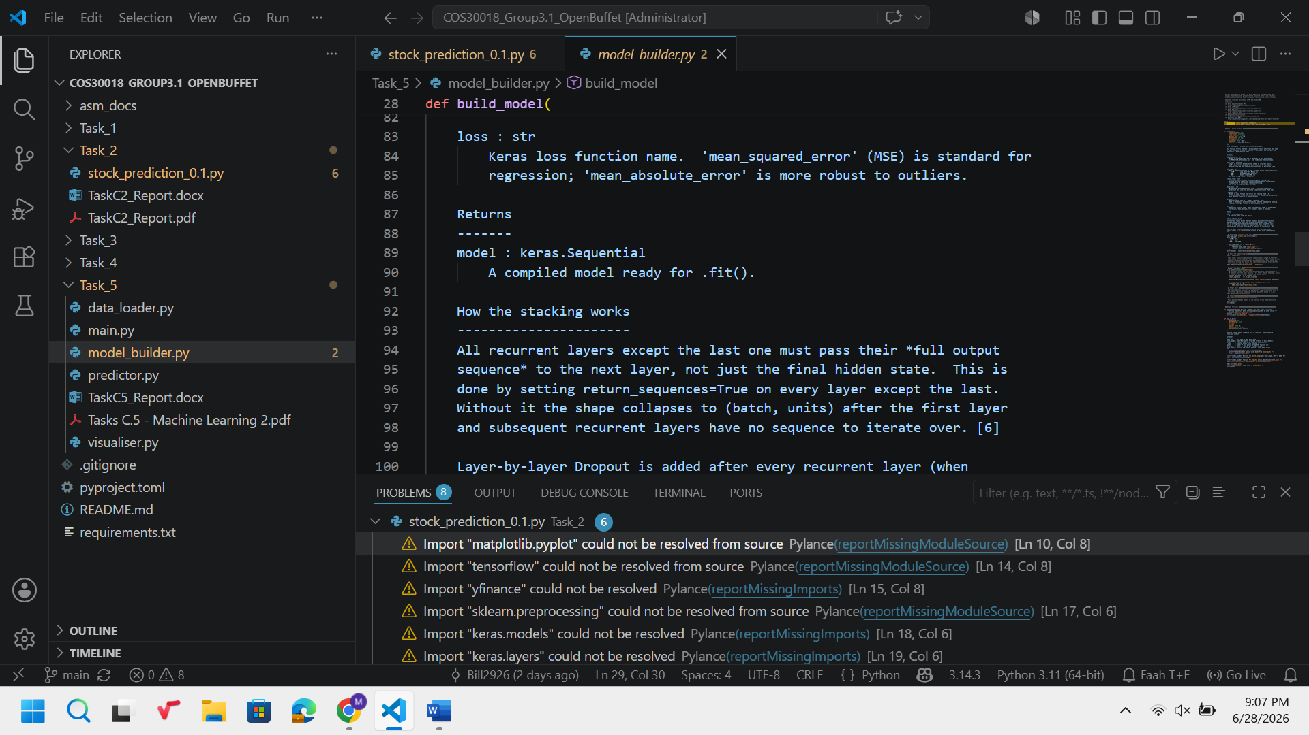
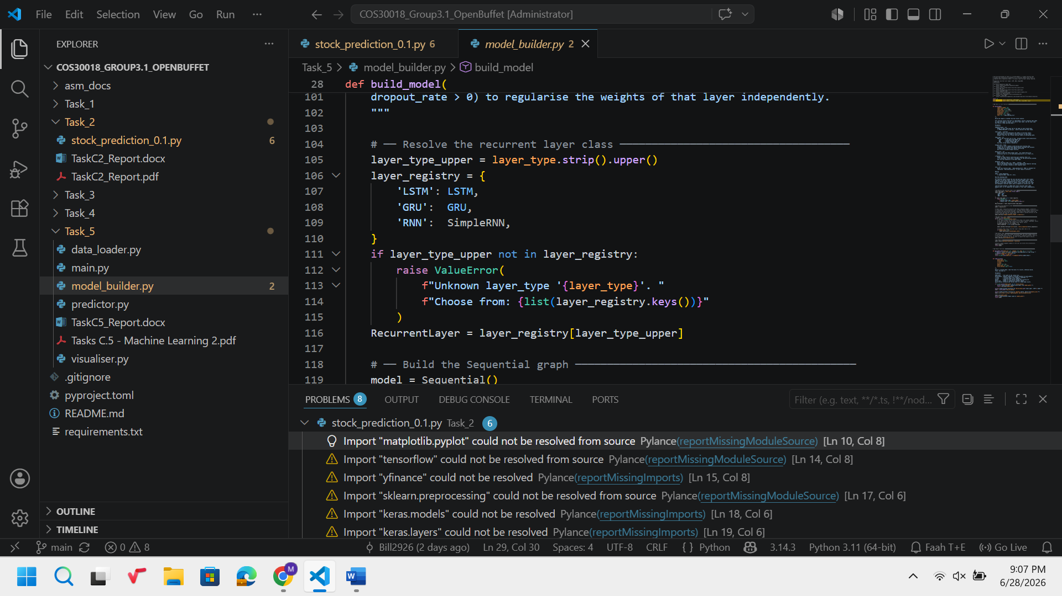
In Task C.5 the build_model() function created in Task C.4 is utilized without any changes in the code by passing two additional keyword arguments – n_features and dense_units. Any changes in the code structure are not necessary since those two parameters were added to the arguments' list.
The n_features parameter is responsible for the setting the last dimension of Input(shape=(sequence_length, n_features)) layer. For the univariate baseline case n_features = 1 as each timestep contains only one value. For the multivariate case n_features = 5 (Open, High, Low, Close, Volume), which means that the model gets matrixes as timesteps instead of vector. This particular dimensionality of the input is automatically propagated in all recurrent layers by the Keras framework.
The dense_units parameter defines the number of units in the output layer: model.add(Dense(units=dense_units)). In the case of single-step prediction (Task C.4) dense_units = 1, which means that the output of the model is one price. In the case of multistep prediction (Task C.5) dense_units = k, which means that the output of the model is k prices during one forward pass. It is an example of the direct multi-output strategy where instead of predicting sequentially each timestep we predict all k timesteps in one forward pass using one lookback window.
3. Task_5/predictor.py / forecast_future()
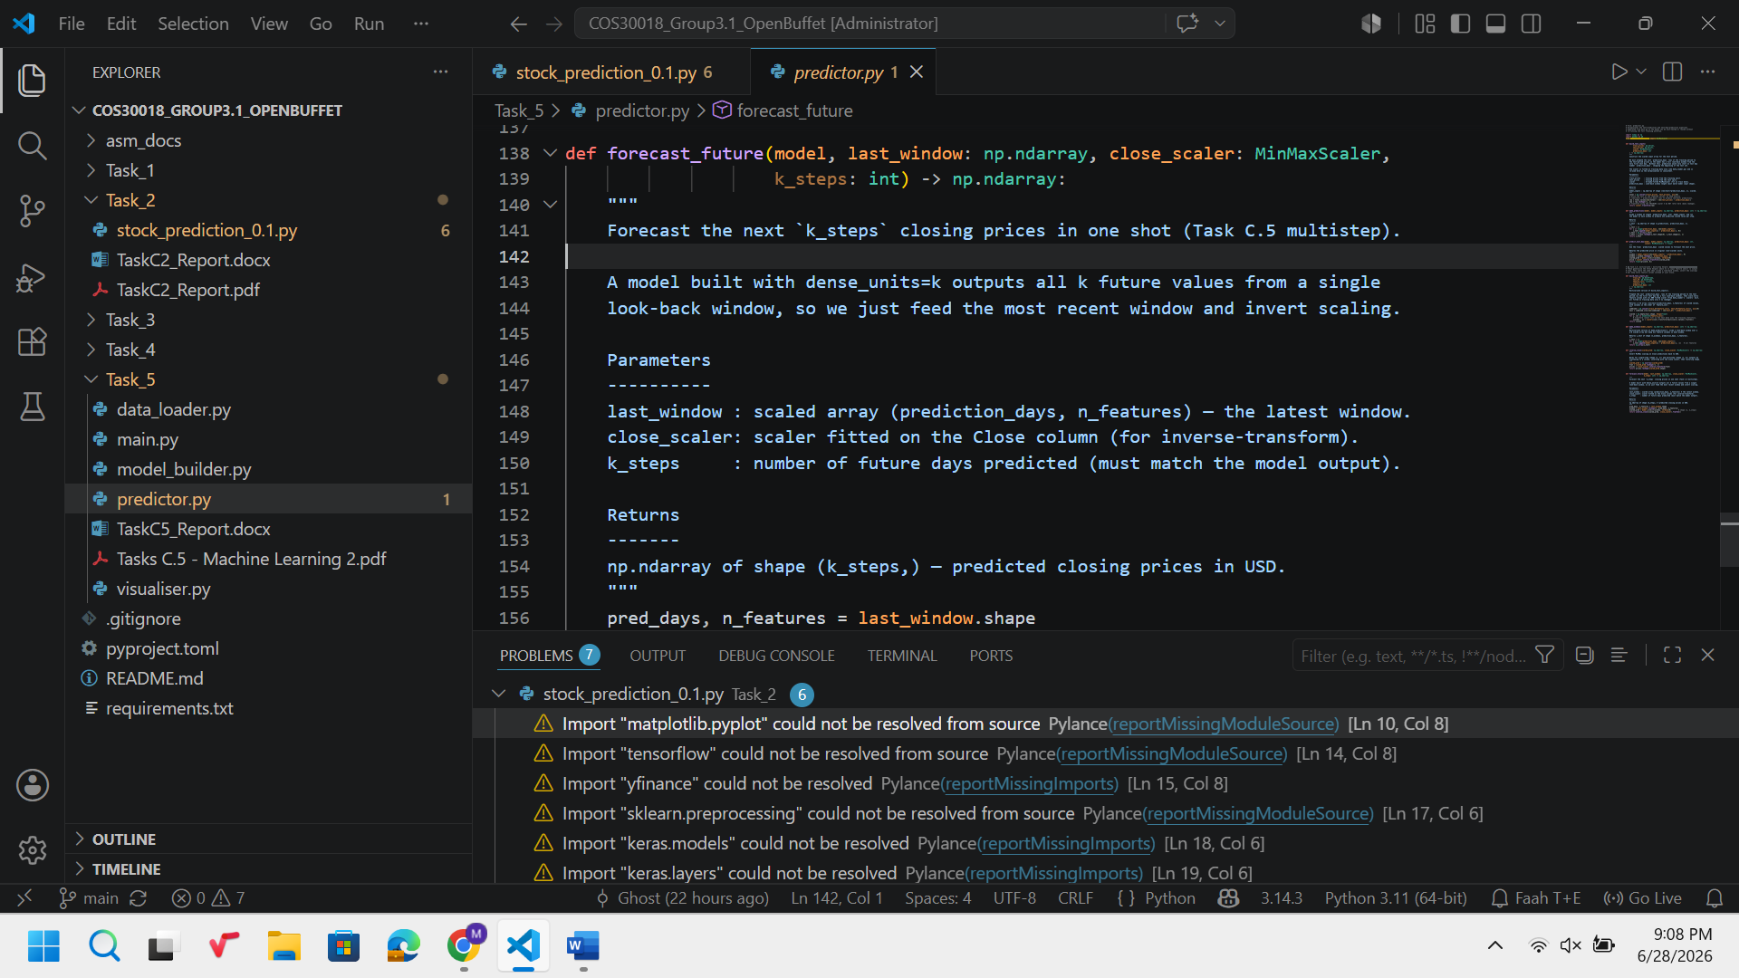
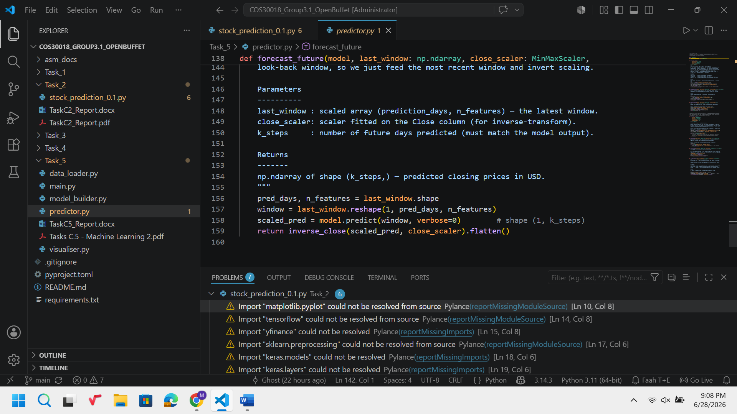
It deals with the prediction part through inference. It accepts the latest lookback window and produces k predicted price points in regular USD.

Window = last_window.reshape(1, pred_days, n_features) generates an additional batch dimension with index 0. The keras model expects the input always in the format (batch_size, timesteps, features). In the case of training, the batch size dimension is handled automatically by keras; but in the case of prediction, while feeding a single lookback window to model.predict(), it needs to be handled manually through either reshape or np.expand_dims(). If not done, keras will receive a 2D input and throw an error on mismatch of shape.

The output from keras model is of the shape (1, k_steps), i.e., one sample of k predicted scaled price points. This is further processed with inverse_close(), where the output is reshaped into a column vector and the data is inverse scaled using Close scaler. There are two reasons behind keeping inverse_close() outside of the two functions: one, avoiding code repetition.
4. Task_5/predictor.py / build_test_inputs_mv() & make_windows()
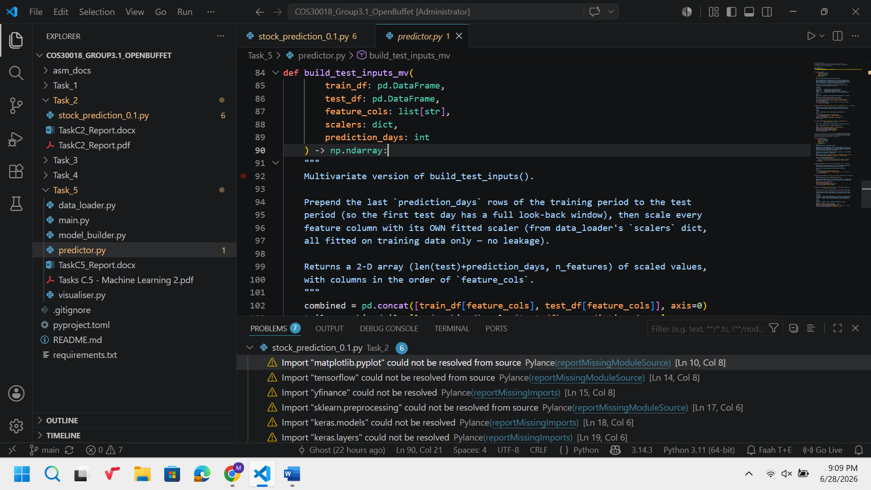
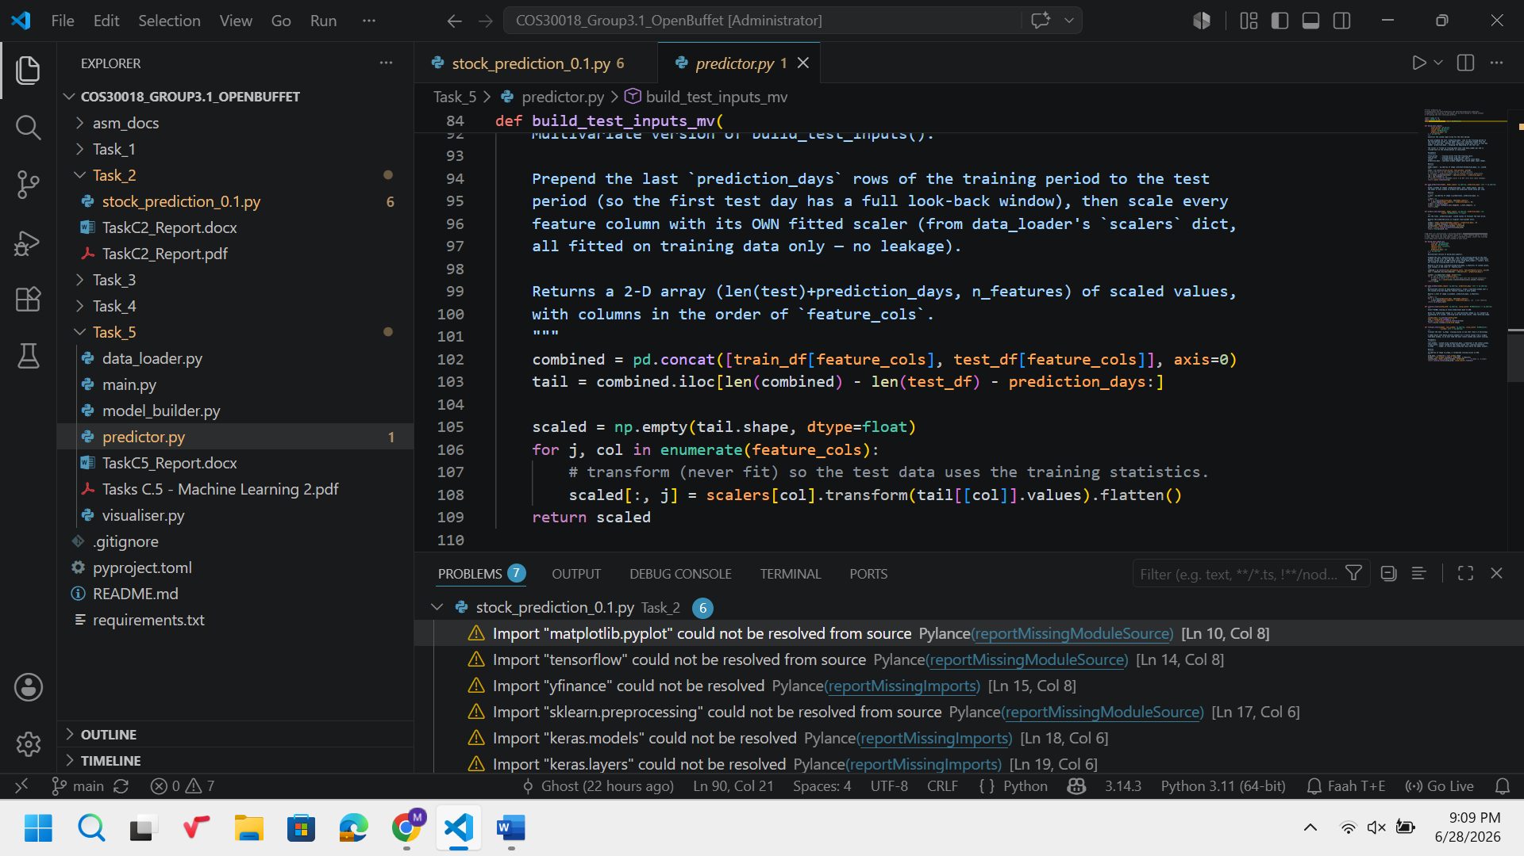
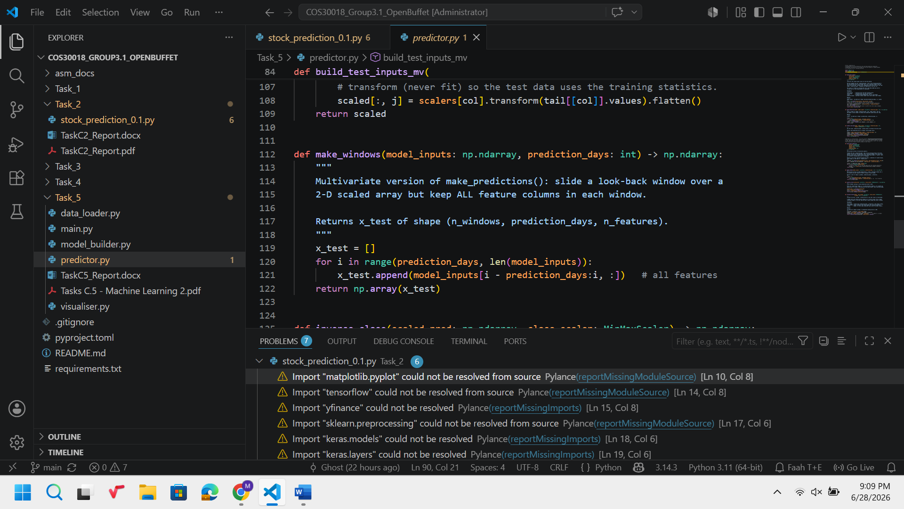
The multivariate version of the function build_test_inputs() is build_test_inputs_mv(). In this function, we add the last prediction_days days of the training period into the test period so that the first day of the test period contains the complete look-back window similar to the univariate version, but this time it will be done on all the feature columns.
The important line in this function is: scaled[:, j] = scalers[col].transform(tail[[col]].values).flatten(). The reason why this line individual normalization of the columns is performed using their respective scalers because Open, High, Low, Close, and Volume have completely different ranges of values ($10s for prices, and $100 million in case of Volume). Had we performed one scaler for all these columns, then the values of all other columns except one column would have become either zero or one. We loose the relative variations in the columns which we need in the multivariate input. Since we have fitted the scalers only on the training data (data_loader.py), we use transform instead of fit_transform here.
The function make_windows() is same as the function make_prediction() except that the part model_inputs[i - prediction_days : i, :] is replaced by model_inputs[i - prediction_days : i, :]. Now we extract windows of size (prediction_days, n_features) instead of (prediction_days, 1). The shape of the output is (n_windows, prediction_days, n_features).

5. Task_5/visualiser.py / plot_multistep_forecast()
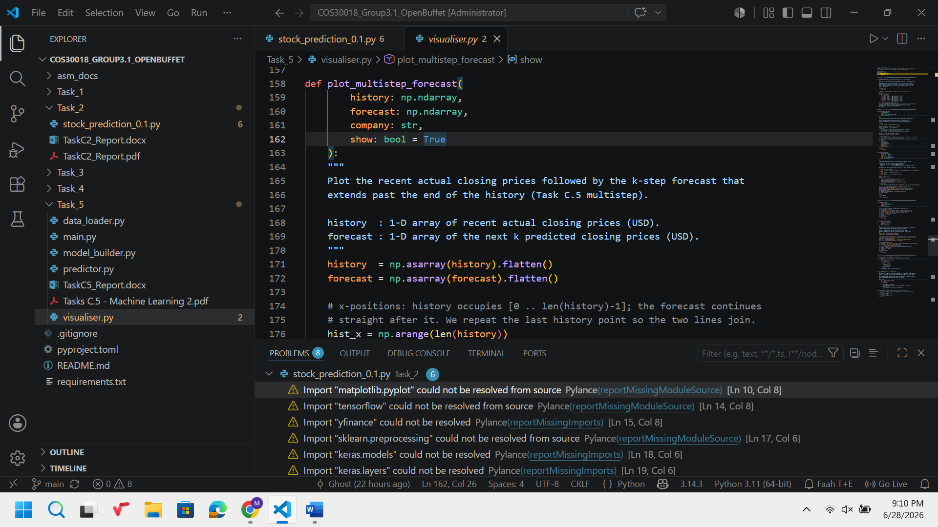
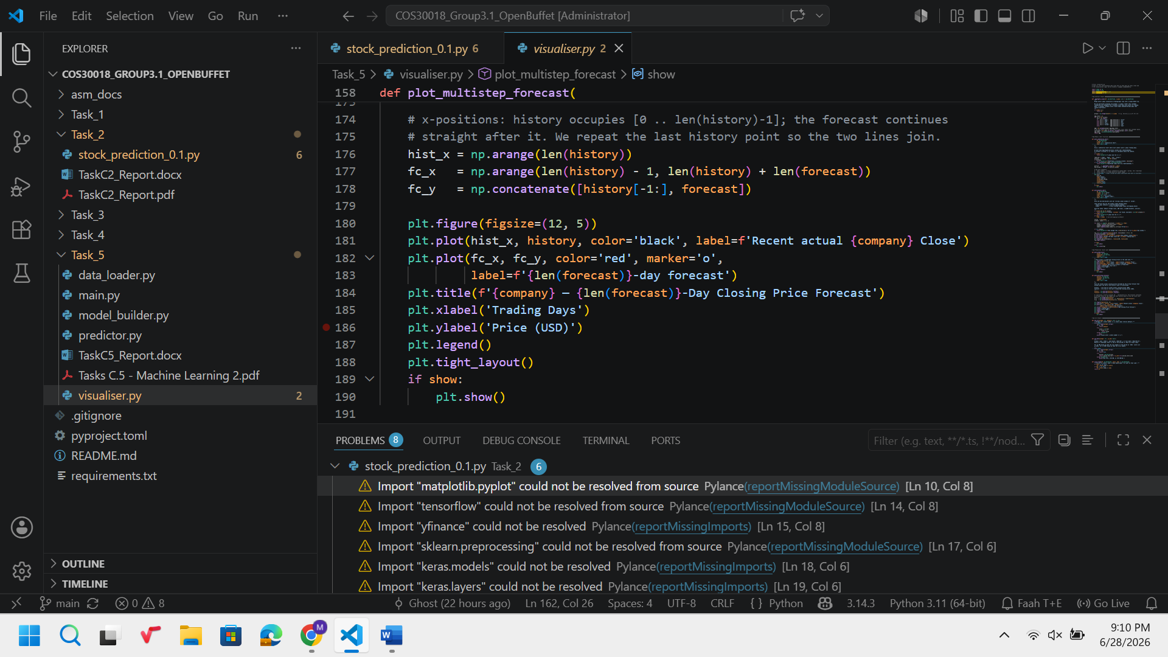
The plot represents the past prices plotted together with the extension of the graph via k-step forecast.
The x-axis values are calculated as follows: fc_x = np.arange(len(history) − 1, len(history) + len(forecast)). We should start from the index which is one before the last value of the historical data (len(history) − 1) to make sure that the forecast line will begin from the same point from which the actual line ends to ensure the continuity of the two lines. If we take fc_x = np.arange(len(history), len(history) + len(forecast)), then there will be one-step discontinuity between the lines.
The y-values of the forecast line can be represented by the following formula: fc_y = np.concatenate([history[−1:], forecast]). This is because the forecast line begins from history[−1:], i.e., the last value of history due to the specific of np.concatenate function.

6. Task_5/main.py — Three Prediction Scenarios
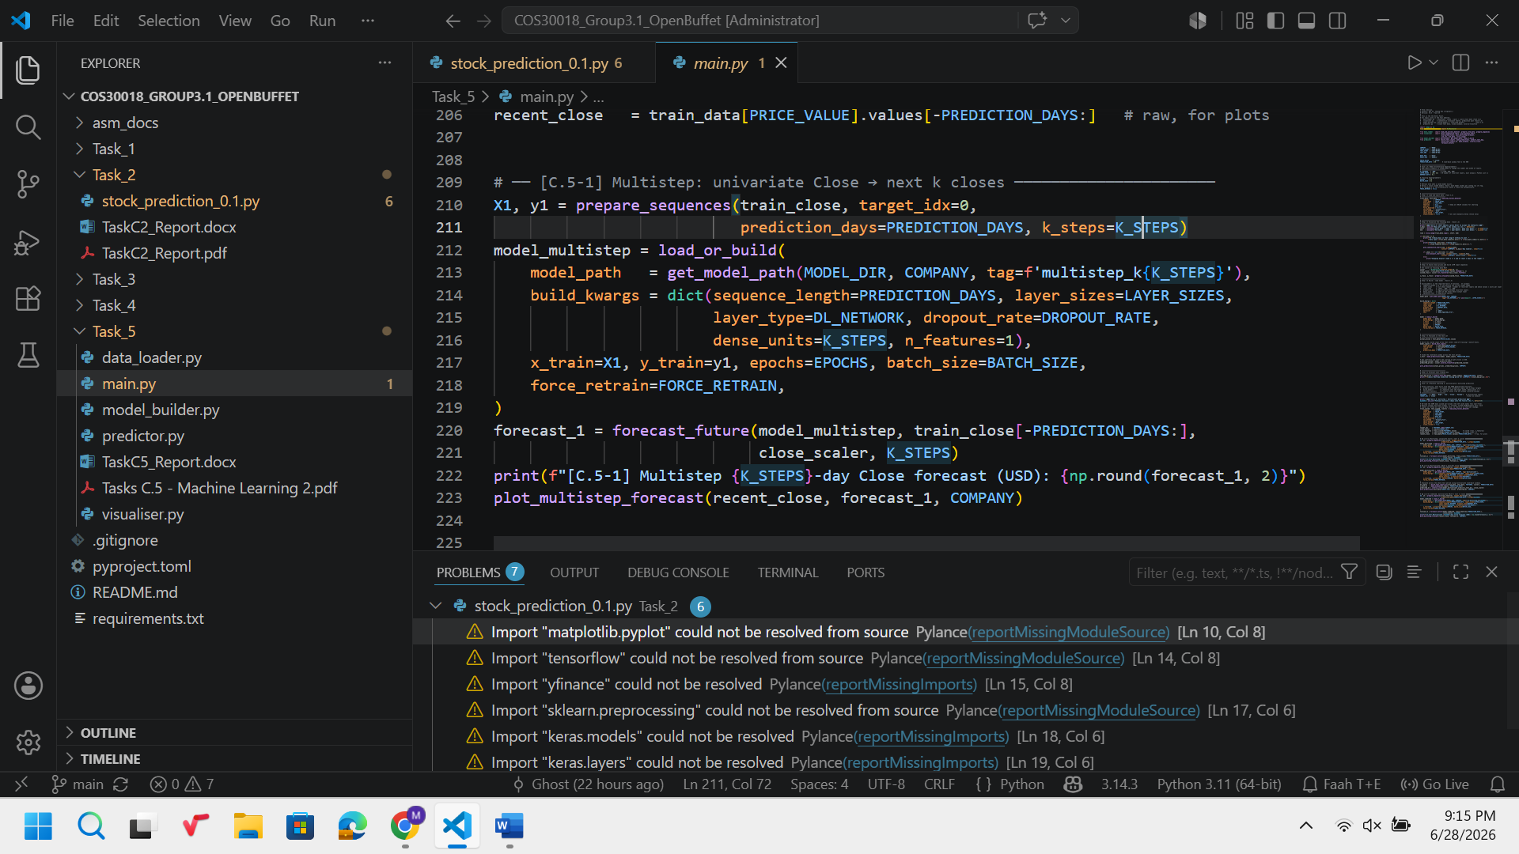
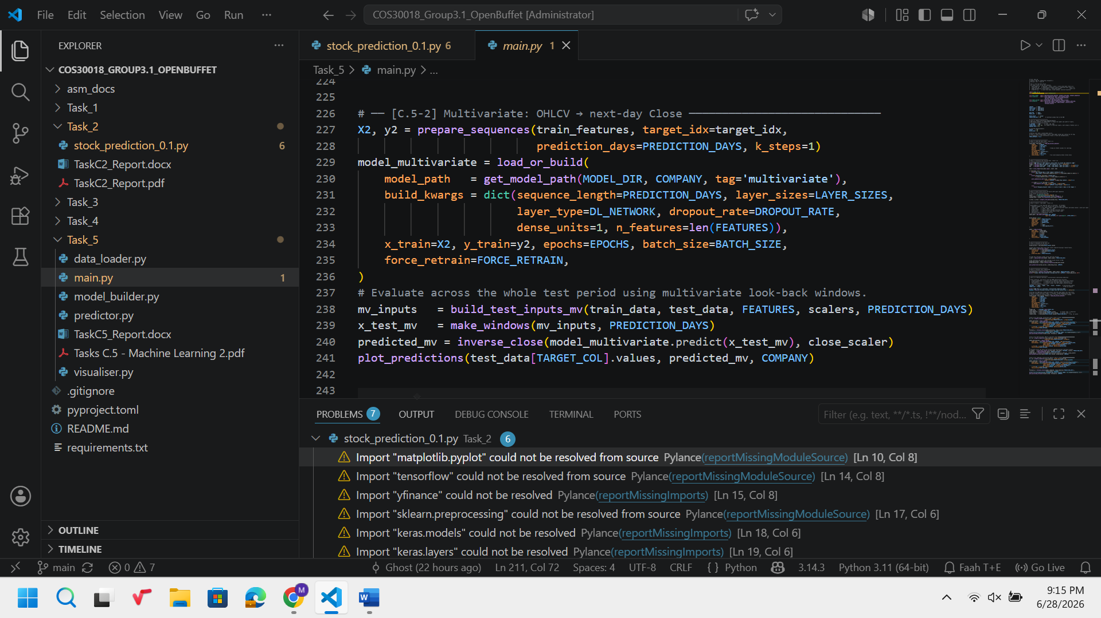
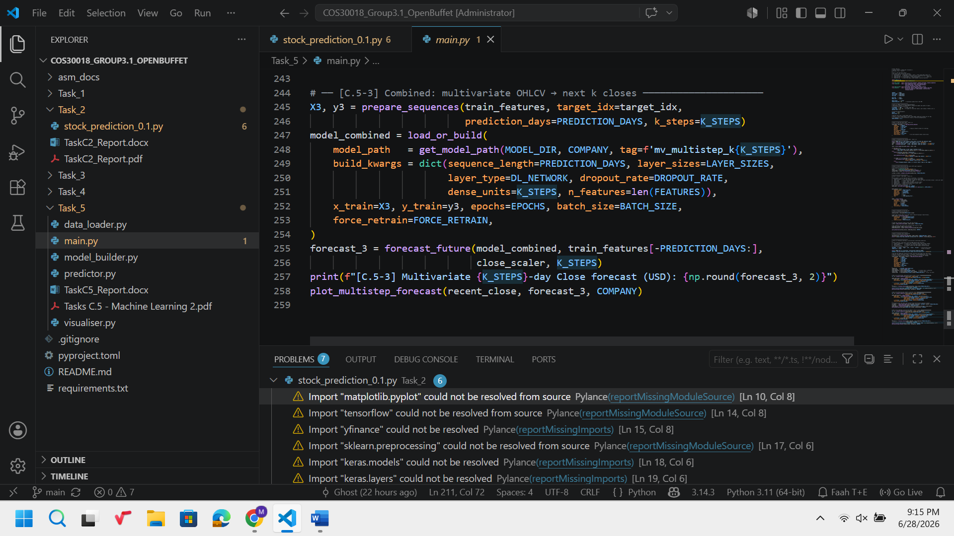
Scenario C.5 uses the same two functions for all three scenarios, namely prepare_sequences() and build_model(), however, changes their arguments.
[C.5-1] Multistep – univariate: prepare_sequences(train_close, target_idx=0, k_steps=K_STEPS) is used in the case of the one-column dataset (shape (n, 1)), where target_idx=0 (one feature) and k_steps=K_STEPS is the number of steps that is defined by a user. The model will be trained on n_features=1 and dense_units=K_STEPS, that is, it will learn to transform the last K_STEPS values of Close to the next K_STEPS values of Close.
[C.5-2] Multivariate – single step: prepare_sequences(train_features, target_idx=3, k_steps=1) applies for the five-column dataset (shape (n, 5)), where target_idx=3 refers to Close and k_steps=1. The model will be trained on n_features=5 and dense_units=1, which means that the model will have more information about the features and will forecast the Close of the next day.
[C.5-3] Multivariate and multistep: the same features and k_steps=K_STEPS are used, however, dense_units=K_STEPS. Thus, the scenario is the most generalised one: five features will be required for forecasting the value of Close K_STEPS days ahead. The difference between the scenario C.5-2 and C.5-3 is only dense_units, the rest is the same data pipeline.
The ask_int("Forecast horizon k ...", default=5) lets a user define K_STEPS interactively. It will be better not to use the try/except block in the main.py in order to avoid the incorrect passing of the argument (0 or negative) to the model and use the helper function.

7. Experiment Results
These three cases were conducted on the stock of NVDA data (starting from 2020-01-01 to 2024-07-02), where training was done on the data up until 2023-08-02 while testing was done on the remaining data using GRU.
C.5-1 Multistep (5-day forecast):
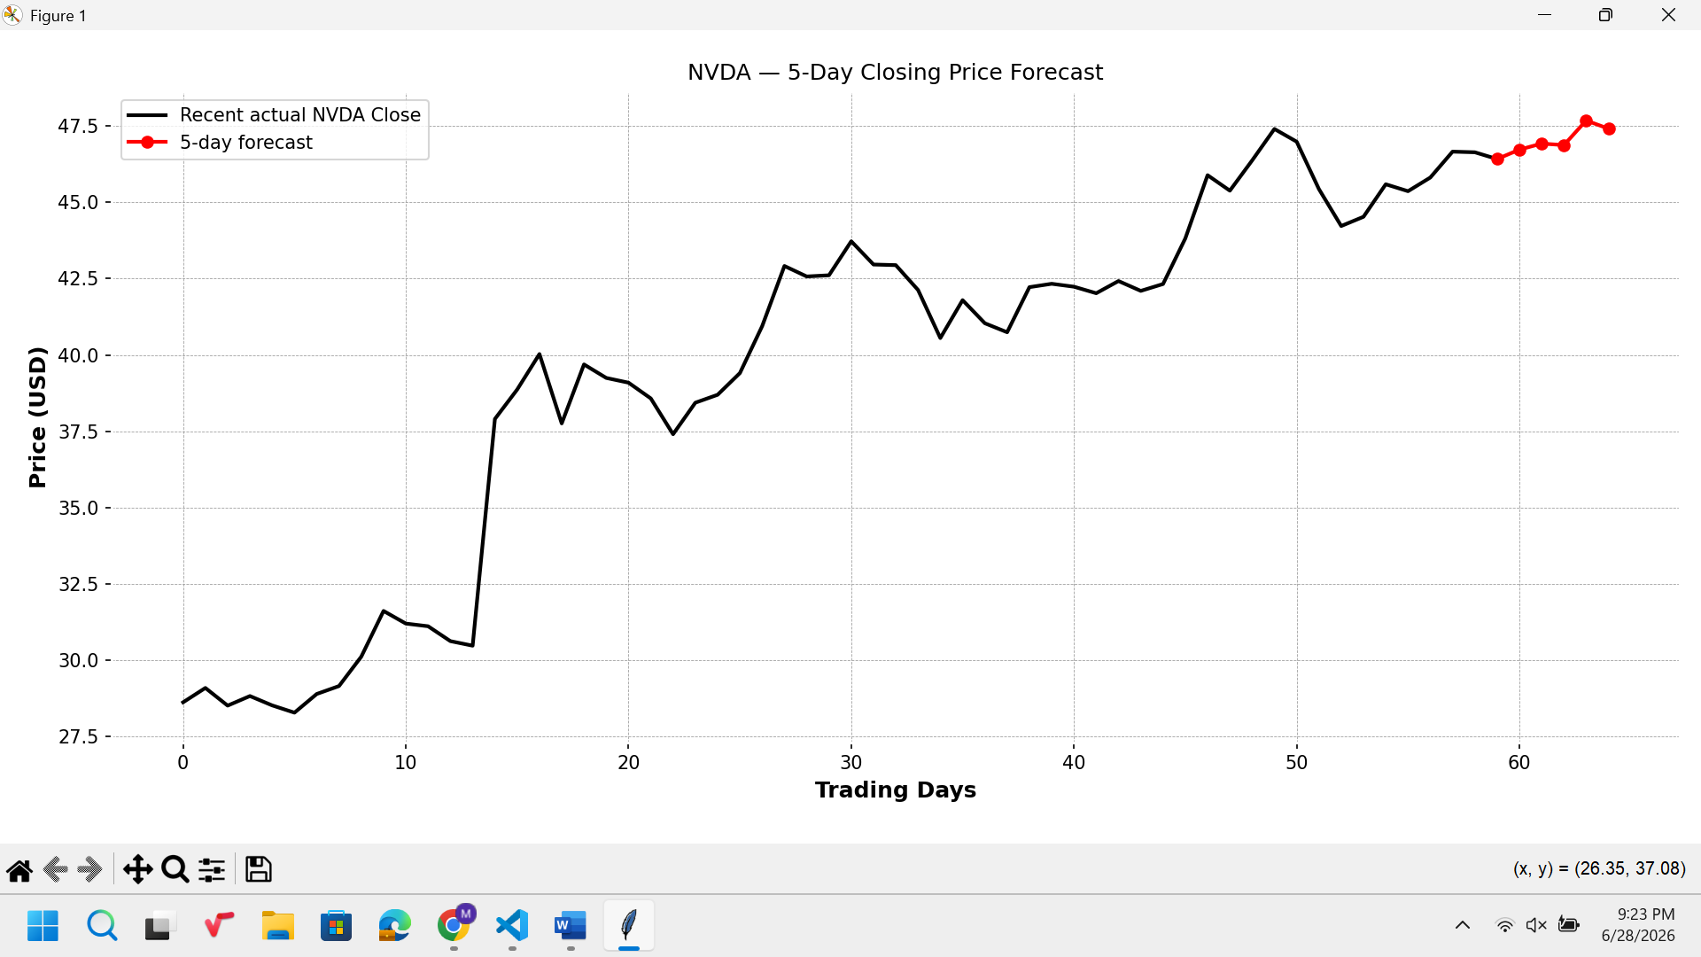
The multivariate forecast for 5 days ahead follows a pattern that is similar to the recent days’ price behavior, yet displays higher variance with the passage of time into the future; this is expected. The multivariate model has captured the short-term pattern; however, the model can’t predict the unforeseen changes due to news reports.
C.5-2 Multivariate (next-day Close):
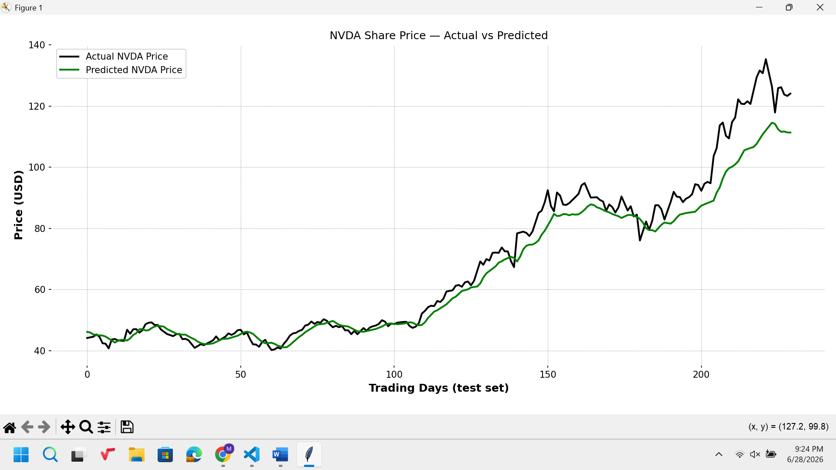
The application of the extra variables Open, High, Low, and Volume in addition to the target variable in the multi-input model has played an important role in obtaining a better fit with the closing prices relative to the univariate model in Task C.4. The use of the extra input variables has expanded the horizon of the model for daily events.
C.5-3 Combined (multivariate, 5-day):
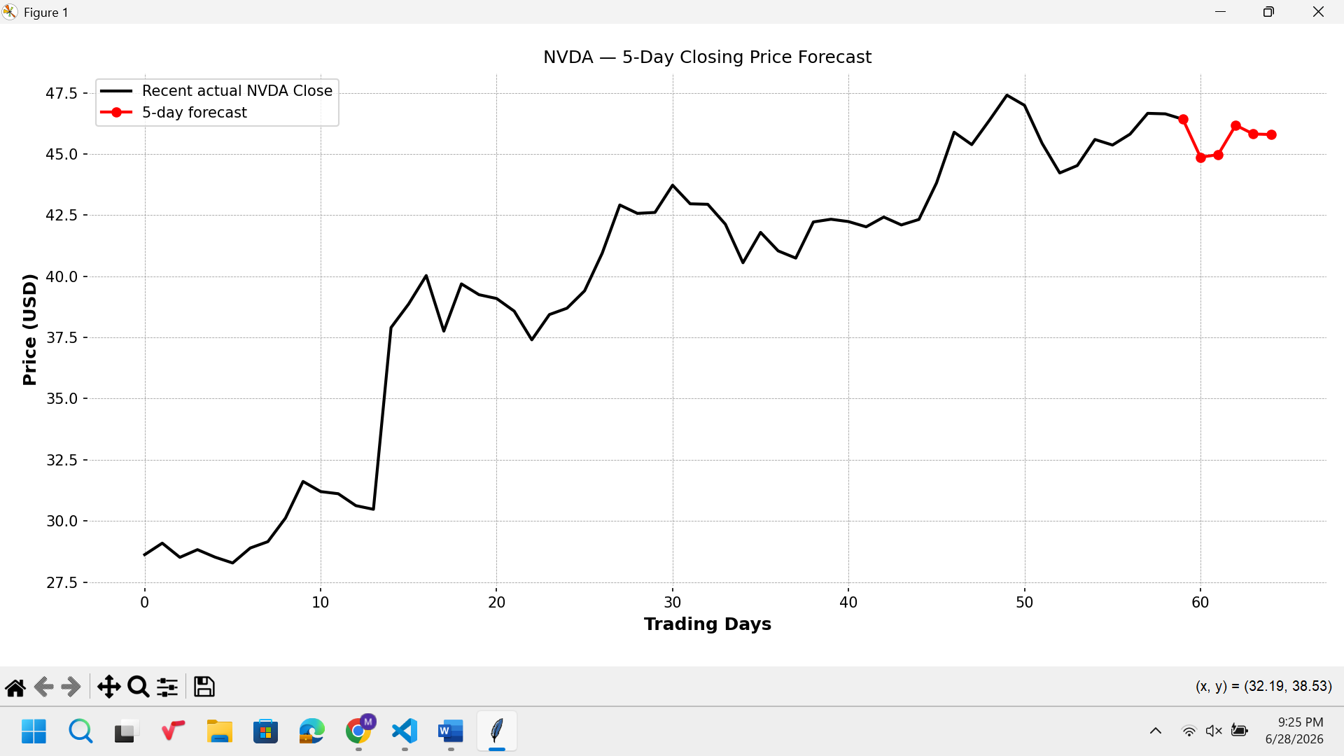
The multi-day forecasts obtained from the multi-input model were smoother compared to the multi-step forecasts from the univariate model due to the availability of information through the extra input variables.

