
Option C Task Report
COS30018 – Intelligent Systems
Lecturer: Dr. Nguyen Manh Toan
Group: 3.1 – OpenBuffet
Task name: C.2 – Data Processing 1

We’ve implemented the load_and_process_dataset function that satisifies all the functional requirements from the task description. The final objective of this function is to allow user flexiblity in choosing the timeframe of the stock’s dataset.
Here is the breakdown of what we’ve done for each requirement:
Fucntion’s Params:
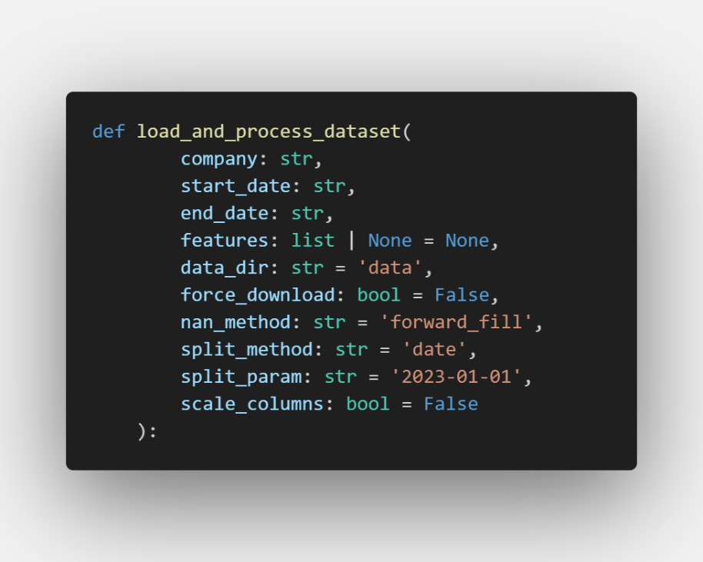
- company (type: str): Represents the stock ticker or market symbol of the target corporation.
- start_date & end_date (type: str): Define the absolute bounds of the historical timeline, formatted as 'YYYY-MM-DD' strings.
- features (type: list | None, default: None): Accepts a specific list of market data columns to extract from the raw dataset, such as ['Open', 'High', 'Low', 'Close', 'Volume'].
- data_dir (type: str, default: 'data'): Specifies the target directory on your local machine where downloaded stock datasets are managed.
- force_download (type: bool, default: False): A Boolean switch that forces the system to pull a fresh copy of the dataset from the web, ignoring any existing files on disk.
- nan_method (type: str, default: 'forward_fill'): Determines the mathematical approach used to clean missing data values (NaN) from the time-series arrays.
- split_method (type: str, default: 'date'): Controls the core architectural approach used to split the dataset into your training and testing matrices.
- split_param (type: str, default: '2023-01-01'): Provides the explicit modifier value or threshold rule utilized by your chosen split_method.
- scale_columns (type: bool, default: False): A Boolean toggle that decides whether or not to map feature distributions down to normalized ranges like $[0, 1]$ before exiting the function.
1. Requirement a - Flexible Date Specification and Validation:
The function uses pd.to_datetime to convert the input date strings into formal Pandas datetime objects. It introduces a vital logical sanity check with a conditional statement to ensure the start date precedes the end date chronologically, preventing invalid input like the start date and the end are the same day.
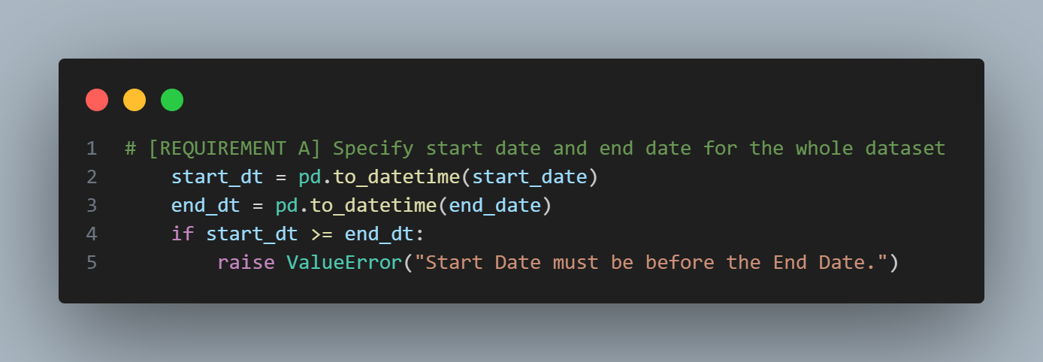
2. Requirement b - NaN Management:
The function is built to handle financial data missingness caused by weekends and market holidays. It supports data imputation techniques: forward filling (ffill), backward filling (bfill), and column-mean. The inclusion of a trailing .bfill() statement serves as a safety fallback to clear any NaN values residing at the very beginning of the dataset where forward filling is ineffective.
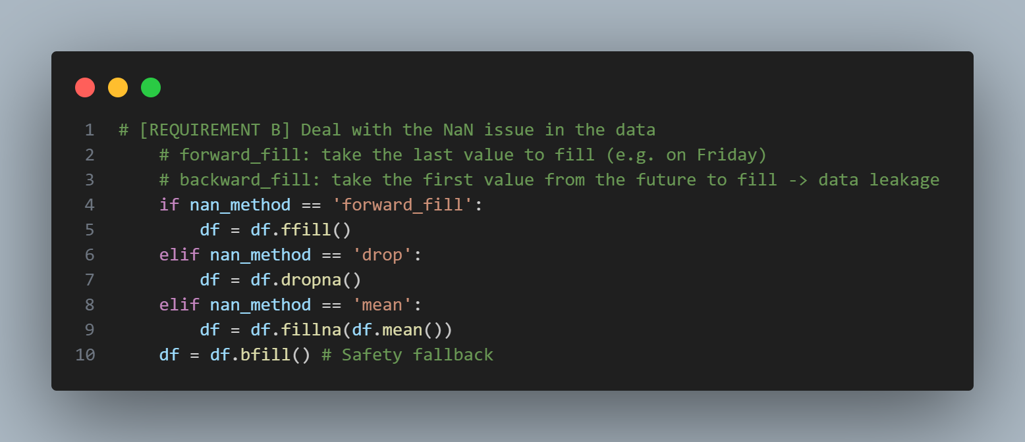
3. Requirement c - Dynamic Data Splitting Methods:
The function supports different dataset splitting strategies determined by user-defined arguments. When set to split by date, it utilizes a timestamp cutoff to partition data chronologically without shuffling, preserving time-series consistency and preventing data leakage. It also features a ratio-based approach that segments the data sequentially using a specified fractional threshold (e.g. 80/20 split).
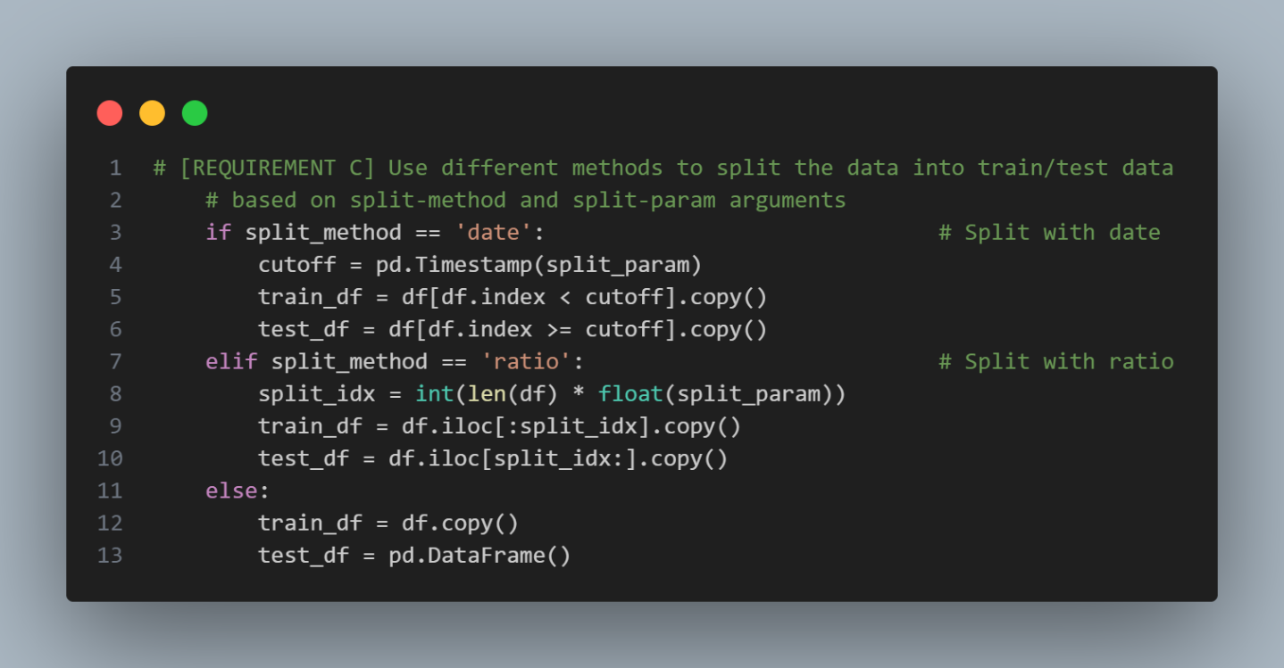
4. Requirement d - Local Data Caching Framework:
Redundant download segments from the original script have been completely eliminated. The function checks for the historical existence of the target dataset locally using os.path.exists inside a dedicated directory. If found and not overridden by the force download flag, it reads the local CSV file instantly to save time and bandwidth; otherwise, it downloads the fresh data via Yahoo Finance.
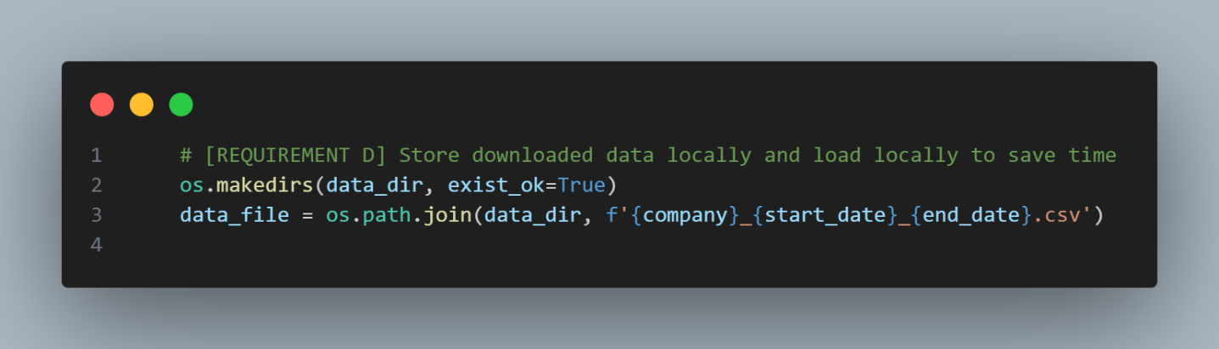
5. Requirement e - Multi-Feature Scaling and Scaler Storage:
The function includes an integrated scaling pipeline that iterates over all specified feature columns. It instantiates a separate MinMaxScaler for each feature column, performs a fit_transform exclusively on the training set to avoid data leakage, applies a transform on the test set, and stores every fitted scaler inside a dictionary structure for downstream inverse-transform operations.
