CS 440 Homework 1

Matthew Liu mliu56

01/29/2017

1. Uniform Cost
   1. M
   2. Yes, it has the smallest g(), g(M) = 5
   3. Node Traversal Order

|  |  |
| --- | --- |
| Node | queue |
| - | (A) |
| A | (CBD) |
| C | (BHDG) |
| B | (HDEFG) |
| H | (MDENFG) |
| M | (DENFG) |

1. Greedy
   1. P
   2. No, it does not have the smallest g(), g(P)=12
   3. Node Traversal Order

|  |  |
| --- | --- |
| Node | queue |
| - | (A) |
| A | (DCB) |
| D | (IJCB) |
| I | (JCB) |
| J | (PCB) |
| P | (CB) |

1. A*
   1. M
   2. Yes, it has the smallest g(), g(M) = 5
   3. Node Traversal Order

|  |  |
| --- | --- |
| Node | queue |
| - | (A) |
| A | (CDB) |
| C | (HDBG) |
| H | (MDBGN) |
| M | (DBGN) |

1. Depth First
   1. K
   2. No, it does not have the smallest g(), g(K)=10
   3. Node Traversal Order

|  |  |
| --- | --- |
| Node | queue |
| - | (A) |
| A | (BCD) |
| B | (EFCD) |
| E | (FCD) |
| F | (CD) |
| C | (GHD) |
| G | (KLHD) |
| K | (LHD) |

1. Beam w/ beam width=3
   1. P
   2. No, it does not have the smallest g(), g(P)=12
   3. Node Traversal Order

|  |  |
| --- | --- |
| Node | queue |
| - | (A) |
| A | (DCB) |
| D | (IJC) |
| I | (JC) |
| J | (PC) |
| P | (C) |

1. Hill-Climbing
   1. NONE
   2. No, Hill-Climbing was unable to find a solution
   3. Node Traversal Order

|  |  |
| --- | --- |
| Node | queue |
| - | (A) |
| A | (D) |
| D | (I) |
| I | () |

1. Using the search tree above, specify the values for each of the following
   1. f(A) = 3
   2. f(M)=5
   3. g(C)=1
   4. g(F)=8
   5. h(J)=2
   6. f(K)=10
2. Define admissible. Be Brief.

A search algorithm is admissible if and only if it will find the optimal goal assuming there exists one for all search problems.

1. Two admissible A* searches A1 and A2 have heuristic functions h1 and h2 respectively. h1 is more informed than h2.
   1. It means that for all non-goal nodes n, h1(n) > h2(n).
   2. The A1 search is guaranteed not to search more than the A2 search.
2. For each case below, say whether constrained convex optimization may be directly applied
   1. Yes, the specified interval is convex

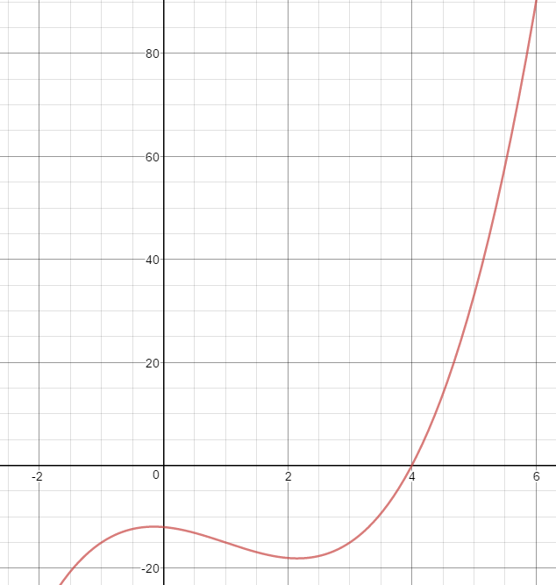

* 1. No, the specified interval is not convex



* 1. Yes, the specified interval is convex

