mbv2 W2/A4 tradition

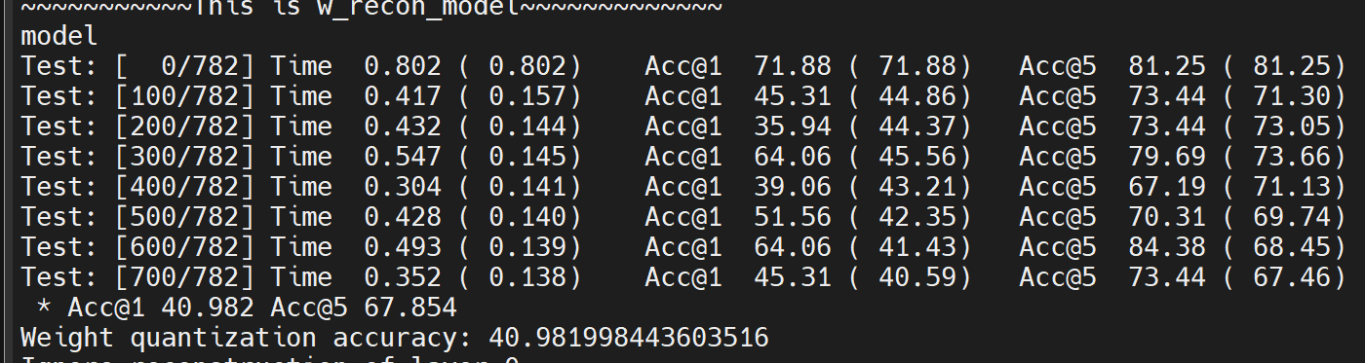

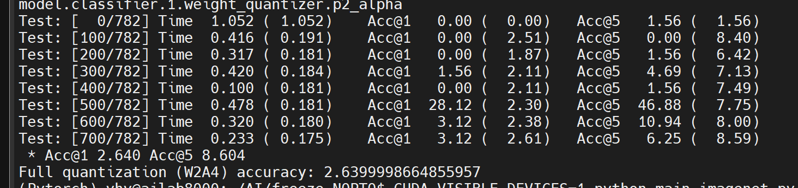

Mbv2 w2/A4 method 1 only

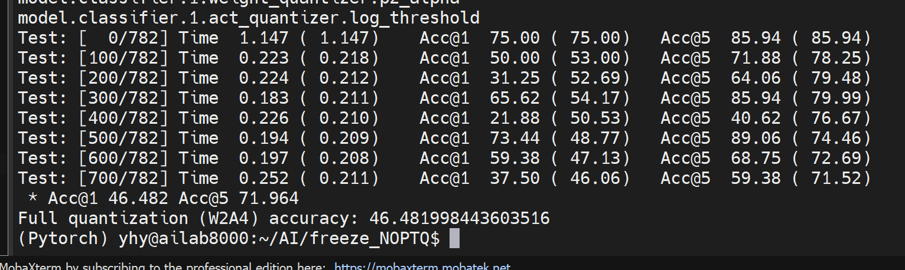

Mbv2 w2/a4 1+0.9sigmoid 8w



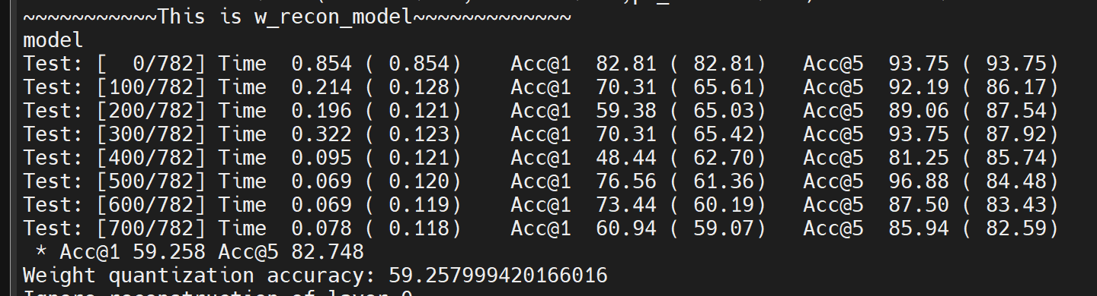

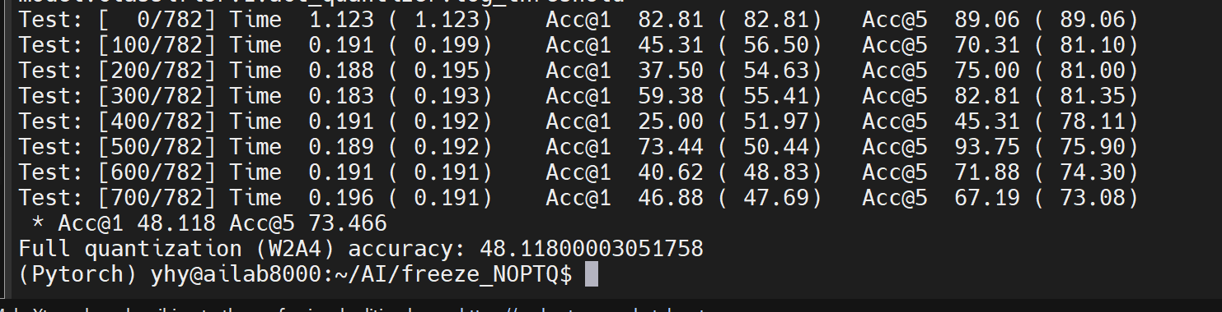

1+0.1sigmoid mbv2 W2/A4

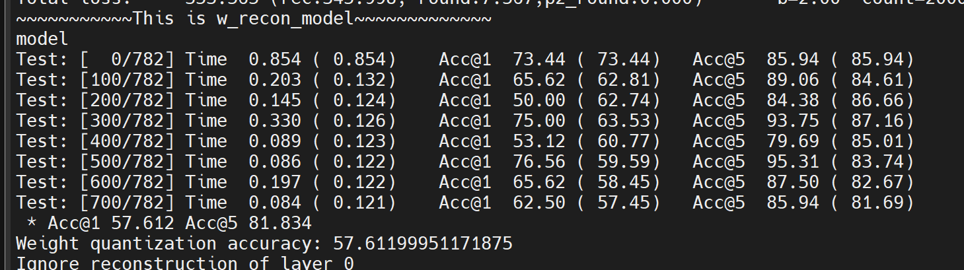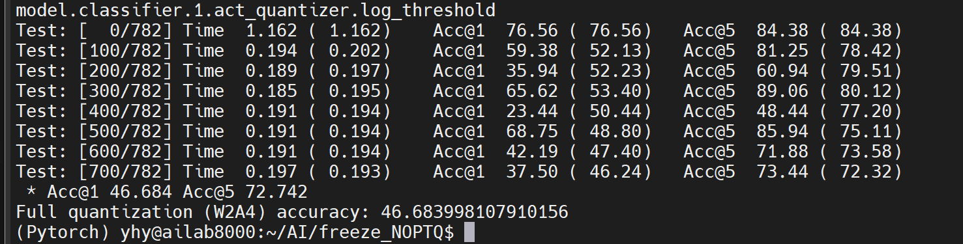

Resnet18 W2/A4 1+0.9sigomid 8w

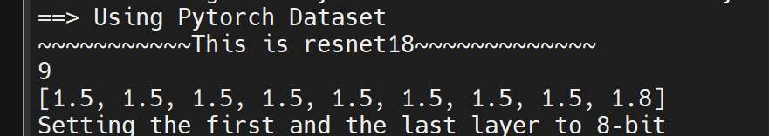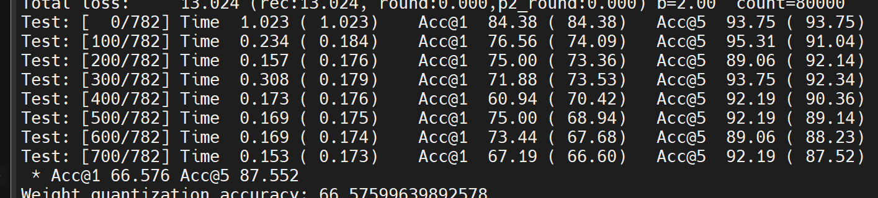

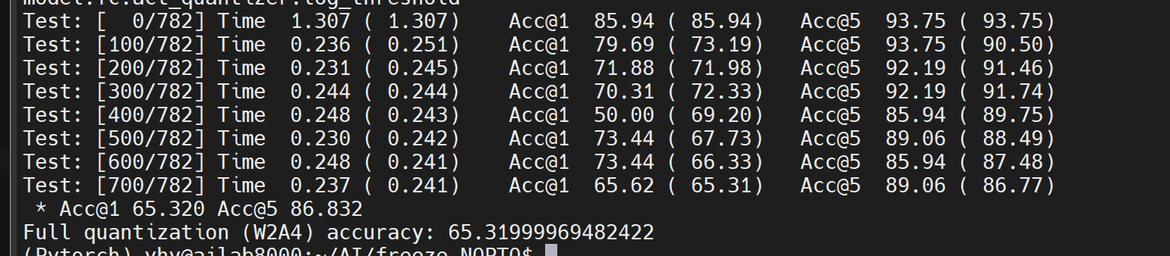

**Resnet18 4/4 1+0.9sigomid 8w**

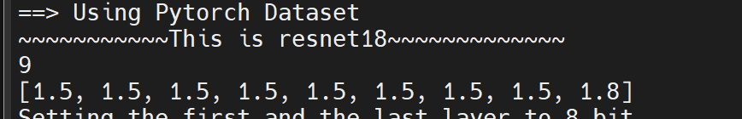

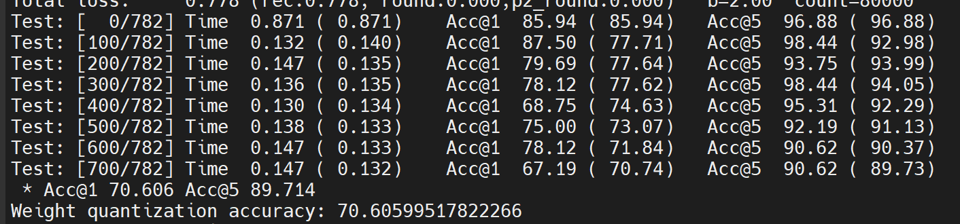

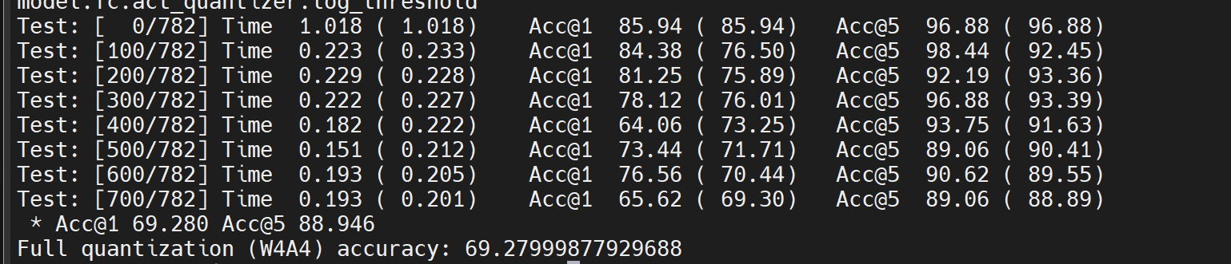

**Resnet50 W2/A4 1+0.9sigomid 8w**

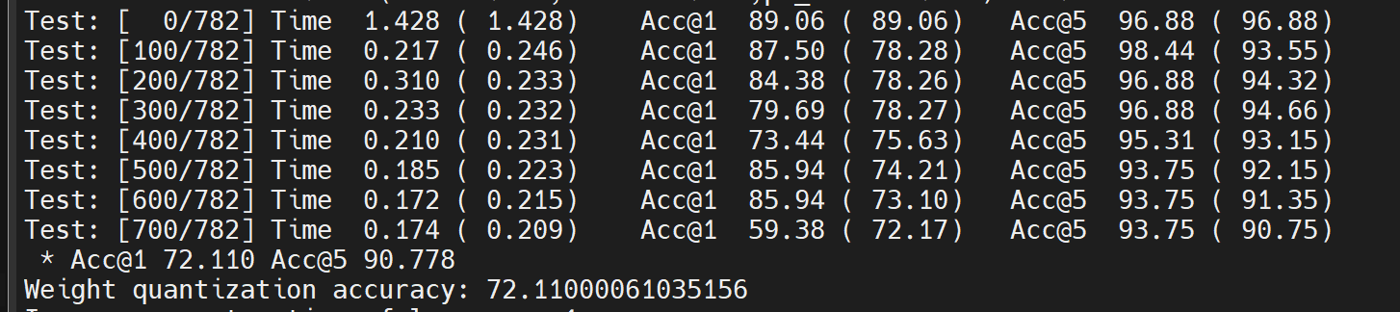

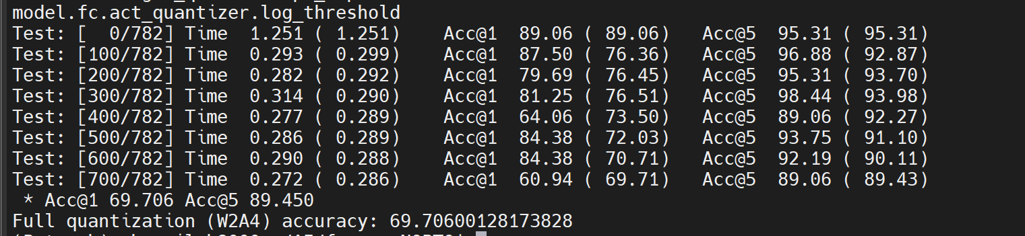

**Resnet50 4/4 1+0.9sigomid 8w**

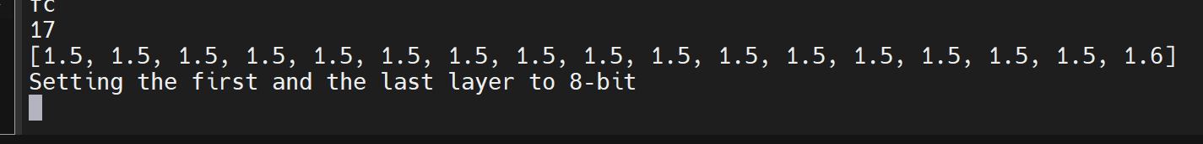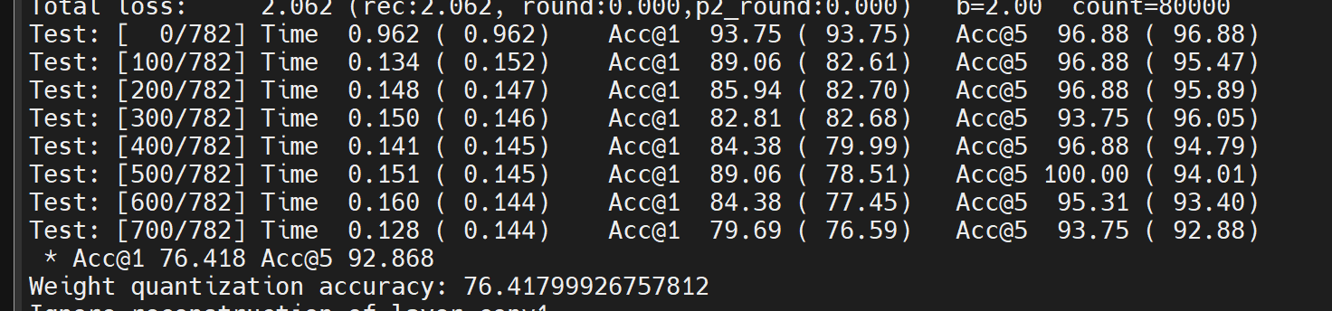

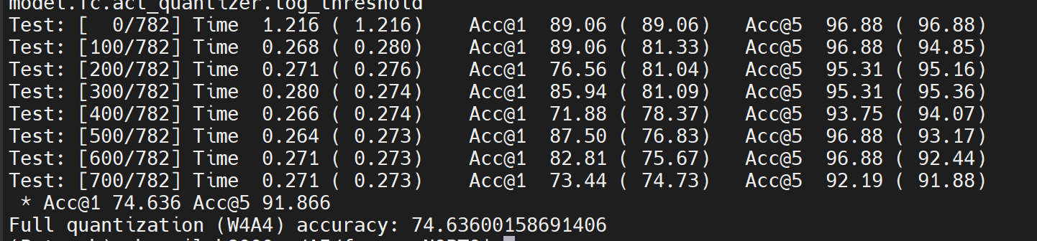

**128 Resnet50 W2/A4 without RAPQ 8w**

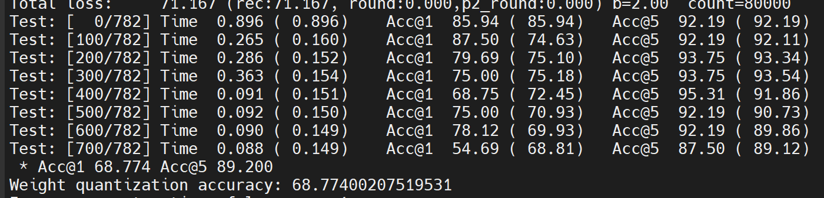

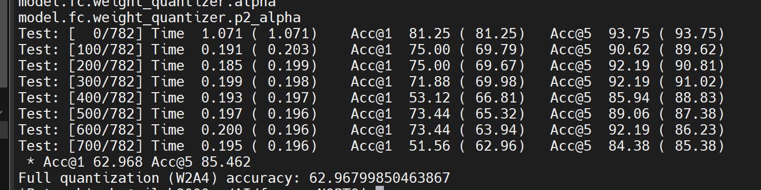

**Resnet18 2/4 tradition 8w**

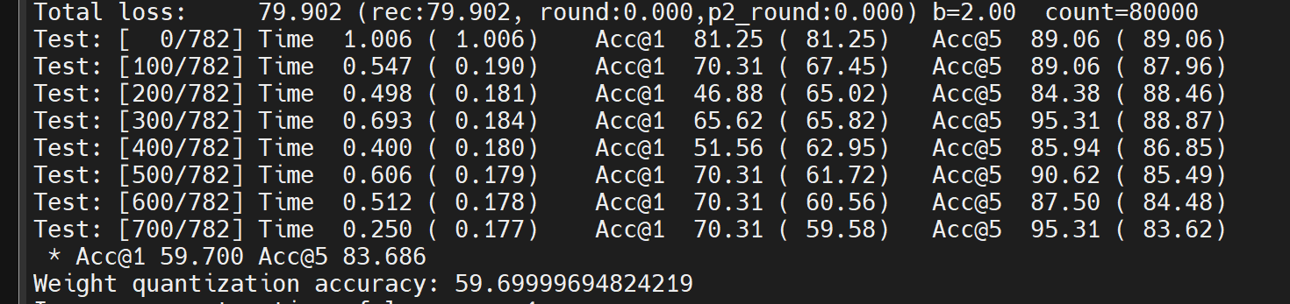

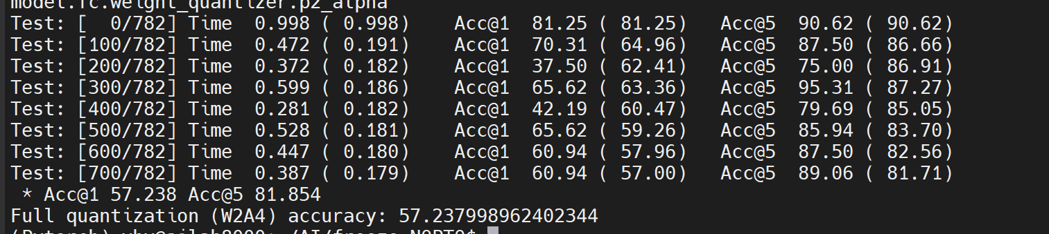

**129 Resnet18 2/4 1+0.1sig 2W**

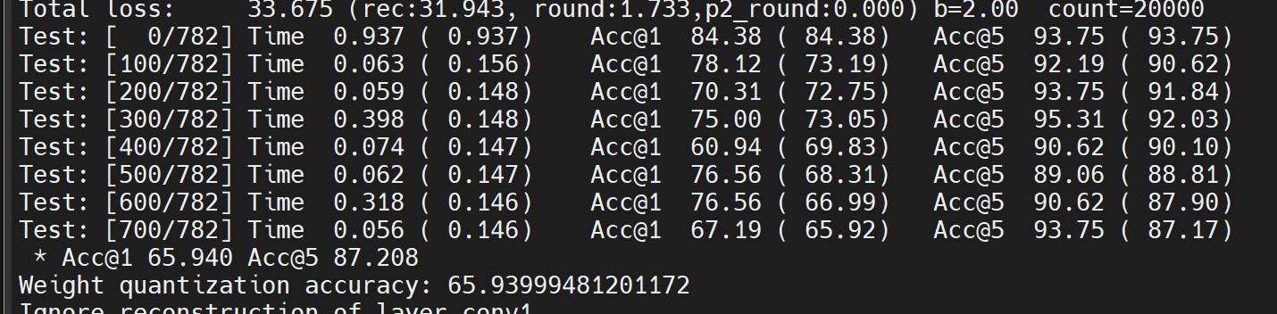

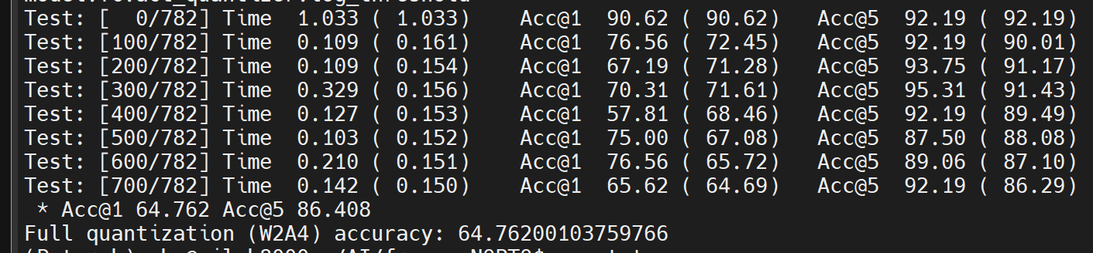

**Resnet50 2/4 1+0.1sig 2W**

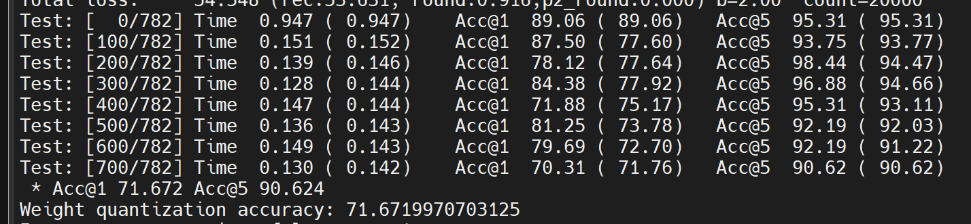

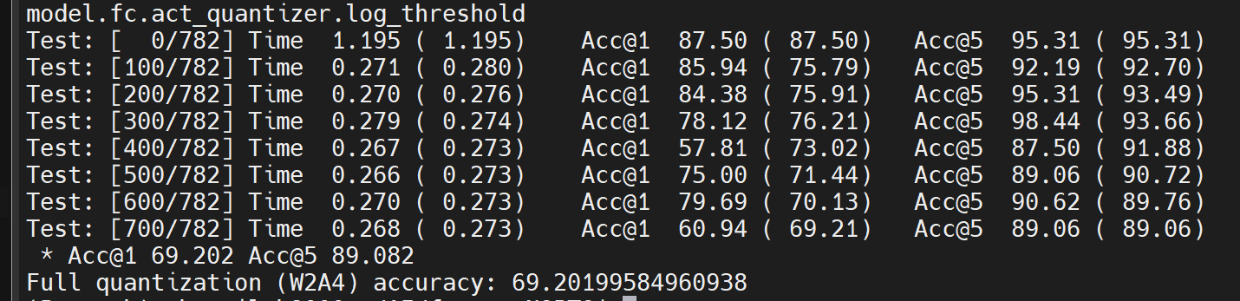

**Resnet18 4/4 1+0.1sig 2W**

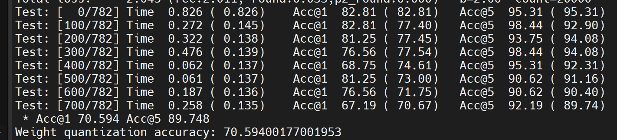

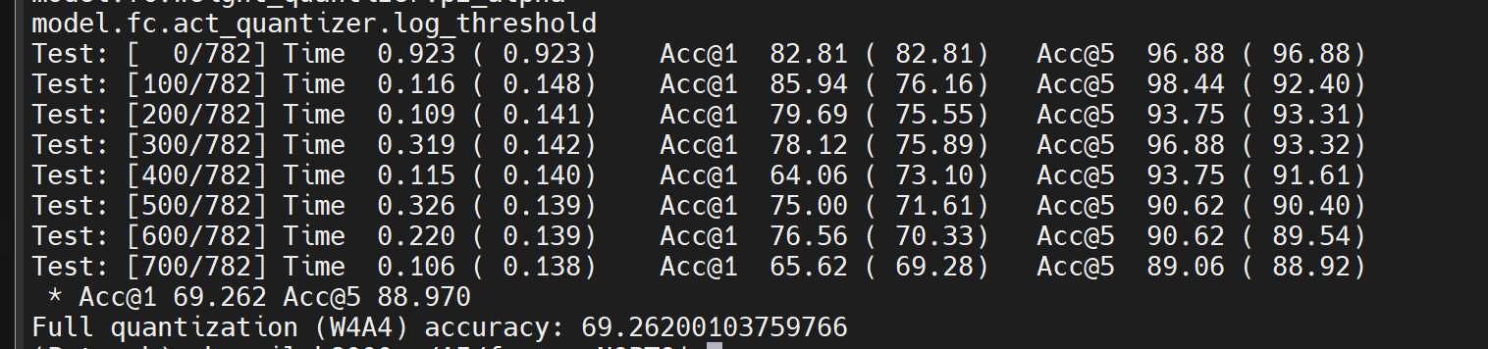

**Resnet50 4/4 1+0.1sig 2W**

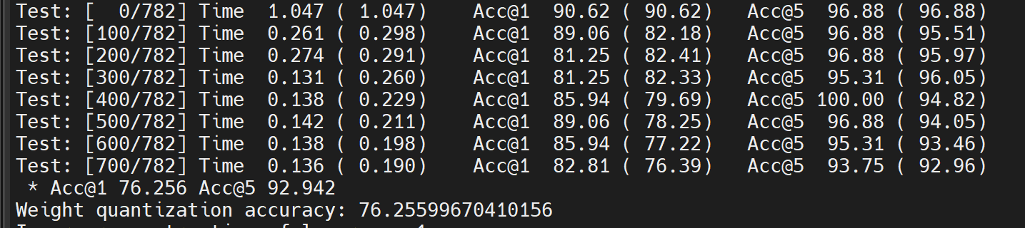

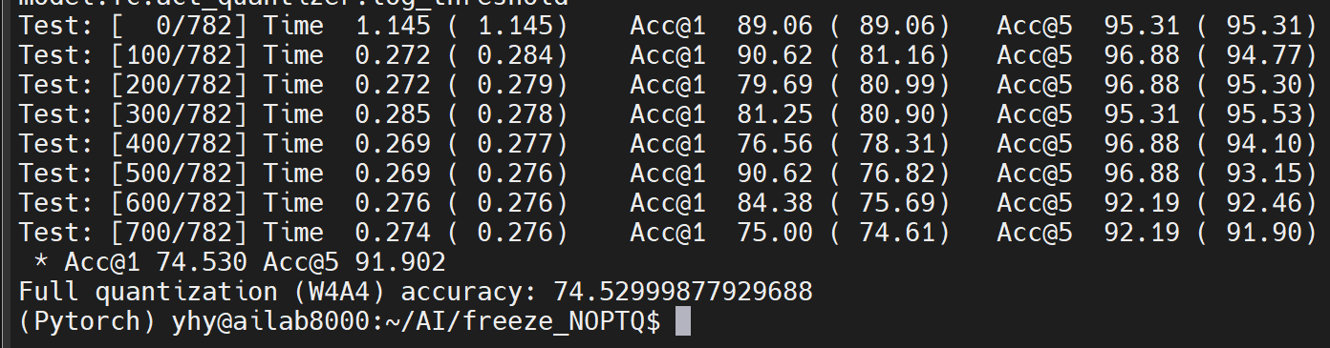

**regnet600m RAPQ 1+0.9sigmoid 2/4 20000**

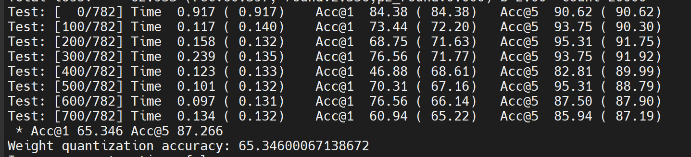

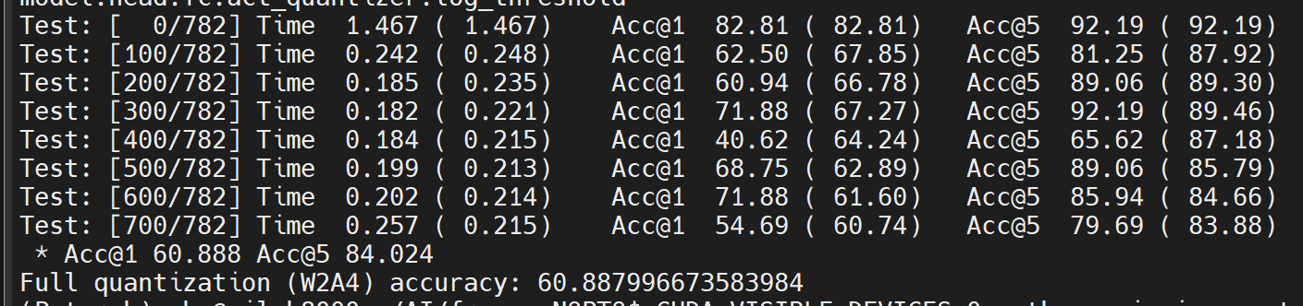

**regnet600m RAPQ 1+0.1sigmoid 2/4 20000**

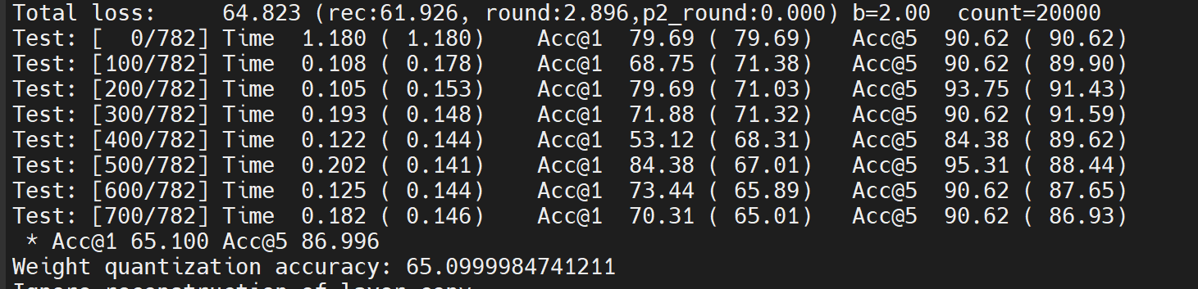

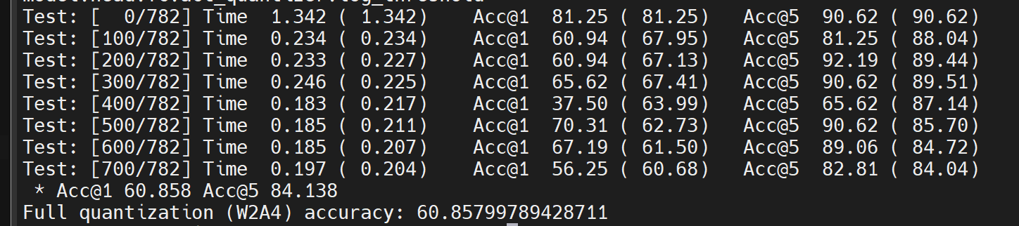

**regnet600m RAPQ 全2 2/4 20000**

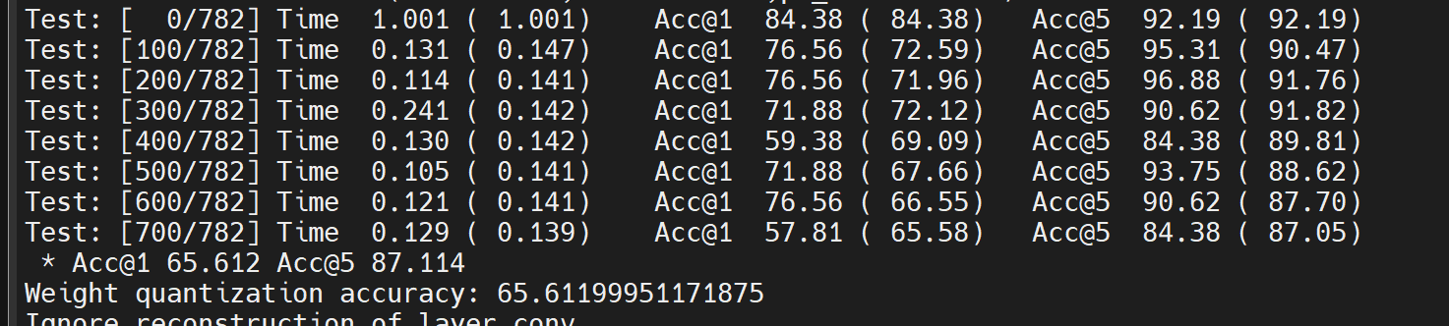

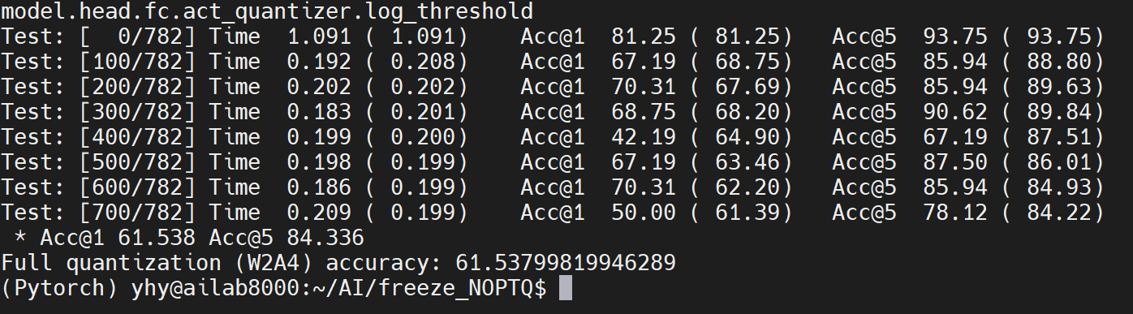

**regnet600m RAPQ 1+0.9sigmoid 2/4 80000**

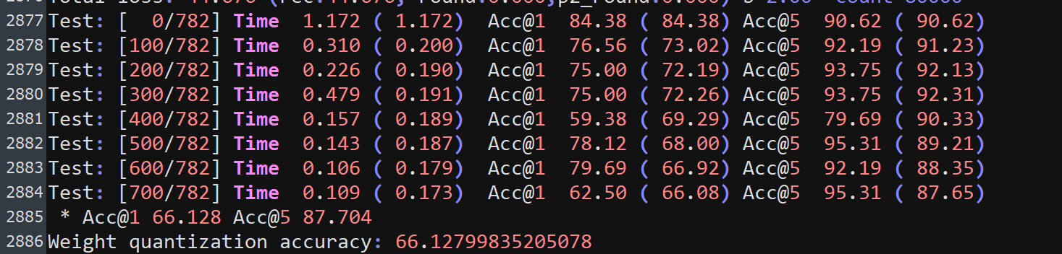

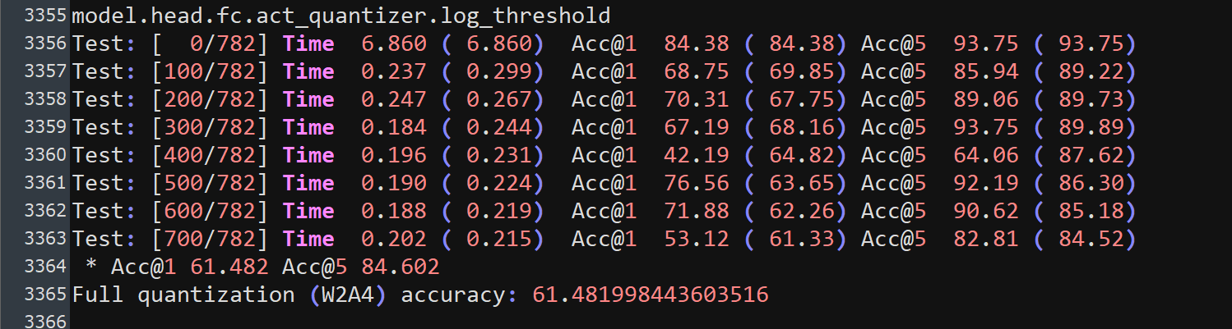

**regnet600m RAPQ 1+0.9sigmoid 4/4 80000**

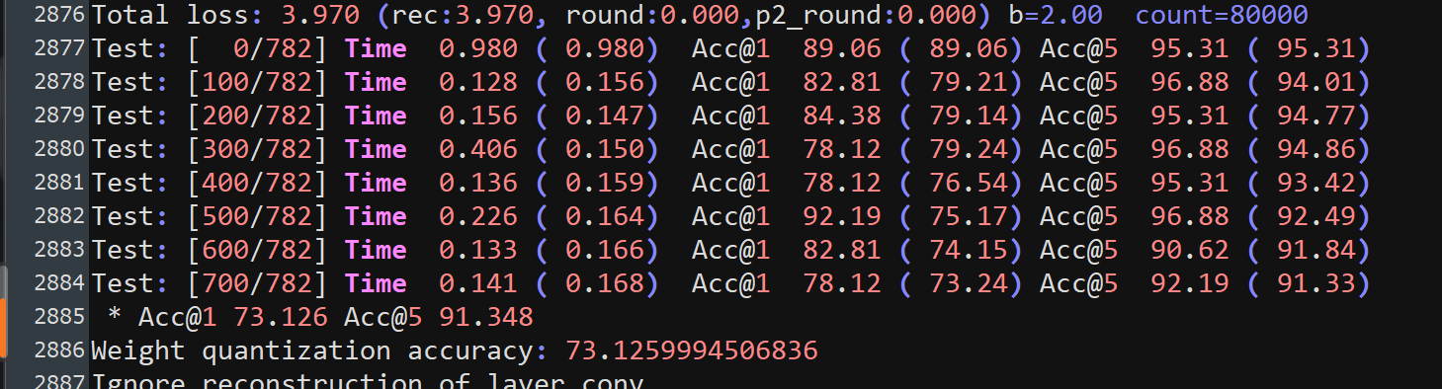

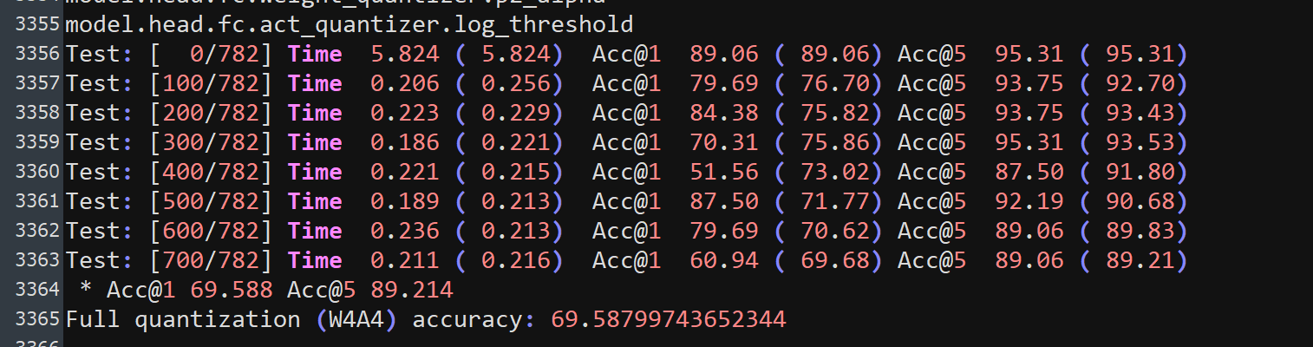

**regnet600m RAPQ 1+0.1sigmoid 4/4 20000**

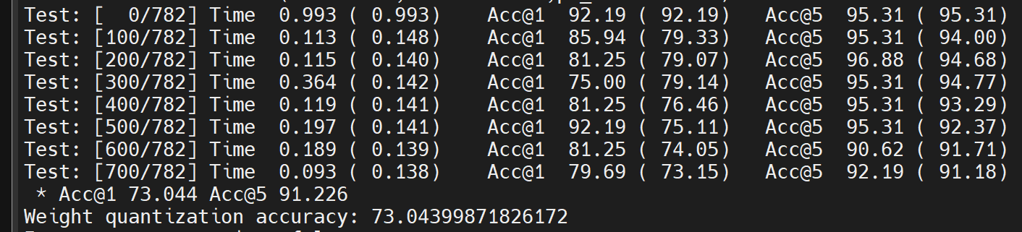

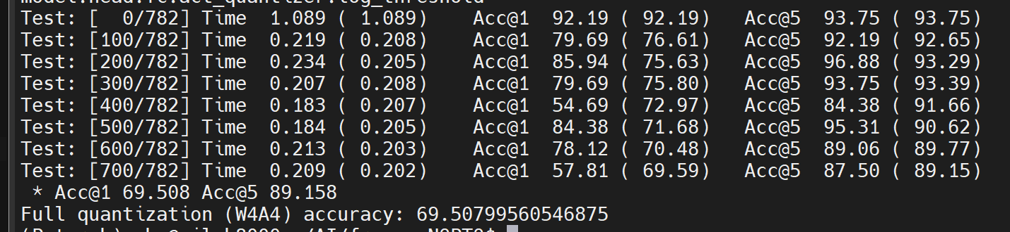

**regnet3200m RAPQ 1+0.1sigmoid2/4 20000**

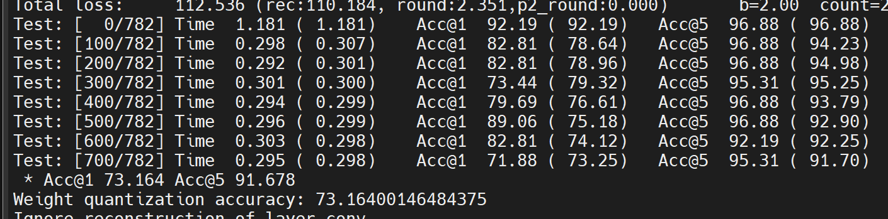

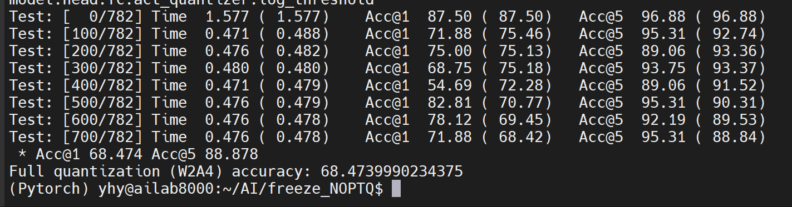

**regnet3200m RAPQ 1+0.9sigmoid 2/4 80000**

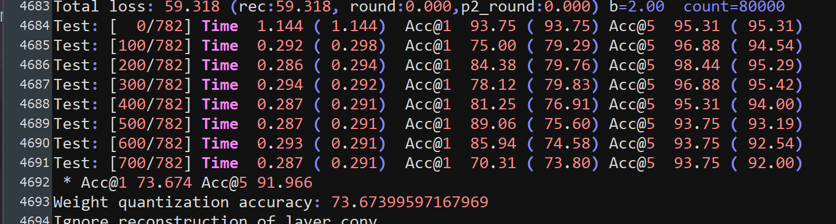

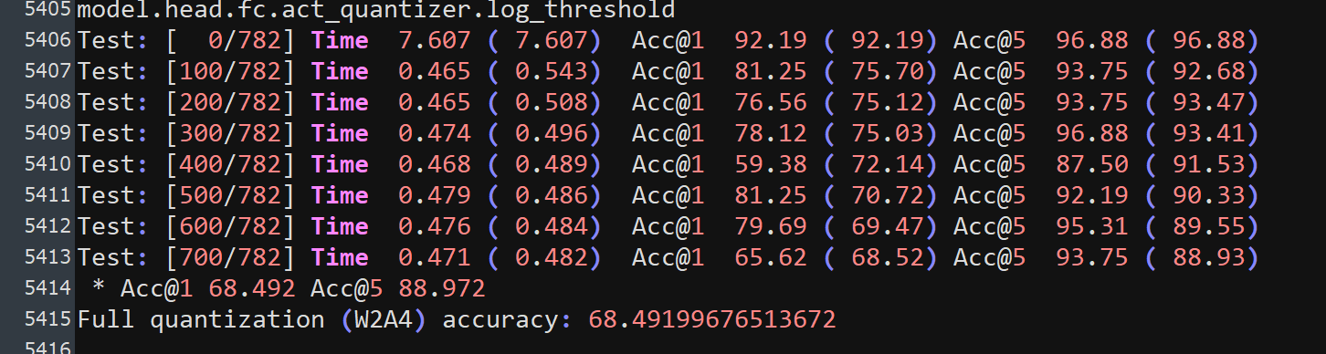

**regnet3200m RAPQ 1+0.9sigmoid 4/4 80000**

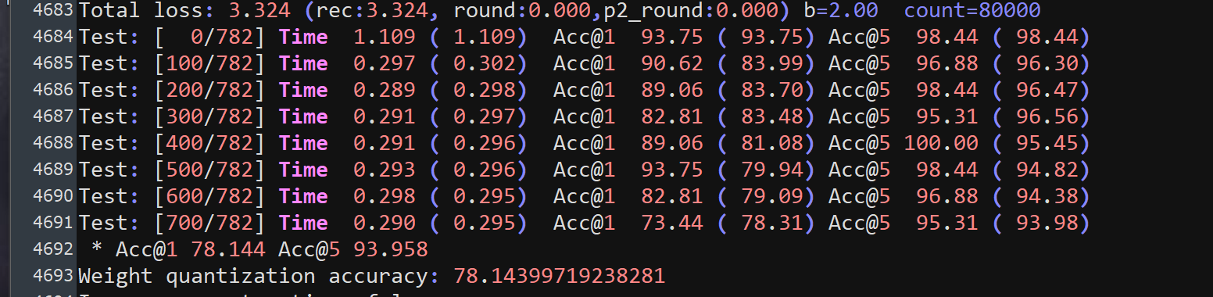

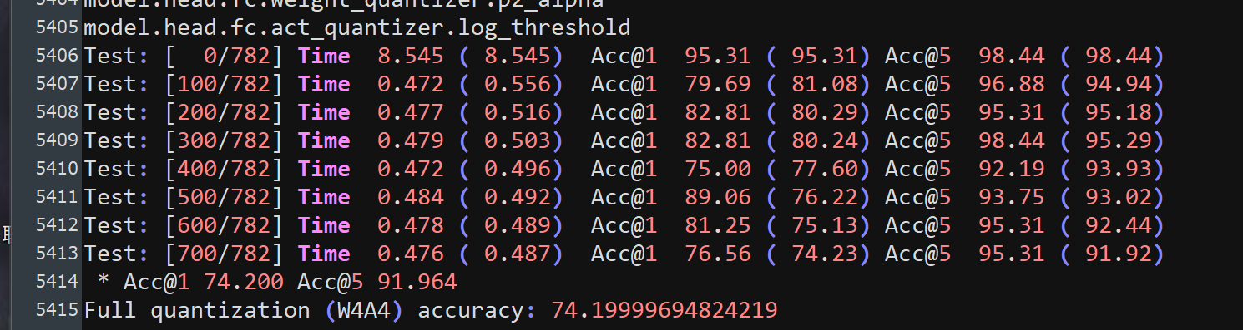

**regnet3200m RAPQ 1+0.1sigmoid 4/4 20000\**

