G503 Mobile App Requirements
Bill Cutshall

Version 1.0
November 20, 2014

Table of Contents
Introduction 3
Features/Requirements 3
Constraints 3
Design 4
Historical 5

Introduction
G503 is the nomenclature used by the United States Army during World War II to identify the Willys MB or Ford GPW jeeps. I bought a Ford GPW (actually, a pile of parts that would become a Ford GPW) in July, 2005. In the intervening years I learned a lot from the flatfender jeep community and especially the g503.com site hosted by Ron Fitzpatrick of Ron Fitzpatrick Jeep Parts. I've taken way more than I'll ever be able to give back but one way I figure I can contribute is to create a mobile app. They say the best applications are written by someone who is solving a personal problem. One of the frustrations I have is when I find myself in a hardware store to buy replacement nuts and bolts for my jeep. The US government published a jeep parts manual (ORD9 SNL G-503) that listed every part on the jeep – including all the nuts and bolts. That serves as the basis for developing the app. The goal of this exercise will be to develop a smartphone app that allows the user to quickly lookup the correct nut/bolt/washer based on the SNL G-503 numbers and descriptions. Other desirable functions, trivia, and history will be identified to round out the app.

Features/Requirements
- Build smartphone applications for both the iOS and Android platforms that will be distributed to the Apple and Google markets at no charge.
- A searchable table with sections corresponding to the sections of the SNL G-503. The list of bolts comes from downloadable spreadsheet from 1945gpw.com or jeepdraw.com. (Claude Pons is the originator but it has been updated several times. Will try to find the latest representation.)
- List the relevant manuals and where they can be obtained (web links as well as printed).
- List the production statistics (models, years, manufacturer, etc.).
- List the spotting/production features by year and model. Use photos if possible.
- Have a section on historical locations, manufacturing facilities, assembly plants, etc. Have links to Apple/Google maps to show where the facilities are/were.
- Perhaps a section listing vendors and their web sites.
- Section dedicated to the on-board tools shipped with each jeep. Include photos and spotting features.
- Section dedicated to General Mechanics Tool Kits (GMTK). Include photos and spotting features.
- Add capability to use Google Cast (https://developers.google.com/cast/) to be able to project/share on a supporting device (e.g., a TV).

Constraints
- Apps will be developed as native applications in order to keep mobile development skills sharp and current.
- Try to use default components as much as possible. Make sure any third party libraries have free (libre) license (e.g., Apache).
- iOS version will be 7.1 and above and developed in Objective-C.
- Use Core Data to handle iOS database.
- Android version will be 4.1.x (API level 16 or greater) based on Google's version chart (https://developer.android.com/about/dashboards/index.html). Try to incorporate Material Design (https://developer.android.com/design/material/index.html) and app compatibility (http://android-developers.blogspot.com/2014/10/appcompat-v21-material-design-for-pre.html).
- I will hold copyright but release as open source on Github.
- Store the “bolts” data in a sqlite database. The database need not be shared between the two platforms. I'm thinking of distributing JSON with the app and building the database from the JSON on startup after install/update (e.g., delete the database file if it exists and recreate it from the JSON). Python script to read CSV (spreadsheet) file and create JSON:

#!/usr/bin/python
import csv, json
csvreader = csv.reader(open('bolts.csv', 'rb'), delimiter=',', quotechar='"')
data = []
for row in csvreader:
r = []
for field in row:
if field == '': field = None
else: field = unicode(field.strip(), 'ISO-8859-1')
r.append(field)
data.append(r)
jsonStruct = {
'header': data[0],
'data': data[1:]
}
open('bolts.json', 'wb').write(json.dumps(jsonStruct, indent=4))

header = data[0]
jsonData = []
for rowIndex in range(2,len(data)):
jsonRow={}
for headerIndex in range(len(header)):
row = data[rowIndex]
print '"%s":"%s"' %( header[headerIndex].lower(), row[headerIndex])
jsonRow[header[headerIndex].lower()] = str(row[headerIndex])
jsonData.append(jsonRow)

open('bolts1.json', 'wb').write(json.dumps(jsonData, indent=4))

Design
- “Front” page should be allow for easy addition of new features. I'm thinking a UICollectionView in iOS or FlowLayout in Android:
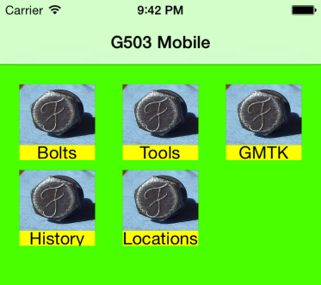
- Possibly also a table like the following:
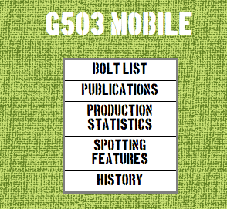
- Use military colors (i.e., “khaki” or “olive drab”). Need to find the “right” RGB/Hex/... values.
- Use stencil or typewriter fonts (e.g., open source fonts like boston.ttf or MyUnderwood.ttf).
- Use textures simulating canvas, wood, or old paper (interesting article on creating parchment using Gimp http://www.gimpusers.com/tutorials/old-pergament-paper):
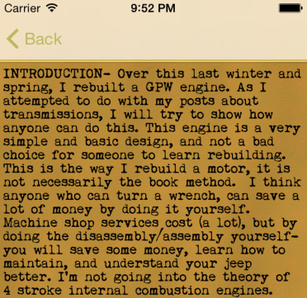

Historical

Description | Assigned To | Completed On | Comment
Create Github account | Bill | 11/20/14
Decide on ADT or Android Studio (IntelliJ) for Android development. |  | 11/21/14 | Going to use ADT for now. Android Studio requires Java 6 on the Mac.
Determine best source for bolt data.
Determine design of “home screen”.

