William Groble

CMPS 1600

4/4/16

I had difficulty getting the program to function properly stemming initially from the need to convert coordinates in the array to the array position relative to the 81 cells. This compounded with the recursion from the solve function led to most instances of gentle.txt being solved to return zero after the third zone of 9 cells was completed. While input and output function well the solve function is still outputting zero. Additionally repetition was found within blocks up to this point with only the first few cells being solved properly.

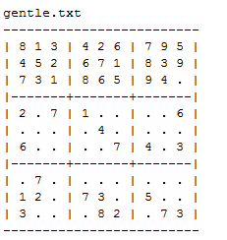

4/5/16 Changelog

After revaluating the source code the following changes were made to restore it to a functional state:

-The previous 1 dimensional array was changed to a 2D array for simplicity, and while this was likely not the root of the initial problem the code now reads more coherently

-The block (3x3 zone) verification was modified as to not allow repeats

-Base case changed as to not have to rely on unknown behavior, as so when the base case was reached it would not rely on referencing a value outside of the range of SudokuGrid (i.e. (0,9)(10,10) etc..)

-The root of the problem in the previous code was found to be in the solve() function where I found I had been referencing the nextEmpty coordinates as opposed to the current coordinates when solve did not return 1 to set the value as zero for the next iteration of solve. This caused the function to permanently set the first candidate in a cell as it went which lead to the puzzle very quickly becoming unsolvable forcing it to behave as if it was not solvable usually by row 3 (and even earlier when the block verification worked). A possible reason for this error may have been the similarity between the next variables and the current variables (“X” and “Y” being next and “x” and “y” being current) so the takeaway from this is to be more descriptive in my variable naming. The variable names have since been changed to “nextX” and “nextY”.

232| sudokuGrid[X][Y] = 0;

Screenshots:

