Chapter 4
The Market Forces of Supply and Demand
Multiple Choice
1. The forces that make market economies work are
a. work and leisure.
b. demand and supply.
c. regulation and restraint.
d. taxes and government spending.
ANS: B PTS: 1 DIF: 1 REF: 4-0
TOP: Market economy MSC: Interpretive
2. Which of the following are the words most commonly used by economists?
a. surplus and shortage
b. resources and allocation
c. supply and demand
d. theory and practice
ANS: C PTS: 1 DIF: 1 REF: 4-0
TOP: Economists MSC: Interpretive
3. In a market economy,
a. supply determines demand and, in turn, demand determines prices.
b. demand determines supply and, in turn, supply determines prices.
c. the allocation of scarce resources determines prices and, in turn, prices determine supply and demand.
d. supply and demand determine prices and, in turn, prices allocate scarce resources.
ANS: D PTS: 1 DIF: 2 REF: 4-0
TOP: Market economy MSC: Interpretive
4. In a market economy, supply and demand are important because they
a. play a critical role in the allocation of the economy’s scarce resources.
b. determine how much of each good gets produced.
c. can be used to predict the impact on the economy of various events and policies.
d. All of the above are correct.
ANS: D PTS: 1 DIF: 1 REF: 4-0
TOP: Market economy MSC: Interpretive
5. A market is a
a. group of buyers and sellers of a particular good or service.
b. group of people with common economic characteristics.
c. place where buyers and sellers come together to engage in trade.
d. place where an auctioneer helps set prices and arrange sales.
ANS: A PTS: 1 DIF: 1 REF: 4-1
TOP: Markets MSC: Definitional
6. For a market for a good or service to exist,
a. there must be a group of buyers and sellers.
b. there must be a specific time and place at which the good or service is traded.
c. the price of the good must be determined by the sellers.
d. All of the above are correct.
ANS: A PTS: 1 DIF: 1 REF: 4-1
TOP: Market(s MSC: Definitional
7. The term market always refers to
a. an arrangement in which buyers and sellers meet at a specific time and place.
b. an arrangement in which an auctioneer plays at least a limited role in setting prices.
c. a group of buyers and sellers of a particular good or service.
d. All of the above are correct.
ANS: C PTS: 1 DIF: 1 REF: 4-1
TOP: Markets MSC: Definitional
8. A group of buyers and sellers of a particular good or service is called a
a. coalition.
b. partnership.
c. market.
d. union.
ANS: C PTS: 1 DIF: 1 REF: 4-1
TOP: Markets MSC: Definitional
9. A market is always characterized by
a. a high degree of organization.
b. an individual or small group of individuals who set the price of the product for all buyers and sellers.
c. the presence of buyers and sellers.
d. All of the above are correct.
ANS: C PTS: 1 DIF: 2 REF: 4-1
TOP: Markets MSC: Interpretive
10. Which of the following statements is correct?
a. Buyers determine supply and sellers determine demand.
b. Buyers determine demand and sellers determine supply.
c. Buyers and sellers as one group determine supply, but only buyers determine demand.
d. Buyers and sellers as one group determine demand, but only sellers determine supply.
ANS: B PTS: 1 DIF: 2 REF: 4-1
TOP: Demand | Supply MSC: Interpretive
11. For each good produced in a market economy, the interaction of demand and supply determines
a. the price of the good, but not the quantity.
b. the quantity of the good, but not the price.
c. both the price of the good and the quantity of the good.
d. neither price nor quantity, because prices and quantities are determined by the sellers of the goods alone.
ANS: C PTS: 1 DIF: 2 REF: 4-1
TOP: Market economy MSC: Interpretive
12. A competitive market is a market in which
a. an auctioneer helps set prices and arrange sales.
b. there are only a few sellers.
c. the forces of supply and demand do not apply.
d. no individual buyer or seller has any significant impact on the market price.
ANS: D PTS: 1 DIF: 1 REF: 4-1
TOP: Competitive markets MSC: Definitional
13. The demand for a good or service is determined by
a. those who buy the good or service.
b. the government.
c. the producers who create the good or service.
d. those who supply the raw materials used in the production of the good or service.
ANS: A PTS: 1 DIF: 2 REF: 4-1
TOP: Demand MSC: Interpretive
14. A competitive market is one in which
a. there is only one seller, but there are many buyers.
b. there are many sellers and each seller has the ability to set the price of his product.
c. there are many sellers and they compete with one another in such a way that some sellers are always being forced out of the market.
d. there are so many buyers and so many sellers that each has a negligible impact on the price of the product.
ANS: D PTS: 1 DIF: 2 REF: 4-1
TOP: Competitive markets MSC: Definitional
15. In a competitive market,
a. only a few sellers sell the same product.
b. each seller has a limited degree of control over the price of his product.
c. if one buyer chooses to purchase a large quantity of the product, the price will rise.
d. if one seller withholds his product from the market, prices will rise.
ANS: B PTS: 1 DIF: 2 REF: 4-1
TOP: Competitive markets MSC: Interpretive
16. In a competitive market, each seller has limited control over the price of his product because
a. other sellers are offering similar products.
b. buyers exert more control over the price than do sellers.
c. these markets are highly regulated by government.
d. sellers usually agree to set a common price that will allow each seller to earn a comfortable profit.
ANS: A PTS: 1 DIF: 2 REF: 4-1
TOP: Competitive markets MSC: Interpretive
17. Most markets in the economy are
a. markets in which sellers, rather than buyers, control the price of the product.
b. markets in which buyers, rather than sellers, control the price of the product.
c. markets in which each seller of the product is aware that there are few, if any, similar products offered by other sellers.
d. highly competitive.
ANS: D PTS: 1 DIF: 2 REF: 4-1
TOP: Markets MSC: Interpretive
18. For a competitive market, which of the following statements is correct?
a. A seller can always increase her profit by raising the price of her product.
b. If a seller charges more than the going price, buyers will go elsewhere to make their purchases.
c. A seller often charges less than the going price to increase sales and profit.
d. A single buyer can influence the price of the product, but only when purchasing from several sellers in a short period of time.
ANS: B PTS: 1 DIF: 2 REF: 4-1
TOP: Competitive markets MSC: Interpretive
19. Assume Teresa buys computers in a competitive market. Then
a. Teresa has a limited number of sellers to turn to when she buys a computer.
b. Teresa will find herself negotiating with sellers whenever she buys a computer.
c. if Teresa buys a large number of computers, the price of computers will rise noticeably.
d. None of the above is correct.
ANS: D PTS: 1 DIF: 2 REF: 4-1
TOP: Competitive markets MSC: Interpretive
20. The highest form of competition is called
a. absolute competition.
b. cutthroat competition.
c. perfect competition.
d. market competition.
ANS: C PTS: 1 DIF: 1 REF: 4-1
TOP: Perfect competition MSC: Definitional
21. Which of the following is not a characteristic of a perfectly competitive market?
a. Different sellers sell identical products.
b. There are many sellers.
c. Sellers must accept the price the market determines.
d. All of the above are characteristics of a perfectly competitive market.
ANS: D PTS: 1 DIF: 2 REF: 4-1
TOP: Perfect competition MSC: Interpretive
22. Which of the following is not a characteristic of a perfectly competitive market?
a. Sellers possess market power.
b. There are many sellers.
c. Buyers must accept the price the market determines.
d. All of the above are characteristics of a perfectly competitive market.
ANS: A PTS: 1 DIF: 2 REF: 4-1
TOP: Perfect competition MSC: Interpretive
23. The term price takers refers to buyers and sellers in
a. perfectly competitive markets.
b. monopolies.
c. markets that are regulated by government.
d. markets in which buyers cannot buy all they want and/or sellers cannot sell all they want.
ANS: A PTS: 1 DIF: 2 REF: 4-1
TOP: Perfect competition MSC: Interpretive
24. Buyers and sellers who have no influence on market price are referred to as
a. market pawns.
b. marginalists.
c. price takers.
d. price makers.
ANS: C PTS: 1 DIF: 1 REF: 4-1
TOP: Perfect competition MSC: Definitional
25. Price takers have no influence over prices in markets that feature
a. only a few buyers and a few sellers.
b. numerous sellers but only a few buyers.
c. numerous buyers but only a few sellers.
d. numerous buyers and numerous sellers.
ANS: D PTS: 1 DIF: 1 REF: 4-1
TOP: Perfect competition MSC: Interpretive
26. An example of a perfectly competitive market would be the
a. cable TV market.
b. soybean market.
c. new car market.
d. blue jean market.
ANS: B PTS: 1 DIF: 2 REF: 4-1
TOP: Perfect competition MSC: Interpretive
27. The market for ice cream is
a. a monopolistic market.
b. a competitive market.
c. a highly organized market.
d. a market in which there is no connection whatsoever between buyers and sellers.
ANS: B PTS: 1 DIF: 1 REF: 4-1
TOP: Markets MSC: Interpretive
28. If a seller in a competitive market chooses to charge more than the market price, then
a. the sellers’ profits definitely would increase.
b. the owners of the raw materials used in production would raise the prices for the raw materials.
c. other sellers would also raise their prices.
d. buyers will tend to make purchases from other sellers.
ANS: D PTS: 1 DIF: 2 REF: 4-1
TOP: Competitive markets MSC: Interpretive
29. If buyers and sellers in a certain market are price takers, then individually
a. they have no influence on market price.
b. they have some influence on market price, but that influence is limited.
c. buyers will be able to find prices lower than those determined in the market.
d. sellers will find it difficult to sell all they want to sell at the market price.
ANS: A PTS: 1 DIF: 2 REF: 4-1
TOP: Perfect competition MSC: Interpretive
30. A monopoly is a market
a. with one seller, and that seller is a price taker.
b. with one seller, and that seller sets the price.
c. with one buyer.
d. in which competition has reached its highest form.
ANS: B PTS: 1 DIF: 1 REF: 4-1
TOP: Monopoly MSC: Definitional
31. Which of the following would most likely serve as an example of a monopoly?
a. a bakery in a large city
b. a bank in a large city
c. a local cable television company
d. a small group of corn farmers
ANS: C PTS: 1 DIF: 1 REF: 4-1
TOP: Monopoly MSC: Interpretive
32. Despite the fact that not all markets are perfectly competitive, the study of perfect competition is worthwhile, in part because
a. buyers and sellers are price takers in all markets, not just in perfectly competitive markets.
b. buyers find it difficult to buy all they want to buy, and sellers find it difficult to sell all they want to sell, in all markets, not just in perfectly competitive markets.
c. some degree of competition is present in most markets, not just in perfectly competitive markets.
d. perfectly competitive markets are the most difficult markets to analyze, and this makes the study of other types of markets easy in comparison.
ANS: C PTS: 1 DIF: 2 REF: 4-1
TOP: Perfect competition MSC: Interpretive
33. To say that the quantity demanded of a good is negatively related to the price of the good is to say that
a. an increase in the quantity demanded of the good leads to a decrease in the price of the good.
b. an increase in the price of the good leads to a decrease in the quantity demanded of the good.
c. there is a weak relationship between the quantity demanded of a good and the price of the good.
d. there is no relationship between the quantity demanded of a good and the price of the good.
ANS: B PTS: 1 DIF: 2 REF: 4-2
TOP: Price | Quantity demanded MSC: Interpretive
34. Quantity demanded falls as the price rises and rises as the price falls, so we say that
a. quantity demanded is determined by quantity supplied.
b. price is determined by quantity demanded.
c. quantity demanded is a function of demand.
d. quantity demanded is negatively related to the price.
ANS: D PTS: 1 DIF: 2 REF: 4-2
TOP: Price | Quantity demanded MSC: Interpretive
35. The negative relationship between price and quantity demanded
a. applies to most goods in the economy.
b. is represented by a downward-sloping demand curve.
c. is referred to as the law of demand.
d. All of the above are correct.
ANS: D PTS: 1 DIF: 1 REF: 4-2
TOP: Negative relationships | Law of demand MSC: Interpretive
36. Which of the following would not be a determinant of the demand for a particular good?
a. prices of related goods
b. income
c. tastes
d. the prices of the inputs used to produce the good
ANS: D PTS: 1 DIF: 2 REF: 4-2
TOP: Demand MSC: Interpretive
37. Each of the following is a determinant of demand except
a. tastes.
b. technology.
c. expectations.
d. the prices of related goods.
ANS: B PTS: 1 DIF: 2 REF: 4-2
TOP: Demand MSC: Interpretive
38. The amount of the good buyers are willing and able to purchase is called the
a. demand.
b. quantity demanded.
c. supply.
d. quantity supplied.
ANS: B PTS: 1 DIF: 1 REF: 4-2
TOP: Quantity demanded MSC: Definitional
39. If a good is normal, then an increase in income will result in
a. an increase in the demand for the good.
b. a decrease in the demand for the good.
c. a movement down and to the right along the demand curve for the good.
d. a movement up and to the left along the demand curve for the good.
ANS: A PTS: 1 DIF: 2 REF: 4-2
TOP: Normal goods MSC: Interpretive
40. If Francis experiences a decrease in his income, we would expect that, as a result, Francis’s demand for
a. each good he purchases will remain unchanged.
b. normal goods will decrease.
c. luxury goods will increase.
d. inferior goods will decrease.
ANS: B PTS: 1 DIF: 2 REF: 4-2
TOP: Normal goods MSC: Interpretive
41. You lose your job and as a result you buy fewer romance novels. This shows that you consider romance novels to be a(n)
a. luxury good.
b. inferior good.
c. normal good.
d. complementary good.
ANS: C PTS: 1 DIF: 2 REF: 4-2
TOP: Normal goods MSC: Interpretive
42. Currently you purchase 6 packages of hot dogs a month. You will graduate from college in December and you will start a new job in January. You have no plans to purchase hot dogs in January. For you, hot dogs are
a. a substitute good.
b. a normal good.
c. an inferior good.
d. a law-of-demand good.
ANS: C PTS: 1 DIF: 2 REF: 4-2
TOP: Inferior goods MSC: Interpretive
43. Two goods are substitutes if a decrease in the price of one good
a. decreases the demand for the other good.
b. decreases the quantity demanded of the other good.
c. increases the demand for the other good.
d. increases the quantity demanded of the other good.
ANS: A PTS: 1 DIF: 2 REF: 4-2
TOP: Substitutes MSC: Definitional
44. Two goods are complements if a decrease in the price of one good
a. decreases the quantity demanded of the other good.
b. decreases the demand for the other good.
c. increases the quantity demanded of the other good.
d. increases the demand for the other good.
ANS: D PTS: 1 DIF: 2 REF: 4-2
TOP: Complements MSC: Definitional
45. A likely example of complementary goods for most people would be
a. hamburgers and hot dogs.
b. lawnmowers and automobiles.
c. hamburgers and French fries.
d. Dr. Pepper and Pepsi.
ANS: C PTS: 1 DIF: 1 REF: 4-2
TOP: Complements MSC: Interpretive
46. A likely example of substitute goods for most people would be
a. peanut butter and jelly.
b. tennis balls and tennis rackets.
c. televisions and subscriptions to cable television services.
d. pencils and pens.
ANS: D PTS: 1 DIF: 1 REF: 4-2
TOP: Substitutes MSC: Interpretive
47. Which of the following statements about people’s tastes is correct?
a. Generally, economists are interested in explaining people’s tastes.
b. Generally, economists are interested in how changes in people’s tastes affect markets.
c. Tastes never change enough over time to cause noticeable shifts in demand curves.
d. All of the above are correct.
ANS: B PTS: 1 DIF: 2 REF: 4-2
TOP: Tastes MSC: Interpretive
48. When it comes to people's tastes, economists generally believe that
a. tastes are based on forces that are well within the realm of economics.
b. tastes are based on historical and psychological forces.
c. tastes can only be studied through well-constructed, real-life models.
d. since tastes do not directly affect demand, there is little need to explain people's tastes.
ANS: B PTS: 1 DIF: 2 REF: 4-2
TOP: Tastes MSC: Interpretive
49. Economists in general
a. do not try to explain people's tastes, but they do try to explain what happens when tastes change.
b. believe that they must be able to explain people's tastes in order to explain what happens when tastes change.
c. do not believe that people's tastes determine demand and therefore they ignore the subject of tastes.
d. incorporate tastes into economic models only to the extent that tastes determine whether pairs of goods are substitutes or complements.
ANS: A PTS: 1 DIF: 2 REF: 4-2
TOP: Tastes MSC: Interpretive
50. Suppose today people change their expectations about the future. This change in expectations
a. results in a movement along a demand curve.
b. can affect future demand, but not today’s demand.
c. can affect today’s demand.
d. cannot affect either today’s demand or future demand.
ANS: C PTS: 1 DIF: 2 REF: 4-2
TOP: Expectations MSC: Interpretive
51. You love peanut butter. You hear on the news that 50 percent of the peanut crop in the South has been wiped out by drought, and that this will cause the price of peanuts to double by the end of the year. As a result,
a. your demand for peanut butter will increase, but not until the end of the year.
b. your demand for peanut butter increases today.
c. your demand for peanut butter decreases as you look for a substitute good.
d. you will wait for the price of jelly to change before altering your demand for peanut butter.
ANS: B PTS: 1 DIF: 2 REF: 4-2
TOP: Expectations MSC: Interpretive
52. Ford Motor Company announces that it will offer $3,000 rebates on new Mustangs starting next month. As a result of this information, today’s demand curve for Mustangs
a. shifts to the right.
b. shifts to the left.
c. shifts either to the right or to the left, but we cannot determine the direction of the shift from the given information.
d. will not shift; rather, the demand curve for Mustangs will shift to the right next month.
ANS: B PTS: 1 DIF: 2 REF: 4-2
TOP: Expectations MSC: Interpretive
53. Suppose you like to make, from scratch, pies filled with banana cream and vanilla pudding. You notice that the price of bananas has increased. How would this price increase affect your demand for vanilla pudding?
a. It would decrease.
b. It would increase.
c. It would be unaffected.
d. There is insufficient information given to answer the question.
ANS: A PTS: 1 DIF: 2 REF: 4-2
TOP: Complements MSC: Interpretive
54. Alyssa rents 5 movies per month when the price is $3.00 per rental and 7 movies per month when the price is $2.50 per rental. Alyssa’s demand demonstrates the law of
a. price.
b. supply.
c. demand.
d. expectations.
ANS: C PTS: 1 DIF: 1 REF: 4-2
TOP: Law of demand MSC: Interpretive
55. According to the law of demand,
a. quantity supplied and quantity demanded are positively related.
b. quantity supplied and quantity demanded are negatively related.
c. price and quantity demanded are positively related.
d. price and quantity demanded are negatively related.
ANS: D PTS: 1 DIF: 1 REF: 4-2
TOP: Law of demand MSC: Definitional
56. The law of demand says that
a. an increase in price causes quantity demanded to increase.
b. an increase in price causes quantity demanded to decrease.
c. an increase in quantity demanded causes price to increase.
d. an increase in quantity demanded causes price to decrease.
ANS: B PTS: 1 DIF: 1 REF: 4-2
TOP: Law of demand MSC: Definitional
57. Which of the following demonstrates the law of demand?
a. Relative to last month, Jon buys more pretzels at $1.50 per pretzel since he got a raise at work this month.
b. Melissa buys fewer muffins at $0.75 per muffin than at $1 per muffin, other things equal.
c. Dave buys more donuts at $0.25 per donut than at $0.50 per donut, other things equal.
d. Kendra buys fewer Snickers at $0.60 per Snickers since the price of Milky Ways fell to $0.50 per Milky Way.
ANS: C PTS: 1 DIF: 2 REF: 4-2
TOP: Law of demand MSC: Interpretive
58. A downward-sloping demand curve reflects
a. the idea that the demand for the good in question is decreasing as time goes by.
b. the idea that there are fewer suppliers of the good as time goes by.
c. the idea that there exists a substitute for the good in question and the price of that substitute is decreasing.
d. the law of demand.
ANS: D PTS: 1 DIF: 2 REF: 4-2
TOP: Law of demand MSC: Interpretive
59. The negative relationship between price and quantity demanded
a. applies to most goods in the economy.
b. is represented by a downward-sloping demand curve.
c. is referred to as the law of demand.
d. All of the above are correct.
ANS: D PTS: 1 DIF: 1 REF: 4-2
TOP: Negative relationships | Law of demand MSC: Interpretive
60. A higher price for batteries would result in a(n)
a. increase in the demand for flashlights.
b. decrease in the demand for flashlights.
c. increase in the demand for batteries.
d. decrease in the demand for batteries.
ANS: B PTS: 1 DIF: 2 REF: 4-2
TOP: Complements MSC: Applicative
61. If a decrease in income increases the demand for a good, then the good is
a. a substitute good.
b. a complement good.
c. a normal good.
d. an inferior good.
ANS: D PTS: 1 DIF: 1 REF: 4-2
TOP: Inferior goods MSC: Definitional
62. Which of the following is not a determinant of demand?
a. the price of a resource that is used to produce the good
b. the price of a complementary good
c. the price of the good next month
d. the price of a substitute good
ANS: A PTS: 1 DIF: 2 REF: 4-2
TOP: Demand MSC: Interpretive
63. What will happen in the rice market if buyers are expecting higher rice prices in the near future?
a. The demand for rice will increase.
b. The demand for rice will decrease.
c. The demand for rice will be unaffected.
d. The supply of rice will increase.
ANS: A PTS: 1 DIF: 2 REF: 4-2
TOP: Expectations MSC: Interpretive
64. A table that shows the relationship between the price of a good and the quantity demanded of that good is called a(n)
a. price-quantity table.
b. complementary table.
c. demand schedule.
d. equilibrium schedule.
ANS: C PTS: 1 DIF: 1 REF: 4-2
TOP: Demand schedule MSC: Definitional
65. A demand schedule is a table showing the relationship between
a. quantity demanded and quantity supplied.
b. income and quantity demanded.
c. price and quantity demanded.
d. price and expected price.
ANS: C PTS: 1 DIF: 1 REF: 4-2
TOP: Demand schedule MSC: Definitional
66. A demand schedule is a table showing the relationship between
a. quantity demanded and quantity supplied, and those quantities are usually positively related.
b. quantity demanded and quantity supplied, and those quantities are usually negatively related.
c. price and quantity demanded, and those quantities are usually positively related.
d. price and quantity demanded, and those quantities are usually negatively related.
ANS: D PTS: 1 DIF: 2 REF: 4-2
TOP: Demand schedule | Negative relationshipss MSC: Interpretive
67. With respect to the variables price and quantity demanded,
a. price and quantity demanded are independent of each other.
b. price is the dependent variable and quantity demanded is the independent variable.
c. price is the independent variable and quantity demanded is the dependent variable.
d. price and quantity demanded are both dependent variables, since both depend on the actions of buyers and sellers.
ANS: C PTS: 1 DIF: 3 REF: 4-2
TOP: Price | Quantity demanded MSC: Interpretive
68. When constructing a demand curve,
a. demand is on the vertical axis and quantity is on the horizontal axis.
b. price is on the horizontal axis and quantity is on the vertical axis.
c. price is on the vertical axis and demand is on the horizontal axis.
d. price is on the vertical axis and quantity demanded is on the horizontal axis.
ANS: D PTS: 1 DIF: 1 REF: 4-2
TOP: Demand curve MSC: Interpretive
69. The line that relates the price of a good to the quantity demanded of that good is called the
a. demand schedule, and it usually slopes upward.
b. demand schedule, and it usually slopes downward.
c. demand curve, and it usually slopes upward.
d. demand curve, and it usually slopes downward.
ANS: D PTS: 1 DIF: 1 REF: 4-2
TOP: Demand curve MSC: Definitional
70. The line that relates the price of a good to the quantity demanded of that good is called the
a. demand schedule, and it slopes upward only if the good for which the line is drawn fails to conform to the law of demand.
b. demand schedule, and it slopes upward only if the demand for the good in question, relative to the demand for other goods, is increasing over time.
c. demand curve, and it slopes upward only if there is a positive relationship between income and quantity demanded.
d. demand curve, and it slopes downward as long as the good in question conforms to the law of demand.
ANS: D PTS: 1 DIF: 2 REF: 4-2
TOP: Demand curve MSC: Interpretive
71. A downward-sloping demand curve illustrates the
a. relationship between consumers’ income and their willingness to purchase the good in question, provided the good is inferior.
b. negative relationship between quantity demanded and quantity supplied.
c. idea that the more of one good that a consumer buys, the less income she has to spend on other goods.
d. law of demand.
ANS: D PTS: 1 DIF: 2 REF: 4-2
TOP: Demand curve MSC: Interpretive
72. The demand curve for a good is
a. a line that relates the price to quantity demanded.
b. a line that relates income to quantity demanded.
c. a line that will shift only if the price of a related good changes.
d. the same thing as a production possibilities frontier, except the axes are labeled differently.
ANS: A PTS: 1 DIF: 1 REF: 4-2
TOP: Demand curve MSC: Interpretive
Figure 4-1
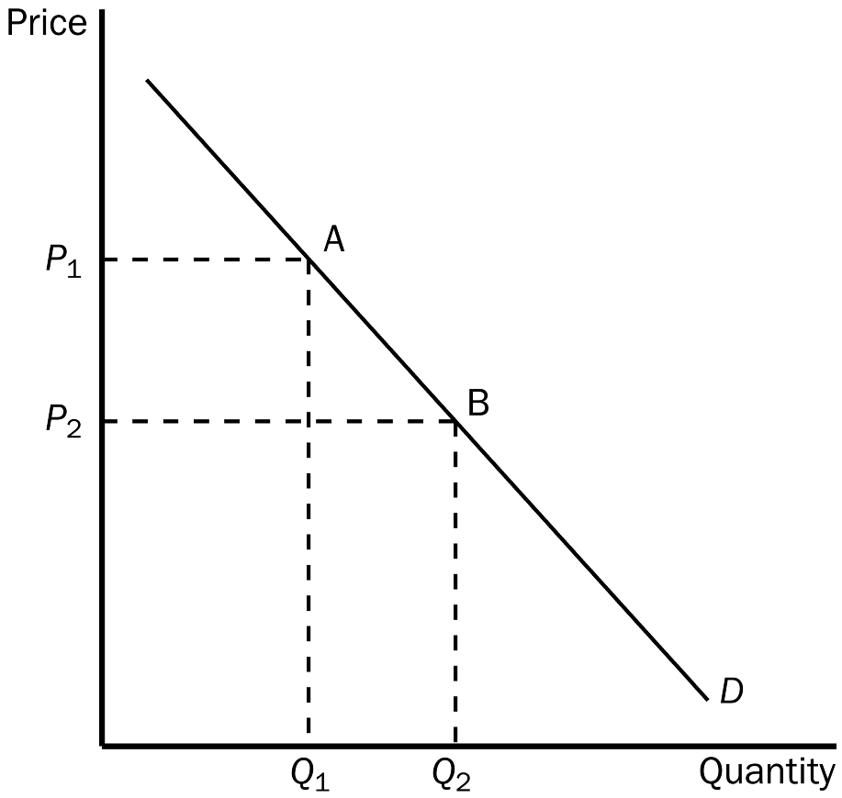
73. Refer to Figure 4-1. The movement from point A to point B on the graph would be caused by
a. an increase in price.
b. a decrease in price.
c. a decrease in the price of a substitute good.
d. an increase in income.
ANS: B PTS: 1 DIF: 1 REF: 4-2
TOP: Demand curve MSC: Interpretive
74. Refer to Figure 4-1. The movement from point A to point B on the graph shows
a. a decrease in demand.
b. an increase in demand.
c. a decrease in quantity demanded.
d. an increase in quantity demanded.
ANS: D PTS: 1 DIF: 1 REF: 4-2
TOP: Demand curve MSC: Interpretive
75. Refer to Figure 4-1. It is apparent from the figure that
a. the good is inferior.
b. the demand for the good decreases as income increases.
c. the demand for the good conforms to the law of demand.
d. All of the above are correct.
ANS: C PTS: 1 DIF: 2 REF: 4-2
TOP: Demand curve | Law of demand MSC: Interpretive
76. When we move along a given demand curve,
a. only price is held constant.
b. income and the price of the good are held constant.
c. all nonprice determinants of demand are held constant.
d. all determinants of quantity demanded are held constant.
ANS: C PTS: 1 DIF: 2 REF: 4-2
TOP: Demand curve MSC: Interpretive
77. Which of the following changes would not shift the demand curve for a good or service?
a. a change in income
b. a change in the price of the good or service
c. a change in expectations about the future price of the good or service
d. a change in the price of a related good or service
ANS: B PTS: 1 DIF: 2 REF: 4-2
TOP: Demand curve | Shifts of curves MSC: Interpretive
78. Which of the following would not affect an individual's demand curve?
a. expectations
b. income
c. prices of related goods
d. the number of buyers
ANS: D PTS: 1 DIF: 2 REF: 4-2
TOP: Individual demand MSC: Interpretive
79. When the number of buyers in a market increases,
a. the market demand curve shifts to the right.
b. the demand curves of the individual demanders in the market are unaffected.
c. the market demand for the good in question increases.
d. Al of the above are correct.
ANS: D PTS: 1 DIF: 2 REF: 4-2
TOP: Individual demand | Market demand MSC: Interpretive
80. If the number of buyers in the market decreases, the
a. market demand will increase.
b. market demand will decrease.
c. market supply will increase.
d. market supply will decrease.
ANS: B PTS: 1 DIF: 2 REF: 4-2
TOP: Market demand MSC: Interpretive
81. When the law of demand applies to a good, then
a. the quantity demanded of the good is negatively related to the price of the good.
b. the demand curve for the good slopes downward.
c. when the price of the good falls, the quantity demanded of the good rises.
d. All of the above are correct.
ANS: D PTS: 1 DIF: 2 REF: 4-2
TOP: Demand | Demand curve MSC: Interpretive
82. The market demand curve
a. is found by adding vertically the individual demand curves.
b. slopes upward.
c. represents the sum of the prices that all the buyers are willing to pay for a given quantity of the good.
d. represents the sum of the quantities demanded by all the buyers at each price of the good.
ANS: D PTS: 1 DIF: 2 REF: 4-2
TOP: Market demand curve MSC: Interpretive
83. Suppose Spencer and Kate are the only two demanders of lemonade. Each month, Spencer buys six glasses of lemonade when the price is $1.00 per glass, and he buys four glasses when the price is $1.50 per glass. Each month, Kate buys four glasses of lemonade when the price is $1.00 per glass, and she buys two glasses when the price is $1.50 per glass. Which of the following points is on the market demand curve?
a. (quantity demanded = 4, price = $2.50)
b. (quantity demanded = 16, price = $2.50)
c. (quantity demanded = 3, price = $1.50)
d. (quantity demanded = 10, price = $1.00)
ANS: D PTS: 1 DIF: 2 REF: 4-2
TOP: Market demand MSC: Interpretive
84. An increase in demand is represented by
a. a movement downward and to the right along a demand curve.
b. a movement upward and to the left along a demand curve.
c. a rightward shift of a demand curve.
d. a leftward shift of a demand curve.
ANS: C PTS: 1 DIF: 1 REF: 4-2
TOP: Demand curve MSC: Definitional
85. Pizza is a normal good if
a. the demand for pizza rises when income rises.
b. the demand for pizza rises when the price of pizza falls.
c. the demand curve for pizza slopes downward.
d. the demand curve for pizza shifts to the right when the price of burritos falls, assuming pizza and burritos are substitutes.
ANS: A PTS: 1 DIF: 1 REF: 4-2
TOP: Demand curve | Normal goodss MSC: Definitional
86. Today's demand curve for gasoline could shift in response to
a. a change in today's price of gasoline.
b. a change in the expected future price of gasoline.
c. a change in the number of sellers of gasoline.
d. All of the above are correct.
ANS: B PTS: 1 DIF: 2 REF: 4-2
TOP: Shifts of curves MSC: Interpretive
87. Which of the following events could shift the demand curve for gasoline to the left?
a. Income of gasoline buyers rises, and gasoline is a normal good.
b. Income of gasoline buyers falls, and gasoline is an inferior good.
c. Public service announcements are run on television, encouraging people to walk or ride bicycles instead of driving cars.
d. The price of gasoline rises.
ANS: C PTS: 1 DIF: 2 REF: 4-2
TOP: Shifts of curves MSC: Interpretive
88. The sum of all individual demand curves for a product is called
a. total demand.
b. consumption demand.
c. aggregate demand.
d. market demand.
ANS: D PTS: 1 DIF: 1 REF: 4-2
TOP: Market demand MSC: Definitional
89. The market demand is
a. the sum of all individual demands.
b. the demand for every product in an industry.
c. the average quantity demanded by individual demanders at each price.
d. positively related to the price of the product in question.
ANS: A PTS: 1 DIF: 1 REF: 4-2
TOP: Market demand MSC: Interpretive
90. To find the market demand for a product, individual demand curves are summed
a. vertically.
b. diagonally.
c. horizontally.
d. and then averaged.
ANS: C PTS: 1 DIF: 2 REF: 4-2
TOP: Market demand | Individual demand MSC: Interpretive
91. A market demand curve
a. is derived by a vertical summation of individual demand curves.
b. is derived by a horizontal summation of individual demand curves.
c. will shift in response to a change in the price of the good.
d. is always steeper than an individual demand curve.
ANS: B PTS: 1 DIF: 2 REF: 4-2
TOP: Market demand MSC: Interpretive
92. A market demand curve represents
a. the fact that the level of income is inversely related to quantity demanded.
b. how quantity demanded changes when the number of buyers changes.
c. the sum of all prices that individual buyers are willing and able to pay for each possible quantity of the good.
d. how much of a good all buyers are willing and able to buy at each possible price.
ANS: D PTS: 1 DIF: 2 REF: 4-2
TOP: Market demand MSC: Interpretive
The table shows individual demand schedules for a market.
Table 4-1
Price of the Good | Aaron | Angela | Austin | Alyssa
$0.00 | 20 | 16 | 4 | 8
0.50 | 18 | 12 | 6 | 6
1.00 | 14 | 10 | 2 | 5
1.50 | 12 | 8 | 0 | 4
2.00 | 6 | 6 | 0 | 2
2.50 | 0 | 4 | 0 | 0

93. Refer to Table 4-1. When the price of the good is $1.00, the quantity demanded in this market would be
a. 42 units.
b. 31 units.
c. 24 units.
d. 14 units.
ANS: B PTS: 1 DIF: 2 REF: 4-2
TOP: Demand schedule MSC: Applicative
94. Refer to Table 4-1. If the price increases from $1.00 to $1.50,
a. the market demand decreases by 20 units.
b. individual demand curves, when drawn, will shift to the left.
c. the quantity demanded in the market decreases by 2 units.
d. the quantity demanded in the market decreases by 7 units.
ANS: D PTS: 1 DIF: 2 REF: 4-2
TOP: Demand schedule MSC: Applicative
95. Refer to Table 4-1. Whose demand does not conform to the law of demand?
a. Aaron’s
b. Angela’s
c. Austin’s
d. Alyssa’s
ANS: C PTS: 1 DIF: 2 REF: 4-2
TOP: Demand schedule | Law of demand MSC: Applicative
96. Refer to Table 4-1. For whom is the good a normal good?
a. for Aaron
b. for Austin
c. for all of the four demanders
d. This cannot be determined from the table.
ANS: D PTS: 1 DIF: 2 REF: 4-2
TOP: Demand schedule | Normal goods MSC: Applicative
97. Suppose the American Medical Association announces that men who shave their heads are less likely to die of heart failure. We could expect the current demand for
a. hair gel to increase.
b. razors to increase.
c. combs to increase.
d. None of the above is correct.
ANS: B PTS: 1 DIF: 2 REF: 4-2
TOP: Demand MSC: Interpretive
98. Suppose scientists provide evidence to the effect that chocolate pudding increases cholesterol. We would expect to see
a. no change in the demand for chocolate pudding.
b. a decrease in the demand for chocolate pudding.
c. an increase in the demand for chocolate pudding.
d. a decrease in the supply of chocolate pudding.
ANS: B PTS: 1 DIF: 2 REF: 4-2
TOP: Demand MSC: Interpretive
99. If buyers today become more willing and able than before to purchase larger quantities of Vanilla Coke at each price of Vanilla Coke,
a. we will observe a movement downward along the demand curve for Vanilla Coke.
b. we will observe a movement upward along the demand curve for Vanilla Coke.
c. the demand curve for Vanilla Coke will shift to the right.
d. the demand curve for Vanilla Coke will shift to the left.
ANS: C PTS: 1 DIF: 2 REF: 4-2
TOP: Demand curve MSC: Interpretive
100. Once the demand curve for a product or service is drawn, it
a. can shift either rightward or leftward.
b. remains stable over time at all possible prices.
c. is possible to move up or down the curve, but the curve will not shift.
d. tends to become steeper over time.
ANS: A PTS: 1 DIF: 1 REF: 4-2
TOP: Demand curve MSC: Interpretive
101. When the price of a good or service changes,
a. the supply curve shifts in the opposite direction.
b. the demand curve shifts in the opposite direction.
c. the demand curve shifts in the same direction.
d. there is a movement along a given demand curve.
ANS: D PTS: 1 DIF: 2 REF: 4-2
TOP: Demand curve MSC: Interpretive
102. Suppose that Carolyn receives a pay increase. We would expect
a. to observe Carolyn moving down and to the right along her given demand curve.
b. Carolyn's demand for inferior goods to decrease.
c. Carolyn's demand for each of two goods that are complements to increase.
d. Carolyn's demand for normal goods to decrease.
ANS: B PTS: 1 DIF: 2 REF: 4-2
TOP: Inferior goods MSC: Interpretive
103. Nancy likes pasta today more than she did yesterday. This fact leads us to conclude that
a. Nancy must now consider pasta a luxury.
b. Nancy must have experienced an increase in her income.
c. Nancy is now willing to pay more than before for pasta at each relevant price of pasta.
d. the supply of pasta must have increased and stimulated Nancy’s enhanced taste for pasta.
ANS: C PTS: 1 DIF: 2 REF: 4-2
TOP: Demand | Tastes MSC: Applicative
104. A very hot summer in Atlanta will cause
a. the demand for lemonade to shift to the left.
b. the demand for air conditioners to decrease.
c. the demand for jackets to decrease.
d. a movement downward and to the right along the demand curve for jackets.
ANS: C PTS: 1 DIF: 2 REF: 4-2
TOP: Demand MSC: Applicative
105. If a study by medical researchers found that brown sugar caused weight loss while white sugar caused weight gain we likely would see
a. an increase in demand for brown sugar and a decrease in demand for white sugar.
b. an increase in demand for brown sugar, but no change in the demand for white sugar.
c. a decrease in the demand for white sugar, but no change in the demand for brown sugar.
d. no change in either demand because weight loss is not a nonprice determinant of demand.
ANS: A PTS: 1 DIF: 2 REF: 4-2
TOP: Demand MSC: Applicative
106. Warrensburg is a small college town in Missouri. At the end of August each year, the market demand for fast food in Warrensburg
a. increases.
b. decreases.
c. remains constant, but we observe a movement downward and to the right along the demand curve.
d. remains constant, but we observe a movement upward and to the right along the supply curve.
ANS: A PTS: 1 DIF: 2 REF: 4-2
TOP: Demand MSC: Interpretive
107. The downward slope of the typical demand curve reflects which of the following concepts?
a. Price is positively related to quantity supplied.
b. There is a negative relationship between price and quantity demanded.
c. There is a direct relationship between price and quantity demanded.
d. When the price falls, buyers are willing to buy more but they are able to buy less.
ANS: B PTS: 1 DIF: 1 REF: 4-2
TOP: Demand | Negative relationshipss MSC: Interpretive
108. Which of these statements best represents the law of demand?
a. When buyers’ tastes for a good increase, they purchase more of the good.
b. When income levels increase, buyers respond by purchasing more of most goods.
c. When the price of a good falls, buyers respond by purchasing more of the good.
d. When buyers’ demands for a good increase, the price of the good will increase.
ANS: C PTS: 1 DIF: 1 REF: 4-2
TOP: Law of demand MSC: Definitional
109. An increase in the number of college scholarships issued by private foundations would
a. increase the supply of education.
b. decrease the supply of education.
c. increase the demand for education.
d. decrease the demand for education.
ANS: C PTS: 1 DIF: 2 REF: 4-2
TOP: Demand MSC: Applicative
Figure 4-2
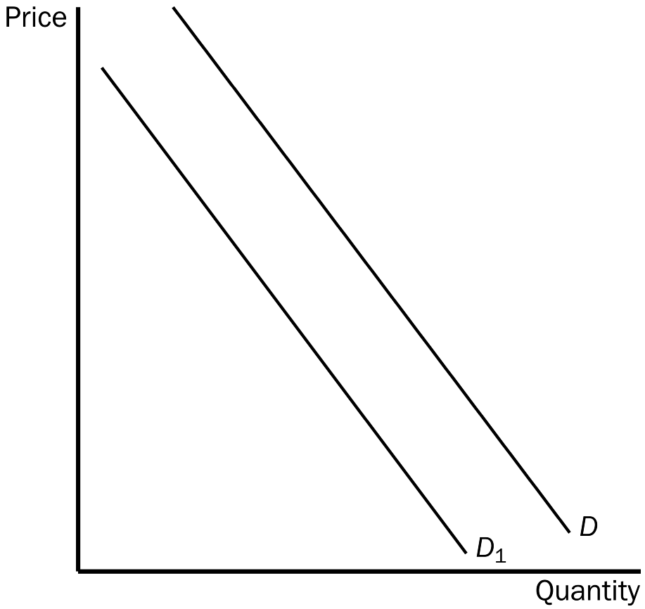
110. Refer to Figure 4-2. The shift from D to D₁ is called
a. an increase in demand.
b. a decrease in demand.
c. a decrease in quantity demanded.
d. an increase in quantity demanded.
ANS: B PTS: 1 DIF: 1 REF: 4-2
TOP: Demand MSC: Definitional
111. Refer to Figure 4-2. The movement from D to D₁ could be caused by
a. an increase in price.
b. a decrease in the price of a complement.
c. a technological advance.
d. a decrease in the price of a substitute.
ANS: D PTS: 1 DIF: 2 REF: 4-2
TOP: Demand | Substitutes MSC: Applicative
112. Refer to Figure 4-2. If the demand curve shifts from D to D₁, then
a. firms would be willing to supply less of the good than before at each possible price.
b. people are willing to buy less of the good than before at each possible price.
c. people’s incomes evidently have decreased.
d. the price of the product has increased, causing consumers to buy less of the product.
ANS: B PTS: 1 DIF: 2 REF: 4-2
TOP: Demand MSC: Interpretive
113. When quantity demanded decreases at every possible price, we know that the demand curve has
a. shifted to the left.
b. shifted to the right.
c. not shifted; rather, we have moved down the demand curve to a new point on the same curve.
d. not shifted; rather, the demand curve has become flatter.
ANS: A PTS: 1 DIF: 2 REF: 4-2
TOP: Demand MSC: Interpretive
114. When quantity demanded has increased at every price, it might be because
a. the number of buyers in the market has decreased.
b. income has increased and the good is an inferior good.
c. the costs incurred by sellers in producing the good have decreased.
d. the price of a complementary good has decreased.
ANS: D PTS: 1 DIF: 2 REF: 4-2
TOP: Demand | Complements MSC: Interpretive
115. The demand curve for textbooks shifts
a. when a determinant of the demand for textbooks other than income changes.
b. when a determinant of the demand for textbooks other than the price of textbooks changes.
c. when any determinant of the demand for textbooks changes.
d. only when the number of textbook-buyers changes.
ANS: B PTS: 1 DIF: 2 REF: 4-2
TOP: Demand | Shifts of curves MSC: Interpretive
116. The demand curve for hot dogs
a. shifts when the price of hot dogs changes, because the price of hot dogs is measured on the vertical axis of the graph.
b. shifts when the price of hot dogs changes, because the quantity demanded of hot dogs is measured on the horizontal axis of the graph.
c. does not shift when the price of hot dogs changes, because the price of hot dogs is measured on the vertical axis of the graph.
d. does not shift when the price of hot dogs changes, because the quantity demanded of hot dogs is measured on the horizontal axis of the graph.
ANS: C PTS: 1 DIF: 2 REF: 4-2
TOP: Demand | Shifts of curves MSC: Interpretive
117. Most studies indicate that tobacco and marijuana tend to be
a. substitutes.
b. complements.
c. not related since one is legal and one is illegal.
d. inferior goods.
ANS: B PTS: 1 DIF: 2 REF: 4-2
TOP: Complements MSC: Interpretive
118. The belief that tobacco is a “gateway drug” is consistent with
a. the idea that tobacco and marijuana are substitutes.
b. the idea that an increase in income causes a decrease in the demand for tobacco and an increase in the demand for marijuana.
c. the idea that lower cigarette prices are associated with less use of marijuana.
d. most of the available evidence.
ANS: D PTS: 1 DIF: 3 REF: 4-2
TOP: Complements MSC: Applicative
Figure 4-3
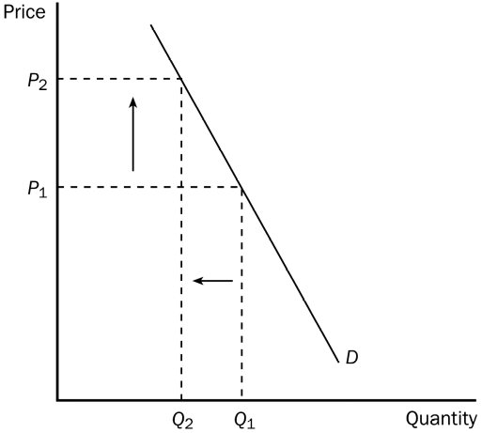
119. Refer to Figure 4-3. The graph shows the demand for cigarettes. The arrows are consistent with which of the following events?
a. The price of marijuana, a complement to cigarettes, increased.
b. Mandatory health warnings were placed on cigarette packages.
c. Several foreign countries banned U.S. cigarettes in their countries.
d. A tax was placed on cigarettes.
ANS: D PTS: 1 DIF: 3 REF: 4-2
TOP: Demand curve MSC: Applicative
120. Refer to Figure 4-3. The graph shows the demand for cigarettes. The arrows are consistent with which of the following events?
a. Tobacco and marijuana are complements and the price of marijuana decreased.
b. Tobacco is a “gateway drug” and the price of marijuana increased.
c. The price of cigarettes increased.
d. The arrows are consistent with all of these events.
ANS: C PTS: 1 DIF: 3 REF: 4-2
TOP: Demand curve MSC: Applicative
121. For teens, a 10 percent increase in the price of cigarettes leads to a
a. 6 percent drop in teenage smoking.
b. 12 percent drop in teenage smoking.
c. 18 percent drop in teenage smoking.
d. 24 percent drop in teenage smoking.
ANS: B PTS: 1 DIF: 2 REF: 4-2
TOP: Demand MSC: Definitional
122. For which of the following groups of people does a 10 percent increase in the price of cigarettes lead to a decrease in the quantity demanded of cigarettes that exceeds 10 percent?
a. women
b. teenagers
c. Southerners
d. the population as a whole
ANS: B PTS: 1 DIF: 2 REF: 4-2
TOP: Demand MSC: Definitional
123. The side of the market that deals with the willingness and ability to produce and sell is
a. demand.
b. competition.
c. supply.
d. monopoly.
ANS: C PTS: 1 DIF: 1 REF: 4-3
TOP: Supply MSC: Definitional
124. The relationship between price and quantity supplied is
a. negative.
b. positive.
c. the same as the relationship between price and quantity demanded.
d. not well understood by economists because laboratory-type experiments have not been conducted.
ANS: B PTS: 1 DIF: 1 REF: 4-3
TOP: Price | Quantity supplied MSC: Interpretive
125. According to the law of supply,
a. the quantity supplied of a good is negatively related to the price of the good.
b. when the price of a good falls, the quantity supplied of the good rises.
c. the supply curve for a good is upward-sloping.
d. All of the above are correct.
ANS: C PTS: 1 DIF: 1 REF: 4-3
TOP: Supply curve MSC: Definitional
126. Which of the following events would cause a movement upward and to the right along the supply curve for tomatoes?
a. The number of sellers of tomatoes increases.
b. There is an advance in technology that reduces the cost of producing tomatoes.
c. The price of fertilizer decreases, and fertilizer is an input in the production of tomatoes.
d. The price of tomatoes rises.
ANS: D PTS: 1 DIF: 1 REF: 4-3
TOP: Supply curve MSC: Interpretive
127. A decrease in the supply of televisions is represented by
a. a leftward shift of the supply curve for televisions.
b. a rightward shift of the supply curve for televisions.
c. a flattening of the supply curve for televisions.
d. a movement down and to the left along the supply curve for televisions.
ANS: A PTS: 1 DIF: 1 REF: 4-3
TOP: Shifts of curves MSC: Definitional
128. Which of the following events could cause an increase in the supply of ceiling fans?
a. The number of sellers of ceiling fans increases.
b. There is an increase in the price of air conditioners, and consumers regard air conditioners and ceiling fans as substitutes.
c. There is an increase in the price of the motor that powers ceiling fans.
d. All of the above are correct.
ANS: A PTS: 1 DIF: 2 REF: 4-3
TOP: Shifts of curves MSC: Interpretive
129. Other things equal, when the price of a good rises, the
a. quantity demanded of the good increases.
b. supply increases.
c. quantity supplied of the good increases.
d. demand curve shifts to the left.
ANS: C PTS: 1 DIF: 2 REF: 4-3
TOP: Price | Quantity supplied MSC: Interpretive
130. If the price of a good is low,
a. firms would increase profit by increasing output.
b. the quantity supplied of the good could be zero.
c. the supply curve for the good will shift to the left.
d. firms can and should raise the price of the product.
ANS: B PTS: 1 DIF: 2 REF: 4-3
TOP: Price | Quantity supplied MSC: Interpretive
131. The supply schedule is a table that shows the relationship between
a. price and quantity supplied.
b. input costs and quantity supplied.
c. quantity demanded and quantity supplied.
d. price and profit.
ANS: A PTS: 1 DIF: 1 REF: 4-3
TOP: Supply schedule MSC: Definitional
132. The difference between a supply schedule and a supply curve is that
a. a supply schedule incorporates demand and a supply curve does not.
b. a supply schedule incorporates prices of related goods and a supply curve does not.
c. a supply schedule can shift, but a supply curve cannot shift.
d. a supply schedule is a table and a supply curve is drawn on a graph.
ANS: D PTS: 1 DIF: 1 REF: 4-3
TOP: Supply schedule | Supply curve MSC: Definitional
133. A market supply curve is determined by
a. vertically summing individual supply curves.
b. horizontally summing individual supply curves.
c. finding the average quantity supplied by sellers at each possible price.
d. finding the average price at which sellers are willing and able to sell a particular quantity of the good.
ANS: B PTS: 1 DIF: 2 REF: 4-3
TOP: Market supply | Individual supply MSC: Interpretive
134. The market supply curve shows
a. the total quantity supplied at all possible prices.
b. the average quantity supplied by producers at all possible prices.
c. a ratio between price and quantity supplied for the market.
d. suppliers’ responses, in terms of the amounts they will supply, to the demands of buyers.
ANS: A PTS: 1 DIF: 1 REF: 4-3
TOP: Market supply MSC: Interpretive
135. For a seller, which of the following quantities are not positively related?
a. the price of the good and the seller's profit
b. the price of the good and quantity supplied
c. the seller's profit and production costs
d. the seller's profit and quantity supplied
ANS: C PTS: 1 DIF: 2 REF: 4-3
TOP: Supply | Positive relationships MSC: Applicative
136. The positive relationship between price and quantity supplied is called
a. profit.
b. a change in supply.
c. a shift of the supply curve.
d. the law of supply.
ANS: D PTS: 1 DIF: 1 REF: 4-3
TOP: Law of supply MSC: Definitional
137. The supply of a good is negatively related to the
a. price of inputs used to make the good.
b. demand for the good by consumers.
c. price of the good itself.
d. amount of profit a firm can expect to receive from selling the good.
ANS: A PTS: 1 DIF: 2 REF: 4-3
TOP: Supply | Inputs MSC: Interpretive
138. “Other things equal, when the price of a good rises, the quantity supplied of the good rises also.” This is a statement of the law of
a. increasing costs.
b. diminishing returns.
c. supply.
d. supply and demand.
ANS: C PTS: 1 DIF: 1 REF: 4-3
TOP: Law of supply MSC: Definitional
139. If the number of sellers in a market increases, the
a. demand in that market will increase.
b. supply in that market will increase.
c. supply in that market will decrease.
d. demand in that market will decrease.
ANS: B PTS: 1 DIF: 2 REF: 4-3
TOP: Supply MSC: Interpretive
140. A decrease in the number of sellers in the market causes
a. the supply curve to shift to the left.
b. the supply curve to shift to the right.
c. a movement up and to the right along a stationary supply curve.
d. a movement downward and to the left along a stationary supply curve.
ANS: A PTS: 1 DIF: 2 REF: 4-3
TOP: Supply MSC: Interpretive
141. Which of the following is a determinant of market supply curve but not a determinant of an individual seller’s supply?
a. technology
b. expectations
c. input prices
d. the number of sellers
ANS: D PTS: 1 DIF: 2 REF: 4-3
TOP: Market supply | Individual supply MSC: Interpretive
142. A movement along the supply curve might be caused by a change in
a. technology.
b. input prices.
c. expectations about future prices.
d. the price of the good or service that is being supplied.
ANS: D PTS: 1 DIF: 2 REF: 4-3
TOP: Supply MSC: Interpretive
143. Lead is an important input in the production of crystal. If the price of lead decreases, other things equal, we would expect the supply of
a. crystal to be unaffected.
b. crystal to decrease.
c. crystal to increase.
d. lead to increase.
ANS: C PTS: 1 DIF: 2 REF: 4-3
TOP: Supply | Inputs MSC: Applicative
144. Suppose you make jewelry. If the price of gold falls, we would expect you to
a. be willing and able to produce less jewelry than before at each possible price.
b. be willing and able to produce more jewelry than before at each possible price.
c. face a greater demand for your jewelry.
d. face a weaker demand for your jewelry.
ANS: B PTS: 1 DIF: 2 REF: 4-3
TOP: Supply | Inputs MSC: Applicative
145. A technological advance will shift the
a. supply curve to the right.
b. supply curve to the left.
c. demand curve to the right.
d. demand curve to the left.
ANS: A PTS: 1 DIF: 2 REF: 4-3
TOP: Supply | Technology MSC: Interpretive
146. An advance in production technology will
a. increase a firm's costs.
b. allow firms to raise the price of their product.
c. shift the supply curve to the right, but the demand curve will be unaffected.
d. shift the supply curve to the right and shift the demand curve to the right.
ANS: C PTS: 1 DIF: 2 REF: 4-3
TOP: Supply | Technology MSC: Interpretive
147. A dress manufacturer recently has come to expect higher prices for dresses in the near future. We would expect
a. the dress manufacturer to supply more dresses now than it was supplying previously.
b. the dress manufacturer to supply fewer dresses now than it was supplying previously.
c. the demand for this manufacturer's dresses to fall.
d. no change in the dress manufacturer's current supply; instead, future supply will be affected.
ANS: B PTS: 1 DIF: 2 REF: 4-3
TOP: Supply | Expectations MSC: Interpretive
148. Holding the nonprice determinants of supply constant, a change in price would
a. result in either a decrease in supply or an increase in supply.
b. result in a movement along a stationary supply curve.
c. result in a shift of demand.
d. have no effect on the quantity supplied.
ANS: B PTS: 1 DIF: 2 REF: 4-3
TOP: Supply MSC: Interpretive
149. A supply curve slopes upward because
a. as more is produced, total cost of production falls.
b. an increase in input prices increases supply.
c. the quantity supplied of most goods and services increases over time.
d. an increase in price gives producers an incentive to supply a larger quantity.
ANS: D PTS: 1 DIF: 2 REF: 4-3
TOP: Supply curve MSC: Interpretive
150. Which of the following events could shift both the demand curve and the supply curve for a good?
a. A technological advance pertaining to the production of the good is observed.
b. Incomes of all buyers of the good increase.
c. The number of sellers of the good increases.
d. Everyone revises upward their expectation of next month’s price of the good.
ANS: D PTS: 1 DIF: 2 REF: 4-3
TOP: Demand curve | Supply curve | Expectations MSC: Interpretive
151. An increase in the price of rubber coincides with an advance in the technology of tire production. As a result of these two events,
a. the demand for tires increases and the supply of tires decreases.
b. the supply of tires decreases and the demand for tires is unaffected.
c. the supply of tires increases and the demand for tires is unaffected.
d. none of the above is necessarily correct.
ANS: D PTS: 1 DIF: 3 REF: 4-3
TOP: Supply | Inputs | Technology MSC: Applicative
Figure 4-5
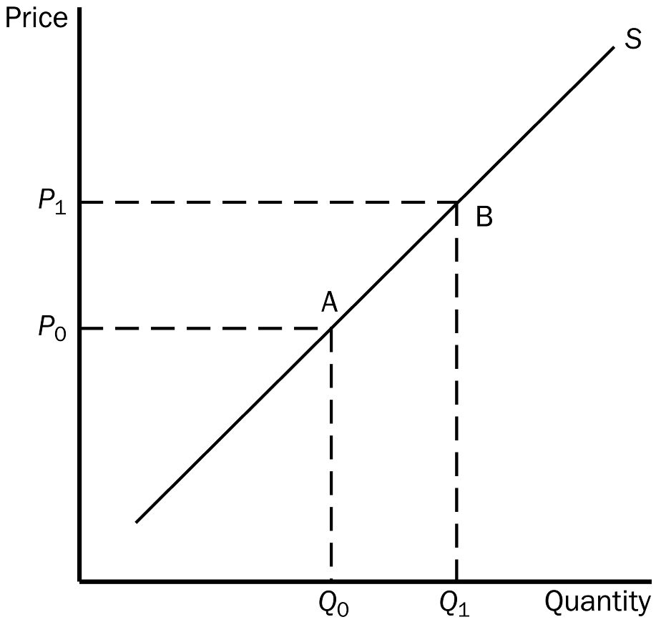
152. Refer to Figure 4-5. The movement from point A to point B on the graph would be caused by
a. a decrease in the price of the good.
b. an increase in the price of the good.
c. an advance in technology.
d. a decrease in input prices.
ANS: B PTS: 1 DIF: 2 REF: 4-3
TOP: Supply curve MSC: Interpretive
153. Refer to Figure 4-5. The movement from point A to point B on the graph is called
a. a decrease in supply.
b. an increase in supply.
c. an increase in the quantity supplied.
d. a decrease in the quantity supplied.
ANS: C PTS: 1 DIF: 1 REF: 4-3
TOP: Quantity supplied MSC: Definitional
154. Refer to Figure 4-5. The movement from point A to point B on the graph represents
a. an increased willingness and ability on the part of suppliers to supply the good at each possible price.
b. an increase in the number of suppliers.
c. a decrease in the price of a relevant input.
d. an increase in the price of the good that is being supplied and suppliers’ response to that price change.
ANS: D PTS: 1 DIF: 2 REF: 4-3
TOP: Supply curve MSC: Interpretive
155. In a market, to find the total amount supplied at a particular price,
a. we must add up all of the amounts that firms are willing and able to supply at that price.
b. we must take the average of the amounts that firms are willing and able to supply at that price.
c. the tastes and preferences of buyers must be established.
d. all determinants of demand must be taken into account.
ANS: A PTS: 1 DIF: 2 REF: 4-3
TOP: Market supply MSC: Interpretive
156. When we compare an increase in supply with an increase in quantity supplied, we know that
a. the former is depicted by a movement along the supply curve and the latter is depicted by a shift of the curve.
b. the former could be caused by a decrease in input costs and the latter would be caused by an increase in the price of the good.
c. both are always caused by a change in demand.
d. both are always caused by a change in the number of market participants.
ANS: B PTS: 1 DIF: 2 REF: 4-3
TOP: Supply | Shifts of curves MSC: Applicative
157. A leftward shift of a supply curve is called
a. an increase in supply.
b. a decrease in supply.
c. a decrease in quantity supplied.
d. an increase in quantity supplied.
ANS: B PTS: 1 DIF: 2 REF: 4-3
TOP: Supply | Shifts of curves MSC: Definitional
158. Workers at a bicycle assembly plant currently earn the mandatory minimum wage. If the federal government increases the minimum wage by $1.00 an hour it is likely that the
a. demand for bicycle assembly workers will increase.
b. supply of bicycles will shift to the right.
c. supply of bicycles will shift to the left.
d. firm must increase output to maintain profit levels.
ANS: C PTS: 1 DIF: 2 REF: 4-3
TOP: Supply | Inputs MSC: Applicative
159. If car manufacturers begin utilizing new labor-saving technology on their assembly lines, we would not expect
a. a smaller quantity of labor to be used.
b. the supply of cars to increase.
c. costs to the firm to fall.
d. individual car manufacturers to move up and to the right along their individual supply curves.
ANS: D PTS: 1 DIF: 2 REF: 4-3
TOP: Individual supply | Technology MSC: Applicative
160. Recent forest fires in the western states are expected to cause the price of lumber to rise in the next 6 months. As a result we can expect the supply of lumber to
a. fall in 6 months, but not now.
b. increase in 6 months when the price goes up.
c. fall now.
d. increase now to meet as much demand as possible.
ANS: C PTS: 1 DIF: 2 REF: 4-3
TOP: Supply | Expectations MSC: Applicative
161. If suppliers expect the price of their product to fall in the future they will
a. decrease supply now.
b. increase supply now.
c. decrease supply in the future but not now.
d. increase supply in the future but not now.
ANS: B PTS: 1 DIF: 2 REF: 4-3
TOP: Supply | Expectations MSC: Interpretive
162. Funsters, Inc., the largest toy company in the country, sells its most popular doll for $15. It has just learned that its leading competitor Toysorama is mass producing an excellent copy and plans to flood the market with their $5 doll in 6 weeks. Funsters should
a. “fight fire with fire” by decreasing supply of its doll for 6 weeks and then increasing the supply.
b. increase the supply of their doll now before the other doll hits the market.
c. increase the price of their doll now.
d. discontinue their doll.
ANS: B PTS: 1 DIF: 2 REF: 4-3
TOP: Supply | Expectations MSC: Applicative
163. Suppose there is an increase in steel prices. We would expect the supply curve for steel barrels
a. to shift rightward.
b. to shift leftward.
c. to become flatter.
d. to remain unchanged.
ANS: B PTS: 1 DIF: 2 REF: 4-3
TOP: Supply | Inputs MSC: Applicative
164. An increase in the price of a good would
a. increase the supply of the good.
b. increase the amount purchased by buyers.
c. give producers an incentive to produce more.
d. decrease both the quantity demanded of the good and the quantity supplied of the good.
ANS: C PTS: 1 DIF: 2 REF: 4-3
TOP: Price | Supply MSC: Interpretive
165. A decrease in the price of a good would
a. increase the supply of the good.
b. increase the quantity demanded of the good.
c. give producers an incentive to produce more to keep profits from falling.
d. shift the supply curve for the good to the left.
ANS: B PTS: 1 DIF: 2 REF: 4-3
TOP: Price | Supply | Quantity demanded MSC: Interpretive
166. Wheat is the main input in the production of flour. If the price of wheat decreases, all else equal, we would expect the
a. demand for flour to increase.
b. demand for flour to decrease.
c. supply of flour to increase.
d. supply of flour to decrease.
ANS: C PTS: 1 DIF: 2 REF: 4-3
TOP: Supply | Inputs MSC: Interpretive
167. An increase in the price of oranges would lead to
a. an increased supply of oranges.
b. a reduction in the prices of inputs used in orange production.
c. an increased demand for oranges.
d. a movement up and to the right along the supply curve for oranges.
ANS: D PTS: 1 DIF: 2 REF: 4-3
TOP: Price | Quantity supplied MSC: Interpretive
Figure 4-6
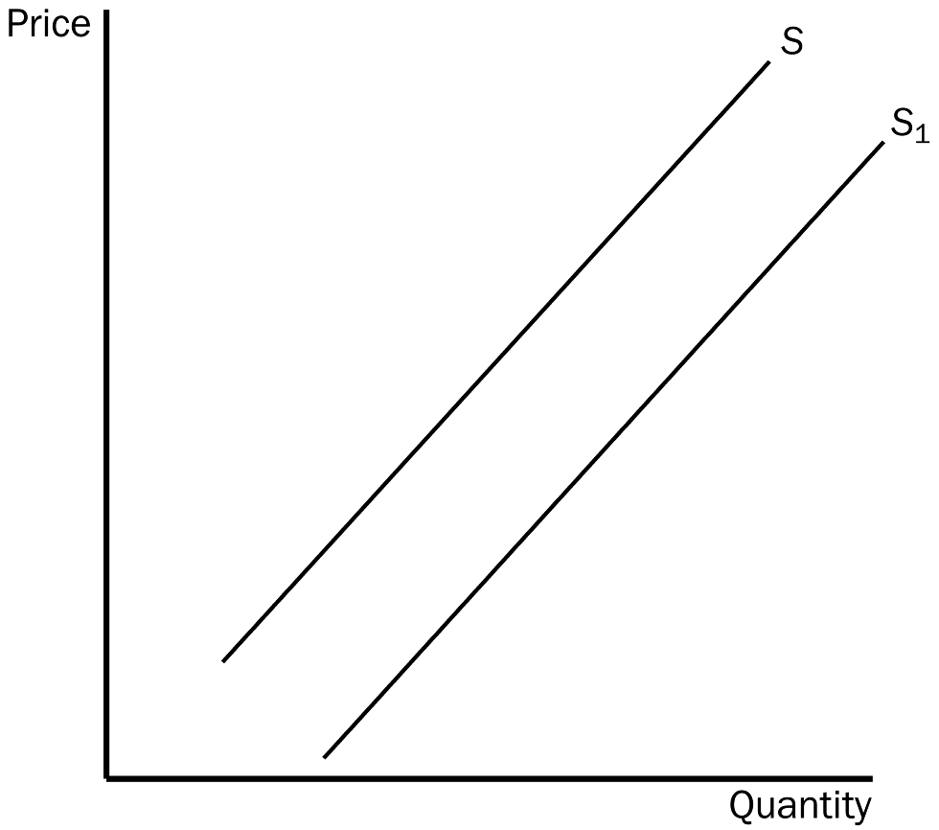
168. Refer to Figure 4-6. The movement from S to S₁ is called
a. a decrease in supply.
b. a decrease in quantity supplied.
c. an increase in supply.
d. an increase in quantity supplied.
ANS: C PTS: 1 DIF: 1 REF: 4-3
TOP: Supply MSC: Definitional
169. Refer to Figure 4-6. The movement from S to S₁ could be caused by
a. a decrease in the price of the good.
b. an improvement in technology.
c. an increase in income.
d. an increase in input prices.
ANS: B PTS: 1 DIF: 2 REF: 4-3
TOP: Supply curve | Technology MSC: Interpretive
170. Refer to Figure 4-6. Suppose the supply curves that are drawn represent supply curves for single-family residential houses. Then the movement from S to S₁ could be caused by
a. an increase in the price of apartments (a substitute for single-family houses for many people looking for a place to live).
b. a newly-formed expectation by house-builders that prices of houses will increase significantly in the next six months.
c. a decrease in the price of lumber.
d. All of the above are correct.
ANS: C PTS: 1 DIF: 3 REF: 4-3
TOP: Supply curve | Expectations | Inputs MSC: Applicative
1. The unique point at which the supply and demand curves intersect is called
a. market harmony.
b. coincidence.
c. cohesion.
d. equilibrium.
ANS: D PTS: 1 DIF: 1 REF: 4-4
TOP: Equilibrium MSC: Definitional
2. The dictionary defines equilibrium as a situation in which forces
a. balance.
b. are the same.
c. clash.
d. remain constant.
ANS: A PTS: 1 DIF: 1 REF: 4-4
TOP: Equilibrium MSC: Definitional
3. The price at which quantity supplied equals quantity demanded is called the
a. coordinating price.
b. monopoly price.
c. equilibrium price.
d. All of the above are correct.
ANS: C PTS: 1 DIF: 1 REF: 4-4
TOP: Equilibrium price MSC: Definitional
4. Another term for equilibrium price is
a. dynamic price.
b. market-clearing price.
c. quantity-defining price.
d. satisfactory price.
ANS: B PTS: 1 DIF: 1 REF: 4-4
TOP: Equilibrium price MSC: Definitional
5. If, at the current price, there is a shortage of a good,
a. sellers are producing more than buyers wish to buy.
b. the market must be in equilibrium.
c. the price is below the equilibrium price.
d. quantity demanded equals quantity supplied.
ANS: C PTS: 1 DIF: 2 REF: 4-4
TOP: Shortages MSC: Interpretive
6. A decrease in input costs to firms in a market will result in
a. a decrease in equilibrium price and an increase in equilibrium quantity.
b. a decrease in equilibrium price and a decrease in equilibrium quantity.
c. an increase in equilibrium price and no change in equilibrium quantity.
d. an increase in equilibrium price and an increase in equilibrium quantity.
ANS: A PTS: 1 DIF: 2 REF: 4-4
TOP: Equilibrium | Inputs MSC: Applicative
Figure 4-7
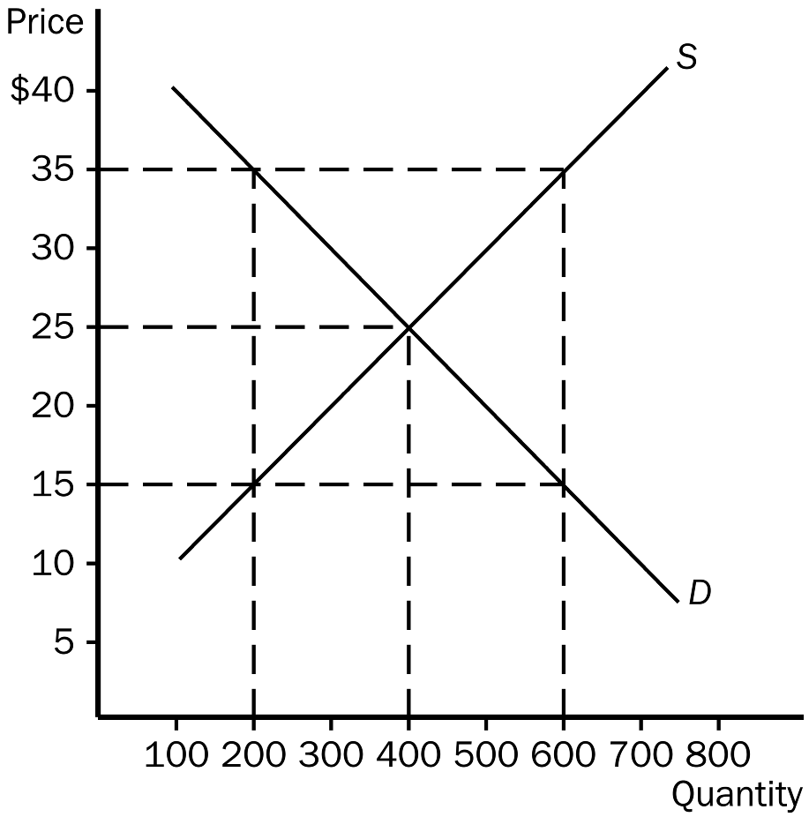
7. Refer to Figure 4-7. Equilibrium price and quantity are, respectively,
a. $35 and 200.
b. $35 and 600.
c. $25 and 400.
d. $15 and 200.
ANS: C PTS: 1 DIF: 1 REF: 4-4
TOP: Equilibrium MSC: Interpretive
8. Refer to Figure 4-7. At a price of $35,
a. there would be a shortage of 400 units.
b. there would be a surplus of 200 units.
c. there would be a surplus of 400 units.
d. there would be an excess supply of 200 units.
ANS: C PTS: 1 DIF: 2 REF: 4-4
TOP: Surpluses MSC: Interpretive
9. Refer to Figure 4-7. At a price of $15,
a. there would be a shortage of 400 units.
b. there would be a surplus of 400 units.
c. there would be a shortage of 200 units.
d. there would be an excess demand of 200 units.
ANS: A PTS: 1 DIF: 2 REF: 4-4
TOP: Shortages MSC: Interpretive
10. Refer to Figure 4-7. At the equilibrium price,
a. 200 units would be supplied and demanded.
b. 400 units would be supplied and demanded.
c. 600 units would be supplied and demanded.
d. 600 units would be supplied, but only 200 would be demanded.
ANS: B PTS: 1 DIF: 1 REF: 4-4
TOP: Equilibrium MSC: Interpretive
11. Refer to Figure 4-7. At a price of $35,
a. a shortage would exist and the price would tend to fall from $35 to a lower price.
b. a surplus would exist and the price would tend to rise from $35 to a higher price.
c. a surplus would exist and the price would tend to fall from $35 to a lower price.
d. an excess demand would exist and the price would tend to fall from $35 to a lower price.
ANS: C PTS: 1 DIF: 2 REF: 4-4
TOP: Shortages MSC: Applicative
12. Refer to Figure 4-7. At what price would there be an excess demand amounting to 200 units of the good?
a. $15
b. $20
c. $30
d. $35
ANS: B PTS: 1 DIF: 2 REF: 4-4
TOP: Shortages MSC: Applicative
13. Refer to Figure 4-7. At a price of $27.50,
a. there is an excess supply of 50 units of the good and the law of supply and demand predicts that the price will rise from $27.50 to a higher price.
b. there is an excess supply of 100 units of the good and the law of supply and demand predicts that the price will fall from $27.50 to a lower price.
c. there is an excess demand of 100 units of the good and the law of supply and demand predicts that the price will fall from $27.50 to a lower price.
d. there is a surplus of 75 units of the good and the law of supply predicts that the price will fall from $27.50 to a lower price.
ANS: B PTS: 1 DIF: 3 REF: 4-4
TOP: Surpluses | Law of supply and demand MSC: Applicative
Figure 4-8
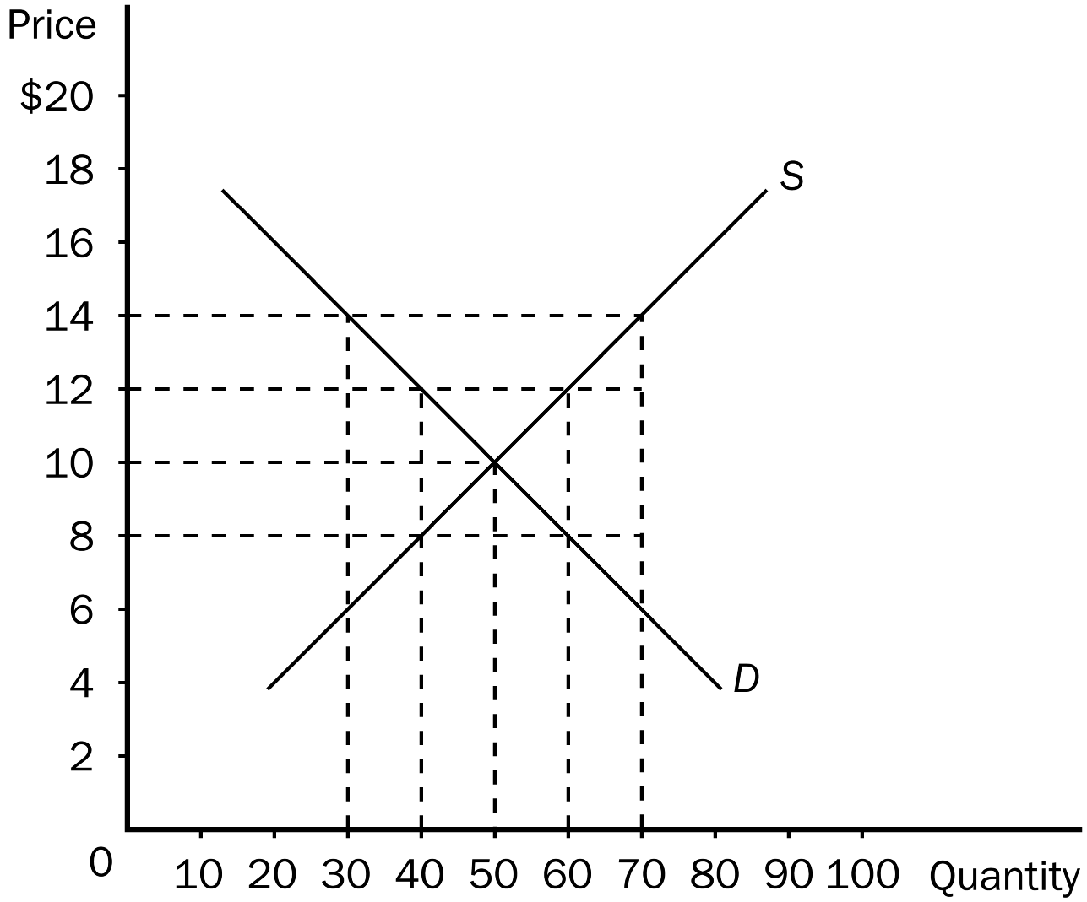
14. Refer to Figure 4-8. In this market, equilibrium price and quantity, respectively, are
a. $14 and 70.
b. $12 and 40.
c. $10 and 50.
d. $8 and 50.
ANS: C PTS: 1 DIF: 1 REF: 4-4
TOP: Equilibrium MSC: Interpretive
15. Refer to Figure 4-8. If price in this market is currently $14, there would be a
a. shortage of 20 units and the law of demand predicts that the price will rise from $14 to a higher price.
b. excess supply of 20 units and the law of supply and demand predicts that the price will fall from $14 to a lower price.
c. shortage of 40 units and the law of supply predicts that the price will fall from $14 to a lower price.
d. surplus of 40 units and the law of supply and demand predicts that the price will fall from $14 to a lower price.
ANS: D PTS: 1 DIF: 3 REF: 4-4
TOP: Surpluses | Law of supply and demand MSC: Applicative
16. Refer to Figure 4-8. If there is currently a shortage of 30 units of the good, then
a. the law of demand predicts that the price will rise by $5 to eliminate the shortage.
b. the law of supply predicts that the price will rise by $5 to eliminate the shortage.
c. the law of supply and demand predicts that the price will rise by $3 to eliminate the shortage.
d. the law of supply and demand predicts that the price will fall from its current level by an indeterminate amount, exacerbating the shortage.
ANS: C PTS: 1 DIF: 3 REF: 4-4
TOP: Shortages | Law of supply and demand MSC: Applicative
Table 4-2
PRICE | QUANTITY DEMANDED | QUANTITY SUPPLIED
$10 | 10 | 60
$ 8 | 20 | 45
$ 6 | 30 | 30
$ 4 | 40 | 15
$ 2 | 50 | 0

17. Refer to Table 4-2. The equilibrium price and quantity, respectively, are
a. $4 and 40.
b. $6 and 30.
c. $8 and 30.
d. $10 and 35.
ANS: B PTS: 1 DIF: 1 REF: 4-4
TOP: Equilibrium MSC: Interpretive
18. Refer to Table 4-2. If the price were $8, a
a. surplus of 50 units would exist and price would tend to fall.
b. surplus of 10 units would exist and price would tend to fall.
c. surplus of 25 units would exist and price would tend to fall.
d. shortage of 25 units would exist and price would tend to rise.
ANS: C PTS: 1 DIF: 2 REF: 4-4
TOP: Surpluses MSC: Interpretive
19. Refer to Table 4-2. If the price were $2, a
a. shortage of 25 units would exist and price would tend to fall.
b. surplus of 50 units would exist and price would tend to rise.
c. surplus of 25 units would exist and price would tend to fall.
d. shortage of 50 units would exist and price would tend to rise.
ANS: D PTS: 1 DIF: 2 REF: 4-4
TOP: Shortages MSC: Interpretive
Figure 4-9
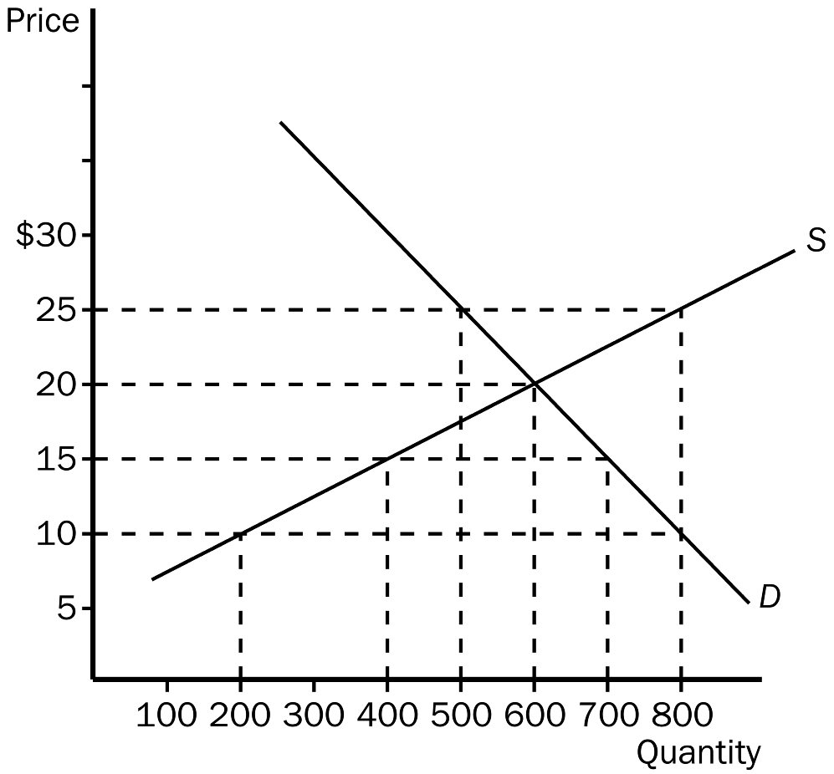
20. Refer to Figure 4-9. In this market, equilibrium price and quantity, respectively, are
a. $15 and 400.
b. $20 and 600.
c. $25 and 500.
d. $25 and 800.
ANS: B PTS: 1 DIF: 1 REF: 4-4
TOP: Equilibrium MSC: Interpretive
21. Refer to Figure 4-9. If price is $25, quantity demanded and quantity supplied, respectively, are
a. 400 and 600.
b. 500 and 800.
c. 600 and 600
d. 800 and 500.
ANS: B PTS: 1 DIF: 2 REF: 4-4
TOP: Surpluses MSC: Interpretive
22. Refer to Figure 4-9. If the price is $25, there would be an
a. excess supply of 300 and price would fall.
b. excess supply of 200 and price would fall.
c. shortage of 200 and price would rise.
d. shortage of 300 and price would fall.
ANS: A PTS: 1 DIF: 2 REF: 4-4
TOP: Surpluses MSC: Applicative
23. Refer to Figure 4-9. If the price is $10, there would be a
a. shortage of 200 and price would rise.
b. surplus of 200 and price would fall.
c. shortage of 600 and price would rise.
d. surplus of 600 and price would fall.
ANS: C PTS: 1 DIF: 2 REF: 4-4
TOP: Shortages MSC: Applicative
24. Refer to Figure 4-9. At a price of $15,
a. quantity demanded exceeds quantity supplied.
b. there is a shortage.
c. there is an excess demand.
d. All of the above are correct.
ANS: D PTS: 1 DIF: 2 REF: 4-4
TOP: Shortages MSC: Interpretive
25. Refer to Figure 4-9. At a price of $20, which of the following statements is not correct?
a. The market is in equilibrium.
b. Equilibrium price is equal to equilibrium quantity.
c. There is no pressure for price to change.
d. The quantity of the good that is bought and sold is 600.
ANS: B PTS: 1 DIF: 2 REF: 4-4
TOP: Equilibrium MSC: Interpretive
26. In markets, prices move toward equilibrium because of
a. the actions of buyers and sellers.
b. government regulations placed on market participants.
c. increased competition among sellers.
d. buyers' ability to affect market outcomes.
ANS: A PTS: 1 DIF: 2 REF: 4-4
TOP: Equilibrium price MSC: Interpretive
27. When the price of a good is higher than the equilibrium price,
a. a shortage will exist.
b. buyers desire to purchase more than is produced.
c. sellers desire to produce and sell more than buyers wish to purchase.
d. quantity demanded exceeds quantity supplied.
ANS: C PTS: 1 DIF: 2 REF: 4-4
TOP: Surpluses MSC: Interpretive
28. Suppose roses are currently selling for $40.00 per dozen, while the equilibrium price of roses is $30.00 per dozen. We would expect a
a. shortage to exist and the market price of roses to increase.
b. shortage to exist and the market price of roses to decrease.
c. surplus to exist and the market price of roses to increase.
d. surplus to exist and the market price of roses to decrease.
ANS: D PTS: 1 DIF: 2 REF: 4-4
TOP: Surpluses MSC: Applicative
29. When there is a shortage of 100 units of a particular good,
a. the law of supply predicts upward pressure on the price of the good from its current level.
b. the law of demand predicts downward pressure on the price of the good from its current level.
c. we say that there is a scarcity of 100 units of the good.
d. None of the above is correct.
ANS: D PTS: 1 DIF: 3 REF: 4-4
TOP: Shortages MSC: Interpretive
30. A surplus exists in a market if
a. there is an excess demand for the good.
b. the situation is such that the law of supply and demand would predict an increase in the price of the good from its current level.
c. the current price is above its equilibrium price.
d. None of the above is correct.
ANS: C PTS: 1 DIF: 2 REF: 4-4
TOP: Surpluses MSC: Interpretive
31. If a surplus exists in a market we know that the actual price is
a. above equilibrium price and quantity supplied is greater than quantity demanded.
b. above equilibrium price and quantity demanded is greater than quantity supplied.
c. below equilibrium price and quantity demanded is greater than quantity supplied.
d. below equilibrium price and quantity supplied is greater than quantity demanded.
ANS: A PTS: 1 DIF: 2 REF: 4-4
TOP: Surpluses | Equilibrium price MSC: Applicative
32. If excess demand exists in a market we know that the actual price is
a. below equilibrium price and quantity demanded is greater than quantity supplied.
b. above equilibrium price and quantity demanded is greater than quantity supplied.
c. above equilibrium price and quantity supplied is greater than quantity demanded.
d. below equilibrium price and quantity supplied is greater than quantity demanded.
ANS: A PTS: 1 DIF: 2 REF: 4-4
TOP: Shortages | Equilibrium price MSC: Applicative
33. Step one in the Three-Step program for analyzing changes in equilibrium is as follows:
a. Decide which direction the curve shifts.
b. Decide whether the event shifts the supply or demand curve.
c. Use the supply-and-demand diagram to see how the shift changes the equilibrium.
d. Any of these could be used first.
ANS: B PTS: 1 DIF: 1 REF: 4-4
TOP: Equilibrium MSC: Interpretive
34. You have been asked by your economics professor to graph the market for lumber and then to analyze the change that would occur in equilibrium price as a result of recent forest fires in the west. Your first step would be to
a. decide which direction to shift the curve.
b. decide whether the fires affected demand or supply.
c. graph the shift to see the affect on equilibrium.
d. None of the above are correct.
ANS: B PTS: 1 DIF: 2 REF: 4-4
TOP: Equilibrium MSC: Interpretive
Figure 4-10
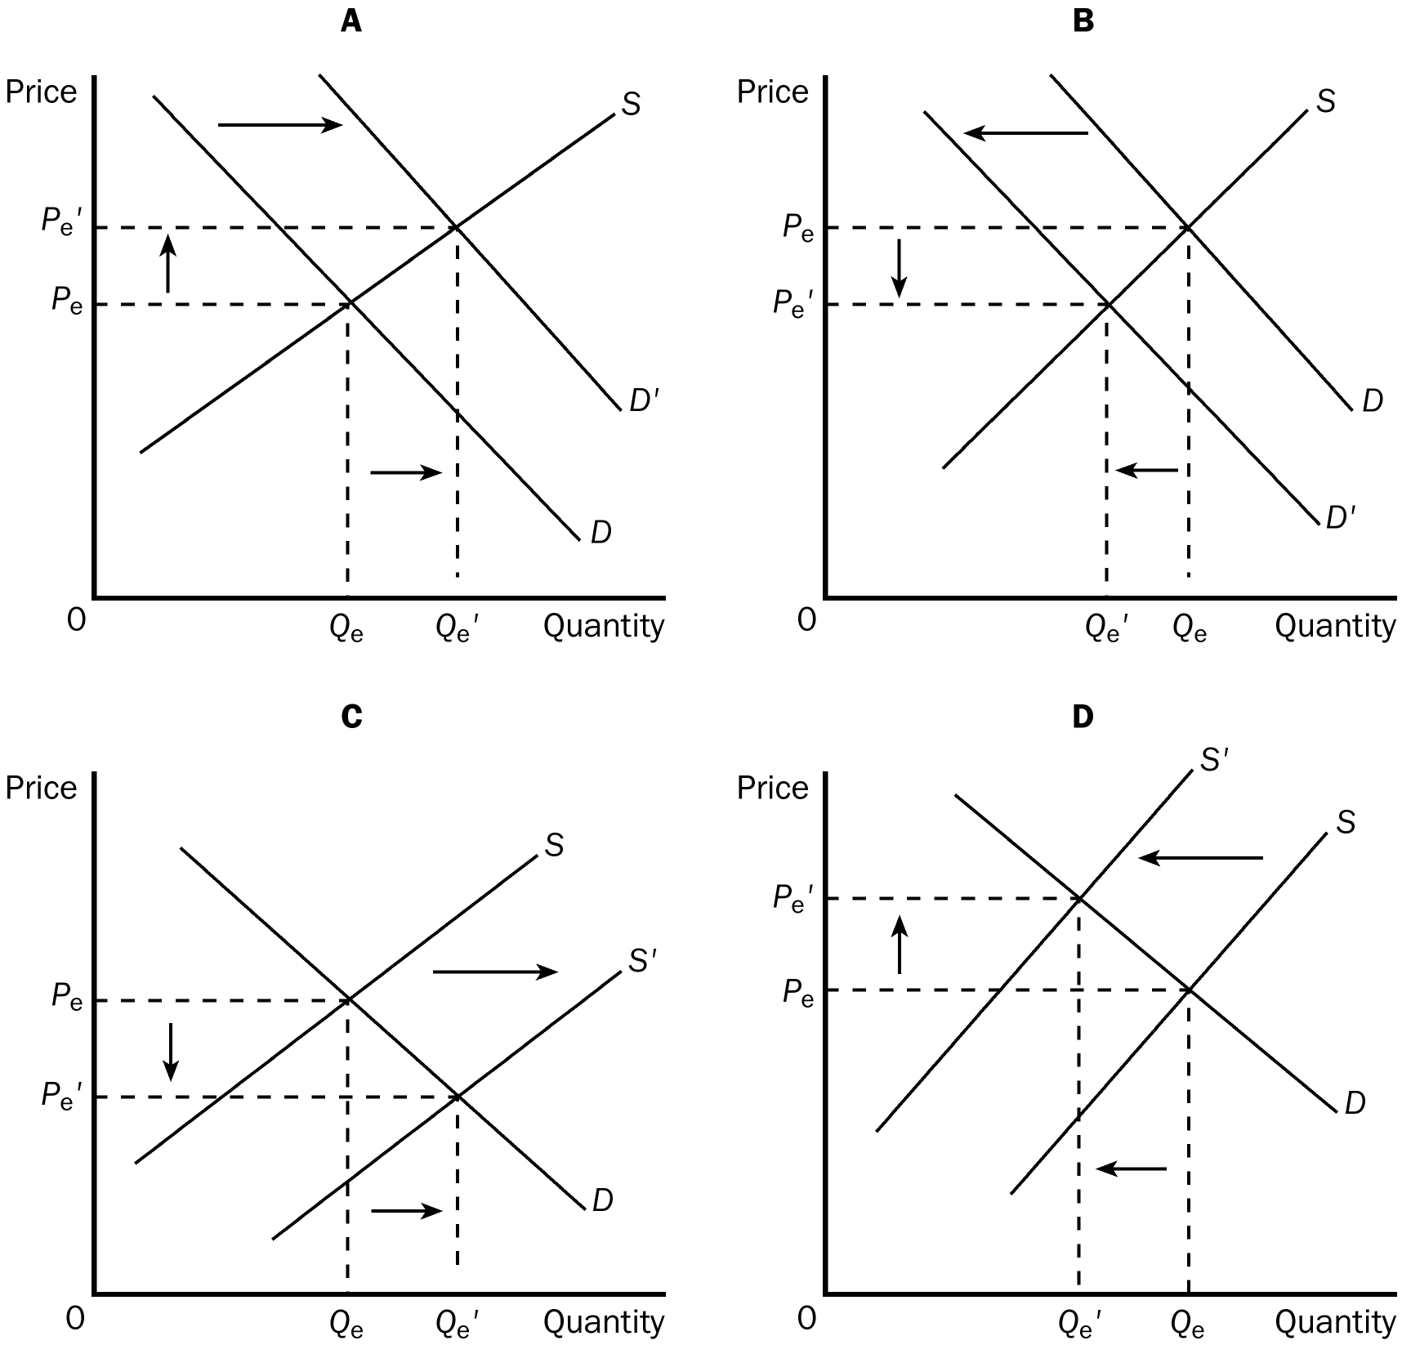
35. Refer to Figure 4-10. Which of the four graphs represents the market for peanut butter after a major hurricane hits the peanut-growing south?
a. A
b. B
c. C
d. D
ANS: D PTS: 1 DIF: 2 REF: 4-4
TOP: Equilibrium | Shifts of curves MSC: Applicative
36. Refer to Figure 4-10. Which of the four graphs represents the market for winter coats as we progress from winter to spring?
a. A
b. B
c. C
d. D
ANS: B PTS: 1 DIF: 2 REF: 4-4
TOP: Equilibrium | Shifts of curves MSC: Applicative
37. Refer to Figure 4-10. Which of the four graphs represents the market for pizza delivery in a college town as we go from summer to the beginning of the fall semester?
a. A
b. B
c. C
d. D
ANS: A PTS: 1 DIF: 2 REF: 4-4
TOP: Equilibrium | Shifts of curves MSC: Applicative
38. Refer to Figure 4-10. Which of the four graphs represents the market for cars as a result of the adoption of new technology on assembly lines?
a. A
b. B
c. C
d. D
ANS: C PTS: 1 DIF: 2 REF: 4-4
TOP: Equilibrium | Shifts of curves MSC: Applicative
39. Refer to Figure 4-10. Graph A shows which of the following?
a. an increase in demand and an increase in quantity supplied
b. an increase in demand and an increase in supply
c. an increase in quantity demanded and an increase in quantity supplied
d. an increase in supply and an increase in quantity demanded
ANS: A PTS: 1 DIF: 2 REF: 4-4
TOP: Demand | Quantity supplied MSC: Applicative
40. Refer to Figure 4-10. Graph C shows which of the following?
a. an increase in demand and an increase in quantity supplied
b. an increase in demand and an increase in supply
c. an increase in quantity demanded and an increase in quantity supplied
d. an increase in supply and an increase in quantity demanded
ANS: D PTS: 1 DIF: 2 REF: 4-4
TOP: Supply | Quantity demanded MSC: Applicative
41. Refer to Figure 4-10. Which of the four graphs illustrates an increase in quantity supplied?
a. A.
b. B.
c. C.
d. D.
ANS: A PTS: 1 DIF: 2 REF: 4-4
TOP: Quantity supplied MSC: Applicative
42. Refer to Figure 4-10. Which of the four graphs illustrates a decrease in quantity demanded?
a. A.
b. B.
c. C.
d. D.
ANS: D PTS: 1 DIF: 2 REF: 4-4
TOP: Quantity demanded MSC: Applicative
43. Refer to Figure 4-10. Suppose the events depicted in graphs A and C were illustrated together on a single graph. A definitive result of the two events would be
a. an increase in the equilibrium quantity.
b. an increase in the equilibrium price.
c. an instance in which the law of demand fails to hold.
d. All of the above are correct.
ANS: A PTS: 1 DIF: 2 REF: 4-4
TOP: Equilibrium | Demand | Supply MSC: Applicative
44. Suppose there is an earthquake that destroys several corn canneries. Which of the following would not be a direct result of this event?
a. Sellers would decrease their ability to produce and sell as much as before at each relevant price.
b. The supply would decrease.
c. Buyers would not be willing to buy as much as before at each relevant price.
d. The equilibrium price would rise.
ANS: C PTS: 1 DIF: 2 REF: 4-4
TOP: Equilibrium | Supply MSC: Applicative
45. If goods A and B are complements, then an increase in the price of good A will result in
a. more of good A being sold.
b. more of good B being sold.
c. less of good B being sold.
d. no difference in the quantity sold of either good.
ANS: C PTS: 1 DIF: 2 REF: 4-4
TOP: Complements MSC: Applicative
46. Holding all other things constant, a higher price for ski lift tickets would
a. increase the number of skiers.
b. increase the price of skis.
c. decrease the number of skis sold.
d. decrease the demand for other winter recreational activities.
ANS: C PTS: 1 DIF: 2 REF: 4-4
TOP: Complements MSC: Applicative
47. Which of the following events will definitely cause equilibrium quantity to fall?
a. demand increases and supply decreases
b. demand and supply both decrease
c. demand decreases and supply increases
d. demand and supply both increase
ANS: B PTS: 1 DIF: 2 REF: 4-4
TOP: Equilibrium | Demand | Supply MSC: Applicative
48. If the demand for a product increases, we would expect
a. equilibrium price to increase and equilibrium quantity to decrease.
b. equilibrium price to decrease and equilibrium quantity to increase.
c. equilibrium price and equilibrium quantity both to increase.
d. equilibrium price and equilibrium quantity both to decrease.
ANS: C PTS: 1 DIF: 2 REF: 4-4
TOP: Equilibrium price | Demand MSC: Interpretive
49. If the demand for a product decreases, we would expect
a. equilibrium price to increase and equilibrium quantity to decrease.
b. equilibrium price to decrease and equilibrium quantity to increase.
c. equilibrium price and equilibrium quantity to both increase.
d. equilibrium price and equilibrium quantity to both decrease.
ANS: D PTS: 1 DIF: 2 REF: 4-4
TOP: Equilibrium | Demand MSC: Interpretive
50. If the supply of a product increases, we would expect
a. equilibrium price to increase and equilibrium quantity to decrease.
b. equilibrium price to decrease and equilibrium quantity to increase.
c. equilibrium price and equilibrium quantity both to increase.
d. equilibrium price and equilibrium quantity both to decrease.
ANS: B PTS: 1 DIF: 2 REF: 4-4
TOP: Equilibrium | Supply MSC: Interpretive
51. If the supply of a product decreases, we would expect
a. equilibrium price to increase and equilibrium quantity to decrease.
b. equilibrium price to decrease and equilibrium quantity to increase.
c. equilibrium price and equilibrium quantity both to increase.
d. equilibrium price and equilibrium quantity both to decrease.
ANS: A PTS: 1 DIF: 2 REF: 4-4
TOP: Equilibrium | Supply MSC: Interpretive
52. Suppose the number of buyers in a market increases and a technological advancement occurs also. What would we expect to happen in the market?
a. The equilibrium price would increase, but the impact on the amount sold in the market would be ambiguous.
b. The equilibrium price would decrease, but the impact on the amount sold in the market would be ambiguous.
c. Equilibrium quantity would increase, but the impact on equilibrium price would be ambiguous.
d. Both equilibrium price and equilibrium quantity would increase.
ANS: C PTS: 1 DIF: 3 REF: 4-4
TOP: Equilibrium | Demand | Supply MSC: Applicative
53. Suppose that demand decreases and supply decreases. What would you expect to occur in the market for the good?
a. Equilibrium price would increase, but the impact on equilibrium quantity would be ambiguous.
b. Equilibrium price would decrease, but the impact on equilibrium quantity would be ambiguous.
c. Equilibrium quantity would decrease, but the impact on equilibrium price would be ambiguous.
d. Both equilibrium price and equilibrium quantity would increase.
ANS: C PTS: 1 DIF: 2 REF: 4-4
TOP: Equilibrium | Demand | Supply MSC: Interpretive
54. Which of the following events would result in an increase in equilibrium price and an ambiguous change in equilibrium quantity?
a. an increase in supply and an increase in demand
b. an increase in supply and a decrease in demand
c. a decrease in supply and an increase in demand
d. a decrease in supply and a decrease in demand
ANS: C PTS: 1 DIF: 2 REF: 4-4
TOP: Equilibrium | Demand | Supply MSC: Applicative
55. Suppose that a decrease in the price of good X results in fewer units of good Y being sold. This implies that X and Y are
a. complementary goods.
b. normal goods.
c. inferior goods.
d. substitute goods.
ANS: D PTS: 1 DIF: 3 REF: 4-4
TOP: Substitutes MSC: Applicative
56. A weaker demand together with a stronger supply would necessarily result in
a. a lower price.
b. a higher price.
c. an increase in equilibrium quantity.
d. a decrease in equilibrium quantity.
ANS: A PTS: 1 DIF: 2 REF: 4-4
TOP: Equilibrium | Demand | Supply MSC: Applicative
57. Which of the following events would cause the price of oranges to fall?
a. There is a shortage of oranges.
b. An article is published in which it is claimed that tangerines cause a serious disease, and oranges and tangerines are substitutes.
c. The price of land throughout Florida decreases, and Florida produces a significant proportion of the nation’s oranges.
d. All of the above are correct.
ANS: C PTS: 1 DIF: 2 REF: 4-4
TOP: Equilibrium price MSC: Applicative
58. Which of the following quantities would increase in response to a decrease in the price of ironing boards?
a. the quantity of irons demanded at each possible price of irons
b. the equilibrium quantity of irons
c. the equilibrium price of irons
d. All of the above are correct.
ANS: D PTS: 1 DIF: 2 REF: 4-4
TOP: Complements MSC: Applicative
Table 4-3. The demand schedule below pertains to sandwiches demanded per week.

 | Price | Quantity  Demanded
Alfred | $3.00 | 3
Alfred | $5.00 | 1
Belinda | $3.00 | 4
Belinda | $5.00 | 2
Charissa | $3.00 | 3
Charissa | $5.00 | x

59. Refer to Table 4-3. Regarding Alfred and Belinda, whose demand for sandwiches conforms to the law of demand?
a. only Alfred’s
b. only Belinda’s
c. both Alfred’s and Belinda’s
d. neither Alfred’s nor Belinda’s
ANS: C PTS: 1 DIF: 2 REF: 4-4
TOP: Law of demand MSC: Applicative
60. Refer to Table 4-3. Regarding Alfred and Belinda, for whom are sandwiches a normal good?
a. only for Alfred
b. only for Bellinda
c. for Alfred and for Belinda
d. This cannot be determined from the given information.
ANS: D PTS: 1 DIF: 2 REF: 4-4
TOP: Normal goods MSC: Applicative
61. Refer to Table 4-3. Suppose x = 1. Then it must be true that
a. Alfred and Charissa have the same income, which is lower than Belinda’s income.
b. if sandwiches and potato chips are complements for Alfred, then those two goods are also complements for Charissa.
c. Alfred’s demand curve is identical to Charissa’s demand curve.
d. All of the above are correct.
ANS: C PTS: 1 DIF: 2 REF: 4-4
TOP: Demand curve MSC: Applicative
62. Refer to Table 4-3. Suppose x = 1. Then the slope of the market demand curve is
a. -1/3.
b. -1/2.
c. -2.
d. -3.
ANS: A PTS: 1 DIF: 2 REF: 4-4
TOP: Market demand curve MSC: Applicative
63. Refer to Table 4-3. Suppose Alfred, Belinda, and Charissa are the only demanders of sandwiches. Also suppose x = 2. Then
a. the slope of Charissa’a demand curve is -1/2 and the slope of the market demand curve is -5/2.
b. the slope of Charissa’a demand curve is -1/2 and the slope of the market demand curve is -2/5
c. the slope of Charissa’a demand curve is -2 and the slope of the market demand curve is -5/2.
d. the slope of Charissa’a demand curve is -2 and the slope of the market demand curve is -2/5.
ANS: D PTS: 1 DIF: 2 REF: 4-4
TOP: Individual demand | Market demand MSC: Applicative
64. Refer to Table 4-3. Suppose Alfred, Belinda, and Charissa are the only demanders of sandwiches and that the market demand violates the law of demand. Then, in the table,
a. x < 5.
b. x > 5.
c. x > 7.
d. x > 10.
ANS: C PTS: 1 DIF: 2 REF: 4-4
TOP: Market demand MSC: Applicative
65. Refer to Table 4-3. Suppose Alfred, Belinda, and Charissa are the only demanders of sandwiches. Also suppose:
• x = 2;
• the current price of a sandwich is $5.00;
• the market quantity supplied of sandwiches is 10;
• the law of supply applies to the supply of sandwiches.
Then
a. there is a shortage of 3 sandwiches and the price would be expected to rise from its current level of $5.00.
b. there is a shortage of 3 sandwiches and the price would be expected to fall from its current level of $5.00.
c. there is a surplus of 5 sandwiches and the price would be expected to rise from its current level of $5.00.
d. there is a surplus of 5 sandwiches and the price would be expected to fall from its current level of $5.00.
ANS: D PTS: 1 DIF: 2 REF: 4-4
TOP: Surpluses MSC: Applicative
66. Refer to Table 4-3. Suppose Alfred, Belinda, and Charissa are the only demanders of sandwiches. Also suppose:
• x = 2;
• the current price of a sandwich is $3.00;
• the market quantity supplied of sandwiches is 4;
• the slope of the supply curve is 2.
Then
a. there is currently a shortage of 6 sandwiches and the equilibrium price of a sandwich is between $3.00 and $5.00.
b. there is currently a shortage of 6 sandwiches and the equilibrium price of a sandwich is $5.00.
c. there is currently a shortage of 8 sandwiches and the equilibrium price of a sandwich is between $3.00 and $5.00.
d. there is currently a shortage of 8 sandwiches and the equilibrium price of a sandwich is higher than $5.00.
ANS: B PTS: 1 DIF: 3 REF: 4-4
TOP: Equilibrium MSC: Analytical
67. Refer to Table 4-3. Suppose Alfred, Belinda, and Charissa are the only demanders of sandwiches. Also suppose:
• x = 2;
• the current price of a sandwich is $3.00;
• the market quantity supplied of sandwiches is 5;
• the slope of the supply curve is 1.
Then
a. there is currently a shortage of 5 sandwiches and the equilibrium price of a sandwich is between $3.00 and $5.00.
b. there is currently a shortage of 5 sandwiches and the equilibrium price of a sandwich is $5.00.
c. there is currently a shortage of 7 sandwiches and the equilibrium price of a sandwich is between $3.00 and $5.00.
d. there is currently a shortage of 7 sandwiches and the equilibrium price of a sandwich is higher than $5.00.
ANS: A PTS: 1 DIF: 3 REF: 4-4
TOP: Equilibrium MSC: Analytical
68. In a given market, how are the equilibrium price and the market-clearing price related?
a. There is no relationship.
b. They are the same price.
c. The market-clearing price exceeds the equilibrium price.
d. The equilibrium price exceeds the market-clearing price.
ANS: B PTS: 1 DIF: 1 REF: 4-4
TOP: Equilibrium price MSC: Definitional
69. The current price of neckties is $30 and the equilibrium price of neckties is $25. As a result,
a. the quantity supplied of neckties exceeds the quantity demanded of neckties at the $30 price.
b. the equilibrium quantity of neckties exceeds the quantity demanded at the $30 price.
c. There is a surplus of neckties at the $30 price.
d. All of the above are correct.
ANS: D PTS: 1 DIF: 2 REF: 4-4
TOP: Equilibrium | Surpluses MSC: Interpretive
70. The law of supply and demand asserts that
a. demand curves and supply curves tend to shift to the right as time goes by.
b. the price of a good will eventually rise in response to an excess demand for that good.
c. when the supply curve for a good shifts, the demand curve for that good shifts in response.
d. the equilibrium price of a good will be rising more often than it will be falling.
ANS: B PTS: 1 DIF: 2 REF: 4-4
TOP: Law of supply and demand MSC: Interpretive
71. Suppose buyers of computers and printers regard those two goods as complements. Then an increase in the price of computers will cause
a. a decrease in the demand for printers and a decrease in the quantity supplied of printers.
b. a decrease in the supply of printers and a decrease in the quantity demanded of printers.
c. a decrease in the equilibrium price of printers and an increase in the equilibrium quantity of printers.
d. an increase in the equilibrium price of printers and a decrease in the equilibrium quantity of printers.
ANS: A PTS: 1 DIF: 2 REF: 4-4
TOP: Complements | Equilibrium MSC: Applicative
72. During the last few decades in the United States, health officials have argued that eating too much beef might be harmful to human health. As a result, there has been a significant decrease in the amount of beef produced. Which of the following best explains the decrease in production?
a. Beef producers, concerned about the health of their customers, decided to produce relatively less beef.
b. Government officials, concerned about consumer health, ordered beef producers to produce relatively less beef.
c. Individual consumers, concerned about their own health, decreased their demand for beef, which lowered the relative price of beef, making it less attractive to produce.
d. Anti-beef protesters have made it difficult for both buyers and sellers of beef to meet in the marketplace.
ANS: C PTS: 1 DIF: 2 REF: 4-4
TOP: Equilibrium | Demand | Supply MSC: Applicative
73. What will happen to the equilibrium price and quantity of traditional camera film if traditional cameras become more expensive, digital cameras become cheaper, the cost of the resources needed to manufacture traditional film falls and more firms decide to manufacture traditional film?
a. Price will fall and the effect on quantity is ambiguous.
b. Price will rise and the effect on quantity is ambiguous.
c. Quantity will fall and the effect on price is ambiguous.
d. The effect on both price and quantity is ambiguous.
ANS: A PTS: 1 DIF: 3 REF: 4-4
TOP: Equilibrium | Demand | Supply MSC: Analytical
74. Which of the following events would result in an increase in equilibrium price and an ambiguous change in equilibrium quantity?
a. an increase in supply and an increase in demand
b. an increase in supply and a decrease in demand
c. a decrease in supply and an increase in demand
d. a decrease in supply and a decrease in demand
ANS: C PTS: 1 DIF: 2 REF: 4-4
TOP: Equilibrium | Demand | Supply MSC: Applicative
75. Good X and good Y are substitutes. If the price of good Y increases, then the
a. demand for good X will decrease.
b. market price of good X will decrease.
c. demand for good X will increase.
d. quantity demanded of good X will increase.
ANS: C PTS: 1 DIF: 2 REF: 4-4
TOP: Substitutes MSC: Interpretive
76. Suppose that a decrease in the price of good X results in fewer units of good Y being sold. This implies that X and Y are
a. complementary goods.
b. normal goods.
c. inferior goods.
d. substitute goods.
ANS: D PTS: 1 DIF: 3 REF: 4-4
TOP: Substitutes MSC: Applicative
77. When supply and demand both increase, equilibrium
a. price will increase.
b. price will decrease.
c. quantity may increase, decrease, or remain unchanged.
d. price may increase, decrease, or remain unchanged.
ANS: D PTS: 1 DIF: 2 REF: 4-4
TOP: Equilibrium | Demand | Supply MSC: Applicative
78. If there is a shortage of farm laborers, we would expect
a. the wages of farm laborers to increase.
b. the wages of farm laborers to decrease.
c. the prices of farm commodities to decrease.
d. a decrease in the demand for substitutes for farm labor.
ANS: A PTS: 1 DIF: 2 REF: 4-4
TOP: Shortages MSC: Applicative
79. Which of the following events would cause both the equilibrium price and equilibrium quantity of number two grade potatoes (an inferior good) to increase?
a. an increase in consumer income
b. a decrease in consumer income
c. greater government restrictions on agricultural chemicals
d. fewer government restrictions on agricultural chemicals
ANS: B PTS: 1 DIF: 3 REF: 4-4
TOP: Equilibrium price | Equilibrium quantity | Inferior goods MSC: Applicative
80. Which of the following events would unambiguously cause a decrease in the equilibrium price of cotton shirts?
a. an increase in the price of wool shirts and a decrease in the price of raw cotton
b. a decrease in the price of wool shirts and a decrease in the price of raw cotton
c. an increase in the price of wool shirts and an increase in the price of raw cotton
d. a decrease in the price of wool shirts and an increase in the price of raw cotton
ANS: B PTS: 1 DIF: 3 REF: 4-4
TOP: Equilibrium | Demand | Price MSC: Applicative
Table 4-4
 | An Increase in Supply | A Decrease in Supply
An Increase in Demand | A | B
A Decrease in Demand | C | D

81. Refer to Table 4-4. Which space represents an increase in equilibrium quantity and an indeterminate change in equilibrium price?
a. A.
b. B.
c. C.
d. D.
ANS: A PTS: 1 DIF: 2 REF: 4-4
TOP: Equilibrium | Demand | Supply MSC: Applicative
82. Refer to Table 4-4. Which space represents an increase in equilibrium price and an indeterminate change in equilibrium quantity?
a. A.
b. B.
c. C.
d. D.
ANS: B PTS: 1 DIF: 2 REF: 4-4
TOP: Equilibrium | Demand | Supply MSC: Applicative
83. Refer to Table 4-4. Which space represents a decrease in equilibrium price and an indeterminate change in equilibrium quantity?
a. A.
b. B.
c. C.
d. D.
ANS: C PTS: 1 DIF: 2 REF: 4-4
TOP: Equilibrium | Demand | Supply MSC: Applicative
84. Refer to Table 4-4. Which space represents a decrease in equilibrium quantity and an indeterminate change in equilibrium price?
a. A.
b. B.
c. C.
d. D.
ANS: D PTS: 1 DIF: 2 REF: 4-4
TOP: Equilibrium | Demand | Supply MSC: Applicative
85. What would happen to the equilibrium price and quantity of coffee if the wages of coffee-bean pickers fell and the price of tea fell?
a. Price will fall and the effect on quantity is ambiguous.
b. Price will rise and the effect on quantity is ambiguous.
c. Quantity will fall and the effect on price is ambiguous.
d. Quantity will rise and the effect on price is ambiguous.
ANS: A PTS: 1 DIF: 3 REF: 4-4
TOP: Equilibrium | Demand | Supply MSC: Applicative
86. New oak tables are normal goods. What would happen to the equilibrium price and quantity in the market for oak tables if the price of maple tables rises, the price of oak wood rises, more buyers enter the market for oak tables and the price of wood saws increased?
a. Price will fall and the effect on quantity is ambiguous.
b. Price will rise and the effect on quantity is ambiguous.
c. Quantity will fall and the effect on price is ambiguous.
d. Quantity will rise and the effect on price is ambiguous.
ANS: B PTS: 1 DIF: 3 REF: 4-4
TOP: Equilibrium | Demand | Supply MSC: Analytical
87. What will happen to the equilibrium price and quantity of new cars if the price of gasoline rises, the price of steel rises, public transportation becomes cheaper and more comfortable, and auto-workers negotiate higher wages?
a. Price will fall and the effect on quantity is ambiguous.
b. Price will rise and the effect on quantity is ambiguous.
c. Quantity will fall and the effect on price is ambiguous.
d. Quantity will rise and the effect on price is ambiguous.
ANS: C PTS: 1 DIF: 3 REF: 4-4
TOP: Equilibrium | Demand | Supply MSC: Analytical
88. Music compact discs are normal goods. What will happen to the equilibrium price and quantity of music compact discs if musicians accept lower royalties, compact disc players become cheaper, more firms start producing music compact discs and music lovers experience an increase in income?
a. Price will fall and the effect on quantity is ambiguous.
b. Price will rise and the effect on quantity is ambiguous.
c. Quantity will fall and the effect on price is ambiguous.
d. Quantity will rise and the effect on price is ambiguous.
ANS: D PTS: 1 DIF: 3 REF: 4-4
TOP: Equilibrium | Demand | Supply MSC: Analytical
89. New cars are normal goods. What will happen to the equilibrium price of new cars if the price of gasoline rises, the price of steel falls, public transportation becomes cheaper and more comfortable, auto-workers accept lower wages and automobile insurance becomes more expensive?
a. Price will rise.
b. Price will fall.
c. Price will stay exactly the same.
d. The price change will be ambiguous.
ANS: B PTS: 1 DIF: 3 REF: 4-4
TOP: Equilibrium | Demand | Supply MSC: Analytical
90. What will happen to the equilibrium price of new textbooks if more students attend college, paper becomes cheaper, textbook authors accept lower royalties and fewer used textbooks are sold?
a. Price will rise.
b. Price will fall.
c. Price will stay exactly the same.
d. The price change will be ambiguous.
ANS: D PTS: 1 DIF: 3 REF: 4-4
TOP: Equilibrium | Demand | Supply MSC: Analytical
91. Consider the market for new DVDs. If DVD players became cheaper, buyers expected DVD prices to fall next year, used DVDs became more expensive, and DVD production technology improved, then we could safely conclude that the equilibrium price of a new DVD would
a. rise.
b. fall.
c. stay the same.
d. We couldn't be sure what it might do.
ANS: D PTS: 1 DIF: 3 REF: 4-4
TOP: Equilibrium | Demand | Supply MSC: Analytical
92. What would happen to the equilibrium price and quantity of peanut butter if the price of peanuts went up, the price of jelly (a complementary good) fell, fewer firms decided to produce peanut butter, and health officials announced that eating peanut butter was good for you?
a. Price will fall and the effect on quantity is ambiguous.
b. Price will rise and the effect on quantity is ambiguous.
c. Quantity will fall and the effect on price is ambiguous.
d. The effect on both price and quantity is ambiguous.
ANS: B PTS: 1 DIF: 3 REF: 4-4
TOP: Equilibrium | Demand | Supply MSC: Analytical
93. Pens are normal goods. What will happen to the equilibrium price of pens if the price of pencils rises, consumers experience an increase in income, writing in ink becomes fashionable, people expect the price of pens to rise in the near future, the population increases, fewer firms manufacture pens, and the wages of pen-makers increase?
a. Price will rise.
b. Price will fall.
c. Price will stay exactly the same.
d. The price change will be ambiguous.
ANS: A PTS: 1 DIF: 3 REF: 4-4
TOP: Equilibrium | Demand | Supply MSC: Analytical
94. Pens are normal goods. What will happen to the equilibrium price of pens if the price of pencils rises, consumers experience an increase in income, writing in ink becomes fashionable, people expect the price of pens to fall in the near future, the population increases, fewer firms manufacture pens, and the wages of pen-makers decrease?
a. Price will rise.
b. Price will fall.
c. Price will stay exactly the same.
d. The price change will be ambiguous.
ANS: D PTS: 1 DIF: 3 REF: 4-4
TOP: Equilibrium | Demand | Supply MSC: Analytical
95. Beef is a normal good. You observe that both the equilibrium price and quantity of beef have fallen over time. Which of the following explanations would be most consistent with this observation?
a. Consumers have experienced an increase in income and beef-production technology has improved.
b. The price of chicken has risen and the price of steak sauce has fallen.
c. New medical evidence has been released that indicates a negative correlation between a person’s beef consumption and his or her longevity.
d. The demand curve for beef must be positively sloped.
ANS: C PTS: 1 DIF: 3 REF: 4-4
TOP: Equilibrium | Demand MSC: Applicative
96. Which of the following sets of events would most likely cause an increase in the price of a new house?
a. higher wages for carpenters, higher wood prices, increases in consumer incomes, higher apartment rents, increases in population and expectations of higher house prices in the future
b. lower wages for carpenters, lower wood prices, increases in consumer incomes, higher apartment rents, increases in population and expectations of higher house prices in the future
c. lower wages for carpenters, higher wood prices, decreases in consumer incomes, higher apartment rents, decreases in population and expectations of higher house prices in the future
d. higher wages for carpenters, lower wood prices, decreases in consumer incomes, lower apartment rents, decreases in population and expectations of lower house prices in the future
ANS: A PTS: 1 DIF: 3 REF: 4-4
TOP: Equilibrium | Demand | Supply MSC: Analytical
97. Suppose that demand for a good increases and, at the same time, supply of the good decreases. What would happen in the market for the good?
a. Equilibrium price would decrease, but the impact on equilibrium quantity would be ambiguous.
b. Equilibrium price would increase, but the impact on equilibrium quantity would be ambiguous.
c. Both equilibrium price and quantity would increase.
d. Both equilibrium price and quantity would decrease.
ANS: B PTS: 1 DIF: 2 REF: 4-4
TOP: Equilibrium | Supply | Demand MSC: Applicative
98. Suppose the incomes of buyers in a market for a particular normal good decrease and there is also a reduction in input prices. What would we expect to occur in this market?
a. The equilibrium price would increase, but the impact on the amount sold in the market would be ambiguous.
b. The equilibrium price would decrease, but the impact on the amount sold in the market would be ambiguous.
c. Both equilibrium price and equilibrium quantity would increase.
d. Equilibrium quantity would increase, but the impact on equilibrium price would be ambiguous.
ANS: B PTS: 1 DIF: 2 REF: 4-4
TOP: Equilibrium | Demand | Supply MSC: Applicative
99. Which of the following events would definitely result in a higher price in the market for Snickers?
a. Demand for Snickers increases and supply of Snickers decreases.
b. Demand for Snickers and supply of Snickers both decrease.
c. Demand for Snickers decreases and supply of Snickers increases.
d. Demand for Snickers and supply of Snickers both increase
ANS: A PTS: 1 DIF: 2 REF: 4-4
TOP: Equilibrium price | Demand | Supply MSC: Applicative
100. An early frost in the vineyards of Napa Valley would cause
a. an increase in the demand for wine, increasing price.
b. an increase in the supply of wine, decreasing price.
c. a decrease in the demand for wine, decreasing price.
d. a decrease in the supply of wine, increasing price.
ANS: D PTS: 1 DIF: 2 REF: 4-4
TOP: Equilibrium | Supply MSC: Applicative
101. The signals that guide the allocation of resources in a market economy are
a. surpluses and shortages.
b. quantities.
c. property rights.
d. prices.
ANS: D PTS: 1 DIF: 1 REF: 4-5
TOP: Resource allocation | Prices MSC: Interpretive
102. In a free market system, what coordinates the actions of millions of people with their varying abilities and desires?
a. producers
b. prices
c. consumers
d. the government
ANS: B PTS: 1 DIF: 1 REF: 4-5
TOP: Resource allocation | Prices MSC: Interpretive
103. Which of these statements does not apply to market economies?
a. Prices guide economic decisions and thereby allocate scarce resources.
b. Prices ensure that quantity supplied and quantity demanded are in balance.
c. Prices ensure that anyone who wants a product can get it.
d. Prices influence how much of a good buyers choose to purchase and how much sellers choose to produce.
ANS: C PTS: 1 DIF: 2 REF: 4-5
TOP: Resource allocation | Prices MSC: Interpretive
True/False
1. Prices, which are determined by all buyers and sellers as they interact in the marketplace, allocate the economy's scarce resources.
ANS: T PTS: 1 DIF: 2 REF: 4-0
TOP: Prices | Resource allocation MSC: Interpretive
2. A market is a group of buyers and sellers of a particular product.
ANS: T PTS: 1 DIF: 1 REF: 4-1
TOP: Markets MSC: Definitional
3. In a perfectly competitive market, buyers and sellers are price setters.
ANS: F PTS: 1 DIF: 2 REF: 4-1
TOP: Perfect competition MSC: Interpretive
4. If a good or service has only one seller, it is called a monopoly.
ANS: T PTS: 1 DIF: 1 REF: 4-1
TOP: Monopoly MSC: Definitional
5. Local cable TV companies frequently are monopolists.
ANS: T PTS: 1 DIF: 1 REF: 4-1
TOP: Monopoly MSC: Interpretive
6. The quantity demanded of a product is the amount that buyers are willing and able to purchase at a particular price.
ANS: T PTS: 1 DIF: 1 REF: 4-2
TOP: Quantity demanded MSC: Definitional
7. The law of demand states that the quantity demanded of a product is positively related to price.
ANS: F PTS: 1 DIF: 1 REF: 4-2
TOP: Law of demand MSC: Interpretive
8. If the demand for a good falls when income falls, the good is called an inferior good.
ANS: F PTS: 1 DIF: 1 REF: 4-2
TOP: Inferior goods MSC: Definitional
9. When an increase in the price of one good lowers the demand for another good, the two goods are called complements.
ANS: T PTS: 1 DIF: 1 REF: 4-2
TOP: Complements MSC: Definitional
10. Baseballs and baseball bats are substitute goods.
ANS: F PTS: 1 DIF: 2 REF: 4-2
TOP: Substitutes MSC: Interpretive
11. An increase in the price of pizza will shift the demand curve for pizza to the left.
ANS: F PTS: 1 DIF: 2 REF: 4-2
TOP: Demand MSC: Interpretive
12. The market demand is the average of all of the individual demands for a particular good or service.
ANS: F PTS: 1 DIF: 2 REF: 4-2
TOP: Market demand MSC: Interpretive
13. Whenever a determinant of demand other than price changes, the demand curve shifts.
ANS: T PTS: 1 DIF: 2 REF: 4-2
TOP: Demand curve MSC: Interpretive
14. A decrease in the price of a product and an increase in the number of buyers in the market affect the demand curve in the same general way.
ANS: F PTS: 1 DIF: 2 REF: 4-2
TOP: Demand curve MSC: Interpretive
15. The quantity supplied of a good or service is the amount that sellers are willing and able to sell at a particular price.
ANS: T PTS: 1 DIF: 1 REF: 4-3
TOP: Quantity supplied MSC: Definitional
16. The law of supply states that, other things equal, when the price of a good rises, the quantity supplied of the good falls.
ANS: F PTS: 1 DIF: 2 REF: 4-3
TOP: Law of supply MSC: Interpretive
17. If a company making frozen orange juice expects the price of their product to be higher next month, it will supply more to the market this month.
ANS: F PTS: 1 DIF: 2 REF: 4-3
TOP: Expectations MSC: Interpretive
18. A supply curve slopes upward because, all else equal, a higher price means a greater quantity supplied.
ANS: T PTS: 1 DIF: 2 REF: 4-3
TOP: Supply curve MSC: Interpretive
19. A movement along a supply curve is called a change in supply while a shift of the curve is called a change in quantity supplied.
ANS: F PTS: 1 DIF: 2 REF: 4-3
TOP: Supply | Quantity supplied MSC: Definitional
20. If there is an improvement in the technology used to produce a good, the supply curve for that good will shift to the left.
ANS: F PTS: 1 DIF: 2 REF: 4-3
TOP: Supply | Technology MSC: Interpretive
21. A reduction in an input price will cause a change in quantity supplied, but not a change in supply.
ANS: F PTS: 1 DIF: 2 REF: 4-3
TOP: Supply | Inputs MSC: Interpretive
22. At the equilibrium price, quantity demanded is equal to quantity supplied.
ANS: T PTS: 1 DIF: 1 REF: 4-4
TOP: Equilibrium MSC: Definitional
23. Surpluses drive price up while shortages drive price down.
ANS: F PTS: 1 DIF: 2 REF: 4-4
TOP: Shortages | Surpluses MSC: Interpretive
24. A shortage will occur at any price below equilibrium price and a surplus will occur at any price above equilibrium price.
ANS: T PTS: 1 DIF: 2 REF: 4-4
TOP: Shortages | Surpluses MSC: Interpretive
25. It is not possible for demand and supply to shift at the same time.
ANS: F PTS: 1 DIF: 1 REF: 4-4
TOP: Supply | Demand MSC: Interpretive
26. In a market, the price of any good adjusts until quantity demanded equals quantity supplied.
ANS: T PTS: 1 DIF: 2 REF: 4-4
TOP: Quantity demanded | Quantity supplied MSC: Interpretive
27. The behavior of buyers and sellers drives markets toward equilibrium.
ANS: T PTS: 1 DIF: 2 REF: 4-4
TOP: Equilibrium MSC: Interpretive
Short Answer
1.
A. | What is the difference between a "change in demand" and a "change in quantity demanded"? Graph your answer.
B. | For each of the following changes, determine whether there will be a movement along the demand curve (a change in quantity demanded) or a shift in the demand curve (a change in demand).
 | a. | a change in the price of a related good
 | b. | a change in tastes
 | c. | a change in the number of buyers
 | d. | a change in price
 | e. | a change in expectations
 | f. | a change in income

ANS:
a. A change in demand refers to a shift in the demand curve. A change in quantity demanded refers to a movement along a fixed demand curve.
b. A change in price causes a change in quantity demanded. All of the other changes listed shift the demand curve.
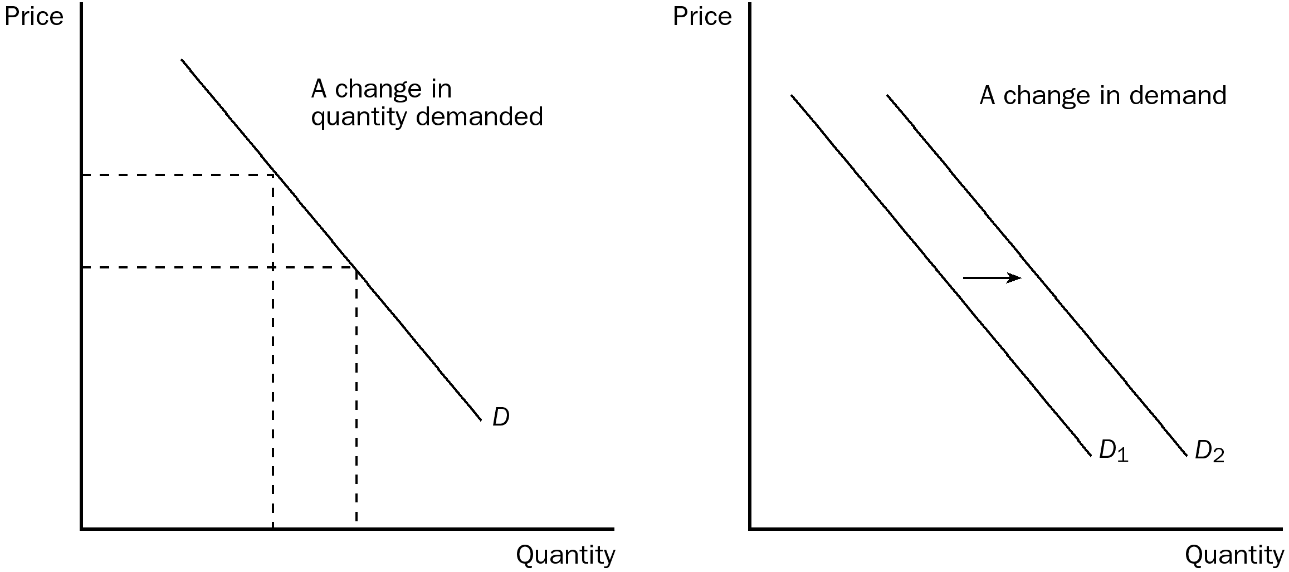
PTS: 1 DIF: 2 REF: 4-2
TOP: Demand | Quantity demanded MSC: Applicative
2.
a. What is the difference between a "change in supply" and a "change in quantity supplied"? Graph your answer.
b. For each of the following changes, determine whether there will be a change in quantity supplied or a change in supply.
i. a change in the resource cost
ii. a change in producer expectations
iii. a change in price
iv. a change in technology
v. the number of sellers
ANS:
a. A change in supply refers to a shift in the supply curve. A change in quantity supplied refers to a movement along a fixed supply curve.

In part b, all of the events except (iii) shift the supply curve.
PTS: 1 DIF: 2 REF: 4-3
TOP: Supply | Quantity supplied MSC: Applicative
3. This question deals with demand and supply and refers you to the table below.
a. Given the table, graph the demand and supply curves for flashlights. Make certain to label equilibrium price and equilibrium quantity.

Price | Quantity Demanded/Month | Quantity Supplied/Month
$5 | 6,000 | 10,000
$4 | 8,000 | 8,000
$3 | 10,000 | 6,000
$2 | 12,000 | 4,000
$1 | 14,000 | 2,000

b. What is the equilibrium price and equilibrium quantity?
c. Suppose the price is currently at $5. What problem would exist in the economy? What would you expect to happen to price? Show this on your graph.
d. Suppose the price is currently $2. What problem exists in the economy? What would you expect to happen to price? Show this on your graph.
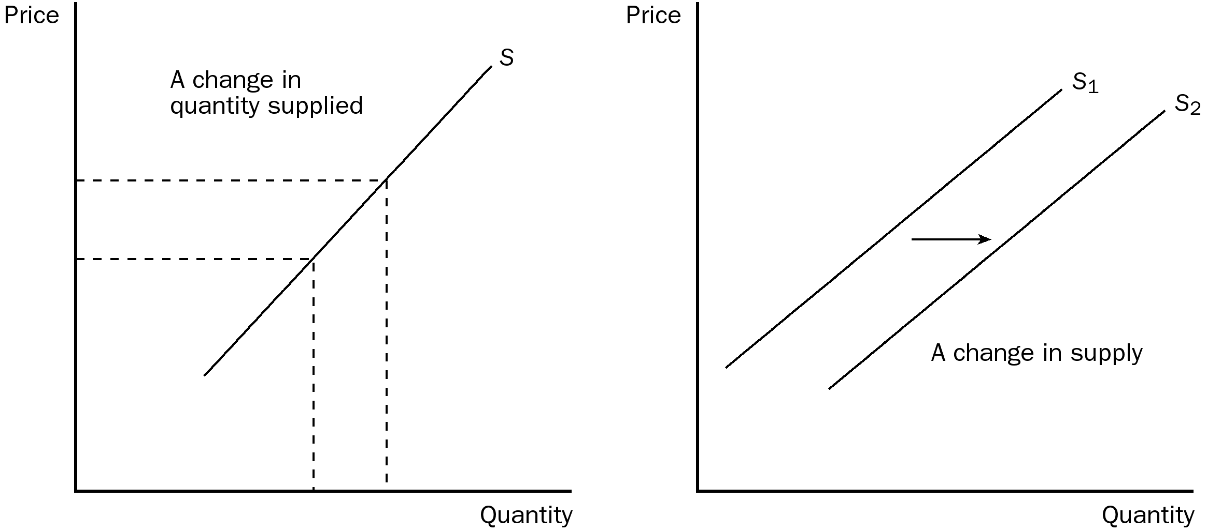
ANS:
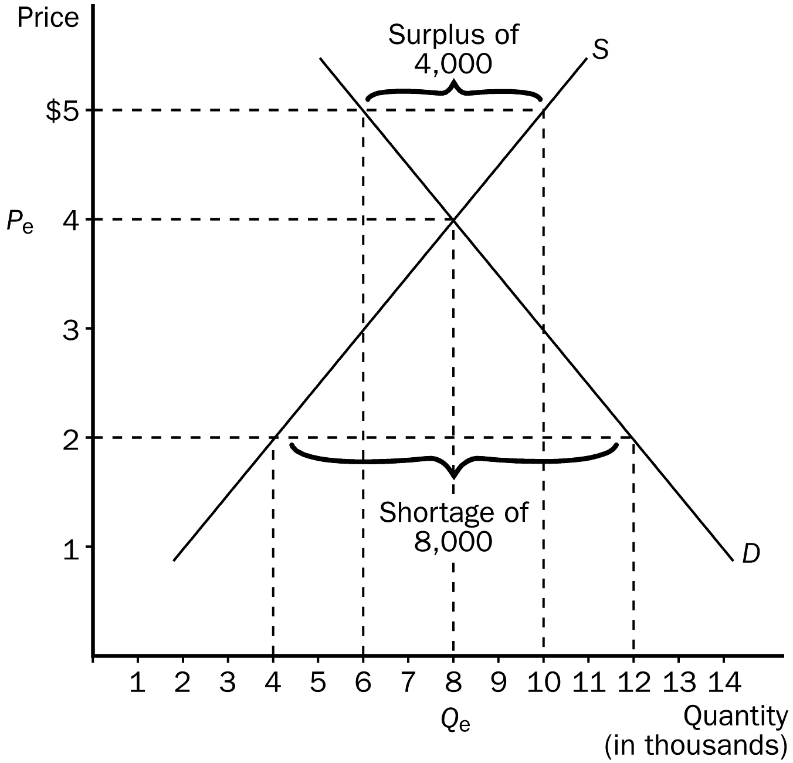a.
b. Equilibrium price would be $4 and equilibrium quantity would be 8,000.
c. A surplus of 4,000 flashlights would be the problem in the economy and we would expect the price to fall.
d. A shortage of 8,000 flashlights would be the problem in the economy and we would expect the price to rise.
PTS: 1 DIF: 2 REF: 4-4
TOP: Equilibrium | Shortages | Surpluses MSC: Applicative
4. Fill in the accompanying table, showing whether equilibrium price and equilibrium quantity go up, down or stay the same.

 | No Change in Supply | An Increase in Supply | A Decrease in Supply
No Change in Demand
An Increase in Demand
A Decrease in Demand

ANS:
 | No Change in Supply | An Increase in Supply | A Decrease in Supply
No Change in Demand | P same  Q same | P down  Q up | P up  Q down
An Increase in Demand | P up  Q up | P ambiguous  Q up | P up  Q ambiguous
A Decrease in Demand | P down  Q down | P down  Q ambiguous | P ambiguous  Q Down

PTS: 1 DIF: 2 REF: 4-4
TOP: Demand | Supply MSC: Interpretive
5. Suppose we are analyzing the market for hot chocolate. Graphically illustrate the impact each of the following would have on demand or supply. Also show how equilibrium price and quantity have changed.
a. Winter starts and the weather turns sharply colder.
b. The price of tea, a substitute for hot chocolate, falls.
c. The price of cocoa beans decreases.
d. The price of whipped cream falls.
e. A better method of harvesting cocoa beans is introduced.
f. The Surgeon General of the U.S. announces that hot chocolate cures acne.
g. Protesting farmers dump millions of gallons of milk, causing the price of milk to rise.
h. Consumer income falls because of a recession and hot chocolate is considered a normal good.
i. Producers expect the price of hot chocolate to increase next month.
j. Currently, the price of hot chocolate is $0.50 per cup above equilibrium.
ANS:
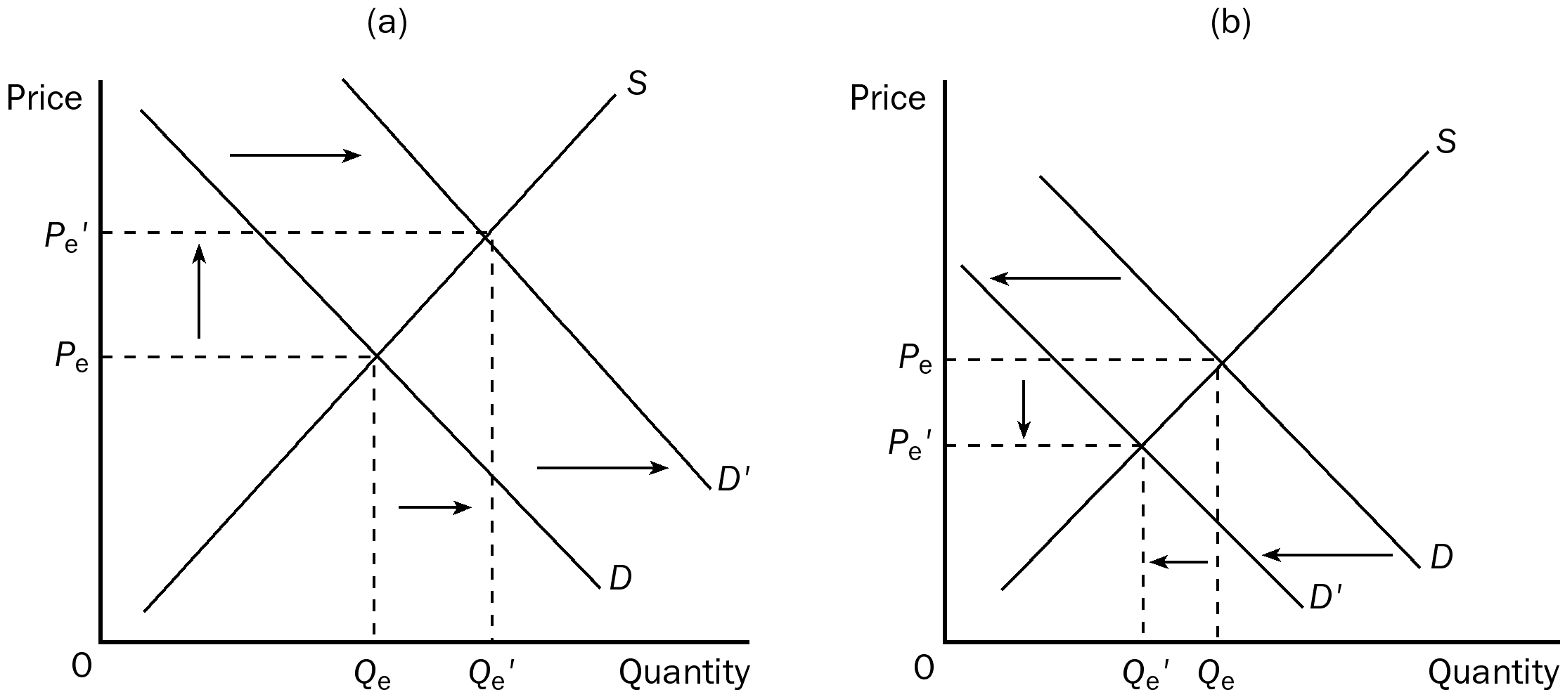

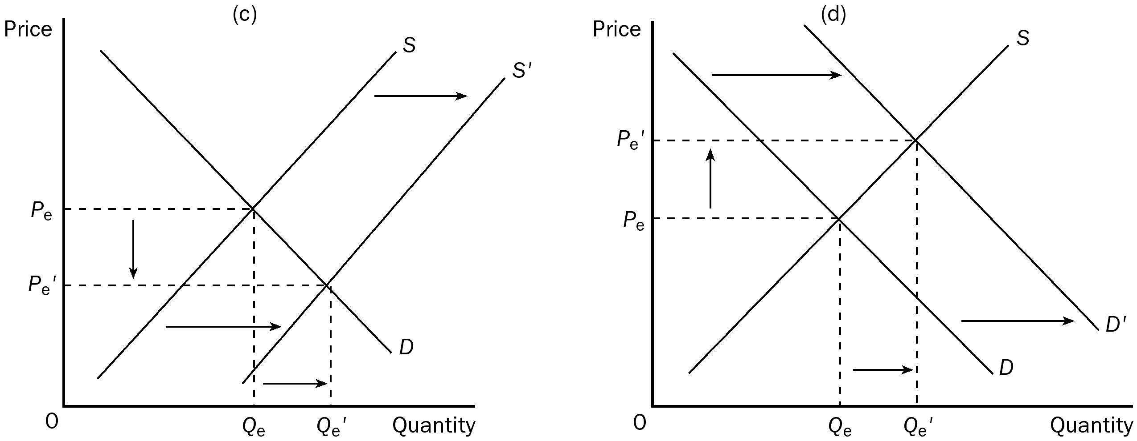
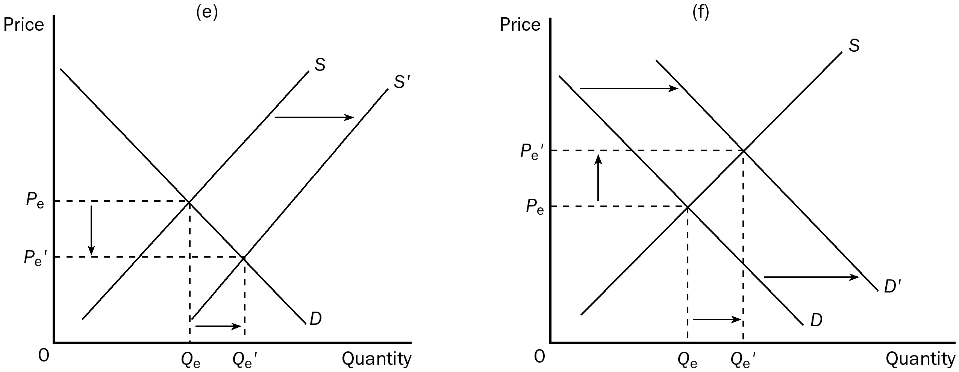

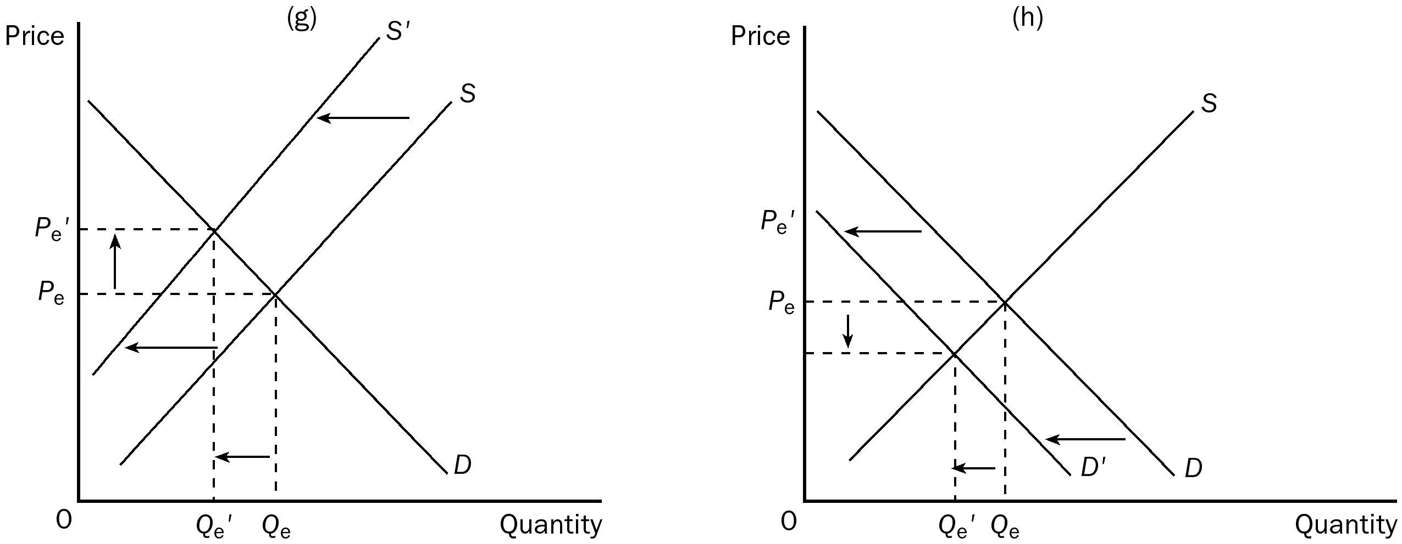
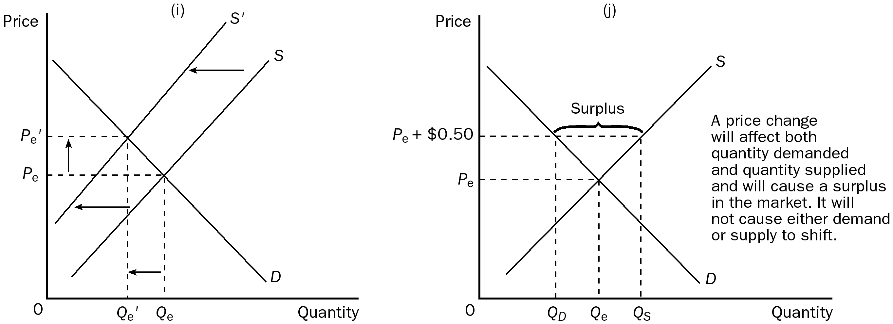
PTS: 1 DIF: 3 REF: 4-4
TOP: Demand | Supply MSC: Applicative

