Chapter 5
Elasticity and Its Applications
Multiple Choice
1. In general, elasticity is a measure of
a. the extent to which advances in technology are adopted by producers.
b. the extent to which a market is competitive.
c. how fast the price of a good responds to a shift of the supply curve or demand curve.
d. how much buyers and sellers respond to changes in market conditions.
ANS: D PTS: 1 DIF: 1 REF: 5-0
TOP: Elasticity MSC: Definitional
2. When studying how some event or policy affects a market, elasticity provides information on the
a. direction of the effect on the market.
b. magnitude of the effect on the market.
c. speed of adjustment of the market in response to the event or policy.
d. number of market participants who are directly affected by the event or policy.
ANS: B PTS: 1 DIF: 2 REF: 5-0
TOP: Elasticity MSC: Interpretive
3. How does the concept of elasticity allow us to improve upon our understanding of supply and demand?
a. Elasticity allows us to analyze supply and demand with greater precision than would be the case in the absence of the elasticity concept.
b. Elasticity provides us with a better rationale for statements such as “an increase in x will lead to a decrease in y” than we would have in the absence of the elasticity concept.
c. Without elasticity, we would not be able to address the direction in which price is likely to move in response to a surplus or a shortage.
d. Without elasticity, it is very difficult to assess the degree of competition within a market.
ANS: A PTS: 1 DIF: 2 REF: 5-0
TOP: Elasticity MSC: Interpretive
4. Elasticity improves our understanding of supply and demand by adding
a. measures of equity.
b. measures of efficiency.
c. a quantitative element to our analysis.
d. a qualitative element to our analysis.
ANS: C PTS: 1 DIF: 2 REF: 5-0
TOP: Elasticity MSC: Interpretive
5. The price elasticity of demand measures how much
a. quantity demanded responds to a change in price.
b. quantity demanded responds to a change in income.
c. price responds to a change in demand.
d. demand responds to a change in supply.
ANS: A PTS: 1 DIF: 1 REF: 5-1
TOP: Price elasticity of demand MSC: Definitional
6. The price elasticity of demand measures
a. buyers’ responsiveness to a change in the price of a good.
b. the extent to which demand increases as additional buyers enter the market.
c. how much more of a good consumers will demand when incomes rise.
d. the movement along a supply curve when there is a change in demand.
ANS: A PTS: 1 DIF: 1 REF: 5-1
TOP: Price elasticity of demand MSC: Definitional
7. Demand is said to be elastic if
a. the price of the good responds substantially to changes in demand.
b. demand shifts substantially when income or the expected future price of the good changes.
c. buyers do not respond much to changes in the price of the good.
d. buyers respond substantially to changes in the price of the good.
ANS: D PTS: 1 DIF: 2 REF: 5-1
TOP: Elastic demand MSC: Definitional
8. Demand is said to be inelastic if
a. buyers respond substantially to changes in the price of the good.
b. demand shifts only slightly when the price of the good changes.
c. the quantity demanded changes only slightly when the price of the good changes.
d. the price of the good responds only slightly to changes in demand.
ANS: C PTS: 1 DIF: 2 REF: 5-1
TOP: Inelastic demand MSC: Definitional
9. If demand is inelastic, then
a. buyers do not respond much to a change in price.
b. buyers respond substantially to a change in price, but the response is very slow.
c. buyers do not alter their quantities demanded much in response to advertising, fads, or general changes in tastes.
d. the demand curve is very flat.
ANS: A PTS: 1 DIF: 2 REF: 5-1
TOP: Inelastic demand MSC: Definitional
10. When quantity demanded responds strongly to changes in price, demand is said to be
a. fluid.
b. elastic.
c. dynamic.
d. highly variable.
ANS: B PTS: 1 DIF: 1 REF: 5-1
TOP: Elastic demand MSC: Definitional
11. Which of the following statements about the price elasticity of demand is correct?
a. The price elasticity of demand for a good measures the willingness of buyers of the good to move away from the good as its price increases.
b. Price elasticity of demand reflects the many economic, psychological, and social forces that shape consumer tastes.
c. Other things equal, if good x has close substitutes and good y does not have close substitutes, then the demand for good x will be more elastic than the demand for good y.
d. All of the above are correct.
ANS: D PTS: 1 DIF: 2 REF: 5-1
TOP: Price elasticity of demand MSC: Interpretive
12. For a good that is a necessity,
a. quantity demanded tends to respond substantially to a change in price.
b. demand tends to be inelastic.
c. the law of demand often does not apply.
d. All of the above are correct.
ANS: B PTS: 1 DIF: 2 REF: 5-1
TOP: Price elasticity of demand MSC: Interpretive
13. For a good that is a luxury, demand
a. tends to be inelastic.
b. tends to be elastic.
c. has unit elasticity.
d. cannot be represented by a demand curve in the usual way.
ANS: B PTS: 1 DIF: 2 REF: 5-1
TOP: Price elasticity of demand MSC: Interpretive
14. If a person only occasionally buys a cup of coffee, his demand for coffee is probably
a. represented by a vertical or nearly-vertical demand curve.
b. not easily represented by a demand schedule or demand curve.
c. inelastic.
d. elastic.
ANS: D PTS: 1 DIF: 2 REF: 5-2
TOP: Price elasticity of demand MSC: Interpretive
15. A person who takes a prescription drug to control high cholesterol most likely has a demand for that drug that is
a. inelastic.
b. unit elastic.
c. elastic.
d. highly responsive to changes in income.
ANS: A PTS: 1 DIF: 2 REF: 5-1
TOP: Price elasticity of demand MSC: Interpretive
16. Other things equal, the demand for a good tends to be more inelastic, the
a. fewer the available substitutes.
b. longer the time period considered.
c. more the good is considered a luxury good.
d. more narrowly defined is the market for the good.
ANS: A PTS: 1 DIF: 2 REF: 5-1
TOP: Inelastic demand MSC: Interpretive
17. The demand for Chocolate Chip Cookie Dough ice cream is likely quite elastic because
a. ice cream must be eaten quickly.
b. this particular flavor of ice cream is viewed as a necessity by many ice-cream lovers.
c. the market is broadly defined.
d. other flavors of ice cream are good substitutes for this particular flavor.
ANS: D PTS: 1 DIF: 2 REF: 5-1
TOP: Price elasticity of demand | Substitutes MSC: Interpretive
18. The demand for Werthers candy is likely
a. elastic because candy is expensive relative to other snacks.
b. elastic because there are many close substitutes for Werthers.
c. elastic because Werthers are regarded as a necessity by many people.
d. inelastic because it is usually eaten quickly, making the relevant time horizon short.
ANS: B PTS: 1 DIF: 2 REF: 5-1
TOP: Price elasticity of demand MSC: Interpretive
19. There are very few, if any, good substitutes for motor oil. Therefore,
a. the demand for motor oil would tend to be inelastic.
b. the demand for motor oil would tend to be elastic.
c. the demand for motor oil would tend to respond strongly to changes in prices of other goods.
d. the supply of motor oil would tend to respond strongly to changes in people’s tastes for large cars relative to their tastes for small cars.
ANS: A PTS: 1 DIF: 2 REF: 5-1
TOP: Price elasticity of demand MSC: Interpretive
20. Holding all other forces constant, when the price of gasoline rises, the number of gallons of gasoline demanded would fall substantially over a ten-year period because
a. buyers tend to be much less sensitive to a change in price when given more time to react.
b. buyers tend to be much more sensitive to a change in price when given more time to react.
c. buyers will have substantially more income over a ten-year period.
d. the quantity supplied of gasoline increases very little in response to an increase in the price of gasoline.
ANS: B PTS: 1 DIF: 2 REF: 5-1
TOP: Price elasticity of demand MSC: Interpretive
21. A good will have a more inelastic demand,
a. the greater the availability of close substitutes.
b. the broader the definition of the market.
c. the longer the period of time.
d. the more it is regarded as a luxury.
ANS: B PTS: 1 DIF: 2 REF: 5-1
TOP: Price elasticity of demand MSC: Interpretive
22. It is likely that
a. the demand for flat-screen computer monitors is more elastic than the demand for monitors in general.
b. the demand for grandfather clocks is more elastic than the demand for wristwatches.
c. the demand for cardboard is more elastic over a long period of time than over a short period of time.
d. All of the above are correct.
ANS: D PTS: 1 DIF: 2 REF: 5-1
TOP: Price elasticity of demand MSC: Interpretive
23. It is likely that
a. the demand for natural gas is more elastic over a short period of time than over a long period of time.
b. the demand for smoke alarms is more elastic than the demand for Persian rugs.
c. the demand for bourbon whiskey is more elastic than the demand for alcoholic beverages in general.
d. All of the above are correct.
ANS: C PTS: 1 DIF: 2 REF: 5-1
TOP: Price elasticity of demand MSC: Interpretive
24. When the price of bubble gum is $0.50, the quantity demanded is 400 packs per day. When the price falls to $0.40, the quantity demanded increases to 600. Given this information and using the midpoint method, we know that the demand for bubble gum is
a. inelastic.
b. elastic.
c. unit elastic.
d. perfectly inelastic.
ANS: B PTS: 1 DIF: 2 REF: 5-1
TOP: Price elasticity of demand | Midpoint method MSC: Applicative
25. Economists compute the price elasticity of demand as the
a. percentage change in price divided by the percentage change in quantity demanded.
b. change in quantity demanded divided by the change in the price.
c. percentage change in quantity demanded divided by the percentage change in price.
d. percentage change in quantity demanded divided by the percentage change in income.
ANS: C PTS: 1 DIF: 2 REF: 5-1
TOP: Price elasticity of demand MSC: Definitional
26. Suppose you calculate the price elasticity of demand for a certain good and you report that the elasticity is 0.8. The fact that the elasticity is a positive number means that
a. when the price of the good increases, the quantity demanded increases in response.
b. demand for the good is elastic.
c. you have dropped the minus sign and reported the absolute value of the elasticity.
d. the good has close substitutes and/or the good is a luxury.
ANS: C PTS: 1 DIF: 2 REF: 5-1
TOP: Price elasticity of demand MSC: Interpretive
27. The midpoint method is used to compute elasticity because it
a. automatically computes a positive number instead of a negative number.
b. results in an elasticity that is the same as the slope of the demand curve.
c. gives the same answer regardless of the direction of change.
d. automatically rounds quantities to the nearest whole unit.
ANS: C PTS: 1 DIF: 2 REF: 5-1
TOP: Price elasticity of demand | Midpoint method MSC: Interpretive
28. The main reason for using the midpoint method to calculate an elasticity is that it
a. gives the same answer regardless of whether the price increases or decreases.
b. recognizes that prices are usually increasing, not decreasing.
c. rounds prices to the nearest dollar and quantities to the nearest whole unit.
d. uses fewer numbers than alternative methods.
ANS: A PTS: 1 DIF: 2 REF: 5-1
TOP: Midpoint method MSC: Interpretive
29. Which of the following is not a determinant of the price elasticity of demand for a good?
a. the time horizon
b. the steepness or flatness of the supply curve for the good
c. the definition of the market for the good
d. the availability of substitutes for the good
ANS: B PTS: 1 DIF: 2 REF: 5-1
TOP: Price elasticity of demand MSC: Interpretive
30. The price elasticity of demand for a good measures the willingness of
a. consumers to move away from the good as price rises.
b. consumers to avoid monopolistic markets in favor of competitive markets.
c. firms to produce more of a good as price rises.
d. firms to cater to the tastes of consumers.
ANS: A PTS: 1 DIF: 1 REF: 5-1
TOP: Price elasticity of demand MSC: Interpretive
31. If the quantity demanded of a certain good responds only slightly to a change in the price of the good, then
a. the demand for the good is said to be elastic.
b. the demand for the good is said to be inelastic.
c. the law of demand does not apply to the good.
d. the demand curve for the good shifts only slightly in response to a change in price.
ANS: B PTS: 1 DIF: 1 REF: 5-1
TOP: Inelastic demand MSC: Definitional
32. The greater the price elasticity of demand, the
a. more likely the product is a necessity.
b. smaller the responsiveness of quantity demanded to a change in price.
c. greater the percentage change in price over the percentage change in quantity demanded.
d. greater the responsiveness of quantity demanded to a change in price.
ANS: D PTS: 1 DIF: 2 REF: 5-1
TOP: Price elasticity of demand MSC: Interpretive
33. The value of the price elasticity of demand for a good will be relatively large when
a. there are no good substitutes available for the good.
b. the time period in question is relatively short.
c. the good is a luxury as opposed to a necessity.
d. All of the above are correct.
ANS: C PTS: 1 DIF: 2 REF: 5-1
TOP: Price elasticity of demand MSC: Interpretive
34. Suppose there is a 6 percent increase in the price of good X and a resulting 6 percent decrease in the quantity of X demanded. Price elasticity of demand for X is
a. 0.
b. 1.
c. 6.
d. 36.
ANS: B PTS: 1 DIF: 2 REF: 5-1
TOP: Price elasticity of demand MSC: Applicative
35. Suppose the price of Twinkies decreases from $1.45 to $1.25 and, as a result, the quantity of Twinkies demanded increases from 2,000 to 2,200. Using the midpoint method, the price elasticity of demand for Twinkies in the given price range is
a. 2.00.
b. 1.55.
c. 1.00.
d. 0.64.
ANS: D PTS: 1 DIF: 2 REF: 5-1
TOP: Price elasticity of demand MSC: Applicative
36. If the price elasticity of demand for a good is 4.0, then a 10 percent increase in price results in a
a. 0.4 percent decrease in the quantity demanded.
b. 2.5 percent decrease in the quantity demanded.
c. 4 percent decrease in the quantity demanded.
d. 40 percent decrease in the quantity demanded.
ANS: D PTS: 1 DIF: 2 REF: 5-1
TOP: Price elasticity of demand MSC: Applicative
37. If the price elasticity of demand for a good is 1.65, then a 3 percent decrease in price results in a
a. 0.55 percent increase in the quantity demanded.
b. 1.82 percent increase in the quantity demanded.
c. 4.95 percent increase in the quantity demanded.
d. 5.55 percent increase in the quantity demanded.
ANS: C PTS: 1 DIF: 2 REF: 5-1
TOP: Price elasticity of demand MSC: Applicative
38. If the price elasticity of demand for a good is 0.94, then which of the following events is consistent with a 4 percent decrease in the quantity of the good demanded?
a. a 0.235 percent increase in the price of the good
b. a 2.350 percent increase in the price of the good
c. a 3.760 percent increase in the price of the good
d. a 4.255 percent increase in the price of the good
ANS: D PTS: 1 DIF: 2 REF: 5-1
TOP: Price elasticity of demand MSC: Applicative
39. Using the midpoint method, the price elasticity of demand for a good is computed to be approximately 0.78. Which of the following events is consistent with a 4.68 percent decrease in the quantity of the good demanded?
a. a 3.65 increase in the price of the good
b. a 16.67 percent increase in the price of the good
c. an increase in the price of the good from $48.00 to $50.97
d. an increase in the price of the good from $65.00 to $66.98
ANS: C PTS: 1 DIF: 3 REF: 5-1
TOP: Price elasticity of demand MSC: Applicative
40. Using the midpoint method, the price elasticity of demand for a good is computed to be approximately 1.5. Which of the following events is consistent with a 3.5 percent increase in the price of the good?
a. The quantity of the good demanded decreases from 25,294 to 24,000.
b. The quantity of the good demanded decreases from 50,000 to 48,847.
c. The quantity of the good demanded decreases by 2.33 percent.
d. The quantity of the good demanded decreases by 4.29 percent.
ANS: A PTS: 1 DIF: 3 REF: 5-1
TOP: Price elasticity of demand MSC: Applicative
41. The midpoint method for calculating elasticities is convenient in that it allows us to
a. ignore the percentage change in quantity demanded and instead focus entirely on the percentage change in price.
b. calculate the same value for the elasticity, regardless of whether the price increases or decreases.
c. assume that sellers' total revenue stays constant when the price changes.
d. restrict all elasticity values to between 0 and 1.
ANS: B PTS: 1 DIF: 2 REF: 5-1
TOP: Midpoint method MSC: Interpretive
42. The price elasticity of demand for bread
a. is computed as the percentage change in quantity demanded of bread divided by the percentage change in price of bread.
b. depends, in part, on the availability of close substitutes for bread.
c. reflects the many economic, social, and psychological forces that influence consumers' tastes for bread.
d. All of the above are correct.
ANS: D PTS: 1 DIF: 1 REF: 5-1
TOP: Price elasticity of demand MSC: Interpretive
43. When the price of a good is $5, the quantity demanded is 100 units per month; when the price is $7, the quantity demanded is 80 units per month. Using the midpoint method, the price elasticity of demand is about
a. 0.22.
b. 0.67.
c. 1.33.
d. 1.50.
ANS: B PTS: 1 DIF: 1 REF: 5-1
TOP: Price elasticity of demand MSC: Applicative
44. Consider airfares on flights between New York and Minneapolis. When the airfare is $250, the quantity demanded of tickets is 2,000 per week. When the airfare is $280, the quantity demanded of tickets is 1,700 per week. Using the midpoint method,
a. the price elasticity of demand is about 1.43 and an increase in the airfare will cause airlines' total revenue to decrease.
b. the price elasticity of demand is about 1.43 and an increase in the airfare will cause airlines' total revenue to increase.
c. the price elasticity of demand is about 0.70 and an increase in the airfare will cause airlines' total revenue to decrease.
d. the price elasticity of demand is about 0.70 and an increase in the airfare will cause airlines' total revenue to increase.
ANS: A PTS: 1 DIF: 2 REF: 5-1
TOP: Price elasticity of demand | Total revenue MSC: Applicative
45. For a particular good, a 2 percent increase in price causes a 12 percent decrease in quantity demanded. Which of the following statements is most likely applicable to this good?
a. There are no close substitutes for this good.
b. The good is a luxury.
c. The market for the good is broadly defined.
d. The relevant time horizon is short.
ANS: B PTS: 1 DIF: 3 REF: 5-1
TOP: Price elasticity of demand MSC: Analytical
46. For a particular good, a 3 percent increase in price causes a 10 percent decrease in quantity demanded. Which of the following statements is most likely applicable to this good?
a. The relevant time horizon is short.
b. The good is a necessity.
c. The market for the good is broadly defined.
d. There are many close substitutes for this good.
ANS: D PTS: 1 DIF: 3 REF: 5-1
TOP: Price elasticity of demand MSC: Analytical
47. Demand is elastic if elasticity is
a. less than 1.
b. equal to 1.
c. equal to 0.
d. greater than 1.
ANS: D PTS: 1 DIF: 1 REF: 5-1
TOP: Elastic demand MSC: Definitional
48. Demand is inelastic if elasticity is
a. less than 1.
b. equal to 1.
c. greater than 1.
d. equal to 0.
ANS: A PTS: 1 DIF: 1 REF: 5-1
TOP: Inelastic demand MSC: Definitional
49. Demand is said to have unit elasticity if elasticity is
a. less than 1.
b. greater than 1.
c. equal to 1.
d. equal to 0.
ANS: C PTS: 1 DIF: 1 REF: 5-1
TOP: Price elasticity of demand MSC: Definitional
Figure 5-1
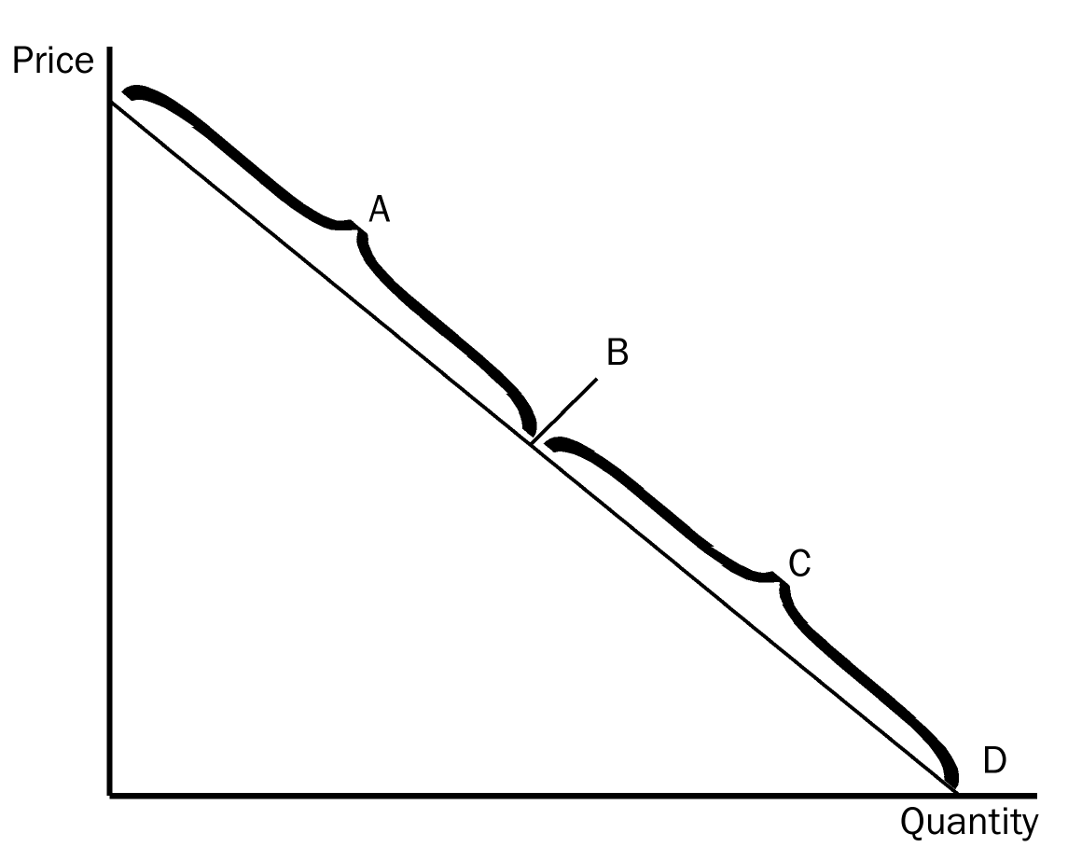
50. Refer to Figure 5-1. The section of the demand curve labeled A represents the
a. elastic section of the demand curve.
b. inelastic section of the demand curve.
c. unit elastic section of the demand curve.
d. perfectly elastic section of the demand curve.
ANS: A PTS: 1 DIF: 2 REF: 5-1
TOP: Elastic demand MSC: Interpretive
51. Refer to Figure 5-1. Suppose the point labeled B is the “halfway point” on the demand curve and it corresponds to a price of $5.00. Then, between prices of $4.90 and $5.10,
a. the price elasticity of demand is less than 1.
b. the price elasticity of demand is equal to 1.
c. the price elasticity of demand is greater than 1.
d. any of the above could be correct, depending on the quantities demanded at prices of $4.90 and $5.10.
ANS: B PTS: 1 DIF: 2 REF: 5-1
TOP: Price elasticity of demand MSC: Interpretive
52. Refer to Figure 5-1. The section of the demand curve labeled C represents the
a. elastic section of the demand curve.
b. perfectly elastic section of the demand curve.
c. unit elastic section of the demand curve.
d. inelastic section of the demand curve.
ANS: D PTS: 1 DIF: 2 REF: 5-1
TOP: Inelastic demand MSC: Interpretive
53. Refer to Figure 5-1. Assume the section of the demand curve labeled A corresponds to prices between $8 and $16. Then, when the price changes between $9 and $10,
a. quantity demanded changes proportionately less than the price.
b. quantity demanded changes proportionately more than the price.
c. quantity demanded changes the same amount proportionately as price.
d. the price elasticity of demand is less than 1.
ANS: B PTS: 1 DIF: 2 REF: 5-1
TOP: Elastic demand MSC: Applicative
54. Refer to Figure 5-1. Assume the section of the demand curve labeled C corresponds to prices between $0 and $15. Then, when the price changes between $7 and $9,
a. quantity demanded changes proportionately less than the price.
b. quantity demanded changes proportionately more than the price.
c. quantity demanded changes the same amount proportionately as price.
d. the price elasticity of demand is greater than 1.
ANS: A PTS: 1 DIF: 2 REF: 5-1
TOP: Inelastic demand MSC: Applicative
55. Refer to Figure 5-1. Assume the section of the demand curve labeled A corresponds to prices between $6 and $12. Then, when the price increases from $8 to $10,
a. the percent decrease in the quantity demanded exceeds the percent increase in the price.
b. the percent increase in the price exceeds the percent decrease in the quantity demanded.
c. sellers’ total revenue increases as a result.
d. it is possible that the quantity demanded fell from 550 to 500 as a result.
ANS: A PTS: 1 DIF: 3 REF: 5-1
TOP: Elastic demand MSC: Applicative
56. Refer to Figure 5-1. Assume, for the good in question, two specific points on the demand curve are (Q = 1,000, P = $40) and (Q = 1,500, P = $30). Then which of the following scenarios is possible?
a. Both of these points lie on section C of the demand curve.
b. The vertical intercept of the demand curve is the point (Q = 0, P = $60).
c. The horizontal intercept of the demand curve is the point (Q = 1,800, P = $0).
d. Any of these scenarios is possible.
ANS: B PTS: 1 DIF: 3 REF: 5-1
TOP: Elastic demand MSC: Analytical
57. Refer to Figure 5-1. Assume, for the good in question, two specific points on the demand curve are (Q = 2,000, P = $15) and (Q = 2,400, P = $12). Then which of the following scenarios is possible?
a. Both of these points lie on section C of the demand curve.
b. The vertical intercept of the demand curve is the point (Q = 0, P = $22).
c. The horizontal intercept of the demand curve is the point (Q = 5,000, P = $0).
d. Any of these scenarios is possible.
ANS: A PTS: 1 DIF: 3 REF: 5-1
TOP: Inelastic demand MSC: Analytical
Figure 5-2
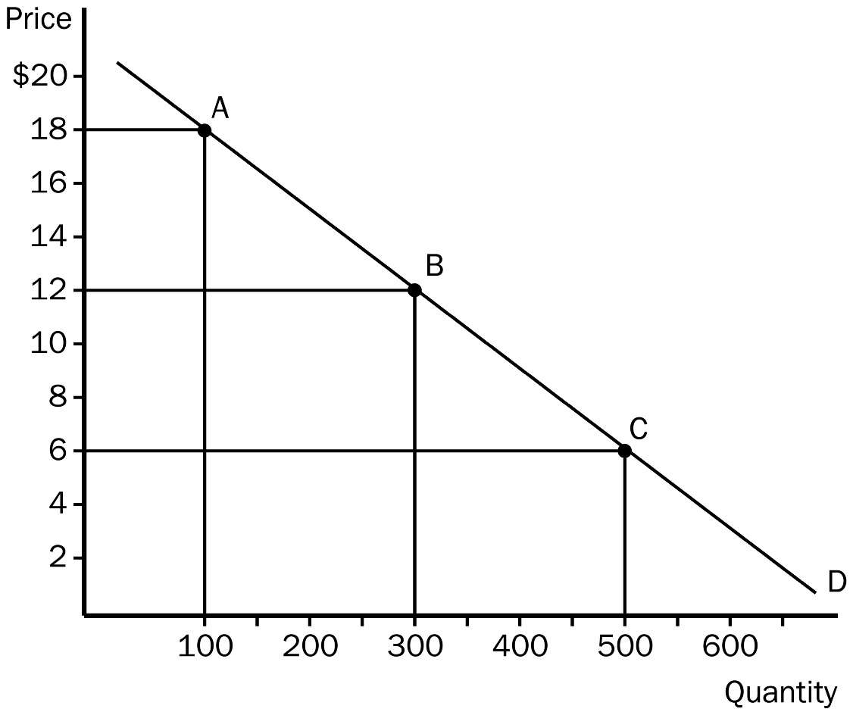
58. Refer to Figure 5-2. The price elasticity of demand between point A and point B, using the midpoint method, is
a. 1.
b. 1.5.
c. 2.
d. 2.5.
ANS: D PTS: 1 DIF: 2 REF: 5-1
TOP: Price elasticity of demand MSC: Applicative
59. Refer to Figure 5-2. The elasticity of demand between point B and point C, using the midpoint method, is
a. 0.5.
b. 0.75.
c. 1.0.
d. 1.3.
ANS: B PTS: 1 DIF: 2 REF: 5-1
TOP: Price elasticity of demand MSC: Applicative
60. Refer to Figure 5-2. If the price decreased from $18 to $6,
a. total revenue would increase by $1,200 and demand is elastic between points A and C.
b. total revenue would increase by $800 and demand is elastic between points A and C.
c. total revenue would decrease by $1,200 and demand is inelastic between points A and C.
d. total revenue would decrease by $800 and demand is inelastic between points A and C.
ANS: A PTS: 1 DIF: 2 REF: 5-1
TOP: Price elasticity of demand | Total revenue MSC: Applicative
61. Refer to Figure 5-2. Sellers’ total revenue would increase if the price
a. increased from $4 to $6.
b. increased from $16 to $18.
c. decreased from $8 to $6.
d. All of the above are correct.
ANS: A PTS: 1 DIF: 2 REF: 5-1
TOP: Total revenue MSC: Applicative
62. Refer to Figure 5-2. Sellers’ total revenue would increase if the price
a. increased from $6 to $8.
b. decreased from $18 to $16.
c. decreased from $16 to $15.
d. All of the above are correct.
ANS: D PTS: 1 DIF: 2 REF: 5-1
TOP: Total revenue MSC: Applicative
63. Refer to Figure 5-2. Which of the following price changes would result in no change in sellers’ total revenue?
a. The price increases from $6 to $9.
b. The price increases from $9 to $15.
c. The price decreases from $12 to $9.
d. The price decreases from $9 to $5.
ANS: C PTS: 1 DIF: 3 REF: 5-1
TOP: Total revenue MSC: Applicative
64. When the price of kittens was $25 each, the pet shop sold 20 per month. When they raised the price to $35 each, they sold 14 per month. The price elasticity of demand for kittens is about
a. 1.66.
b. 1.06.
c. 0.94.
d. 0.60.
ANS: B PTS: 1 DIF: 2 REF: 5-1
TOP: Price elasticity of demand MSC: Applicative
65. When the local used bookstore prices economics books at $15.00 each, they generally sell 70 books per month. If they lower the price to $7.00, sales increase to 90 books per month. Given this information, we know that the price elasticity of demand for economics books is about
a. 2.91, and an increase in price from $7.00 to $15.00 results in an increase in total revenue.
b. 2.91, and an increase in price from $7.00 to $15.00 results in a decrease in total revenue.
c. 0.34, and an increase in price from $7.00 to $15.00 results in an increase in total revenue.
d. 0.34, and an increase in price from $7.00 to $15.00 results in a decrease in total revenue.
ANS: C PTS: 1 DIF: 2 REF: 5-1
TOP: Price elasticity of demand | Total revenue MSC: Applicative
66. Demand is said to be inelastic if the
a. quantity demanded changes proportionately more than price.
b. price changes proportionately more than income.
c. quantity demanded changes proportionately less than price.
d. quantity demanded changes proportionately the same as price.
ANS: C PTS: 1 DIF: 2 REF: 5-1
TOP: Inelastic demand MSC: Definitional
67. Demand is said to be unit elastic if
a. quantity demanded changes by the same percent as the price.
b. quantity demanded changes by a larger percent than the price.
c. the demand curve shifts by the same percentage amount as the price.
d. quantity demanded does not respond to a change in price.
ANS: A PTS: 1 DIF: 2 REF: 5-1
TOP: Price elasticity of demand MSC: Definitional
68. Elasticity of demand is closely related to the slope of the demand curve. The more responsive buyers are to a change in price, the
a. steeper the demand curve will be.
b. flatter the demand curve will be.
c. further to the right the demand curve will sit.
d. closer to the vertical axis the demand curve will sit.
ANS: B PTS: 1 DIF: 2 REF: 5-1
TOP: Price elasticity of demand MSC: Interpretive
69. The flatter the demand curve through a given point, the
a. greater the price elasticity of demand at that point.
b. smaller the price elasticity of demand at that point.
c. closer the price elasticity of demand will be to the slope of the curve.
d. greater the absolute value of the change in total revenue when there is a movement from that point upward and to the left along the demand curve.
ANS: A PTS: 1 DIF: 3 REF: 5-1
TOP: Price elasticity of demand MSC: Analytical
70. A perfectly elastic demand implies that
a. buyers will not respond to any change in price.
b. any rise in price above that represented by the demand curve will result in a quantity demanded of zero.
c. quantity demanded and price change by the same percent as we move along the demand curve.
d. price will rise by an infinite amount when there is a change in quantity demanded.
ANS: B PTS: 1 DIF: 2 REF: 5-1
TOP: Perfectly elastic demand MSC: Interpretive
71. The case of perfectly elastic demand is illustrated by a demand curve that is
a. vertical.
b. horizontal.
c. downward-sloping but relatively steep.
d. downward-sloping but relatively flat.
ANS: B PTS: 1 DIF: 1 REF: 5-1
TOP: Perfectly elastic demand MSC: Interpretive
72. The smaller the price elasticity of demand, the
a. steeper the demand curve will be through a given point.
b. flatter the demand curve will be through a given point.
c. more strongly buyers respond to a change in price between any two prices P₁ and P₂.
d. larger the decrease in equilibrium price when the supply curve shifts rightward from S₁ to S₂.
ANS: A PTS: 1 DIF: 3 REF: 5-1
TOP: Price elasticity of demand MSC: Analytical
73. In the case of perfectly inelastic demand,
a. the change in quantity demanded equals the change in price.
b. the percentage change in quantity demanded equals the percentage change in price.
c. infinitely-large changes in quantity demanded result from very small changes in the price.
d. quantity demanded stays the same whenever price changes.
ANS: D PTS: 1 DIF: 2 REF: 5-1
TOP: Perfectly inelastic demand MSC: Interpretive
74. When demand is perfectly inelastic, the demand curve will be
a. negatively sloped, because buyers decrease their purchases when the price rises.
b. vertical, because buyers purchase the same amount as before whenever the price rises or falls.
c. positively sloped, because buyers respond by increasing the market quantity demanded of the good when price rises.
d. positively sloped, because buyers respond by increasing their total expenditure on the good when price rises.
ANS: B PTS: 1 DIF: 2 REF: 5-1
TOP: Perfectly inelastic demand MSC: Interpretive
75. When small changes in price lead to infinite changes in quantity demanded, demand is perfectly
a. elastic and the demand curve will be horizontal.
b. inelastic and the demand curve will be horizontal.
c. elastic and the demand curve will be vertical.
d. inelastic and the demand curve will be vertical.
ANS: A PTS: 1 DIF: 2 REF: 5-1
TOP: Perfectly elastic demand MSC: Interpretive
76. When quantity moves proportionately the same amount as price, demand is
a. elastic and the price elasticity of demand is 1.
b. perfectly elastic and the price elasticity of demand is infinitely large.
c. perfectly inelastic and the price elasticity of demand is 0.
d. unit elastic and the price elasticity of demand is 1.
ANS: D PTS: 1 DIF: 2 REF: 5-1
TOP: Price elasticity of demand MSC: Interpretive
77. When demand is perfectly inelastic, the price elasticity of demand
a. is zero and the demand curve is vertical.
b. is zero and the demand curve is horizontal.
c. approaches infinity and the demand curve is vertical.
d. approaches infinity and the demand curve is horizontal.
ANS: A PTS: 1 DIF: 2 REF: 5-1
TOP: Perfectly inelastic demand MSC: Interpretive
78. A perfectly inelastic demand implies that buyers
a. decrease their purchases when the price rises.
b. purchase the same amount as before when the price rises or falls.
c. increase their purchases only slightly when the price falls.
d. respond substantially to an increase in price.
ANS: B PTS: 1 DIF: 2 REF: 5-1
TOP: Perfectly inelastic demand MSC: Interpretive
79. Suppose demand is perfectly inelastic and the supply of the good in question decreases. As a result,
a. the equilibrium quantity decreases and the equilibrium price is unchanged.
b. the equilibrium price increases and the equilibrium quantity is unchanged.
c. the equilibrium quantity and the equilibrium price both are unchanged.
d. buyers’ total expenditure on the good is unchanged.
ANS: B PTS: 1 DIF: 2 REF: 5-1
TOP: Perfectly inelastic demand | Equilibrium price | Equilibrium quantity MSC: Applicative
80. Suppose demand is perfectly elastic and the supply of the good in question decreases. As a result,
a. the equilibrium quantity decreases and the equilibrium price is unchanged.
b. the equilibrium price increases and the equilibrium quantity is unchanged.
c. the equilibrium quantity and the equilibrium price both are unchanged.
d. buyers’ total expenditure on the good is unchanged.
ANS: A PTS: 1 DIF: 2 REF: 5-1
TOP: Perfectly elastic demand | Equilibrium price | Equilibrium quantity MSC: Applicative
81. Alice says that she would buy one banana split a day regardless of the price. If she is telling the truth,
a. Alice's demand for banana splits is perfectly inelastic.
b. Alice's price elasticity of demand for banana splits is 1.
c. Alice's income elasticity of demand for banana splits is 0.
d. None of the above answers is correct.
ANS: A PTS: 1 DIF: 2 REF: 5-1
TOP: Perfectly inelastic demand MSC: Interpretive
82. Jean-Paul says that he will spend exactly 75 cents a day on M&Ms, regardless of the price of M&Ms. Jean-Paul’s demand for M&Ms is
a. perfectly elastic.
b. unit elastic.
c. perfectly inelastic.
d. None of the above answers is correct.
ANS: B PTS: 1 DIF: 2 REF: 5-1
TOP: Price elasticity of demand MSC: Interpretive
83. Which of the following expressions is valid for the price elasticity of demand?
a. Price elasticity of demand = 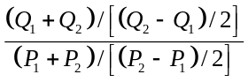
b. Price elasticity of demand = 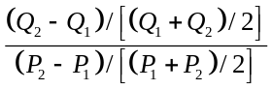
c. Price elasticity of demand = 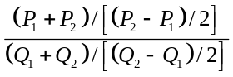
d. Price elasticity of demand = 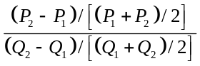
ANS: B PTS: 1 DIF: 2 REF: 5-1
TOP: Price elasticity of demand MSC: Applicative
84. Which of the following expressions can be used to compute the price elasticity of demand?
a. Price elasticity of demand = 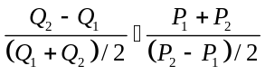
b. Price elasticity of demand = 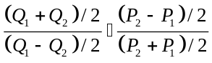
c. Price elasticity of demand = 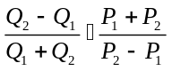
d. Price elasticity of demand = 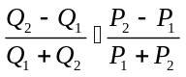
ANS: C PTS: 1 DIF: 3 REF: 5-1
TOP: Price elasticity of demand MSC: Analytical
85. For which of the following goods would demand be most elastic?
a. clothing
b. blue jeans
c. Tommy Hilfiger jeans
d. All three would have the same elasticity of demand since they are all related.
ANS: C PTS: 1 DIF: 2 REF: 5-1
TOP: Price elasticity of demand MSC: Applicative
86. In any market, total revenue is calculated by taking the price of the good and
a. dividing it by the price elasticity of demand.
b. multiplying it by the price elasticity of demand.
c. multiplying it by the quantity of the good.
d. multiplying it by the quantity of the good and then subtracting the costs of production.
ANS: C PTS: 1 DIF: 1 REF: 5-1
TOP: Total revenue MSC: Definitional
87. How does total revenue change as one moves downward and to the right along a linear demand curve?
a. It always increases.
b. It always decreases.
c. It first increases, then decreases.
d. It is unaffected by a movement along the demand curve.
ANS: C PTS: 1 DIF: 3 REF: 5-1
TOP: Total revenue | Demand curve MSC: Analytical
88. On a downward-sloping linear demand curve, total revenue reaches its maximum value at the
a. midpoint of the demand curve.
b. lower end of the demand curve.
c. upper end of the demand curve.
d. It is impossible to tell without knowing prices and quantities demanded.
ANS: A PTS: 1 DIF: 3 REF: 5-1
TOP: Total revenue | Demand curve MSC: Analytical
89. Suppose the point (Q = 2,000, P = $60) is the midpoint on a certain downward-sloping, linear demand curve. Then
a. an increase in price from $40 to $42 will increase total revenue.
b. a decrease in price from $61 to $59 will leave total revenue unchanged.
c. the maximum value of total revenue is $120,000.
d. All of the above are correct.
ANS: D PTS: 1 DIF: 3 REF: 5-1
TOP: Total revenue | Demand curve MSC: Analytical
90. If the price elasticity of demand is 1.5, regardless of which two points on the demand curve are used to compute the elasticity, then
a. demand is perfectly inelastic and the demand curve is vertical.
b. demand is elastic and the demand curve is a straight, downward-sloping line.
c. demand is perfectly elastic and the demand curve is horizontal.
d. demand is elastic and the demand curve is something other than a straight, downward-sloping line.
ANS: D PTS: 1 DIF: 3 REF: 5-1
TOP: Price elasticity of demand MSC: Applicative
Figure 5-3
91. Refer to Figure 5-3. If price falls within the A range of the demand curve we can expect total revenue to
a. increase.
b. decrease.
c. stay the same.
d. This determination cannot be made without further information.
ANS: A PTS: 1 DIF: 2 REF: 5-1
TOP: Total revenue MSC: Applicative
92. Refer to Figure 5-3. If price falls within the C range of the demand curve we can expect total revenue to
a. increase.
b. decrease.
c. stay the same.
d. This determination cannot be made without further information.
ANS: B PTS: 1 DIF: 2 REF: 5-1
TOP: Total revenue MSC: Applicative
93. Refer to Figure 5-3. If price is originally within the C range of the demand curve and then it increases to a value within the A range of the demand curve, we can expect total revenue to
a. increase.
b. decrease.
c. stay the same.
d. This determination cannot be made without further information.
ANS: D PTS: 1 DIF: 2 REF: 5-1
TOP: Total revenue MSC: Applicative
Figure 5-4
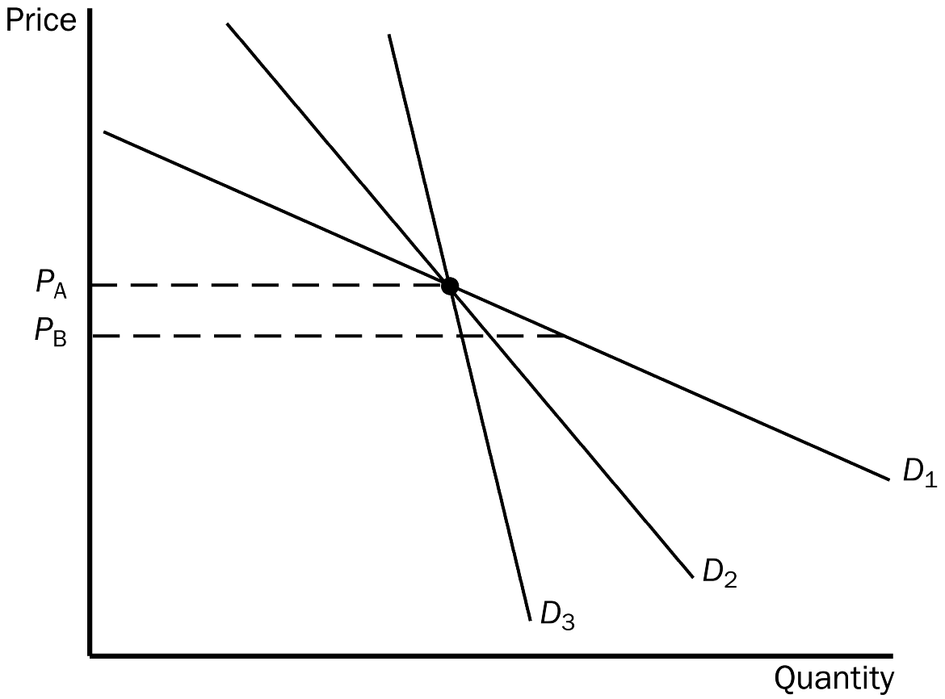
94. Refer to Figure 5-4. As price falls from P_{A} to P_{B}, which demand curve represents the most elastic demand?
a. D₁
b. D₂
c. D₃
d. All of the above are equally elastic.
ANS: A PTS: 1 DIF: 2 REF: 5-1
TOP: Price elasticity of demand MSC: Applicative
95. Refer to Figure 5-4. As price falls from P_{A} to P_{B}, we could use the three demand curves to calculate three different values of the price elasticity of demand. Which of the three demand curves would produce the smallest elasticity?
a. D₁
b. D₂
c. D₃
d. All of the above are equally elastic.
ANS: C PTS: 1 DIF: 2 REF: 5-1
TOP: Price elasticity of demand MSC: Applicative
96. When demand is inelastic, a decrease in price will cause
a. an increase in total revenue.
b. a decrease in total revenue.
c. no change in total revenue, but an increase in quantity demanded.
d. no change in total revenue, but a decrease in quantity demanded.
ANS: B PTS: 1 DIF: 2 REF: 5-1
TOP: Inelastic demand | Total revenue MSC: Applicative
Figure 5-5
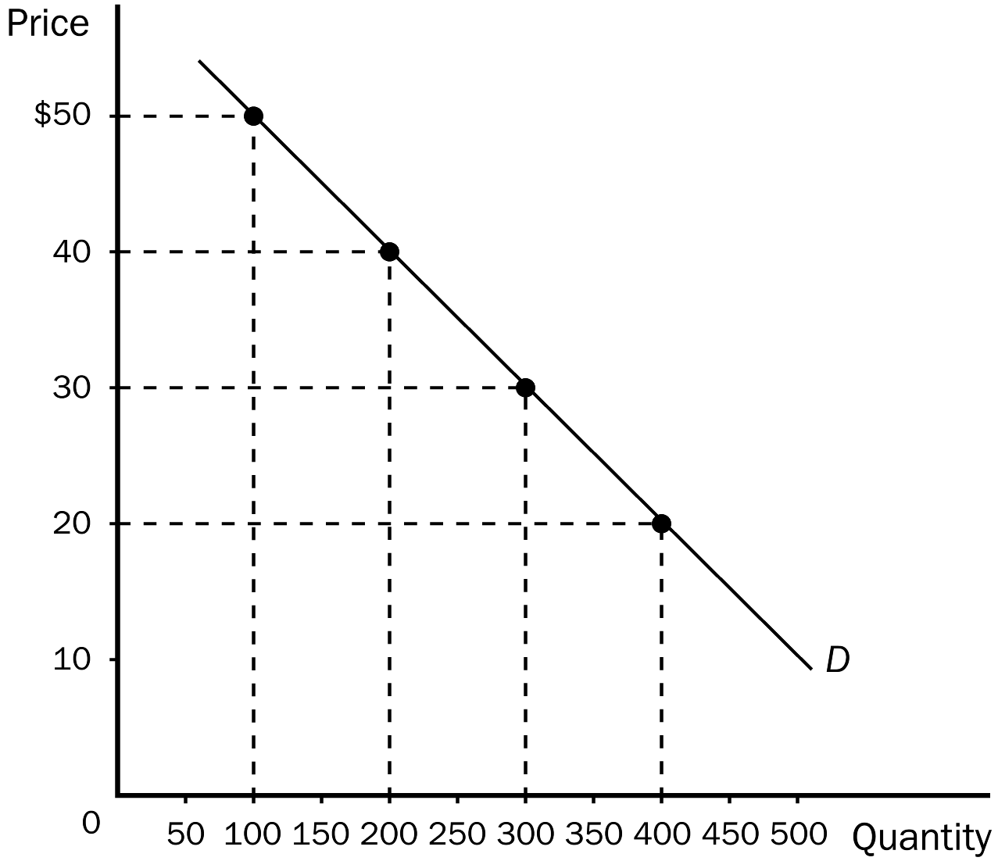
97. Refer to Figure 5-5. When the price is $30, total revenue is
a. $3,000.
b. $5,000.
c. $7,000.
d. $9,000.
ANS: D PTS: 1 DIF: 1 REF: 5-1
TOP: Total revenue MSC: Interpretive
98. Refer to Figure 5-5. When price falls from $50 to $40, it can be inferred that demand between those two prices is
a. inelastic, since total revenue decreases from $8,000 to $5,000.
b. inelastic, since total revenue increases from $5,000 to $8,000.
c. elastic, since total revenue increases from $5,000 to $8,000.
d. unit elastic, since total revenue increases from $5,000 to $8,000.
ANS: C PTS: 1 DIF: 2 REF: 5-1
TOP: Elastic demand | Total revenue MSC: Applicative
99. Refer to Figure 5-5. An increase in price from $20 to $30 would
a. increase total revenue by $2,000.
b. decrease total revenue by $2,000.
c. increase total revenue by $1,000.
d. decrease total revenue by $1,000.
ANS: C PTS: 1 DIF: 2 REF: 5-1
TOP: Total revenue MSC: Applicative
100. Refer to Figure 5-5. An increase in price from $30 to $35 would
a. increase total revenue by $250
b. decrease total revenue by $250.
c. increase total revenue by $500.
d. decrease total revenue by $500.
ANS: B PTS: 1 DIF: 2 REF: 5-1
TOP: Total revenue MSC: Applicative
101. An increase in price causes an increase in total revenue when
a. demand is elastic.
b. demand is inelastic.
c. demand is unit elastic.
d. All of the above are possible.
ANS: B PTS: 1 DIF: 2 REF: 5-1
TOP: Inelastic demand | Total revenue MSC: Applicative
Figure 5-6
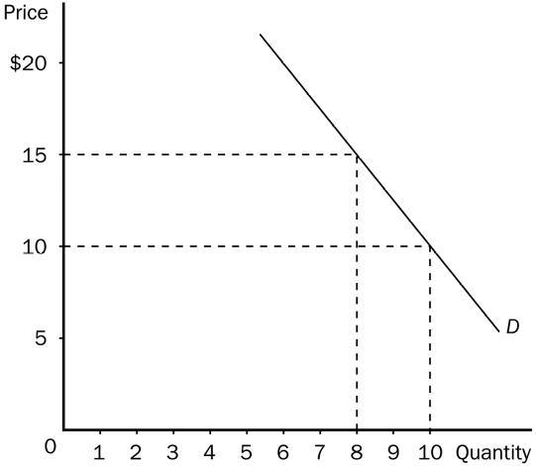
102. Refer to Figure 5-6. If price increases from $10 to $15, total revenue will
a. increase by $20, so demand must be inelastic in this price range.
b. increase by $5, so demand must be inelastic in this price range.
c. decrease by $20, so demand must be elastic in this price range.
d. decrease by $10, so demand must be elastic in this price range.
ANS: A PTS: 1 DIF: 2 REF: 5-1
TOP: Inelastic demand | Total revenue MSC: Applicative
103. Refer to Figure 5-6. Suppose this demand curve is a straight, downward-sloping line all the way from the horizontal intercept to the vertical intercept. We choose two prices, P₁ and P₂, and the corresponding quantities demanded, Q₁ and Q₂, for the purpose of calculating the price elasticity of demand. Also suppose P₂ > P_{1.} In which of the following cases could we possibly find that (i) demand is elastic and (ii) an increase in price from P₁ to P₂ causes an increase in total revenue?
a. 0 < P₁ < P₂ < $10.
b. $10 < P₁ < P₂ < $15.
c. P₁ > $15.
d. None of the above is correct.
ANS: D PTS: 1 DIF: 3 REF: 5-1
TOP: Price elasticity of demand | Total revenue MSC: Analytical
104. Refer to Figure 5-6. A decrease in price from $15 to $10 leads to
a. a decrease in total revenue of $10, so the price elasticity of demand is greater than 1 in this price range.
b. a decrease in total revenue of $10, so the price elasticity of demand is less than 1 in this price range.
c. a decrease in total revenue of $20, so the price elasticity of demand is less than 1 in this price range.
d. a decrease in total revenue of $20, so demand is elastic in this price range.
ANS: C PTS: 1 DIF: 2 REF: 5-1
TOP: Inelastic demand | Total revenue MSC: Applicative
Figure 5-7
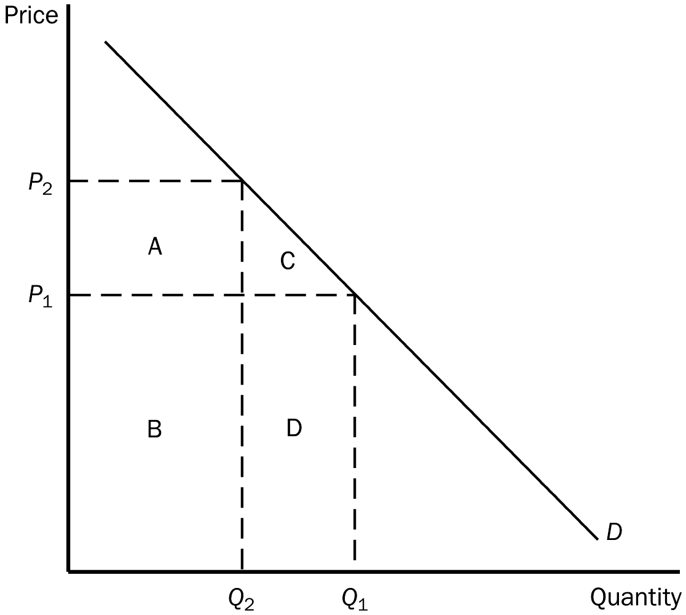
105. Refer to Figure 5-7. Total revenue when the price is P₁ is represented by the area(s)
a. B + D.
b. A + B.
c. C + D.
d. D.
ANS: A PTS: 1 DIF: 2 REF: 5-1
TOP: Demand curve | Total revenue MSC: Applicative
106. Refer to Figure 5-7. Total revenue when the price is P₂ is represented by the area(s)
a. B + D.
b. A + B.
c. C + D.
d. D.
ANS: B PTS: 1 DIF: 2 REF: 5-1
TOP: Demand curve | Total revenue MSC: Applicative
107. Refer to Figure 5-7. If rectangle D is larger than rectangle A, then
a. demand is elastic between prices P₁ and P₂.
b. a decrease in price from P₂ to P₁ will cause an increase in total revenue.
c. the magnitude of the percent change in price between P₁ and P₂ is smaller than the magnitude of the corresponding percent change in quantity demanded.
d. All of the above are correct.
ANS: D PTS: 1 DIF: 3 REF: 5-1
TOP: Price elasticity of demand | Total revenue MSC: Analytical
Figure 5-8. A demand curve is shown on the graph below. On the graph, Q represents quantity demanded and P represents price.
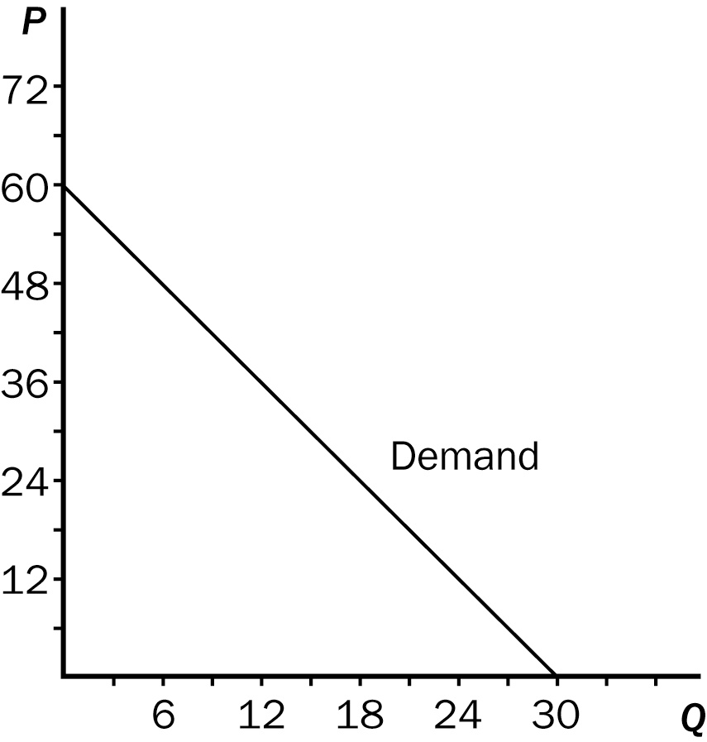

108. Refer to Figure 5-8. The maximum value of total revenue corresponds to a price of
a. $18.
b. $30.
c. $42.
d. $48.
ANS: B PTS: 1 DIF: 2 REF: 5-1
TOP: Total revenue MSC: Applicative
109. Refer to Figure 5-8. Demand is unit elastic between prices of
a. $18 and $24.
b. $24 and $30.
c. $24 and $36.
d. $30 and $36.
ANS: C PTS: 1 DIF: 2 REF: 5-1
TOP: Price elasticity of demand MSC: Applicative
110. Refer to Figure 5-8. Using the midpoint method, between prices of $12 and $18, price elasticity of demand is
a. 0.33.
b. 0.67.
c. 1.33.
d. 1.89.
ANS: A PTS: 1 DIF: 2 REF: 5-1
TOP: Price elasticity of demand MSC: Applicative
111. Refer to Figure 5-8. Using the midpoint method, between prices of $48 and $54, price elasticity of demand is about
a. 0.92.
b. 3.89.
c. 4.33.
d. 5.67.
ANS: D PTS: 1 DIF: 2 REF: 5-1
TOP: Price elasticity of demand MSC: Applicative
112. Refer to Figure 5-8. At a price of $48 per unit, sellers' total revenue amounts to
a. $150.
b. $200.
c. $288.
d. $364.
ANS: C PTS: 1 DIF: 1 REF: 5-1
TOP: Total revenue MSC: Definitional
113. If the demand for donuts is elastic, then a decrease in the price of donuts will
a. increase total revenue of donut sellers.
b. decrease total revenue of donut sellers.
c. not change total revenue of donut sellers.
d. There is not enough information to answer this question.
ANS: A PTS: 1 DIF: 2 REF: 5-1
TOP: Elastic demand | Total revenue MSC: Applicative
114. The local pizza restaurant makes such great bread sticks that consumers do not respond much at all to a change in the price. If the owner is only interested in increasing revenue, he should
a. lower the price of the bread sticks.
b. leave the price of the bread sticks alone.
c. raise the price of the bread sticks.
d. reduce costs.
ANS: C PTS: 1 DIF: 2 REF: 5-1
TOP: Inelastic demand | Total revenue MSC: Interpretive
115. Eric produces jewelry boxes. If the demand for jewelry boxes is elastic and Eric wants to increase his total revenue, he should
a. increase the price of his jewelry boxes.
b. decrease the price of his jewelry boxes.
c. not change the price of his jewelry boxes.
d. None of the above answers is correct.
ANS: B PTS: 1 DIF: 2 REF: 5-1
TOP: Elastic demand | Total revenue MSC: Interpretive
116. When demand is inelastic within a certain price range, then within that price range,
a. an increase in price would increase total revenue because the decrease in quantity demanded is proportionately less than the increase in price.
b. an increase in price would decrease total revenue because the decrease in quantity demanded is proportionately greater than the increase in price.
c. a decrease in price would increase total revenue because the increase in quantity demanded is proportionately smaller than the decrease in price.
d. a decrease in price would not affect total revenue.
ANS: A PTS: 1 DIF: 3 REF: 5-1
TOP: Inelastic demand | Total revenue MSC: Applicative
117. When demand is inelastic the price elasticity of demand is
a. less than 1, and price and total revenue will move in the same direction.
b. less than 1, and price and total revenue will move in opposite directions.
c. greater than 1, and price and total revenue will move in the same direction.
d. greater than 1, and price and total revenue will move in opposite directions.
ANS: A PTS: 1 DIF: 2 REF: 5-1
TOP: Inelastic demand | Total revenue MSC: Applicative
118. If the price elasticity of demand for tuna is 0.7, then a 1.5% increase in the price of tuna will decrease the quantity demanded of tuna by
a. 1.05% and tuna sellers' total revenue will increase as a result.
b. 1.05% and tuna sellers' total revenue will decrease as a result.
c. 2.14% and tuna sellers' total revenue will increase as a result.
d. 2.14% and tuna sellers' total revenue will decrease as a result.
ANS: A PTS: 1 DIF: 3 REF: 5-1
TOP: Price elasticity of demand | Total revenue MSC: Analytical
119. If the price elasticity of demand for aluminum foil is 1.45, then a 2.4% decrease in the price of aluminum foil will increase the quantity demanded of aluminum foil by
a. 1.66% and aluminum foil sellers' total revenue will increase as a result.
b. 1.66% and aluminum foil sellers' total revenue will decrease as a result.
c. 3.48% and aluminum foil sellers' total revenue will increase as a result.
d. 3.48% and aluminum foil sellers' total revenue will decrease as a result.
ANS: C PTS: 1 DIF: 3 REF: 5-1
TOP: Price elasticity of demand | Total revenue MSC: Analytical
120. Holding all other forces constant, if raising the price of a good leads to a fall in total revenue, then the demand for the good must be
a. unit elastic.
b. inelastic.
c. elastic.
d. None of the above is correct, since a price increase always leads to an increase in total revenue.
ANS: C PTS: 1 DIF: 2 REF: 5-1
TOP: Elastic demand | Total revenue MSC: Applicative
121. If a change in the price of a good results in no change in total revenue, then
a. the demand for the good must be elastic.
b. the demand for the good must be inelastic.
c. the demand for the good must be unit elastic.
d. buyers must not respond very much to a change in price.
ANS: C PTS: 1 DIF: 2 REF: 5-1
TOP: Price elasticity of demand | Total revenue MSC: Interpretive
122. When demand is unit elastic, price elasticity of demand
a. equals 1 and total revenue and price move in the same direction.
b. equals 1 and total revenue and price move in opposite directions.
c. equals 1 and total revenue does not change when price changes.
d. equals 0 and total revenue does not change when price changes.
ANS: C PTS: 1 DIF: 2 REF: 5-1
TOP: Price elasticity of demand | Total revenue MSC: Interpretive
123. If the demand curve is linear and downward sloping, which of the following statements is not correct?
a. Demand is more elastic on the lower part of the demand curve than on the upper part.
b. Different pairs of points on the demand curve can result in different values of the price elasticity of demand.
c. Different pairs of points on the demand curve cannot result in different values of the slope of the demand curve.
d. Starting from a point on the upper part of the demand curve, an increase in price leads to a decrease in total revenue.
ANS: A PTS: 1 DIF: 3 REF: 5-1
TOP: Price elasticity of demand | Total revenue MSC: Analytical
124. For a vertical demand curve,
a. slope is undefined and price elasticity of demand is equal to 0.
b. slope is equal to 0 and price elasticity of demand is undefined.
c. slope and price elasticity of demand both are undefined.
d. slope and price elasticity of demand both are equal to 0.
ANS: A PTS: 1 DIF: 2 REF: 5-1
TOP: Perfectly inelastic demand MSC: Interpretive
125. In which of these instances is demand said to be perfectly inelastic?
a. An increase in price of 2% causes a decrease in quantity demanded of 2%.
b. A decrease in price of 2% causes an increase in quantity demanded of 0%.
c. A decrease in price of 2% causes a decrease in total revenue of 0%.
d. The demand curve is horizontal.
ANS: B PTS: 1 DIF: 2 REF: 5-1
TOP: Perfectly inelastic demand MSC: Interpretive
126. For a horizontal demand curve,
a. slope is undefined and price elasticity of demand is equal to 0.
b. slope is equal to 0 and price elasticity of demand is undefined.
c. slope and price elasticity of demand both are undefined.
d. slope and price elasticity of demand both are equal to 0.
ANS: B PTS: 1 DIF: 2 REF: 5-1
TOP: Perfectly elastic demand MSC: Interpretive
127. As we move downward and to the right along a linear, downward-sloping demand curve,
a. slope and elasticity both remain constant.
b. slope changes but elasticity remains constant.
c. slope and elasticity both change.
d. slope remains constant but elasticity changes.
ANS: D PTS: 1 DIF: 2 REF: 5-1
TOP: Price elasticity of demand MSC: Interpretive
128. When we move upward and to the left along a linear demand curve, price elasticity of demand
a. first becomes smaller, then larger.
b. always becomes larger.
c. always becomes smaller.
d. first becomes larger, then smaller.
ANS: B PTS: 1 DIF: 2 REF: 5-1
TOP: Price elasticity of demand MSC: Interpretive
129. Moving downward and to the right along a linear demand curve, we know that total revenue
a. first increases, then decreases.
b. first decreases, then increases.
c. always increases.
d. always decreases.
ANS: A PTS: 1 DIF: 2 REF: 5-1
TOP: Demand curve | Total revenue MSC: Interpretive
130. Total revenue will be at its largest value on a linear demand curve at
a. the top of the curve, where prices are highest.
b. the midpoint of the curve.
c. the low end of the curve, where quantity demanded is highest.
d. None of the above is correct.
ANS: B PTS: 1 DIF: 2 REF: 5-1
TOP: Demand curve | Total revenue MSC: Interpretive
131. Total revenue
a. always increases as price increases.
b. increases as price increases, as long as demand is elastic.
c. decreases as price increases, as long as demand is inelastic.
d. remains unchanged as price increases when demand is unit elastic.
ANS: D PTS: 1 DIF: 2 REF: 5-1
TOP: Price elasticity of demand | Total revenue MSC: Applicative
132. In which of the following situations will total revenue increase?
a. Price elasticity of demand is 1.2 and the price of the good decreases.
b. Price elasticity of demand is 0.5 and the price of the good increases.
c. Price elasticity of demand is 3.0 and the price of the good decreases.
d. All of the above are correct.
ANS: D PTS: 1 DIF: 2 REF: 5-1
TOP: Price elasticity of demand | Total revenue MSC: Analytical
133. Suppose you are in charge of setting prices at a local sandwich shop. The business needs to increase its total revenue and your job is on the line. If the demand for sandwiches is elastic, you
a. should increase the price of sandwiches.
b. should decrease the price of sandwiches.
c. should not change the price of sandwiches.
d. could not determine what to do with price until you determine whether supply is elastic or inelastic.
ANS: B PTS: 1 DIF: 2 REF: 5-1
TOP: Elastic demand | Total revenue MSC: Applicative
134. You have just been hired as a business consultant to determine what pricing policy would be appropriate in order to increase the total revenue of a major shoe store. The first step you would take would be to
a. increase the price of every shoe in the store.
b. look for ways to cut costs and increase profit for the store.
c. determine the price elasticity of demand for the store's products.
d. determine the price elasticity of supply for the store’s products.
ANS: C PTS: 1 DIF: 2 REF: 5-1
TOP: Price elasticity of demand | Total revenue MSC: Interpretive
135. Harry's Barber Shop increased its total monthly revenue from $1,500 to $1,800 when it raised the price of a haircut from $5 to $9. The price elasticity of demand for Harry's Haircuts is
a. 0.567.
b. 0.700.
c. 1.429.
d. 2.200.
ANS: B PTS: 1 DIF: 3 REF: 5-1
TOP: Price elasticity of demand | Total revenue MSC: Applicative
136. Barb's Bakery earned $200 in total revenue last month when it sold 100 loaves of bread. This month it earned $300 in total revenue when it sold 60 loaves of bread. The price elasticity of demand for Barb's bread is
a. 0.27.
b. 0.58.
c. 1.25.
d. 1.71.
ANS: B PTS: 1 DIF: 3 REF: 5-1
TOP: Price elasticity of demand | Total revenue MSC: Applicative
137. You are in charge of the local city-owned golf course. You need to increase the revenue generated by the golf course in order to meet expenses. The mayor advises you to increase the price of a round of golf. The city manager recommends reducing the price of a round of golf. You realize that
a. the mayor thinks demand is elastic and the city manager thinks demand is inelastic.
b. both the mayor and the city manager think that demand is elastic.
c. both the mayor and the city manager think that demand is inelastic.
d. the mayor thinks demand is inelastic and the city manager thinks demand is elastic.
ANS: D PTS: 1 DIF: 2 REF: 5-1
TOP: Price elasticity of demand | Total revenue MSC: Applicative
138. Suppose that when the price of corn is $2 per bushel, farmers can sell 10 million bushels. When the price of corn is $3 per bushel, farmers can sell 8 million bushels. Which of the following statements is true?
a. The demand for corn is income inelastic, and so an increase in the price of corn will increase the total revenue of corn farmers.
b. The demand for corn is income elastic, and so an increase in the price of corn will increase the total revenue of corn farmers.
c. The demand for corn is price inelastic, and so an increase in the price of corn will increase the total revenue of corn farmers.
d. The demand for corn is price elastic, and so an increase in the price of corn will increase the total revenue of corn farmers.
ANS: C PTS: 1 DIF: 3 REF: 5-1
TOP: Price elasticity of demand | Total revenue MSC: Applicative
139. Suppose a producer is able to separate customers into two groups, one having an inelastic demand and the other having an elastic demand. If the producer's objective is to increase total revenue, she should
a. increase the price charged to customers with the elastic demand and decrease the price charged to customers with the inelastic demand.
b. decrease the price charged to customers with the elastic demand and increase the price charged to customers with the inelastic demand.
c. charge the same price to both groups of customers.
d. increase the price for both groups of customers.
ANS: B PTS: 1 DIF: 3 REF: 5-1
TOP: Elastic demand | Inelastic demand | Total revenue MSC: Analytical
140. Suppose that 50 candy bars are demanded at a particular price. If the price of candy bars rises from that price by 4 percent, the number of candy bars demanded falls to 46. Using the midpoint approach to calculate the price elasticity of demand, it follows that the
a. demand for candy bars in this price range is elastic.
b. demand for candy bars in this price range is inelastic.
c. demand for candy bars in this price range is unit elastic.
d. price elasticity of demand for candy bars in this price range is 0.
ANS: A PTS: 1 DIF: 2 REF: 5-1
TOP: Price elasticity of demand MSC: Applicative
141. Suppose that 50 candy bars are demanded at a particular price. If the price of candy bars rises from that price by 5 percent, the number of candy bars demanded falls to 48. Using the midpoint approach to calculate the price elasticity of demand, it follows that the
a. demand for candy bars in this price range is elastic.
b. price increase will decrease the total revenue of candy bar sellers.
c. price elasticity of demand for candy bars in this price range is about 1.22.
d. price elasticity of demand for candy bars in this price range is about 0.82.
ANS: D PTS: 1 DIF: 3 REF: 5-1
TOP: Price elasticity of demand | Total revenue MSC: Applicative
Figure 5-9
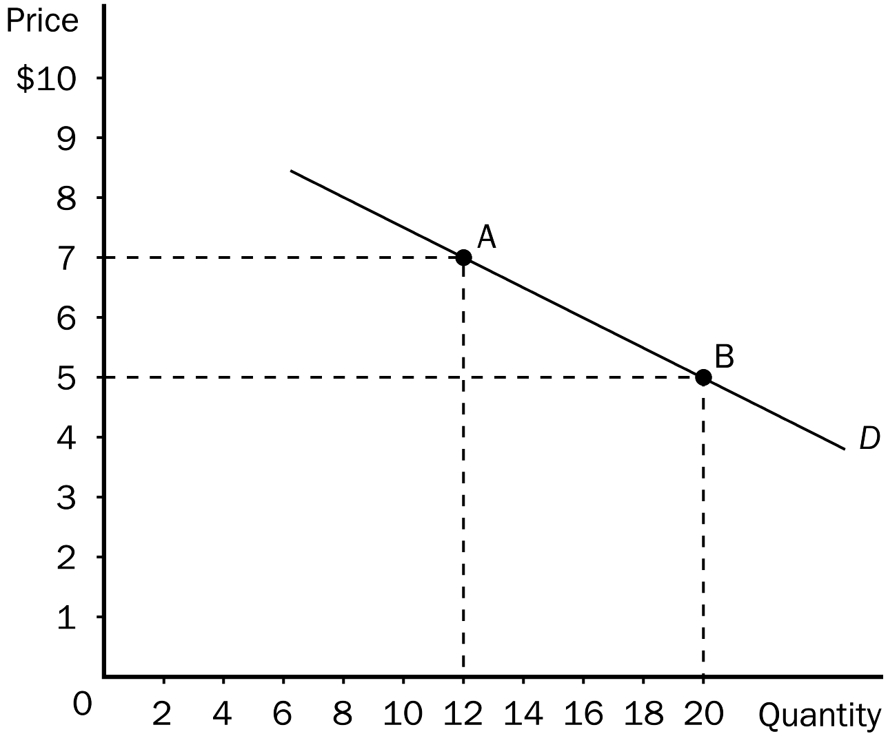
142. Refer to Figure 5-9. Between point A and point B,
a. the slope is equal to -1/4 and the price elasticity of demand is equal to 2/3.
b. the slope is equal to -1/4 and the price elasticity of demand is equal to 3/2.
c. the slope is equal to -3/2 and the price elasticity of demand is equal to 1/4.
d. the slope is equal to -2/3 and the price elasticity of demand is equal to 3/2.
ANS: B PTS: 1 DIF: 2 REF: 5-1
TOP: Price elasticity of demand MSC: Applicative
143. Refer to Figure 5-9. Between point A and point B on the graph, demand is
a. perfectly elastic.
b. inelastic.
c. unit elastic.
d. elastic, but not perfectly elastic.
ANS: D PTS: 1 DIF: 2 REF: 5-1
TOP: Elastic demand MSC: Applicative
144. The price elasticity of demand changes as we move along a
a. horizontal demand curve.
b. vertical demand curve.
c. linear, downward-sloping demand curve.
d. All of the above are correct.
ANS: C PTS: 1 DIF: 2 REF: 5-1
TOP: Demand curve | Price elasticity of demand MSC: Interpretive
145. The difference between slope and elasticity is that
a. slope is a ratio of two changes and elasticity is a ratio of two percentage changes.
b. slope is a ratio of two percentage changes and elasticity is a ratio of two changes.
c. slope measures changes in quantity demanded more accurately than elasticity.
d. none of the above; there is no difference between slope and elasticity.
ANS: A PTS: 1 DIF: 2 REF: 5-1
TOP: Price elasticity of demand MSC: Interpretive
146. For which of the following goods is demand probably most inelastic?
a. camcorders
b. insulin
c. apples
d. devices that remove cores from apples
ANS: B PTS: 1 DIF: 2 REF: 5-1
TOP: Elastic demand MSC: Interpretive
147. According to a Los Angeles Times article published in May 2005, John Felmy, chief economist at the American Petroleum Institute, asserts that the short-run price elasticity of demand for gasoline is about
a. 0.10.
b. 0.25.
c. 0.50.
d. 1.00.
ANS: A PTS: 1 DIF: 2 REF: 5-1
TOP: Price elasticity of demand MSC: Interpretive
148. According to a Los Angeles Times article published in May 2005, recent estimates indicate that
a. the short-run and long-run price elasticities of demand for gasoline are 0.1 and 0.5, respectively.
b. the short-run and long-run price elasticities of demand for gasoline are 0.1 and 1.0, respectively.
c. the short-run and long-run price elasticities of demand for gasoline are 0.2 and 1.5, respectively.
d. the short-run and long-run price elasticities of demand for gasoline are 0.5 and 1.5, respectively.
ANS: B PTS: 1 DIF: 3 REF: 5-1
TOP: Price elasticity of demand MSC: Applicative
149. Whether a good is a luxury or necessity depends on
a. the price of the good.
b. the preferences of the buyer.
c. the intrinsic properties of the good.
d. how scarce the good is.
ANS: B PTS: 1 DIF: 2 REF: 5-1
TOP: Demand MSC: Interpretive
150. Last year, Sheila bought 6 pairs of shoes when her income was $40,000. This year, her income is $50,000 and she purchased 10 pairs of shoes. Holding other factors constant, it follows that Sheila
a. considers shoes to be a necessity.
b. considers shoes to be an inferior good.
c. considers shoes to be a normal good.
d. has a low price elasticity of demand for shoes.
ANS: C PTS: 1 DIF: 2 REF: 5-1
TOP: Normal goods MSC: Interpretive
151. Last year, Sheila bought 6 pairs of shoes when her income was $40,000. This year, her income is $52,000 and she purchased 7 pairs of shoes. Holding other factors constant and using the midpoint method, it follows that Sheila’s income elasticity of demand is about
a. 0.59 and Sheila regards shoes as an inferior good.
b. 0.59 and Sheila regards shoes as a normal good.
c. 1.7 and Sheila regards shoes as an inferior good.
d. 1.7 and Sheila regards shoes as a normal good.
ANS: B PTS: 1 DIF: 2 REF: 5-1
TOP: Income elasticity of demand | Normal goods MSC: Applicative
152. When the rental price of DVD movies is $4, Denise rents five per month. When the price is $3, she rents nine per month. Denise's demand for DVD rentals is
a. elastic and her demand curve would be relatively flat.
b. elastic and her demand curve would be relatively steep.
c. inelastic and her demand curve would be relatively flat.
d. inelastic and her demand curve would be relatively steep.
ANS: A PTS: 1 DIF: 2 REF: 5-1
TOP: Elastic demand MSC: Applicative
153. Your younger sister needs $50 to buy a new bike. She has opened a lemonade stand to make the money she needs. She currently is charging 25 cents per cup, but she wants to adjust her price to earn the $50 faster. If you know that the demand for lemonade is elastic, what is your advice to her?
a. Leave the price at 25 cents and be patient.
b. Raise the price to increase total revenue.
c. Lower the price to increase total revenue.
d. There isn't enough information given to answer this question.
ANS: C PTS: 1 DIF: 2 REF: 5-1
TOP: Elastic demand | Total revenue MSC: Applicative
154. Income elasticity of demand measures how
a. the quantity demanded changes as consumer income changes.
b. consumer purchasing power is affected by a change in the price of a good.
c. the price of a good is affected when there is a change in consumer income.
d. many units of a good a consumer can buy given a certain income level.
ANS: A PTS: 1 DIF: 1 REF: 5-1
TOP: Income elasticity of demand MSC: Definitional
155. If a 6 percent increase in income results in a 10 percent increase in the quantity demanded of pizza, then the income elasticity of demand for pizza is
a. negative and therefore pizza is an normal good.
b. negative and therefore pizza is a inferior good.
c. positive and therefore pizza is an inferior good.
d. positive and therefore pizza is a normal good.
ANS: D PTS: 1 DIF: 2 REF: 5-1
TOP: Income elasticity of demand MSC: Applicative
156. For which of the following goods is the income elasticity of demand likely highest?
a. water
b. diamonds
c. hamburgers
d. housing
ANS: B PTS: 1 DIF: 2 REF: 5-1
TOP: Income elasticity of demand MSC: Interpretive
157. Necessities such as food and clothing tend to have
a. high price elasticities of demand and high income elasticities of demand.
b. high price elasticities of demand and low income elasticities of demand.
c. low price elasticities of demand and high income elasticities of demand.
d. low price elasticities of demand and low income elasticities of demand.
ANS: D PTS: 1 DIF: 2 REF: 5-1
TOP: Price elasticity of demand | Income elasticity of demand MSC: Interpretive
158. Last year, Joan bought 50 pounds of hamburger when her household’s income was $40,000. This year, her household income was only $30,000 and Joan bought 60 pounds of hamburger. All else constant, Joan's income elasticity of demand for hamburger is
a. positive, so Joan considers hamburger to be an inferior good.
b. positive, so Joan considers hamburger to be a normal good and a necessity.
c. negative, so Joan considers hamburger to be an inferior good.
d. negative, so Joan considers hamburger to be a normal good, but not a necessity.
ANS: C PTS: 1 DIF: 2 REF: 5-1
TOP: Inferior goods | Income elasticity of demand MSC: Interpretive
159. If an increase in income results in a decrease in the quantity demanded of a good, then for that good,
a. the cross-price elasticity of demand is negative.
b. the price elasticity of demand is negative.
c. the income elasticity of demand is negative.
d. an increase in the market supply will increase the equilibrium price of the good.
ANS: C PTS: 1 DIF: 2 REF: 5-1
TOP: Income elasticity of demand MSC: Interpretive
160. Which of the following expressions represents a cross-price elasticity of demand?
a. percentage change in quantity demanded of apples divided by percentage change in quantity supplied of apples
b. percentage change in quantity demanded of apples divided by percentage change in price of pears
c. percentage change in price of apples divided by percentage change in quantity demanded of apples
d. percentage change in quantity demanded of apples divided by percentage change in income
ANS: B PTS: 1 DIF: 1 REF: 5-1
TOP: Cross-price elasticity of demand MSC: Definitional
161. To determine whether a good is considered normal or inferior, one could examine the value of the
a. income elasticity of demand for that good.
b. price elasticity of demand for that good.
c. price elasticity of supply for that good.
d. cross-price elasticity of demand for that good.
ANS: A PTS: 1 DIF: 1 REF: 5-1
TOP: Income elasticity of demand MSC: Interpretive
162. You and your college roommate eat three packages of Ramen noodles each week. After graduation last month, both of you were hired at several times your college income. You still enjoy Ramen noodles very much and buy even more, but your roommate plans to buy fewer Ramen noodles in favor of foods she prefers more. When looking at income elasticity of demand for Ramen noodles,
a. yours would be negative and your roommate's would be positive.
b. yours would be positive and your roommate's would be negative.
c. yours would be zero and your roommate's would approach infinity.
d. yours would approach infinity and your roommate's would be zero.
ANS: B PTS: 1 DIF: 2 REF: 5-1
TOP: Income elasticity of demand MSC: Interpretive
163. Suppose good X has a negative income elasticity of demand. This implies that good X is
a. a normal good.
b. a necessity.
c. an inferior good.
d. a luxury.
ANS: C PTS: 1 DIF: 1 REF: 5-1
TOP: Income elasticity of demand MSC: Interpretive
164. For which of the following types of goods would the income elasticity of demand be positive and relatively large?
a. all inferior goods
b. all normal goods
c. goods for which there are many good complements
d. luxuries
ANS: D PTS: 1 DIF: 2 REF: 5-1
TOP: Income elasticity of demand MSC: Interpretive
165. Assume that a 4 percent increase in income results in a 2 percent increase in the quantity demanded of a good. The income elasticity of demand for the good is
a. negative and therefore the good is an inferior good.
b. negative and therefore the good is a normal good.
c. positive and therefore the good is a normal good.
d. positive and therefore the good is an inferior good.
ANS: C PTS: 1 DIF: 2 REF: 5-1
TOP: Income elasticity of demand | Normal goods MSC: Applicative
166. Assume that a 4 percent decrease in income results in a 6 percent increase in the quantity demanded of a good. The income elasticity of demand for the good is
a. negative and therefore the good is an inferior good.
b. negative and therefore the good is a normal good.
c. positive and therefore the good is an inferior good.
d. positive and therefore the good is a normal good.
ANS: A PTS: 1 DIF: 2 REF: 5-1
TOP: Income elasticity of demand | Inferior goods MSC: Applicative
167. Muriel's income elasticity of demand for football tickets is 1.50. All else equal, this means that if her income increases by 20 percent, she will buy
a. 150 percent more football tickets.
b. 50 percent more football tickets.
c. 30 percent more football tickets.
d. 20 percent more football tickets.
ANS: C PTS: 1 DIF: 2 REF: 5-1
TOP: Income elasticity of demand MSC: Applicative
168. When her income increased from $10,000 to $20,000, Heather's consumption of macaroni decreased from 10 pounds to 5 pounds and her consumption of soy-burgers increased from 2 pounds to 4 pounds. We can conclude that for Heather,
a. macaroni and soy-burgers are both normal goods with income elasticities equal to 1.
b. macaroni is an inferior good and soy-burgers are normal goods; both have income elasticities of 1.
c. macaroni is an inferior good with an income elasticity of -1 and soy-burgers are normal goods with an income elasticity of 1.
d. macaroni and soy-burgers are both inferior goods with income elasticities equal to -1.
ANS: C PTS: 1 DIF: 3 REF: 5-1
TOP: Income elasticity of demand | Normal goods | Inferior goods MSC: Applicative
169. Which of the following should be held constant when calculating an income elasticity of demand?
a. the quantity of the good demanded
b. the price of the good
c. income
d. All of the above should be held constant.
ANS: B PTS: 1 DIF: 2 REF: 5-1
TOP: Income elasticity of demand MSC: Interpretive
170. Which of the following should be held constant when calculating an income elasticity of demand?
a. the price of the good
b. prices of related goods
c. tastes
d. All of the above should be held constant.
ANS: D PTS: 1 DIF: 2 REF: 5-1
TOP: Income elasticity of demand MSC: Interpretive
Table 5-1
Income | Quantity of Good X  Purchased | Quantity of Good Y  Purchased
$30,000 | 2 | 20
$40,000 | 6 | 10

171. Refer to Table 5-1. Using the midpoint method, what is the income elasticity of demand for good X?
a. -3.5
b. -0.29
c. 0.29
d. 3.5
ANS: D PTS: 1 DIF: 2 REF: 5-1
TOP: Income elasticity of demand MSC: Applicative
172. Refer to Table 5-1. Using the midpoint method, the income elasticity of demand for good Y is
a. 2.33 and good Y is a normal good.
b. -2.33 and Y is an inferior good.
c. -0.43 and Y is an inferior good.
d. -0.43 and Y is a law-of-demand good.
ANS: B PTS: 1 DIF: 2 REF: 5-1
TOP: Income elasticity of demand | Inferior goods MSC: Applicative
173. Cross-price elasticity of demand measures how
a. the price of one good changes in response to a change in the price of another good.
b. the quantity demanded of one good changes in response to a change in the quantity demanded of another good.
c. the quantity demanded of one good changes in response to a change in the price of another good.
d. strongly normal or inferior a good is.
ANS: C PTS: 1 DIF: 2 REF: 5-1
TOP: Cross-price elasticity of demand MSC: Definitional
174. The cross-price elasticity of demand can tell us whether goods are
a. normal or inferior.
b. elastic or inelastic.
c. luxuries or necessities.
d. complements or substitutes.
ANS: D PTS: 1 DIF: 2 REF: 5-1
TOP: Cross-price elasticity of demand MSC: Interpretive
175. If the cross-price elasticity of two goods is negative, then those two goods are
a. necessities.
b. complements.
c. normal goods.
d. inferior goods.
ANS: B PTS: 1 DIF: 2 REF: 5-1
TOP: Cross-price elasticity of demand MSC: Interpretive
176. Last month, sellers of good Y took in $100 in total revenue on sales of 50 units of good Y. This month sellers of good Y raised their price and took in $120 in total revenue on sales of 40 units of good Y. At the same time, the price of good X stayed the same, but sales of good X increased from 20 units to 40 units. We can conclude that goods X and Y are
a. substitutes, and have a cross-price elasticity of 0.60.
b. complements, and have a cross-price elasticity of 0.60.
c. substitutes, and have a cross-price elasticity of 1.67.
d. complements, and have a cross-price elasticity of 1.67.
ANS: C PTS: 1 DIF: 3 REF: 5-1
TOP: Cross-price elasticity of demand | Substitutes MSC: Applicative
177. Suppose the cross-price elasticity of demand between hot dogs and mustard is -2.00. This implies that a 20 percent increase in the price of hot dogs will cause the quantity of mustard purchased to
a. fall by 200 percent.
b. fall by 40 percent.
c. rise by 200 percent.
d. rise by 40 percent.
ANS: B PTS: 1 DIF: 2 REF: 5-1
TOP: Cross-price elasticity of demand MSC: Applicative
178. If two goods are substitutes, their cross-price elasticity will be
a. positive.
b. negative.
c. zero.
d. equal to the difference between the income elasticities of demand for the two goods.
ANS: A PTS: 1 DIF: 2 REF: 5-1
TOP: Cross-price elasticity of demand MSC: Interpretive
179. If, for two goods, the cross-price elasticity of demand is 1.25, then
a. the two goods are luxuries.
b. the two goods are substitutes.
c. one of the goods is normal and the other good is inferior.
d. the demand for one of the goods conforms to the law of demand and the demand for the other good violates the law of demand.
ANS: B PTS: 1 DIF: 2 REF: 5-1
TOP: Cross-price elasticity of demand MSC: Interpretive
180. Food and clothing tend to have
a. small income elasticities because consumers, regardless of their incomes, choose to buy relatively constant quantities of these goods.
b. small income elasticities because consumers buy proportionately more of both goods at higher income levels than they buy at low income levels.
c. large income elasticities because they are necessities.
d. large income elasticities because they are relatively inexpensive.
ANS: A PTS: 1 DIF: 2 REF: 5-1
TOP: Income elasticity of demand MSC: Applicative
181. The income elasticity of demand for caviar tends to be
a. high because caviar is relatively expensive.
b. low because caviar is packaged in small containers.
c. high because buyers generally feel that they can do without it.
d. low because it is almost always in short supply.
ANS: C PTS: 1 DIF: 2 REF: 5-1
TOP: Income elasticity of demand MSC: Interpretive
182. Suppose the income elasticity of demand for basketballs is 1.20. A 3 percent increase in the price of basketballs will result in
a. a 3.6 percent decrease in the quantity of basketballs demanded.
b. a 3.6 percent increase in the quantity of basketballs demanded.
c. a 4 percent decrease in the number of basketballs demanded.
d. None of the above is correct.
ANS: D PTS: 1 DIF: 2 REF: 5-1
TOP: Income elasticity of demand MSC: Applicative
183. Get Smart University is contemplating an increase in tuition to enhance revenue. If GSU feels that raising tuition would enhance revenue, they are
a. ignoring the law of demand.
b. assuming that the demand for university education is elastic.
c. assuming that the demand for university education is inelastic.
d. assuming that the supply of university education is elastic.
ANS: C PTS: 1 DIF: 2 REF: 5-1
TOP: Price elasticity of demand MSC: Applicative
184. The price elasticity of supply measures how much
a. the quantity supplied responds to changes in input prices.
b. the quantity supplied responds to changes in the price of the good.
c. the price of the good responds to changes in supply.
d. sellers respond to changes in technology.
ANS: B PTS: 1 DIF: 1 REF: 5-2
TOP: Price elasticity of supply MSC: Definitional
185. The price elasticity of supply measures how responsive
a. sellers are to a change in price.
b. sellers are to a change in buyers' income.
c. buyers are to a change in production costs.
d. equilibrium price is to a change in supply.
ANS: A PTS: 1 DIF: 1 REF: 5-2
TOP: Price elasticity of supply MSC: Definitional
186. If the price elasticity of supply is 1.5 and a price increase led to a 1.8% increase in quantity supplied, then the price increase amounted to
a. 0.67%.
b. 0.83%.
c. 1.20%.
d. 2.70%.
ANS: C PTS: 1 DIF: 2 REF: 5-2
TOP: Price elasticity of supply MSC: Applicative
187. On a certain supply curve, one point is (quantity supplied = 200, price = $4.00) and another point is (quantity supplied = 250, price = $4.50). Using the midpoint method, the price elasticity of supply is about
a. 0.22.
b. 0.53.
c. 1.89.
d. 2.22.
ANS: C PTS: 1 DIF: 1 REF: 5-2
TOP: Price elasticity of supply MSC: Definitional
188. A key determinant of the price elasticity of supply is
a. the ability of sellers to change the price of the good they produce.
b. the ability of sellers to change the amount of the good they produce.
c. how responsive buyers are to changes in sellers' prices.
d. the slope of the demand curve.
ANS: B PTS: 1 DIF: 2 REF: 5-2
TOP: Price elasticity of supply MSC: Interpretive
189. Frequently, in the short run, the quantity supplied of a good is
a. impossible, or nearly impossible, to measure.
b. not very responsive to price changes.
c. determined by the quantity demanded of the good.
d. determined by psychological forces and other non-economic forces.
ANS: B PTS: 1 DIF: 2 REF: 5-2
TOP: Short run | Quantity supplied MSC: Interpretive
190. Holding all other factors constant and using the midpoint method, if a pencil manufacturer increases production by 20 percent when the market price of pencils increases from $0.50 to $0.60, then supply is
a. inelastic, since the price elasticity of supply is equal to .91.
b. inelastic, since the price elasticity of supply is equal to 1.1.
c. elastic, since the price elasticity of supply is equal to 0.91.
d. elastic, since the price elasticity of supply is equal to 1.1.
ANS: D PTS: 1 DIF: 2 REF: 5-2
TOP: Price elasticity of supply MSC: Applicative
191. If the quantity supplied responds only slightly to changes in price, then
a. supply is said to be elastic.
b. supply is said to be inelastic.
c. an increase in price will not shift the supply curve very much.
d. even a large decrease in demand will change the equilibrium price only slightly.
ANS: B PTS: 1 DIF: 2 REF: 5-2
TOP: Price elasticity of supply MSC: Interpretive
192. A key determinant of the price elasticity of supply is
a. the length of the time period.
b. the definition of the market.
c. the number of close substitutes for the good in question.
d. the extent to which buyers alter their quantities demanded in response to changes in their incomes.
ANS: A PTS: 1 DIF: 2 REF: 5-2
TOP: Price elasticity of supply MSC: Interpretive
193. The supply of a good will be more elastic, the
a. more the good is considered a luxury.
b. broader is the definition of the market for the good.
c. larger the number of close substitutes for the good.
d. longer the time period being considered.
ANS: D PTS: 1 DIF: 2 REF: 5-2
TOP: Price elasticity of supply MSC: Interpretive
Figure 5-10
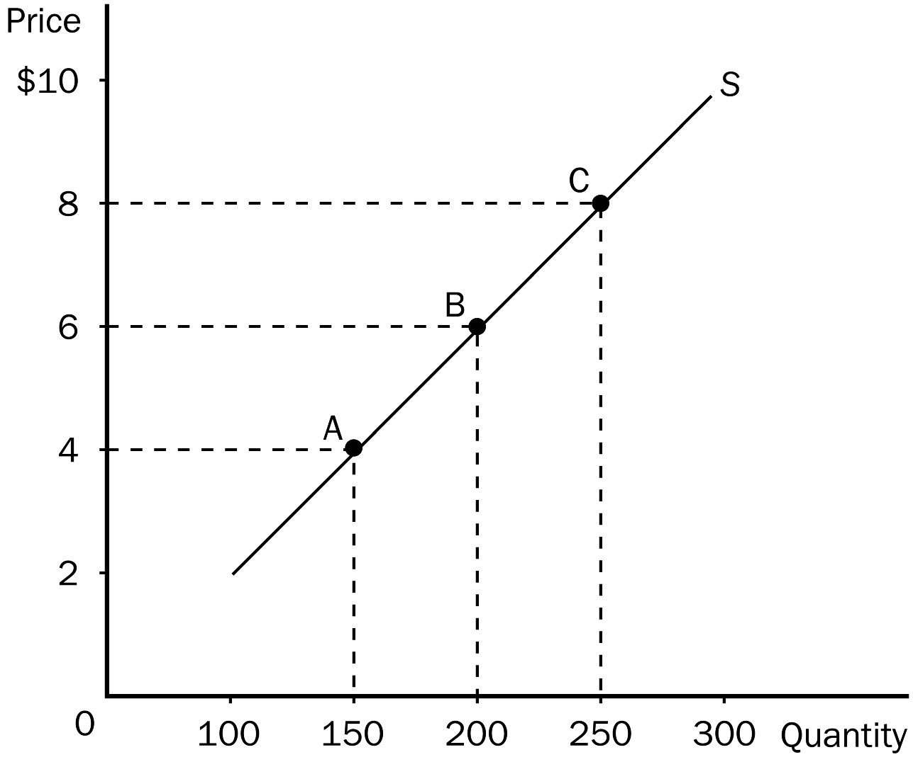
194. Refer to Figure 5-10. The price elasticity of supply between point A and point B, using the midpoint method, is approximately
a. 0.58.
b. 0.71.
c. 1.06.
d. 1.4.
ANS: B PTS: 1 DIF: 2 REF: 5-2
TOP: Price elasticity of supply MSC: Applicative
195. Refer to Figure 5-10. The price elasticity of supply between point B and point C, using the midpoint method, is approximately
a. 1.44.
b. 1.29.
c. 0.96.
d. 0.78.
ANS: D PTS: 1 DIF: 2 REF: 5-2
TOP: Price elasticity of supply MSC: Applicative
196. Refer to Figure 5-10. If, holding the supply curve fixed, there were an increase in demand that caused the equilibrium price to increase from $6 to $8, then sellers’ total revenue would
a. increase.
b. decrease.
c. remain unchanged.
d. The effect on total revenue cannot be determined from the given information.
ANS: A PTS: 1 DIF: 2 REF: 5-2
TOP: Total revenue MSC: Applicative
Figure 5-11
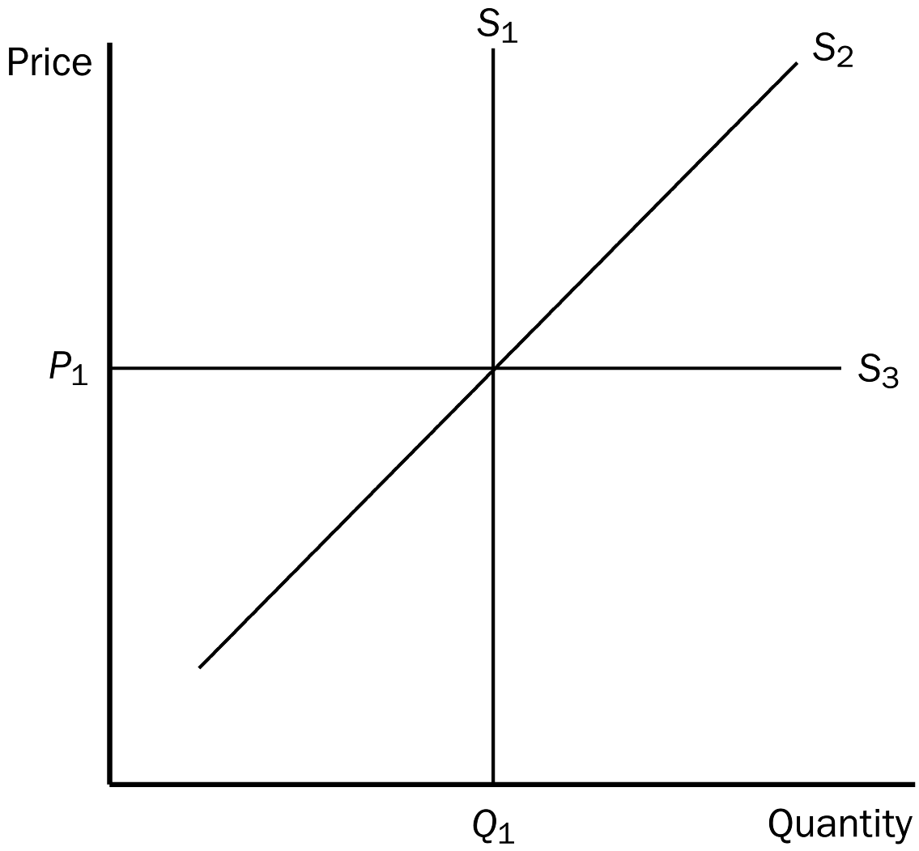
197. Refer to Figure 5-11. Which supply curve represents perfectly inelastic supply?
a. S₁
b. S₂
c. S₃
d. It is impossible to tell without more information.
ANS: A PTS: 1 DIF: 1 REF: 5-2
TOP: Perfectly inelastic supply MSC: Interpretive
198. Refer to Figure 5-11. Which supply curve is most likely relevant over a very long period of time?
a. S₁
b. S₂
c. S₃
d. All of the above are equally likely to be relevant over a very long period of time.
ANS: C PTS: 1 DIF: 2 REF: 5-2
TOP: Perfectly elastic supply MSC: Interpretive
199. Suppose that an increase in the price of carrots from $1.30 to $1.80 per pound increases the quantity of carrots that carrot farmers produce from 1.2 million pounds to 1.6 million pounds. Using the midpoint method, what is the approximate value of the price elasticity of supply?
a. -1.04
b. 0.67
c. 0.89
d. 1.13
ANS: C PTS: 1 DIF: 2 REF: 5-2
TOP: Price elasticity of supply MSC: Applicative
200. An increase in the price of pure chocolate morsels from $2.25 to $2.45 causes suppliers of chocolate morsels to increase their quantity supplied from 125 bags per minute to 145 bags per minute. Supply is
a. elastic and the price elasticity of supply is 1.74.
b. elastic and the price elasticity of supply is 0.57.
c. inelastic and the price elasticity of supply is 1.74.
d. inelastic and the price elasticity of supply is 0.57.
ANS: A PTS: 1 DIF: 3 REF: 5-2
TOP: Price elasticity of supply MSC: Applicative
201. If the supply curve for news magazines is an upward-sloping line and goes through the point (quantity supplied = 0, price = $1.00), then the price elasticity of supply for news magazines is
a. less than one.
b. greater than one.
c. perfectly inelastic.
d. equal to the price elasticity of demand for news magazines.
ANS: B PTS: 1 DIF: 2 REF: 5-2
TOP: Price elasticity of supply MSC: Applicative
202. If a 30 percent change in price causes a 15 percent change in quantity supplied, then the price elasticity of supply is
a. 0.5 and supply is elastic.
b. 0.5 and supply is inelastic.
c. 2 and supply is inelastic.
d. 2 and supply is elastic.
ANS: B PTS: 1 DIF: 3 REF: 5-2
TOP: Price elasticity of supply MSC: Applicative
203. A bakery would be willing to supply 500 bagels per day at a price of $0.50 each. At a price of $0.80, the bakery would be willing to supply 1,100 bagels. Using the midpoint method, the elasticity of supply for bagels is about
a. 0.62.
b. 0.77.
c. 1.24.
d. 1.63.
ANS: D PTS: 1 DIF: 2 REF: 5-2
TOP: Price elasticity of supply MSC: Applicative
204. In the long run, the quantity supplied of most goods
a. will increase in almost all cases, regardless of what happens to price.
b. cannot respond at all to a change in price.
c. can respond to a change in price, but the change is almost always inconsequential.
d. can respond substantially to a change in price.
ANS: D PTS: 1 DIF: 2 REF: 5-2
TOP: Price elasticity of supply | Long run MSC: Interpretive
205. When a supply curve is relatively flat,
a. sellers are not at all responsive to a change in price.
b. the equilibrium price changes substantially when the demand for the good changes.
c. the supply is relatively elastic.
d. the supply is relatively inelastic.
ANS: C PTS: 1 DIF: 2 REF: 5-2
TOP: Inelastic supply MSC: Interpretive
206. In January the price of widgets was $2.00 and Wendy's Widgets produced 80 widgets. In February the price of widgets was $2.50 and Wendy's Widgets produced 110 widgets. In March the price of widgets was $3.00 and Wendy's Widgets produced 140 widgets. The price elasticity of supply of Wendy's Widgets was
a. 0.70 when the price increased from $2.00 to $2.50 and 0.76 when the price increased from $2.50 to $3.00.
b. 0.88 when the price increased from $2.00 to $2.50 and 1.08 when the price increased from $2.50 to $3.00.
c. 1.42 when the price increased from $2.00 to $2.50 and 1.32 when the price increased from $2.50 to $3.00.
d. 1.50 when the price increased from $2.00 to $2.50 and 1.18 when the price increased from $2.50 to $3.00.
ANS: C PTS: 1 DIF: 3 REF: 5-2
TOP: Price elasticity of supply MSC: Applicative
207. If sellers do not adjust their quantities supplied at all in response to a change in price,
a. advances in technology must be prevalent.
b. the time period under consideration must be very long.
c. supply is perfectly elastic.
d. supply is perfectly inelastic.
ANS: D PTS: 1 DIF: 2 REF: 5-2
TOP: Perfectly inelastic supply MSC: Interpretive
208. If an increase in the price of a good results in an increase in total revenue for the firm, then the supply of the good must be
a. unit elastic.
b. inelastic.
c. elastic.
d. Nothing can be said about price elasticity of supply from the information given.
ANS: D PTS: 1 DIF: 2 REF: 5-2
TOP: Price elasticity of supply | Total revenue MSC: Applicative
209. If the price elasticity of supply for wheat is less than 1, then the supply of wheat is
a. inelastic.
b. elastic.
c. unit elastic.
d. quite sensitive to change in price.
ANS: A PTS: 1 DIF: 2 REF: 5-2
TOP: Inelastic supply MSC: Interpretive
210. If the price elasticity of supply is zero, then
a. supply is more elastic than it is in any other case.
b. the supply curve is horizontal.
c. the quantity supplied is the same, regardless of price.
d. a change in demand will cause a relatively small change in the equilibrium price.
ANS: C PTS: 1 DIF: 2 REF: 5-2
TOP: Perfectly inelastic supply MSC: Interpretive
211. If two supply curves pass through the same point and one is steep and the other is flat, which of the following statements is correct?
a. The flatter supply curve represents a supply that is inelastic relative to the supply represented by the steeper supply curve.
b. The steeper supply curve represents a supply that is inelastic relative to the supply represented by the flatter supply curve.
c. Given two prices with which to calculate the price elasticity of supply, that elasticity is the same for both curves.
d. A decrease in demand will increase total revenue if the steeper supply curve is relevant, while a decrease in demand will decrease total revenue if the flatter supply cure is relevant.
ANS: B PTS: 1 DIF: 2 REF: 5-2
TOP: Price elasticity of supply MSC: Interpretive
212. Which of the following statements is valid when the market supply curve is vertical?
a. Market quantity supplied does not change when the price changes.
b. Supply is perfectly elastic.
c. An increase in market demand will increase the equilibrium quantity.
d. An increase in market demand will not increase the equilibrium price.
ANS: A PTS: 1 DIF: 2 REF: 5-2
TOP: Perfectly inelastic supply MSC: Interpretive
213. Which of the following statements is not valid when supply is perfectly elastic?
a. The elasticity of supply approaches infinity.
b. The supply curve is horizontal.
c. Very small changes in price lead to large changes in quantity supplied.
d. The time period under consideration is more likely a short period rather than a long period.
ANS: D PTS: 1 DIF: 3 REF: 5-2
TOP: Perfectly elastic supply MSC: Applicative
214. A linear, upward-sloping supply curve has
a. a constant slope and a changing elasticity of supply.
b. a changing slope and a constant elasticity of supply.
c. both a constant slope and a constant elasticity of supply.
d. both a changing slope and a changing elasticity of supply.
ANS: A PTS: 1 DIF: 2 REF: 5-2
TOP: Price elasticity of supply MSC: Interpretive
215. If the quantity supplied is the same regardless of price, then supply is
a. elastic.
b. perfectly elastic.
c. perfectly inelastic.
d. inelastic.
ANS: C PTS: 1 DIF: 2 REF: 5-2
TOP: Perfectly inelastic supply MSC: Definitional
216. When supply is perfectly elastic, the value of the price elasticity of supply is
a. 0.
b. 1.
c. greater than 0 and less than 1.
d. infinity.
ANS: D PTS: 1 DIF: 2 REF: 5-2
TOP: Perfectly elastic supply MSC: Interpretive
217. As price elasticity of supply increases, the supply curve
a. becomes flatter.
b. becomes steeper.
c. becomes downward sloping.
d. shifts to the right.
ANS: A PTS: 1 DIF: 2 REF: 5-2
TOP: Price elasticity of supply MSC: Interpretive
218. Which of the following would be true as the price elasticity of supply approaches infinity?
a. Very small changes in price lead to very large changes in quantity supplied.
b. Very large changes in price lead to very small changes in quantity supplied.
c. Very small changes in price lead to no change in quantity supplied.
d. Very large changes in price lead to no change in quantity supplied.
ANS: A PTS: 1 DIF: 2 REF: 5-2
TOP: Perfectly elastic supply MSC: Interpretive
219. A key determinant of the price elasticity of supply is the time period under consideration. Which of the following statements best explains this fact?
a. Supply curves are steeper over long periods of time than over short periods of time.
b. Buyers of goods tend to be more responsive to price changes over long periods of time than over short periods of time.
c. The number of firms in a market tends to be more variable over short periods of time than over long periods of time.
d. Firms tend to be more responsive to price changes over long periods of time than over short periods of time.
ANS: D PTS: 1 DIF: 2 REF: 5-2
TOP: Price elasticity of supply MSC: Interpretive
220. Some firms eventually experience problems with their capacity to produce output as their output levels increase. For these firms,
a. market power is substantial.
b. supply is perfectly inelastic.
c. supply is more elastic at low levels of output and less elastic at high levels of output.
d. supply is less elastic at low levels of output and more elastic at high levels of output.
ANS: C PTS: 1 DIF: 3 REF: 5-2
TOP: Price elasticity of supply MSC: Applicative
Figure 5-12
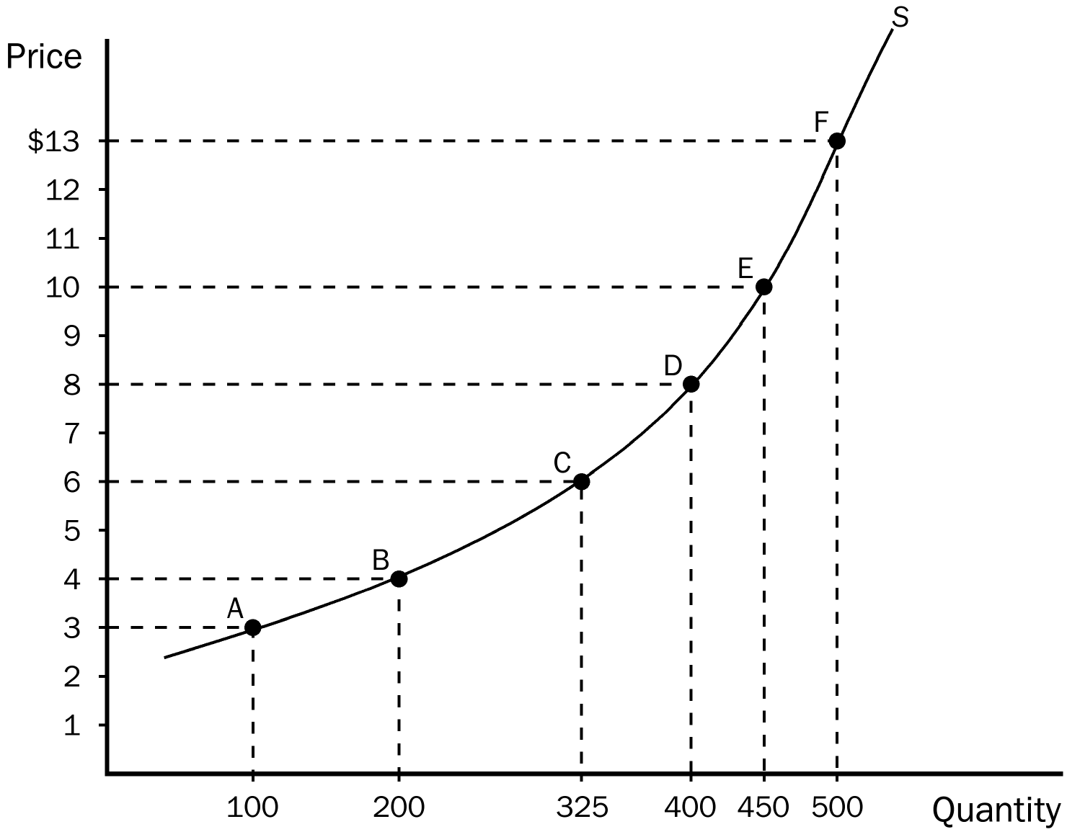
221. Refer to Figure 5-12. Along which of these segments of the supply curve is supply least elastic?
a. between E and F
b. between C and D
c. between A and C
d. between A and B
ANS: A PTS: 1 DIF: 2 REF: 5-2
TOP: Price elasticity of supply MSC: Applicative
222. Refer to Figure 5-12. Along which of these segments of the supply curve is supply most elastic?
a. between A and B
b. between C and D
c. between D and F
d. between E and F
ANS: A PTS: 1 DIF: 2 REF: 5-2
TOP: Price elasticity of supply MSC: Applicative
223. Refer to Figure 5-12. Using the midpoint method, what is the price elasticity of supply between points D and E?
a. 1.89
b. 1.26
c. 0.53
d. 0.34
ANS: C PTS: 1 DIF: 2 REF: 5-2
TOP: Price elasticity of supply MSC: Applicative
224. Refer to Figure 5-12. Using the midpoint method, what is the price elasticity of supply between points B and C?
a. 1.67
b. 1.19
c. 0.84
d. 0.61
ANS: B PTS: 1 DIF: 2 REF: 5-2
TOP: Price elasticity of supply MSC: Applicative
225. Generally, a firm is more willing and able to increase quantity supplied in response to a price change when
a. the relevant time period is short rather than long.
b. the relevant time period is long rather than short.
c. supply is inelastic.
d. the firm is experiencing capacity problems.
ANS: B PTS: 1 DIF: 2 REF: 5-2
TOP: Price elasticity of supply MSC: Applicative
Table 5-2
 | Supply Curve A |  | Supply Curve B |  | Supply Curve C
Price | $1.00 | $2.00 | $1.00 | $3.00 | $2.00 | $5.00
Quantity  Supplied | 500 | 600 | 600 | 900 | 400 | 700

226. Refer to Table 5-2. Which of the three supply curves represents the least elastic supply?
a. supply curve A
b. supply curve B
c. supply curve C
d. There is no difference in the elasticity of the three supply curves.
ANS: A PTS: 1 DIF: 2 REF: 5-2
TOP: Price elasticity of supply MSC: Applicative
227. Refer to Table 5-2. Which of the three supply curves represents the most elastic supply?
a. supply curve A
b. supply curve B
c. supply curve C
d. There is no difference in the elasticity of the three supply curves.
ANS: C PTS: 1 DIF: 2 REF: 5-2
TOP: Price elasticity of supply MSC: Applicative
228. Refer to Table 5-2. Along which of the supply curves does quantity supplied move proportionately more than the price?
a. along supply curve B only
b. along supply curves B and C
c. along all three supply curves
d. Quantity supplied moves proportionately more than the price along none of the three supply curves.
ANS: D PTS: 1 DIF: 3 REF: 5-2
TOP: Price elasticity of supply MSC: Applicative
229. The discovery of a new hybrid wheat would increase the supply of wheat. As a result, wheat farmers would realize an increase in total revenue if
a. the supply of wheat is elastic.
b. the supply of wheat is inelastic.
c. the demand for wheat is inelastic.
d. the demand for wheat is elastic.
ANS: D PTS: 1 DIF: 2 REF: 5-3
TOP: Supply | Price elasticity of demand | Total revenue MSC: Applicative
230. Because the demand for wheat tends to be inelastic, the development of a new, more productive hybrid wheat would tend to
a. increase the total revenue of wheat farmers.
b. decrease the total revenue of wheat farmers.
c. decrease the demand for wheat.
d. decrease the supply of wheat.
ANS: B PTS: 1 DIF: 2 REF: 5-3
TOP: Supply | Price elasticity of demand | Total revenue MSC: Applicative
231. Knowing that the demand for wheat is inelastic, if all farmers voluntarily plowed under 10 percent of their wheat crop, then
a. consumers of wheat would buy more wheat.
b. wheat farmers would suffer a reduction in their total revenue.
c. wheat farmers would experience an increase in their total revenue.
d. the demand for wheat would decrease.
ANS: C PTS: 1 DIF: 2 REF: 5-3
TOP: Supply | Price elasticity of demand | Total revenue MSC: Applicative
232. Technological advances in wheat production can lower farmers' total revenue because the
a. demand for wheat is inelastic.
b. demand for wheat is elastic.
c. supply of wheat is elastic.
d. supply of wheat is inelastic.
ANS: A PTS: 1 DIF: 2 REF: 5-2
TOP: Price elasticity of demand | Total revenue MSC: Applicative
233. When a technological advance in wheat production is developed and applied to wheat farming, which of the following consequences is most likely?
a. The price of wheat decreases by 6 percent and the quantity of wheat sold increases by 10 percent.
b. The price of wheat decreases by 10 percent and the quantity of wheat sold increases by 6 percent.
c. Wheat farmers' total revenue increases.
d. All of the above are equally likely.
ANS: B PTS: 1 DIF: 2 REF: 5-3
TOP: Price elasticity of demand | Total revenue MSC: Applicative
234. If corn farmers know that the demand for corn is inelastic, and they want to increase their total revenue, they should all
a. plant more corn so that they would be able to sell more each year.
b. increase spending on fertilizer in an attempt to produce more corn on the acres they farm.
c. reduce the number of acres they plant in corn.
d. contribute to a fund that promotes technological advances in corn production.
ANS: C PTS: 1 DIF: 2 REF: 5-3
TOP: Price elasticity of demand | Total revenue MSC: Applicative
235. Which of the following was not a reason OPEC failed to keep the price of oil high?
a. Over the long run, producers of oil outside of OPEC responded to higher prices by increasing oil exploration and by building new extraction capacity.
b. Consumers responded to higher prices with greater conservation.
c. Consumers replaced old inefficient cars with newer efficient ones.
d. The agreement OPEC members signed allowed each country to produce as much oil as each wanted.
ANS: D PTS: 1 DIF: 2 REF: 5-3
TOP: OPEC MSC: Applicative
236. OPEC successfully raised the world price of oil in the 1970s and early 1980s, primarily due to
a. an inelastic demand for oil and a reduction in the amount of oil supplied.
b. a reduction in the amount of oil supplied and a world-wide oil embargo.
c. a world-wide oil embargo and an elastic demand for oil.
d. a reduction in the amount of oil supplied and an elastic demand for oil.
ANS: A PTS: 1 DIF: 2 REF: 5-3
TOP: OPEC MSC: Applicative
237. In the market for oil in the short run, demand
a. and supply are both elastic.
b. and supply are both inelastic.
c. is elastic and supply is inelastic.
d. is inelastic and supply is elastic.
ANS: B PTS: 1 DIF: 2 REF: 5-3
TOP: Price elasticity of demand | Price elasticity of supply MSC: Interpretive
238. A decrease in supply will cause the largest increase in price when
a. both supply and demand are inelastic.
b. both supply and demand are elastic.
c. demand is elastic and supply is inelastic.
d. demand is inelastic and supply is elastic.
ANS: A PTS: 1 DIF: 3 REF: 5-3
TOP: Price elasticity of demand | Price elasticity of supply MSC: Analytical
239. A decrease in supply will cause the smallest increase in price when
a. both supply and demand are inelastic.
b. demand is elastic and supply is inelastic.
c. both supply and demand are elastic.
d. demand is inelastic and supply is elastic.
ANS: C PTS: 1 DIF: 3 REF: 5-3
TOP: Price elasticity of demand | Price elasticity of supply MSC: Analytical
240. Which of the following statements does not help to explain why government drug interdiction increases drug-related crime?
a. The demand for illegal drugs is inelastic.
b. Interdiction results in drug addicts having a greater need for quick cash.
c. Interdiction results in an increase in the amount of money needed to buy the same amount of drugs.
d. Government drug programs are more lenient now with drug offenders than they were in the 1980s.
ANS: D PTS: 1 DIF: 2 REF: 5-3
TOP: Government | Price elasticity of demand MSC: Applicative
241. Which of the following statements is not correct concerning government attempts to reduce the flow of illegal drugs into the country?
a. Drug interdiction raises prices and total revenue in the drug market.
b. Drug interdiction can increase drug-related crime.
c. Drug interdiction shifts the demand curve for drugs to the left.
d. Drug interdiction shifts the supply curve of drugs to the left.
ANS: C PTS: 1 DIF: 2 REF: 5-3
TOP: Government | Demand | Supply MSC: Applicative
242. Given the market for illegal drugs, when the government is successful in reducing the flow of drugs into the United States,
a. supply decreases, demand is unaffected, and price increases.
b. demand decreases, supply is unaffected, and price decreases.
c. demand and supply both decrease, leaving price essentially unchanged.
d. supply decreases, demand increases, and price increases substantially as a result.
ANS: A PTS: 1 DIF: 2 REF: 5-3
TOP: Government | Demand | Supply MSC: Applicative
243. There are fewer farmers in the United States today than 200 years ago because of
a. more educational opportunities and increases in farm technology.
b. increased government regulations in farming and increased farm technology.
c. an elastic demand for food and more attractive urban alternatives to farming.
d. increases in farm technology and an inelastic demand for food.
ANS: D PTS: 1 DIF: 2 REF: 5-3
TOP: Technology | Inelastic demand MSC: Applicative
244. How did the farm population in the United States change between 1950 and 2000?
a. It dropped from 10 million to fewer than 3 million people.
b. It dropped from 20 million to fewer than 5 million people.
c. It dropped from 30 million to just over 6 million people.
d. It increased from 10 million to almost 12 million people.
ANS: A PTS: 1 DIF: 1 REF: 5-3
TOP: Population MSC: Definitional
245. Between 1950 and 2000 there was a
a. 20 percent drop in the number of farmers, but farm output more than tripled.
b. 30 percent drop in the number of farmers, but farm output more than tripled.
c. 50 percent drop in the number of farmers, but farm output more than doubled.
d. 70 percent drop in the number of farmers, but farm output more than doubled.
ANS: D PTS: 1 DIF: 2 REF: 5-3
TOP: Population | Output MSC: Definitional
246. An advance in farm technology that results in an increased market supply is
a. good for farmers because it raises prices for their products, but bad for consumers because it raises prices consumers pay for food.
b. bad for farmers because total revenue will fall, but good for consumers because prices for food will fall.
c. good for farmers because it raises prices for their products, and also good for consumers because more output is available for consumption.
d. bad for farmers because total revenue will fall, and bad for consumers because farmers will raise the price of food to increase their total revenue.
ANS: B PTS: 1 DIF: 2 REF: 5-3
TOP: Technology | Supply MSC: Applicative
247. Farm programs that pay farmers not to plant crops on all their land
a. hurt farmers by lowering their total revenue, and hurt consumers by causing shortages of some food items.
b. help farmers by cutting costs, which helps consumers by lowering food prices.
c. help farmers by increasing total revenue in the market, but hurt consumers by raising prices.
d. help farmers directly since they receive government payments, but has no real effect on consumers.
ANS: C PTS: 1 DIF: 2 REF: 5-3
TOP: Total revenue MSC: Applicative
248. If marijuana were legalized, it is likely that there would be an increase in the supply of marijuana. Advocates of marijuana legalization argue that this would significantly reduce the amount of revenue going to the criminal organizations that currently supply marijuana. These advocates believe that the
a. supply for marijuana is elastic.
b. demand for marijuana is elastic.
c. supply for marijuana is inelastic.
d. demand for marijuana is inelastic.
ANS: D PTS: 1 DIF: 2 REF: 5-3
TOP: Price elasticity of demand | Total revenue MSC: Applicative
249. Under which of the following conditions would the interdiction of illegal drugs result in a decrease in the quantity of drugs sold and in a decrease in total spending on illegal drugs by drug users?
a. The interdiction has the effect of shifting the demand curve for illegal drugs to the right.
b. The price elasticity of demand for illegal drugs is 1.3.
c. The price elasticity of supply for illegal drugs is 0.8.
d. As a result of the interdiction, the price of illegal drugs increases by 20 percent and the quantity of illegal drugs sold decreases by 16 percent.
ANS: B PTS: 1 DIF: 2 REF: 5-3
TOP: Price elasticity of demand | Total revenue MSC: Applicative
True/False
1. Demand for a good is said to be inelastic if the quantity demanded increases substantially when the price falls by a small amount.
ANS: F PTS: 1 DIF: 1 REF: 5-1
TOP: Inelastic demand MSC: Definitional
2. Necessities tend to have inelastic demands, whereas luxuries have elastic demands.
ANS: T PTS: 1 DIF: 2 REF: 5-1
TOP: Price elasticity of demand MSC: Interpretive
3. Goods with close substitutes tend to have more elastic demands than do goods without close substitutes.
ANS: T PTS: 1 DIF: 2 REF: 5-1
TOP: Price elasticity of demand | Substitutes MSC: Interpretive
4. The demand for Rice Krispies is more elastic than the demand for cereal in general.
ANS: T PTS: 1 DIF: 2 REF: 5-1
TOP: Price elasticity of demand MSC: Interpretive
5. The demand for gasoline will respond more to a change in price over a period of five weeks than over a period of five years.
ANS: F PTS: 1 DIF: 2 REF: 5-1
TOP: Price elasticity of demand MSC: Interpretive
6. The price elasticity of demand is defined as the percentage change in quantity demanded divided by the percentage change in price.
ANS: T PTS: 1 DIF: 1 REF: 5-1
TOP: Price elasticity of demand MSC: Definitional
7. If the price of calculators increases by 15 percent and the quantity demanded per week falls by 45 percent as a result, then the price elasticity of demand is 3.
ANS: T PTS: 1 DIF: 2 REF: 5-1
TOP: Price elasticity of demand MSC: Applicative
8. Demand is inelastic if the price elasticity of demand is greater than 1.
ANS: F PTS: 1 DIF: 1 REF: 5-1
TOP: Inelastic demand MSC: Definitional
9. If the price elasticity of demand is equal to 0, then demand is unit elastic.
ANS: F PTS: 1 DIF: 1 REF: 5-1
TOP: Price elasticity of demand MSC: Definitional
10. The midpoint method is used to calculate elasticity between two points because it gives the same answer regardless of the direction of the change.
ANS: T PTS: 1 DIF: 2 REF: 5-1
TOP: Midpoint method MSC: Interpretive
11. The flatter the demand curve that passes through a given point, the more inelastic the demand.
ANS: F PTS: 1 DIF: 2 REF: 5-1
TOP: Price elasticity of demand MSC: Interpretive
12. If demand is perfectly inelastic, the demand curve is vertical, and elasticity is equal to 0.
ANS: T PTS: 1 DIF: 2 REF: 5-1
TOP: Perfectly inelastic demand MSC: Interpretive
13. When demand is inelastic, a decrease in price increases total revenue.
ANS: F PTS: 1 DIF: 2 REF: 5-1
TOP: Inelastic demand | Total revenue MSC: Interpretive
14. A linear, downward-sloping demand curve has constant elasticity, but not constant slope.
ANS: F PTS: 1 DIF: 2 REF: 5-1
TOP: Demand curve | Price elasticity of demand MSC: Interpretive
15. Price elasticity of demand along a linear, downward-sloping demand curve increases as price falls.
ANS: F PTS: 1 DIF: 2 REF: 5-1
TOP: Price elasticity of demand MSC: Interpretive
16. The income elasticity of demand is defined as the percentage change in quantity demanded divided by the percentage change in income.
ANS: T PTS: 1 DIF: 1 REF: 5-1
TOP: Income elasticity of demand MSC: Definitional
17. Normal goods have negative income elasticities of demand, while inferior goods have positive income elasticities of demand.
ANS: F PTS: 1 DIF: 2 REF: 5-1
TOP: Normal goods | Inferior goods MSC: Interpretive
18. Cross-price elasticity of demand measures how the quantity demanded of one good changes as the price of another good changes.
ANS: T PTS: 1 DIF: 1 REF: 5-1
TOP: Cross-price elasticity of demand MSC: Definitional
19. Cross-price elasticity is used to determine whether goods are inferior or normal goods.
ANS: F PTS: 1 DIF: 2 REF: 5-1
TOP: Cross-price elasticity of demand MSC: Interpretive
20. Price elasticity of supply measures how much the quantity supplied responds to changes in the price.
ANS: T PTS: 1 DIF: 1 REF: 5-2
TOP: Price elasticity of supply MSC: Definitional
21. Supply is said to be inelastic if the quantity supplied responds substantially to changes in the price, and elastic if the quantity supplied responds only slightly to price.
ANS: F PTS: 1 DIF: 1 REF: 5-2
TOP: Price elasticity of supply MSC: Definitional
22. Supply tends to be more elastic in the short run and more inelastic in the long run.
ANS: F PTS: 1 DIF: 2 REF: 5-2
TOP: Price elasticity of supply MSC: Interpretive
23. When the price of knee braces increased by 25 percent, the Brace Yourself Company increased its quantity supplied of knee braces per week by 75 percent. BYC's price elasticity of supply of knee braces is 0.33.
ANS: F PTS: 1 DIF: 2 REF: 5-2
TOP: Price elasticity of supply MSC: Applicative
24. If a supply curve is horizontal then supply is said to be perfectly elastic and the price elasticity of supply approaches infinity.
ANS: T PTS: 1 DIF: 2 REF: 5-2
TOP: Perfectly elastic supply MSC: Interpretive
25. A government program that reduces land under cultivation hurts farmers but helps consumers.
ANS: F PTS: 1 DIF: 2 REF: 5-3
TOP: Total revenue MSC: Applicative
26. OPEC failed to maintain a high price of oil in the long run, partly because both the supply of oil and the demand for oil are more elastic in the long run than in the short run.
ANS: T PTS: 1 DIF: 2 REF: 5-3
TOP: OPEC | Price elasticity of demand | Price elasticity of supply MSC: Applicative
27. Drug interdiction, which reduces the supply of drugs, may decrease drug-related crime because the demand for drugs is inelastic.
ANS: F PTS: 1 DIF: 2 REF: 5-3
TOP: Price elasticity of demand MSC: Applicative
Short Answer
1. Consider the following pairs of goods. For which of the two goods would you expect the demand to be more price elastic? Why?
a. water or diamonds
b. insulin or nasal decongestant spray
c. food in general or breakfast cereal
d. gasoline over the course of a week or gasoline over the course of a year
e. personal computers or IBM personal computers
ANS:
a. Diamonds are luxuries, and water is a necessity. Therefore, diamonds have the more elastic demand.
b. Insulin has no close substitutes, but decongestant spray does. Therefore, nasal decongestant spray has the more elastic demand.
c. Breakfast cereal has more substitutes than does food in general. Therefore, breakfast cereal has the more elastic demand.
d. The longer the time period, the more elastic demand is. Therefore, gasoline over the course of a year has the more elastic demand.
e. There are more substitutes for IBM personal computers than there are for personal computers. Therefore, IBM personal computers have the more elastic demand.
PTS: 1 DIF: 2 REF: 5-1
TOP: Price elasticity of demand MSC: Applicative
2. You own a small town movie theatre. You currently charge $5 per ticket for everyone who comes to your movies. Your friend who took an economics course in college tells you that there may be a way to increase your total revenue. Given the demand curves shown, answer the following questions.

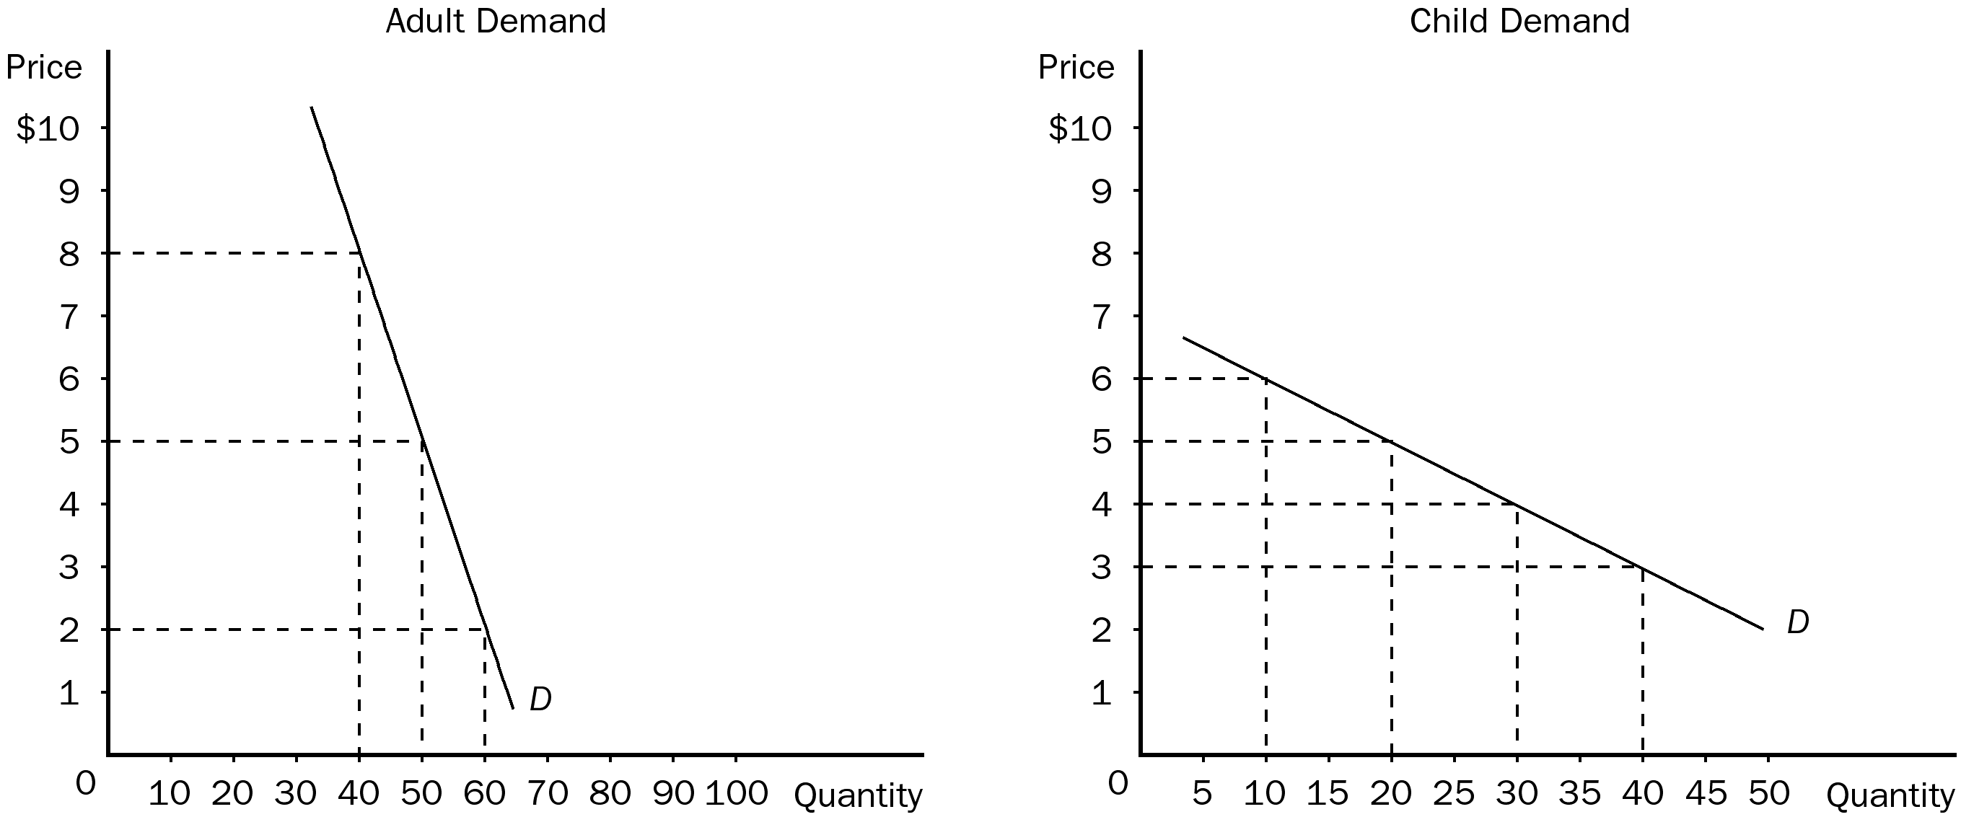

a. What is your current total revenue for both groups?
b. The elasticity of demand is more elastic in which market?
c. Which market has the more inelastic demand?
d. What is the elasticity of demand between the prices of $5 and $2 in the adult market? Is this elastic or inelastic?
e. What is the elasticity of demand between $5 and $3 in the children's market? Is this elastic or inelastic?
f. Given the graphs and what your friend knows about economics, he recommends you increase the price of adult tickets to $8 each and lower the price of a child's ticket to $3. How much could you increase total revenue if you take his advice?
ANS:
a. Total revenue from children's tickets is $100 and from adult tickets is $250. Total revenue from all sales would be $350.
b. the demand for children's tickets is more elastic.
c. The adult ticket market has the more inelastic demand.
d. The elasticity of demand between $5 and $2 is 0.26 or inelastic.
e. The elasticity of demand between $5 and $3 is 1.33 or elastic.
f. If price is increased to $8 for adult tickets (maximum for the graph) and price decreased to $3 for child tickets (minimum for graph), total revenue would increase to $440 [($8)(40) + ($3)(40)] or $90 more than before.
PTS: 1 DIF: 2 REF: 5-1
TOP: Price elasticity of demand | Total revenue MSC: Applicative
3. Use the graph shown to answer the following questions. Put the correct letter in the blank.
a. The elastic section of the graph is represented by section _______.
b. The inelastic section of the graph is represented by section _______.
c. The unit elastic section of the graph is represented by section _______.
d. The portion of the graph in which a decrease in price would cause total revenue to fall would be _________.
e. The portion of the graph in which a decrease in price would cause total revenue to rise would be _________.
f. The portion of the graph in which a decrease in price would not cause a change in total revenue would be _________.
g. The section of the graph in which total revenue would be at a maximum would be _______.
h. The section of the graph in which elasticity is greater than 1 is _______.
i. The section of the graph in which elasticity is equal to 1 is ______.
j. The section of the graph in which elasticity is less than 1 is _______.
ANS:
a. A
b. C
c. B
d. C
e. A
f. B
g. B
h. A
i. B
j. C
PTS: 1 DIF: 2 REF: 5-1
TOP: Price elasticity of demand | Total revenue MSC: Applicative
4. Using the midpoint method, compute the elasticity of demand between points A and B. Is demand along this portion of the curve elastic or inelastic? Interpret your answer with regard to price and quantity demanded. Now compute the elasticity of demand between points B and C. Is demand along this portion of the curve elastic or inelastic?
ANS:
In the section of the demand curve from A to B, the elasticity of demand would be 2.5. This would be an elastic portion of the curve. This would mean that for every 1 percent change in price, quantity demanded would change by 2.5 percent.
In the section of the demand curve from B to C, the elasticity of demand would be .75. This would be an inelastic portion of the curve. This would mean that for every 1 percent change in price, quantity demanded would change by 0.75 percent.
PTS: 1 DIF: 2 REF: 5-1
TOP: Price elasticity of demand MSC: Applicative
5. When the Shaffers had a monthly income of $4,000, they usually ate out 8 times a month. Now that the couple makes $4,500 a month, they eat out 10 times a month. Compute the couple's income elasticity of demand using the midpoint method. Explain your answer. (Is a restaurant meal a normal or inferior good to the couple?)
ANS:
The income elasticity of demand for the Shaffers is 1.89. Since the income elasticity of demand is positive, this would be interpreted as a normal good.
PTS: 1 DIF: 2 REF: 5-1
TOP: Income elasticity of demand MSC: Applicative
6. Recently, in Smalltown, the price of Twinkies fell from $0.80 to $0.70. As a result, the quantity demanded of Ho-Ho's decreased from 120 to 100. What would be the appropriate elasticity to compute? Using the midpoint method, compute this elasticity. What does your answer tell you?
ANS:
The appropriate elasticity to compute would be cross-price elasticity. The cross-price elasticity for this example would be 1.36. The two goods are substitutes because the cross-price elasticity is positive.
PTS: 1 DIF: 2 REF: 5-1
TOP: Cross-price elasticity of demand MSC: Applicative

