尚硅谷大数据技术之Airflow
(作者：尚硅谷大数据研发部)

版本：V3.0

第1章 Airflow基本概念

1.1 概述
Airflow是一个以编程方式编写，安排和监视工作流的平台。
使用Airflow将工作流编写任务的有向无环图(DAG)。Aiflow计划程序在遵循指定的依赖项同时在一组工作线程上执行任务。丰富的命令实用程序使在DAG上执行复杂的调度变的轻而易举。丰富的用户界面使查看生产中正在运行的管道，监视进度以及需要时对问题进行故障排除变的容易。

1.2 名词
（1）Dynamic：Airflow配置需要实用Python,允许动态生产管道。这允许编写可动态。这允许编写可动态实例化管道的代码
（2）Extensible：轻松定义自己的运算符，执行程序并扩展库，使其适合于您的 的环境
（3）Elegant：Airlfow是精简的，使用功能强大的Jinja模板引擎，将脚本参数化内置于Airflow的核心中
（4）Scalable：Airflow具有模板块架构，并使用消息队列来安排任意数量的工作任务。

第2章 Airflow安装(1.10.14)

2.1 Airflow官网
https://airflow.apache.org

2.2 安装环境准备
阿里云 centos7.5 Python2.7.5 Pip 20.3.1 openssl1.02(重要)
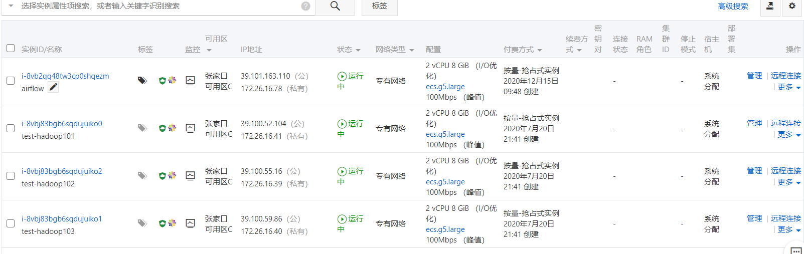
hadoop101,hadoop102,hadoop103为hadoop集群，airflow节点部署airlfow
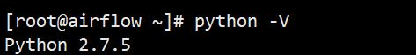

2.2.1升级PIP
[root@airflow ~]# pip install --upgrade pip
[root@airflow ~]# pip -V
pip 20.3.1 from /usr/lib/python2.7/site-packages/pip (python 2.7)
[root@airflow ~]# pip install --upgrade setuptools

2.2.2安装Miniconda
conda是一个开源的包、环境管理器，可以用于在同一个机器上安装不同Python版本的软件包及其依赖，并能够在不同的Python环境之间切换，Anaconda包括Conda、Python以及一大堆安装好的工具包，比如：numpy、pandas等，Miniconda包括Conda、Python。
此处，我们不需要如此多的工具包，故选择MiniConda。
1）下载Miniconda（Python3版本）
下载地址：https://repo.anaconda.com/miniconda/Miniconda3-latest-Linux-x86_64.sh
[root@airflow ~]# mkdir /opt/software
[root@airflow ~]# cd /opt/software/
[root@airflow software]# wget https://repo.anaconda.com/miniconda/Miniconda3-latest-Linux-x86_64.sh
- 安装Miniconda
[root@airflow software]# bash Miniconda3-latest-Linux-x86_64.sh

（1）在安装过程中，出现以下提示时，可以指定安装路径
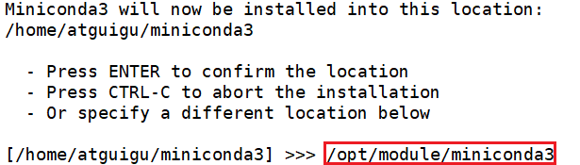
（2）出现以下字样，即为安装完成
3）加载环境变量配置文件，使之生效
[root@airflow software]# source ~/.bashrc
Miniconda安装完成后，每次打开终端都会激活其默认的base环境，我们可通过以下命令，禁止激活默认base环境。
[root@airflow software]# conda config --set auto_activate_base false

2.2.2安装Python3.7.4
1）配置conda国内镜像
[root@airflow ~]# conda config --add channels https://mirrors.tuna.tsinghua.edu.cn/anaconda/pkgs/free
[root@airflow ~]# conda config --add channels https://mirrors.tuna.tsinghua.edu.cn/anaconda/pkgs/main
[root@airflow ~]# conda config --set show_channel_urls yes
[root@airflow ~]# conda create --name python3 python=3.7.4
说明：conda环境管理常用命令
创建环境：conda create -n env_name
查看所有环境：conda info --envs
删除一个环境：conda remove -n env_name --all
2）激活python3环境
[root@airflow ~]# conda activate python3
(python3) [root@airflow ~]# python -V
Python 3.7.4
3）退出python3环境
(python3) [root@airflow ~]# conda deactivate
[root@airflow ~]# python -V
Python 2.7.5

2.2.2安装Airflow
（1）安装airflow,先切换到python3环境
[root@airflow ~]# conda activate python3
(python3) [root@airflow ~]# cd /opt/software/
(python3) [root@airflow software]# pip install "apache-airflow==1.10.14"
- 初始化airflow
(python3) [root@airflow software]# airflow db init
- 查看版本
(python3) [root@airflow software]# airflow version
1.10.14
- airflow安装好存放路径
(python3) [root@airflow airflow]# pwd
/root/airflow
- 启动airflow web服务,启动后浏览器访问http://airflow:8080
(python3) [root@airflow airflow]# airflow webserver -p 8080 -D
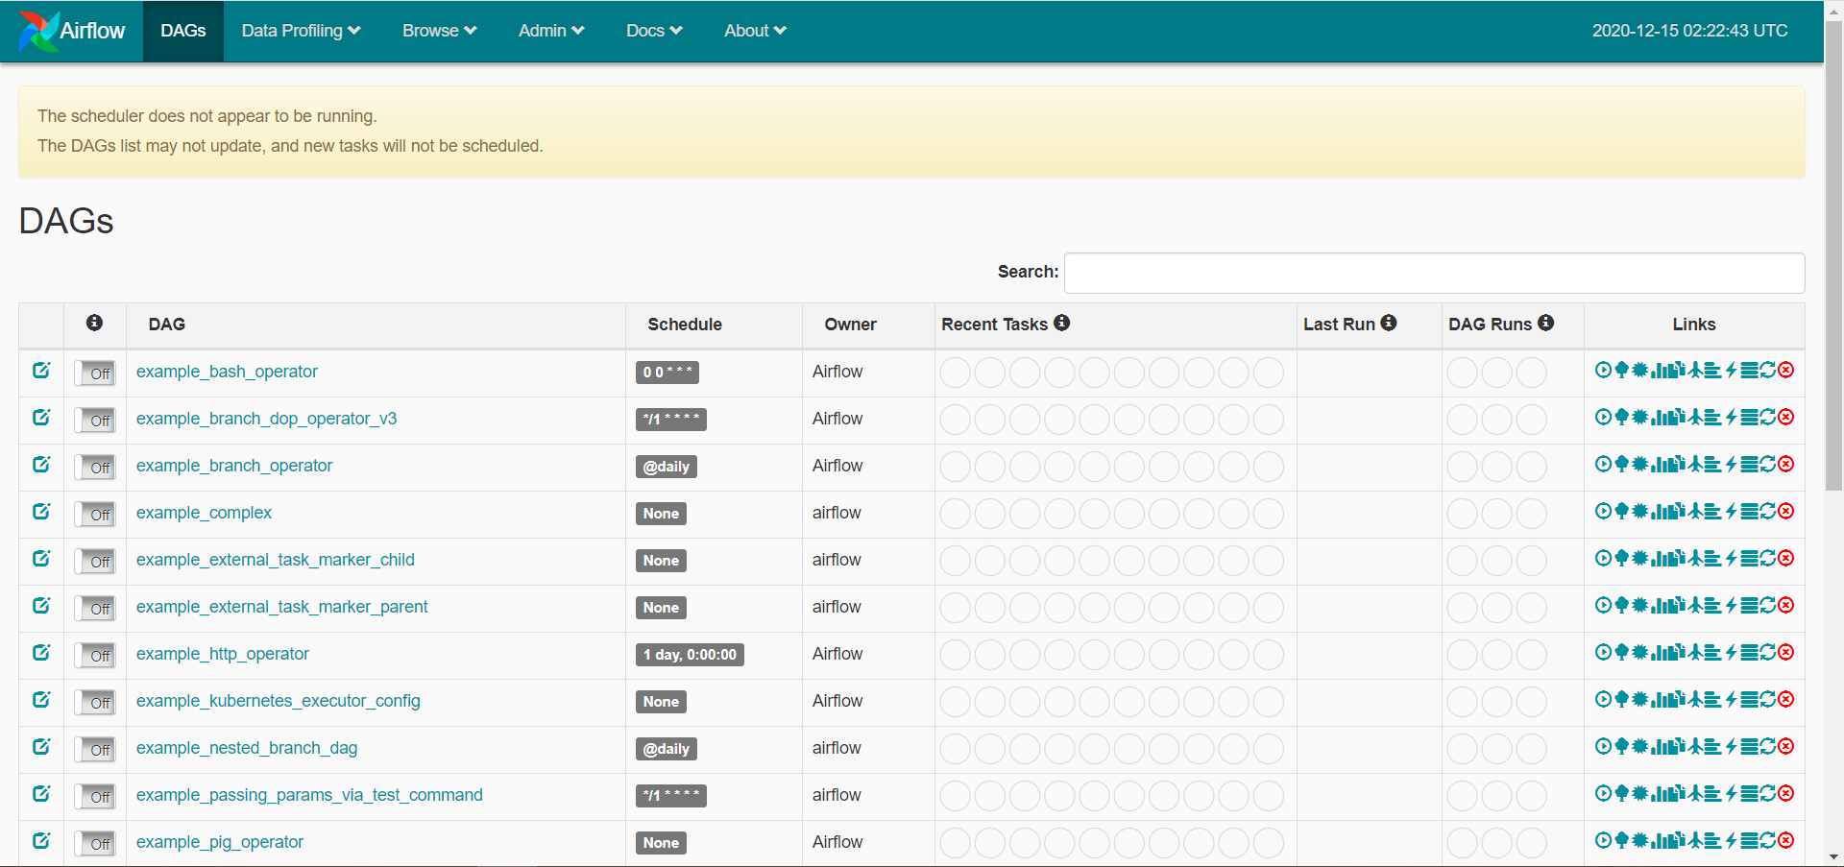
- 启动airflow调度
(python3) [root@airflow airflow]# airflow scheduler -D

2.3 使用Airflow
（1）启动其余三台阿里云集群,并启动hadoop集群
- 配置ssh免密登录
[root@airflow airflow]# vim /etc/hosts
172.26.16.78 airflow airflow
172.26.16.41 hadoop101 hadoop101
172.26.16.39 hadoop102 hadoop102
172.26.16.40 hadoop103 hadoop103

[root@airflow ~]# ssh-keygen -t rsa
[root@airflow ~]# ssh-copy-id hadoop101
[root@airflow ~]# ssh-copy-id hadoop102
[root@airflow ~]# ssh-copy-id hadoop103
- 编写.py脚本，创建work-py目录用于存放python调度脚本
[root@airflow ~]# mkdir -p /opt/module/work-py
[root@airflow ~]# cd /opt/module/work-py/
[root@airflow work-py]# vim test.py

#!/usr/bin/python
from airflow import DAG
from airflow.operators.bash_operator import BashOperator
from datetime import datetime, timedelta

default_args = {
'owner': 'test_owner',
'depends_on_past': True,
'email': ['2473196869@qq.com'],
'start_date':datetime(2020,12,15),
'email_on_failure': False,
'email_on_retry': False,
'retries': 1,
'retry_delay': timedelta(minutes=5),
# 'queue': 'bash_queue',
# 'pool': 'backfill',
# 'priority_weight': 10,
# 'end_date': datetime(2016, 1, 1),
}
dag = DAG('test', default_args=default_args, schedule_interval=timedelta(days=1))

t1 = BashOperator(
task_id='dwd',
bash_command='ssh hadoop103 "spark-submit --master yarn --deploy-mode client --driver-memory 1g --num-executors 2 --executor-cores 2 --executor-memory 2g --class com.atguigu.member.controller.DwdMemberController --queue spark /root/work/com_atguigu_warehouse-1.0-SNAPSHOT-jar-with-dependencies.jar "',
retries=3,
dag=dag)

t2 = BashOperator(
task_id='dws',
bash_command='ssh hadoop103 "spark-submit --master yarn --deploy-mode client --driver-memory 1g --num-executors 2 --executor-cores 2 --executor-memory 2g --class com.atguigu.member.controller.DwsMemberController --queue spark /root/work/com_atguigu_warehouse-1.0-SNAPSHOT-jar-with-dependencies.jar "',
retries=3,
dag=dag)

t3 = BashOperator(
task_id='ads',
bash_command='ssh hadoop103 "spark-submit --master yarn --deploy-mode client --driver-memory 1g --num-executors 2 --executor-cores 2 --executor-memory 2g --class com.atguigu.member.controller.AdsMemberController --queue spark /root/work/com_atguigu_warehouse-1.0-SNAPSHOT-jar-with-dependencies.jar "',
retries=3,
dag=dag)

t2.set_upstream(t1)
t3.set_upstream(t2)
- 配置JDK
注意：ssh的目标机（hadoop002） /etc/bashrc里必须配置java环境变量，配置完毕后source
(python3) [root@airflow work-py]# vim /etc/bashrc
(python3) [root@airflow work-py]# source /etc/bashrc

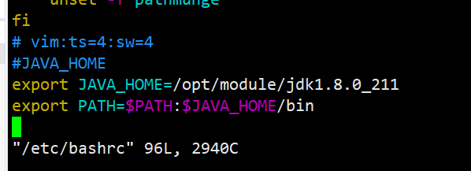

必须导包
from airflow import DAG
from airflow.operators.bash_operator import BashOperator

default_args 设置默认参数
depends_on_past 是否开启任务依赖
schedule_interval 调度频率
retries 重试次数
start_date 开始时间
BashOperator 具体执行任务，如果为true前置任务必须成功完成才会走下一个依赖任务，如果为false则忽略是否成功完成。
task_id 任务唯一标识（必填）
bash_command 具体任务执行命令
set_upstream 设置依赖 如上图所示ads任务依赖dws任务依赖dwd任务

- 查看Airflow配置文件
(python3) [root@airflow work-py]# vim ~/airflow/airflow.cfg
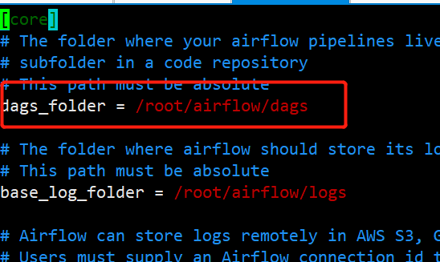
- 得知dag目录，创建dags目录，将.py文件放入此目录
(python3) [root@airflow work-py]# mkdir ~/airflow/dags
(python3) [root@airflow work-py]# cp test.py ~/airflow/dags/
- 等待一段时间，刷新任务列表
(python3) [root@airflow work-py]# airflow list_dags
-------------------------------------------------------------------
DAGS
-------------------------------------------------------------------
example_bash_operator
example_branch_dop_operator_v3
example_branch_operator
example_complex
example_external_task_marker_child
example_external_task_marker_parent
example_http_operator
example_kubernetes_executor_config
example_nested_branch_dag
example_passing_params_via_test_command
example_pig_operator
example_python_operator
example_short_circuit_operator
example_skip_dag
example_subdag_operator
example_subdag_operator.section-1
example_subdag_operator.section-2
example_trigger_controller_dag
example_trigger_target_dag
example_xcom
latest_only
latest_only_with_trigger
test
test_utils
tutorial
- 已出现test任务，刷新页面
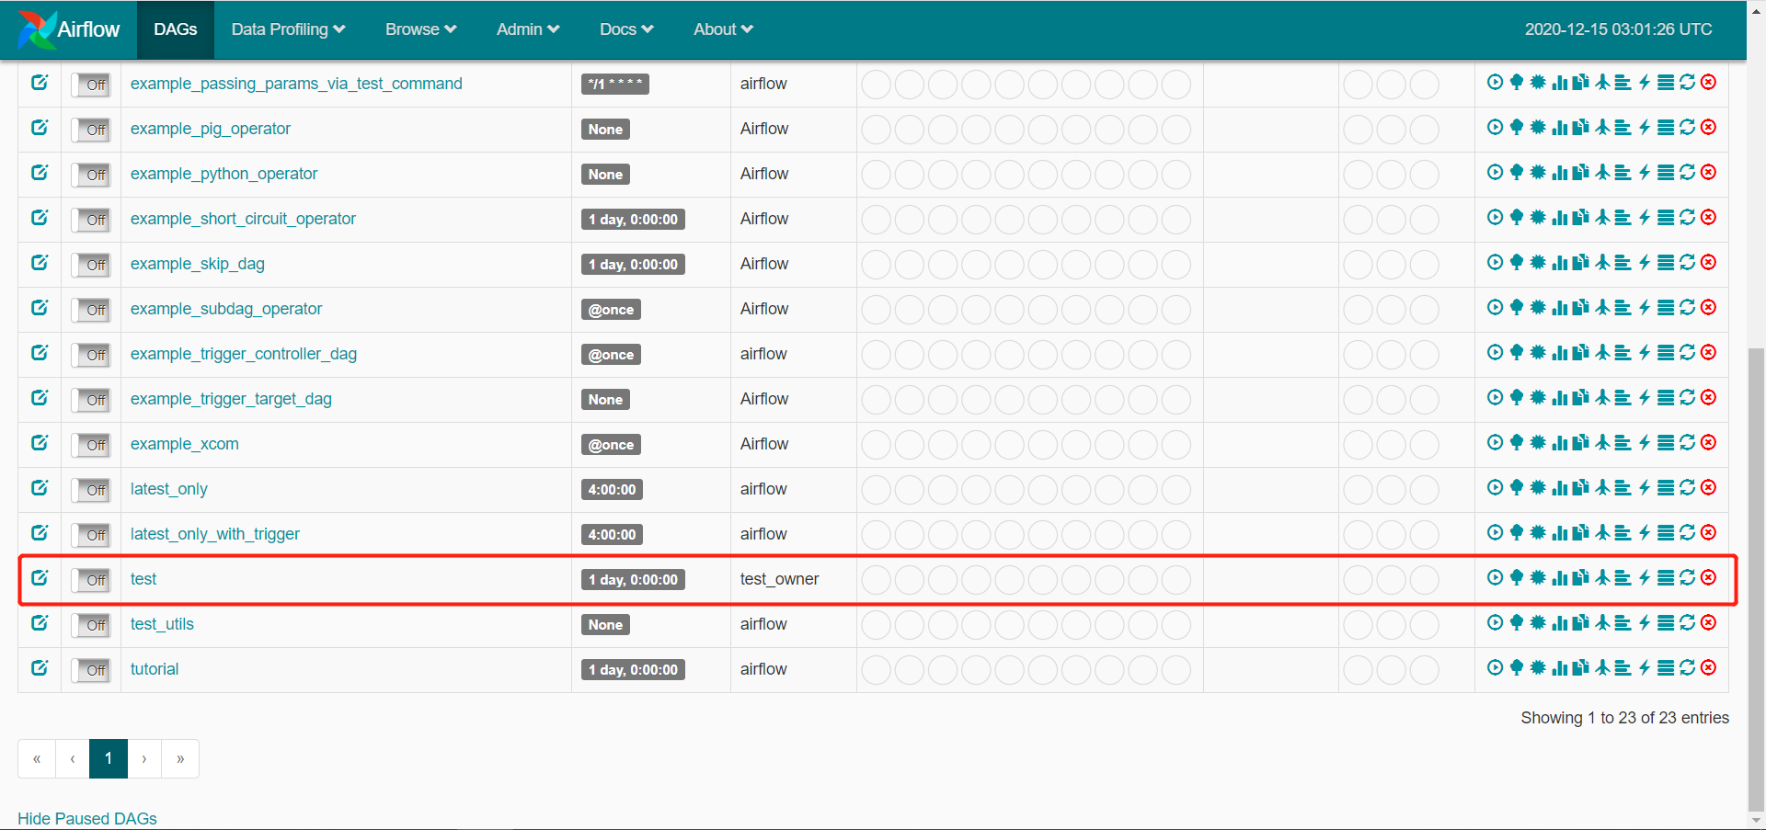
- 点击运行
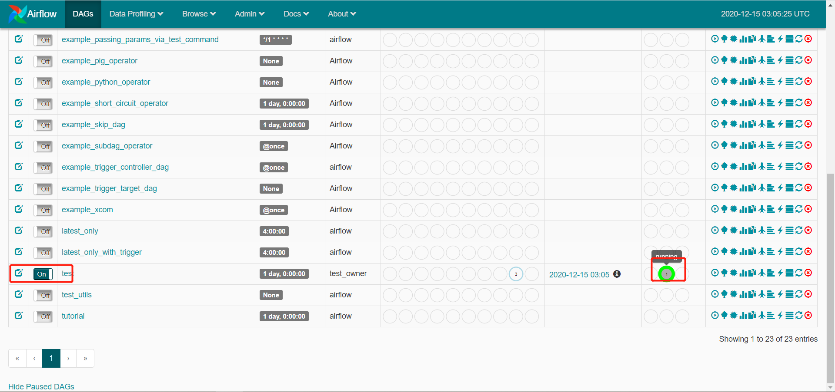
- 点击成功任务，查看日志
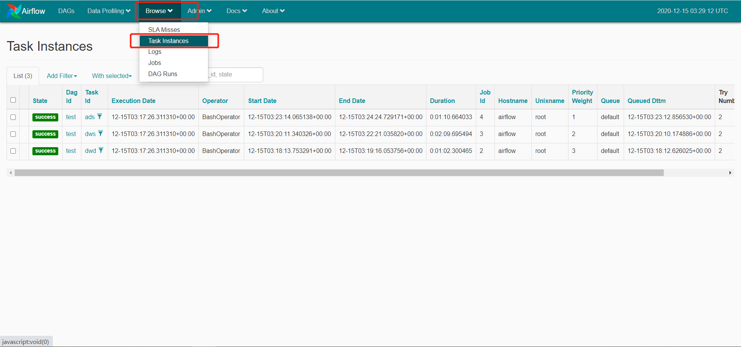

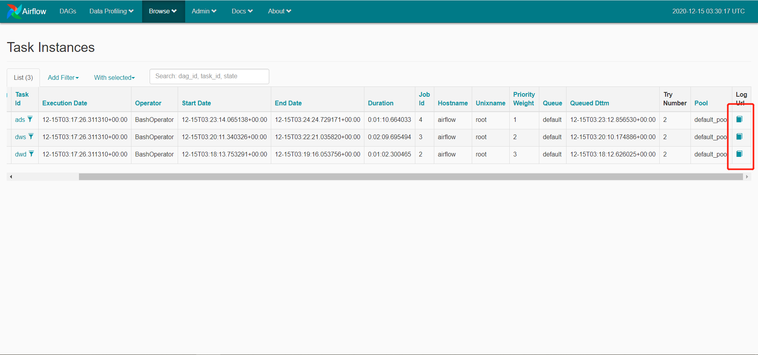
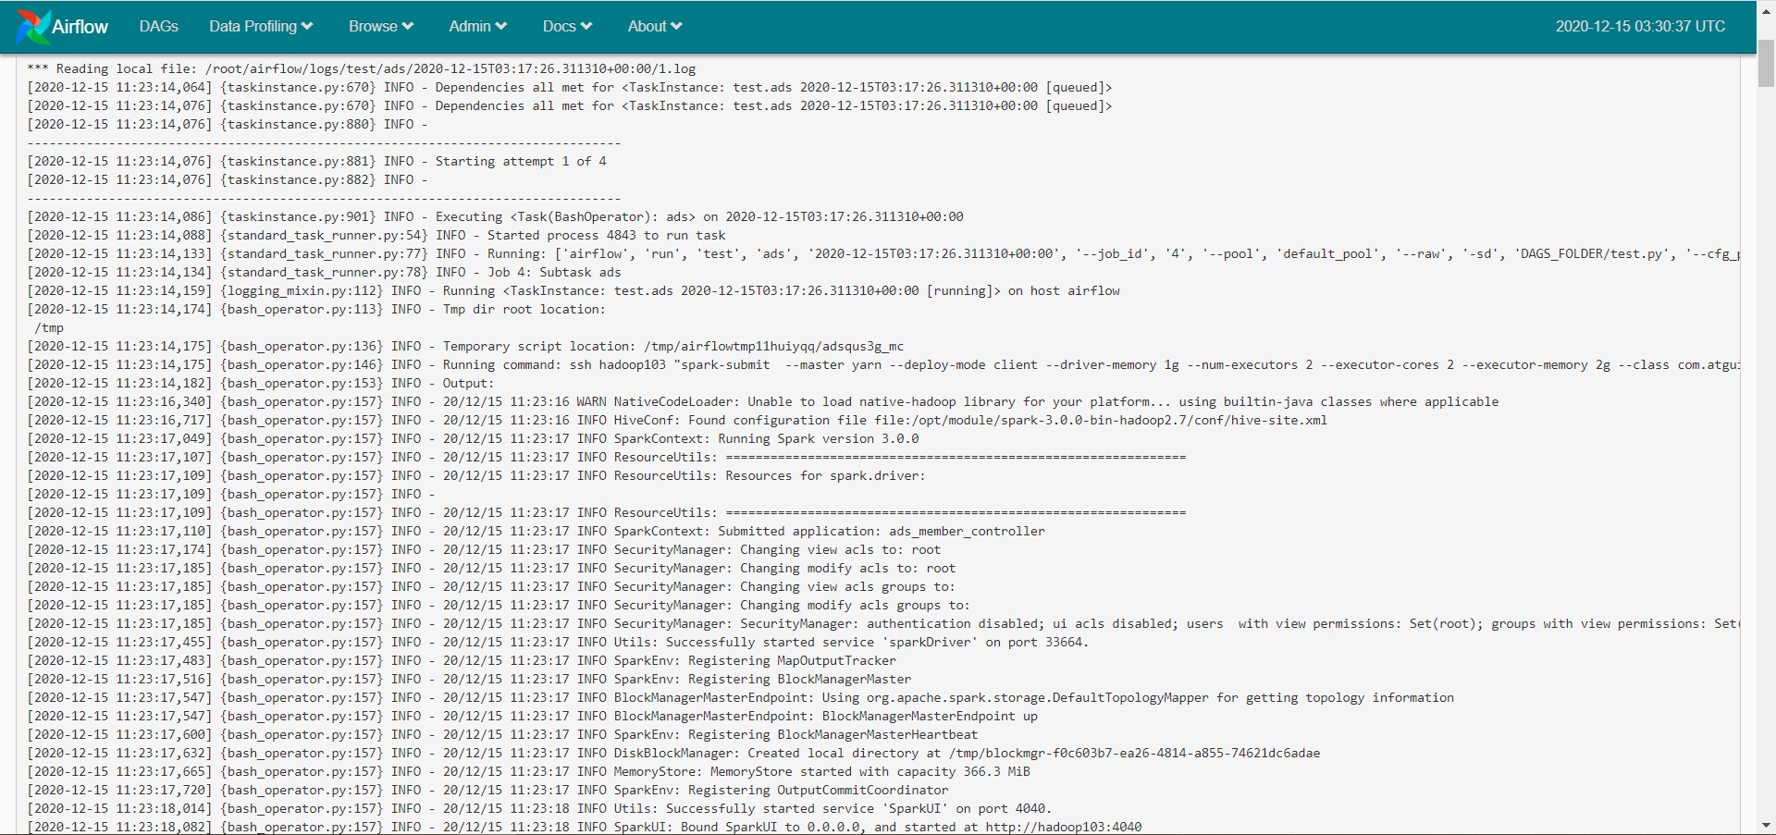
- 查看dag图、甘特图
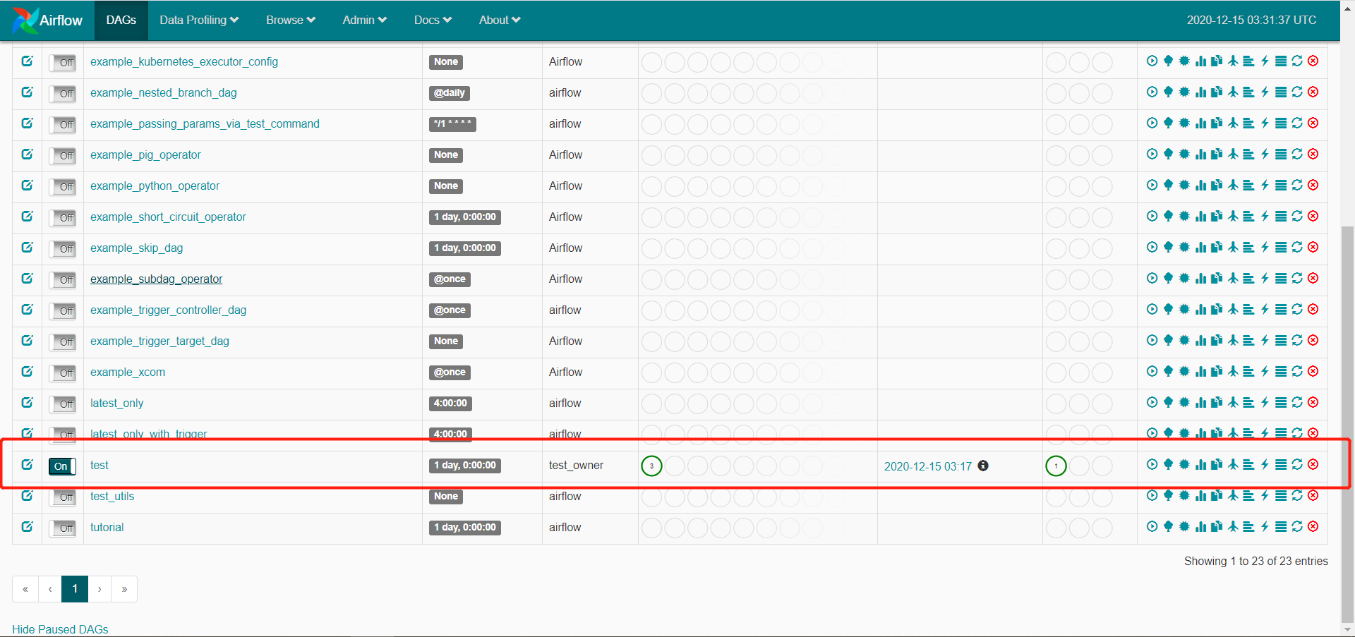
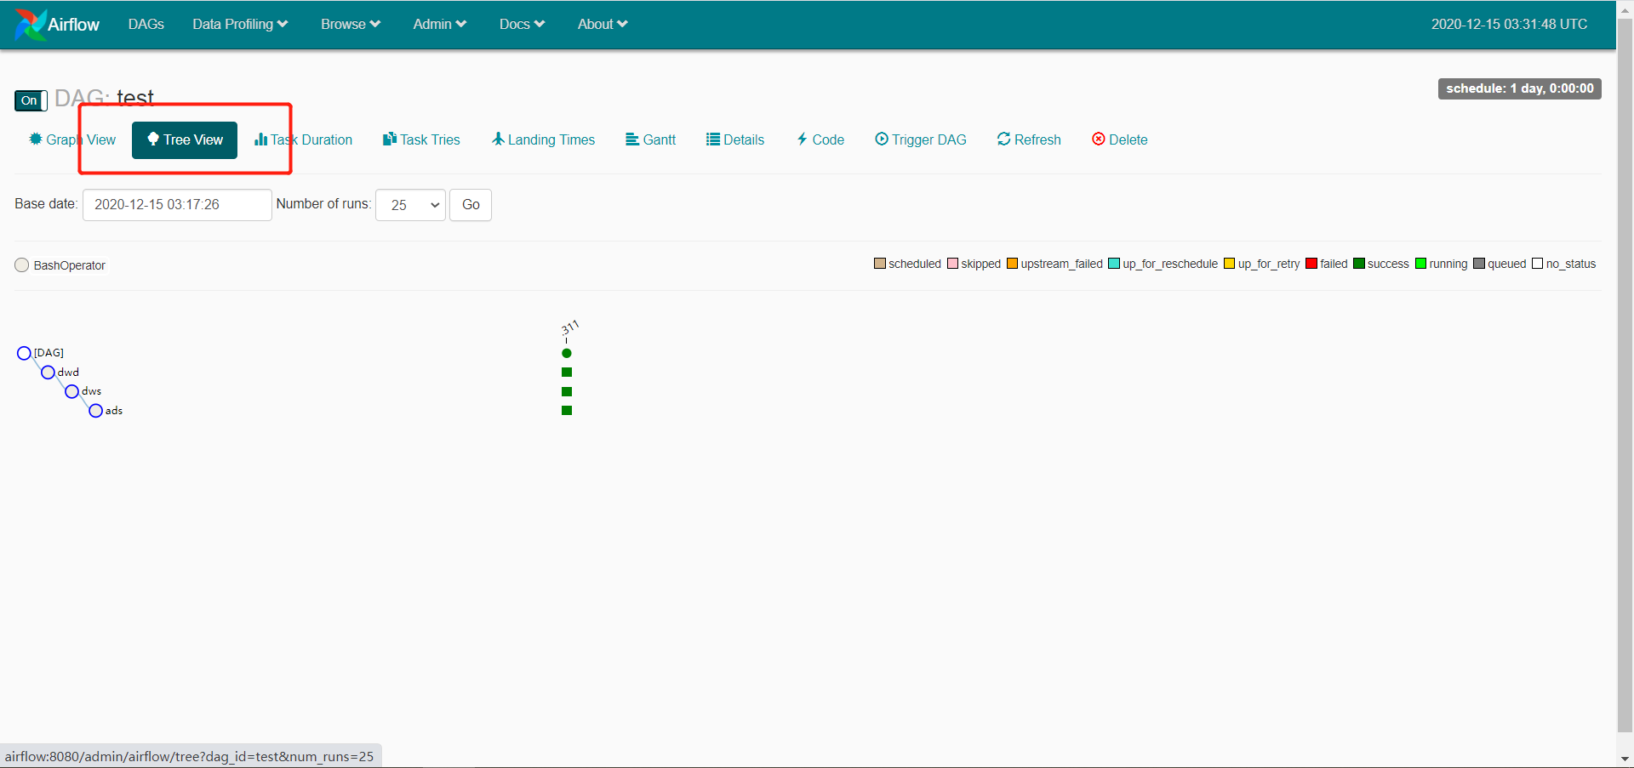
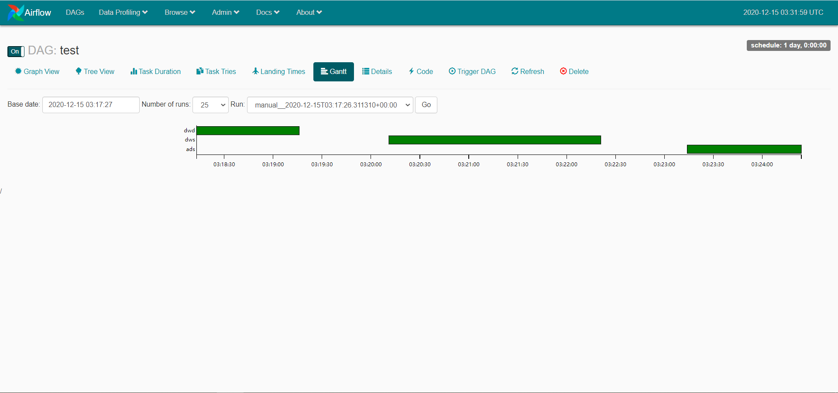
（13）查看脚本代码
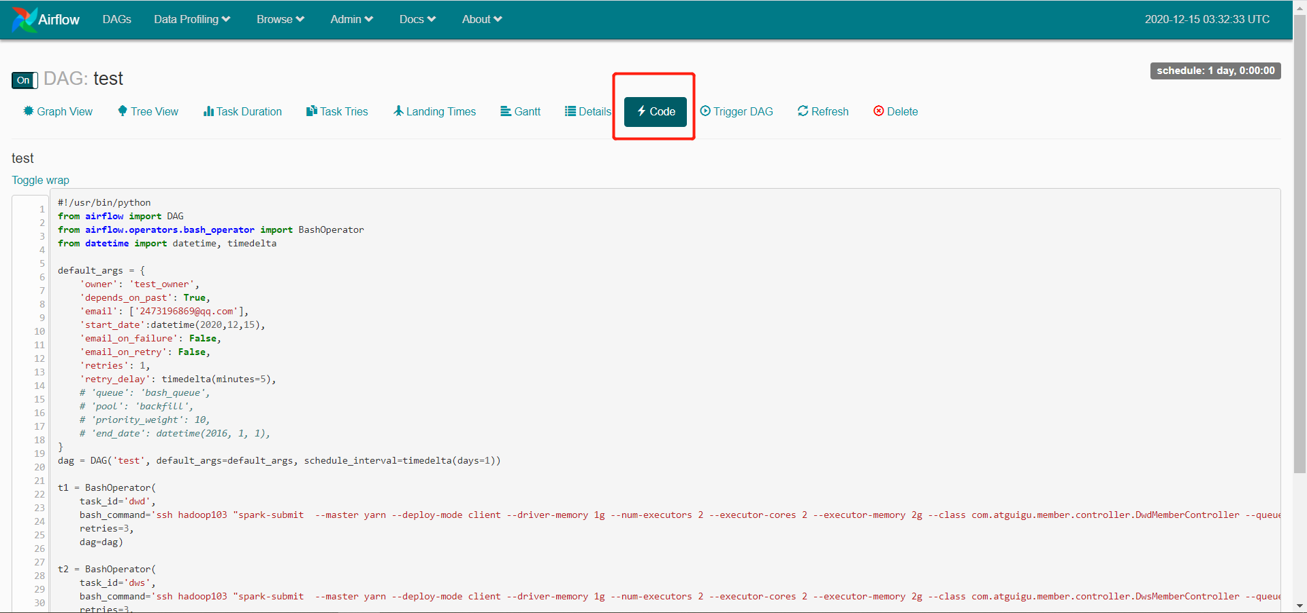

2.4 Dag任务操作

2.4.1 删除Dag任务

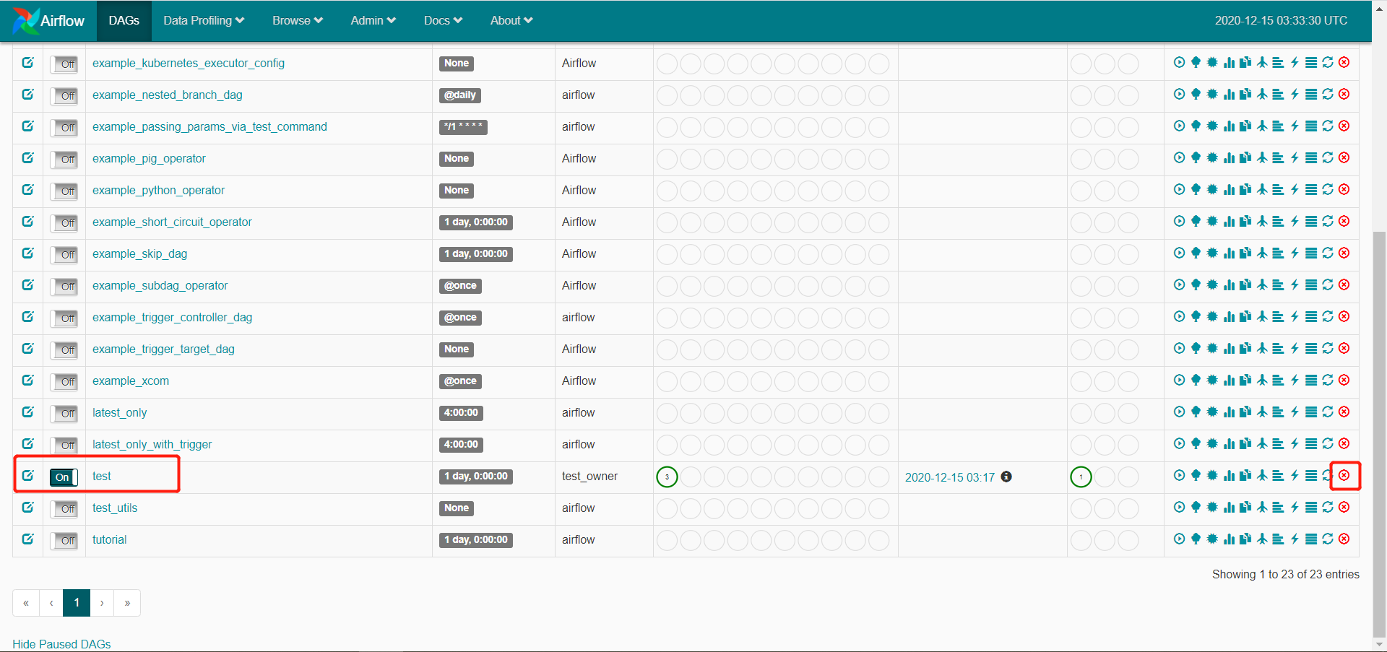

2.4.2查看当前所有dag任务
(python3) [root@airflow work-py]# airflow list_tasks test --tree
The 'list_tasks' command is deprecated and removed in Airflow 2.0, please use 'tasks list' instead
[2020-12-15 11:17:08,981] {__init__.py:50} INFO - Using executor SequentialExecutor
[2020-12-15 11:17:08,982] {dagbag.py:417} INFO - Filling up the DagBag from /root/airflow/dags
<Task(BashOperator): dwd>
<Task(BashOperator): dws>
<Task(BashOperator): ads>
(python3) [root@airflow work-py]#
(python3) [root@airflow work-py]# airflow list_dags
The 'list_dags' command is deprecated and removed in Airflow 2.0, please use 'dags list', or 'dags report' instead
[2020-12-15 11:33:57,106] {__init__.py:50} INFO - Using executor SequentialExecutor
[2020-12-15 11:33:57,106] {dagbag.py:417} INFO - Filling up the DagBag from /root/airflow/dags

-------------------------------------------------------------------
DAGS
-------------------------------------------------------------------
example_bash_operator
example_branch_dop_operator_v3
example_branch_operator
example_complex
example_external_task_marker_child
example_external_task_marker_parent
example_http_operator
example_kubernetes_executor_config
example_nested_branch_dag
example_passing_params_via_test_command
example_pig_operator
example_python_operator
example_short_circuit_operator
example_skip_dag
example_subdag_operator
example_subdag_operator.section-1
example_subdag_operator.section-2
example_trigger_controller_dag
example_trigger_target_dag
example_xcom
latest_only
latest_only_with_trigger
test
test_utils
tutorial

2.4.3 重新添加Dag任务
将test任务重新添加回来,再到ui界面进行查看
[root@airflow work-py]# airflow list_tasks test --tree

已重新添加回来
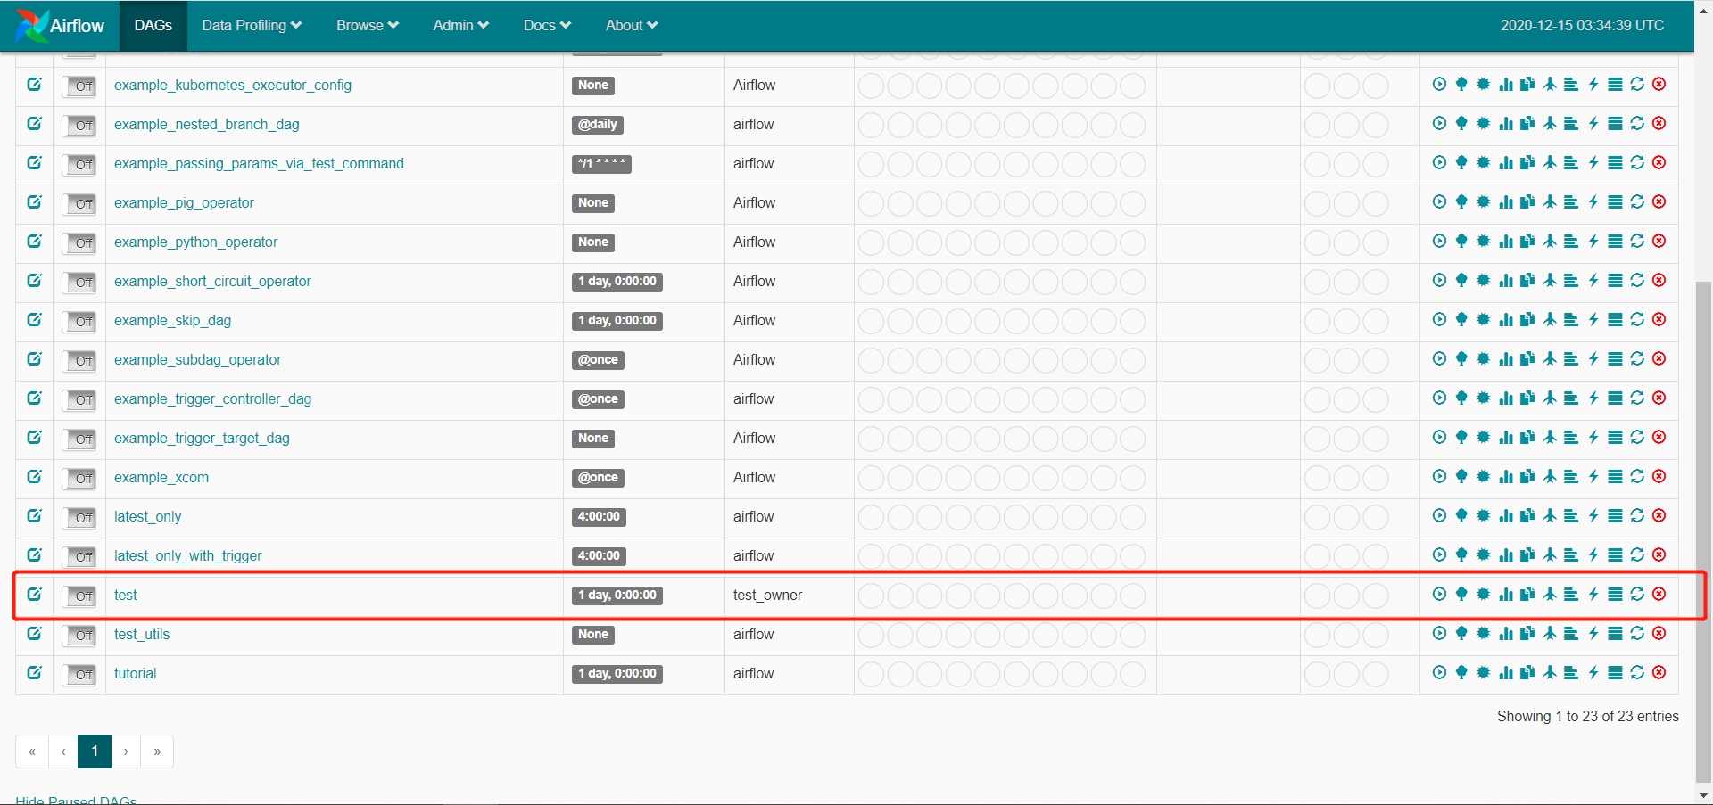

2.5 配置邮件服务器
（1）保证邮箱已开SMTP服务
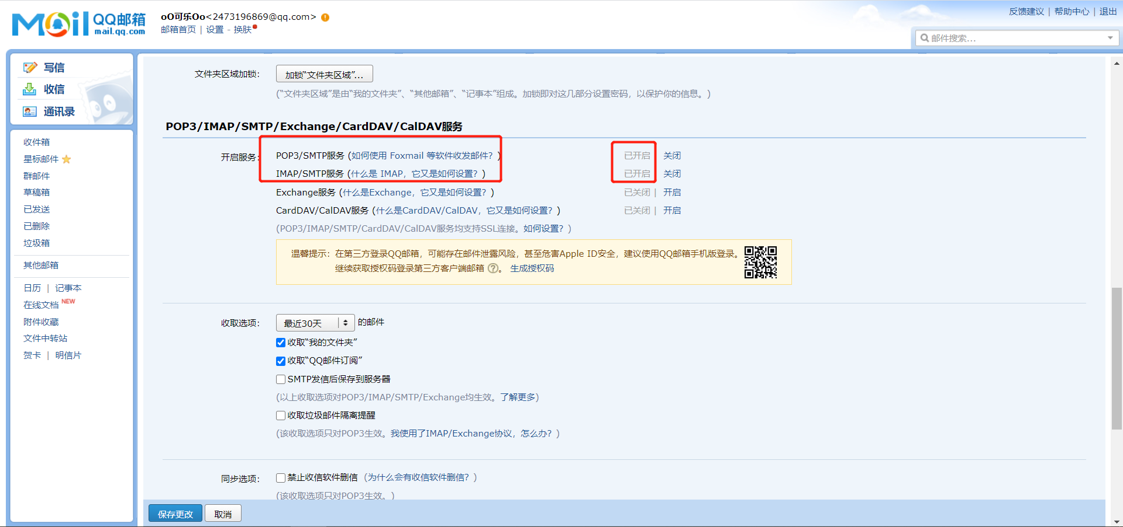
- 修改airflow配置文件，由于我演示的阿里云环境，默认25端口不开启，改用stmps服务对应587端口
(python3) [root@airflow work-py]# vim ~/airflow/airflow.cfg
smtp_host = smtp.qq.com
smtp_starttls = True
smtp_ssl = False
smtp_user = 2473196869@qq.com
# smtp_user =
smtp_password = wjmfbxkfvypdebeg
# smtp_password =
smtp_port = 587
smtp_mail_from = 2473196869@qq.com
（3）重启airflow
(python3) [root@airflow airflow]# ps -ef|egrep 'scheduler|airflow-webserver'|grep -v grep|awk '{print $2}'|xargs kill -15
(python3) [root@airflow airflow]# ps -ef |grep airflow
root 745 1 0 09:50 ? 00:00:00 /sbin/dhclient -1 -q -lf /var/lib/dhclient/dhclient--eth0.lease -pf /var/run/dhclient-eth0.pid -H airflow eth0
root 7875 1851 0 12:51 pts/1 00:00:00 grep --color=auto airflow
(python3) [root@airflow airflow]# kill -15 745

(python3) [root@airflow airflow]# airflow webserver -p 8080 -D
(python3) [root@airflow airflow]# airflow scheduler -D
（4）重新编辑test.py脚本，并且替换
[root@airflow ~]# cd /opt/module/work-py/
[root@airflow work-py]# vim test.py

#!/usr/bin/python
from airflow import DAG
from airflow.operators.bash_operator import BashOperator
from airflow.operators.email_operator import EmailOperator
from datetime import datetime, timedelta

default_args = {
'owner': 'test_owner',
'depends_on_past': True,
'email': ['2473196869@qq.com'],
'start_date':datetime(2020,12,15),
'email_on_failure': False,
'email_on_retry': False,
'retries': 1,
'retry_delay': timedelta(minutes=5),
# 'queue': 'bash_queue',
# 'pool': 'backfill',
# 'priority_weight': 10,
# 'end_date': datetime(2016, 1, 1),
}
dag = DAG('test', default_args=default_args, schedule_interval=timedelta(days=1))

t1 = BashOperator(
task_id='dwd',
bash_command='ssh hadoop103 "spark-submit --master yarn --deploy-mode client --driver-memory 1g --num-executors 2 --executor-cores 2 --executor-memory 2g --class com.atguigu.member.controller.DwdMemberController --queue spark /root/work/com_atguigu_warehouse-1.0-SNAPSHOT-jar-with-dependencies.jar "',
retries=3,
dag=dag)

t2 = BashOperator(
task_id='dws',
bash_command='ssh hadoop103 "spark-submit --master yarn --deploy-mode client --driver-memory 1g --num-executors 2 --executor-cores 2 --executor-memory 2g --class com.atguigu.member.controller.DwsMemberController --queue spark /root/work/com_atguigu_warehouse-1.0-SNAPSHOT-jar-with-dependencies.jar "',
retries=3,
dag=dag)

t3 = BashOperator(
task_id='ads',
bash_command='ssh hadoop103 "spark-submit --master yarn --deploy-mode client --driver-memory 1g --num-executors 2 --executor-cores 2 --executor-memory 2g --class com.atguigu.member.controller.AdsMemberController --queue spark /root/work/com_atguigu_warehouse-1.0-SNAPSHOT-jar-with-dependencies.jar "',
retries=3,
dag=dag)

email=EmailOperator(
task_id="email",
to="2473196869@qq.com",
subject="test-subject",
html_content="<h1>test-content</h1>",
cc="chaosong@qq.com",
dag=dag)

t2.set_upstream(t1)
t3.set_upstream(t2)
email.set_upstream(t3)

(python3) [root@airflow work-py]# cp test.py ~/airflow/dags/
（5）查看页面是否生效
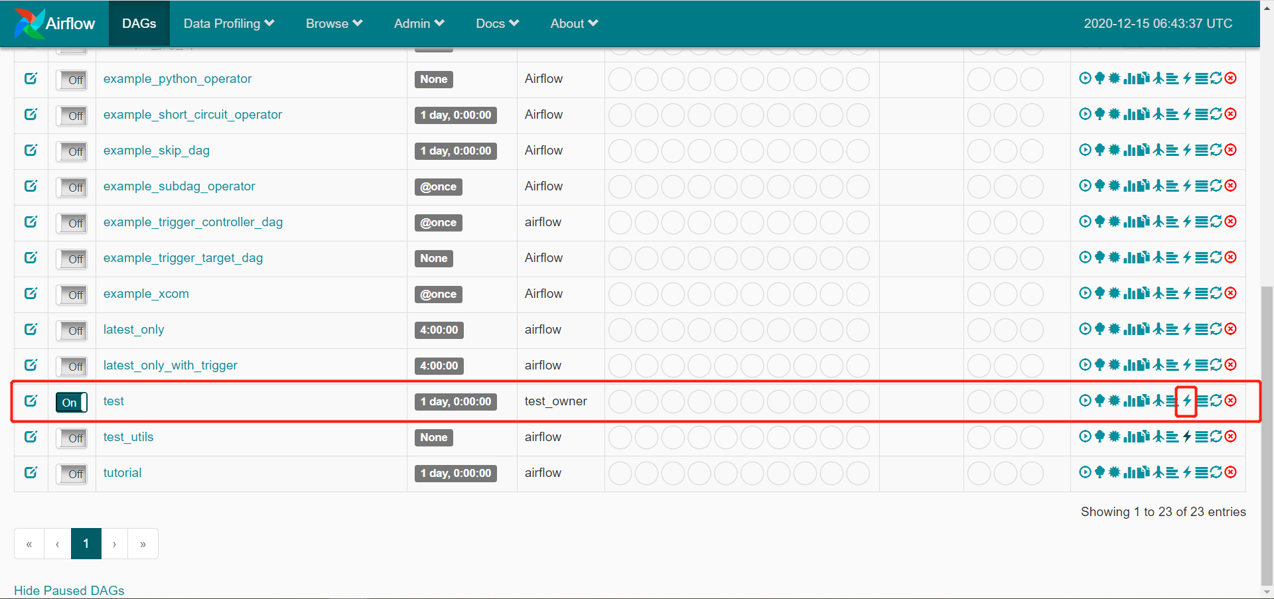
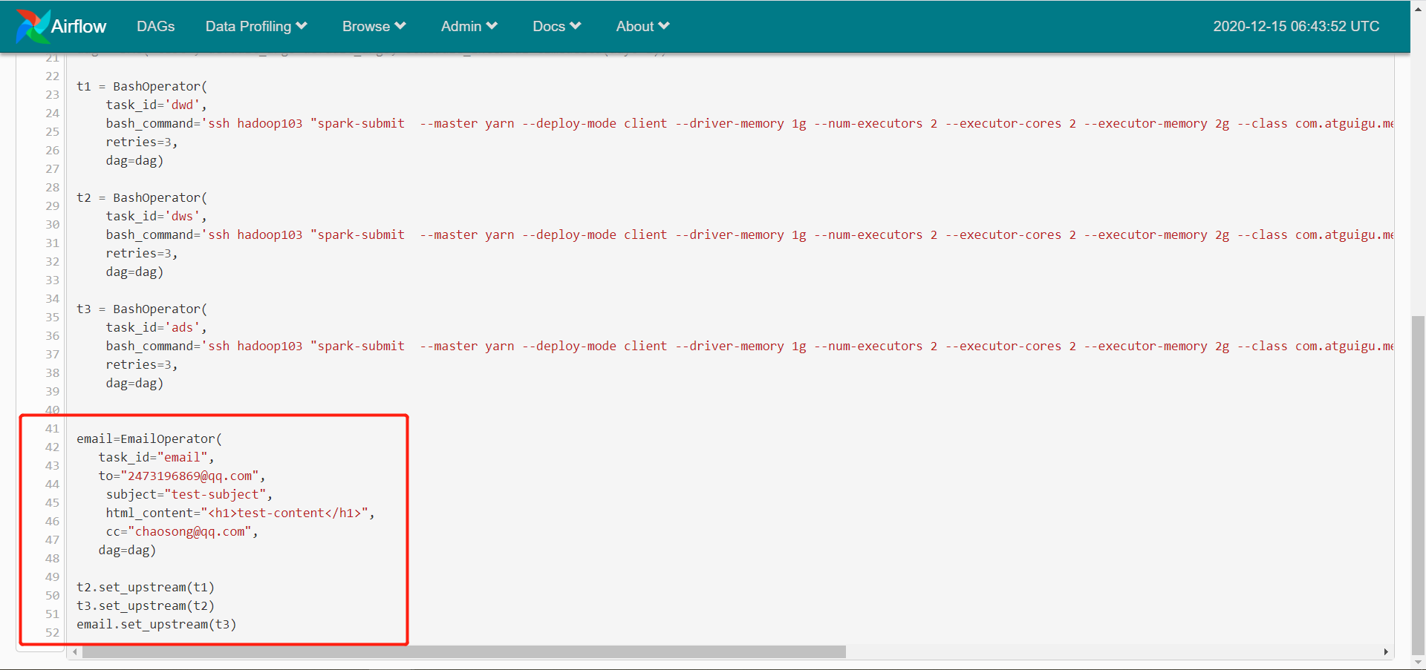
（6）运行测试
