PhilipsHueWebhookHandler

Emby Webhook Handler for Philips Hue Bridges

This standalone application receives webhook messages from your Emby server and sets the configured Hue bridge scene for *Play/Stop/Pause/UnPause*.

This c# application is open source and can be found at   
<https://github.com/BillOatmanWork/PhilipsHueWebhookHandler>

## Command Line Parameters (Case Insensitive)

-Discover = List all Hue Bridges on your network.

-AutoRegister = Register this application with the bridge.   
Note only works if there is only 1 bridge on your network.

-Register=<Bridge IP Address> Register this application on the specified bridge.

-ListScenes=<Config JSON file path> = List all scenes on the bridge using the specified config file.

-Run=<Config JSON file path> = Run using the specified config file.

**Note:** No spaces before or after the =, so for example -register=192.168.11.12

## Emby Configuration

The Emby server must be configured to send the webhook notifications to this application.  
First, go to the Emby configuration web page and select Notifications

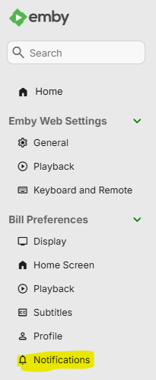

Then, add a new notification

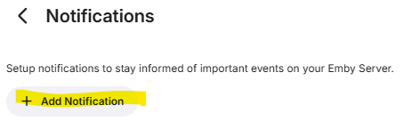

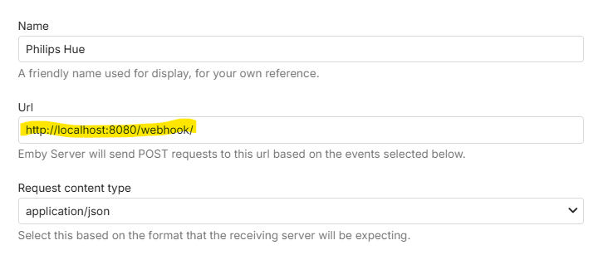

Name it whatever you like. The URL is important. You can pick whatever unused port number you like. I used 8080. Localhost means this application is running on the Emby server. I highly recommend doing that because if you do not, you will need to configure your router and firewall to allow the messages to get through. Take note of the URL that you use because you will need it for this applications configuration later.

Next, set what will be sent to this application.

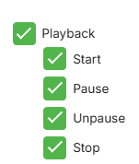

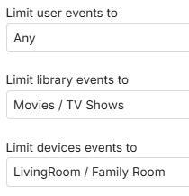

## Application Configuration

There is a sample configuration file in this distribution.

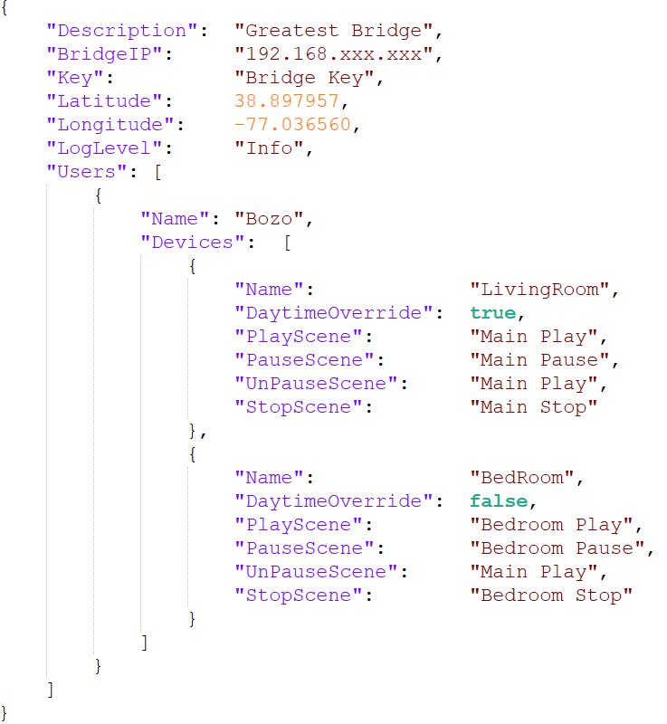

When you have the application *register* or *autoregister* with the bridge, a *Keys.txt* file is created that contains the IP of the bridge and the key.

If you supply *Latitude* and *Longitude* of your location, the application can optionally not adjust the lights between sunrise and sunset.

If you set the *LogLevel* to *Detail* a bunch of data including the webhook payload received will be logged. This is handy to get the configuration correct. But in normal operation you will want it set to *Info*.

The Users area is where you configure what Emby users actions control the lighting and what scenes get set based on their actions. For example, having remote users actions control the lighting in your home while entertaining, is probably not desired!

The *Name* is the Emby device name.

*DaytimeOverride* when set to true will cause the lighting to be controlled even during daytime hours.

The scene settings define what bridge scenes get activated for the four different user actions.