Code sample

This was a challenging part of the project, sending the context to the distribution page. I chose to make diagrams of the source code, to make it easier to follow.

The functions are all part of the DataJobs class, which builds things from the database.

The challenge here was to send all 10 results to the page, so you can hit the + - buttons, and use Javascript to repopulate the grid each time, without going back to the server.

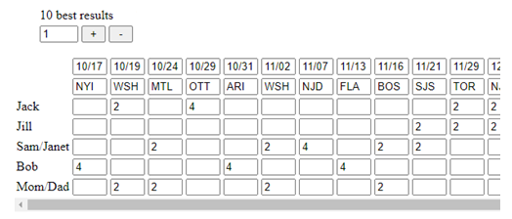

To do this I created 10 2D arrays (a 3D array was too hard to work with). The names of each cell in the html, is R (row), C (column). Like R1C3 is Jack 10/24. To get the row and column, I needed functions to return person id’s and game id’s. Then I needed functions to convert id’s into consecutive numbers.

[Link to source code](CodeSample.png)