Ticket Distributer

Overview: This web app is for season ticket owners, to help them distribute their tickets to multiple people. Information is gathered about the tickets, and each person’s request for tickets. Then results are generated, and the 10 best (fairest) results are saved, for the ticket owner to choose from.

Technology: Python, Django, MySql

The first page is the logon page. It has a link and 2 submit buttons. The Request league link, opens an email to me, with League request as the subject. The New user button takes you to the Ticket info page, if username and password *are not* in the owner table. The Existing user button takes you wherever you had left off, if username and password *are* in the owner table.

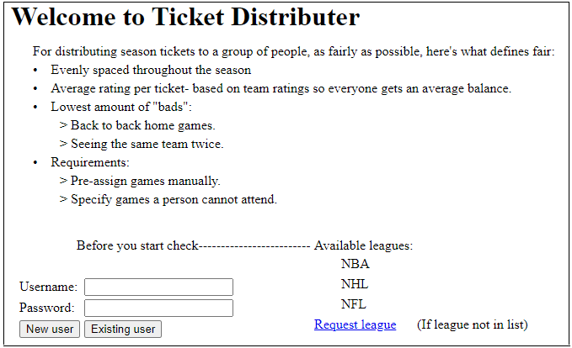

At first only the leagues are available, you select a league and hit the first Submit button. Then you’re returned to this page, where you select your home team, tickets per game, and hit the second submit button.

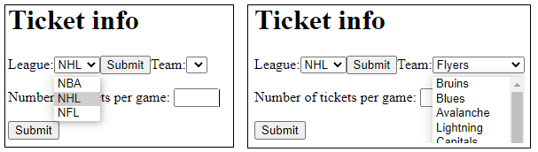

This brings you to the Person info page. In this example there are 4 tickets per game. Tickets remaining, is the number of home games in the season, times tickets per game. Here you keep entering people, and their ticket requests, until Tickets remaining equals 0.

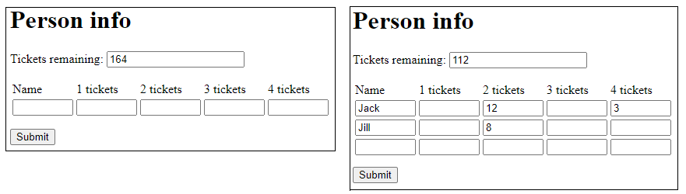

Then you arrive at the Requirements page. Here you can select a button or number of tickets. Then click on cells, to block games, manually pre-assign tickets, or clear a cell.

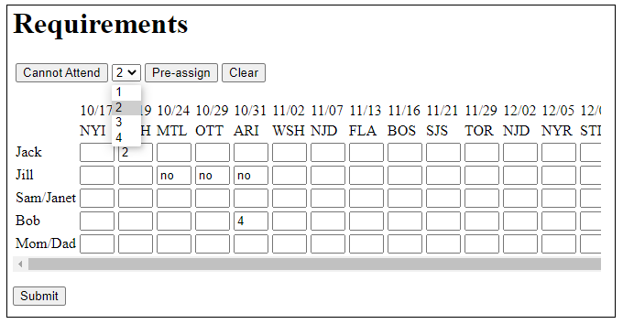

Next is the Distribution page. Hit Run and it will run for the amount of minutes in the box. When it’s done, the status of the top 10 appear in the status table on top, and the number 1 result appears in the distribution grid on the bottom. Use the + - buttons to show each result, which will show in the distribution grid.

How are the best results determined? First they are ordered by least amount of “bads”, which are back to back home games, and duplicate teams. Then they are ordered by lowest rating spread, which is the difference between the person with highest average rating per ticket, and the lowest.

If no results are found, you get directed to the no result page, which can give you a person or a game to check. This can happen if you create an impossible scenario on the Requirements page.

At the bottom are 3 buttons to navigate to other pages. There’s a safety feature on each page, that hides the submit button, unless you click Edit, to prevent all your results from being deleted, if you just wanted to navigate. There’s also a shrink button, so you can see the whole table while viewing each result.

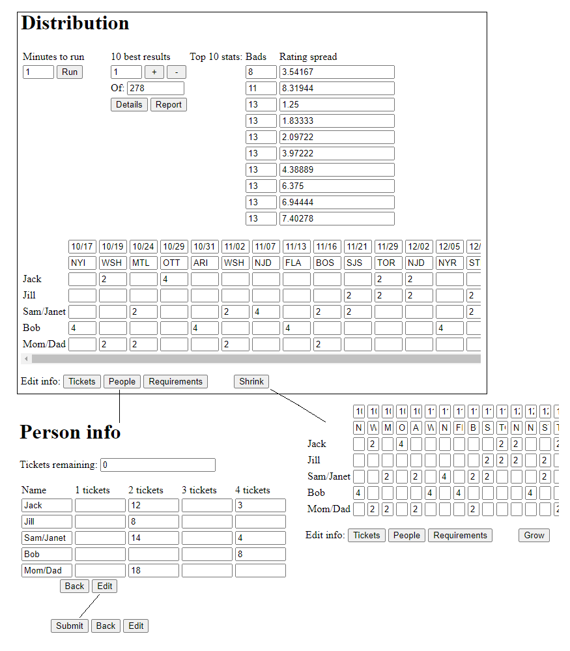

Below are some more diagrams. The first shows the results after 1 minute, then after 10 more minutes. The second shows details and report of result 3. The third is a quick view of the MySql database.

