

SOFTWARE DEVELOPMENT II
PROJECT REPORT:

TEAM

Vasileios Papakyriakou AM: 5324 Anna Tarasidou AM: 5361

TABLE OF CONTENTS

Introduction 4
First Contact 4
Legacy System - Source code Notes 4
Legacy System - Documentation Notes 4
Legacy System - Use Cases 4
Legacy System Installation Notes 5
Initial Understanding and Detailled Model Capture 5
Tests 5
Reengineered/Extended Design of the Legacy System 5

SUMMARY

The goal of the project was to reengineer and extend an existing Java application. The application is a simple Latex editor for inexperienced Latex users. The first phase of the project revolved around understanding the application’s legacy architecture. We studied the documentation, user stories and source code and set up a mock installation of the application. Moreover, test cases were prepared for each of the user stories and the design was captured in UML package and class diagrams. In the second phase refactoring and extension was performed, aiming to improve code quality and extensibility as well as usability for both developers and users. Refactoring techniques such as Extract Method, Move Method, Substitute Algorithm, Singleton Pattern, Remove Middle Man and Externalize Strings were used to address issues such as Duplicate Code, Long Method, Dead Code, Message Chains and Misplaced Responsibilities. The application was also extended to support two more user stories regarding HTML document import and export. The refactored design was captured in UML package and class diagrams as well as CRC cards.

THE LATEX EDITOR PROJECT

Latex Editor is a simple editor aiming to assist inexperienced Latex users with Latex document preparation. Latex is a high-quality document preparation markup language. It provides a large variety of styles and commands that enable advanced document formatting. Formatting documents with Latex is similar to a programming process as it involves the proper usage of Latex commands which are embedded in the document contents. The goal of the Latex Editor is to facilitate the usage of Latex commands for the preparation of Latex documents. One of the prominent features that distinguishes the Latex Editor from other similar applications is its multi-strategy version tracking functionality that enables undo actions.

ARCHITECTURE

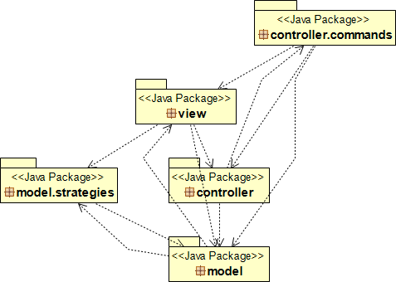
Application architecture prior to reengineering

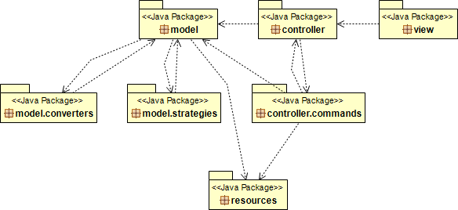
Application architecture after reengineering

DETAILED DESIGN – REFACTORING TASKS

In this section, the implemented refactors are explained in detail for each class followed by the respective UML class diagrams for the classes of each package.

LatexEditorController class
A problem here was Duplicate Code in the constructor of the class. The same commands were repeated to populate the HashMap with the commands of the application. The issue was refactored using the Substitute Algorithm. The string command names are now stored in a list class field. The list is iterated in the createCommands() method to create the required command objects.

Command classes
An issue of Duplicate Code was also existing among the command classes. However, in this case the issue was in the form of common objects as class fields among the command classes. The issue was solved by applying the Singleton Pattern to provide single points of access to the classes of the key objects used by the commands. More specifically, the Singleton Pattern has been applied to the VersionTrackingManager, DocumentManager and LatexEditorController classes. Moreover, unnecessary methods such as the getter and setter in the LoadCommand class have been removed.

DocumentManager class
In this class there were two issues. The first one was Duplicate Code in the constructor of the class, similar to the issue of the LatexEditorController class. The issue was refactored using the Substitute Algorithm in the same manner as the one of the LatexEditorController class. The string template names are now stored in a list class field. The list is iterated in the constructor to create the required document objects. The second issue was a Long Method. In particular, getContents() was a huge method with a clear Duplicate Code problem. The issue was partly caused due to multi-line strings with document template contents which were hard-coded into the method. The strings were externalized to a properties file in a newly created resources package. A Strings class was created in the resources package which is responsible for fetching the corresponding strings. In that way it was possible to fetch any string by providing its template type and therefore the duplicate code issue was solved. It is now also much easier to potentially add more document template types in the future. Finally, the getContents() method was removed since it proved to be an unnecessary method. Instead, it is sufficient to fetch each string of template contents once in the constructor of the class and create one Document object for each template type.

VersionsManager class
This class has been renamed to VersionTrackingManager to match its role more appropriately. Naturally, any other references to the class in the source code have been renamed too. The simplest problem in this class was Dead Code. Unused methods have been removed. Other problems were Misplaced Responsibilities regarding saving and loading document to/from files as well as Message Chains. VersionsManager was a middle man with several methods (getType(), saveContents(), saveToFile(), loadFromFile(), etc.) that simply delegate invocations to corresponding methods of the LatexEditorView class. The delegating methods were removed using the Remove Middle Man refactoring. The delegate class LatexEditorView object was accessed from the server class objects and calls to delegating methods were replaced with direct calls to methods in the delegate class. Note that LatexEditorView was also removed so the above does not describe the final reengineering result.

LatexEditorView class
This class had critical issues. It was part of the view package which contains classes that have to do with the GUI and data visualization. LatexEditorView does not have anything to do with these. Instead, it contained application logic with methods that realize basic commands such as saving or loading a document and creating a new version of the current document. The issues were solved using the Move Method and Move Field refactorings to redistribute the responsibilities to the right classes. Specifically, the following refactorings were done:
- Rename VersionsManager field to VersionTrackingManager and move to LatexEditorController.
- Rename type field to templateType and move to LatexEditorController.
- Move currentDocument field to DocumentManager.
- Move filename field to DocumentManager.
- Rename strategy field to strategyType and move to VersionTrackingManager.
- Move saveContents() method to EditCommand.
- Move loadFromFile() method to LoadCommand.
In addition, saveToFile() method was removed since it was a Message Chain that delegated invocation to the save() method of the Document class. The issue was dealt with using the Remove Middle Man refactoring, similarly to the case of the VersionTrackingManager class. Moreover, methods readFileContents() and findTemplateType() were extracted from loadFromFile() method and placed in LatexEditorController. The remaining code of loadFromFile() was placed back to LoadCommand. Any remaining methods of LatexEditorView class were moved to LatexEditorController and finally LatexEditorView was removed.

MainWindow class
A problem here was a Large Method with Duplicate Code which was also a Misplaced Responsibility. More specifically, the editContents() method is part of the application logic and was moved to the AddLatexCommand class. The issues were caused by multi-line strings with the corresponding Latex commands which were hard-coded into the method. The strings were externalized to a properties file in the resources package. The Strings class is responsible for fetching the corresponding strings. In that way it was possible to fetch any string by providing its command type and therefore the duplicate code issue was solved, similarly to the case of the DocumentManager class. It is now also much easier to potentially support more Latex command types in the future. Another Large Method here was the initialize() method which is responsible for initializing the various components of the GUI. The method was relieved using the Exctract Method refactor such that each GUI component (JMenuItem, JMenu, JMenuBar, etc.) is initialized in its own method. Moreover, the values that determine positions and dimensions of frames and components were converted to static final class fields. In that way it is much easier to potentially adjust or extend the application’s GUI in the future. Note that many of the components of the GUI were converted to class fields with respectable getters to support the development of test cases for the application.

OpeningWindow & ChooseTemplate classes
The above classes were refactored in a similar manner to the MainWindow class. Both classes had an issue with their initialize() methods being Large Methods. . The methods were relieved using the Exctract Method refactor such that each GUI component (JMenuItem, JMenu, JMenuBar, etc.) is initialized in its own method. Moreover, the values that determine positions and dimensions of frames and components were converted to static final class fields. In that way it is much easier to potentially adjust or extend the application’s GUI in the future. Note that many of the components of the GUI were converted to class fields with respectable getters to support the development of test cases for the application.

Other refactors and fixes
In addition to the above refactors, we attempted to further improve the code quality throughout the source code as well as the user experience. Some of the general guidelines that were followed include: Methods should rarely, if ever, surpass 20 lines of code. Field, method and class names should demonstrate their responsibilities as clearly as possible. Lines of code should rarely, if ever, surpass 100 characters in length. Code maintenance and extensibility should be as easy as possible. The purpose of different GUI components should be as clear as possible for the end user.
The following changes were implemented:

- Refactor duplicate code for latex command menu items initialization in MainWindow.
- Refactor duplicate code for check boxes initialization in MainWindow.
- Use ButtonGroup to manage RadioButton selection in ChooseTemplate.
- Refactor duplicate code and unused methods in ChooseTemplate.
- Add separators for MenuBar MenuItems in MainWindow.
- Adjust MenuBar MenuItems’ names in MainWindow to clearly demonstrate their
purposes.
- Refactor and use StrategyFactory (it was unused).
- Refactor duplicate code in VersionTrackingManager.
- Remove unnecessary/misleading comments throughout the source code.
- Fix open existing file functionality in OpeningWindow.
- Fix exit on close for OpeningWindow and ChooseTemplate GUIs.
- Adjust disabled command MenuItems in MainWindow such that when a template type does not support a command, only the corresponding command’s MenuItem is disabled.
- Organized version tracking files (from the stable version tracking strategy) in a respective folder.

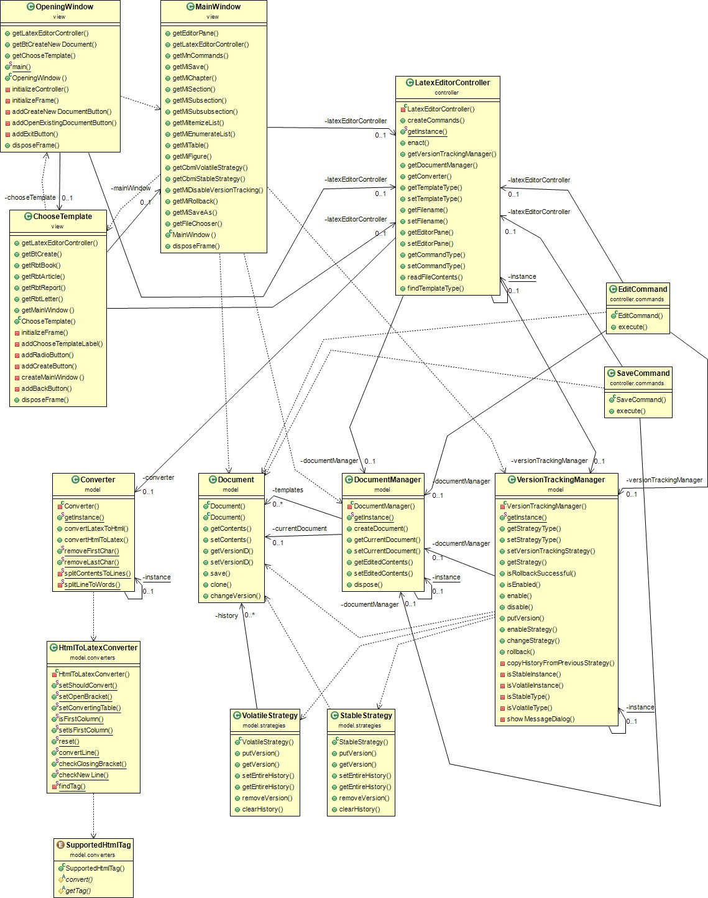

UML class diagram which outlines the general functionality of the application’s architecture

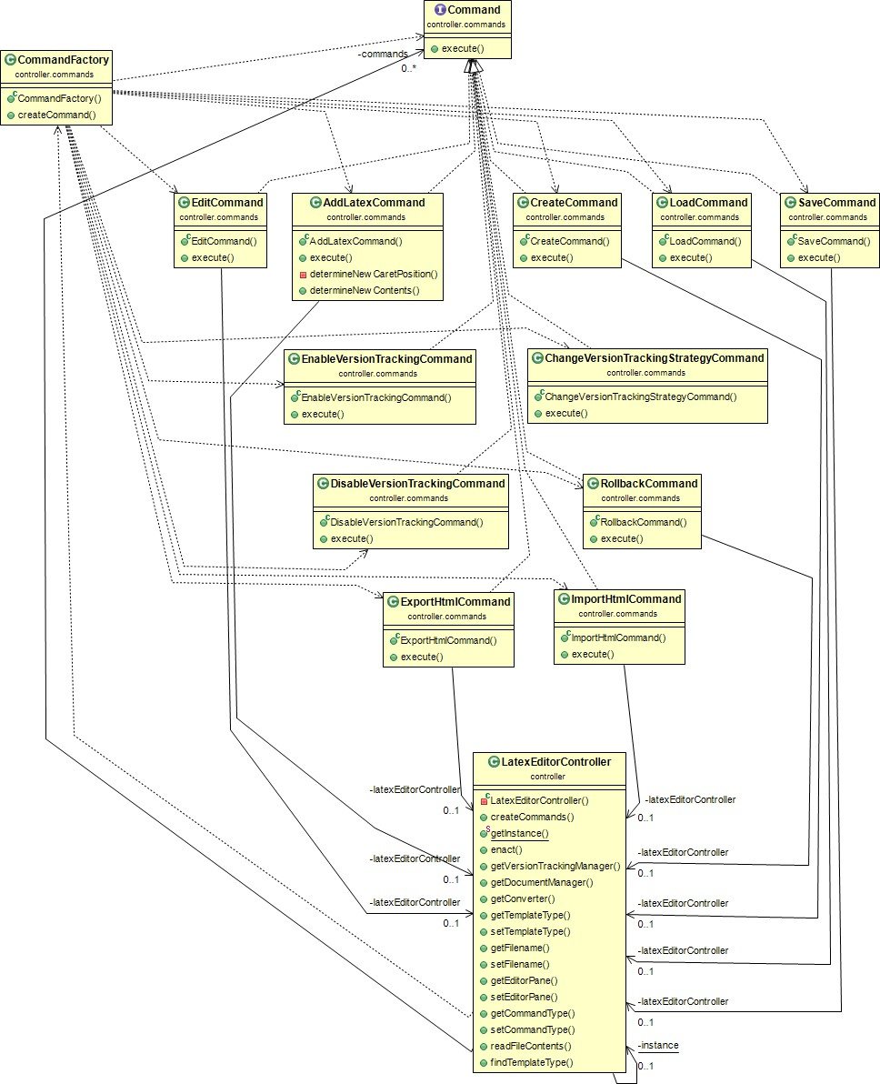
UML class diagram for the classes of the controller package

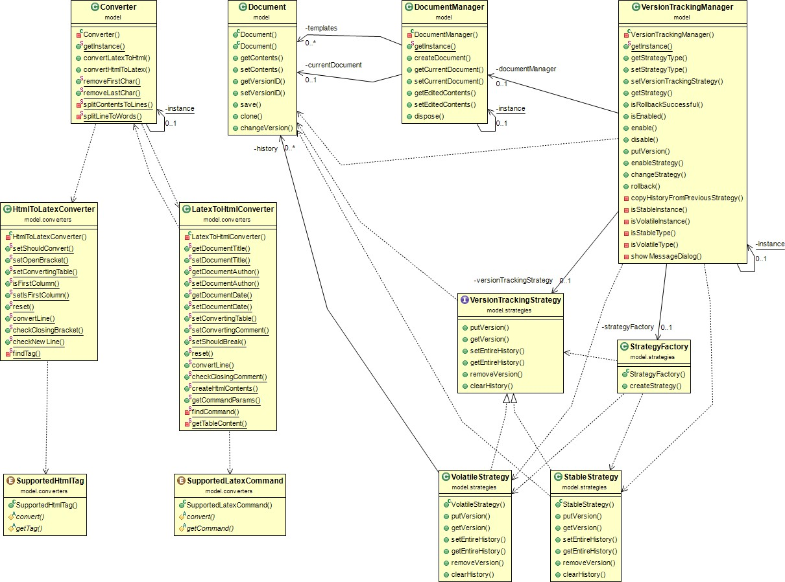
UML class diagram for the classes of the model package

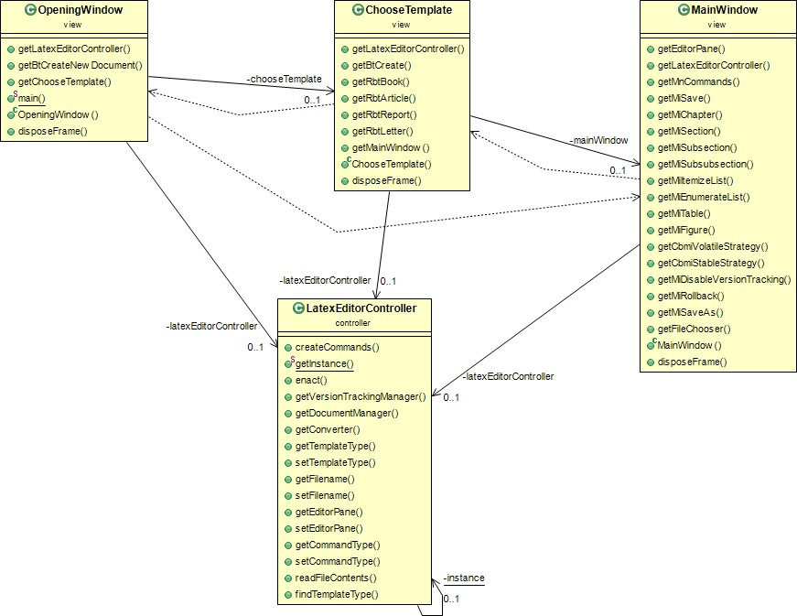

UML class diagram for the classes of the view package (including LatexEditorController)

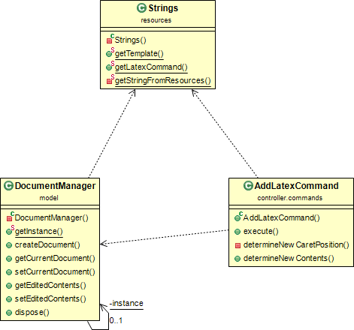
UML class diagram regarding strings fetching

DETAILED DESIGN – EXTENSION TASKS
The application was extended to support two more user stories, regarding document import from HTML files (conversion from HTML to Latex and loading) as well as document export to HTML (conversion from Latex to Html and saving). For this purpose, respective Import -> HTML and Export -> HTML MenuItems were added in the File Menu of the MenuBar of the MainWindow GUI.
The following classes and enums were developed:

Converter class
This is the main class responsible for any kind of document conversion. For the purposes of the project, it supports conversion from Latex to HTML and conversion from HTML to Latex for a specific set of commands/tags. The conversions are implemented by the respective methods, convertLatexToHtml() and convertHtmlToLatex() which split the document contents into words that are converted using methods of the HtmlToLatexConverter or LatexToHtmlConverter classes. The Converter class contains a few more extracted helper methods regarding string manipulation. The class is developed to support potential addition of other conversions by adding an extra method for each conversion. Also, the Singleton Pattern is implemented for the class.

SupportedHtmlTag & SupportedLatexCommand enums
These enums contain the HTML tags and Latex commands which the application supports for conversion. Each tag/command is represented by a value in the respective enum. Each enum value overrides two methods. A getter method which corresponds to the tag/command to be converted as well as a convert method which handles the conversion of the specific tag/command. The use of enums proved to be the best approach since it allows to store all tags/commands in the same place. It also supports potential application extension to support more tags/commands for conversion, it allows for easy adjustments to the existing values and it prevents duplicate code (multiple if statements) in other classes that use the enums. The enum files are placed in a newly created sub-package called model.converters.

HtmlToLatexConverter class
This class is also placed in the model.converters sub-package. Its main purpose is to convert a line from HTML to Latex, oftentimes taking into consideration factors that might come from another line. For instance, during table conversion. The main method of the class is convertLine() which, as its name suggests, is called from the Converter class and converts the

strings of a line from HTML to Latex. The class has a helper method which iterates over the SupportedHtmlTag enum values to find whether a string corresponds to an HTML tag. Moreover, the class has helper methods and boolean fields, regarding conversion of brackets, new lines and tables.

LatexToHtmlConverter class
This class is similar to HtmlToLatexConverter. It is also placed in the model.converters sub- package. Its main purpose is to convert a line from Latex to HTML, while often taking into consideration factors that might come from another line. For instance, during table conversion. The main method of the class is convertLine() which, as its name suggests, is called from the Converter class and converts the strings of a line from Latex to HTML. The class has a helper method which iterates over the SupportedLatexCommand enum values to find whether a string corresponds to a Latex command. Moreover, the class has helper methods and boolean fields, regarding conversion of comments, tables and Latex command parameters.

ImportHtmlCommand class
This class is part of the controller.commands sub-package. It implements a command which reads the contents of a file on disk. Converts the contents to Latex using the Converter class. Checks if the Latex document corresponds to any of the template types supported by the application. And finally, sets the loaded Latex document as the current document of the application. In essence, the purpose of this command class is to import an HTML document. The command is called from the respective Import -> HTML MenuItem of the MainWindow GUI.

ExportHtmlCommand class
This class is similar to the ImportHtmlCommand class. It is also part of the controller.commands sub-package. It implements a command which fetched the current document of the application. Converts it to HTML using the Converter class. And finally, saves the converted HTML document at a specified location on disk. In essence, the purpose of this command class is to export the Latex document as an HTML document. The command is called from the respective Export -> HTML MenuItem of the MainWindow GUI.

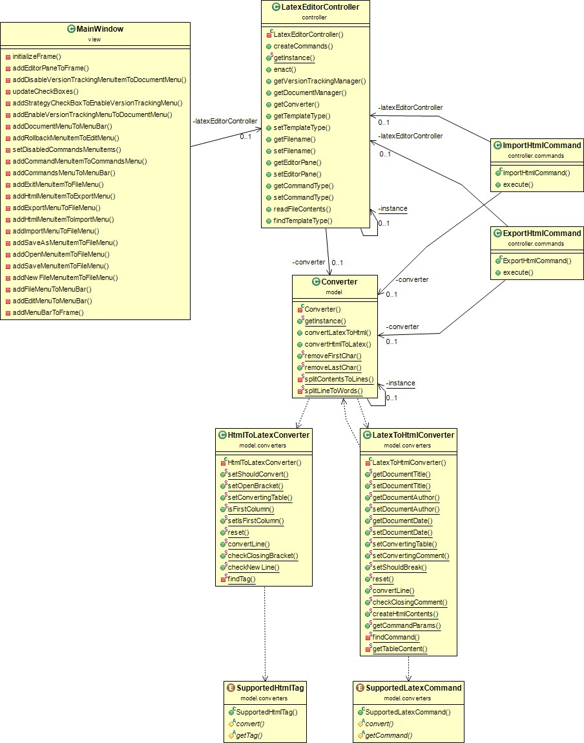

UML class diagram with classes involved in HTML document import and export

CLASS-RESPONSIBILITES-COLLABORATIONS CARDS
In this section a brief description of each class is provided in terms of a CRC card. The cards can also be found in json format in the project contents in the respective folder.

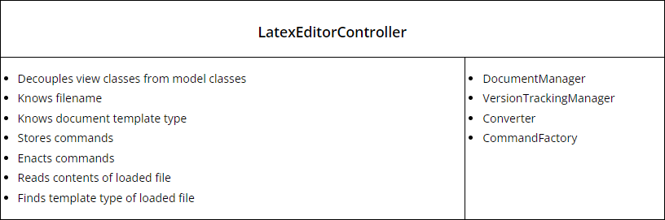

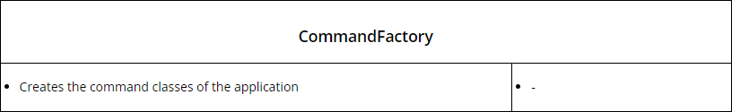

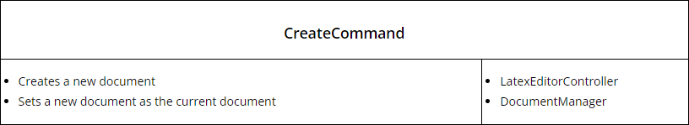

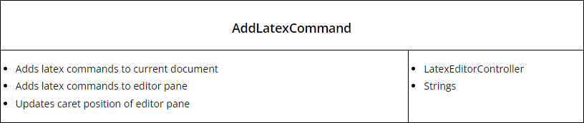

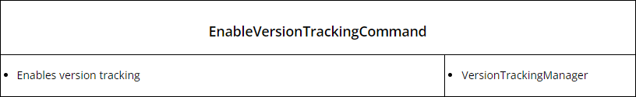

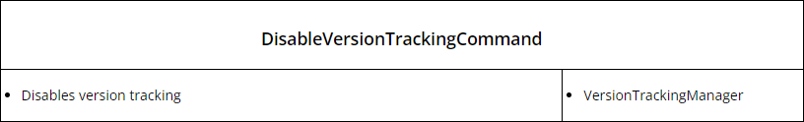

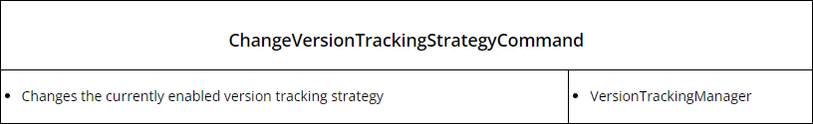

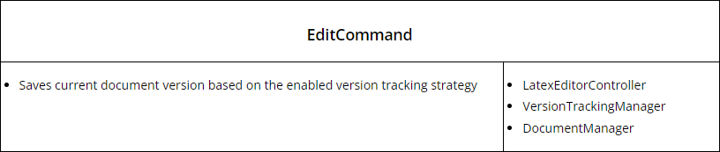

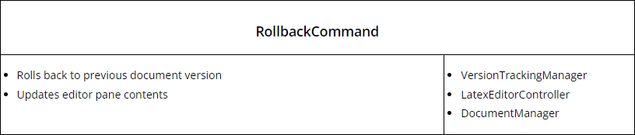

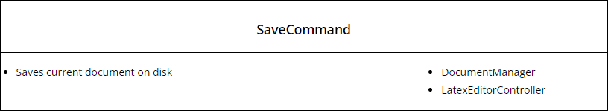

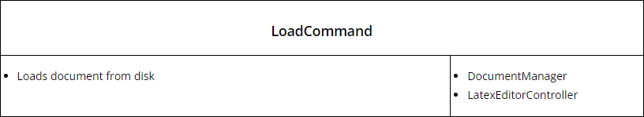

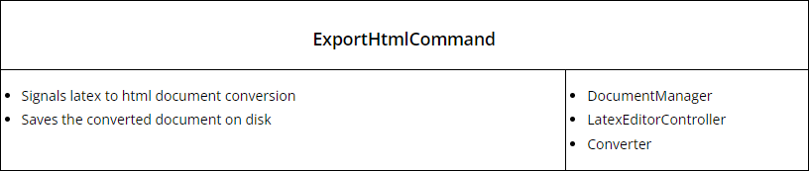

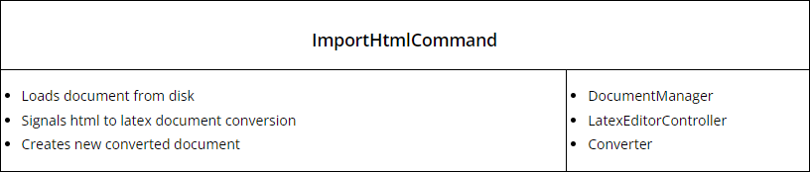

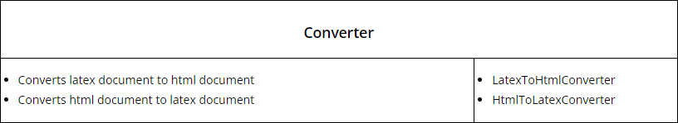

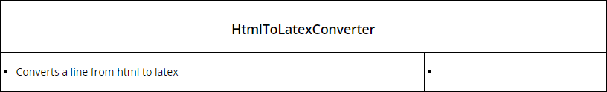

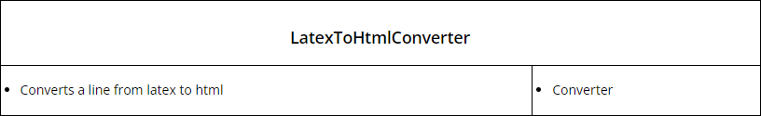

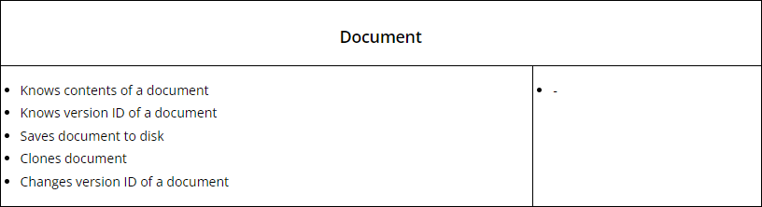

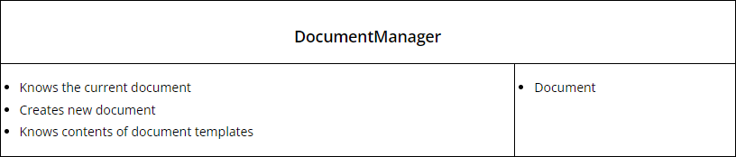

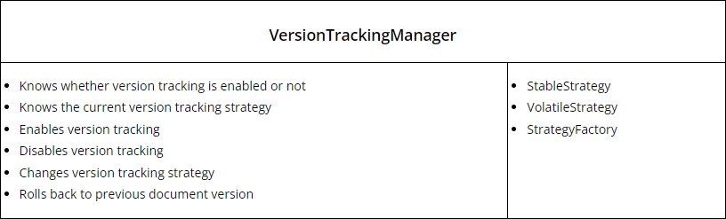

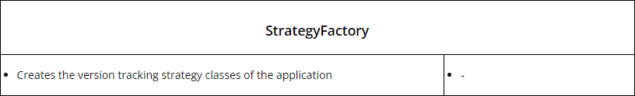

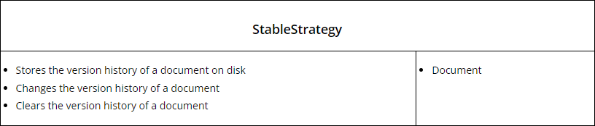

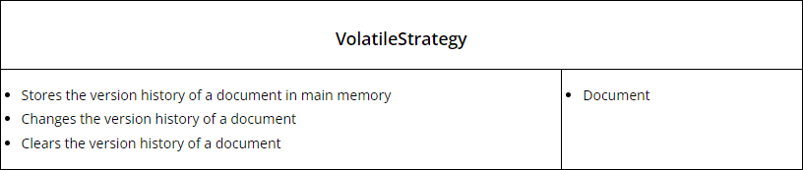

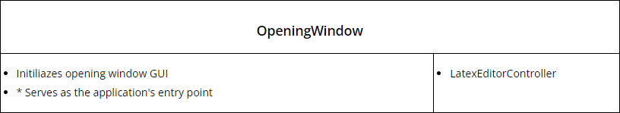

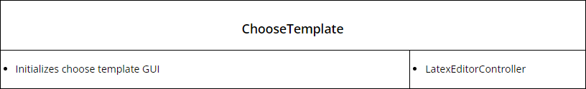

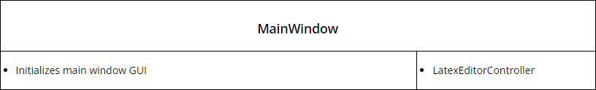

TEST CASES
Test cases have been developed for each of the application’s user stories. To assist with the testing the EnvironmentSetup class has been developed in the respective test package the purpose of which is to simulate the application environment during runtime. Specifically, it initializes the various GUI components along with the application logic and simulates the actions that correspond to each user story. The test cases provide roughly a coverage of 90% of the source code.

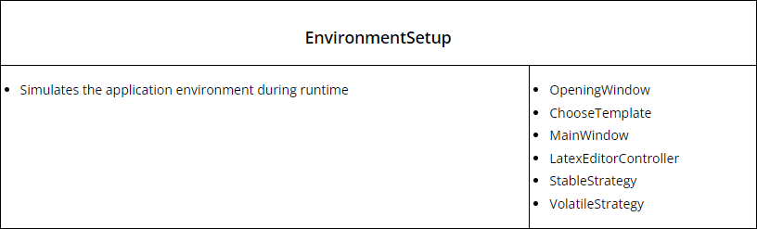
CRC card for the EnvironmentSetup class

The following test cases have been developed: (The test cases can also be found in json format in the respective project folder)
