2015 International Conference on Virtual and Augmented Reality in Education

Rehabilitation using Kinect-based Games and Virtual Reality

Miguel Pedraza-Huesoa*, Sergio Martín-Calzóna,

Francisco Javier Díaz-Pernasa, Mario Martínez-Zarzuelaa aDepartment of Signal Theory, Communications and Telematics Engineering of the University of Valladolid, Spain Abstract This paper introduces the development of a customized virtual reality system based on a serious game which allows the user to carry out physical and cognitive rehabilitation therapies using a natural user interface based on Microsoft© Kinect. Within these serious games you can find the exergames. It is a type of serious game which aims to stimulate body mobility through an immersive experience that situates the user inside virtual interactive landscapes. This type of game has become popular in recent years thanks to the creation of consoles like Nintendo Wii, Playstation or Xbox, which use gestural interaction game interfaces. Likewise, these technologies have become extremely useful tools in rehabilitation, and they are expected to permit a reduction of costs in socio-sanitary environments. The proposed virtual reality platform consists of different types of exercises by which the user is able to train or rehabilitate several aspects such as strength, aerobic or cognitive capacities. The system has been modelled so that the physical presence of a therapist is not required during the course of the session and there is no need to wear any kind of marker or sensor. Moreover, all parameters of the different exercises can be configured without the physical presence of a therapist. The reports of each session can also be read offline, therefore, the therapist will always know if a user has performed the session in a good way and act accordingly modifying whatever he deems necessary in the patient’s therapy. Due to these facts the system developed and presented in this article is a rehabilitation system based on remote assistance. It is important that this type of serious games accomplish all the functionalities a videogame fulfils at the same time that accomplish specific functionalities in its therapeutic environment. Remarkably, it is required an adaptation to the patient's abilities to avoid frustration and provide immediate feedback to the user during the exercises. In our system, the users are monitored and receive an audio-visual feedback during the session, so that they know in real-time if they are correctly doing the exercises of the specific therapy that was designed for them. © 2015 The Authors. Published by Elsevier B.V. Peer-review under responsibility of organizing committee of the 2015 International Conference on Virtual and Augmented Reality in Education (VARE 2015). Keywords: Serious games; Virtual Reality; Kinect.

1. Introduction Ageing affects the nervous system as well as other systems of our body1. When people age, they suffer from lack of memory and have difficulties to learn2, it also can make them lose balance. Because of these reasons our development has been thought to cover the main needs about physical activities for aged people. Research work has suggested that physical activities are very important in order to keep on fit and maintain our intelligence and not to suffer from problems about the brain. Training with video games makes aged people get motivated and get more confident and that is what our system aims3. The present serious game counts with two kind of training, the main one, encourages aged people to practise exercise and keep fit and the other secondary which helps aged people to exercise their mind while playing the physical exercises, it is called dual-task and it is and activity which is recognised to be as useful in improvement of physical and cognitive functions4,5. Currently there are programs which promote the health of aged people in this way4,5 and a lot of platforms of games such as Wii, Play Station, Wii Balance, Xbox, with which you can deploy a physical system6,7, we chose Kinect due to the easy interaction with it, you only need your body and no mouse or keyboard is needed, it is called natural interaction so that it is less intrusive. Kinect is a Microsoft© depth sensor camera, it gives us information about depth, colour and skeletons of people who are standing in front of it. This information is used to calculate angles and poses of each person. One advantage of using Kinect is that patients do not have to wear any kind of markers because Kinect data is good enough as shown in reference8. It makes the system more autonomous so it can be used at home by every people without having knowledge about the system, otherwise the system should be installed in centres where patients ought to go to train and it would make them waste time while therapist are installing the markers, actually some aged people and children cannot stand waiting for the marker setting. In our system, it is used Kinect V2 instead of Kinect V1 because it brings us better results according to this reference9, besides, Kinect V1 does not have an official SDK for Unity Game Engine otherwise you have to download third party software to be able to run Kinect in Unity. We also think that Microsoft© is going to keep developers up to date with new software for Kinect V2. This paper shows the technical specifications of a rehabilitation platform hereinafter Rea Kin G (Rehabilitation using Kinect-based Games) The clinical aspects of the platform have been designed by physiotherapist and doctors and the technical aspects by engineers following the clinical advice. 2. Serious Game proposed 2.1. Purpose of the system The aim of Rea Kin G is to improve the health of aged people by training physically and mentally, while they are in their own home, making ageing more fun and increasing their level of independency. The purposed system is user friendly and is based on natural interaction so that old people who are not used to computers can use it without training. In Fig 1 appears the main scene where the patient should fill-in a text box with his name (login and password in the final release), then he can choose his avatar or he can play. Then the system sends the name to the server side and gets from a database a personalized therapy for the current session.

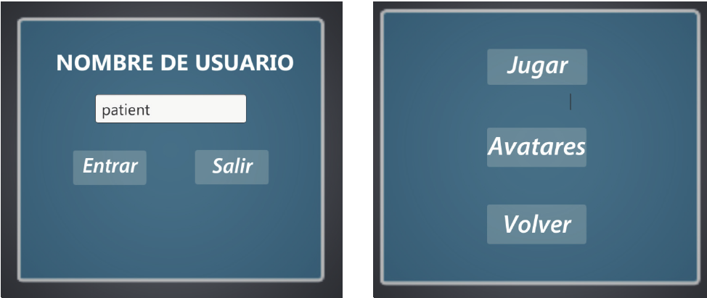
Fig. 1. Initial Scene.

2.2. Technologies The Rea Kin G platform employs the Microsoft Kinect V2 sensor 10 to capture users’ movements and includes a game module to train the users’ body. The platform has been programmed with Unity 11, a “game development ecosystem” which is able to create interactive 3D and 2D content and run it in multiplatform systems like Desktop, Web, i OS, Android and consoles. The recommended hardware and software configurations for Rea Kin G are: • A Microsoft© Kinect sensor V2, which includes a power hub and USB cabling. • A PC with Microsoft© Windows V8 or later with the Kinect drivers installed and the next recommended: 64-bit (x64) processor. 4 GB Memory (at least). Physical dual-core 3.1 GHz (2 logical cores per physical) or faster processor. USB 3.0 controller dedicated to the Kinect for Windows V2 sensor. DX11 capable graphics adapter. 2.3. Main features Rea Kin G is comprised of two kinds of games that include different types of exercises by which the user is able to train or rehabilitate several aspects such as strength, aerobic or cognitive capacities. The platform described in this paper is specifically designed to achieve a prevention and rehabilitation of patients, thus it will be possible to accomplish a short term and long term improvement, as it has been tested in other studies12. Designing rehabilitation in prevention platforms like the one proposed is a complex task because this serious games need to be developed as a game which has all the functionalities of a videogame, and simultaneously has the specific aspects of its therapeutic area such as provide constant monitoring of user performance. Among other features the game should adapt to the patient skills to avoid his frustration or receive instant feedbacks during the game16.During the course of the game feedback information is given, because several authors have demonstrated that providing information is very useful for patients13,14,15. Despite the fact that each exercise has a different orientation, the way of playing and performing during the session is the same, with the only need of a Microsoft© Kinect sensor, a computer and a device which allows the user the viewing of the video content (slide projector, TV), see Fig 2. The use of this motion capture device makes the patient more autonomous and saves costs, since it is not necessary the physical presence of a specialist to place 164 Miguel Pedraza-Hueso et al. / Procedia Computer Science 75 ( 2015 ) 161 – 168 sensors in the patient’s body. Moreover, as it has been proved, new motion capture devices such as Microsoft© Kinect offer very similar data to those provided by other devices that use more intrusive sensors, and being able to offer more freedom of movement to the patient9. These motion capture devices provide high accuracy measurement of the different angles of joints17.

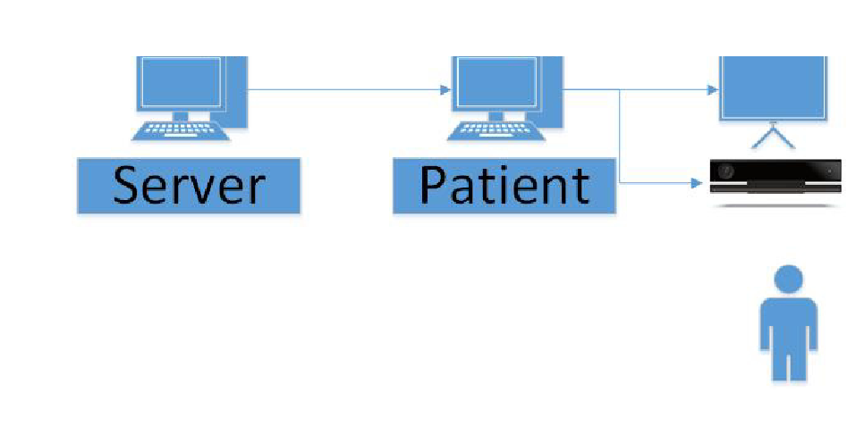
Fig. 2. Scheme of the system.

The application has been designed to be a distributed system. From therapist´s side new therapies can be designed for each patient, depending on their personal situation. Then, on patient´s side it is only required to enter a name in the system to download the session programmed. The platform includes two different kind of games: • The first kind of games are designed to train aerobic capabilities by making the patients walk in front of Kinect along different landscapes, the system tells them when they should increase the speed and when they have to stop. During the game, they have to pick up coins that are spinning on the ground or in the air. • The second kind of games are designed to improve strength skills. Here the scene is situated on the seaside, so the patients are always having beautiful views and relaxing sounds while training. The system counts the number of exercise repetitions and series the patient performs. 2.4. Aerobic games In the aerobic games a maximum of four different activities can be made. In the first one the lower limb is trained. In the second, the upper limb is trained. The third activity is based on a combination of the two previous ones, so the user will be able to train the upper and lower limb simultaneously. In the last activity any of both limbs can be trained with a cognitive training at the same time (dual-task activities4,5). There are different landscapes that are presented to the user, such as Hyde Park (London) or Paris. The landscape will depend on the kind of session configured by the therapist. The patient must stay in front of the device Microsoft© Kinect and make a series of movements that are detected by the sensor. All movements made are transferred to an avatar which is inside the landscape previously selected. Therefore, the user can see how the avatar play every single move he is making opposite to the device. In order to make the avatar move along the landscape the patient must walk on the site, lifting her legs and maintaining a medium speed step. The angle made of his knees when they are lifted is not the same for every Miguel Pedraza-Hueso et al. / Procedia Computer Science 75 ( 2015 ) 161 – 168 165patients, so that it is a configurable parameter and the therapist will be the one who configure the minimum angle the knee must be bend so as to be detected by the system. If the user does not maintain the right pace he will receive both visual and auditory feedback to make him/her aware he needs increase or decrease the pace . As the stage progresses the user is going to find different elements that he must interact with. The frequency these elements appear is also configurable by the therapist. The path where the avatar moves is randomly generated as he or she goes through the landscape. This is possible due to the use of dynamically generated modular scenarios, which are made out of landscape puzzle-based pieces that we call landscape sections. The player can be asked to keep going ahead, turning right or left. This important feature ensures that the generated path is different on different rehabilitation sessions. This avoids that the user could acquire certain automations if he or she has to follow always the same path, what would lead to lose the patient attention. On his way, the player will find elements like squirrels, stones, trunks, flowerpots, etc. His target will be to dodge this object and not bumping into them. If the user does not dodge these objects or ignores the feedback provided, he will lose coins. These coins are another element the player interacts with. He should collect all coins he comes across. Each coin is placed in different strategic positions so the user has to perform different movements (abduction, adduction, rotation…) see Fig. 3. The user will also come across other elements such as traffic signs, which will indicate him to stop a few seconds until another signal is shown. In dual-task activities, in addition to carrying out the activities mentioned before, a cognitive training is also performed. In order to do this, while the user moves around the stage different simple mathematical operations appear and must be solved. At the same time, in this type of training other elements are activated, such as foods or clothing. The patient should collect them all, and at the end of the stage, he must remember which foods and clothes he has collected, from a list of items that contain more elements. The duration of the activity is defined by the therapist, who can indicate how many landscape sections there are in the scene, the speed of the patient in each section, which kind of feedback is triggered and in which moment of the session it will be shown, etc. The therapist can also configure the system to show traffic lights, so if the colour of the lights is red, the patient should stop until the light switches to green, as it is shown in Fig.4.

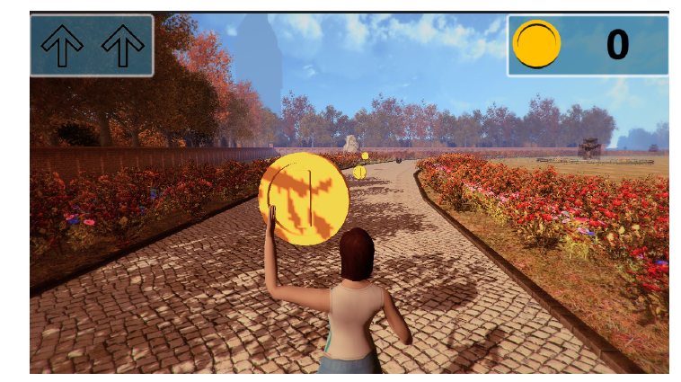

Fig. 3. Aerobic Scene I.

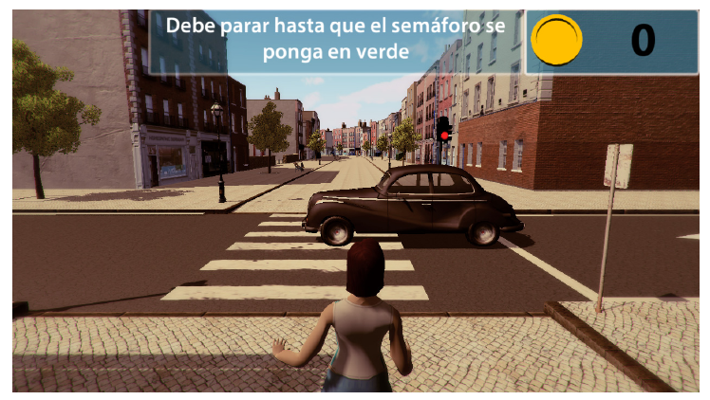
Fig. 4. Aerobic Scene II.

2.5. Strength games In the strength games, the patient has to practise some exercises like if he were in a gym. The platform explains to him what kind of exercises he should do, how much time he has to rest and how much weight he should take. The scene is located in a beautiful beach, where the patient has to move an avatar with his own body and there is also another avatar who indicates the movements he should do. While he is practising the exercises, some avatars are running on the beach and planes and boats appear in the scene, so it can make patients encourage themselves. The therapy about strength is designed by a therapist, who can choose from a list of available exercises, see Table 1. Each patient will have different exercises depending on what things the therapist wants to evaluate. While the patient is playing, the system counts the number of series and the number of repetitions, and a counter increments its value on the screen, see Fig. 5. This is possible because the system is able to detect whether the movement has been correctly performed. If the patient fails to accomplish the exercise in a given period of time, the system will know and will go to the next exercise. Every data about the session such as time in each exercise or time resting is saved so that the therapist can be informed.

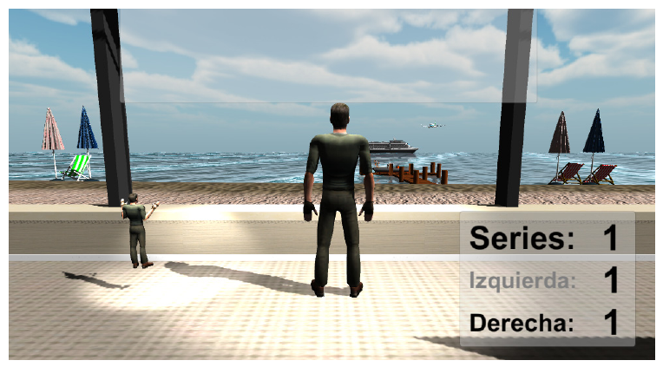

Fig. 5. Strength Scene.

Table 1. Sort of movements Kind of exercise Adduction/Abduction of shoulders Flexion of shoulders Extension of elbows Flexion of elbows Flexion of thigh Adduction/Abduction of thigh Flexion/Extension of knees

3. Conclusions This paper presents the beta version of the Rea Kin G platform. A new system developed to improve ageing through training sessions played in a virtual 3D environment. The system includes Kinect-based exergames that can be easily configured to include exercises oriented to improve patient mobility, aerobic capacity, strength, coordination, flexibility, etc. The exercises can also include dual-task activities in which the patients perform physical and mentally at the same time. Furthermore the patient is asked to remember which elements have appeared during the game. One of the main advantages of this rehabilitation platform is that a therapist can configure the therapies remotely and then send them to a given patient’s computer (i.e. to his or her home). The system is able to detect whether the patient is correctly doing the exercises and trigger feedback alerts if necessary. The therapist receives complete information on how the patient performed during rehabilitation exercises. All the Rea Kin G games and features have been designed with the support of health specialists and is going to be tested with patients in the next months. The results of these tests will be used to further improve the system and to have a platform with a real user centered design. The proposed rehabilitation platform has the intention to represent a very attractive exergame for both therapists and patients. It has been designed with the aim that the user has an enjoyable experience that increases his or her motivation along the rehabilitation process. 4. Acknowledgments. This research was partially supported by the Ministerio de Economía y Competitividad under project RTC-2014-2970-7 and Junta de Castilla y León under project BIO/VA38/15. References 1. Tseng CN, Gau BS, Lou MF. (2011) The effectiveness of exercise on improving cognitive function in older people: a systematic review. The journal of nursing research 2011; 19(2): 31-119. 2. Sofi F, Valecchi D, Bacci D, Abbate R, Gensini GF, Casini A, et al. Physical activity and risk of cognitive decline: a meta-analysis of prospective studies. Journal of internal medicine 2011; 269(1): 17-107. 3. Maillot P, Perrot A, Hartley A. Effects of interactive physical-activity video-game training on physical and cognitive function in older adults.Psychology and aging, Psychology and Aging 2012; 27(3): 589-600. 4. Erickson KI, Kramer AF. Aerobic exercise effects on cognitive and neural plasticity in older adults. British journal of sports medicine. 2009; 43(1): 4-22. 5. Lautenschlager NT, Cox K, Cyarto EV. The influence of exercise on brainaging and dementia. Biochimica et biophysica acta. 2012; 1822(3): 81-474. 6. Roy AK, Soni Y, Dubey S. Enhancing Effectiveness of Motor Rehabilitation Using Kinect Motion Sensing Technology. Global Humanitarian Technology Conference: South Asia Satellite (GHTC-SAS), 2013; pp. 298-304. 7. Vernadakis N, Derri V, Tsitskari E, Antoniou P. The effect of Xbox Kinect interventation on balance ability for previously injured Young competitive male athletes: A preliminary study. Physical Therapy in Sport 2014; 15(3): 55-148. 168 Miguel Pedraza-Hueso et al. / Procedia Computer Science 75 ( 2015 ) 161 – 168 8. Bonnechère B, Jansen B, Salvia P, Nouzahouene H. Omelina L, Moiseev F, Shoulukha V, Cornelis J, Rooze M, Van Sint Jan S. Validity and reliability of the Kinect within functional assessment activities: Comparison with standard stereophotogrammetry. Elsevier Gait & Posture 2014; 39(1): 593-598. 9. Gonzalez-Jorge H, Rodríguez-Gonzálvez P, Martínez-Sánchez J, González-Aqulera D, Arias P, Gesto M, Díaz-Vilariño L. Metrological comparison between Kinect I and Kinect II sensors. Measurement 2015; 70(6): 21-26. 10. Microsoft, Kinect – Windows app development. https://dev.windows.com/en-us/kinect. 11. Unity Technologies, Unity – Game Engine, http://unity3d.com. 12. Lund HH, Jessen JD. Effects of short-term training of community-dwelling elderly with modular interactive tiles. Games For Health: Research, Development, and Clinical Applications 2014; 3(5): 277-283. 13. Wüest S, Borghese NA, Pirovano M, Mainetti R, van de Langenberg R, de Bruin ED. Usability and Effects of an Exergame-Based Balance Training Program. Games For Health: Research, Development, and Clinical Applications 2014; 3(2): 106-114. 14. Sáenz-de-Urturi Z, Zapirain BG, Zorrilla AM. Kinect-based virtual game for motor and cognitive rehabilitation: A pilot study for older adults. Pervasive Health '14 Proceedings of the 8th International Conference on Pervasive Computing Technologies for Healthcare 2014; p.262-265. 15. Shah N, Basteris A, Amirabdollahian F. Design Parameters in Multimodal Games for Rehabilitation. Games For Health: Research, Development, and Clinical Applications 2014; 3(1): 13-20. 16. Borghese NA, Pirovano M, Lanzi PL, Wüest S, de Bruin ED. Computational intelligence and game design for effective at-home stroke rehabilitation. Games For Health: Research, Development, and Clinical Applications 2013; 2(2): 81-88. 17. Schmitz A, Ye M, Shapiro R, Yang R, Noehren B. Accuracy and repeatability of joint angles measured using single camera markerless motion capture system. Journal of Biomechanics 2014; 47(2): 587-591.

