There has been a known issue for developers trying to run the Android emulator in Visual Studio 2017 on Windows 10. There are actually 2 issues that must be resolved.

1. Windows 10, at least for my surface, enables Hyper-V by default. Hyper-V prevents the Intel VT/VX feature from running (presumably because it is already using the service exclusively). Disabling it can be challenging and frustrating, but there is an easy fix that I found here:  
   <https://superuser.com/questions/540055/convenient-way-to-enable-disable-hyper-v-in-windows-8>

Using Dism.exe you can use an elevated command prompt to disable and enable the service.   
  
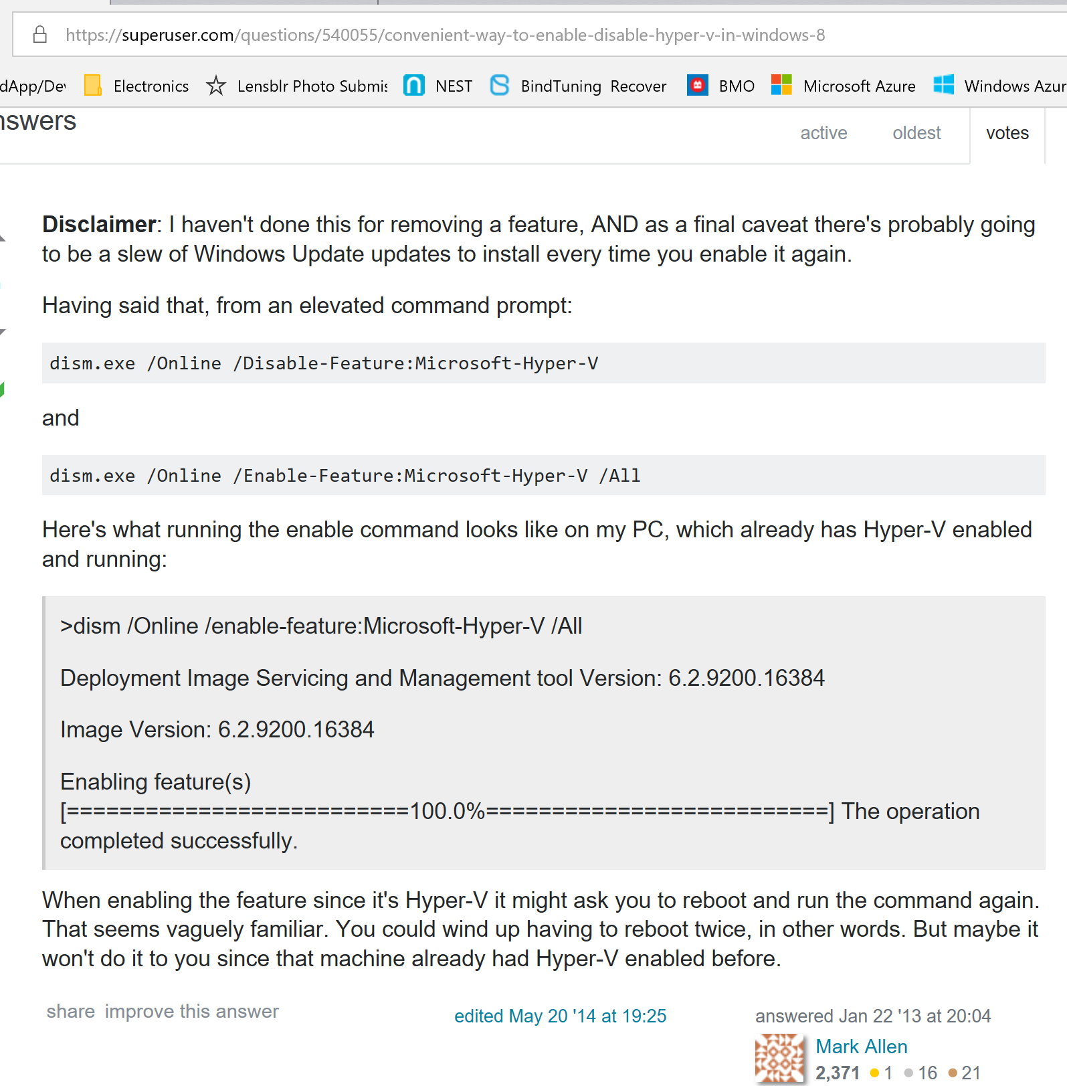

You will likely have to reboot to finish shutting down the services.

1. Next, we need to make sure that HAXM (the Emulator for Intel chips) is installed and configured.  
   This link contains the emulator download:  
   <https://software.intel.com/en-us/articles/intel-hardware-accelerated-execution-manager-intel-haxm>

After downloading and unzipping the software, you must run the “silent_install.bat” file as an administrator. *You may find it helpful to open an elevated command prompt to run the batch file or the status message for success or failure will disappear when the script window closes.*  
  
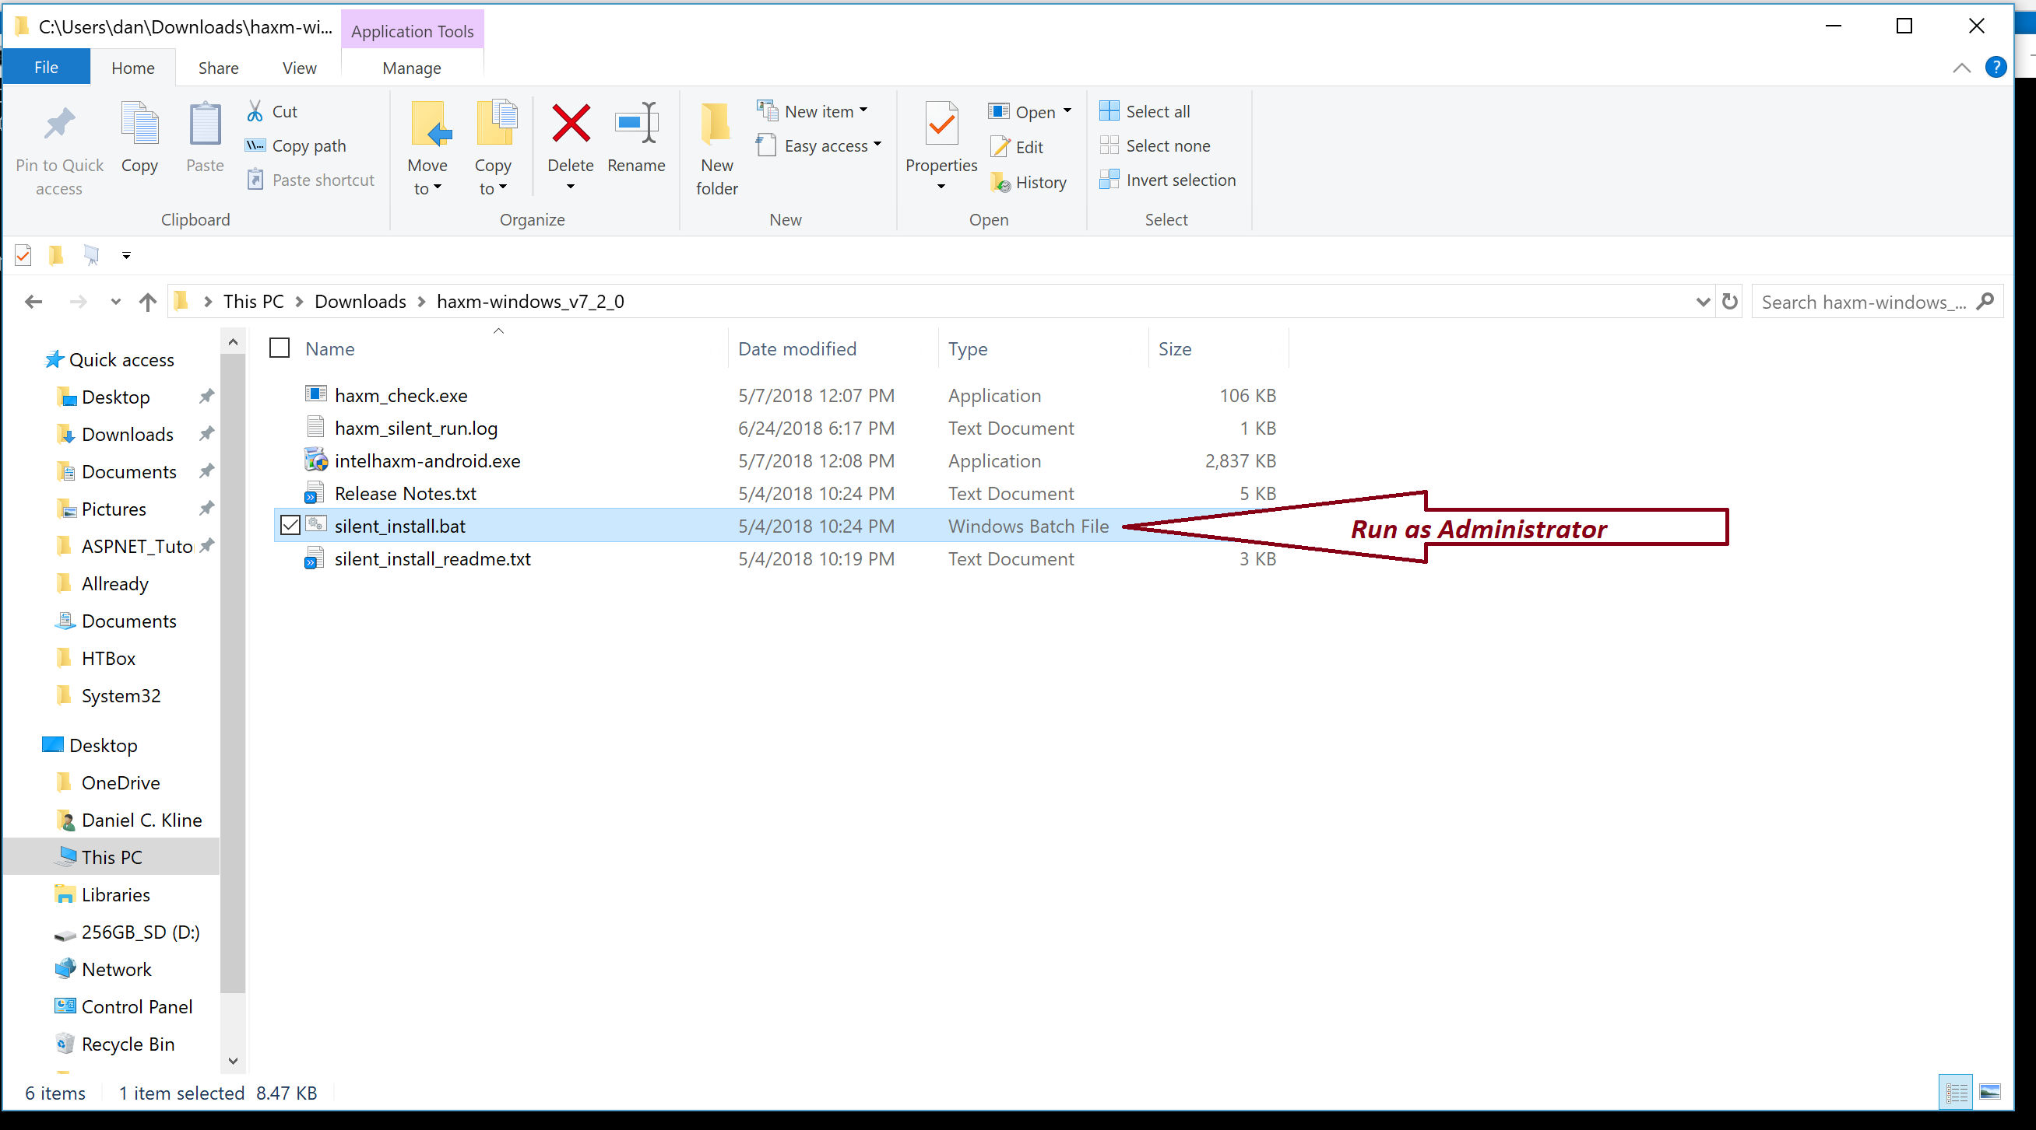

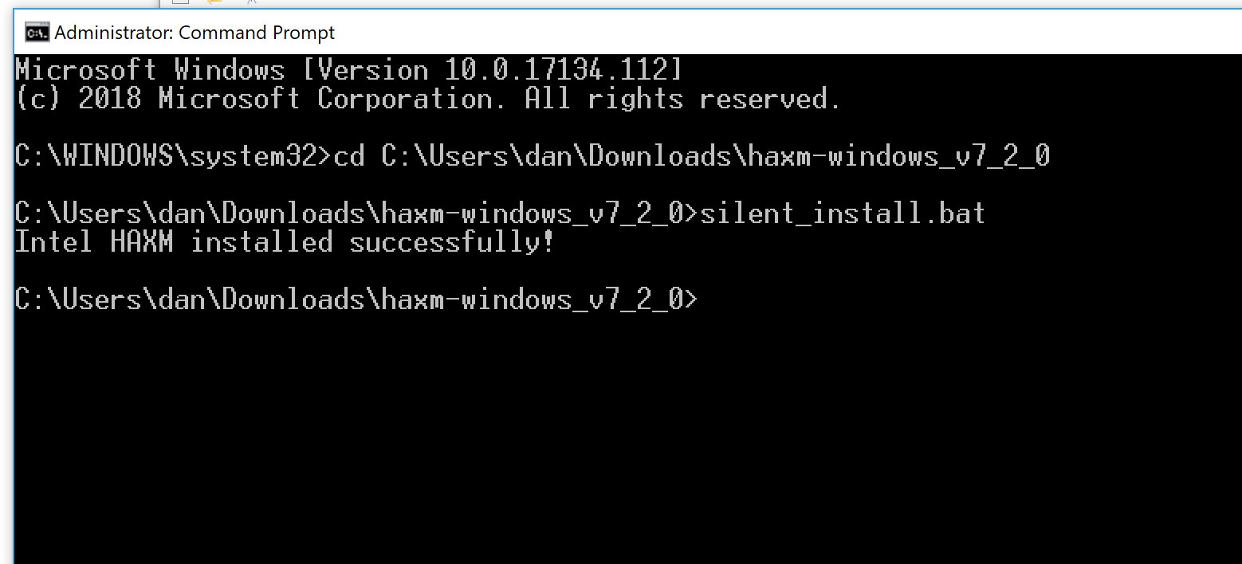

Next we need to make sure that the SDK and virtual device configurations are correct for our device. I was targeting the Samsung Galaxy 9+ with the Oreo 8.1 SDK version 27. The configurations can be set under *tool-android* in Visual Studio, then select the SDK manager to select the correct Android versions, and finally the Device Configurator to choose and/or configure the emulator. When completed, you should be able to select it in the target dropdown in Visual Studio.  
  
I’ve attached the configurations from my machine to provide a guide for configuring yours. I’ve also attached a screen shot of the emulator running the Kids-ID app for proof of success.

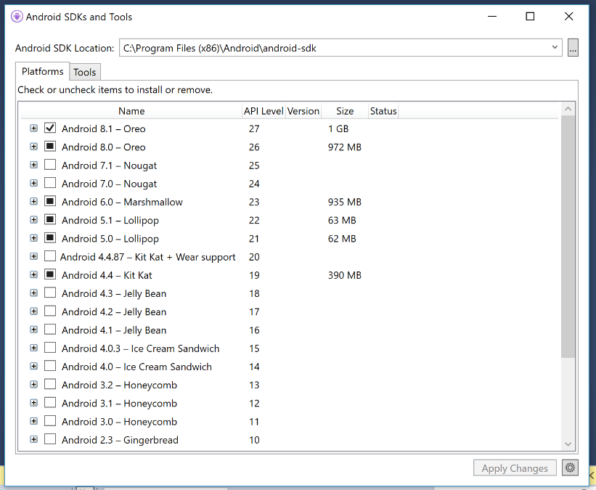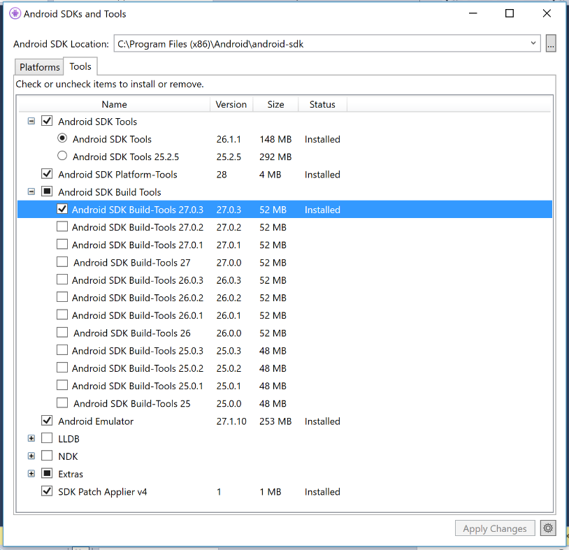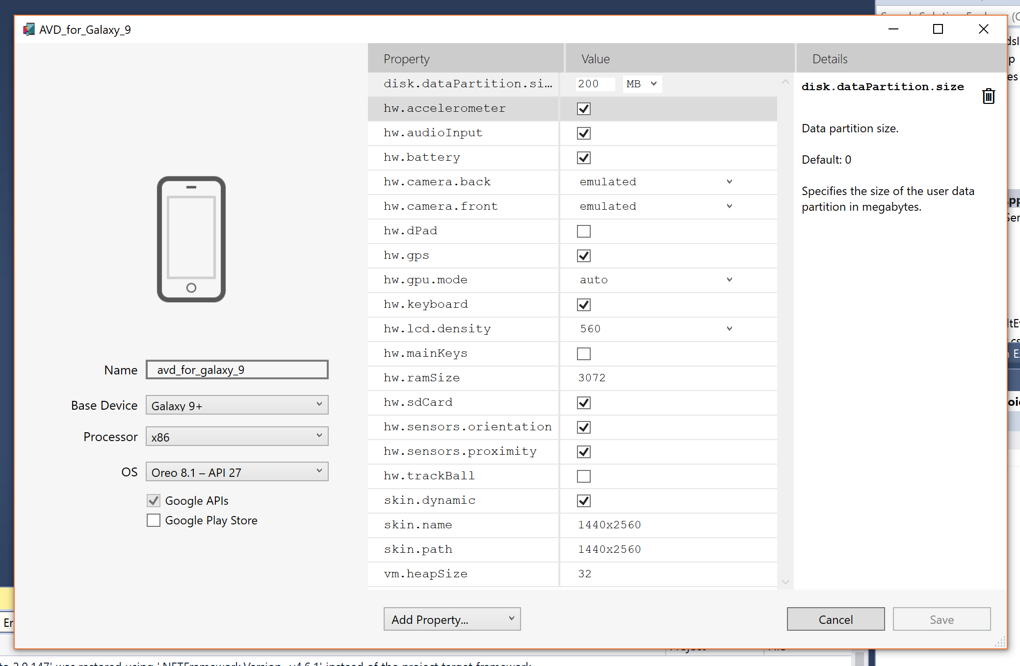

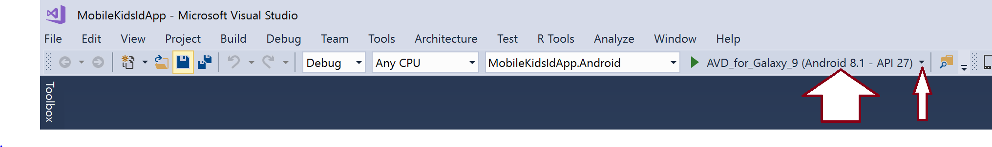

And Voila … The emulator is live. If you are using any of the Hyper-V features, especially with the new Feature Pack, you want to remember to use dism.exe to enable Hyper-V as illustrated previously for disabling it.  
  
Hope this helps.

