**WeRateDogs Project**

**Project Overview**

**WeRateDogs** is a well-known Twitter account for dog lovers. The account is set up for rating people’s dogs with a humorous comment about the dog. Since, it has more than 8 million followers around the world, there are vast amounts of useful data generated from this account for dogs each day. This report is prepared for sharing some of the insights that from analysing **WeRateDogs** ‘datasets.

**Insight 1: Top 5 favorited tweets with dog images**



This is top 1 tweet that received 157726 favourites and this is the dog’ image.

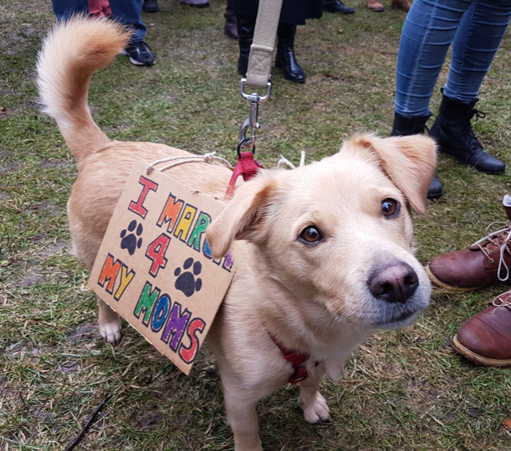

This is the tweet at second place that received 134380 favourites and this is the dog’ image.



This is the tweet at third place that received 121738 favourites and this is the dog’ image.



This is the tweet at fourth place that received 117329 favourites and this is the dog’ image.

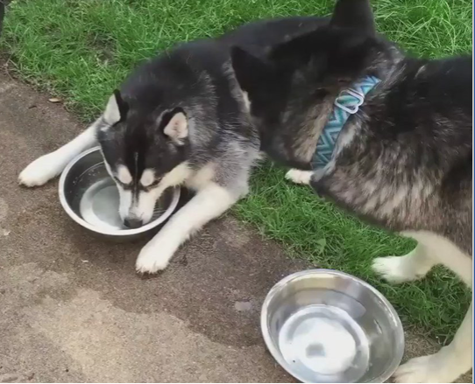

This is the tweet at fifth place that received 116424 favourites and this is the dog’ image.

**Insight 2: Top 5 breeds of dogs that people tweet about**

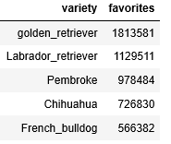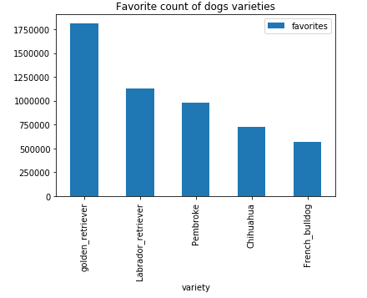

From above bar chart, we can find out that top 5 favorited breeds of dogs are: Golden Retriever, Labrador retriever, Pembroke, Chihuahua and French bulldog. It is obvious that Golden Retriever is the most favourite one among all others that received 1.8 million favourites.

**Insight 3: Relationship between dog’s rating and tweet’s favourites**

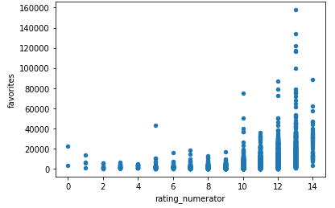

Based on the outcome from above scatter plot, it is agreed to say that the more favourites a tweet get, the better rating a dog will get. It is also notable that there is one specific tweet that received the highest rate ever in history, which I have provided the details below as a bonus.

