Question 1:

1. At very first after reading the file, I calculated arithmetic return by implementing pct_change().dropna(). This function exactly matches the equation for arithmetic return we are taught in class: A black text on a white background

   AI-generated content may be incorrect.. Then, I simply remove the mean by subtract the mean value from the dataset. After these processes, just used .std() to calculate the standard deviation. Below is the last five rows of the arithemetic returns by using .tail() and the standard deviation with std SPY = 0.0081, AAPL = 0.01348, and EQIX = 0.01536

The total standard deviation is adding all three stocks std value:



1. The process of this question is generally the same with last one except for calculation for log return. Based on the equation showed in class, it will be calculated as: A mathematical equation with black text

   AI-generated content may be incorrect., and that’s why this step is different from last one to be: np.log(data / data.shift(1)).dropna(). Everything else is same for this question to remove mean and calculate standard deviation. The result looks like this with std of SPY = 0.0081, AAPL = 0.01345, and EQIX = 0.01527: A white background with numbers

   AI-generated content may be incorrect.

Total standard deviation is adding all three stocks std value:

Question 2:

1. Given the date “today”, I simply converted the date from csv file into date form and lock the row with the date “01/03/2025”, then I multiply the value of stock on that date by the number of shares owned and added three of them together.



The final value of the current value of stocks is about $251862.497.

1. 1. In this method, I build the exponentially weighted covariance matrix in python first using the following code:



which stands for this formula

Then I calculate the portfolio standard deviation by compute arithmetic returns using preprocessed data:

where z05 calculates the Z value of 95% confidence level and “* portfolio_value” gets the money value of value at risk.

Expected shortfall using this formula:

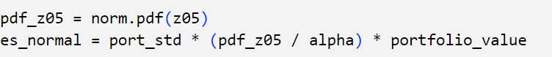

The final answer is:



Explanation of result: Based on the Normal Distribution with EWMA covariance, the 5% Value at Risk (VaR) for the portfolio is about $3,886, meaning there's a 5% chance of losing more than this amount in a single day. The Expected Shortfall (ES) is about $4,873, which represents the average loss if the portfolio exceeds the VaR threshold.

* 1. Firstly, Compute arithmetic returns using pct_changhe().

T-distribution is needed in the first place, so I fit a T-distribution to each stock's returns using

Then Transform data to uniform distribution using T CDF:



Then convert uniform to normal space using Gaussian copula



By using Z, spearman correlation matrix and Simulation of returns using Gaussian Copula are constructed

Next step will be converting simulated copula returns back to T-distributed returns

And compute simulated portfolio pnl

By having the pnl value, I can now calculate VaR by simply computing the 5% percentile of the simulated portfolio profit and loss distribution and ES by formulas we have in class A black and white image of symbols
which looks like this in codes:

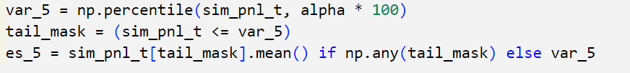

The final result is this:

Using the T-Distribution with a Gaussian Copula, we found that the 5% Value at Risk (VaR) is $4,390.50, meaning there’s a 5% chance the portfolio could lose more than this in a single day. The Expected Shortfall (ES) is $6,139.69, which represents the average loss in the worst 5% of cases.

* 1. For the Historic simulation using the full history, I computed historical PnL spread by this code: 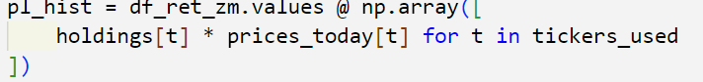

Then compute the historical VaR with 5% quantile 

and historical ES using this equation with alpha to be 0.05:



The result is that:

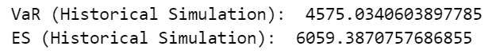

The 5% VaR of $4,575.03 means that, in 5% of the historical scenarios, the portfolio lost *more* than $4,575.03 in one day. The 5% ES of $6,059.39 goes one step further, showing that on those worst 5% of days, the *average* loss was $6,059.39.

The fact that ES is higher than VaR confirms that extreme market drops tend to be worse than the typical risk threshold.

1. The normal distribution method with EWMA assumes that returns follow a normal distribution and estimates risk using an exponentially weighted moving average for volatility. This makes it responsive to recent market changes and computationally simple, but it tends to underestimate extreme losses because normal distributions don’t account for fat tails.

In contrast, the T-distribution with a Gaussian Copula provides a more realistic approach by allowing for heavier tails, meaning it captures extreme market moves better. This makes it useful for modeling financial crises or high-volatility periods, but it requires more complex parameter estimation and is sensitive to how well the T-distribution fits the data.

The historical simulation method is the most straightforward since it doesn’t assume any theoretical distribution. Instead, it directly uses past return data to estimate risk, making it a more empirical approach. However, it assumes that past market conditions will repeat in the future, which may not always be true, and it doesn’t adapt well to changing market conditions. While the normal method is overly optimistic, the T-distribution captures more realistic risk, and historical simulation reflects actual past events but may not be reliable for future uncertainty.

Question 3: (Declaration in advance, all the formulas used under this question are suitable for the situation are because the question states that it is European Call option)

1. Implied volatility is calculated by Black-Scholes formula for sigma located in d2 with this formula: A black text on a white background

   AI-generated content may be incorrect. using root finder of python just similar to the example shown in Julia by professor. I used brentq package and put all the parameters in like this with sigma to be implied volatilityThe result is this
2. The calculation of Delta, Vega, and Theta are basically following the formula from class slide.
   1. Delta: A black text on a white background

      AI-generated content may be incorrect.
   2. Vega: A black text on a white background

      AI-generated content may be incorrect.
   3. A black text on a white background

      AI-generated content may be incorrect.Theta:

I used these formulas in python and generated the report of these values



The result shows that:

The Delta value of 0.6659 means that for every $1 increase in the stock price, the call option price increases by approximately $0.666.

The Vega value of 5.6407 means that for a 1% increase in implied volatility, the call option price increases by approximately $5.64

The Theta value of -5.5446 means that the option loses approximately $5.54 in value per day due to time decay.  
Then, for the price changed when implied volatility increased by 1%, I used Vega method because Vega measures the sensitivity of an option’s price to changes in implied volatility. Therefore I calculated approximate 1% change by multiplying the Vega value by 0.01



For the proof, I add the sigma value by 1%, and used it for B-S model calculations and get the difference.

The result shows that the difference between the estimated change and actual change is very low with the value to be around 0.000091.

1. For the put price using Generalized Black Scholes Merton with the formula below, A black text on a white background

   AI-generated content may be incorrect.

I defined the function in python and plug in the parameters

For whether Put Call Parity holds, I used the formula of Put Call Parity mentioned in class:

Left-hand side is calculated as follows in python with C_market for C in formula:



Right-hand side is calculated as follows which Price of the Put Option is directly plugged into the defined function.



After calculating the difference, the result shows that Put Call Parity holds since lhs is equal to rhs.

1. By implementing the functions used before, the general information of the portfolio is this:

1. Firstly, I transformed annual volatility into the 20-days volatility using simple math as follows



I also recalculated implied volatility as well in order to make the process clear. The reason for calculating this is that implied volatility is not directly observable in the market, so it must be estimated from the option’s market price.

The delta of the portfolio is added by call delta, put delta, and stock delta.

which shows in codes as this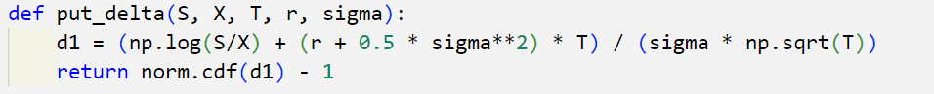

By the way, since holding a stock means the value moves 1-for-1 with price changes, stock delta is 1 in the case.

Theta measures the rate at which the option loses value over time, assuming everything else remains constant which includes the option value decay in my calculation. With Theta Call explained in question before, I also want to explain the formula I used for Theta Put which is the formula below

With function defined in python look like this

All these two functions **ignored the cost-of-carry** term because there is **no dividend** for this European option.

The portfolio theta is then calculated by adding theta call and theta put

using formula

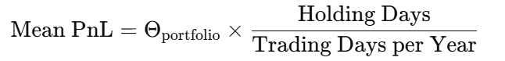 in which z alpha is -1.645. In my code case, negative sign is moved to the front since z_alpha returned by norm.ppf function is positive.

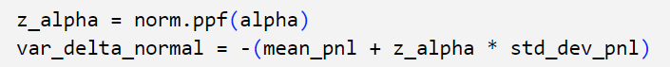



with the final report to be:

Portfolio Delta means that for every $1 increase in the stock price, the portfolio value increases by approximately $1.3319.

Portfolio Theta means that the portfolio loses approximately $8.16 per day due to time decay. As Theta is negative, this portfolio is likely holding long options.

Mean of 20-Day PnL indicates that the expected portfolio loss over the 20-day holding period is about $0.64.

The standard deviation of portfolio returns over 20 days is about $2.89.

Value at Risk at 95% confidence level is $5.3951 which means there is only a 5% probability that the portfolio will lose more than $5.40 over 20 days.

Expected Shortfall is $-5.3225 which measures the expected average loss in the worst 5% of cases.

e.

For the Monte Carlo Simulation, the number of simulated price paths is set to be 100000. Seed (42) ensures reproducibility of random results.

For the parameters below:

mu = 0 assumes the stock has a mean return of 0% per year which states in the question.

Rands generate normally distributed random returns over 20 days.

Then, I adjusted the time to expiration to be updated after 20 days which ensures that options are priced at the correct time to expire after 20 days and time decay is accounted for in the Monte Carlo process. 

I used B-S model for computing new call and put option values with formula to be

And

Which in code, it looks like this



Then I calculated the new portfolio value by adding all three prices





The PnL (profit and loss) is calculated as the change in portfolio value to be





Where portfolio_0 is calculated by adding C + P + S



Finally, I calculated the VaR using the formula

Which shows in code as

The result shows:

In my report, it shows that the Monte Carlo simulation generated 100,000 different portfolio outcomes.

The average portfolio profit & loss (PnL) over 20 days is -0.2166 which suggests that the portfolio loses $0.2166 over the 20-day period on average.

Value at Risk at 95% confidence is around $4.13 and there is a 5% probability that the portfolio will lose more than $4.13 over the 20-day period.

Expected Shortfall is $4.58, meaning that in the worst 5% of cases, the average loss is $4.58.

1. Firstly, I generated the graph for portfolio value vs stock value and compare the assumptions.

The graph obviously shows that there is difference between the Monte Carlo Simulation and Delta-Normal Approximation while stock value, portfolio value, and Monte Carlo has nearly overlayed each other with non-linear relationships while Delta Normal Approximation has a linear relationship. My key takeaway of the differences between the 2 methods with the graph is that Monte Carlo captures nonlinear option behavior while Delta-Normal assumes linear relationships, which can be inaccurate for options-heavy portfolios.

To wrap it up, Delta-Normal is the quick and easy method—it assumes that stock price changes follow a normal distribution and that your portfolio moves linearly with Delta. However, it totally ignores Gamma, which means it’s only accurate for small changes in stock price. On the other hand, Monte Carlo Simulation is like running a bunch of what-if scenarios, fully re-pricing the options using Black-Scholes. This method is way more accurate because it captures the nonlinear behavior of options (Gamma, Theta, and even Vega effects), but it takes way more time to compute. So, if we need a fast estimate, Delta-Normal is okay, but if we want realistic risk measurement, Monte Carlo is the way to go.