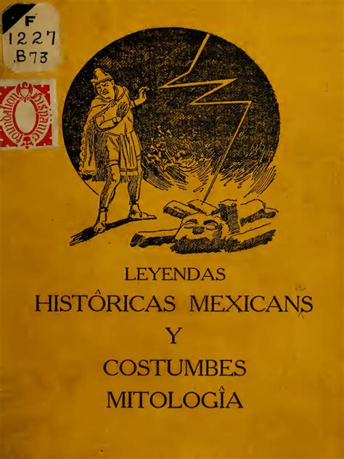
Certainly! Here's a comprehensive overview of Aurelia Bórquez de Whenthoff and her work, Leyendas históricas mexicanas, costumbres y mitología (1915):

📚 Aurelia Bórquez de Whenthoff: Biographical Sketch
Aurelia Bórquez de Whenthoff (1872–1965) was a Mexican-American educator and author born in Tucson, Arizona, to parents of Spanish descent who had settled in Hermosillo, Sonora, Mexico. Due to political unrest in Mexico, her family relocated to the United States. She spent her early years in Tucson and Globe, Arizona, and pursued teacher training at the Arizona Territorial Normal School (now Arizona State University). In 1905, she moved to Los Angeles, California, where she continued her educational endeavors.(Dialnet)
Bórquez was notably active in teaching Spanish at the Ebell Women's Club of Los Angeles between 1914 and 1917. Her innovative teaching methods emphasized natural and direct instruction, utilizing prayers, stories, and legends to engage students in learning Spanish. This approach was particularly effective in a period when Spanish instruction was often limited to domestic settings in California. (Dialnet)
In 1922, she founded the "Asociación Internacional Femenina" in Mexico City, aiming to foster better understanding and friendship among women of various nationalities. She passed away in Texas in 1965.(Dialnet)

📖 Leyendas históricas mexicanas, costumbres y mitología (1915): Overview and Perspective
Published in Los Angeles in 1915, Leyendas históricas mexicanas, costumbres y mitología is a collection of Mexican legends, customs, and myths compiled by Bórquez. The work was intended as supplementary reading material for students learning Spanish, particularly in public schools and private classes. Bórquez's dual purpose was to provide educational content and to help interpret her native land to her adopted country. (Scribd)
Perspective and Representation
Bórquez's work reflects a deep appreciation for Mexican culture and history. While she was of Spanish descent and educated in the United States, her writings exhibit a strong connection to Mexican heritage. She presents a picture of Mexican society that includes indigenous traditions and narratives, even though she was not a member of these indigenous communities. By doing so, she offers readers insights into aspects of Mexican culture that were often overlooked or misunderstood in early 20th-century America.
Her inclusion of a "Dictionary of Indian words" and a "Dictionary of Spanish words" at the end of the book indicates an effort to bridge cultural and linguistic gaps between her students and the rich tapestry of Mexican folklore. (The Library of Congress)

🔍 Critical Reception and Educational Impact
While specific contemporary critical reviews of Bórquez's work are scarce, her contributions to Spanish language education, especially in the context of early 20th-century California, are noteworthy. Her methods aligned with progressive educational practices of the time, emphasizing immersive and culturally rich content to facilitate language learning.
Her work remains a valuable resource for understanding the pedagogical approaches to language instruction and cultural representation during that era.

