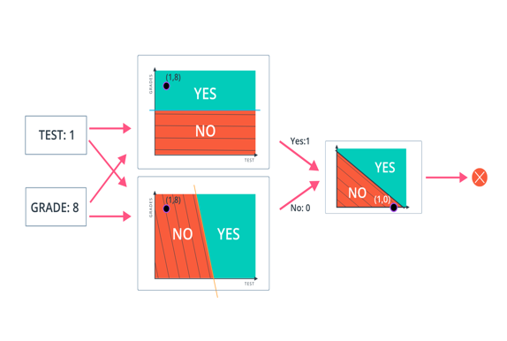

Perceptron

Now you've seen how a simple neural network makes decisions: by taking in input data, processing that information, and finally, producing an output in the form of a decision! Let's take a deeper dive into the university admission example to learn more about processing the input data.

Data, like test scores and grades, are fed into a network of interconnected nodes. These individual nodes are called [**perceptrons**](https://en.wikipedia.org/wiki/Perceptron), or artificial neurons, and they are the basic unit of a neural network. *Each one looks at input data and decides how to categorize that data.* In the example above, the input either passes a threshold for grades and test scores or doesn't, and so the two categories are: yes (passed the threshold) and no (didn't pass the threshold). These categories then combine to form a decision -- for example, if both nodes produce a "yes" output, then this student gains admission into the university.

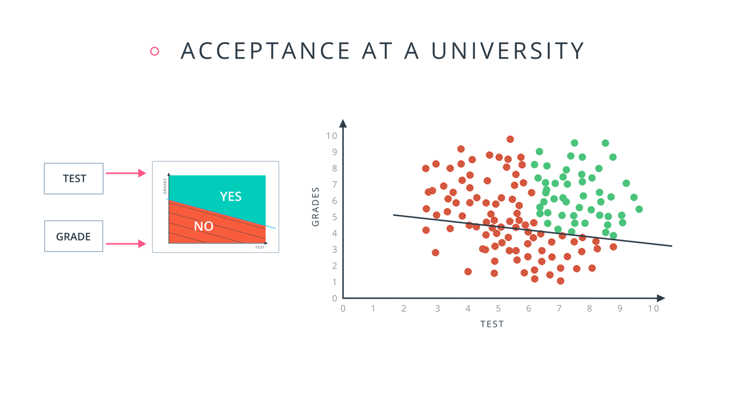

Let's zoom in even further and look at how a single perceptron processes input data.

The perceptron above is one of the two perceptrons from the video that help determine whether or not a student is accepted to a university. It decides whether a student's grades are high enough to be accepted to the university. You might be wondering: "How does it know whether grades or test scores are more important in making this acceptance decision?" Well, **when we initialize a neural network, we don't know what information will be most important in making a decision**. It's up to the neural network to *learn for itself* which data is most important and adjust how it considers that data.

It does this with something called **weights**.

Weights

When input comes into a perceptron, it gets multiplied by a weight value that is assigned to this particular input. For example, the perceptron above has two inputs, tests for test scores and grades, so it has two associated weights that can be adjusted individually. These weights start out as random values, and as the neural network learns more about what kind of input data leads to a student being accepted into a university, the network adjusts the weights based on any errors in categorization that results from the previous weights. This is called **training** the neural network.

A higher weight means the neural network considers that input more important than other inputs, and lower weight means that the data is considered less important. An extreme example would be if test scores had no affect at all on university acceptance; then the weight of the test score input would be zero and it would have no effect on the output of the perceptron.

Summing the Input Data

Each input to a perceptron has an associated weight that represents its importance. These weights are determined during the learning process of a neural network, called training. In the next step, the weighted input data are summed to produce a single value, that will help determine the final output - whether a student is accepted to a university or not. Let's see a concrete example of this.

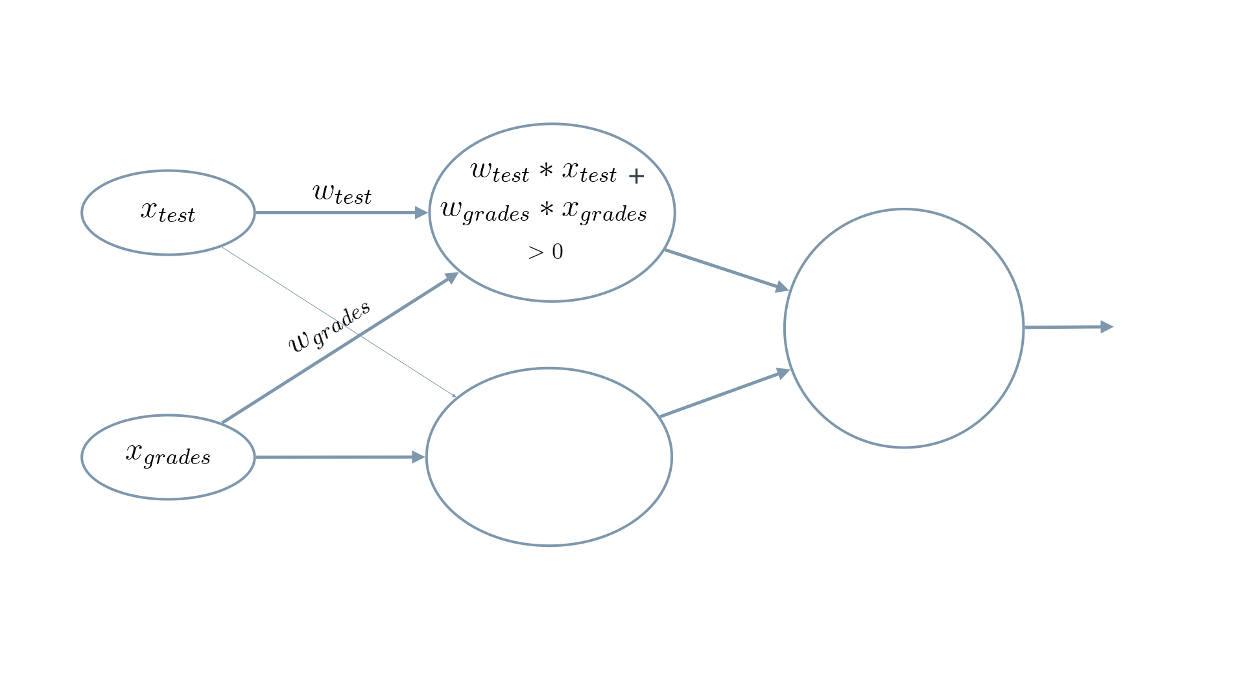

We weight x_test by w_test and add it to x_grades weighted by w_grades.

When writing equations related to neural networks, the weights will always be represented by some type of the letter **w**. It will usually look like a *W* when it represents a **matrix** of weights or a *w* when it represents an **individual** weight, and it may include some additional information in the form of a subscript to specify which weights (you'll see more on that next). But remember, when you see the letter **w**, think **weights**.

In this example, we'll use *w*​*grades*​​ for the weight of grades and *w*​*test*​​ for the weight of test. For the image above, let's say that the weights are: *w*​*grades*​​=−1, *w*​*test*​​ =−0.2. You don't have to be concerned with the actual values, but their relative values are important. *w*​*grades*​​ is 5 times larger than *w*​*test*​​, which means the neural network considers grades input 5 times more important than test in determining whether a student will be accepted into a university.

The perceptron applies these weights to the inputs and sums them in a process known as **linear combination**. In our case, this looks like *w*​*grades*​​⋅*x*​*grades*​​+*w*​*test*​​⋅*x*​*test*​​=−1⋅*x*​*grades*​​−0.2⋅*x*​*test*​​. Now, to make our equation less wordy, let's replace the explicit names with numbers. Let's use 1 for *grades* and 2 for *tests*. So now our equation becomes *w*​1​​⋅*x*​1​​+*w*​2​​⋅*x*​2​​.

In this example, we just have 2 simple inputs: grades and tests. Let's imagine we instead had m different inputs and we labeled them *x*​1​​, *x*​2​​, ..., *x*​*m*​​. Let's also say that the weight corresponding to *x*​1​​ is *w*​1​​ and so on. In that case, we would express the linear combination succinctly as:

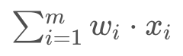

Calculating the Output with an Activation Function

Finally, the result of the perceptron's summation is turned into an output signal! This is done by feeding the linear combination into an **activation function**.

Activation functions are functions that decide, given the inputs into the node, what should be the node's output? Because it's the activation function that decides the actual output, we often refer to the outputs of a layer as its "activations".

One of the simplest activation functions is the **Heaviside step function**. This function returns a **0** if the linear combination is less than 0. It returns a **1** if the linear combination is positive or equal to zero. The [**Heaviside step function**](https://en.wikipedia.org/wiki/Heaviside_step_function) is shown below, where h is the calculated linear combination:

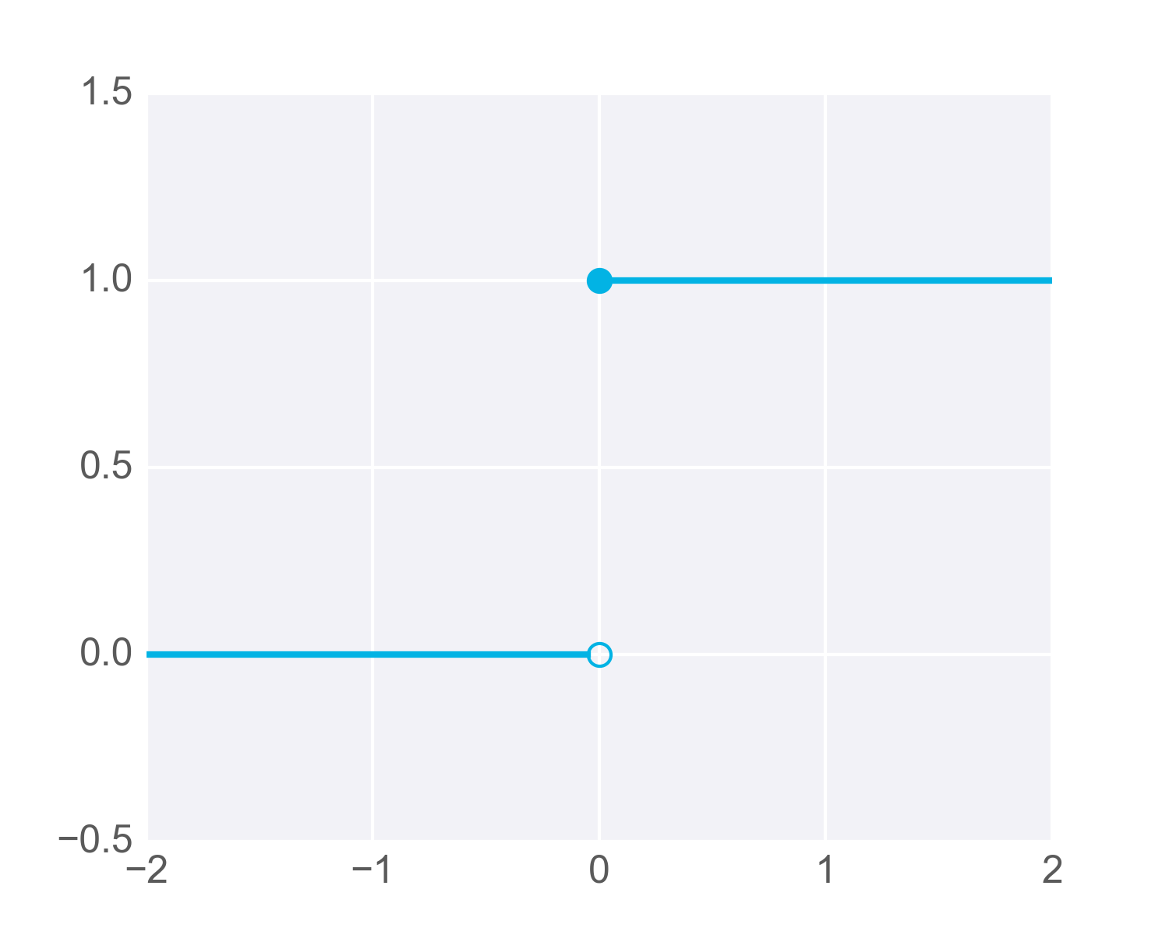

In the university acceptance example above, we used the weights *w*​*grades*​​= −1, *w*​*test*​​ = −0.2. Since *w*​*grades*​​ and *w*​*test*​​ are negative values, the activation function will only return a 1 if grades and test are 0! This is because the range of values from the linear combination using these weights and inputs are (−∞,0) (i.e. negative infinity to 0, including 0 itself).

It's easiest to see this with an example in two dimensions. In the following graph, imagine any points along the line or in the shaded area represent all the possible inputs to our node. Also imagine that the value along the y-axis is the result of performing the linear combination on these inputs and the appropriate weights. It's this result that gets passed to the activation function.

Now remember that the step activation function returns 1 for any inputs greater than or equal to zero. As you can see in the image, only one point has a y-value greater than or equal to zero – the point right at the origin, (0,0):

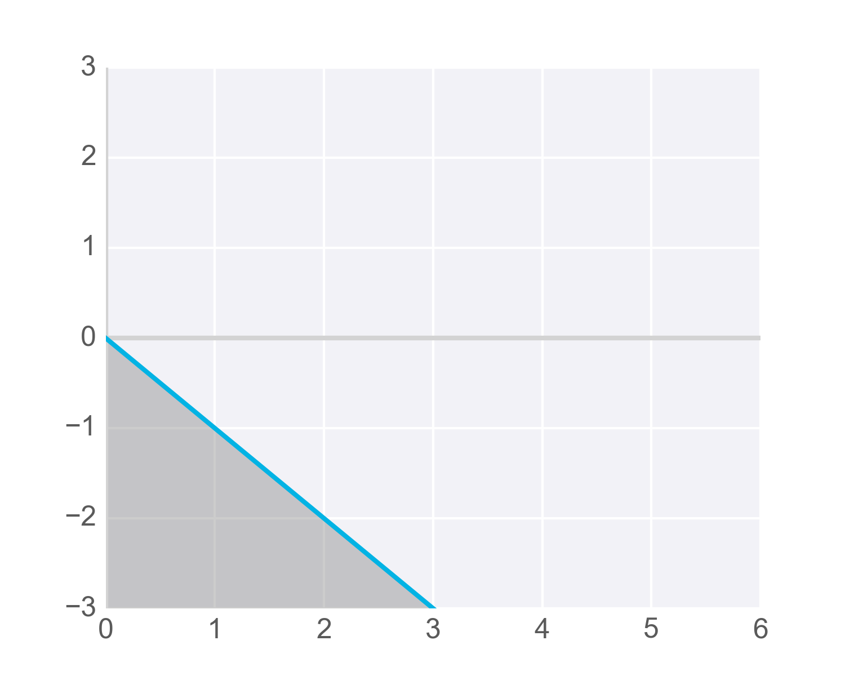

Now, we certainly want more than one possible grade/test combination to result in acceptance, so we need to adjust the results passed to our activation function so it activates – that is, returns 1 – for more inputs. Specifically, we need to find a way so all the scores we’d like to consider acceptable for admissions produce values greater than or equal to zero when linearly combined with the weights into our node.

One way to get our function to return 1 for more inputs is to add a value to the results of our linear combination, called a **bias**.

A bias, represented in equations as b, lets us move values in one direction or another.

For example, the following diagram shows the previous hypothetical function with an added bias of +3. The blue shaded area shows all the values that now activate the function. But notice that these are produced with the same inputs as the values shown shaded in grey – just adjusted higher by adding the bias term:

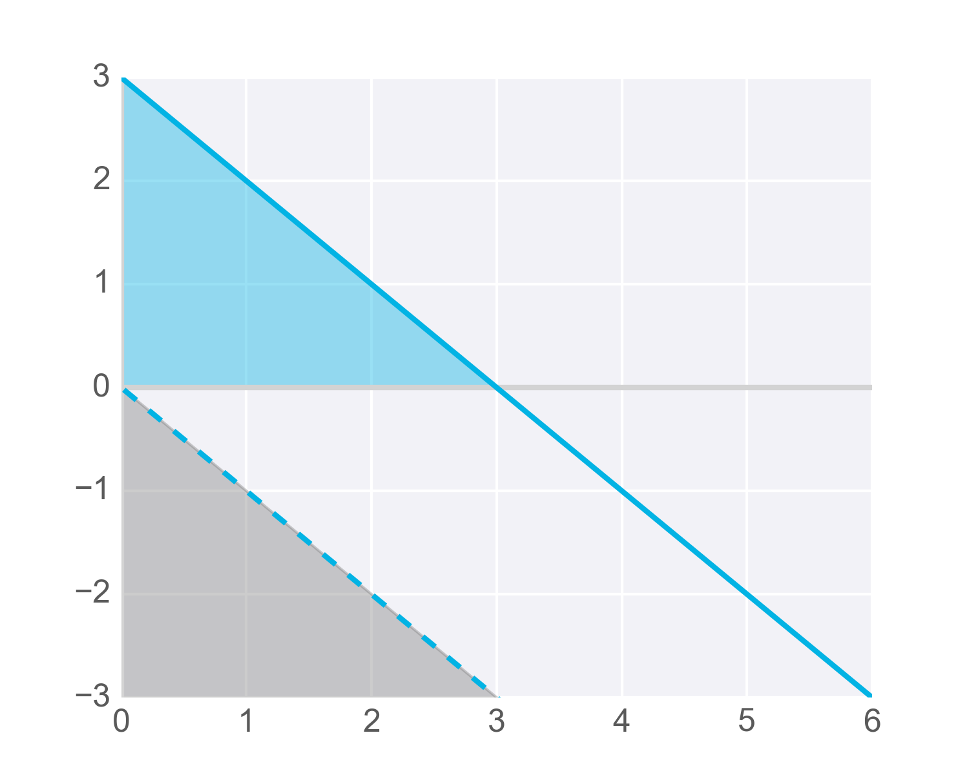

This formula returns 1 if the input (*x*​1​​, *x*​2​​, ..., *x*​*m*​​) belongs to the accepted-to-university category or returns 0 if it doesn't. The input is made up of one or more [**real numbers**](https://en.wikipedia.org/wiki/Real_number), each one represented by *x*​*i*​​, where *m* is the number of inputs.

Then the neural network starts to learn! Initially, the weights (*w*​*i*​​) and bias (*b*) are assigned a random value, and then they are updated using a learning algorithm like gradient descent. The weights and biases change so that the next training example is more accurately categorized, and patterns in data are "learned" by the neural network.

Now that you have a good understanding of perceptions, let's put that knowledge to use. In the next section, you'll create the AND perceptron from the Neural Networks video by setting the values for weights and bias.