**Bill Yerkes**

**CS5542 Big Data Apps and Analytics**

**In Class Programming –10**

**29th October 2020**

**Due Date: 11/3/2020 (Tuesday by 11:59pm)**

**Submit ICP Feedback in Class. :** [**Lnik to Feed back Form**](https://docs.google.com/forms/d/e/1FAIpQLSesllFh5_STnj7RbHyQainRG_2EIKw1csp8ObP5FWjpVnGVOg/viewform)

**Deep Q-Learning:**

**Implementing Deep Q-Learning in Python using Keras & OpenAI Gym:**

In deep Q-learning, we use a neural network to approximate the Q-value function. The state is given as the input and the Q-value of all possible actions is generated as the output. The comparison between Q-learning & deep Q-learning is illustrated below:

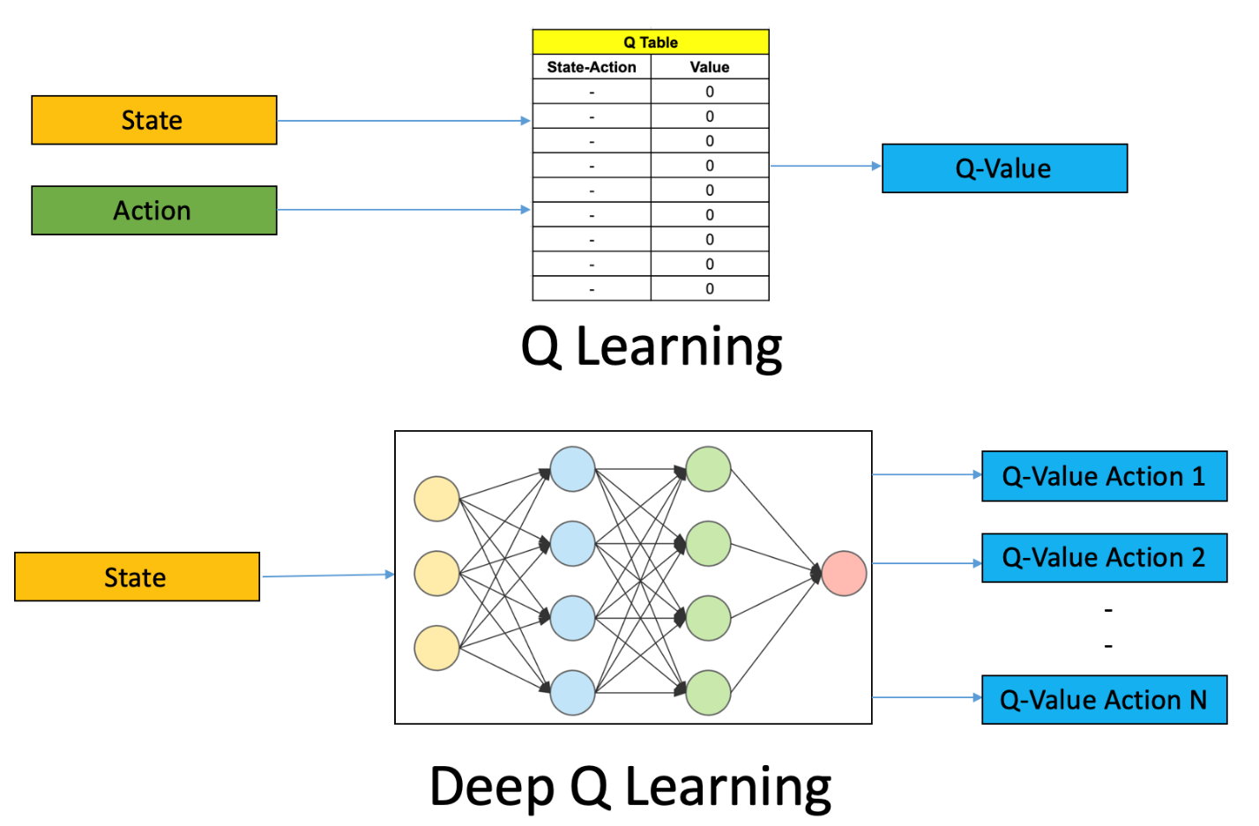

CartPole is one of the simplest environments in the OpenAI gym (a game simulator). The idea of CartPole is that there is a pole standing up on top of a cart. The goal is to balance this pole by moving the cart from side to side to keep the pole balanced upright.

Design a Deep Q learning Network (DQN), using Keras & OpenAI Gym , for cartpole game and visualize your results.

ICP Requirements:

1. Designing a DQN for cartpole game in python using Keras & OpenAI Gym (70 points)
2. Visualization of DQN cartpole game (10 points)
3. overall code quality (10 points)
4. Pdf Report quality, video explanation (10 points)

Submission Guidelines:

Same as previous ICPs.

**ICP Report:**

**What I learned in the ICP:**

I learned how to use Deep Learning to play and solve games. I learned some about the Gym library and how that is use for game play and deep learning. I learned how to display the cart pole environment.

**Description of what task I was performing:**

Design a deep learning solution to play the cart pole game and render it on the screen.

**Challenges I faced:**

One of the hardest parts was trying to figure out how to display the cart pole.

**Screen Shots**

[GitHub:](https://github.com/BillYerkes/CSC5542/tree/master/Lab10)

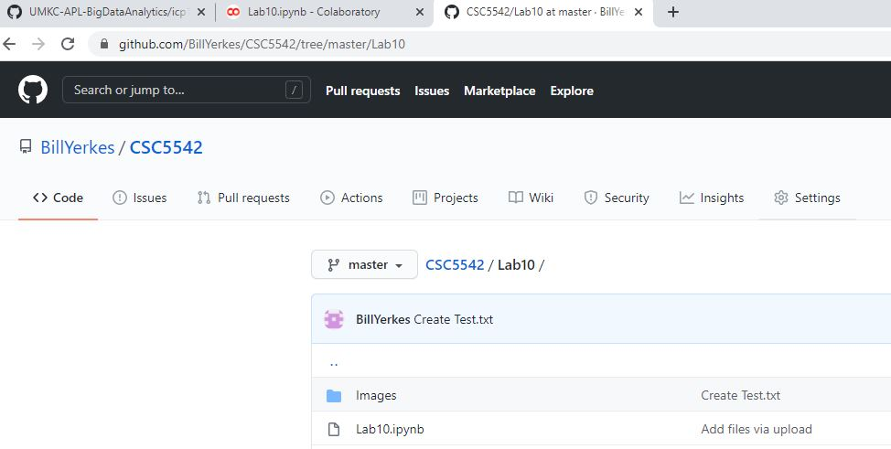

**Load Libraries and Import Modules**

Loading libraries to be able to display cart pole game.

Importing needed modules to create, play, track, and display the game.

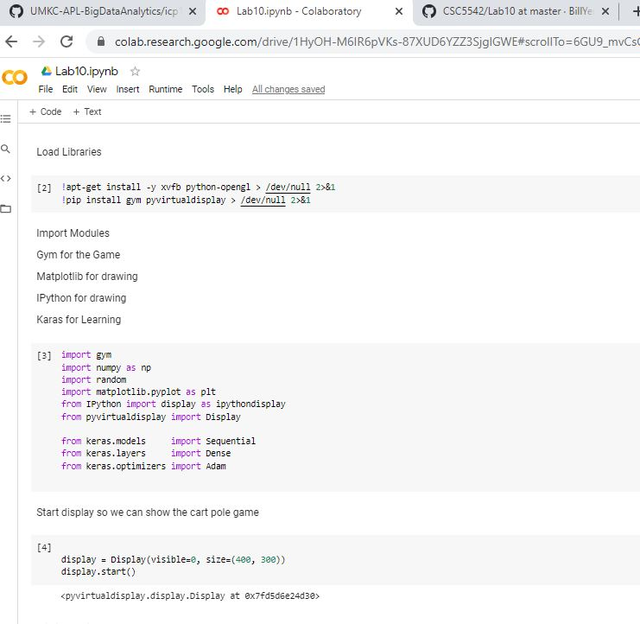

Setting up global variables for the game and creating module to display the game.

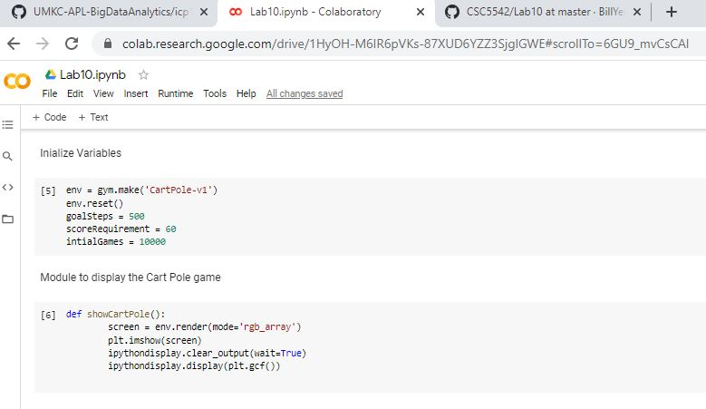

Module to play random game:

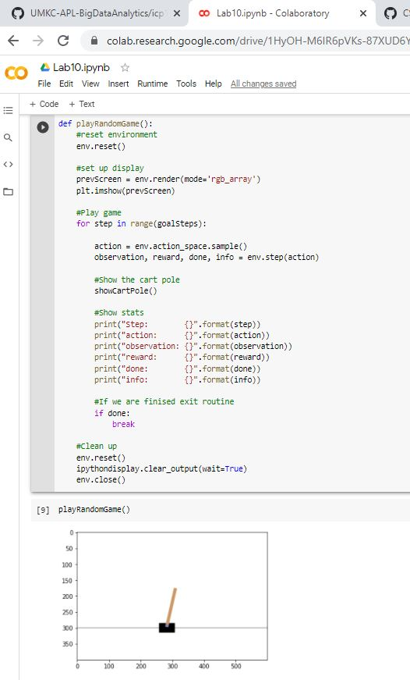

Create the training data:

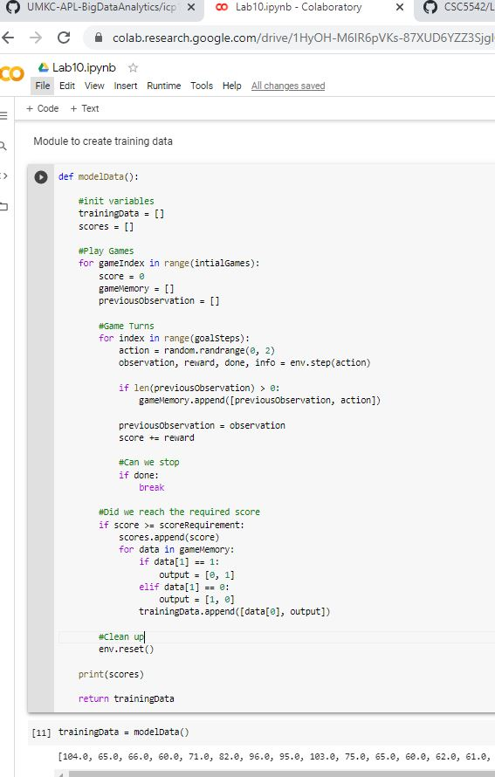

Build and Train the model on how to play the game:

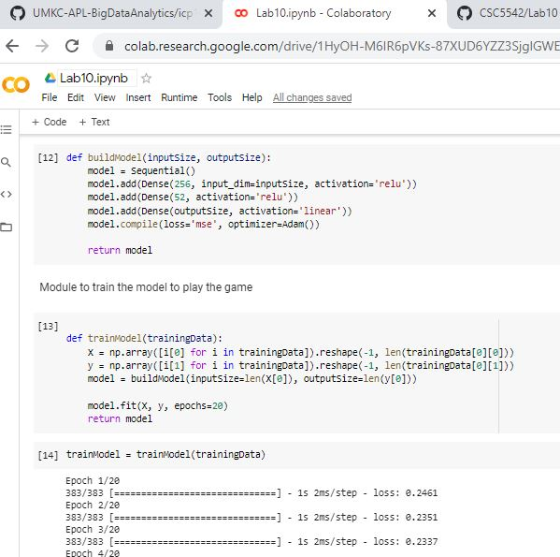

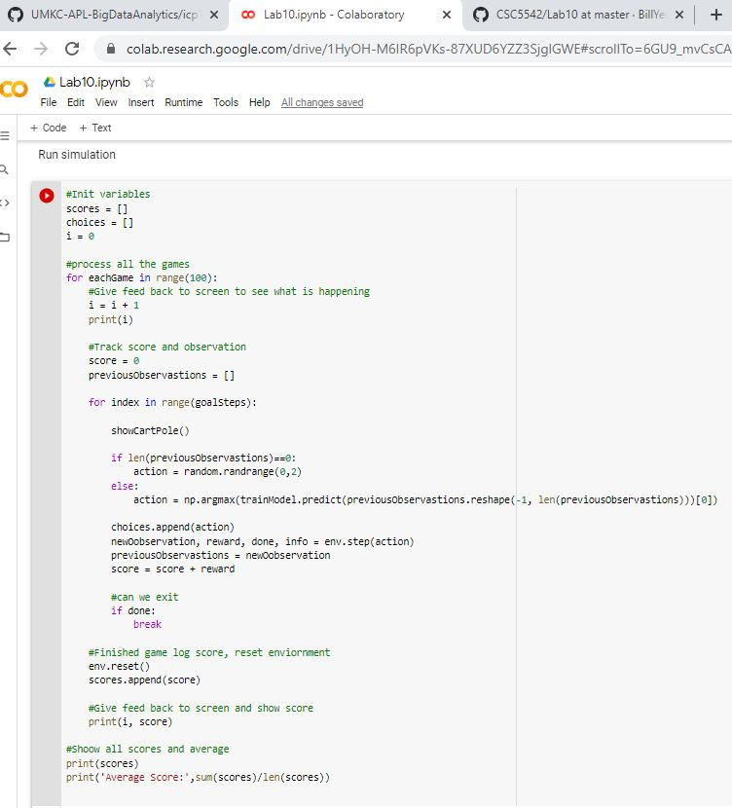Run the simulation:

[**Video Link**](https://youtu.be/EvPvRbaww2c)

**Any in site about the data or the ICP in general**

Would like to do more with this type of programming.