**Bill Yerkes**

**CS5542 Big Data Apps and Analytics**

**In Class Programming –8**

**15th October 2020**

**Submit ICP Feedback in Class. :** [**Lnik to Feed back Form**](https://docs.google.com/forms/d/e/1FAIpQLSesllFh5_STnj7RbHyQainRG_2EIKw1csp8ObP5FWjpVnGVOg/viewform)

**Variational Autoencoders:**

**Use the same data and source code but add two more layers to encoder path and their corresponding two layers to decoder path, run the new model and report your findings. In your report specify which 4 layers (2 layers in encoder path and 2 layers in decoder path) have you added and explain why you added those (their function).**

**Examples of layers that can be added Conv2D, Batchnorm, Conv2DTranspose etc.**

ICP Requirements:

1. Successfully executing the code with new architecture for encoder and decoder path (75 points)
2. Explanation of new layers (5 points)
3. overall code quality (10 points)
4. Pdf Report quality, video explanation (10 points)

Submission Guidelines:

Same as previous ICPs.

ICP Report:

**What I learned in the ICP:**

I learned the basics of Variational Autoencoders. I learned a bit more about the Keras Layers. I got a better understanding of max pooling and average pooling.

**Description of what task I was performing:**

I added two layers each to the encoder and decoder section of the Autoencoder model.

**Challenges I faced:**

I once again ran into issues with making sure that the data size was correct when going between steps. Found that reducing from 7 to 4 in the encoder posed challenges when trying to do the inverse in the decoder as it would go from 4 to 8. I figured out how to keep the size of the data the same so as to be able to add additional layers. I would like to learn if it is possible to increase the image size from 28 x 28 to 32 x 32, and what implications that would have on the model.

**Screen Shots**

**GitHub:**

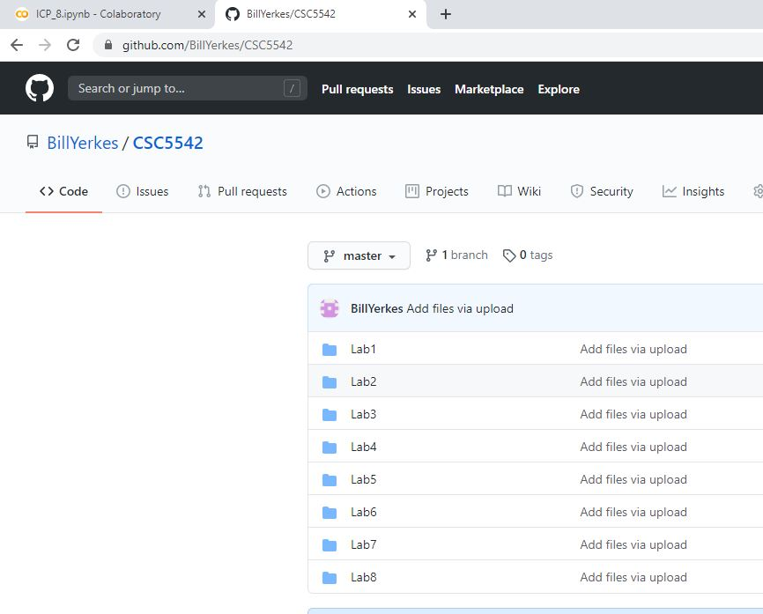

### **Initialize and Install Libraries, establish training and test data:**

### 

### **View Images:**

### 

### **Check the size of reduce data set:**

### 

### **Reshape and Normalize the data:**

### 

### **Encoder Definition from Class:**

### 

### **Updated Encoder Definition, with Max Pooling added:**

### 

### **Encoder Summary (With Max Pooling):**

### 

### **Decoder Definition from Class and the updated definition with Up Sampling:**

### 

### **Decoder Summary (With Up Sampling):**

### 

### **Creating the whole VAE:**

### 

### **Compilation and Training:**

### 

### **Result Visualization:**

### 

### **Plot Results:**

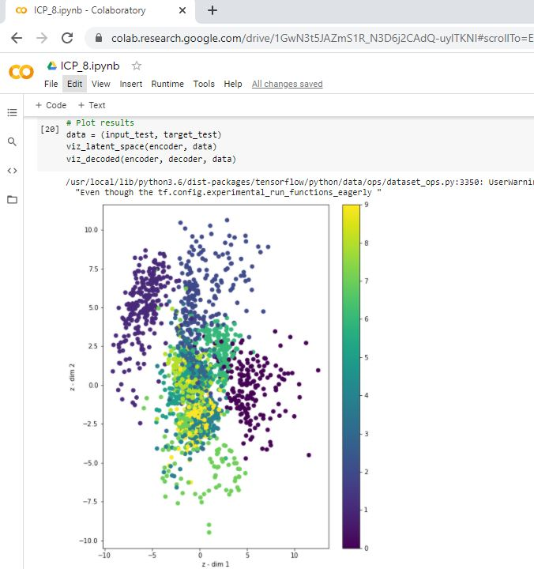

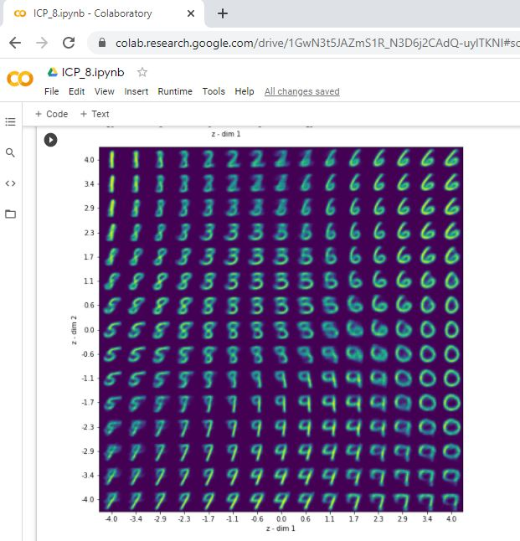

[**Video Link**](https://youtu.be/MTJAGP317O4)

**Any in site about the data or the ICP in general**

The larger the image size, the more layers that can be added with minimal effert.