Bill Yerkes
CS5542 Big Data Apps and Analytics
In Class Programming –3
11th September 2020

Submit ICP Feedback in Class. : Lnik to Feed back Form

NLP:

Use the same data (that we obtained by in source code Data = pd.read_csv('https://raw.githubusercontent.com/dD2405/Twitter_Sentiment_Analysis/master/train.csv')) and perform the sentiment analysis task on this data using one of the scikit learn classifier for text.

ICP Requirements:

- Data cleaning and preprocessing (at minimum have the following: Removing unnecessary columns or data, Removing Twitter Handles( @user ), Removing punctuation, numbers, special characters, Removing stop words, Tokenization, and Stemming, TFIDF vectors, POS tagging, checking for missing values , train/test split of data). (70 points)
- Data Visualization and analysis for critical steps (WordCloud, Bar plots, etc) (10 points)
- Model building and successfully executing the model to make prediction. (10 points )
- Code quality, Pdf Report quality, video explanation (10 points)
Submission Guidelines:
Same as ICP 2.

ICP Report:
What I learned in the ICP:
I learned more about Data Frames and how need to think differently with dealing with immutable data. I continue to learn more about lambda function, but I feel I need to spend some time and focus on them because of how they are leveraged with transforming the RDDs. I learn some about Natural Language processing and some of the libraries that are available for Python.
Description of what task I was performing:
Use the given input file and perform tasks for cleaning analyzing the data.
Challenges I faced:
Had to figure out how to make the Bag of Words without crashing CoLab.
Figuring out how to update the Data Frame after cleaning up the data.
Figuring out how to clean the data so as to reduce the size of the Bag of Words.
Figuring out how to get the Word Cloud to work, re-watching the lecture was a big help.

Screen Shots
GitHub Repository
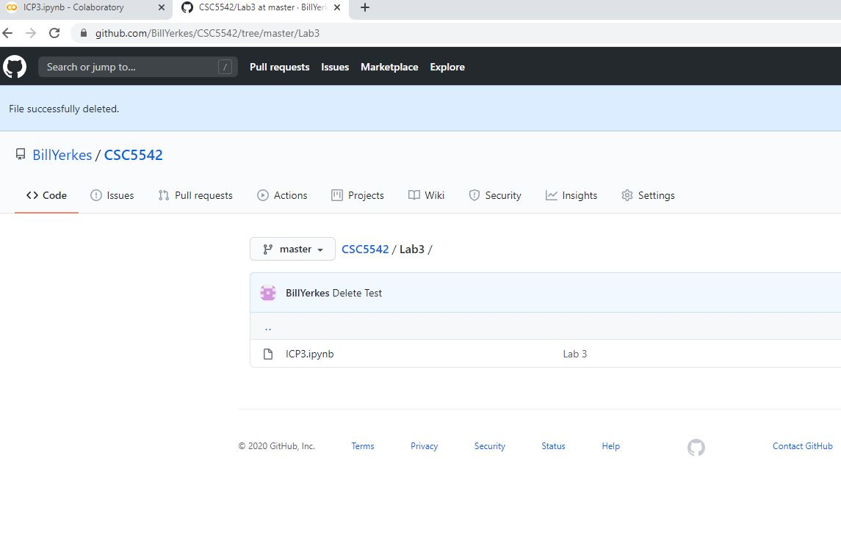
Initialize Libraries for Pandas and NLTK
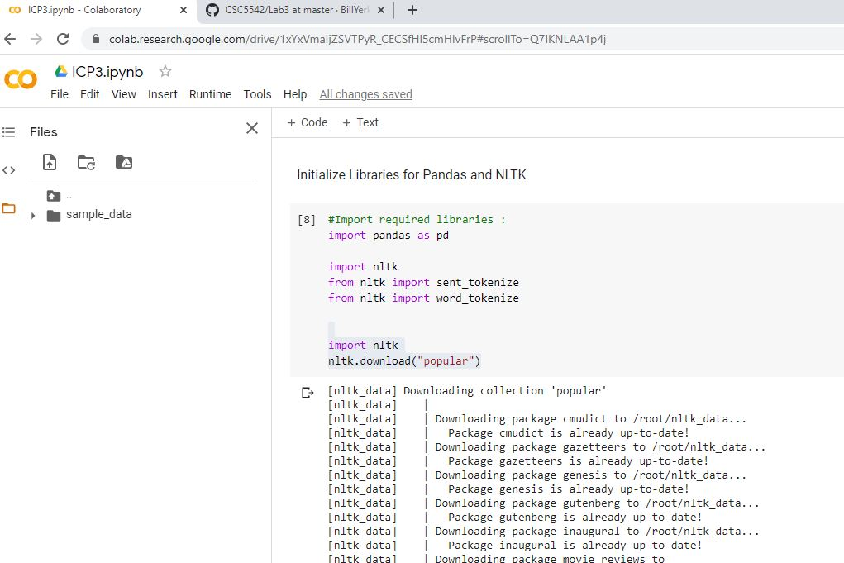
Init DataFrame

Read the CSV file with the Data from the Cloud

Reduce the size of the Dataframe, because of the issue with running out of RAM.

DataFrame Properties
Display portions of the DataFrame for visual insepection of the Data
Formally, given sample of tweets and labels, where label ‘1’ denotes the tweet is racist/sexist and label ‘0’ denotes the tweet is not racist/sexist.
id : The id associated with the tweets in the given dataset.
tweets : The tweets collected from various sources and having either positive or negative sentiments associated with it.
label : A tweet with label ‘0’ is of positive sentiment while a tweet with label ‘1’ is of negative sentiment

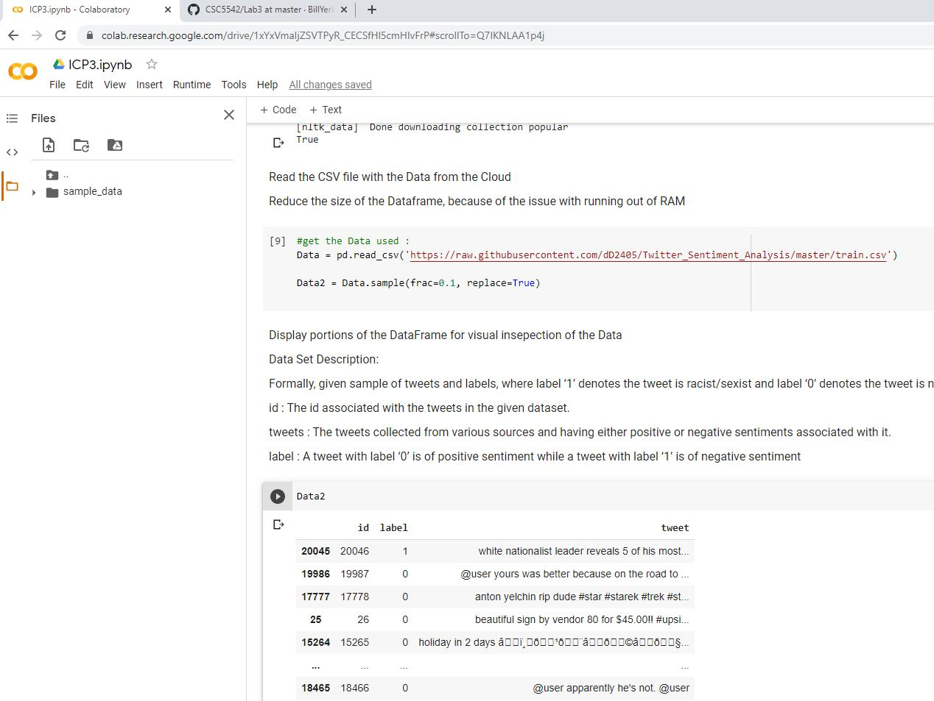
Clean the data:
We are going to remove Stop words
We are going to remove "words" which are not alphabetic
We are going to remove "word" which are not in the english language
We are boing Lemmatize the "words" to their root.

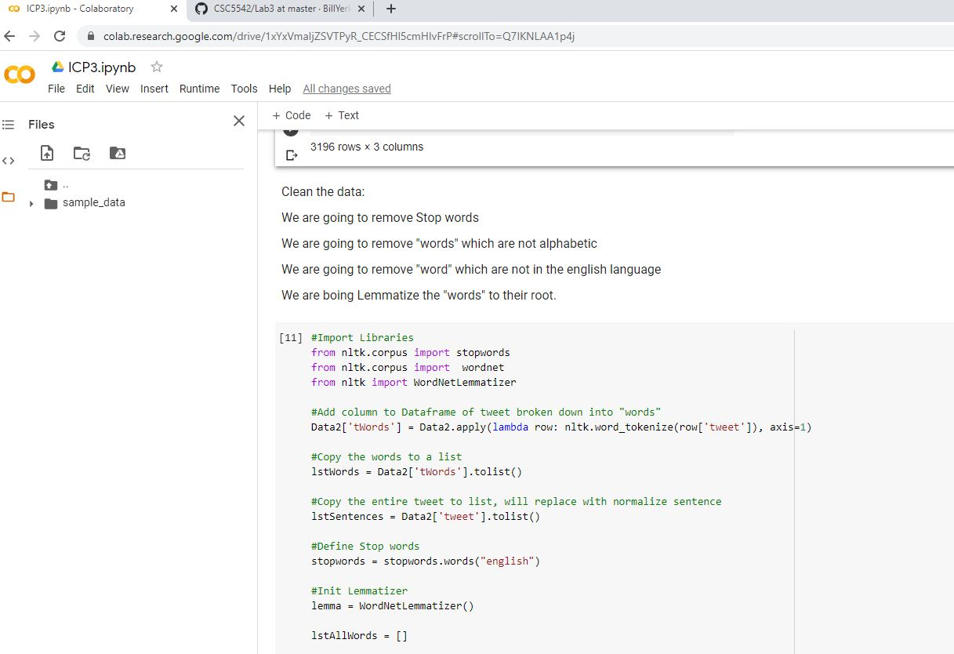

Looping through the Data and cleaning it

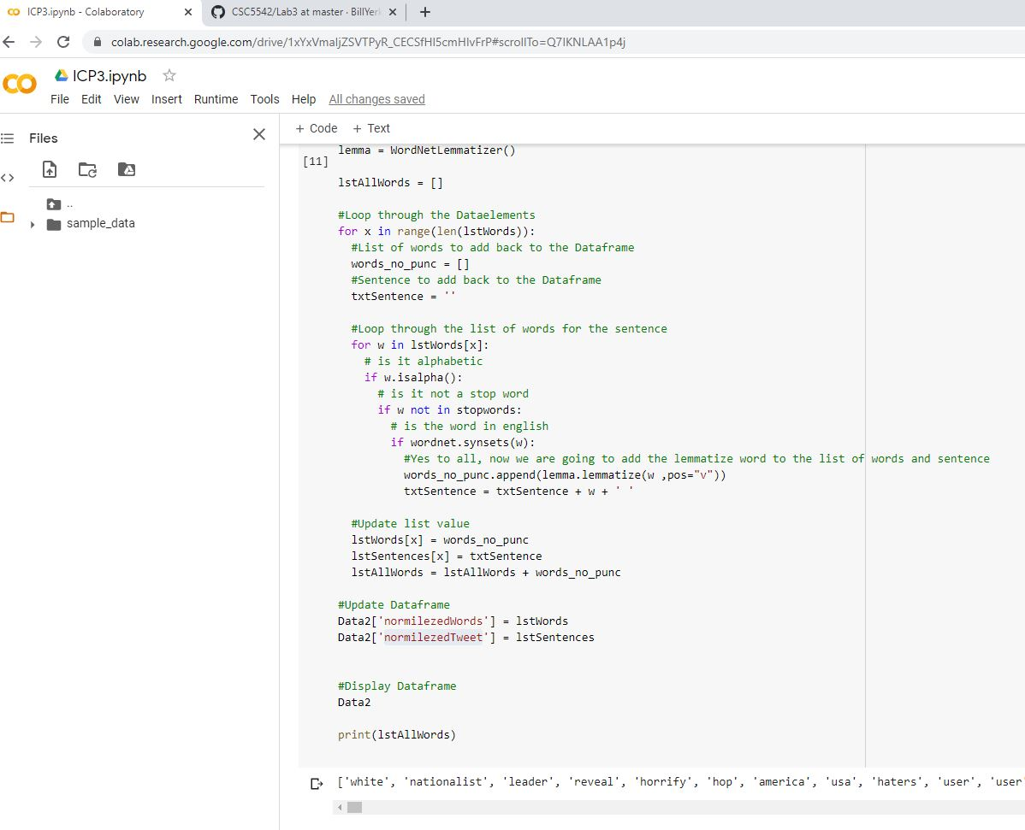

Show the distribution of the 10 most common words

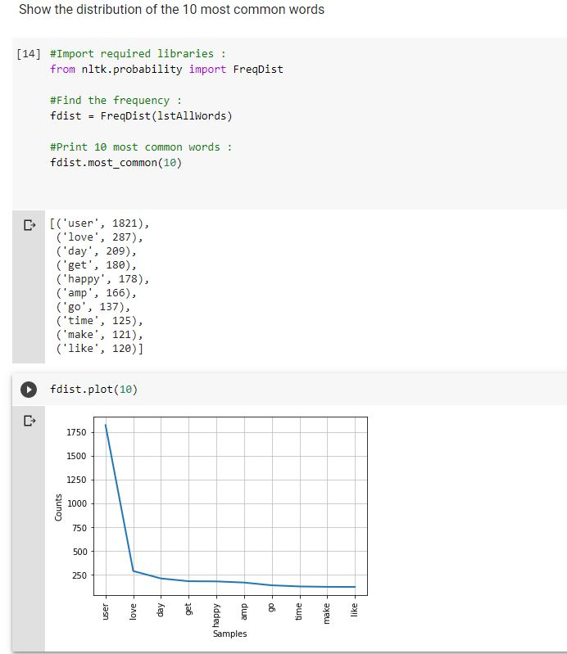

Make a Word Cloud

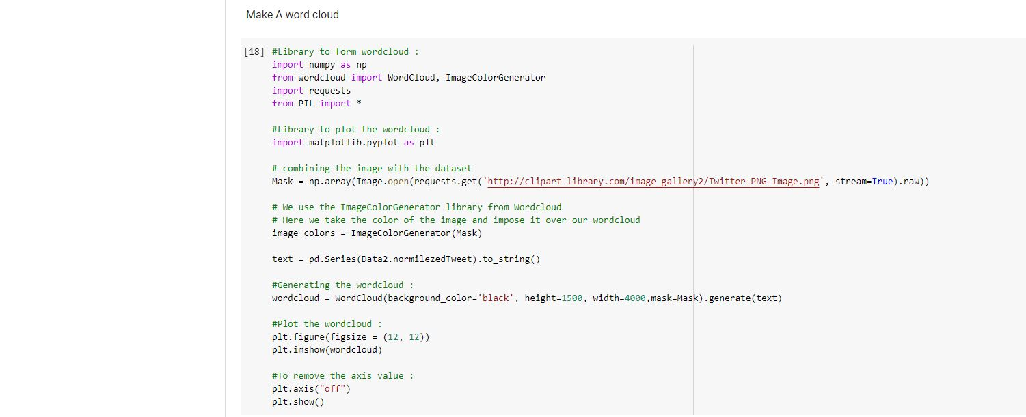
Word Cloud
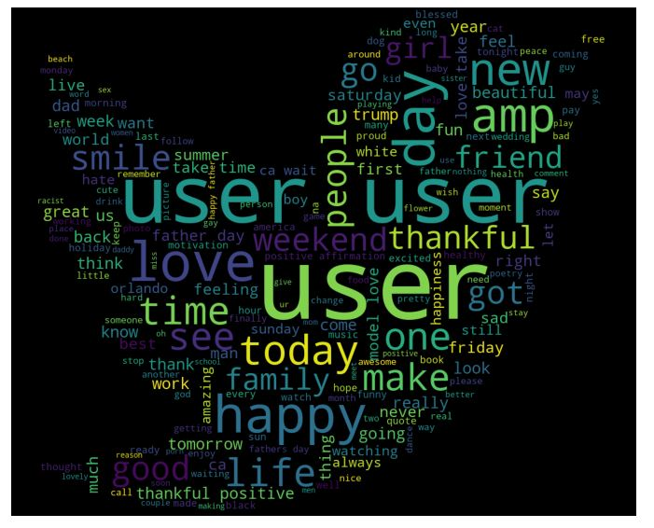

Make a Bag of Words
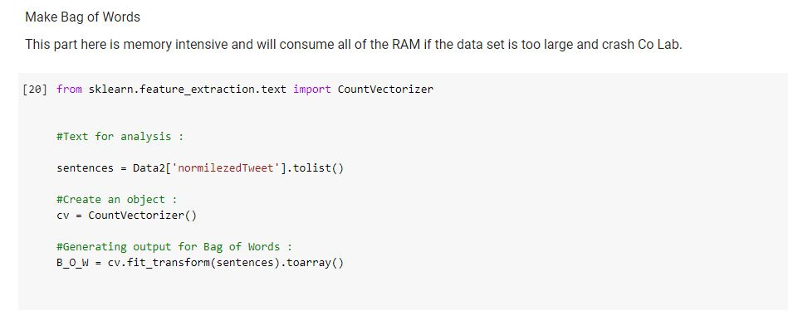

Run the Test on the Data
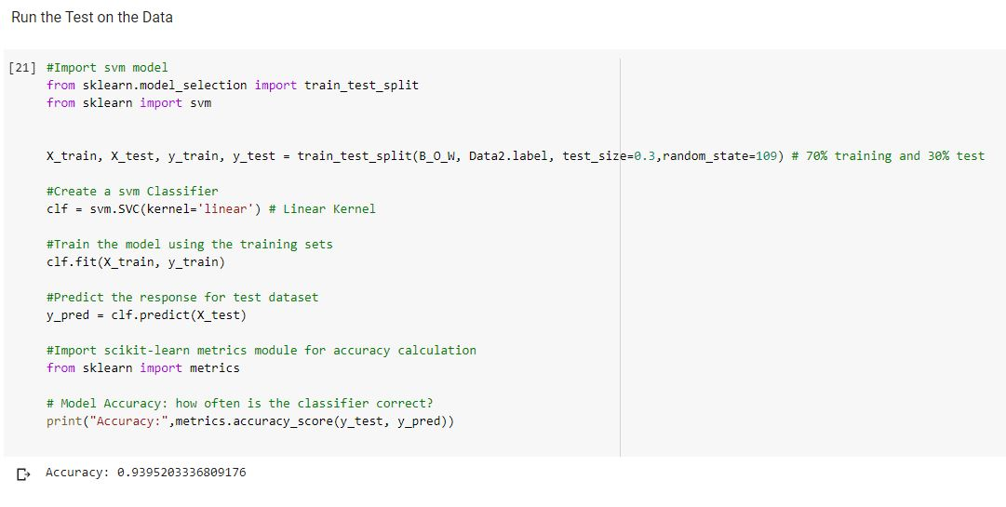

Video Link

Any in site about the data or the ICP in general
Data consisted of Tweet text, with the text being categorized as racist or not racist.
CoLab is great. The Python libraries for NLP seem very powerful.
The code did not run as fast as expected and was taken by surprised by running out of RAM while trying to figure out the lab.

