Magenic Badges

Generated from iRise

08/22/13 08:05 PM

1 Badges

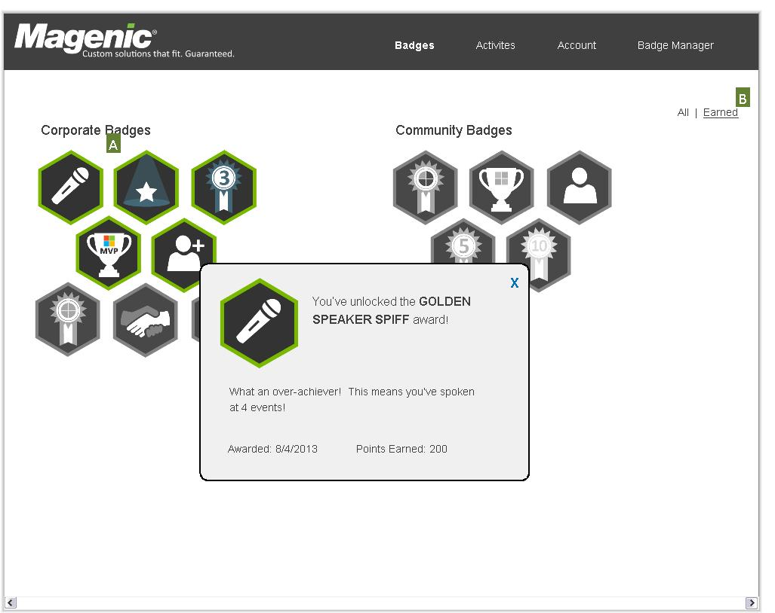

1.1 Onclick of the icons we will show a popup of the details of the badge. If you have earned it the icon will be full color and it will display a message about you earning the badge, The date it was awarded, and the points earned. If you have not yet earned it then the icon will be gray scale and the details of what you need to do to earn it will be shown in the popup, as well as the points you will earn. (1004)[A]

1.2 The all/earned links is a filter to show all possible badges in the corporate and community categories or just the ones the you have earned in those categories. (1005)[B]

2 Activities

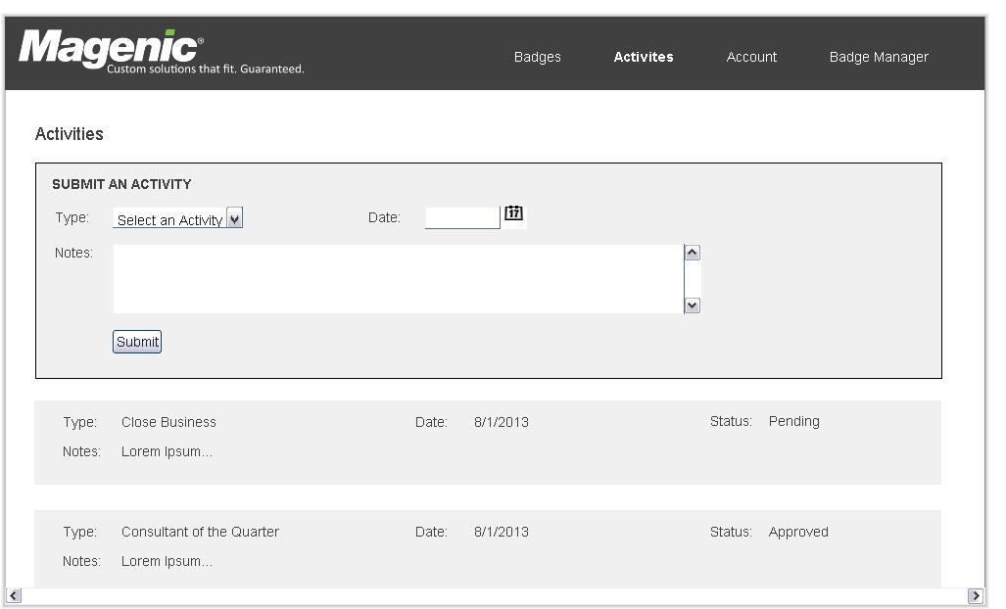

2.1 Upon submitting the form the newly submitted activity should appear in the list of activities below. We should also show a confirmation message showing the activity was submitted, although if we repost the page and show the new activity at the top that might be enough. (1006)

3 Account

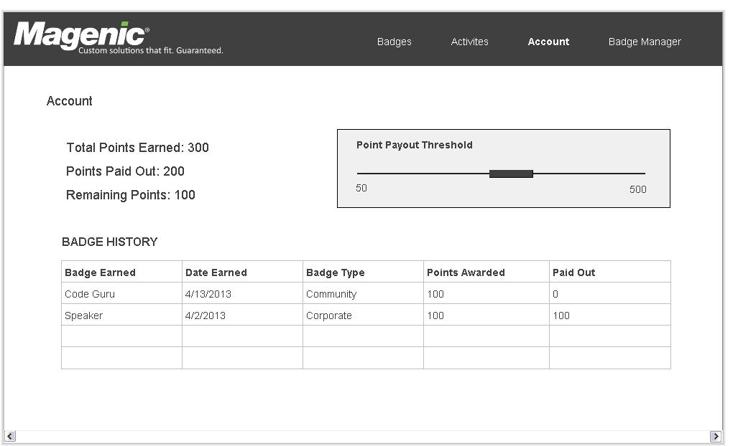

3.1 The point payout threshold uses a slide to adjust the threshold. Need to determine the incremenent of the slider, possibly 25pt increments. (1007)

4 Badge Manager - Active Badges

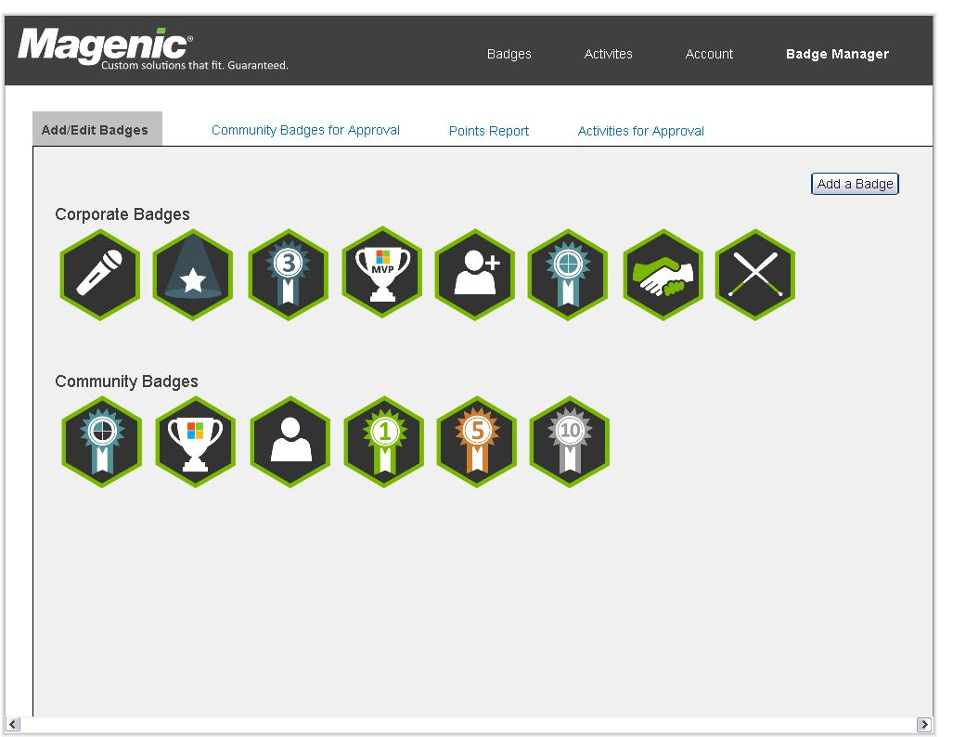

5 Badge Manager - Awaiting Approval

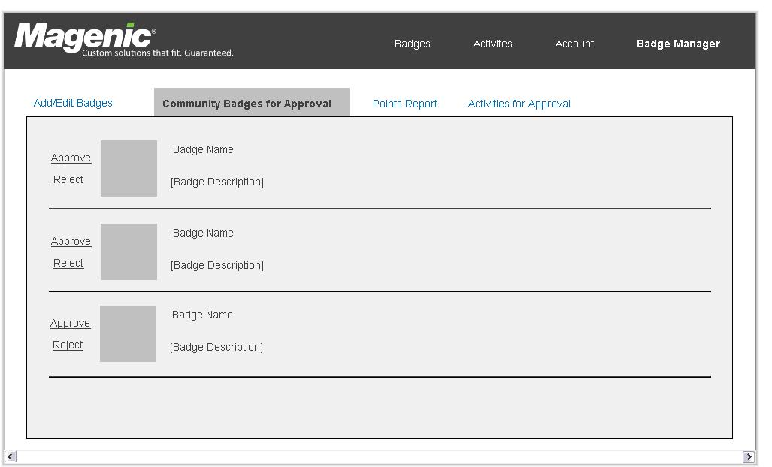

6 Badge Manager - Add a Corp Badge

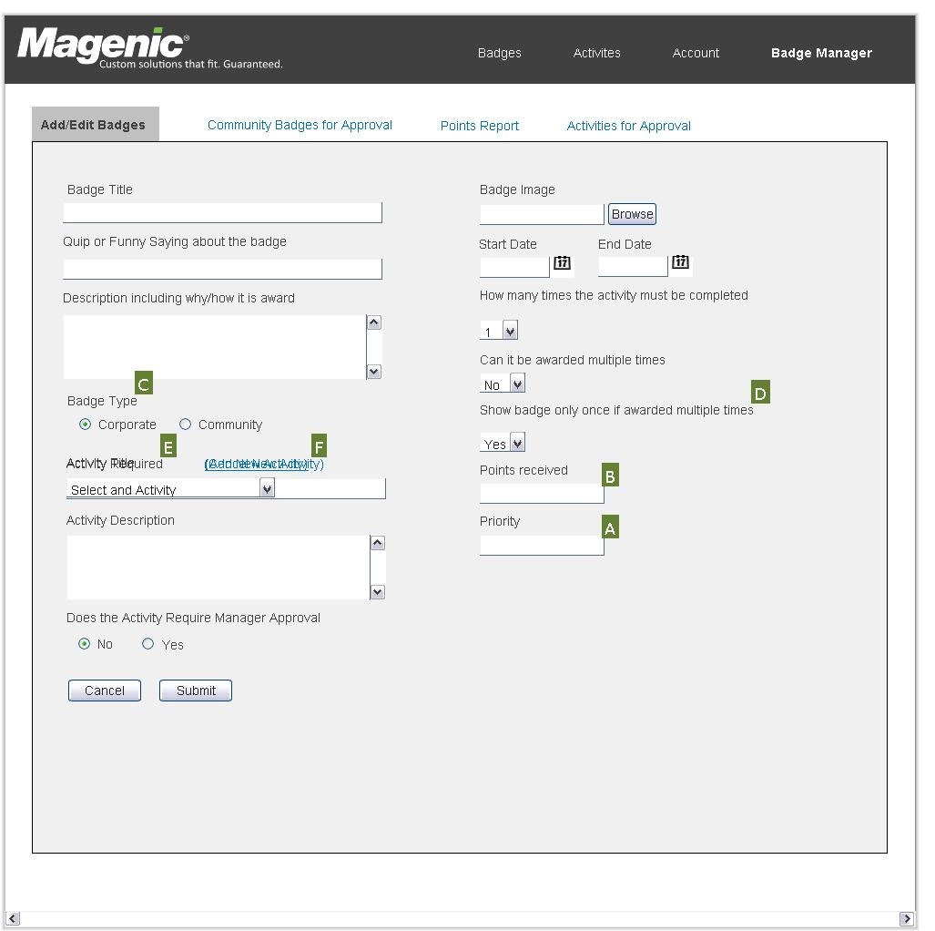

6.1 This is the view that a Corporate user will have.This means that a corporate user can add or edit both corporate and community badges, so in this version of the form we have an added field of Badge Type. (1008)[C]

6.2 The corporate badge also captures Points Received and Priority fields that are not visibly on a Community Badge (1009)[A][B]

6.3 The field to show badges only once if awarded multiple times should only appear if the value selected for "Can it be awarded multiple times" is set to yes. (1010)[D]

6.4 Activity Required field will show a dropdown by default with all existing activity types. If no activities exist then we should default to the new activity fields. The new activity fields are also made visible by a link that says "Add New Activity". If it is selected then the dropdown of existing activities is hidden and we show fields for Activity Name, Activity Description, and Does it Require Manager Approval. (1011)[E][F]

7 Badge Manager - Add a Community Badge

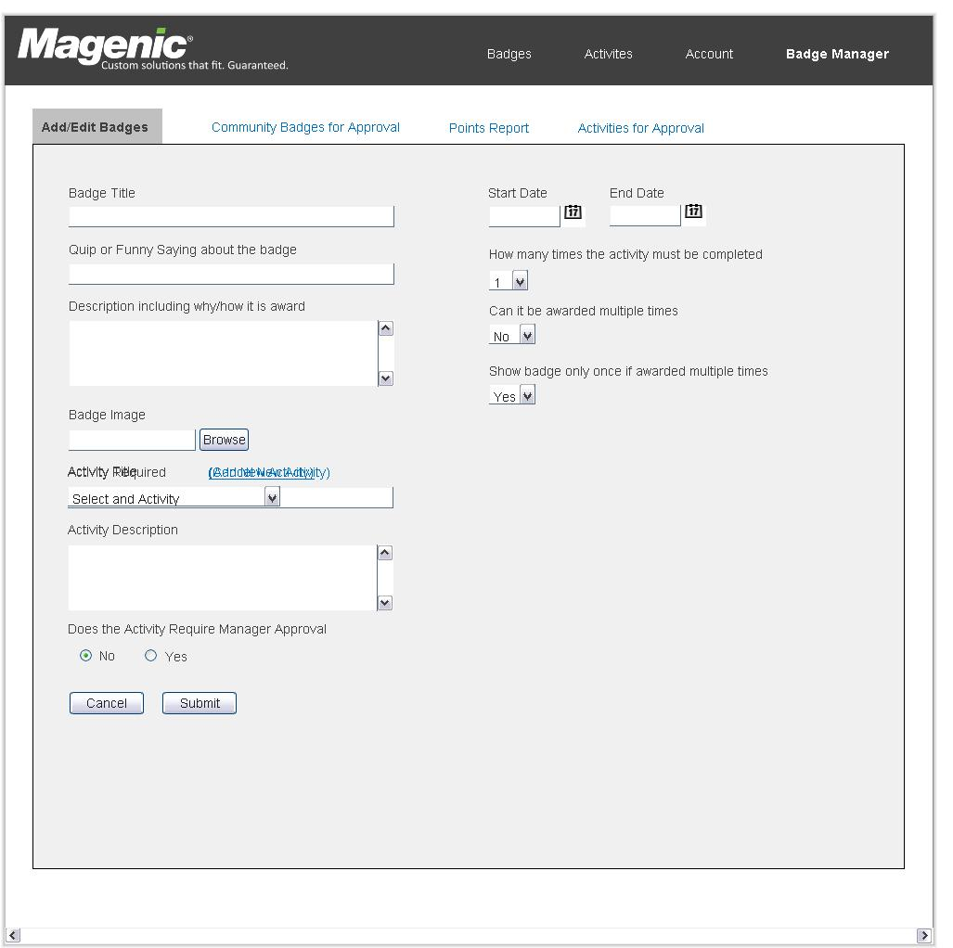

8 Badge Manager - Points Report

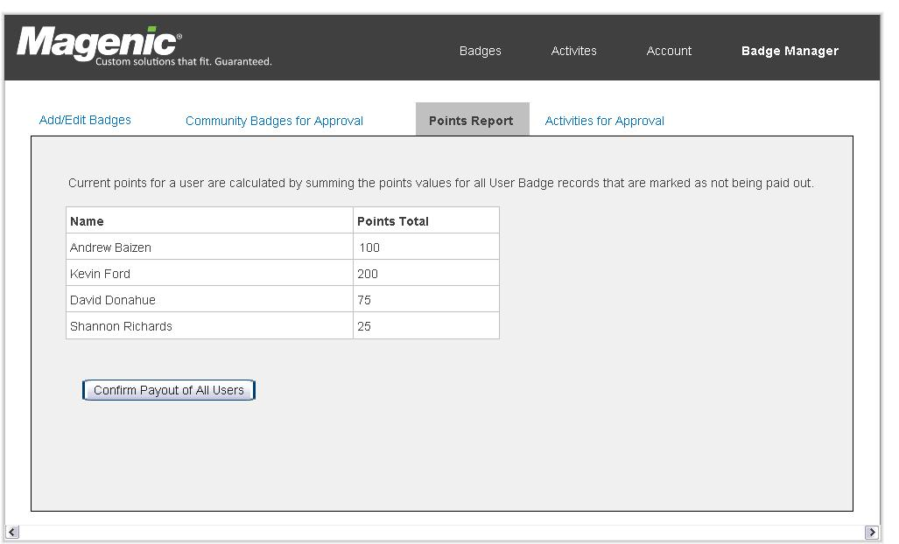

9 Badge Manager - Activities for Approval

