AI Assisted Coding
Assignment - 3
B.Charan
2303A51623
Batch:08
Question 1: Zero-Shot Prompting (Palindrome Number Program) Write a zero-shot prompt (without providing any examples) to generate a Python function that checks whether a given number is a palindrome Code:
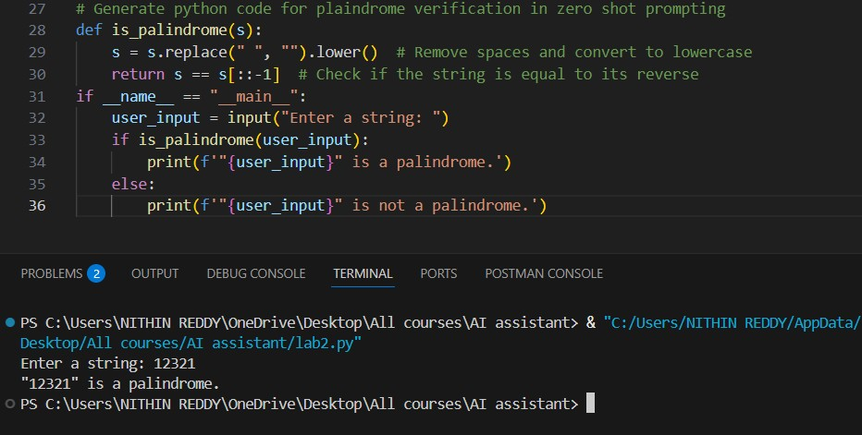
Question 2: One-Shot Prompting (Factorial Calculation)
Write a one-shot prompt by providing one input-output example and ask the AI to generate a Python function to compute the factorial of a given number.
Code:
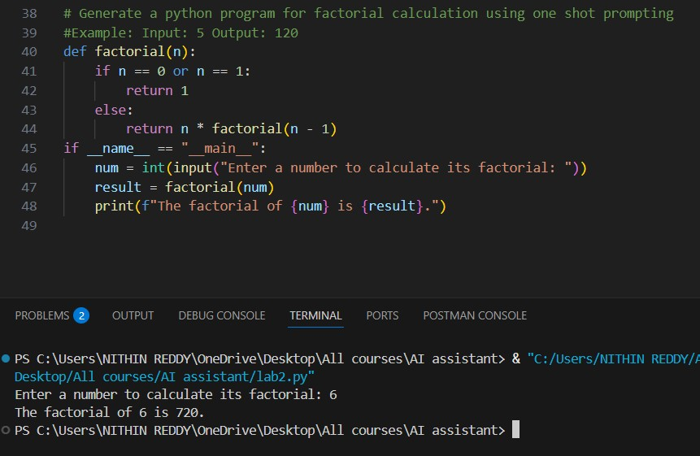
Question 3: Few-Shot Prompting (Armstrong Number Check) Write a few-shot prompt by providing multiple input-output examples to guide the AI in generating a Python function to check whether a
given number is an Armstrong number.
Code:
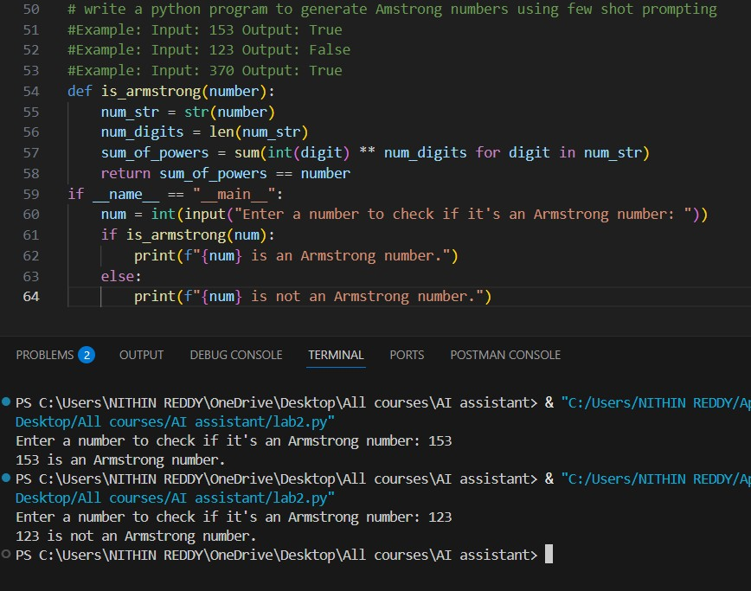
Question 4: Zero-Shot Prompting (Perfect Number Check) Write a zero-shot prompt (without providing any examples) to generate a Python function that checks whether a given number is a perfect number.
Code:
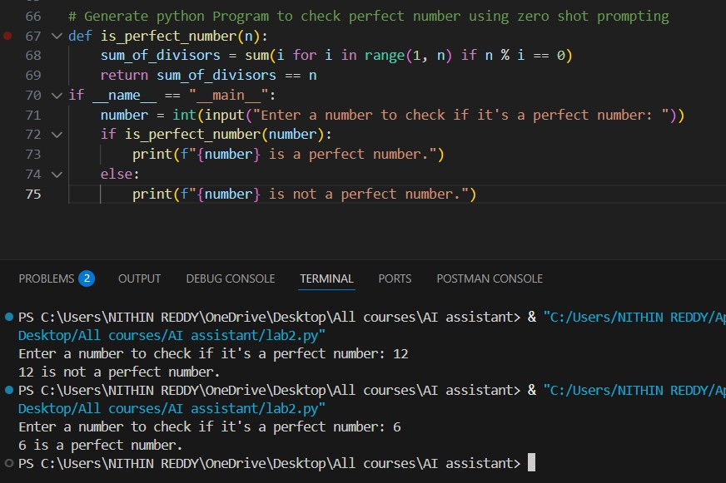
Question 5: Few-Shot Prompting (Even or Odd Classification with
Validation)
Write a few-shot prompt by providing multiple input-output examples to guide the AI in generating a Python program that determines whether a given number is even or odd, including proper input validation.
Code:
