Assignment – 7.1
Error Debugging with AI: Systematic approaches tofinding and fixing bugs
NAME: B.Charan
HT.NO: 2303A51623
BATCH – 08
Lab Objectives:
- To identify and correct syntax, logic, and runtime errors in Python programs using AI tools.
- To understand common programming bugs and AIassisteddebugging suggestions.
- To evaluate how AI explains, detects, and fixes differenttypes of coding errors.
- To build confidence in using AI to perform structureddebugging practices.
Lab Outcomes (LOs):
After completing this lab, students will be able to:
- Use AI tools to detect and correct syntax, logic, and runtimeerrors.
- Interpret AI-suggested bug fixes and explanations.
- Apply systematic debugging strategies supported by AI-generated insights.
- Refactor buggy code using responsible and reliableprogramming patterns.
Task - 01 (Syntax Errors Missing Parentheses in PrintStatement) Buggy Code:
#Missing parentheses in print statement def greet():
print "Hello, AI Debugging Lab!"
greet()
AI Prompt:
Why is this code giving an error? Fix the syntax and explain the issue.
AI Explanation:
The code is giving a SyntaxError because you're using Python 2 syntax for the print statement. In Python 3, print is a function and requires parentheses around its arguments.
Corrected Code:
#Missing Paranthesis def greet():
return "Hello, AI Debugging Lab!"
greet()
Output:
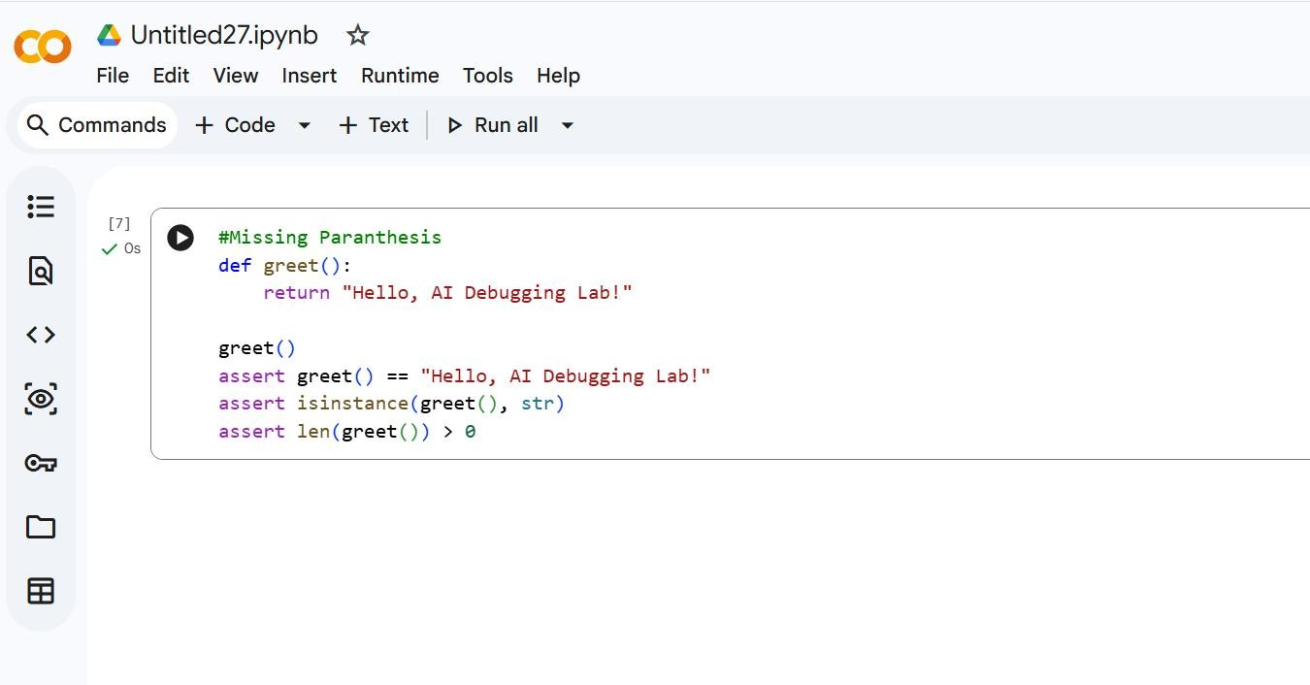
Task - 02 (Incorrect condition in an If Statement)
Buggy Code: def check_number(n): if n = 10: return "Ten" else:
return "Not Ten"
AI Prompt:
Why does using = in the if condition cause an error? Fix it.
AI Explanation:
The error you're seeing, a SyntaxError, is because you're using a single equals sign = in your if statement condition: if n = 10:. In Python, a single equals sign is used for assignment, but for comparison, you need to use a double equals sign ==. I will fix this by changing = to ==. Corrected Code: def check_number(n): if n == 10:
return "Ten" else:
return "Not Ten" Error:
Output:
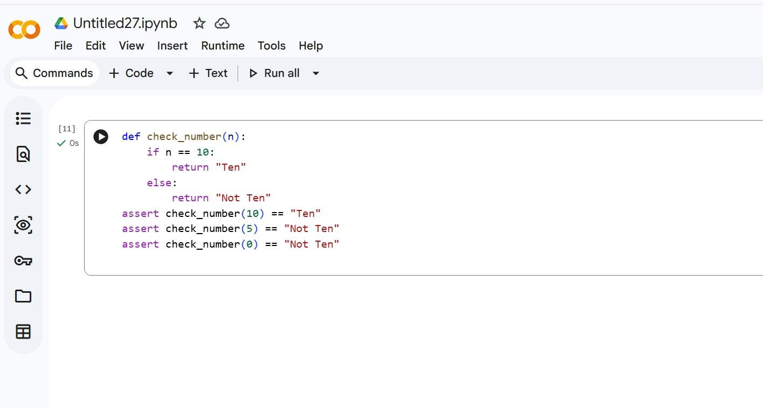
Task - 03 (Runtime Error – File Not Found) Buggy Code: def read_file(filename): with open(filename, 'r') as f:
return f.read()
print(read_file("nonexistent.txt"))
AI Prompt:
Add safe error handling using try-except and give user-friendly messages. AI Explanation:
The error you're encountering is a FileNotFoundError. This means that your program is trying to open a file called nonexistent.txt, but it cannot find a file with that name in the directory where the script is running. I'll modify the code to handle this error gracefully using a try-except block, so it will print a message if the file is not found, instead of stopping execution.
Corrected Code: def read_file(filename):
try:
with open(filename, 'r') as f: return f.read()
except FileNotFoundError:
return "Error: File not found."
except Exception:
return "Error: Invalid file path."
print(read_file("nonexistent.txt"))
Error:
Output:
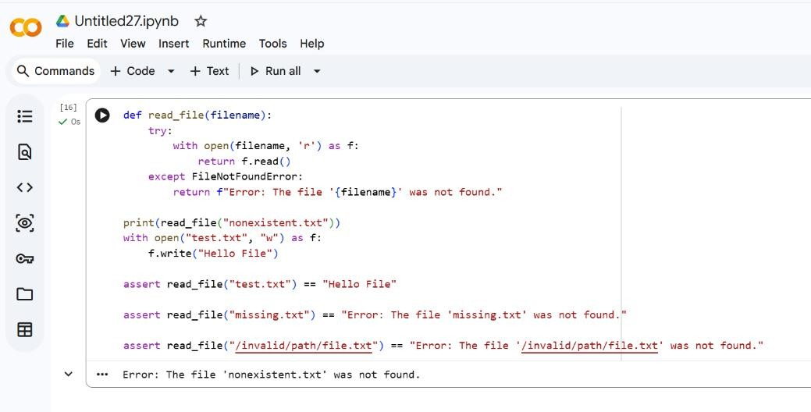
Task – 04(Calling a Non-Existent Method) Buggy Code: class Car:
def start(self):
return "Car started" my_car = Car()
print(my_car.drive()) # drive() is not defined AI Prompt:
Fix the AttributeError and explain the issue.
AI Explanation:
You're getting an AttributeError because you're trying to call a method named drive() on your Car object, but the Car class doesn't have a drive() method defined. It only has a start() method. I will fix this by changing my_car.drive() to my_car.start().
Corrected Code: class Car:
def start(self):
return "Car started"
def drive(self):
return "Car is driving"
my_car = Car()
print(my_car.drive()) Error:
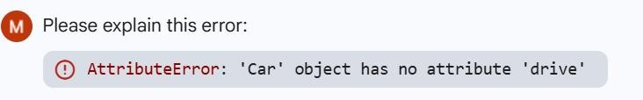
Output:
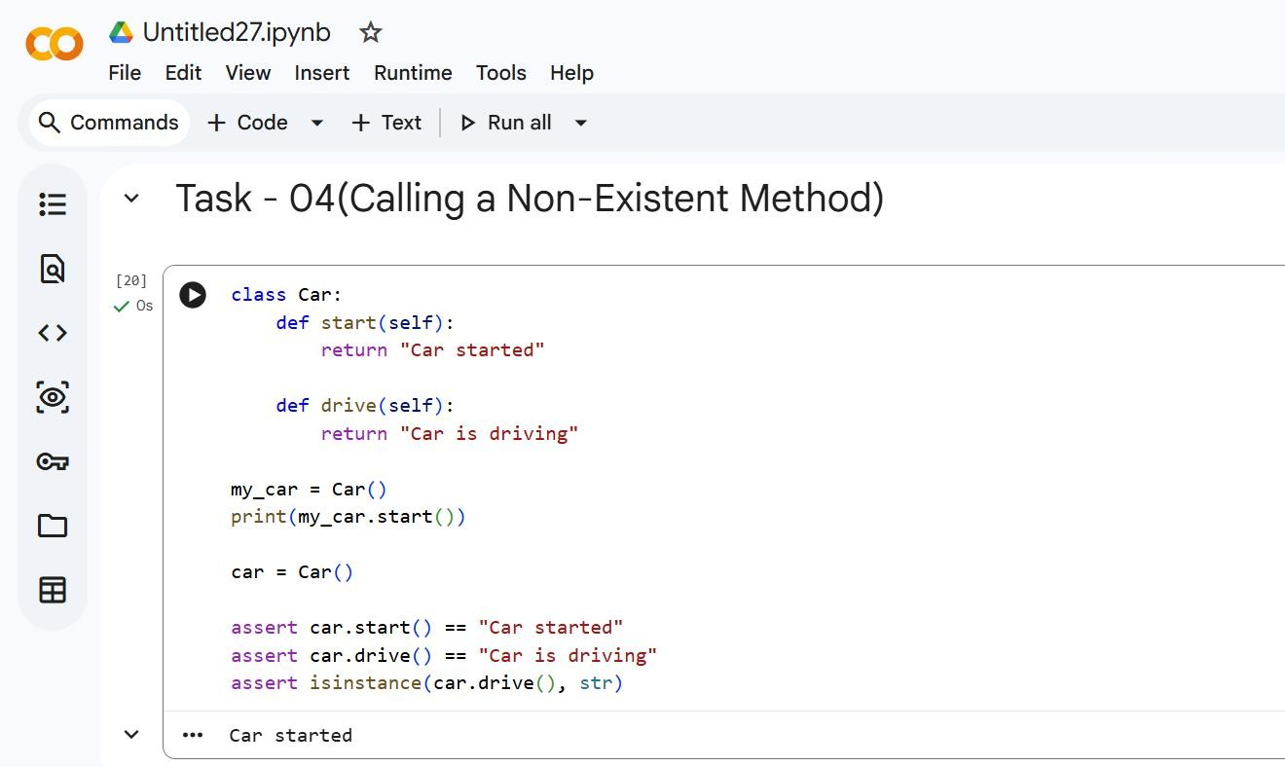
#Task – 05(TypeError – Mixing Strings and Integers inAddition) Buggy Code: def add_five(value): return value + 5 print(add_five("10"))
AI Prompt:
The function below throws a TypeError because it mixes a string and an integer.
AI Explanation:
You're encountering a TypeError because you're trying to add a number to a string without converting the string to a number first. The add_five function receives "10" (a string) and tries to add 5 (an integer) to it. To fix this, you need to convert the value to an integer inside the function. I will modify the code to cast the input value to an int.
Corrected Code: def add_five(value):
return int(value) + 5
print(add_five("10")) Error:
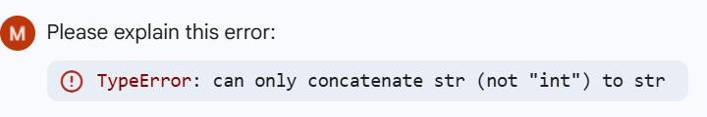
Output:
