EC452 Ultra High Frequency Techniques

Title: Lab 1 - Laboratory Best Practices

Instructor: Dr. Gregory Huff

Student: Shihyuan Yeh

UIN: 423008134

Date: 02/10/20161.Demonstrate the operation of your Python installation by running the plotting program using the three datasets provided in “ECEN_452_Plotting.zip”

Ans:

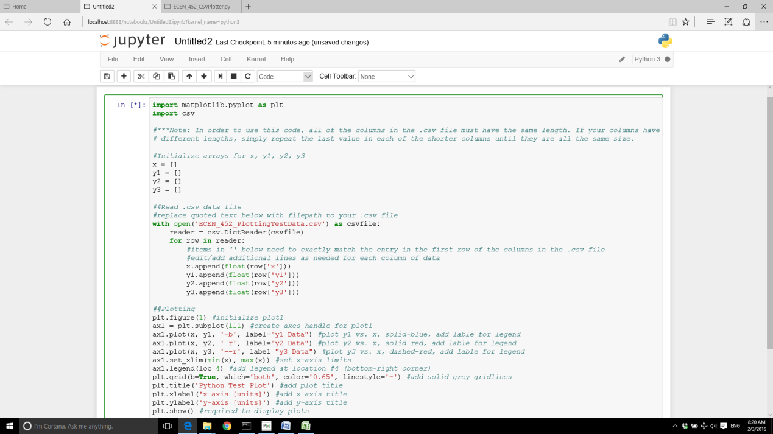

Figure 1 - The Python Code Edited in Anaconda

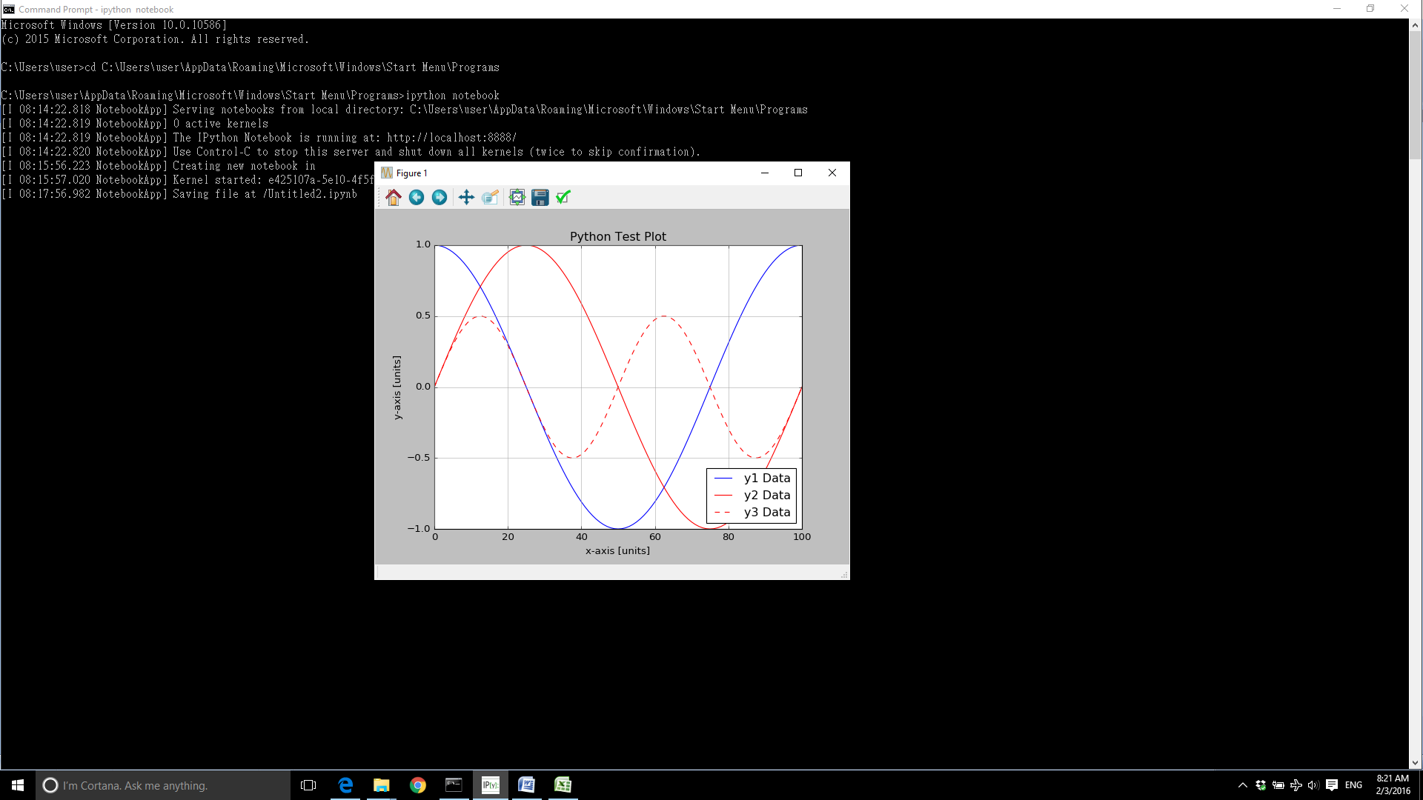

Figure 2 - The Plot of the Dataset

2.Email your GitHub account ID.

Ans: stevenyeh66

3.Familiarize yourself with the design and simulation environments in HFSS and Z0lver by downloading and simulating the files “ECEN_452_Lab1.hfss”, “ECEN_452_Lab1a.zov”, and “ECEN_452_Lab1b.zov”.

Ans:

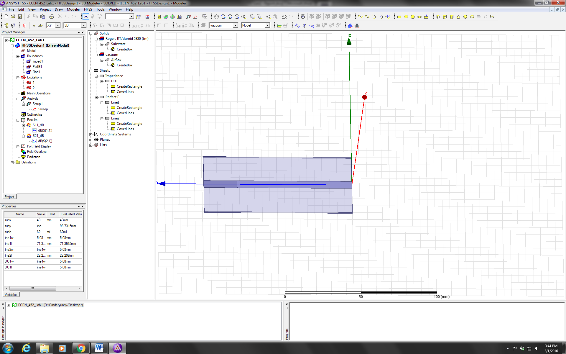

Figure 3 - The ECEN_452_Lab1.hfss Run in HFSS



Figure 4 - The Simulation Results of the S11 and S21 Amplitude in dB

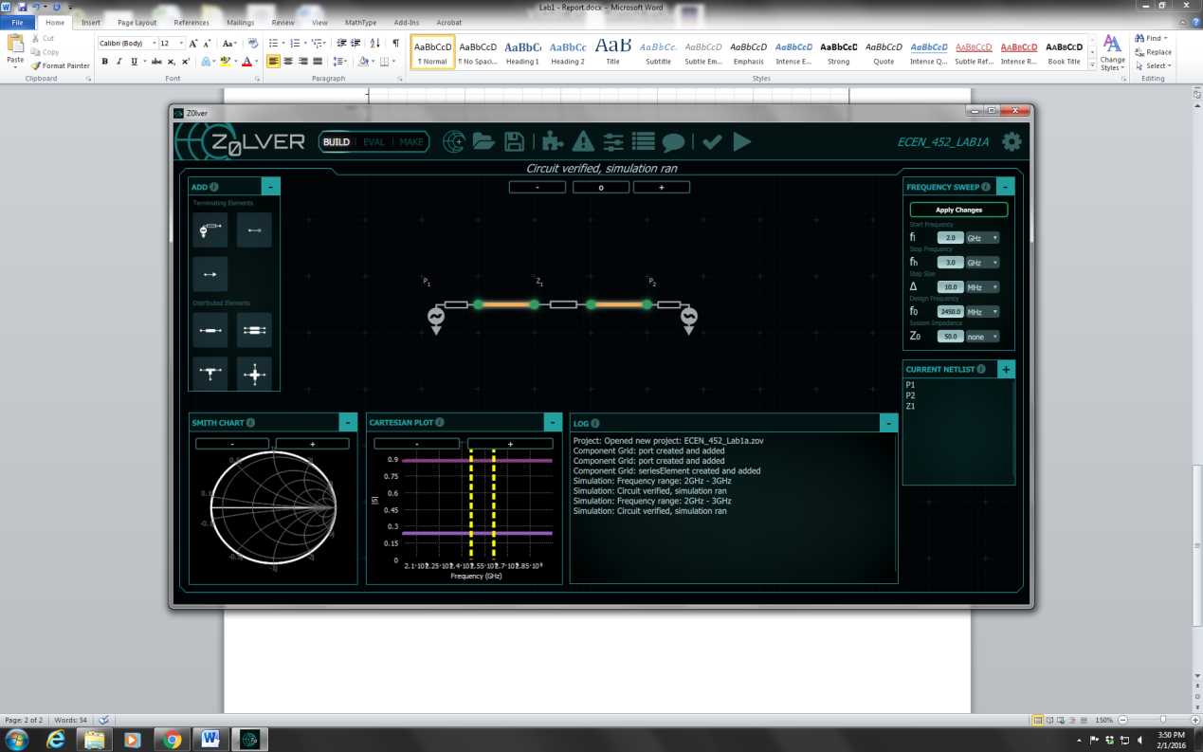

Figure 5 - The ECEN_452_Lab1a.zov Run in Z0lver

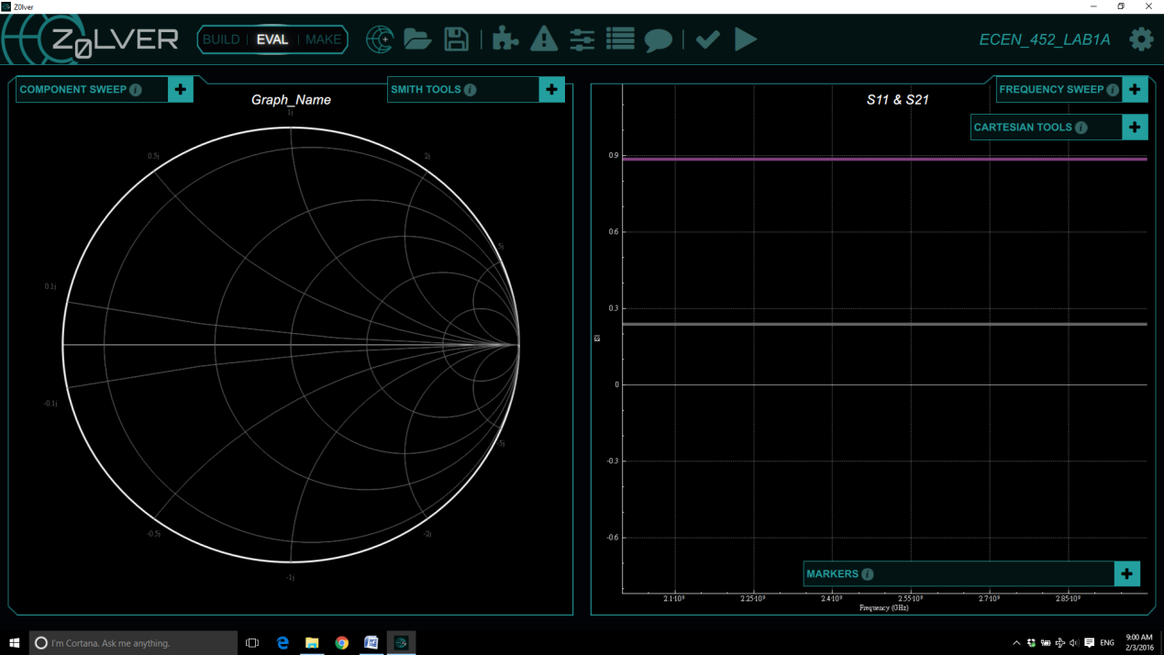

Figure 6 - The Simulation Results of S11 and S21 in Z0lver (ECEN_452_Lab1a.zov)

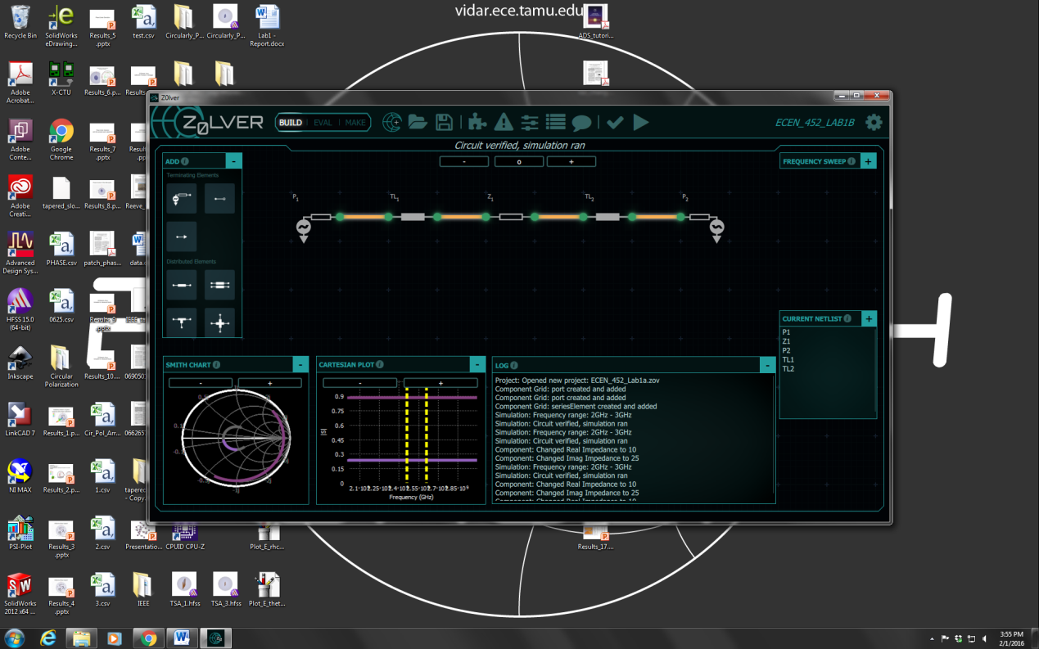

Figure 7 - The ECEN_452_Lab2a.zov Run in Z0lver

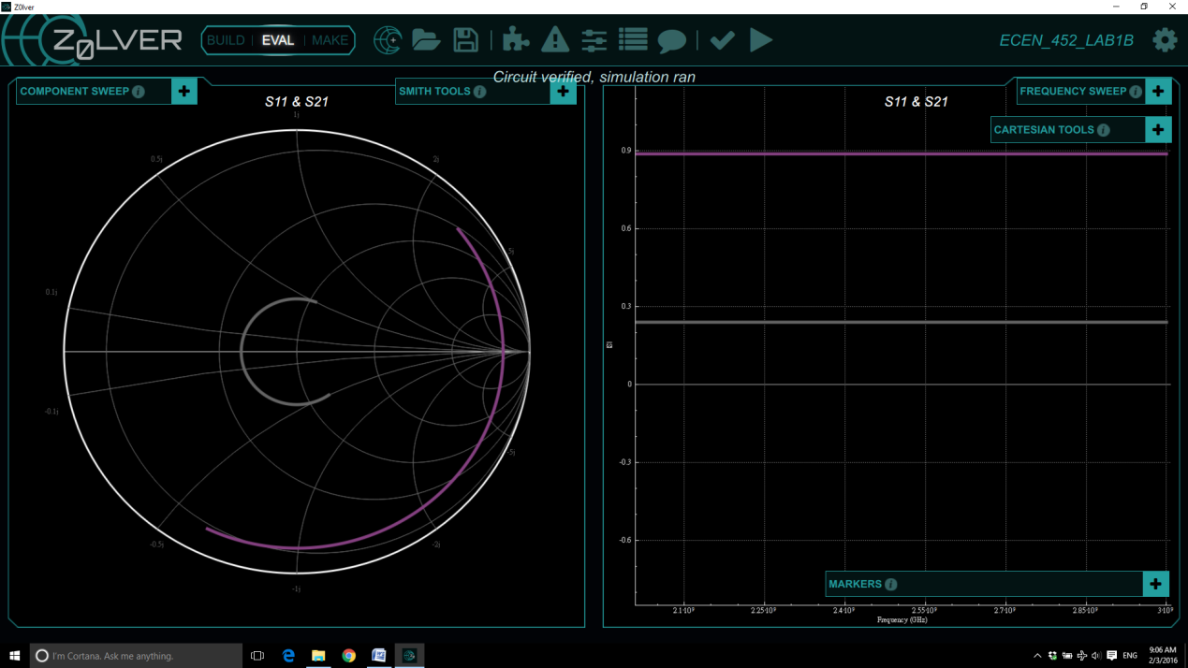

Figure 8 - The Simulation Results of S11 and S21 in Z0lver (ECEN_452_Lab2a.zov)

4. Calculate the two-port S and ABCD-matrices for a series impedance Z = 10+25j Ω using a system impedance Z0 = 50 Ω and the frequency sweep parameters from the simulations.

Ans:

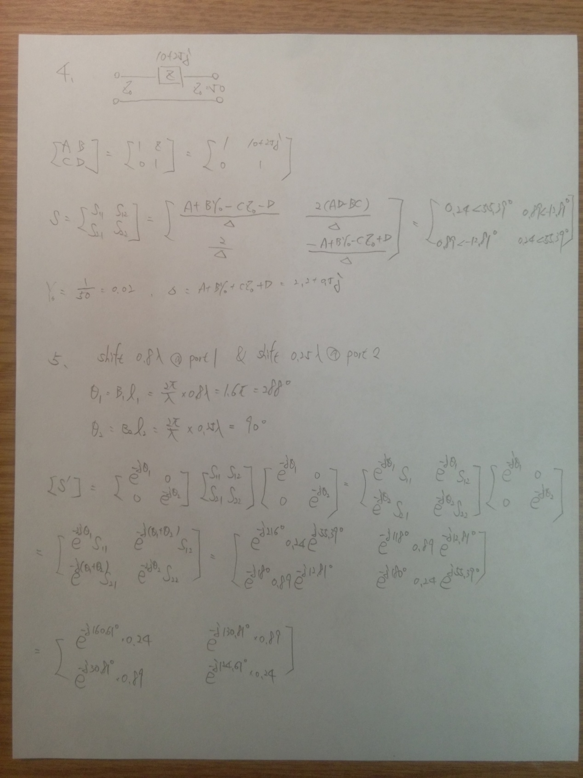

5. Shift the reference planes of both matrices calculated in the previous problem by assuming they are connected to lossless lines of characteristic impedance Z0 = 50 Ω with a length 0.8 λ at Port 1 and 0.25 λ at Port 2.

Ans:



6. Create two separate plots comparing analytical, Z0lver, and HFSS; one with the magnitude of S11 in dB and the other with the magnitude of S21 in dB.

Ans:



Figure 9 - Comparisons of S11 Between Analytical, Z0lver and HFSS



Figure 10 - Comparisons of S21 Between Analytical, Z0lver and HFSS

7. Become familiar with the following substrates by filling out the table below.

|  |  |  |  |  |
| --- | --- | --- | --- | --- |
|  | FR4 | Duroid 5880 | Duroid 6006 | Duroid 6010.2 |
| εr | 4.4 | 2.2 | 6.15 | 10.2 |
| Tanδ | 0.02 | 9e-4 | 0.0027 | 0.0023 |

8. Fill in the table below by indicating which connector types can be mated (Y/N).

|  |  |  |  |  |  |  |
| --- | --- | --- | --- | --- | --- | --- |
|  | Type N | SMA | 3.5 mm | 2.92 mm | 2.4 mm | 1.85 mm |
| Type N | Y | N | N | N | N | N |
| SMA | N | Y | Y | Y | N | N |
| 3.5 mm | N | Y | Y | Y | N | N |
| 2.92 mm | N | Y | Y | Y | N | N |
| 2.4 mm | N | N | N | N | Y | Y |
| 1.85 mm | N | N | N | N | Y | Y |