EC452 Ultra High Frequency Techniques

Title: Prelab 2

Name: Shihyuan Yeh

UIN: 423008134

1. Quarter-Wave Transformer

Microstrip width of the 50Ω transmission = 4.92mm

Microstrip width of the 200Ω transmission = 0.17mm

For the λ/4 matching T-Line, ZOT=100Ω, so the width of the transmission line =1.41mm and the length = 23.04mm

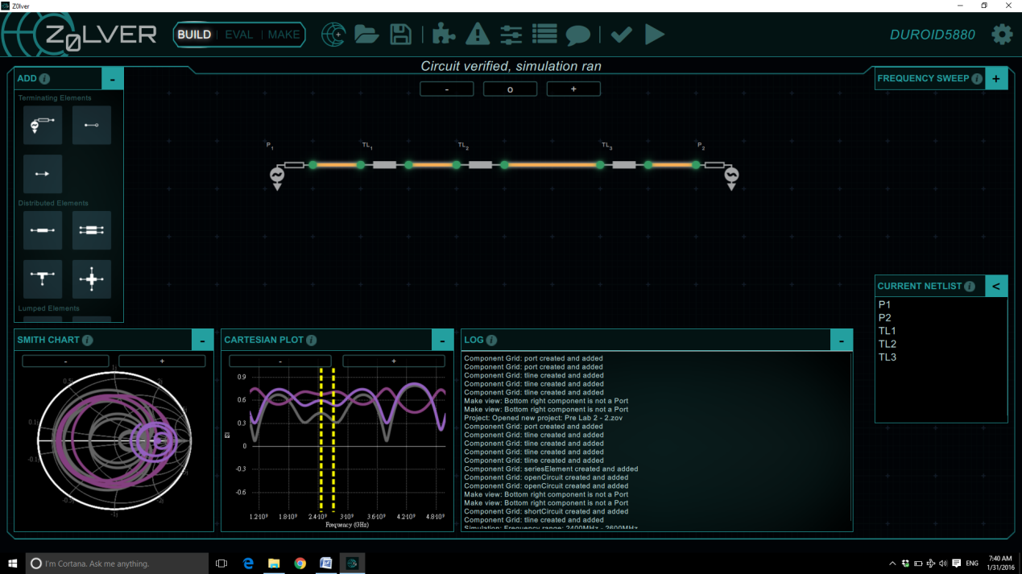

Figure 1 - A Quarter-Wave Transformer Design Layout in Z0lver

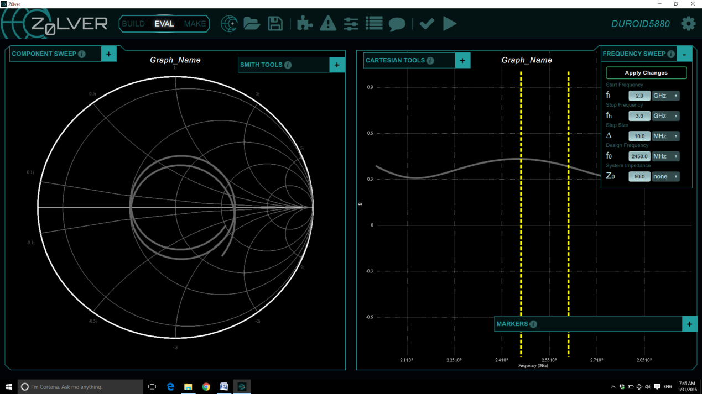Figure 2 - S11 Simulation Results in Z0lver

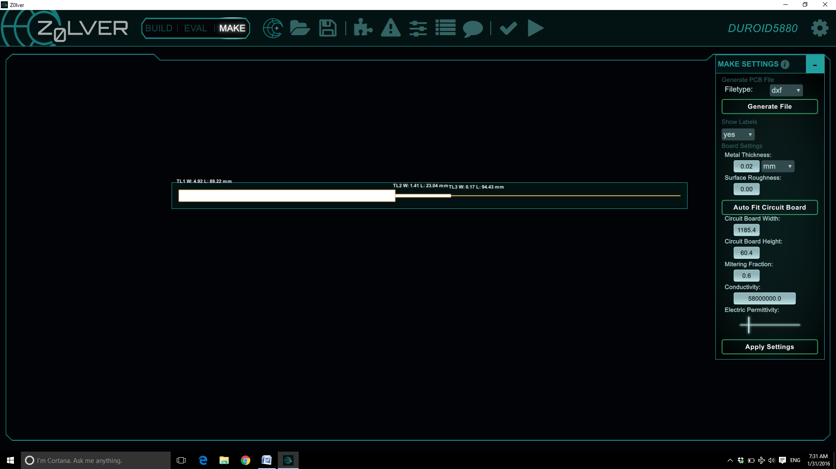

Figure 3 - Circuit Layout on Duroid 5880 Substrate in Z0lver

2. Double-Stub matching network

ZL=100-50j, zL=2-j, yL=0.4+0.2j

Set d1=0.5λ, d2=λ/8

y1=0.4+0.2j, y1'=0.4+1.8j

jb1=0j, jb1'=1.6j

Rotate d2=0.125λ==>jb2=-1.05j, jb2'=2.8j

1st solution: d1=0.5λ, l1=0λ, d2=0.125λ, l2=0.372λ

2nd solution: d1'=0.5λ, l1'=0.16λ, d2'=0.125λ, l2'=0.195λ

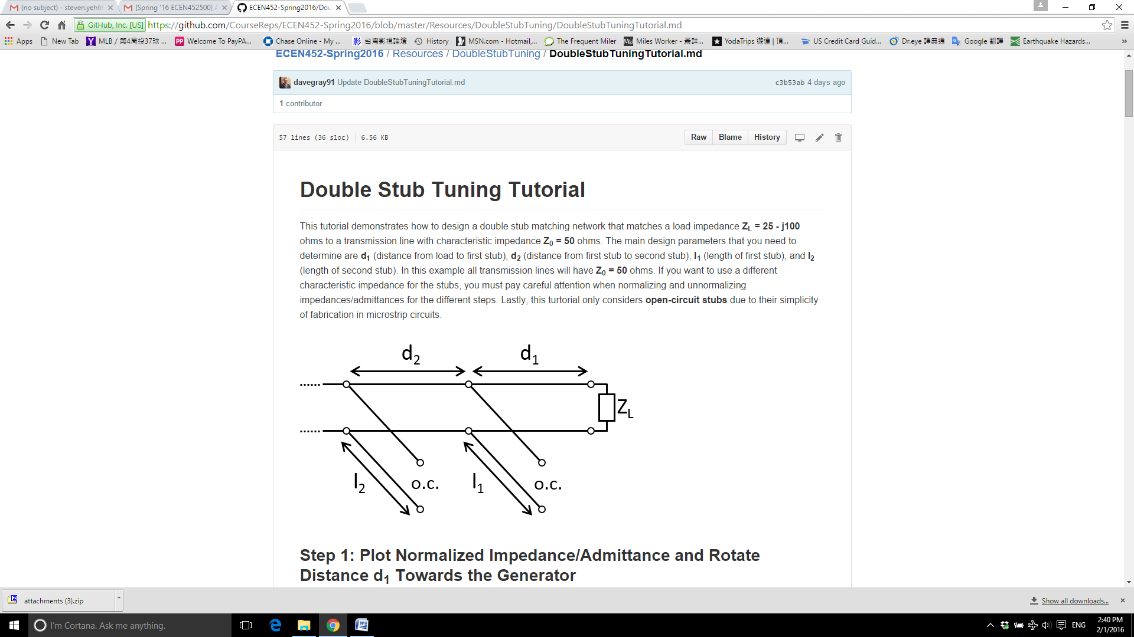

Figure 4 - A Double-Stub Matching Design Layout

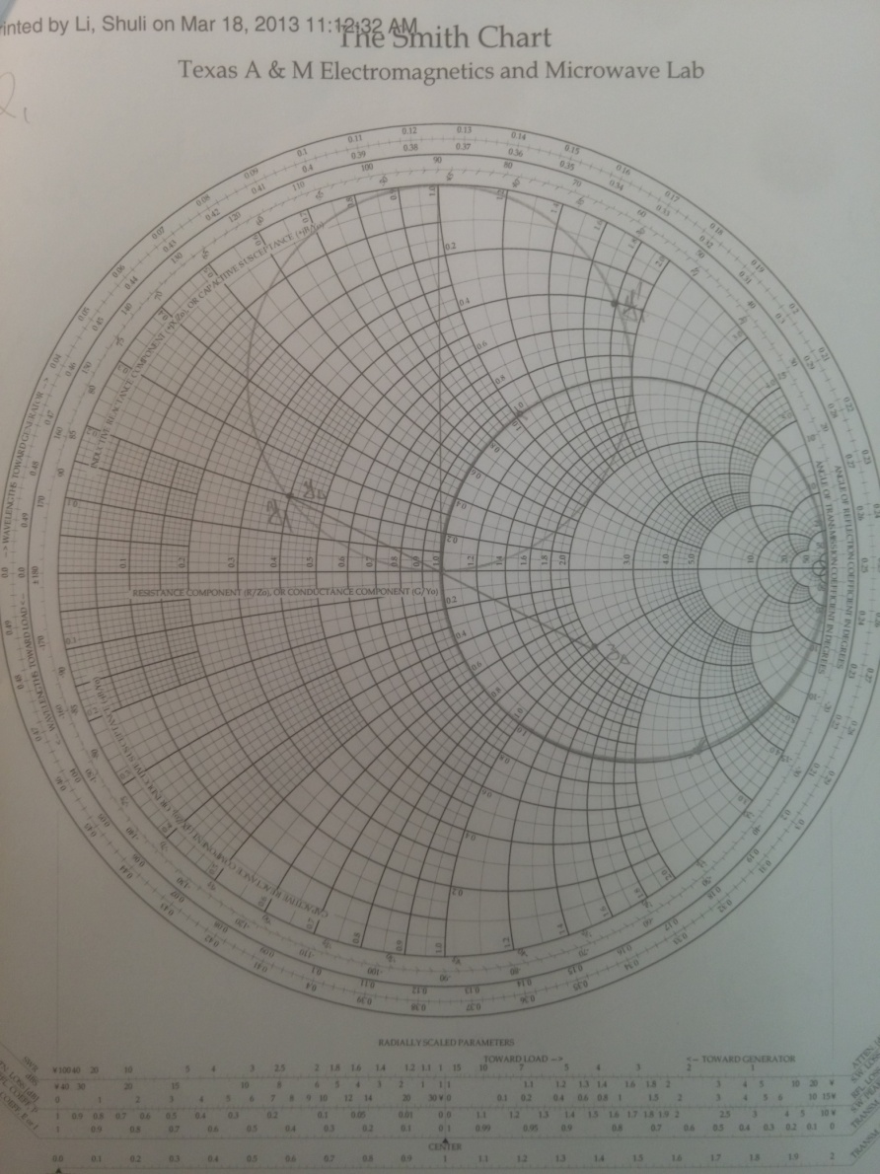

Figure 5 - Smith Chart Degian - 1

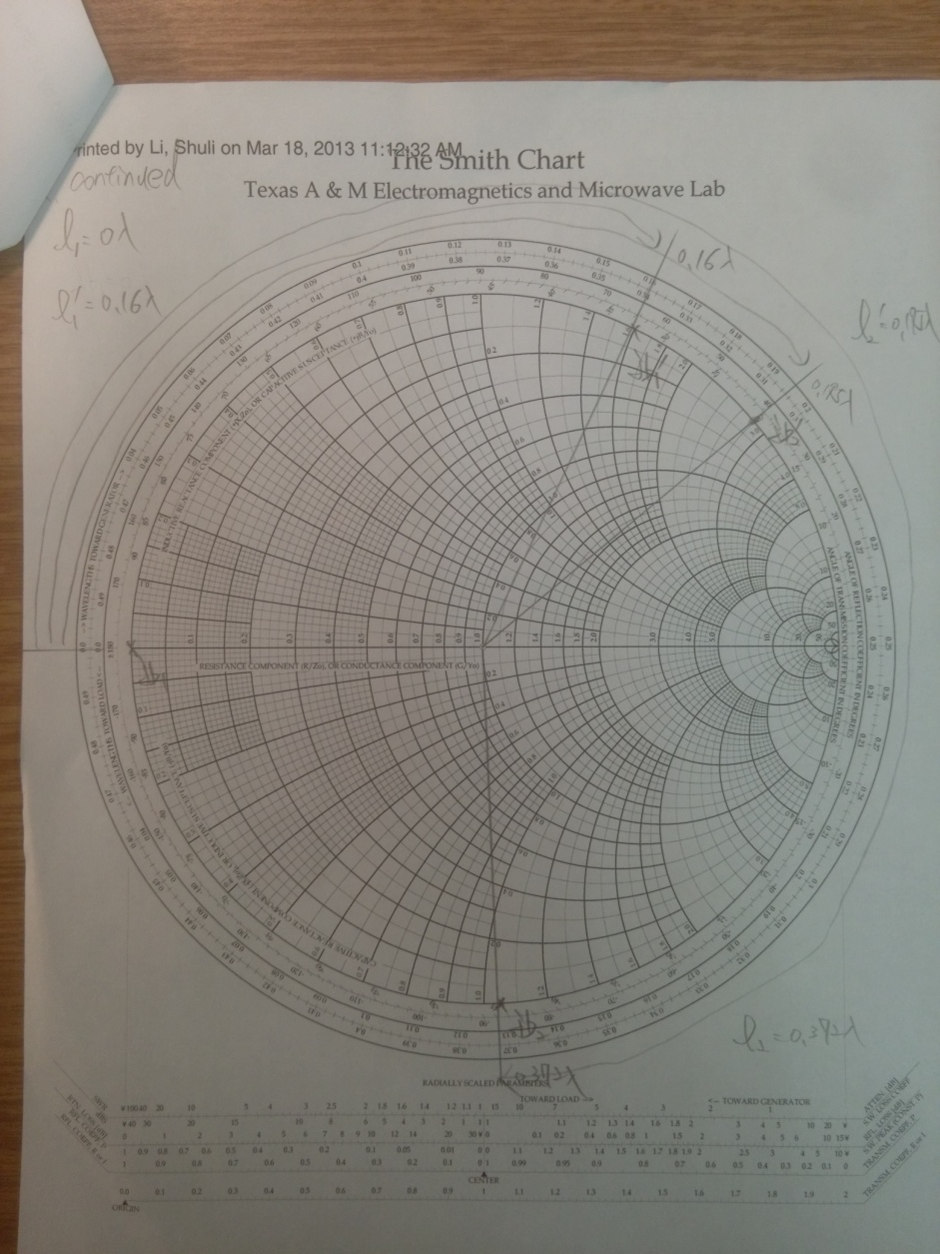

Figure 6 - Smith Chart Degian - 2

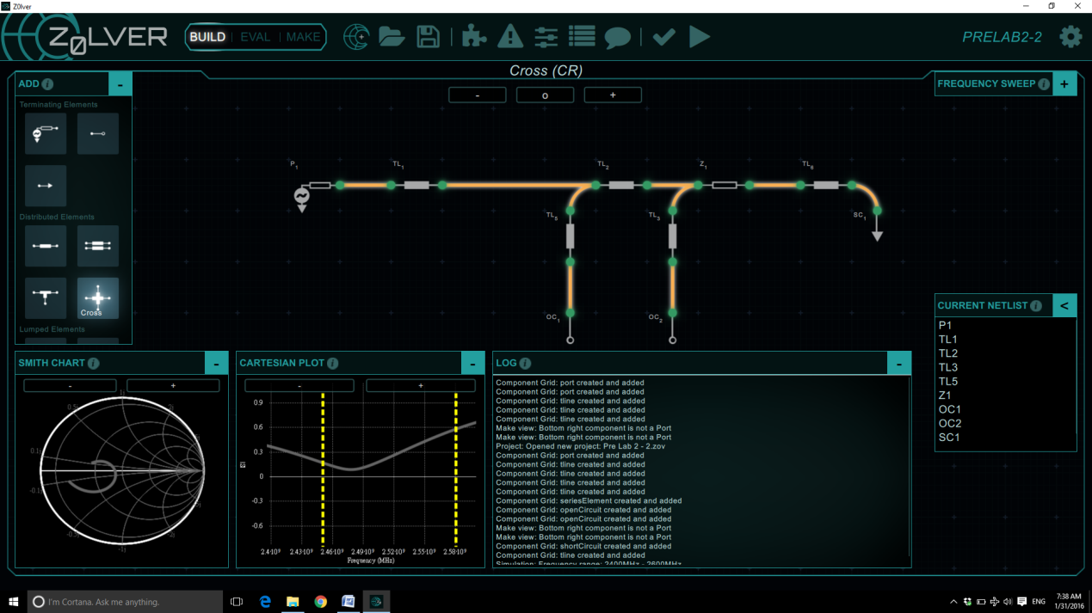

Figure 7 - A Double-Stub Circuit Implemented in Z0lver

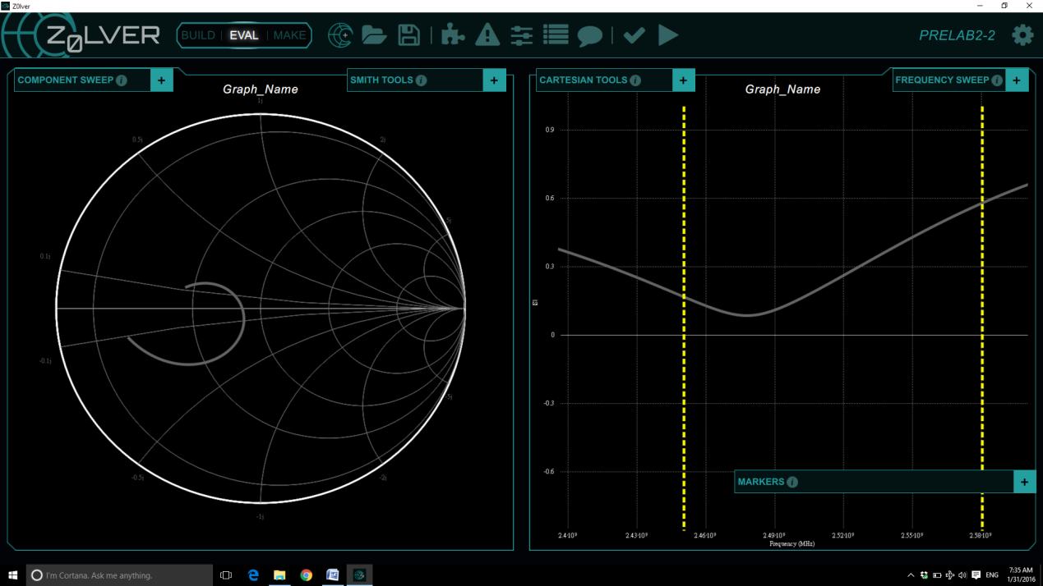

Figure 8 - S11 Simulation Results in Z0lver

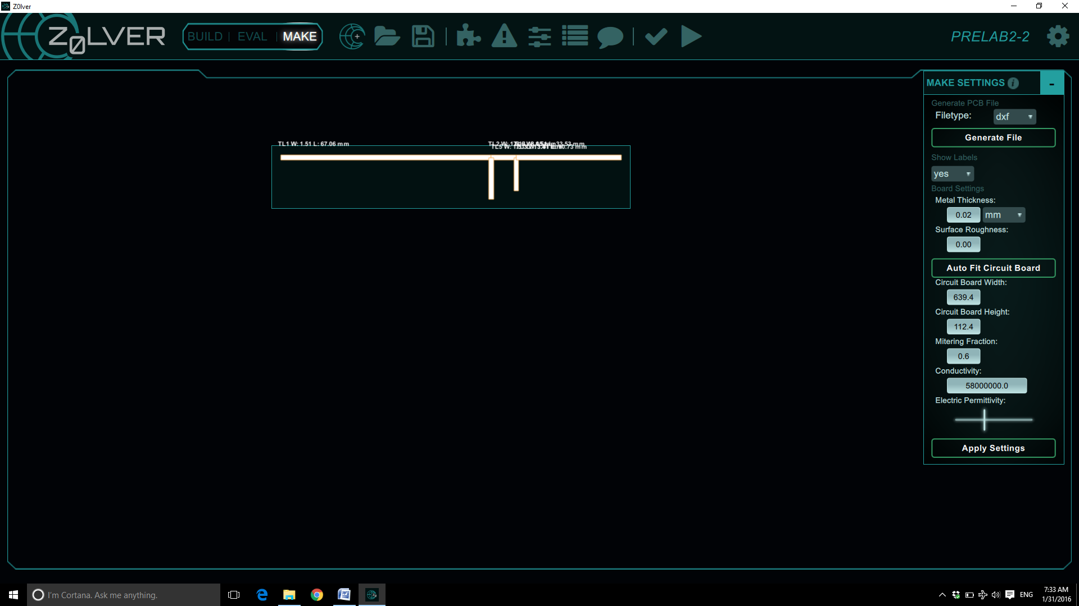

Figure 9 - Circuit Layout on FR4 Substrate in Z0lver