Lab 6: Filter Design

1. Maximally-Flat Low-Pass Filter

|  |  |  |  |  |  |  |  |  |  |
| --- | --- | --- | --- | --- | --- | --- | --- | --- | --- |
|  | OC 1 | UE 3 | OC 2 | UE 1 | Shunt 3 | UE 2 | Shunt 4 | UE 4 | Shunt 5 |
| Z (Ω) | 181 | 69 | 43 | 112 | 25 | 112 | 43 | 69 | 181 |
| w (mm) | .0842 | 1.759 | 3.962 | 0.539 | 8.396 | 0.539 | 3.962 | 1.759 | .0842 |
| L (mm) | 9.096 | 8.636 | 8.351 | 8.898 | 8.043 | 8.898 | 8.351 | 8.636 | 9.096 |

Design simulated in HFSS  
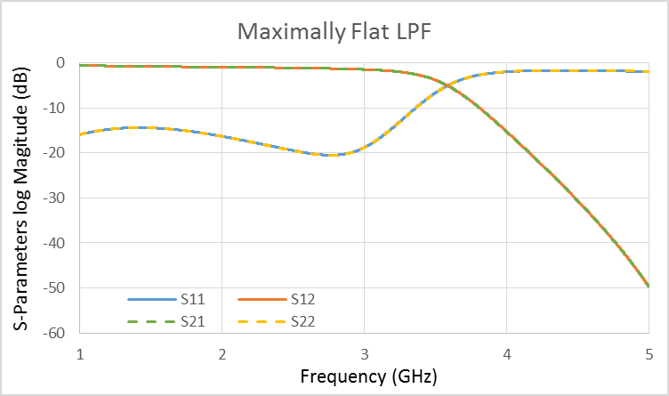

|  |  |  |  |  |  |  |  |  |  |
| --- | --- | --- | --- | --- | --- | --- | --- | --- | --- |
|  | OC 1 | UE 3 | Shunt 2 | UE 1 | Shunt 3 | UE 2 | Shunt 4 | UE 4 | Shunt 5 |
| Z (Ω) | 89 | 69 | 89 | 112 | 89 | 112 | 89 | 69 | 89 |
| w (mm) | 1.008 | 1.759 | 1.008 | 0.539 | 1.008 | 0.539 | 1.008 | 1.759 | 1.008 |
| L (mm) |  | 8.636 |  | 8.898 |  | 8.898 |  | 8.636 |  |

Design simulated in HFSS

1. Band Stop Filter

|  |  |  |  |  |  |  |  |  |  |
| --- | --- | --- | --- | --- | --- | --- | --- | --- | --- |
|  | OC 1 | UE 3 | OC 2 | UE 1 | Shunt 3 | UE 2 | Shunt 4 | UE 4 | Shunt 5 |
| Z (Ω) | 75 | 50 | 104 | 50 | 50 | 50 | 104 | 50 | 75 |
| w (mm) | 1.478 | 3.115 | 0.667 | 3.115 | 3.115 | 3.115 | 0.667 | 3.115 | 1.478 |
| L (mm) | 14.45 | 14.04 | 14.75 | 14.04 | 14.04 | 14.04 | 14.75 | 14.04 | 14.45 |

Design Simulated in HFSS and Built in Lab  
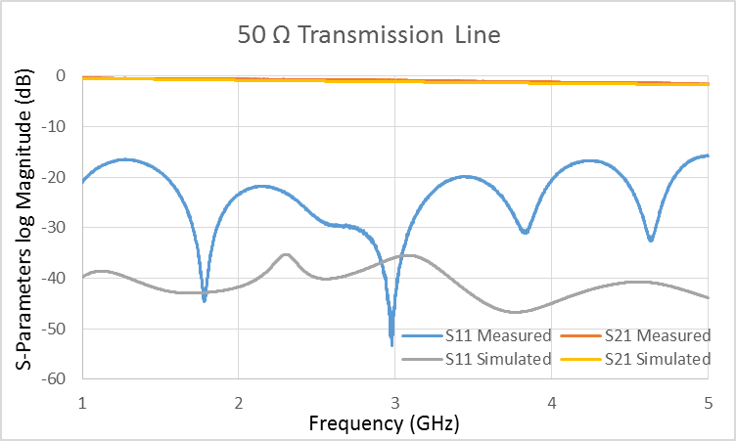 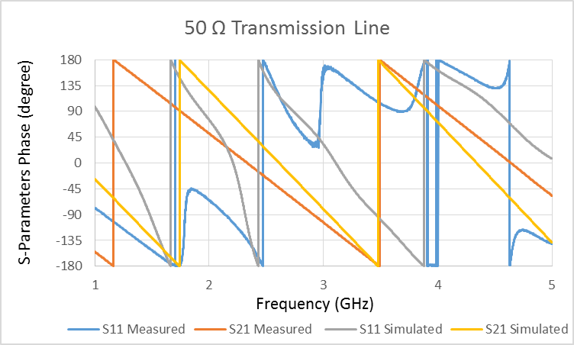  
  
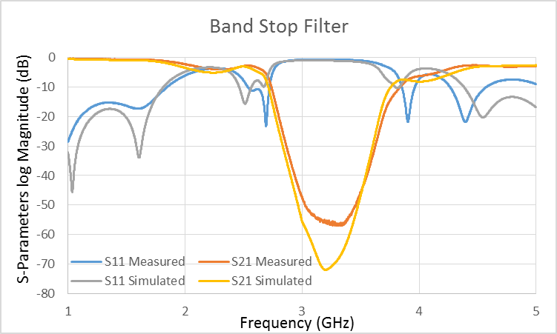 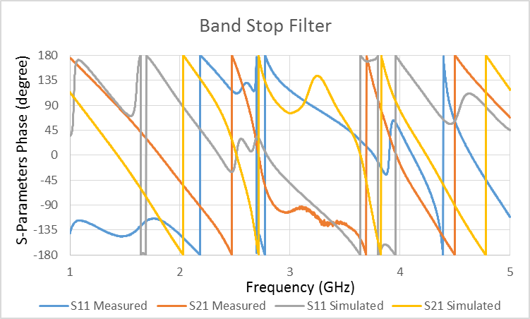

The design operated similarly to the simulated design. Because the device was created by hand, there is some error in both the widths and lengths of the lines in the filter. Here, the stubs were cut too short and therefore the device works at a slightly higher frequency than desired.