Lab 6: Wilkinson Power Divider and Phase Shifter

1. Wilkinson Power Divider  
   λeff/4=17.3 mm

|  |  |  |  |
| --- | --- | --- | --- |
| Parameter | Formula | Z (Ω) | W (mm) |
| Z0 | Z0 | 50 | 3.13 |
| Zλ/4 | Z0 | 70.71 | 1.68 |
| R | 2Z0 | 100 | NA |

Simulated in HFSS and Measured

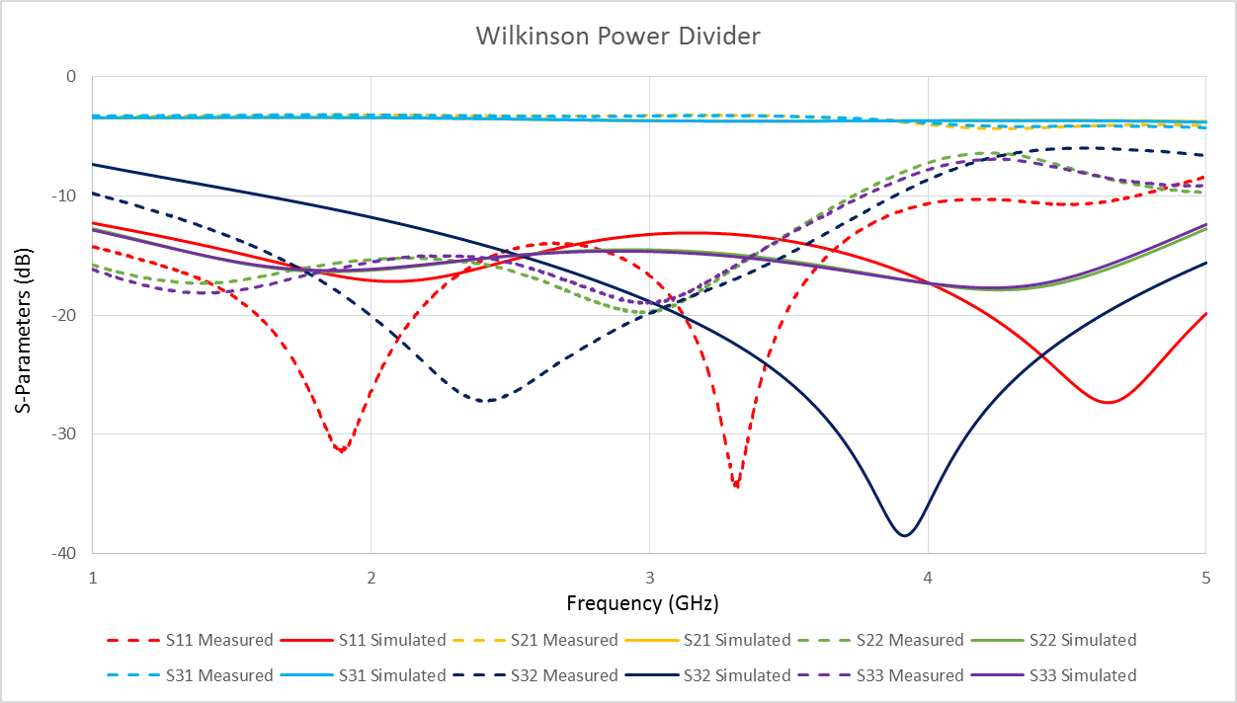

Here the simulated and measured result line up well for the S11 and S21 parameters. The other parameters have varied results for which frequencies the measured and simulated results match.

1. Phase Shifter  
   Reference Length: 102 mm  
   Width at 50 Ω : 3.118 mm

|  |  |  |
| --- | --- | --- |
| Phase Shift (°) | L added (mm) | L (mm) |
| 0 | 0 | 102 |
| 90 | 14.036 | 116.036 |
| 180 | 28.072 | 130.072 |

Measured Results of each part of the Phase Shifter

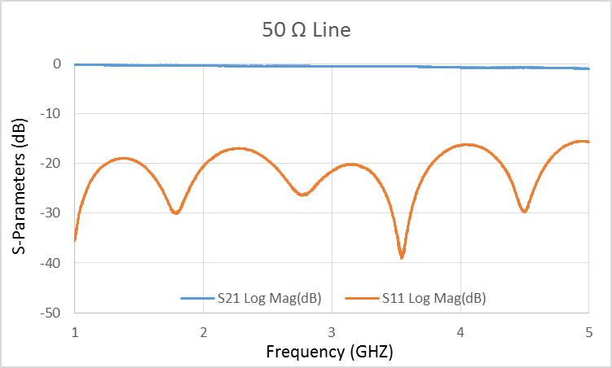 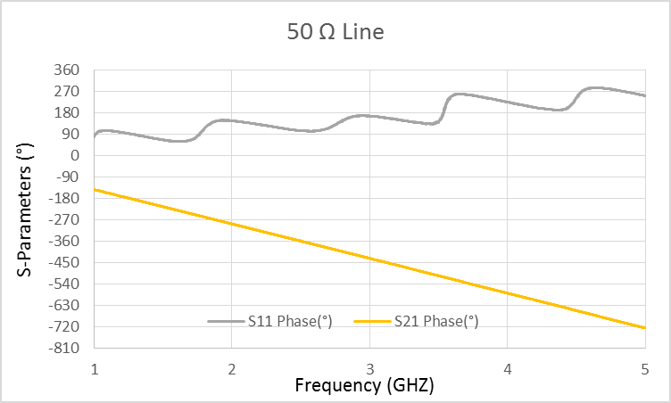

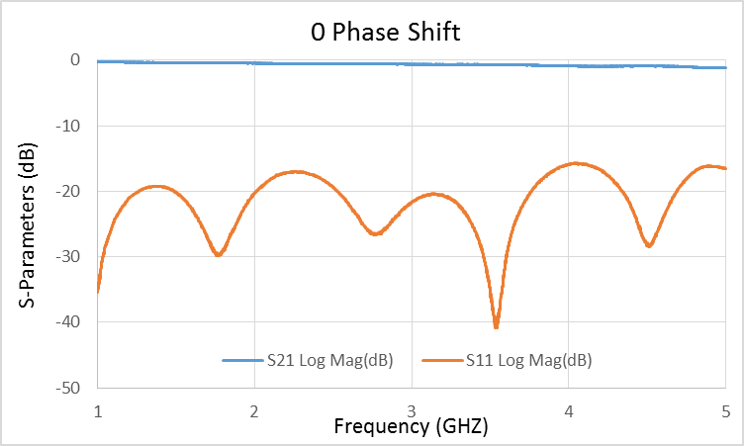 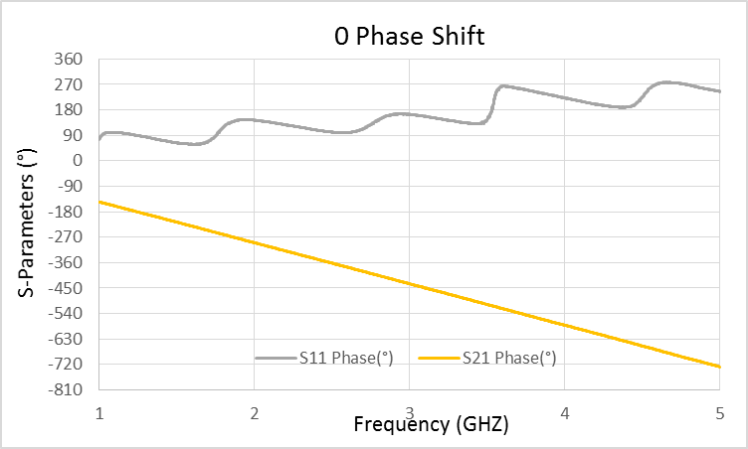

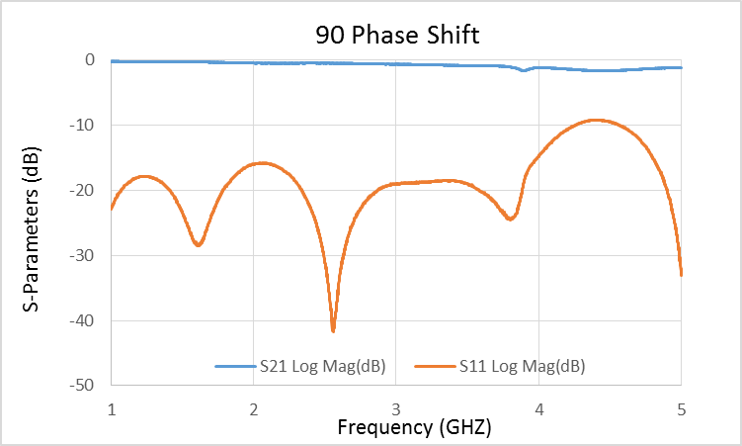 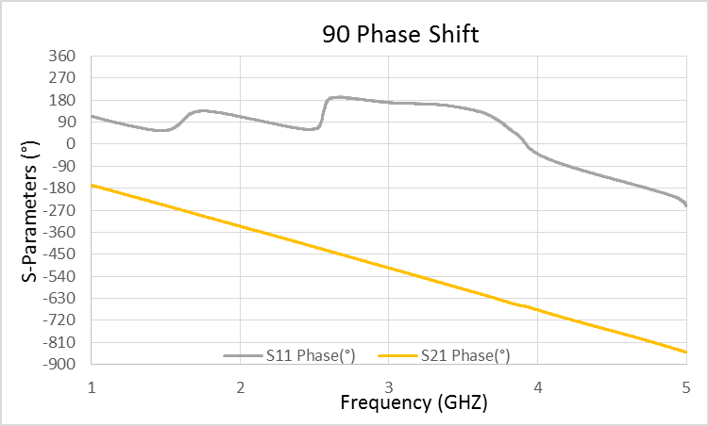

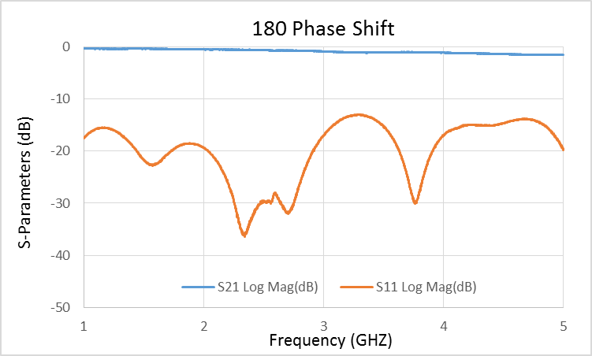 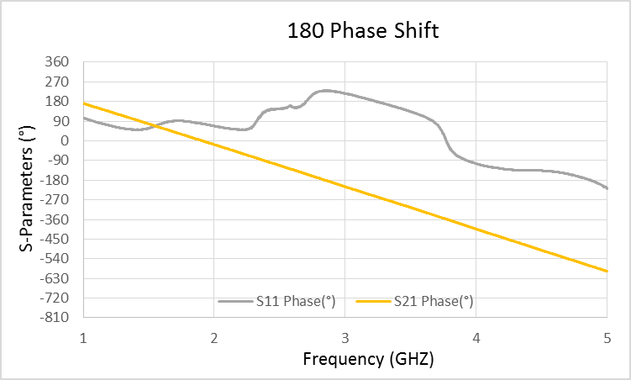

The Phase shifter had problems with the length being too short for both the 90° and 180°. In addition there were problems with attaching/ detaching the copper strips that contribute to the error in the shifts. Also, when the network analyzer unwraps the phase measurement, it did it incorrectly resulting in 3600° needed to be added to the phase values.