Installing Kali Linux as a Virtual Machine on Virtual Box:

This tutorial will go over the proper way to install 2018 Kali rolling Kernel 4.18.0 and how to setup the Virtual Box Guest Additions.

I am using Ubuntu 18.10 as my host machine and Virtual Box 5.2.22

Minimal Install Requirements: 2G RAM and 20GB disk space.

You can check these requirements on a Linux system by running the following command.

df -h ; free -h

Download Kali Image

You will first need to download Kali from https://www.kali.org/downloads/
If you have 64 bit system download the corresponding Kali image.
Please note that each week a new image is generated and denoted by -W version. They can be found here:

http://cdimage.kali.org/kali-images/kali-weekly/
and corresponding SHA256 for each image is here:
http://mirrors.ocf.berkeley.edu/kali-images/kali-weekly/SHA256SUMS

Verify Integrity of ISO Image:

Once downloaded you will need to verify the integrity of the image. This is an important step and should not be skipped. The mirrors are external to Kali.org’s TLS protected page and should not be taken at face value. The potential for a compromised image is real and you should always verify integrity and authenticity of your tools.

1. Download official Kali Key:
First you will check to make sure the SHA256SUMS file is the one generated by Kali. This file is signed with an official Kali key and signature. (Note:I downloaded the files to the current directory where my Kali ISO image is and did a cd into the directory when running the gpg verify command).

You have 2 ways of downloading the public key HTTPS:

wget -q -O - https://www.kali.org/archive-key.asc | gpg –import

or via the OpenPGP Keyserver:

gpg --keyserver hkp://keys.gnupg.net –recv-key “keyID”

gpg --fingerprint (insert Key ID from the wget command)

2. Now you need to make sure the key signatures matches what kali.org has by downloading the SHA256 SUMS:

wget http://cdimage.kali.org/current/SHA256SUMS

wget http://cdimage.kali.org/current/SHA256SUMS.gpg

3. Now verify the SHA SUMS

gpg --verify SHA256SUMS.gpg SHA256SUMS

You will get an output that says “Good Signature” if you get anything else such as Bad Signature then there was a problem.

**The RSA key output should be the same as what you got from the wget -q -O - https://www.kali.org/archive-key.asc | gpg –import **

4. Verify the Kali ISO with the SHA256S (Kali ISO must be in same directory as the SHA256 files)

grep kali-linux-2018.4-amd64.iso SHA256SUMS | sha256sum -c

You should get an output of OK, if you do not get OK then the iso can not be trusted.

Installing the Image to Virtual Box

Download Virtual Box from here https://www.virtualbox.org/wiki/Downloads

- - Before Installing make sure you check your host system BIOS and ensure you turn on virtualization.

- Do not enable Hyper V on Windows. You should check this under Windows Features and uncheck it then do a reboot.

- You need 15% free space on hard disk for host OS and then more space to add the Kali VM and Vbox

- Important: run the following command on your host system terminal for Debian based OS
sudo usermod -a -G vboxusers $USER

This will add the currently logged in user to a group called vboxusers and resolves an issue with USB devices not being recognized after Guest Additions are installed.

(I had to run the above command so that my USB devices would be recognized by Virtual Box).

Pick the correct platform that correlates to your host system. You will also want to use wget to download the SHA256 checksums and validate that the hashes match.

Once installed You will want to do the following:

1. Click on New and input the values I have in screenshot:
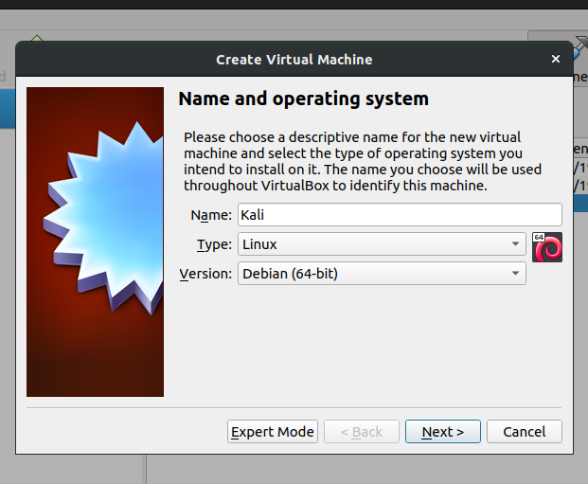

2. Assign 2 GB memory. If you have more to spare you can increase it. I have 8GB on my host system so I went with 2GB. You can change this later if want to. Choose wisely because the memory assigned to the VM will not be available to the host when the VM is up and running.

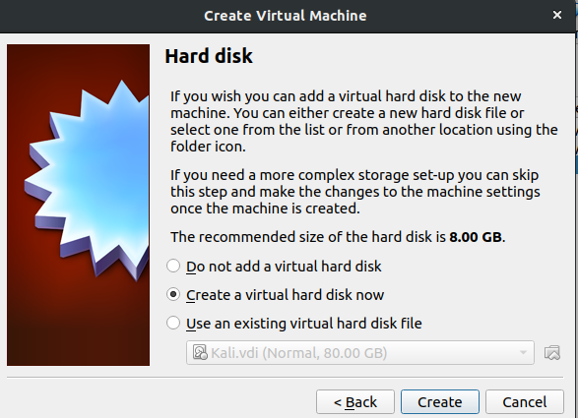
3. Choose Create and click Next

4. Choose VDI
The VDI option is Oracle specific, VMDK is for cross platform such as VMWare, VHD is used by Microsoft.

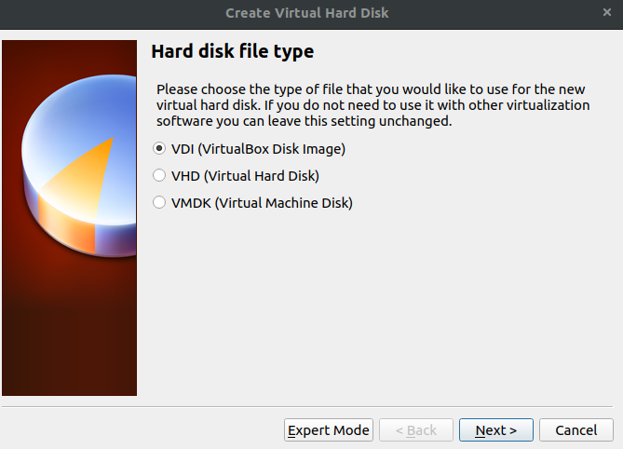

5. I chose 40GB but this all depends on the size of the hard drive on your host system. DO NOT use the default of 8G the Kali install will fail since it is too small. I generally want 15-20% of disk space always open on my host system.

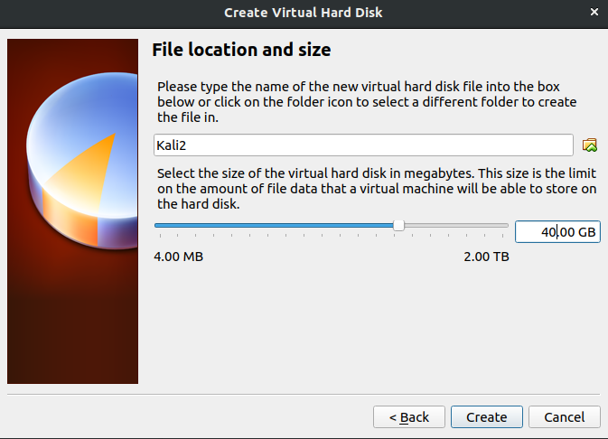

6. Right click on your new machine from left hand pane and choose settings. Go to System and click on Acceleration tab. Ensure the settings are same as in screenshot.

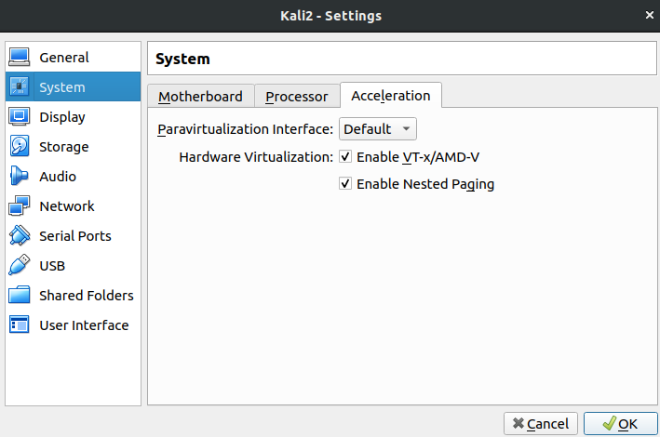
7. This part will change later once you attempt to get an external wifi adapter set up. For right now you can go to Network and under Adapter 1 make sure all settings are the same as in below screenshot.
Note: You will want to do the following command in your terminal on host machine to find out what network interface you are using:

ifconfig

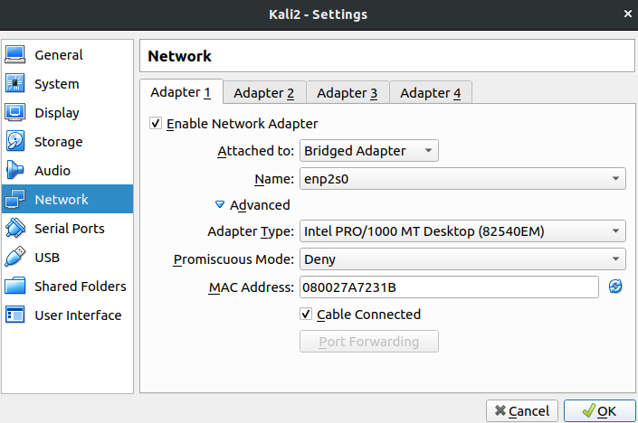
The one with an IP address is the correct interface and you will choose the same interface for the Network settings in Virtual Box under adapter 1.

You can also use the following command to see which route is being used on your host machine.

ip route

You should see a dev with the interface such as wlo1 beside it, this is your active interface.
It will also display your default gateway and current interface IP.

For more info on how to troubleshoot the network connectivity on Kali see this tutorial.

Installing Kali to VM

1.Now click OK and then highlight your VM in left pane and click the START Icon
You will then see the screen below choose Install.

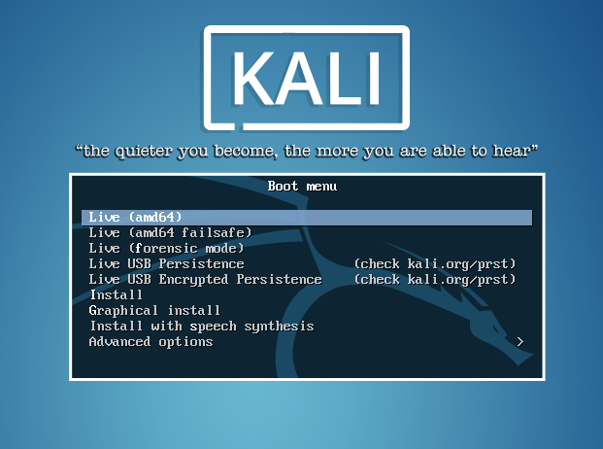

2. Choose Your Language. Hit Enter.

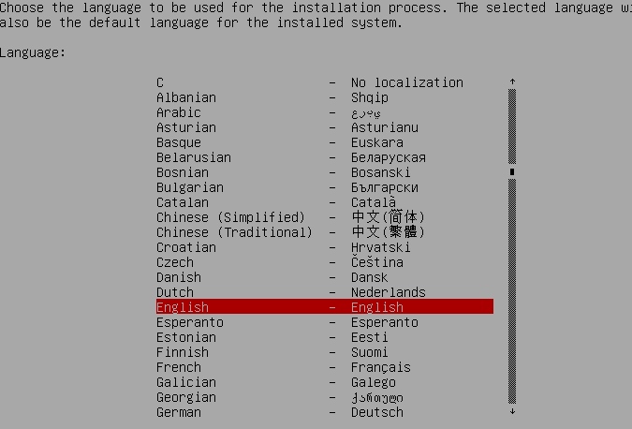

3. Choose your location. Hit Enter.
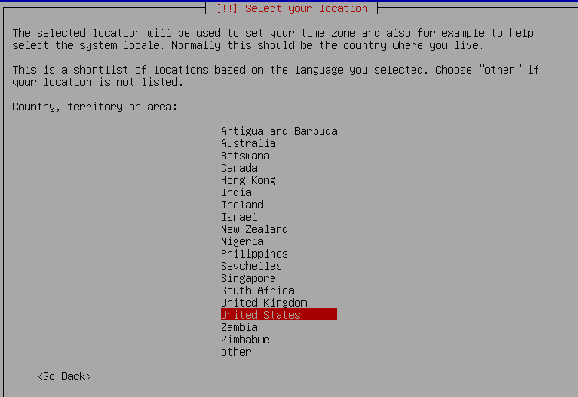

4. Choose Keyboard mapping. Hit Enter.

5. You will then see the progress bar for installing the OS. This will take some time.
You may see a popup message for DHCP configuration. If this fails you can try adding the IP/Default Gateway/Subnet MasK yourself.

6. Enter name Host

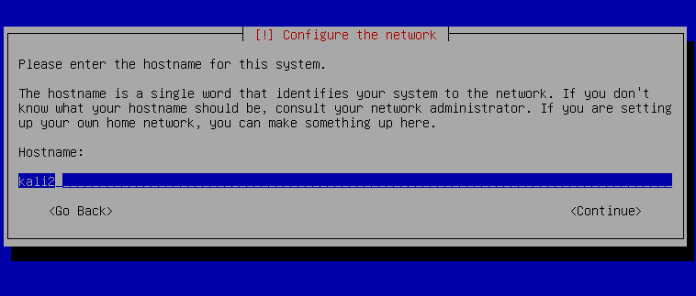

7. Enter in a password for the root user. Make sure it is complex.

8. Choose time zone

9. Now it will want to partition disks. Choose Guided – Use Entire Disk

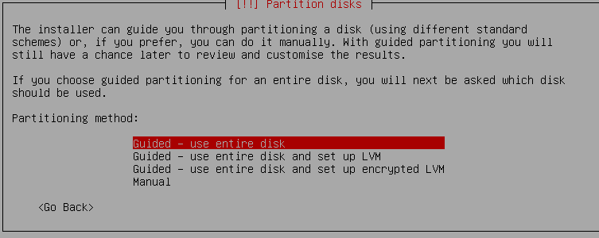

10. Select the disk to partition. Since this is a VM you can choose the default that is already present.

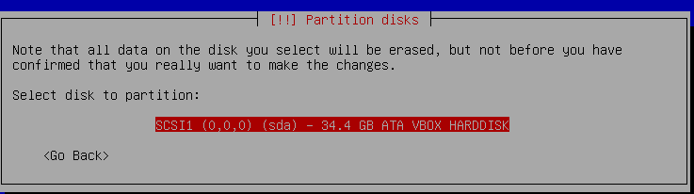

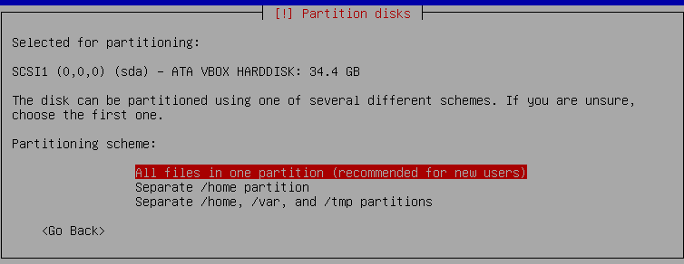
11. Select All Files on one partition.

12. Choose Finish Partitioning

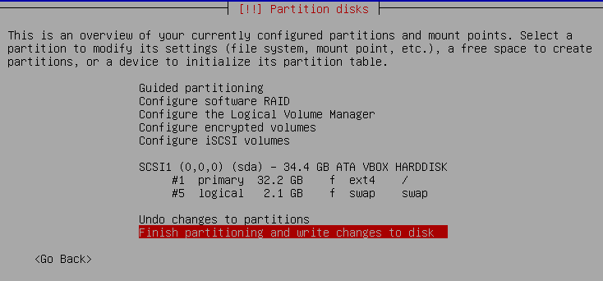

13. Arrow over 1 so that YES is highlighted, hit ENTER

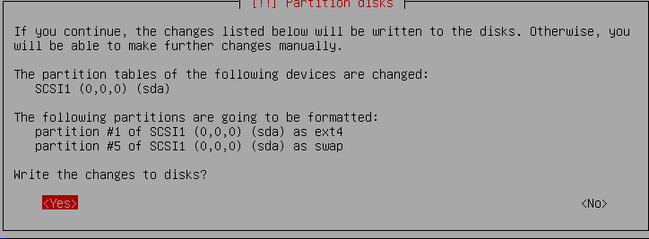

14. Now the OS will be installed. This will take some time.

15. Do not use a Network Mirror, Enter.
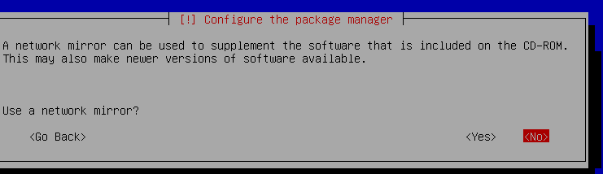

16. Install GRUB Boot Loader to MBR (It is a VM, so keep default)

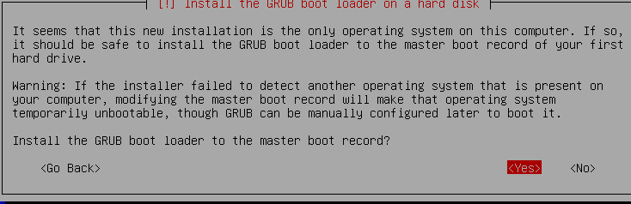

17. Leave as default

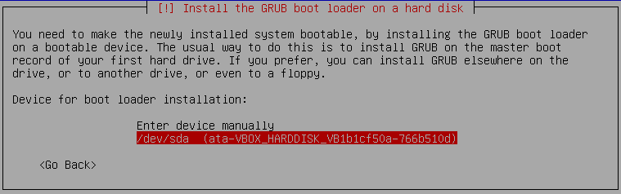

18.Click Continue and the installation will finish and then you can boot into the system.

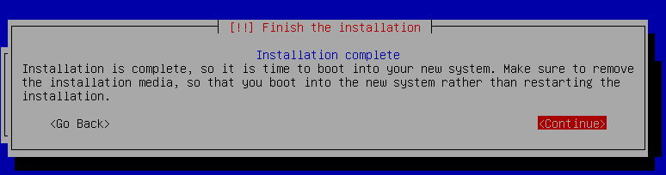

19. Once the VM reboots you can login with root and the password you setup earlier.
Open Terminal window and type below command in:

nano /etc/apt/sources.list

This file holds the listing of repositories for Kali. Only use the ones that the site recommends
https://docs.kali.org/general-use/kali-linux-sources-list-repositories

Do not add unofficial repos!

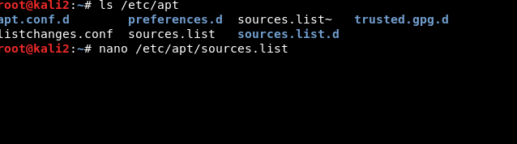

20. You should have the below repositories

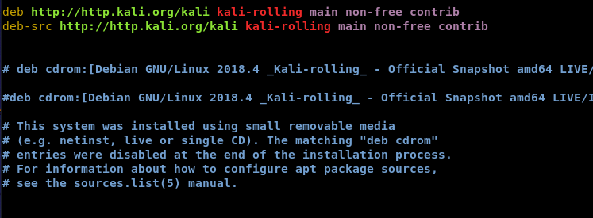

Now do CTRL + X and hit Y and then ENTER to save changes to the config file.

Now run cat /etc/apt/sources.list and make sure the changes are there

21. Now we need to do updates. First ping google.com to ensure you have connectivity, if so do the following command in Terminal.

apt-get update && apt-get upgrade -y
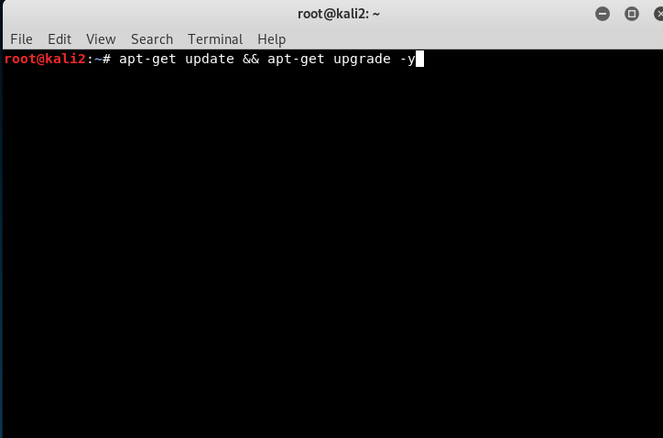

This will take awhile as it grabs all the updates from the Kali Repositories.
You should not see several “E” by the updates this mean an error occurred, so read the error message in order to find out the problem. A “W” means warning and should be fine.

You should do this command often once you have the OS installed, it is best practice. Before doing updates in the future you will want to do a snapshot of the current system before updating in case an update causes an issue.

22. Eventually, this dialogue box will pop up: You need to choose No because it is not best practice to allow all users to be allowed to do packet capture. We will set up a wireshark group later in a separate tutorial to resolve the packet captures issue.

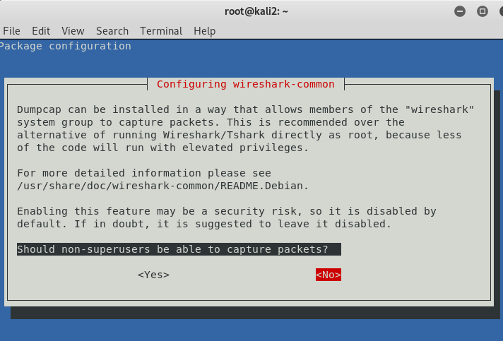

23. When this dialogue box appears choose Yes, so services are auto restarted

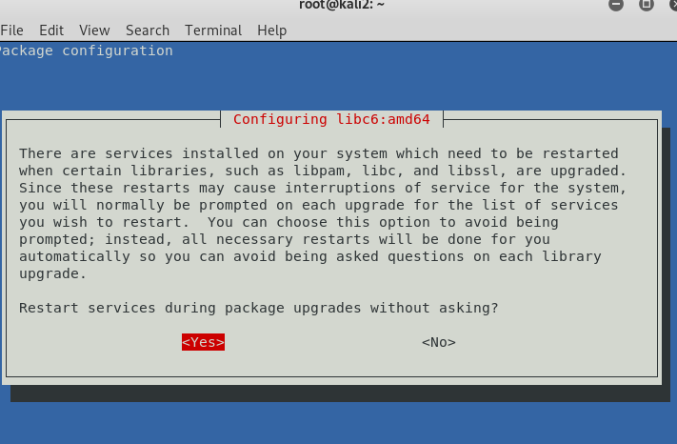

24. After all the updates which may take awhile, you type in reboot into Terminal. Once you log back into your Kali VM you then run the Apt-get update && apt-get upgrade -y command once more to make sure you caught all the updates.

25. Now we will change our Network interface configuration to managed = True by the following command:

cd /etc/NetworkManager/NetworkManager.conf

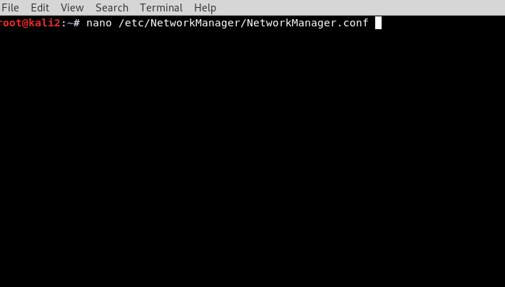

This will bring up a text editor screen and we need to arrow down and change the value of managed to True

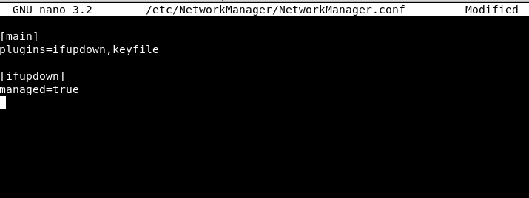

Now do Ctrl + X, enter Y (for yes to save changes), and hit Enter to save the changes.

Double check that file saved the settings by doing:

cat /etc/NetworkManager/NetworkManager.conf

Installation of VirtualBox Guest Additions
Virtual Box Guest Additions provides a better user experience by allowing better mouse and screen integration , shared folders between host and guest system, USB access from host system, and the copy and paste feature. Be aware this will not enable Drag n Drop, you need to setup a shared folder instead.

1. Run the following command:

apt-get install -y virtualbox-guest-x11

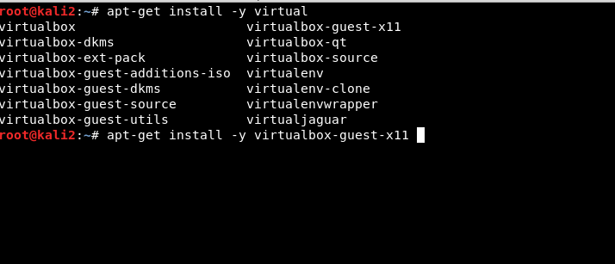
after all the packages are installed type shutdown -h now into Terminal.

Configuring Virtual Box for Guest Additions:

1. First we will make a shared folder under our Host system’s (NOT VM) Home directory by doing the following command: (Note that Kalishare2 can be whatever you want to name the new Directory)

mkdir ~/Kalishare2
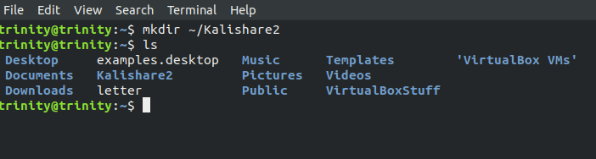

One other thing we need to do is remove old dependencies that are not needed anymore.
Run the following commands in Kali Terminal.

apt autoremove
apt-get remove && apt-get update && apt-get upgrade -y && apt-get dist-upgrade -y
apt autoremove
reboot

(This is the only fix I found for getting shared folder to show up)

Now we will setup the Kali VM

Make sure your VM is highlighted and then click on the Settings Icon in Virtual Box.

You will need to enable Shared clipboard and drag n drop .
We want to ensure the guest OS is isolated from the host so only do Host to Guest NOT Bidirectional.

Make the following settings:

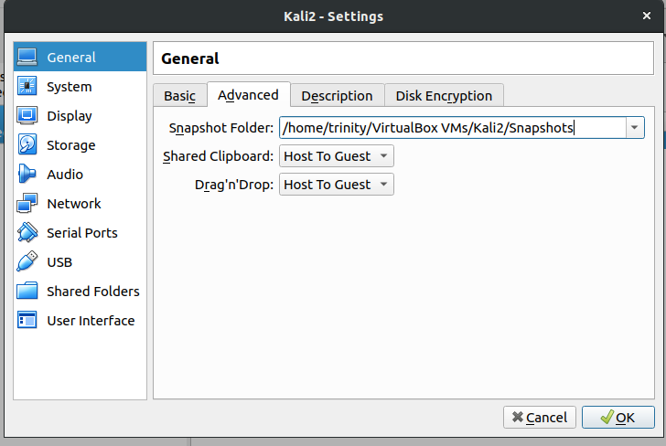

Click OK

2. Now Click on USB in left pane of the VM Settings. Ensure Enable USB Controller is check marked and you will need to pick what USB port you will be using. I will be using USB 3.0 . If you click on the + Icon under USB Device Filters and have followed this tutorial correctly you will see a list of USB devices. This is important because we will install an external wireless adapter that will enable us to do packet injection.

Once we install the driver for a USB device in the host system you should see it as a filter. Like so:
Choose the USB preference and then click OK

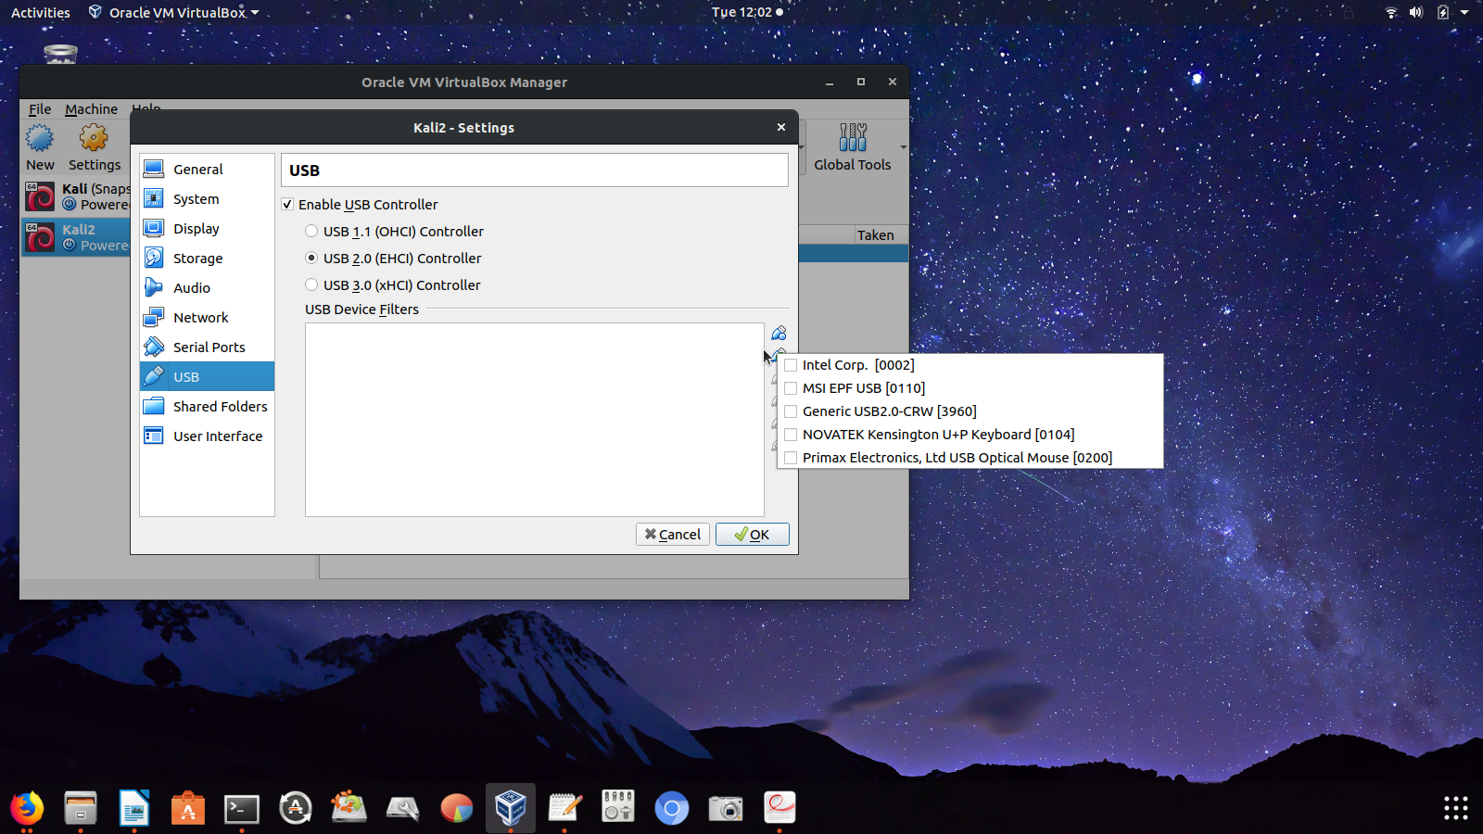

3. Now click on Shared folders, click + icon in the far right and navigate to where you put the shared folder you made earlier. You should see the folder under the current User’s Home directory.
For right now we are making it Read Only and choose Auto Mount so upon reboot it keeps the settings.
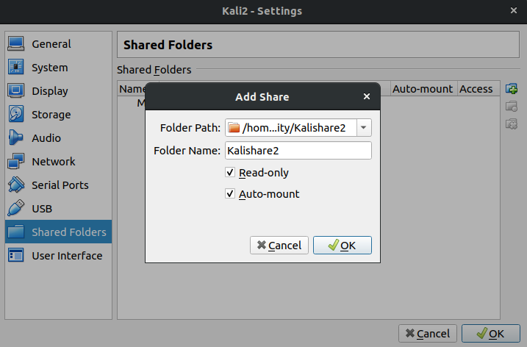

Click OK and Ok again to save settings.

Upon booting into your VM you should have copy and paste functions from your Host system to VM but not vice versa. You can test it out at this point.

Also if you click on Devices at the top of the VM and click USB you should see a list of USB Devices.

You should also see a shared folder that you have Read Only acces to:

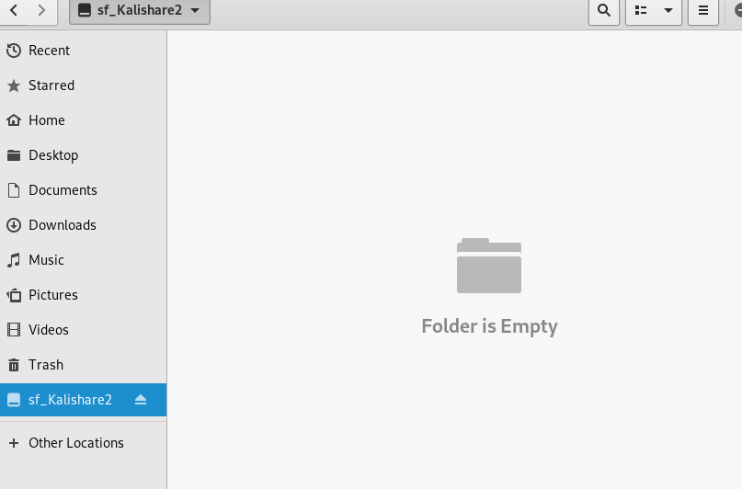

The Next Tutorial is Labeled Installing Wireless Adapter and it goes over the models of adapters that work and why as well as a configuration guide geared towards Debian based OS as your host system.

