MUJI 架構
- Assembly
- Type
- Reflection
- Custom Attribute
- List<T>

Reflection Description
- Assembly
- Run time Type
- View Type Information(Class Property Field Method)
- Dynamic Load Binding

應用
- WPF SilverLight
<Button >
<Button.Background>
<Button.Height>
<x:Static Member=”SystemParameters.IconHeight”/> 利用映射來找資料值。
</Button.Height>
<Button.Content>
<Binding Path=”Height”>
<Binding.RelativeSource>
<RelativeSource Mode=”Self”/>
</Binding.RelativeSource>
</Binding>
</Button.Content>
</Button>

範例二 C# 3.0
ExtensionMethod Static Class Method
namespace ExtensionMethods
{
public static class MyExtensions
{
public static int WordCount(this String str)
{
Return str.count;
}
}
}
using ExtensionMethods;
string s = "Hello Extension Methods";
int i = s.WordCount();
MUJI使用的範圍
FieldInfo
PropertyInfo
MethodInfo
CustomAttribute

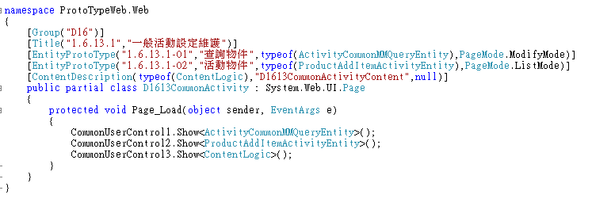
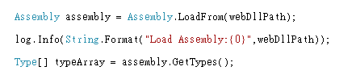
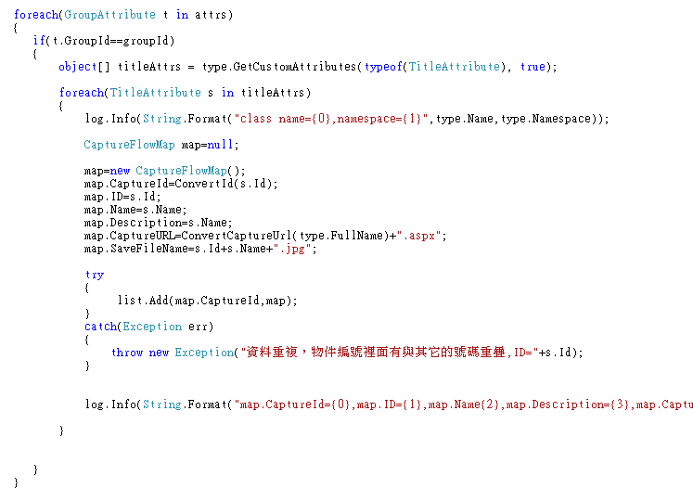

FieldInfo 用於Enum
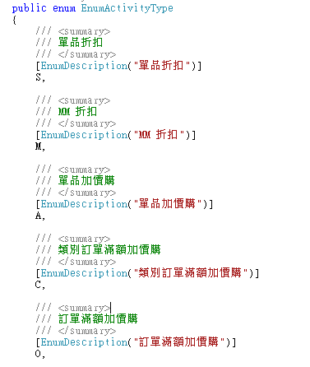
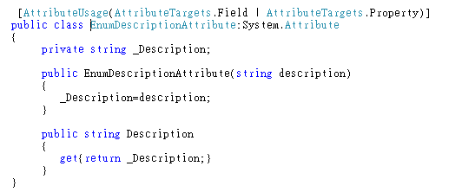
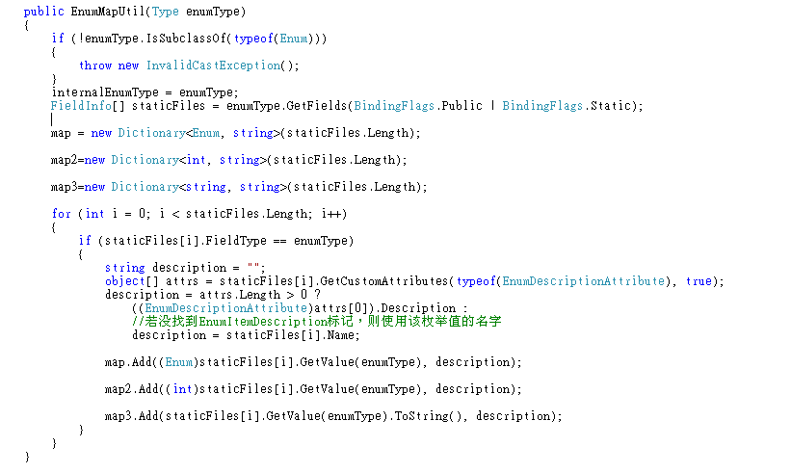
請看WebForm3.aspx-範例

PropertyInfo
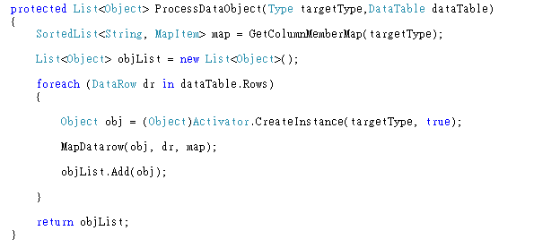
MapDataRow Method 由DataRow的資料變成Object 的方法
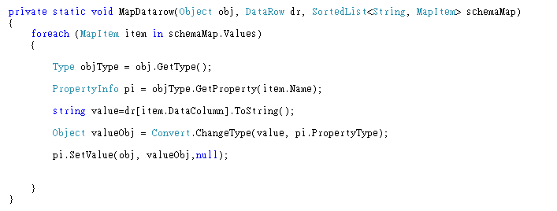

範例二 Property Set
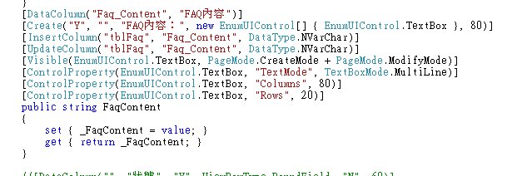
UI畫面顯示如下
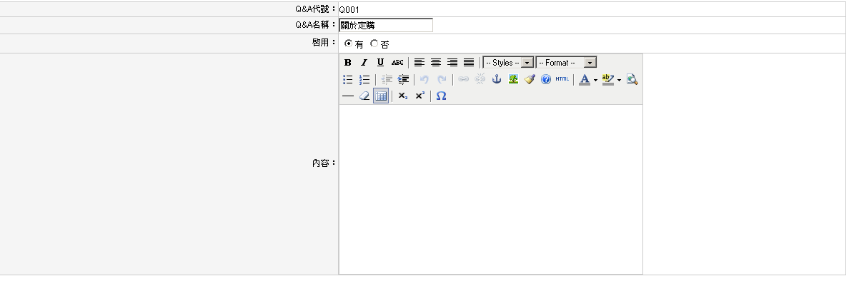

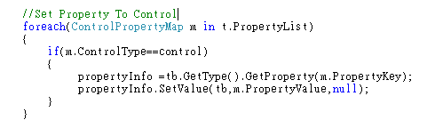
MethodInfo-用於SubClassList
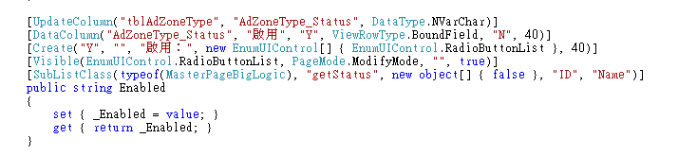
如何使用
