Web Mail Architect Introduction
Resource http://www.systemnetmail.com/
Architecture
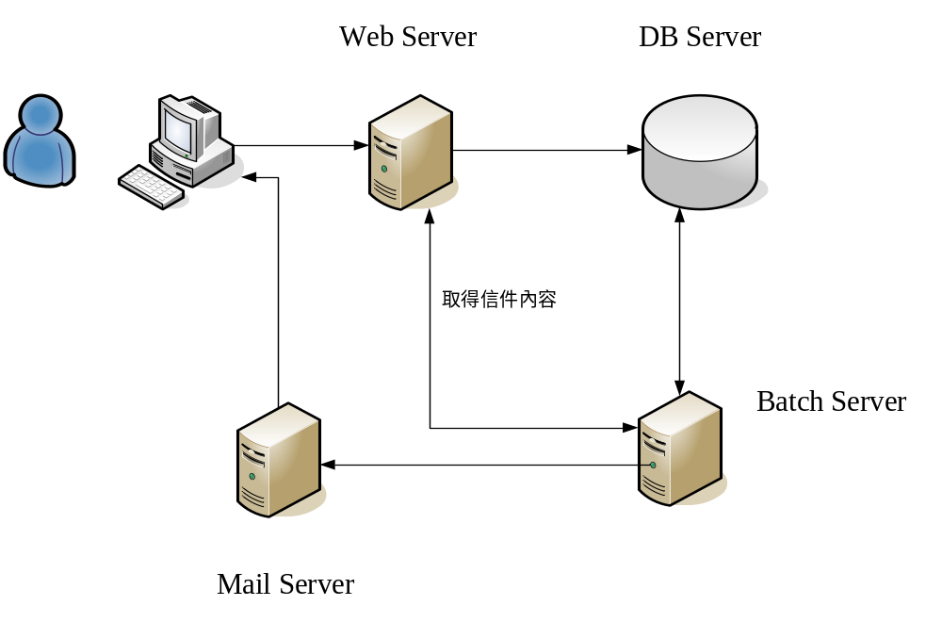
特色：
- Web Mail Style 內容如網頁所示，網頁呈現如何，即是信件內容，可以製作複雜LayOut的信件格式，而不會維護困難狀況發生。
- 批次處理，免除Web Server直接寄送時Mail Server Delay狀況造成網頁失敗。
- 此架構並不用於單一系統中，可以多個系統共用一個Web Mail 批次作業，可以獨立成一個單一系統，專門設計來發送Web信件內容。
- 採用微軟新架構的寫法，符合Net 2.0的規範。
- 利用HTML 4.0以上之標準，相容性高，任何只要是能夠能以網頁方式呈現的網站，本發信系統也能利用，不管Web Mail內容是放在那一種程式語言中，只要能能夠Ping得到，此系統即可運作，所以不管你的網站是用PHP、Java非微軟之語言所製作的網頁一樣可以使用，擴充性極佳。
- 支援Mime Type Mail

Multipurpose Internet Mail Extensions (MIME)-From Wiki
is an Internet standard that extends the format of e-mail to support:
- text in character sets other than US-ASCII;
- non-text attachments;
- multi-part message bodies; and
- header information in non-ASCII character sets
MIME-version: 1.0
Content-type: multipart/mixed; boundary="frontier"

This is a multi-part message in MIME format.
--frontier
Content-type: text/plain

This is the body of the message.
--frontier
Content-type: application/octet-stream
Content-transfer-encoding: base64

PGh0bWw+CiAgPGhlYWQ+CiAgPC9oZWFkPgogIDxib2R5PgogICAgPHA+VGhpcyBpcyB0aGUgYm9keSBvZiB0aGUgbWVzc2FnZS48L3A+CiAgPC9ib2R5Pgo8L2h0bWw+Cg==
--frontier--

Send Easy Mail
Web.Config
<configuration>
<!-- Add the email settings to the <system.net> element -->
<system.net>
<mailSettings>
<smtp>
<network
host="relayServerHostname"
port="portNumber"
userName="username"
password="password" />
</smtp>
</mailSettings>
</system.net>

<system.web>
...
</system.web>
</configuration>

寄一封簡單信的Method 如下
Protected Sub SendEmail_Click(ByVal sender As Object, ByVal e As System.EventArgs) Handles SendEmail.Click
'!!! UPDATE THIS VALUE TO YOUR EMAIL ADDRESS
Const ToAddress As String = "you@youremail.com"
'(1) Create the MailMessage instance
Dim mm As New MailMessage(UsersEmail.Text, ToAddress)
'(2) Assign the MailMessage's properties
mm.Subject = Subject.Text
mm.Body = Body.Text
mm.IsBodyHtml = False
'(3) Create the SmtpClient object
Dim smtp As New SmtpClient
'(4) Send the MailMessage (will use the Web.config settings)
smtp.Send(mm)
End Sub

Net 2.0 架構
Using System.Net
簡單的信件
Dim msg As New MailMessage("sender mail address", "recipient mail address")
msg.Subject = "This is my first email through program"
msg.IsBodyHtml = True

Dim View As AlternateView
Dim resource As LinkedResource
Dim client As SmtpClient
Dim msgText As New StringBuilder

msgText.Append("Hi there,")
msgText.Append("Welcome to the new world programming.")
msgText.Append("Thanks")
msgText.Append("With regards,")
msgText.Append("")

'create an alternate view for your mail
View = AlternateView.CreateAlternateViewFromString(msgText.ToString(),
Nothing, "text/html")

'link the resource to embed
resource = New LinkedResource((Server.MapPath("Images\007jvr.gif")))

'name the resource
resource.ContentId = "Image1"

'add the resource to the alternate view
View.LinkedResources.Add(resource)

'add the view to the message
msg.AlternateViews.Add(View)

client = New SmtpClient()
client.Host = "smtp.gmail.com" 'specify your smtp server name/ip here
'client.EnableSsl = True
'enable this if your smtp server needs SSL to communicate
client.Credentials = New Net.NetworkCredential("username", "pwd")
client.Send(msg)

取回圖片內容
// Get All the img nodes
GetImageNodes(document.Nodes);
private void GetImageNodes(HtmlNodeCollection nodes)
{
foreach (HtmlNode node in nodes)
{
HtmlElement element = node as HtmlElement;
if (element != null)
{
if (element.Name.ToLower() == "img")
{
imageNodes.Add(element);
}
if (element.Nodes.Count > 0)
{
GetImageNodes(element.Nodes);
}
}
}
}

foreach (HtmlElement element in imageNodes)
{
FileInfo imageFileInfo = new FileInfo(Path.Combine(
fileInfo.DirectoryName,
element.Attributes["src"].Value));
string contentId =
imageFileInfo.Name.Replace(imageFileInfo.Extension,
string.Empty);

if (!images.ContainsKey(element.Attributes["src"].Value))
{
// Add Image to the Email
images.Add(
element.Attributes["src"].Value, imageFileInfo.FullName);
FileAttachment relatedFileAttachment =
new FileAttachment(imageFileInfo, contentId);
if ((imageFileInfo.Extension == ".jpg") ||
(imageFileInfo.Extension == ".jpeg"))
{
relatedFileAttachment.ContentType = "image/jpeg";
}
else if (imageFileInfo.Extension == ".gif")
{
relatedFileAttachment.ContentType = "image/gif";
}
emailMessage.AddRelatedAttachment(relatedFileAttachment);
}

//Change the src to "cid:<CONTENTID>"
element.Attributes["src"].Value = string.Format("cid:{0}", contentId);

}
之前
Mail Body
<img src=http://ip/image.gif>

之後
Mail Body
<img src=cid:id1 >

範例
How to achieve this?
We have to include a <IMG> with a contentid specified in src attribute of <IMG> tag in the message body i.e. the HTML body should contain <img src="cid:imageId" />.

Example will be,
<b>View my Pic</b><br>
<img src="cid:Anyid" />

After doing this we need to give the same contentid to the ContentId attribute of LinkedResource to work.

Implememtation:
try
{
MailMessage mail = new MailMessage();
mail.To.Add("satheeshbabu.b@gmail.com");
mail.From = new MailAddress("satheeshbabu.b@gmail.com");
mail.Subject = "Test with Image";
string Body = "<b>Welcome to popfly!!</b><br><img alt=\"\" hspace=0 src=\"cid:imageId\" align=baseline border=0 >";

AlternateView htmlView = AlternateView.CreateAlternateViewFromString(Body, null, "text/html");
LinkedResource imagelink = new LinkedResource(Server.MapPath(".") + @"\popfly.JPG", "image/jpeg");
imagelink.ContentId = "imageId";
imagelink.TransferEncoding = System.Net.Mime.TransferEncoding.Base64;
htmlView.LinkedResources.Add(imagelink);

mail.AlternateViews.Add(htmlView);
SmtpClient smtp = new SmtpClient();
smtp.DeliveryMethod = SmtpDeliveryMethod.PickupDirectoryFromIis;
smtp.Send(mail);
}
catch (Exception ex)
{
Response.Write(ex.Message);
}
public static void Send
(
string SMTPServer,
int SMTPPort,
string fromFromAddress,
string toEmailAddress,
string subject,
string body,
bool isBodyHtml)
{

try
{
//SmtpClient smtpClient = new SmtpClient(SMTPServer,SMTPPort);
SmtpClient smtpClient = new SmtpClient();
smtpClient.Credentials =
new System.Net.NetworkCredential("ningin@bankpro.com.tw", "1qaz2wsx@");
smtpClient.Port = 25;
smtpClient.Host = "srkm.bankpro.com.tw";
MailMessage mailMessage = new MailMessage();
IList embeddedImageList = new ArrayList();
mailMessage.From = new MailAddress(fromFromAddress);
mailMessage.To.Add(toEmailAddress);
mailMessage.IsBodyHtml = isBodyHtml;
mailMessage.Subject = subject;
if (isBodyHtml)
{
string webContent = ScreenScrapeHtml(body);
HtmlDocument doc = HtmlDocument.Create(webContent);
HtmlNodeCollection hc = doc.Nodes;
GetImageArrayList(hc, ref embeddedImageList);
if (embeddedImageList.Count > 0)
{
for (int i = 0; i < embeddedImageList.Count; i++)
{
string str = embeddedImageList[i].ToString();
//log.Info("i=" + i + ":ImagePath=" + str);
webContent = webContent.Replace(str, "cid:image" + i.ToString());
}
}
AlternateView htmlView =
AlternateView.CreateAlternateViewFromString(webContent, null, "text/html");
if (embeddedImageList.Count > 0)
{
for (int i = 0; i < embeddedImageList.Count; i++)
{
string imageUrl = GetRealImagePath(body, embeddedImageList[i].ToString());
WebRequest imageCID = HttpWebRequest.Create(imageUrl);
imageCID.Credentials = CredentialCache.DefaultCredentials;
Stream sr = imageCID.GetResponse().GetResponseStream();
LinkedResource logo = new LinkedResource(sr);
logo.ContentId = "image" + i.ToString();
htmlView.LinkedResources.Add(logo);
}
}
mailMessage.AlternateViews.Add(htmlView);
}
else
{
mailMessage.Body = body;
}
smtpClient.Send(mailMessage);
}
catch(Exception err)
{
}
}

