第四次上課 RUP 簡介

What is the Rational Unified Process (RUP)?

取自網路Wiki
Unified Process is The Unified Software Development Process or Unified Process is a popular iterative and incremental software development process framework. The best-known and extensively documented refinement of the Unified Process is the Rational Unified Process or RUP

這與目前Java所發展的訊息有關連
Java的發展概要
SUN IBM Borland
UML=Unified Modeling Language
兩大UML廠商的歷史(Java)
Rational(IBM) And StarTeam(Borland)+Team System(MS)。
如果你對我的系統有一定的了解的話，裡面是有遵守UML的精神設計。
Eclipse的歷史。
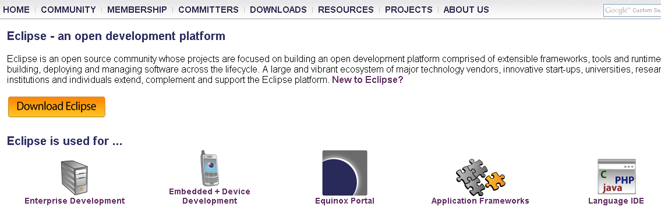
IDE 之爭(Eclipse以及Jbuilder)+NetBeam(Sun)
Support Language IDE(C++,Java,Cobol,PHP,C#)-IBM 主導開發
WebServer 之爭(WebSphere、WebLogic、Sun Server On)+Jboss(RedHat)+Tomcat(Apache)
UML 之爭(IBM-Rational和Borland Together)+MS(Team System)。
介紹Jboss-Red Hat 併購
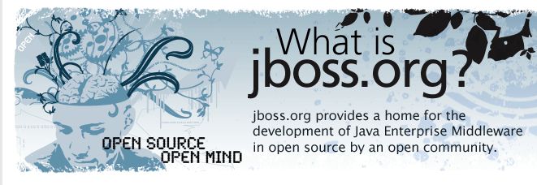
Integrate Tools-架構圖
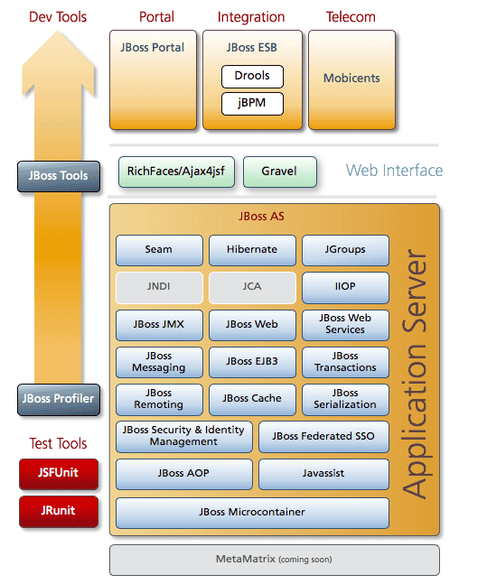

簡介JBoss Seam 下一代Web Application Framework
https://rhstack.108.redhat.com/articles/2006/09/18/jboss-seam-the-next-generation-web-framework.html

軟體工程角色簡介
經理角色一覽表
- 經理級角色
  - PM
    - Monitor Project Status
    - Define Project Organization and Staffing
    - Schedule and Assign Work
    - Initiate Iteration
    - Develop Risk Management Plan
    - Develop Business Case
    - Plan Phases and Iterations
    - Develop Quality Assurance Plan
    - Report Status
  - Configuration Manager
    - Set Up Configuration Management (CM) Environment
    - Create Deployment Unit
  - Change Control Manager(Change Request)
    - Review Change Request
  - Test Manager
  - Deployment Manager
  - Process Engineer
    - Prepare Guidelines for the Project
- 分析
  - Business-Process Analyst
    - Capture a Common Business Vocabulary
    - Assess Target Organization
    - Set and Adjust Objectives
    - Maintain Business Rules
    - Identify Business Goals
    - Structure the Business Use-Case Model
    - Find Business Actors and Use Cases
    - Define the Business Architecture
  - Business Designer
    - Define Automation Requirements
    - Detail a Business Use Case
    - Detail a Business Entity
    - Detail a Business Worker
    - Find Business Workers and Entities
  - System Analyst
    - Elicit Stakeholder Requests
    - Capture a Common Vocabulary
    - Structure the Use-Case Model
    - Find Actors and Use Cases
    - Manage Dependencies
    - Develop Requirements Management Plan
  - Software Architect
    - Construct Architectural Proof-of-Concept
    - Architectural Analysis
  - Designer
    - Class Design
    - Subsystem Design
    - Use-Case Design
    - Design Testability Elements
  - User-Interface Designer
    - User-Centered Design
  - Database Designer
    - Database Design
  - Implementer
    - PR
  - Integrator
    - Plan Subsystem Integration

請參考MUJI範例說明。

