**Boot local Tuxedo**

C:\bea\tuxedo8.1\NinjaJoltEditor

. ./setenv.sh

tmboot -y

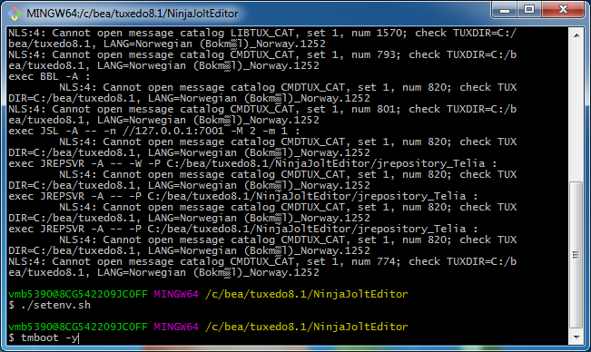

tmshutdown -y

(When done)

**Edit services**

C:\bea\jolt

. ./run_applet.sh

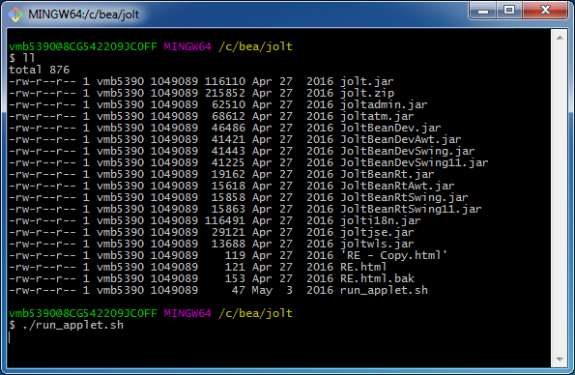

127.0.0.1 / 7001

|  |  |
| --- | --- |
|  |  |

Long: integer

Short: short

Char: byte

String: String

Double: double