1. Login with your userID

2. Find values of env variables
a. PATH
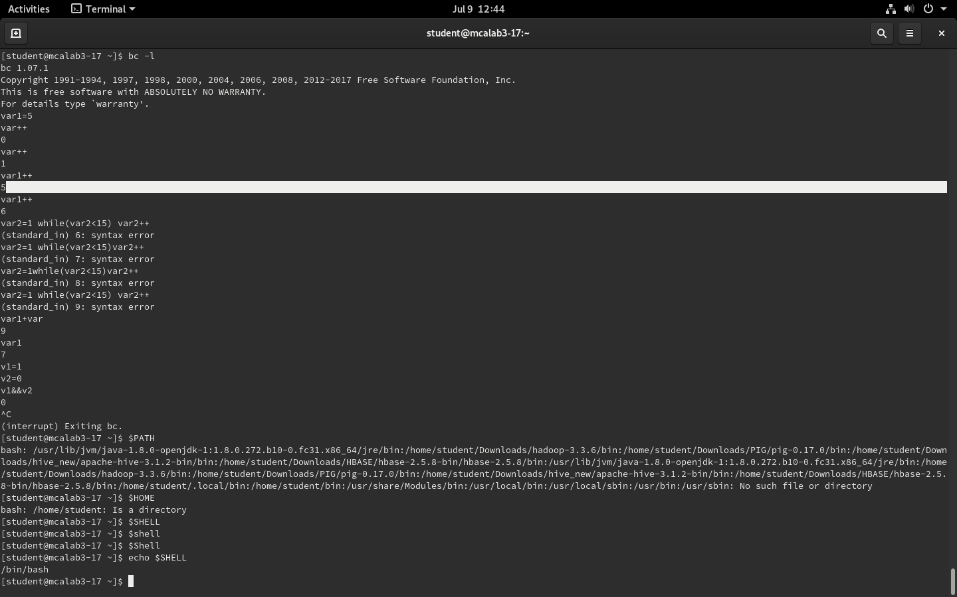
b. HOME

c. SHELL

3. Present Directory → $PWD

4. What are the directories under your home directory

5. What are the directories under the root directory

6. Display the following content using echo command
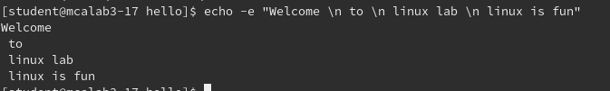

7. Write Linux commands to perform the following tasks

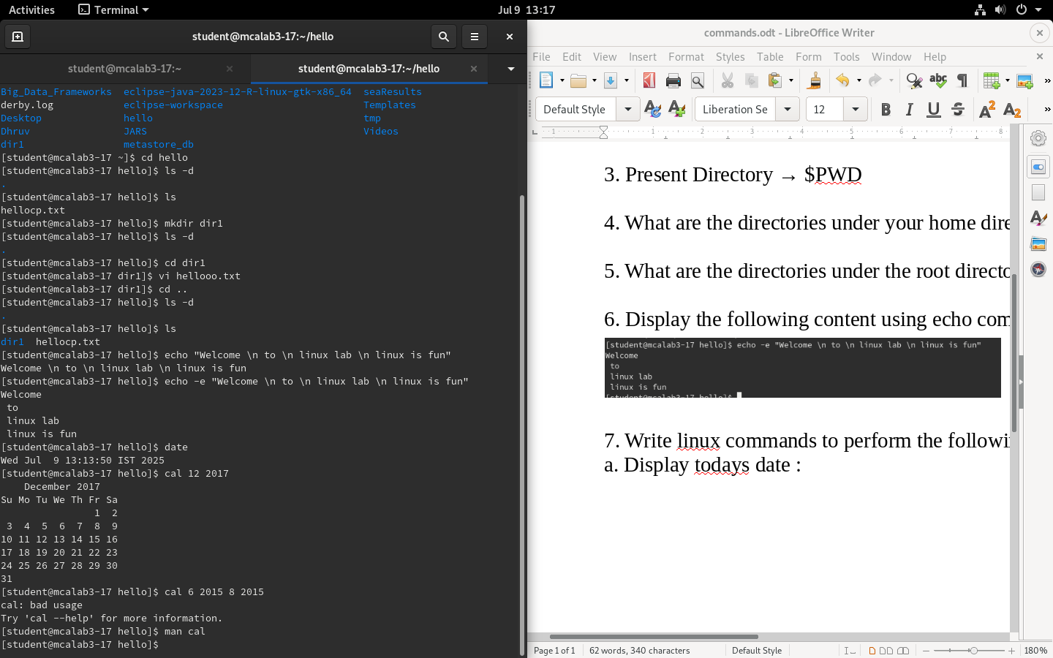
a. Display today's date :

b. display calendar of June 2017

c. Display the calender of the months June and august 2015

d. Display the calender for july 2018 with the starting day of the week as Monday

e. Display the current date and month

f. To repeat your last command

f. To repeat the last command that begins with the letter C

g.

