|  |
| --- |
| MTU Kerry |
| Capturing, Editing and Merging Gaussian Splats to Create Novel 3D Environments |
| Academic Year:2023/2024  Programme Title: Computing with Games Development – MT803  Module Title: Final Year Project  Module Code: PROJ 81003  Lecturer’s Name: Claire Horgan |

|  |
| --- |
| STUDENT Billy Elsbury  0-0-2024 |

# Abstract:

Gaussian Splatting, a rendering technique originating in the 1990s, has recently seen significant advancements, making it a possible alternative to traditional 3D rendering methods. This paper explores the potential and limitations of Gaussian Splatting for creating novel environments in various applications, including game development. The exploration of techniques for editing and merging splats to generate unique and visually impressive 3D scenes. This paper examines the process of editing and merging Gaussian Splats and compares it with other emerging methods, such as Neural Radiance Fields (NeRF) and traditional photogrammetry. This research demonstrates how Gaussian Splatting can contribute to creating highly detailed and dynamic virtual environments.

## Introduction

Computer graphics, photogrammetry, 3D rendering, and game development are the main research areas relevant to this research project. A focus on applying Gaussian splatting, a point-cloud-based 3D rendering technique, to create novel and visually compelling 3D environments.

Techniques for editing and merging Gaussian splats are investigated, exploring their potential to alter Gaussian Splats to create unique 3D scenes for various applications, such as game development. The research aims to assess its strengths, limitations, and potential contributions to 3D content creation.

Contents

Abstract: 1

Chapter 1. Literature Review 3

1.1 Introduction to Gaussian Splatting 3

1.1.1 From Video to Gaussian Splat 4

1.2 Gaussian Splatting in 3D Content Creation 5

1.3: Editing and Merging Gaussian Splats 5

1.4: Future Directions and Potential Improvements 5

2. Methodology 6

2.1 Research Question 6

2.2 Research Area 6

References 7

# Chapter 1. Literature Review

## 1.1 **Introduction to Gaussian Splatting**

The core idea of Gaussian Splatting goes back as far as described by Lee Westover in his 1991 dissertation “Splatting”. Westover derived the term splatting "from a non-technical description of the feed-forward volume-rendering process" (Westover, 1991). Westover used the mental image of a snowball hitting a wall to inspire the name for the process, as it makes a ‘splat’ sound and leaves “its contribution across the wall” (Westover, 1991). This metaphor highlights the essence of the splatting process, where each volumetric data point (splat) contributes to the final image by spreading its effect over the image plane and obscuring previous points for that view.

Westover suggested splatting as a response to limitations in traditional triangle rendering, which often produced artefacts with limited interactive viewing. Westover found traditional rendering methods that “coerced the volumetric data into line and surface primitives” ​(Westover, 1991) could produce artefacts during data processing that could be mistaken for features in the data.

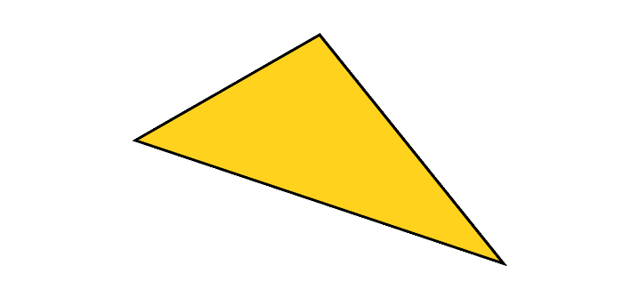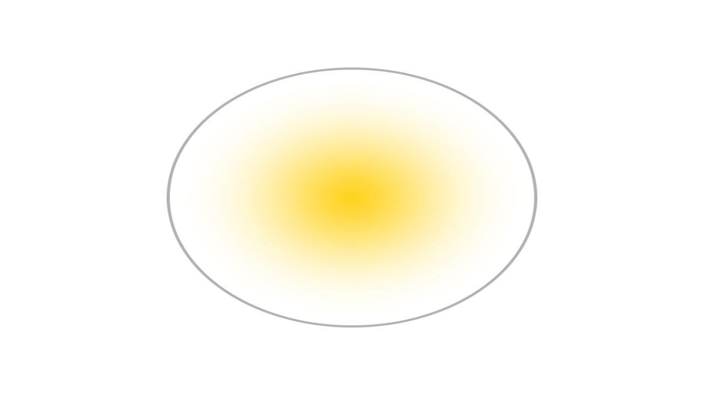

Figure 1 Rasterised Triangle & Gaussian representation (Ebert, 2023)

The core principles of splatting revolve around its ability to map volume data onto an image plane without first transforming the data into geometric primitives. Gaussian functions are optimal for representing volume data due to their bell-curve-like (figure 2), which facilitates natural interpolation between data points.

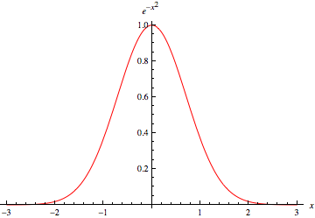

Figure 2 Gaussian Function (Weisstein, 2024)

One of the primary advantages of Gaussian Splatting is its computational efficiency. Using lightweight Gaussians Splats for scene representation enables efficient scene rendering, allowing real-time rendering of point cloud data with high visual quality (Kerbl et al., 2023). This novel approach to scene rendering allows for high visual fidelity while maintaining fast training times (Kerbl et al., 2023).

Despite the potential advantages of Gaussian-based rendering, Gaussian Splatting has limitations. The nature of using splats for smooth blending of point cloud data can introduce artefacts during fast movement or view rotation and may struggle with representing high-frequency details (Radl et al., 2024). Additionally, while real-time rendering at high resolution is achievable, complex scenes may still face challenges maintaining speed and visual clarity at the highest quality levels.

### From Video to Gaussian Splat

The process of Gaussian Splatting in its current form primarily came from a 2023 paper, “3D Gaussian Splatting for Real-Time Radiance Field Rendering” (Kerbl et al., 2023). It was found that Neural Radiance Field (NeRF) rendering methods at the time were lacking in performance and produced noise in the final image. It was proposed that 3D Gaussians (Figure 2.0) be used to represent the point cloud data, retaining high visual fidelity while improving training times and performance with the aim of real-time rendering.

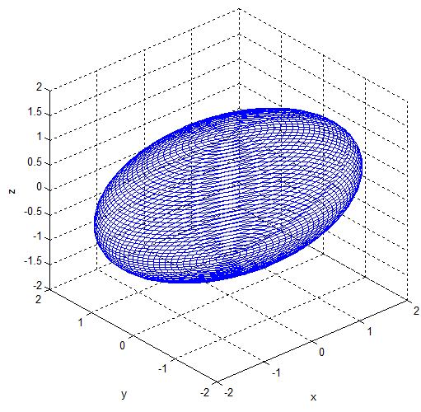

Figure 2.0: Visualisation of a 3D Gaussian model (Park et al., 2012).

The Gaussian Splatting process begins with the same inputs as other similar photogrammetry methods: the camera position between captured images is tracked with a technique such as “Structure-from-Motion” (SFM) (Snavely, Seitz and Szeliski, 2006). The sparse point cloud produced in the SFM process can be initialised with 3D Gaussians derived from the original captures. The properties of these 3D Gaussians can be optimised to fine-tune their position and opacity to best match the original capture; the visual fidelity is improved due to this sorting and blending optimisations. Additionally, anisotropic splatting allows the splats to represent the captured view from that angle best and improve accuracy when viewed from a novel perspective (Kerbl et al., 2023).

## **1.2 Gaussian Splatting in 3D Content Creation**

**Gaussian Splatting offers a promising alternative to traditional 3D rendering, with applications in game development, virtual environments, and interactive 3D content creation. As a volumetric rendering approach, Gaussian Splatting diverges from polygonal and mesh-based models, which dominate the field, offering unique benefits and constraints when used to generate complex 3D scenes.**

### **Applications in Game Development**

**Gaussian Splatting presents new possibilities for creating immersive and efficient environments in game development yet faces limitations in its early implementation stages. The core advantage lies in its ability to render point clouds as coherent scenes with minimal processing time. Gaussian Splatting could streamline rendering workflows for high-fidelity games by bypassing resource-intensive mesh generation steps. However, practical adoption is hampered by its current constraints: lack of dynamic lighting models, limitations in physics integration, limited tools for editing, and absence of Level of Detail (LOD) adaptations, which are critical for rendering performance in games.**

**The inability to re-light scenes dynamically comes from the Gaussian Splatting process using fixed, pre-computed lighting baked into the splat colours; these colours can be adjusted to mimic lighting changes but do not accurately respond to lighting conditions, reducing utility in environments requiring dynamic lighting.**

### **Photogrammetry**

**Photogrammetry uses images to reconstruct detailed 3D models of real-world environments. The method of using photographs in measurement originated** as early as 1851 **from** Aimé Laussedat, **a French military engineer** (Albertz, 2007). Although Laussedat conducted experiments on hand-drawn images and later photographs for topographic mapping purposes, Laussedat called this method “Métrophotographie” (Albertz, 2007). Due to these initial experiments, Laussedat is often considered the “Father of Photogrammetry” (Albertz, 2007). There is, however, debate on how connected Laussedat’s experiments are to the development of photogrammetry as it is practised today (Polidori, 2020). The term photogrammetry was applied later by German architect Albrecht Meydenbauer in an 1867 paper entitled “Die Photogrammetrie” (Beelitz, 1867).

One of the first uses of photogrammetry in video game development is the 2014 game “The Vanishing of Ethan Carter” by an independent Polish studio (Statham, 2020). The technique was quickly adopted by larger studios (Statham, Jacob and Fridenfalk, 2020) as a complex but valuable method to create photoreal scenes for video games.

### **Gaussian Splatting & Photogrammetry**

**Gaussian Splatting shares similarities with photogrammetry in that both methods begin with camera-captured images and apply techniques like Structure-from-Motion (SfM)** (Snavely, Seitz and Szeliski, 2006) **to generate 3D data. Gaussian Splatting deviates in how it handles and renders this data. While traditional photogrammetry converts image data into meshes or voxel grids** (Snavely, Seitz and Szeliski, 2006)**, Gaussian Splatting employs low-weight Gaussian functions that allow smoother, more fluid transitions between data points** (Radl et al., 2024)**.**

**The key difference lies in scalability and render speed: Gaussian Splatting’s lightweight nature allows faster rendering, making it better suited for real-time applications compared to photogrammetry’s polygon-heavy models, which can demand high processing power. This efficiency positions Gaussian Splatting as a potential solution for the increasing demand for video game quality and performance as well as mobile and VR applications where performance constraints are a primary concern. Find reference or change.**

### **Emerging Techniques: NeRF and Beyond**

**With advances in 3D content creation, methods like Neural Radiance Fields (NeRF)** (Mildenhall et al., 2020) **have gained traction for producing realistic and accurate 3D reconstructions. NeRF, which uses neural networks to predict the light intensity and colour across scenes, shares Gaussian Splatting’s goal of efficiently rendering point clouds but achieves this through deep learning. While NeRF can produce high-fidelity scenes it requires significant computation and lengthy training times** (Mildenhall et al., 2020)**, which can limit its suitability for real-time applications. Expand on NeRF a lot more**

**Gaussian Splatting offers a more immediate, lightweight solution with fewer computational demands than NeRF. However, it trades off some fidelity and flexibility, particularly in dynamically lit environments and use cases that require traditional rasterised techniques. Both methods represent compelling alternatives to conventional 3D models, but each addresses distinct needs and constraints. Gaussian Splatting's real-time performance aligns well with applications that prioritise speed and fluidity over intricate detail, whereas NeRF may be preferable when flexible meshed models are required.**

## **1.3: Editing and Merging Gaussian Splats**

* **Editing Techniques:** Explore different methods for manipulating Gaussian splat properties, such as transparency, size, colour, and position.
* **Merging Strategies:** Discuss techniques and uses for combining multiple Gaussian splat datasets into a single, unified representation.
* **Challenges and Considerations:** Address the difficulties and limitations of editing and merging Gaussian splats.

## **1.4: Future Directions and Potential Improvements**

* **Research Gaps and Opportunities:** Identify areas where further research is needed to advance the application of Gaussian splatting.
* **Potential Enhancements:** Suggest ways to improve Gaussian splatting techniques, such as optimising performance or expanding its capabilities.
* **Integration with Other Technologies:** Explore the possibilities of combining Gaussian splatting with other technologies, such as machine learning or artificial intelligence.

# 2. Methodology

## 2.1 Research Question

How can Gaussian Splats be edited and merged to create novel and visually impressive 3D environments for use in game development and beyond?

# References

Albertz, J., 2007. A Look Back; 140 Years of Photogrammetry. *PHOTOGRAMMETRIC ENGINEERING*.

Beelitz, C., 1867. Die Photogrammetrie. *Wochenblatt des Architektenvereins zu Berlin*, No. 49, p.10.

Ebert, D., 2023. *Introduction to 3D Gaussian Splatting*. [online] Available at: <https://huggingface.co/blog/gaussian-splatting> [Accessed 27 October 2024].

Kerbl, B., Kopanas, G., Leimkühler, T. and Drettakis, G., 2023. *3D Gaussian Splatting for Real-Time Radiance Field Rendering*. https://doi.org/10.48550/arXiv.2308.04079.

Mildenhall, B., Srinivasan, P.P., Tancik, M., Barron, J.T., Ramamoorthi, R. and Ng, R., 2020. *NeRF: Representing Scenes as Neural Radiance Fields for View Synthesis*. Available at: <http://arxiv.org/abs/2003.08934> [Accessed 27 October 2024].

Park, J.-H., Shin, Y.-D., Bae, J.-H. and Baeg, M.-H., 2012. Spatial Uncertainty Model for Visual Features Using a Kinect (TM) Sensor. *Sensors (Basel, Switzerland)*, 12, pp.8640–62. https://doi.org/10.3390/s120708640.

Polidori, L., 2020. ON LAUSSEDAT’S CONTRIBUTION TO THE EMERGENCE OF PHOTOGRAMMETRY. *The International Archives of the Photogrammetry, Remote Sensing and Spatial Information Sciences*, XLIII-B2-2020, pp.893–899. https://doi.org/10.5194/isprs-archives-XLIII-B2-2020-893-2020.

Radl, L., Steiner, M., Parger, M., Weinrauch, A., Kerbl, B. and Steinberger, M., 2024. StopThePop: Sorted Gaussian Splatting for View-Consistent Real-time Rendering. *ACM Trans. Graph.*, 43(4), p.64:1-64:17. https://doi.org/10.1145/3658187.

Snavely, N., Seitz, S.M. and Szeliski, R., 2006. Photo tourism: exploring photo collections in 3D. In: *ACM SIGGRAPH 2006 Papers*, SIGGRAPH ’06. [online] New York, NY, USA: Association for Computing Machinery. pp.835–846. https://doi.org/10.1145/1179352.1141964.

Statham, N., Jacob, J. and Fridenfalk, M., 2020. Photogrammetry for Game Environments 2014-2019: What Happened Since The Vanishing of Ethan Carter. In: *Proceedings of DiGRA 2020 Conference: Play Everywhere*. [online] Proceedings of DiGRA 2020 Conference: Play Everywhere. . Available at: <https://dl.digra.org/index.php/dl/article/view/1225> [Accessed 27 October 2024].

Statham, W., 2020. Use of Photogrammetry in Video Games: A Historical Overview. *Games and Culture*, 15(3), pp.289–307. https://doi.org/10.1177/1555412018786415.

Weisstein, E.W., 2024. *Gaussian Function*. [Text] Available at: <https://mathworld.wolfram.com/GaussianFunction.html> [Accessed 2 October 2024].

Westover, L.A., 1991. SPLATTING: A Parallel, Feed-Forward Volume Rendering Algorithm.