Arrabbiata
Menu price 550
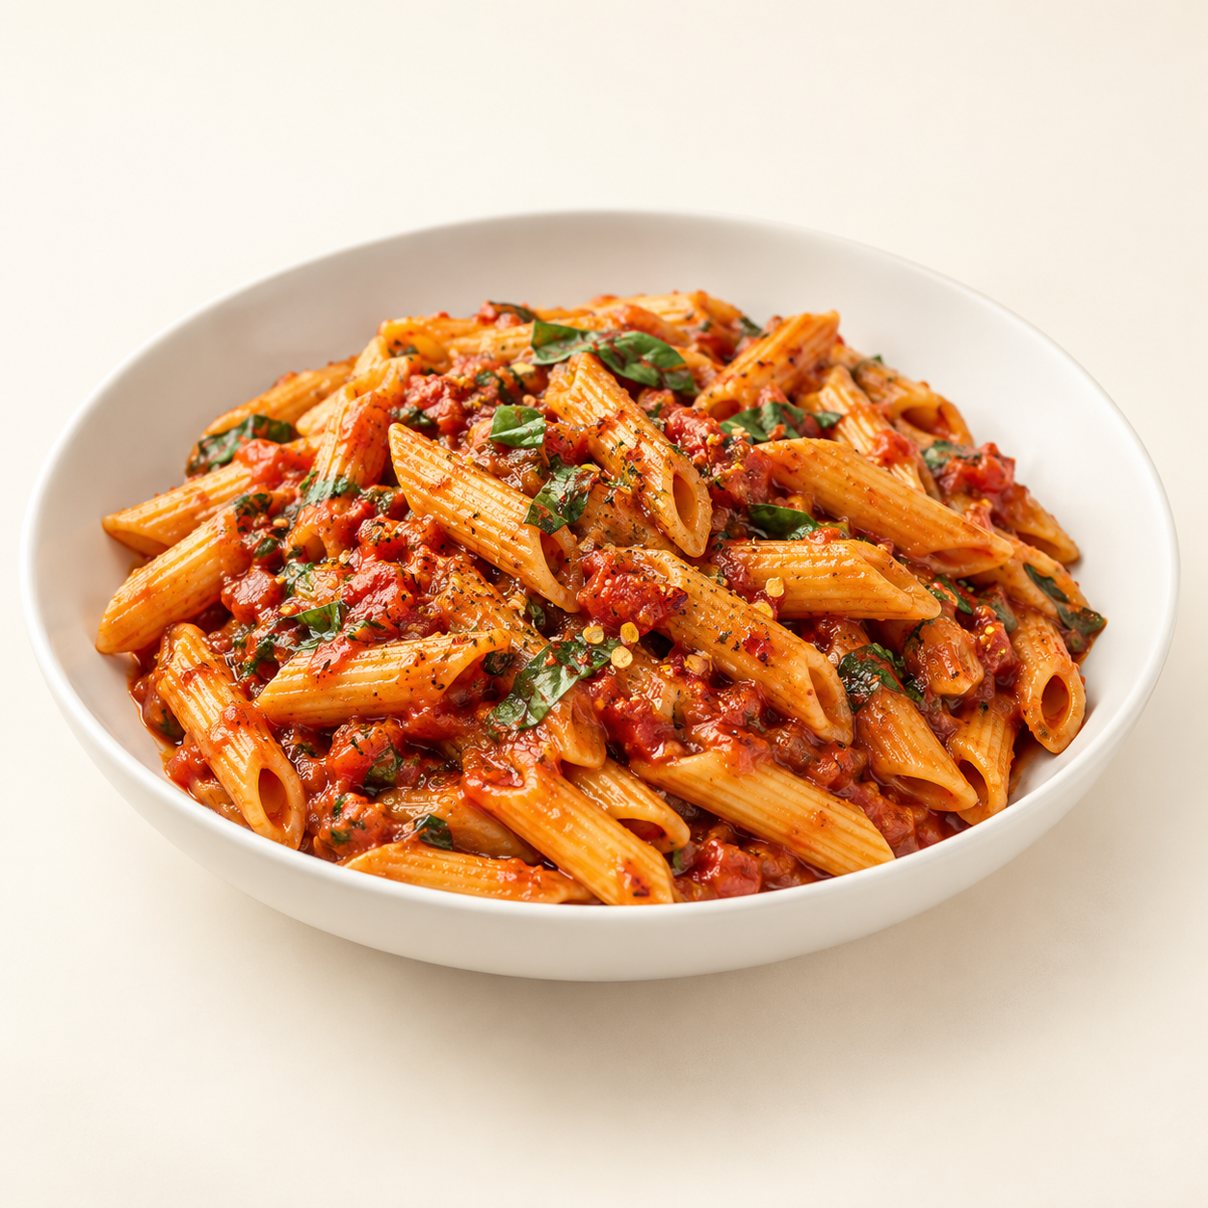
Penne coated in a spicy tomato sauce with garlic and herbs.
Suggested recipe 1 main course
Time 25 minutes

Ingredients
- 100 g dried penne, 200 g crushed tomatoes and 15 ml olive oil
- 2 sliced garlic cloves and 1/4 to 1/2 tsp chili flakes
- 5 g chopped parsley or basil, salt and black pepper
- 60 ml reserved pasta water, as needed

Method
1. Boil penne in salted water until just tender, reserving a little cooking water.
2. Warm oil over medium low heat. Add garlic and chili; cook for 30 to 60 seconds without browning the garlic.
3. Add tomatoes and simmer for 12 to 15 minutes until thickened. Season to taste.
4. Toss penne with the sauce and a splash of reserved water. Stir in herbs and serve hot.
Price source: supplied Nuvora menu; currency not stated. Suggested recipe, not an official restaurant formula. Image is AI generated.

