BBQ Chicken Pizza
Menu price Medium 650 | Large 1,050
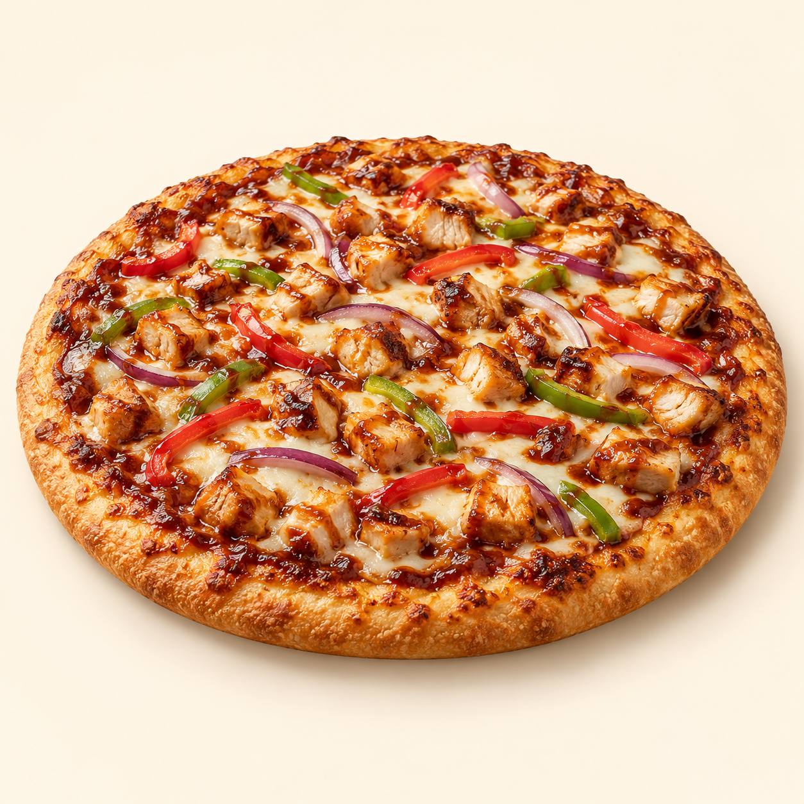
Barbecue sauce, chicken, mozzarella, onion and bell pepper on a golden pizza crust.
Suggested recipe 1 proposed medium pizza, about 28 cm; see scaling note
Time 25 minutes active, plus 1 to 2 hours rising and 8 to 12 minutes baking

Ingredients
- Dough: 180 g strong bread flour, 115 ml lukewarm water, 2 g instant yeast, 3 g salt and 5 ml olive oil
- 70 g barbecue sauce, 100 g cooked chicken
- 100 g mozzarella, 30 g onion and 30 g bell pepper, thinly sliced

Method
1. Mix flour, water and yeast. Add salt and oil, then knead for 8 to 10 minutes until smooth. Cover and let rise for 1 to 2 hours until roughly doubled.
2. Heat the oven to 250 C, or its highest suitable setting, with a pizza stone or heavy baking tray inside for at least 30 minutes. Stretch dough into a 28 cm round on baking paper.
3. Spread barbecue sauce, add mozzarella, cooked chicken, onion and bell pepper, then bake. Bake on the hot surface for about 8 to 12 minutes until the base is cooked and the crust is golden.
4. Rest for 1 minute, slice and serve. For a proposed 35 cm large pizza, multiply dough and toppings by about 1.56; baking time may vary. Menu diameters are not specified.
Price source: supplied Nuvora menu; currency not stated. Suggested recipe, not an official restaurant formula. Image is AI generated.

