BBQ Smoke Burger
Menu price 750
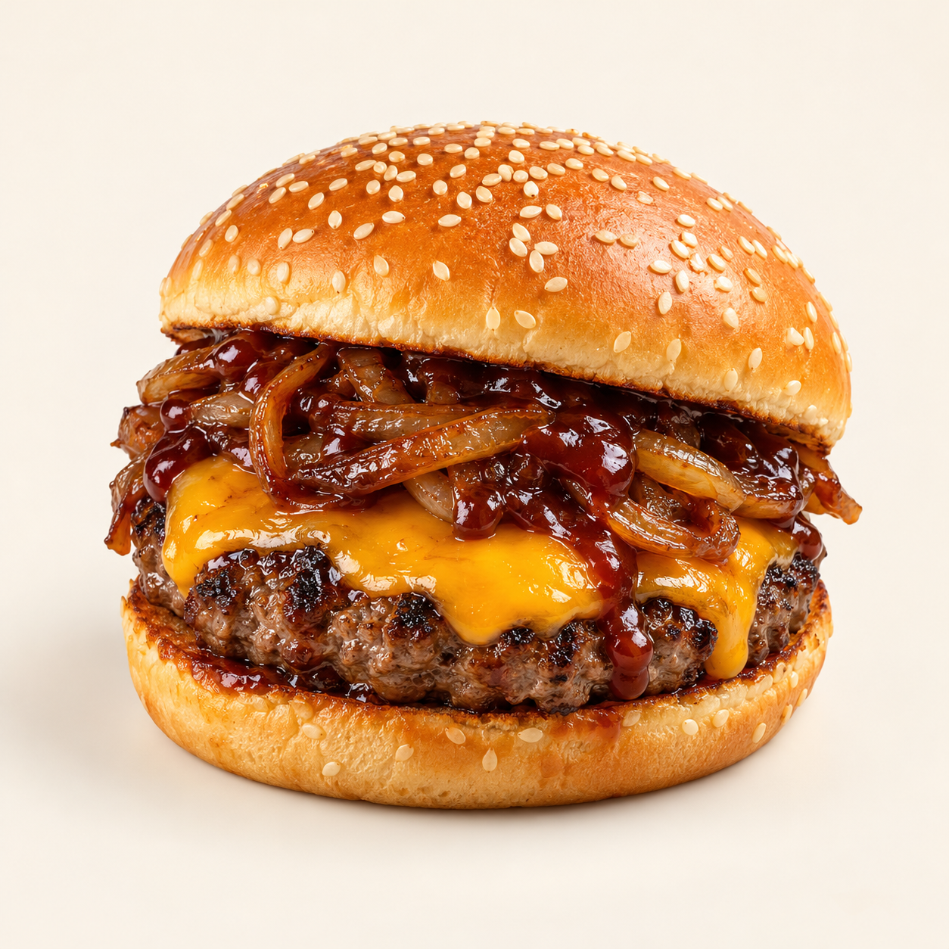
A beef burger with melted cheddar, sweet caramelized onion and smoky barbecue sauce in a sesame bun.
Suggested recipe 1 burger
Time 30 minutes

Ingredients
- 150 g ground beef, 1 sesame bun and 1 cheddar slice
- 60 g sliced onion, 5 g butter and 5 ml neutral oil
- 25 g smoky barbecue sauce, 10 g mayonnaise
- Salt and black pepper to taste

Method
1. Cook onion in butter and oil over medium low heat for 15 to 20 minutes until soft and browned, stirring regularly.
2. Shape and season the beef patty. Sear in a hot skillet for 3 to 5 minutes per side, until the centre reaches 71 C. Melt cheddar on top.
3. Toast the bun. Spread mayonnaise on the base and barbecue sauce on the upper half.
4. Add the beef patty and caramelized onion. Assemble and serve hot.
Price source: supplied Nuvora menu; currency not stated. Suggested recipe, not an official restaurant formula. Image is AI generated.

