Bolognese
Menu price 650
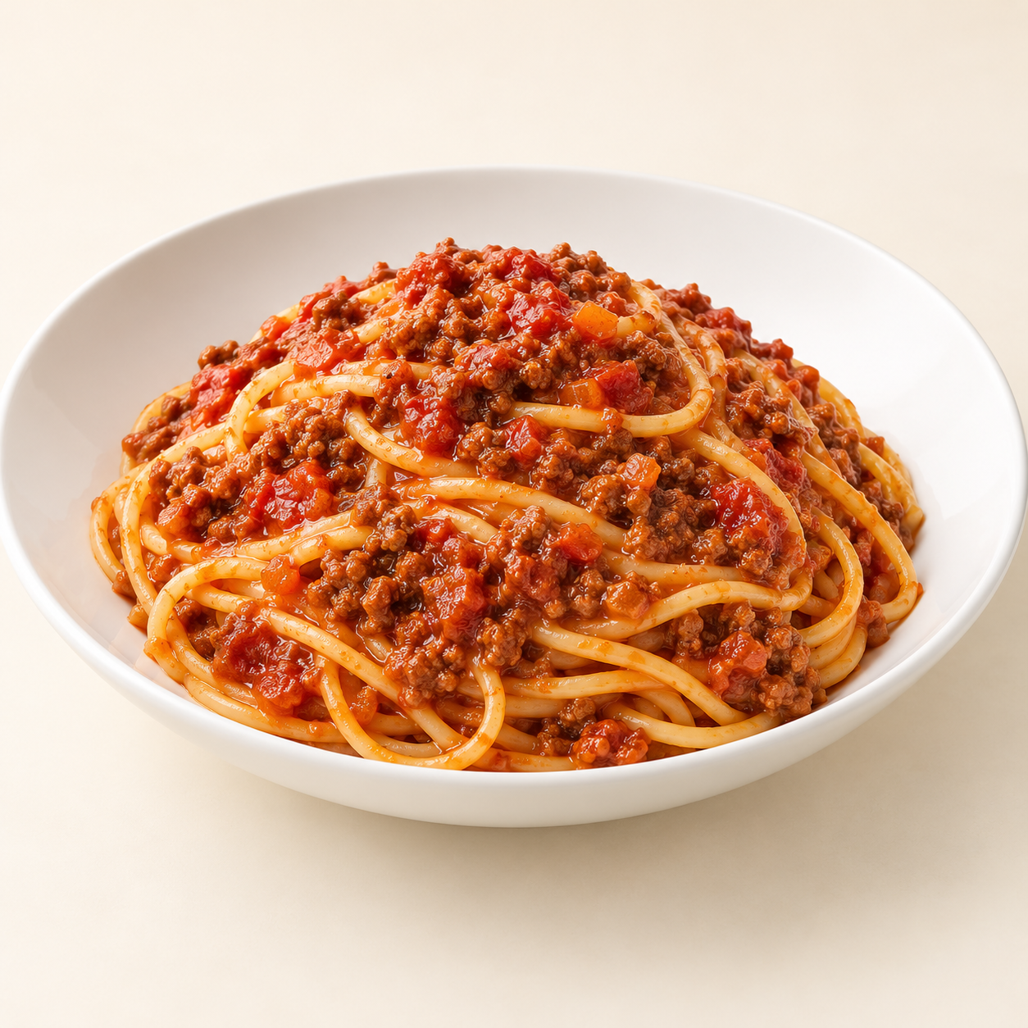
Spaghetti topped with a rich tomato and beef sauce, slowly simmered with finely chopped vegetables.
Suggested recipe 1 main course
Time 50 to 60 minutes

Ingredients
- 100 g dried spaghetti, 120 g ground beef and 200 g crushed tomatoes
- 30 g onion, 20 g carrot and 15 g celery, finely chopped
- 1 minced garlic clove, 10 g tomato paste and 10 ml olive oil
- 60 ml water or stock, 1/4 tsp dried oregano, salt and pepper

Method
1. Soften onion, carrot and celery in oil for 5 minutes. Add garlic and cook for 30 seconds.
2. Add beef and brown thoroughly, breaking it apart. Stir in tomato paste and cook for 1 minute.
3. Add tomatoes, water or stock, and oregano. Simmer gently, partly covered, for 30 to 40 minutes, stirring and adding water if needed. Ensure beef is cooked through to 71 C. Season to taste.
4. Boil spaghetti in salted water until just tender. Drain and serve with the sauce, or toss together with a splash of pasta water.
Price source: supplied Nuvora menu; currency not stated. Suggested recipe, not an official restaurant formula. Image is AI generated.

