Chicken Alfredo
Menu price 750
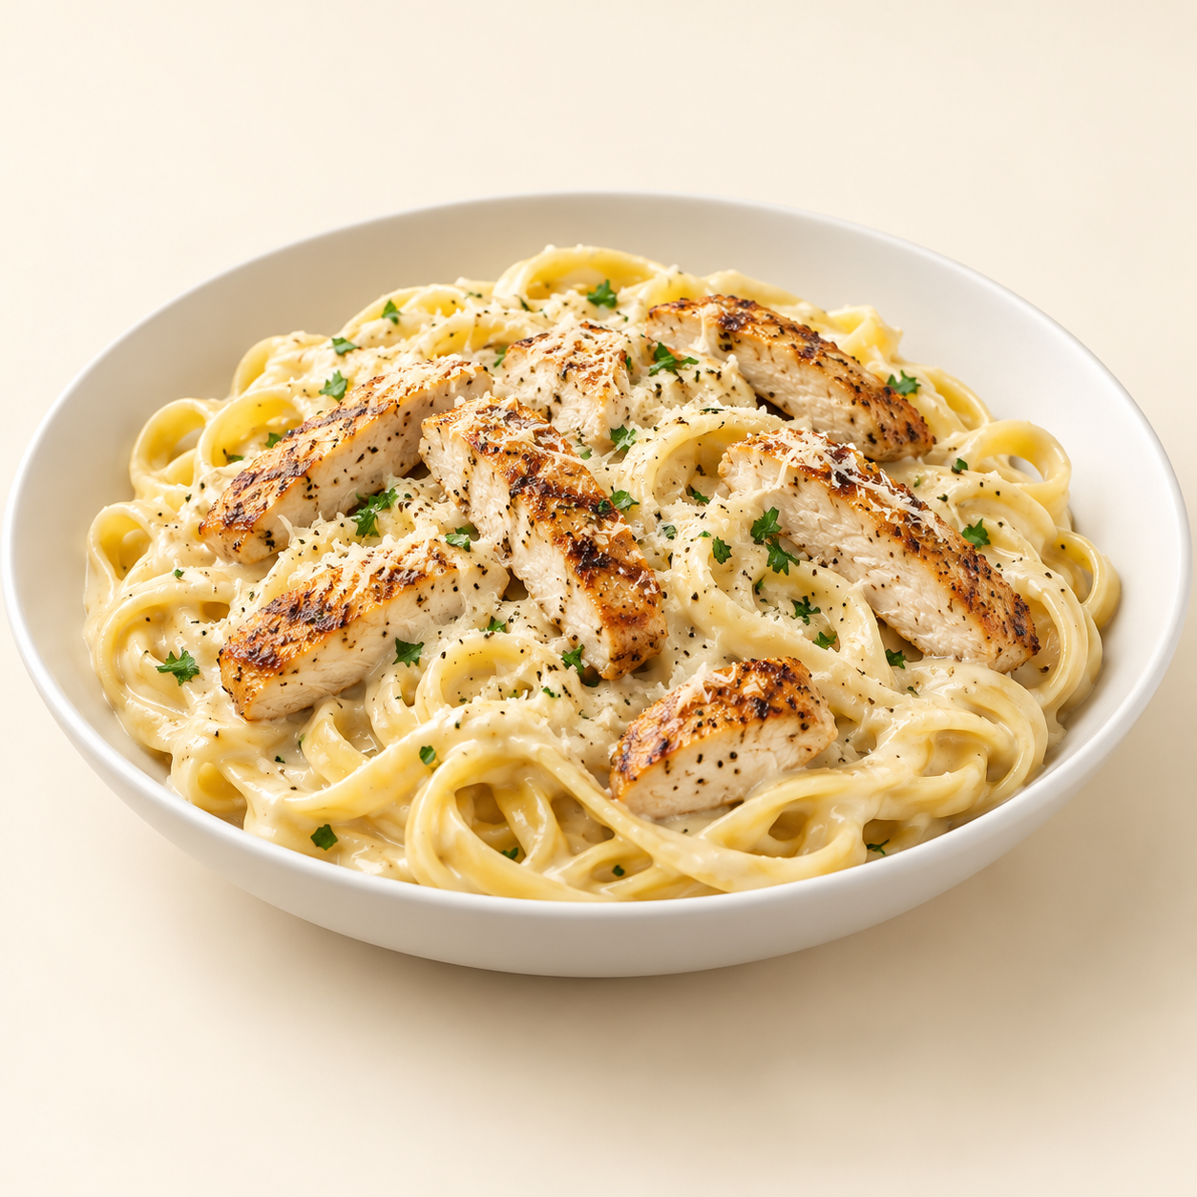
Fettuccine in a creamy Alfredo sauce, topped with juicy grilled chicken and a little parsley.
Suggested recipe 1 main course
Time 30 minutes

Ingredients
- 100 g dried fettuccine and 150 g chicken breast
- 120 ml cream, 15 g butter and 25 g grated Parmesan
- 1 minced garlic clove, 5 ml oil and 5 g parsley
- Salt, black pepper and 60 to 100 ml reserved pasta water

Method
1. Season chicken. Grill or pan cook with oil for about 5 to 7 minutes per side, depending on thickness, until the centre reaches 74 C. Rest briefly and slice.
2. Boil pasta in salted water until just tender; reserve some cooking water before draining.
3. Melt butter over medium low heat and soften garlic for 30 seconds. Add cream and simmer gently for 2 to 3 minutes. Lower heat and stir in Parmesan.
4. Toss pasta with sauce, adding reserved water gradually until glossy. Season, top with chicken and parsley, and serve immediately.
Price source: supplied Nuvora menu; currency not stated. Suggested recipe, not an official restaurant formula. Image is AI generated.

