Nuvora Box 2 Pieces with Fries
Menu price 500
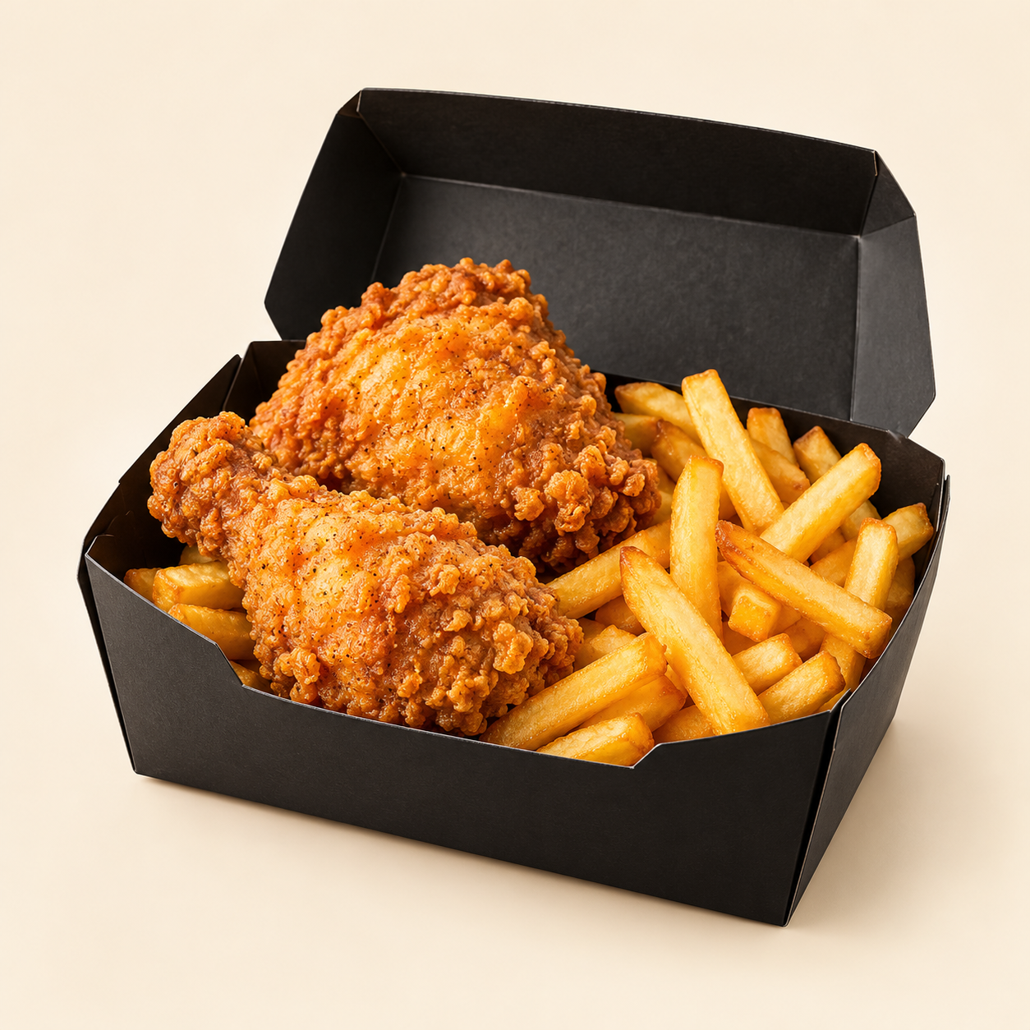
2 pieces of golden, crunchy fried chicken with a tender, juicy centre, served with crisp French fries.
Suggested recipe 1 box with 2 chicken pieces and fries
Time 35 to 50 minutes active cooking, plus 4 to 12 hours marinating

Ingredients
- 2 bone-in chicken pieces, about 260 g total, similar in size
- 100 ml buttermilk
- 70 g plain flour and 20 g cornflour
- 1 tsp paprika, 0.5 tsp garlic powder and 0.5 tsp black pepper
- 0.5 tsp salt for the marinade and 0.5 tsp for the coating
- Neutral frying oil, enough for a safe depth in a heavy pot
- 200 g frozen French fries and a pinch of salt

Method
1. Mix buttermilk with the marinade salt. Coat the chicken and refrigerate, covered, for 4 to 12 hours.
2. Combine flour, cornflour, remaining salt, paprika, garlic and pepper. Lift chicken from the marinade, press into the flour mix, and rest on a rack for 10 minutes.
3. Heat oil to 170 C. Fry in small batches for about 12 to 18 minutes, adjusting for piece size and maintaining 165 to 175 C. Check the thickest part, away from bone, reaches 74 C.
4. Drain on a rack for 3 to 5 minutes. Do not crowd or cover the chicken while it rests.
5. Fry the frozen fries at 175 C according to the pack instructions until golden. Drain, season and serve alongside the chicken.
Price source: supplied Nuvora menu; currency not stated. Suggested recipe, not an official restaurant formula. Image is AI generated.

