Chicken Tenders
Menu price 350
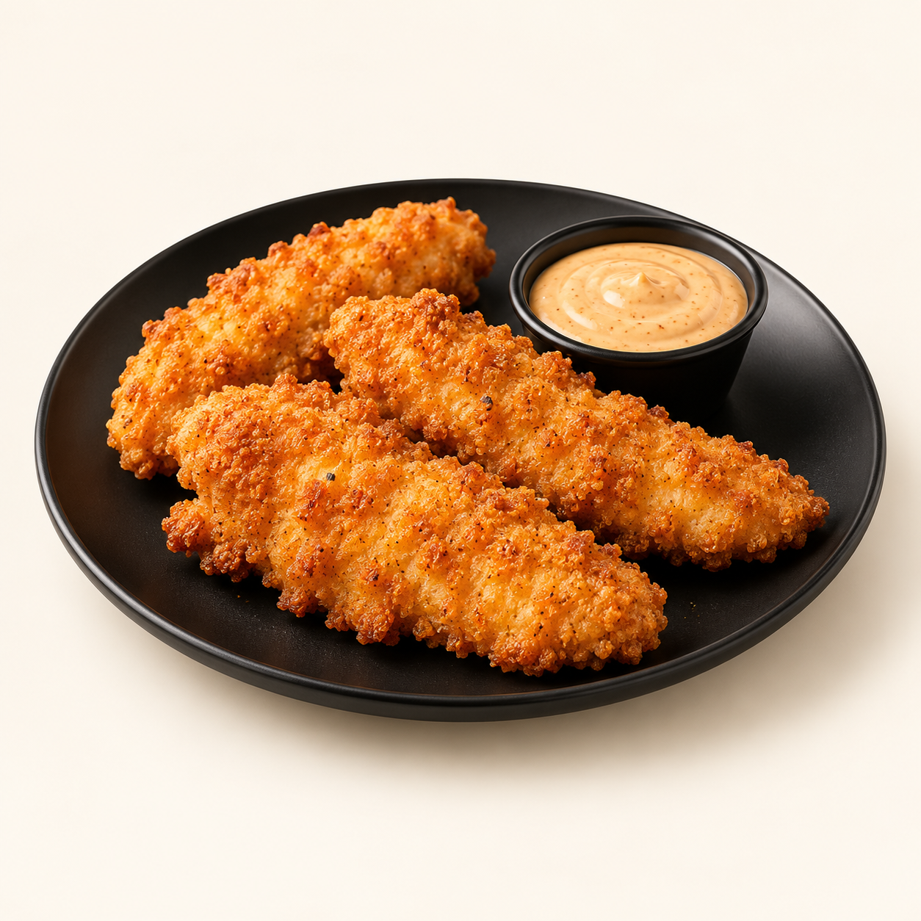
Golden breaded chicken strips with a crunchy coating, served with a creamy dipping sauce.
Suggested recipe 1 portion of 4 tenders
Time 25 minutes, plus 30 minutes marinating

Ingredients
- 200 g chicken breast cut into 4 strips and 100 ml buttermilk
- 60 g flour, 20 g cornflour, 1/2 tsp paprika
- 1/4 tsp each garlic powder and salt, black pepper
- Neutral frying oil; 30 g dipping sauce of choice

Method
1. Marinate chicken in buttermilk in the refrigerator for 30 minutes.
2. Combine flour, cornflour and seasonings. Drain each strip lightly and press into the coating.
3. Heat oil to 170 C. Fry strips in batches for about 4 to 6 minutes, until golden and their centres reach 74 C.
4. Drain on a rack and serve four strips with the dipping sauce.
Price source: supplied Nuvora menu; currency not stated. Suggested recipe, not an official restaurant formula. Image is AI generated.

