Classic Burger
Menu price 650
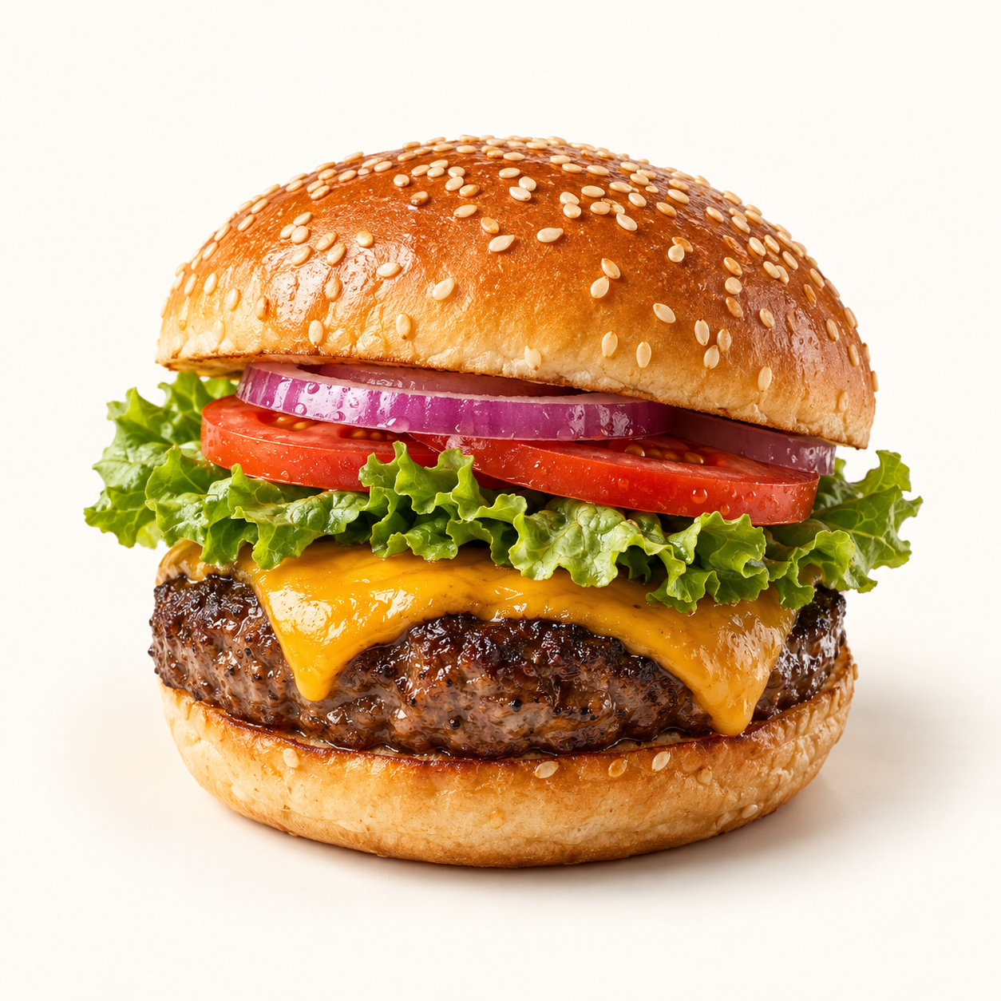
A juicy beef burger layered with cheddar, lettuce, tomato and red onion in a toasted sesame bun.
Suggested recipe 1 burger
Time 20 minutes

Ingredients
- 150 g ground beef, 1 sesame burger bun, 1 cheddar slice
- 1 lettuce leaf, 2 tomato slices and 2 thin red onion rings
- 15 g mayonnaise, 10 g ketchup, 5 g butter
- Salt and black pepper to taste

Method
1. Shape beef into one patty slightly wider than the bun. Season both sides just before cooking.
2. Heat a skillet over medium high heat. Cook the patty for about 3 to 5 minutes per side, until the centre reaches 71 C. Add cheddar for the final minute.
3. Butter the bun and toast cut sides. Stir mayonnaise and ketchup together.
4. Spread sauce over the bun, then add lettuce, patty, tomato and onion. Close and serve immediately.
Price source: supplied Nuvora menu; currency not stated. Suggested recipe, not an official restaurant formula. Image is AI generated.

