Creamy Mushroom
Menu price 650
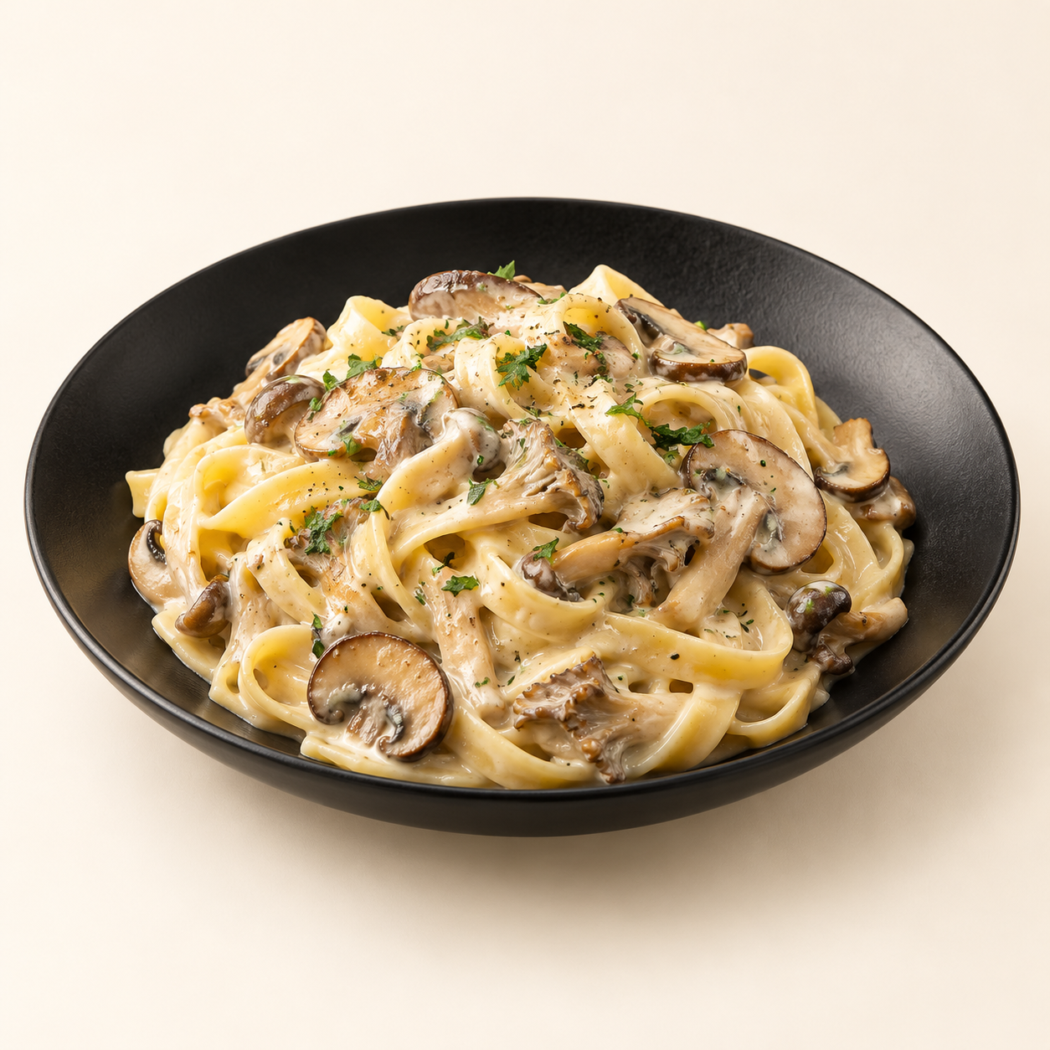
Fettuccine tossed in a creamy sauce with a generous mix of browned mushrooms.
Suggested recipe 1 main course
Time 25 minutes

Ingredients
- 100 g dried fettuccine and 150 g mixed mushrooms, sliced
- 100 ml cream, 15 g butter and 5 ml olive oil
- 1 minced garlic clove, 20 g grated Parmesan and 5 g parsley
- Salt, black pepper and 60 to 100 ml reserved pasta water

Method
1. Boil pasta in salted water until just tender. Reserve some cooking water, then drain.
2. Heat oil and half the butter in a wide skillet. Brown mushrooms for 6 to 8 minutes, letting excess moisture evaporate.
3. Add remaining butter and garlic; cook for 30 seconds. Add cream and simmer gently for 2 minutes. Lower heat, then stir in Parmesan.
4. Add pasta and enough cooking water to loosen the sauce. Season, sprinkle with parsley and serve immediately.
Price source: supplied Nuvora menu; currency not stated. Suggested recipe, not an official restaurant formula. Image is AI generated.

