Crispy Chicken Burger
Menu price 650
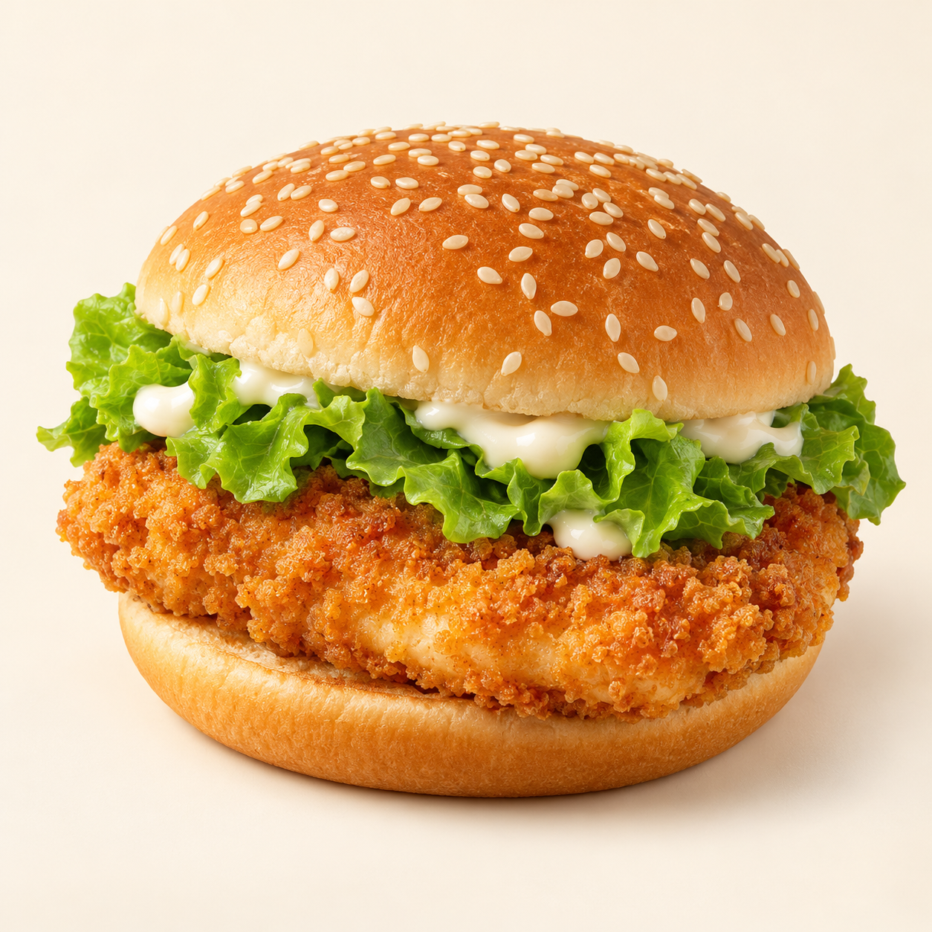
Crunchy breaded chicken breast with fresh lettuce and creamy mayonnaise in a toasted sesame bun.
Suggested recipe 1 burger
Time 25 minutes, plus 1 to 4 hours marinating

Ingredients
- 150 g chicken breast, flattened to about 1.5 cm thick
- 75 ml buttermilk, 40 g flour and 10 g cornflour
- 1/4 tsp each paprika and garlic powder, salt and pepper
- 1 sesame bun, 1 lettuce leaf and 20 g mayonnaise
- Neutral oil for frying

Method
1. Marinate chicken in seasoned buttermilk in the refrigerator for 1 to 4 hours.
2. Mix flour, cornflour and spices. Lift chicken from buttermilk and coat firmly in the flour mixture.
3. Heat oil to 170 C. Fry for about 5 to 7 minutes, turning if needed, until golden and the centre reaches 74 C. Drain on a rack.
4. Toast the bun. Spread with mayonnaise, add lettuce and chicken, and close the burger.
Price source: supplied Nuvora menu; currency not stated. Suggested recipe, not an official restaurant formula. Image is AI generated.

