Double Smash
Menu price 850
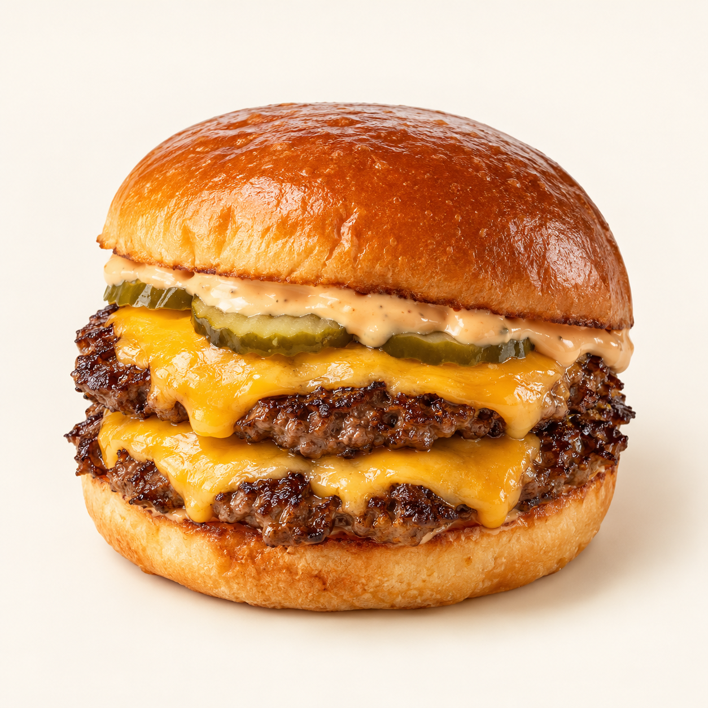
Two thin beef patties with crisp seared edges, melted cheddar, pickles and burger sauce in a toasted bun.
Suggested recipe 1 double burger
Time 20 minutes

Ingredients
- 180 g ground beef divided into two loose 90 g balls
- 1 burger bun, 2 cheddar slices and 15 g sliced pickles
- 15 g mayonnaise, 10 g ketchup and 5 g mustard
- 5 g butter, salt and black pepper

Method
1. Mix mayonnaise, ketchup and mustard. Butter and toast the bun.
2. Heat a heavy skillet until very hot. Place beef balls apart and press each firmly into a thin patty using a sturdy spatula and a piece of baking paper. Remove the paper immediately.
3. Season and cook for about 2 minutes until edges brown. Scrape underneath, flip and cook until the centre reaches 71 C. Add cheese and stack the patties.
4. Spread sauce on the bun, add pickles and the stacked patties, and serve immediately.
Price source: supplied Nuvora menu; currency not stated. Suggested recipe, not an official restaurant formula. Image is AI generated.

