Fries
Menu price 200
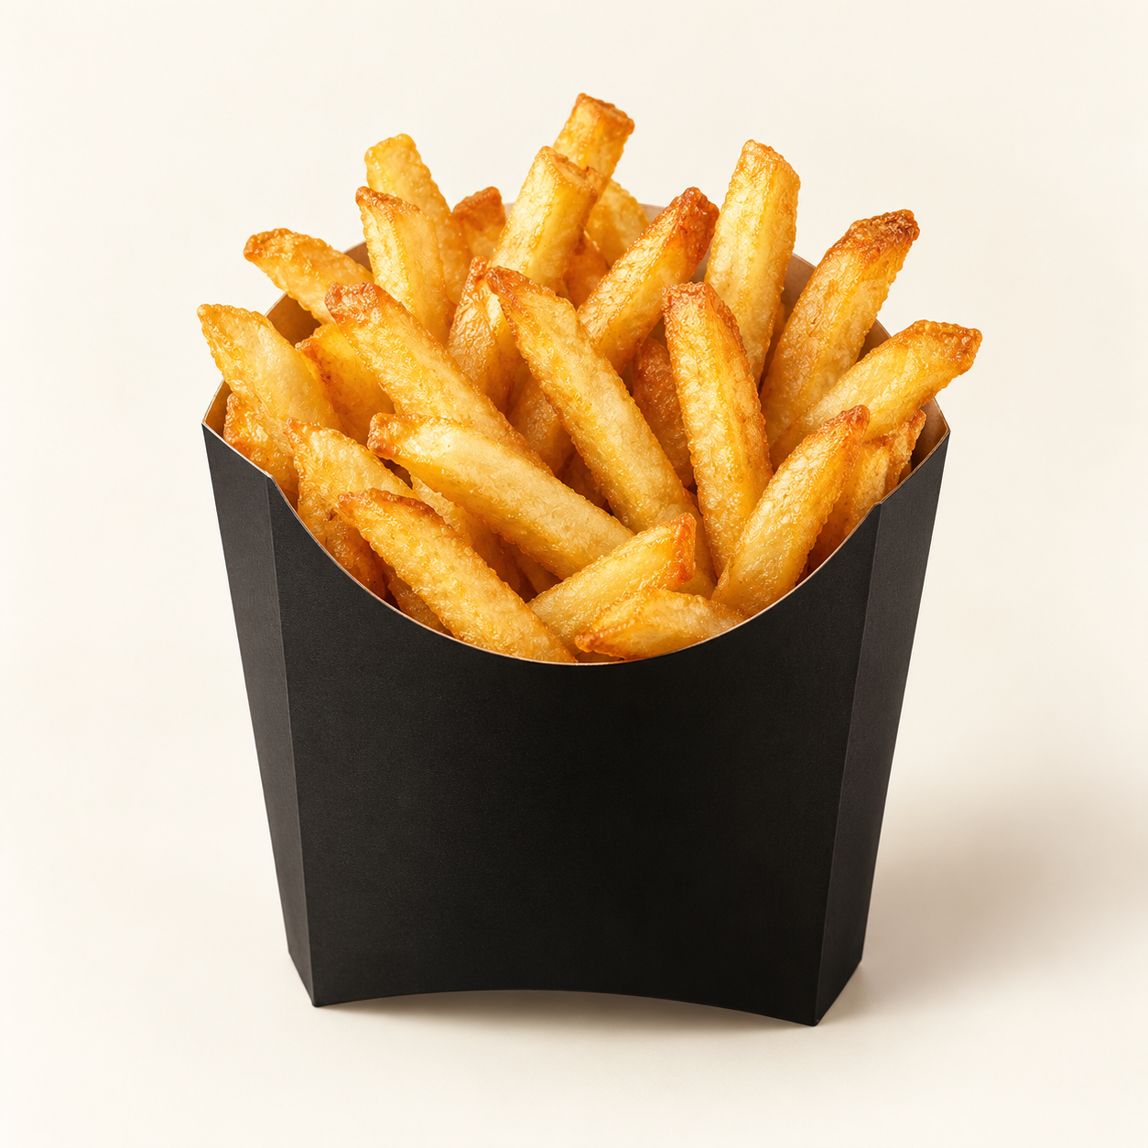
Golden French fries with a crisp exterior, soft potato centre and a light seasoning of salt.
Suggested recipe 1 side portion
Time 15 minutes

Ingredients
- 200 g frozen French fries
- Neutral oil for frying and salt to taste

Method
1. Heat frying oil to 175 C in a suitable deep pot or fryer. Keep frozen fries frozen until cooking.
2. Fry in a small batch for the time on the package, usually 3 to 5 minutes, until golden and crisp.
3. Lift out, drain well and toss with salt. Serve immediately in an open carton or on a plate.
Price source: supplied Nuvora menu; currency not stated. Suggested recipe, not an official restaurant formula. Image is AI generated.

